ANT COLONY Optimization based Optimal path selection and data gathering in WSN
Biswa Mohan Sahoo Ranjeet Kumar Rout Saiyed Umer
Computer Science Engineering Computer Science Engineering Computer Science Engineering
Amity University National Institute of Technology Aliah University, New Town
Greater Noida, India Srinagar, India Kolkata, India
biswamohans@gmail.com ranjeetkumarrout@gmail.com saiyedumer@gmail.com
Hari Mohan Pandey
Computer Science Engineering
Edge Hill University
Lancashire, United Kingdom
pandeyh@edgehill.ac.uk

Abstract: A data aggregation is an essential process in the field of wireless sensor network to deal with base station and sink node. In current data gathering mechanism, the nearest nodes to the sink receives data from all the other nodes and shares it to the sink. The data aggregation process is utilized to increase the capability and efficiency of the existing system. In existing technique, the possibility of data loss is high this may leads to energy loss therefore; the efficiency and performance are damaged. In order to overcome these issues, an effective cluster based data gathering technique is developed. Here the optimal cluster heads are selected which is used for transmission with low energy consumption. The optimal path for mobile sink (MS) is done by Ant Colony Optimization (ACO) algorithm. It provides efficient path along with MS to collect the data along with Cluster centroid. The performance of the proposed method is analyzed in terms of delay, throughput, lifetime, etc.
Keywords: Data aggregation, Ant Colony Optimization, Mobile Sink, Data gathering, WSN
I. INTRODUCTION
Recent technological growth has lead to many advantages to the modern’s society therefore; the births of electronic components are reached the tremendously grown. This cause abundance of system, this system’s progress and activity should be checked frequently in order to provide different type of computer networks. A wireless sensor network is a science emerged ad-hoc network [1], that deals with same kind of applications [2]. WSN provides many advantages therefore; it gets the considerable attention from various applications from all over world due to accessing essential data based on different parameters such as temperature, pressure, acceleration, vibration and the calculation of chemical groups [4]. Recent days the involvement of WSN is inevitable in Big Data as well as Internet of Things [3]. With this usage environmental information can be easily observed and monitored [9]. It performs data collection, detection, tracking and control etc. However, it is critical and difficult to human control in these circumstances [11].
This mechanism acts as a multi-hop in the entire network while sharing and collecting data by the sensor nodes [10]. In addition, the data gathered by the sensor nodes in WSN has spatio-temporal correlation [6]. One of the effective features of WSN is cooperative communication, which sensor nodes transmitting the data to the target location by transferring data before transmission, provides effective communication process between them [5][11]. Most of the applications executed the data collection process by the sensor node at a pre-defined sink [7][19].
In addition, it is utilized in a lot of applications in domains including environmental monitoring, health care, manufacturing and many others [12]. The significant characteristics of WSN are Low cost, energy efficient, communication capabilities, security and privacy, distributed sensing and processing, self-organization and Multi-hop communication [4][15]. In WSN circumstance, power consumption is biggest challenge and it can be caused by many reasons among them data gathering is also the big factor for power consumption issues [5]. In other hand, selection of communication paths and aggregation points are difficult network demands in WSN [14] [2]. The conventional WSN utilized the service is based on distributed network due to the nature of flexible deployment, easy to access and low cost [8].
. Energy constrains are highly serious topic in recent technology especially in WSN environment because it may cause the reason for reducing network lifetime of the entire WSN system, especially in data gathering [13]. In research area, many researchers are focusing on providing effective WSN based system for path selection for efficient data gathering.
The rest of the paper is arranged systematically manner like, related work is discussed in Section 2. Proposed methodology is discussed in section 3. Section 4 represent the simulation result and section 5 concluding the paper.

II. RELATED WORK
Ricardo Simon Carbajo et.al. [16], have proposed a novel technique based WSN. The novel emerged technique in recent technology was smart wireless sensor devices due to its advantages it was utilized to monitor wind turbine as well. Wireless Sensor Network might deal to form network in order to overcome from the limited range communication access to provide distant points communication. Routing protocols were ultimate providers of such ad hoc wireless sensor network and those required the execution of dependable and vitality effective technique to boost network dependability and accessibility.
Wireless sensor network got a considerable attention from various sides. It was inevitable in modern technological developed lifestyle. It was utilized to solve the energy efficiency problems of network which was become a emerged problem to be solved for effective services. Therefore; several algorithm had been proposed to deal with energy efficient problem in order to reduce energy consumption in traditional WSNs [22]. For this work, the author had studied; Software defined networks (SDN) and energy-efficient algorithms in SDN-based WSNs architectures. In this paper, Li Peizhe et.al. [17], have proposed a novel technique where they integrated an SDN into WSNs and an improved software-defined wireless sensor networks (SDWSNs) model was developed.
In this work, Shaimaa M. Mohamed et.al. [18], have proposed a novel technique in the field mobile wireless network. Here, they discussed about a mobile wireless sensor network (M-WSN) consisted of sensors attached with locomotive environment to enable movement after first deployment. MWSNs were helpful for environments that were critical and/or fatal for sensor distribution. An ultimate issue in sensor networks distribution was to confirm that distributed sensors provided the required certain range for the area of interest, while confirming connectivity of the distributed network.
Sergio Montero et.al. [20], have presented a novel technique where they discussed about Industry oriented wireless sensor networks. It could encourage the arrangement of an extensive range of novel modern operations. The significant purposes behind such degradation were the neighbor revelation mechanism. They have developed and classified two novel neighbor discovery protocols that improved the effectiveness of mobile devices to persist associated to the industrial wireless sensor networks as they displaced.
Amar Kaswan et al. [21] have discussed about the Path Detection in “Mobile Sink and Data Gathering in Wireless Sensor Networks”. The author was introduced two algorithms such as reduced k-means (RkM) and Delay bound reduced k-means (DBRkM). Hop counts and average hop distance was minimized for path detection and data was gathered by applying MS scheduling technique.
The great processing and capability of cloud computing could infuse new essentialness into wire sensor networks (WSNs) and had influenced a progression of new applications. However, still the data collection is very hard in cloud environment due to WSNs communication capability was poor. In this paper, Tian Wang et.al. [23], have proposed a fog architecture composed of multiple mobile sinks. Mobile sinks acted as fog nodes helped to solve the issues between WSNs and the Cloud. They made a communication between them to develop a multi-input multi-output (MIMO) network, focusing to increase the throughput and decrease the transmission latency.
III. PROPOSED METHODOLOGY
The primary aim of this research is to develop an efficient data gathering technique with optimal path selection. For optimal path selection ACO algorithm is used and it will decrease the node distance in order to reduce the energy.
- Clustering the sensor node
For efficient energy consumption, clustering of sensor nodes is described. The nodes are grouped based on the cost and memory value. Here, $\text{SN}=\left\{{\text{sn}}_{1},{\text{sn}}_{2},\text{.}\text{.}\text{.}{\text{sn}}_{i}\right\}$where i represents the number of sensors used in the network. The position of the sensor is defined by its x and y coordinate values. The grouping can be done by the following steps: (a) the unused cluster centroids are removed for energy consumption, (b) cluster heads based on the optimal weight are used for transmission purpose, (d) finally the optimal path is selected using ACO.
- Ant Colony Optimization Algorithm (ACO)
For finding the optimal path Ant Colony Optimization Algorithm is used. This algorithm is most widely used for shortest path selection which is a bio inspired behavior of Ant. The probability rule between two node is represent as follows,
$$\text{Pr}\text{ob}=\begin{aligned}\left\{\frac{{\left[μ_{\text{xy}}\right]}^{a} ∗ {\left[ξ_{\text{xy}}\right]}^{b}}{\sum{{\left[μ_{\text{xy}}\right]}^{a} ∗ {\left[ξ_{\text{xy}}\right]}^{b}}} ∀x∈S_{N_{x}} \text{and} m∉M | \right.\end{aligned}$$
(1)
Where $μ_{\text{xy}}$ represents the pheromone intensity of node x and y. $ξ_{\text{xy}}$represents the path length. a and b are two parameters which controls the relative status of pheromone trail and heuristic value. ${S_{N}}_{x}$ represents set of sensor nodes M represents the memory value. The path length is described by equation (2). It is shown in below,
$ξ_{\text{xy}}=\frac{1}{z\left(x, y\right)}$ (2)
Where, $z\left(x, y\right)$represents the length of edge between node $x$and$y$.
Total amount of pheromone quantity on edge $x$to $y$is denoted in equation (3), $μ_{\text{xy}}=μ_{\text{xy}}+Δμ_{\text{xy}}$ (3) The quantity of pheromone is given by,
${Δμ}_{\text{xy}}=\frac{1}{n}$ (4)
Where, n is the length of the path.
A control coefficient picks the amount of pheromone on each edge which is represented by the equation, $μ_{\text{xy}}=\left(1−η\right)μ_{\text{xy}}$ (5)
Where, $η∈\left[0, 1\right]$.
When the number of iteration increases pheromone on shortest path becomes more as associated to another path is existing in the WSN. The finest optimal path is chosen amongst them by linking the number of hops & distances. The procedure of ant colony optimization algorithm is illustrated below,
The whole Procedure of the ACO applied Algorithm is as follows.
Step 1: Source node or Cluster Head broadcasts the data to the destination or mobile sink through the number of path. An ant is generated a path from source to the destination node.
Step 2: Ant at node j chooses the next node i using equation (1). The node with higher values of p is picked as a next node.
Step 3: If a node is visited by an equivalent ant, that ant is rejected from the path evaluation.
Step 4: Then the updating of pheromone is assessed using equation (5).
Step 5: Now the path traversed by each ant is compared. The best optimal path is selected among them by relating the number of hops and distances.
The optimal path of mobile sink is estimated using the above procedure. This method provides the optimal path with quick data gathering capacity and thus improves the speed of reaching the mobile sink. The effectiveness of the proposed method is evaluated in result and discussion section.
IV. RESULTS AND DISCUSSION
The results and discussion of the proposed method is presented in this section. The efficiency and effectiveness of this research is compared with other existing techniques.
A. Experimental design
The proposed data gathering technique is developed in Matlab. The effectiveness of the algorithm is evaluated in terms of throughput, energy, delay, execution time and network life time etc.
B. Performance metrics
The metrics of the performance measures the efficiency of the proposed method as follows.
End to End Delay:
The delay of networks is defined as how long it takes for bit of data to transmit one end to another in communication.
Throughput:
It can be defined the number of data packets send to receiver successfully per second.
Network life time:
Network life time can be defined by the initial network node based on duration or time utilization may reduced from the energy limit to transmit a package.
C. Performance Evaluation
The evaluation of the proposed system is estimated by many performance metrics of the results are tabularized in table.1. It is exposed in underneath,

Table.1 Efficiency analysis of our proposed methodology
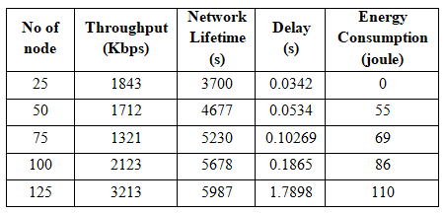
By changing the number of node, the performance is evaluated. The overall throughput value of the proposed technique is 2042.4Kbps. The proposed network life time utilization is 5054.4s.
Table.2 Execution time analysis
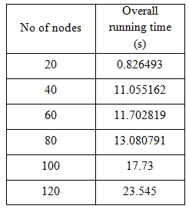
By changing the number of sensor node, the estimated system is measuring the running time. Here we are considering the sensor node as 20, 40, 60, 80, 100 and 120. The overall running time for the proposed technique is 12.99s to compete the packet transmission for all nodes.
D. Comparative Analysis
For comparison, now we are studying present procedure as “DBRkM algorithm” [21]. The detail description is exemplified in additional segment,
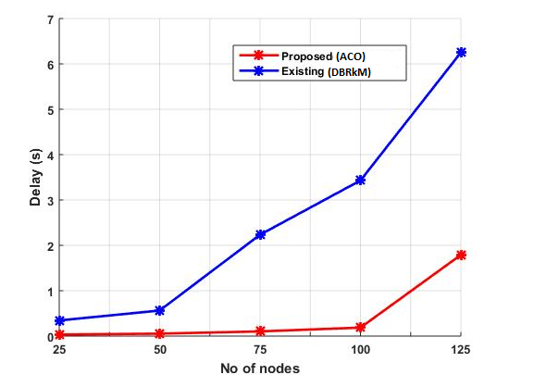
Fig. 1. Comparison between delay and nodes
The comparison result of proposed delay value is shown in fig.1. If the number node increases the delay value also increases. Here the proposed method get the delay value is 0.0342s. For all nodes the proposed method get the minimum delay when compared to the anticipated method.
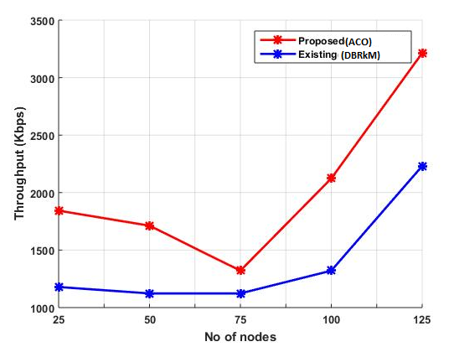
Fig. 2. Nodes Vs Throughput
The throughput comparison of predictable and accessible procedure is shown in fig.2. For 25 and 50 nodes, the proposed throughput value is 1843Kbps and 1123 Kbps respectively. For all nodes the proposed method gets the maximum throughput value when compared to the anticipated method.
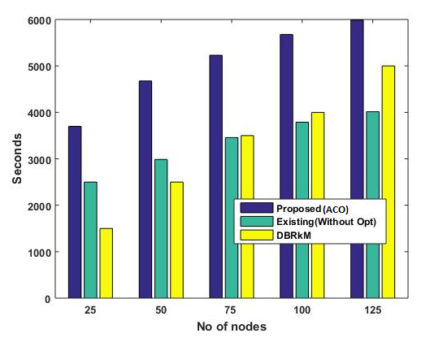
Fig. 3. Nodes Vs Network lifetime
The network lifetime comparison of proposed method is graphically represented in fig.3. 3700s and 4677s of network period is using for node 25 and 50 in our recommended technique gives maximum value. 5230s and 5678s of network period is using for node 75 and 100 in our proposed method. From the result, for all nodes the proposed method uses the maximum network life time compared to the existing methods.
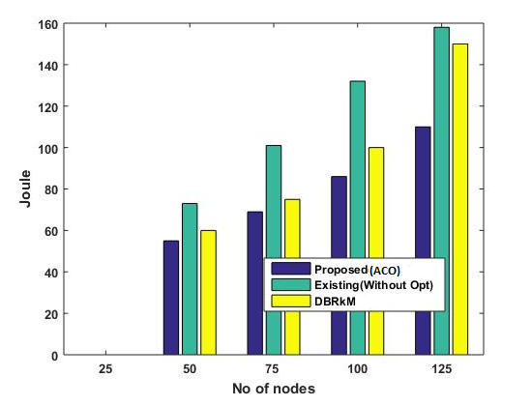
Fig. 4. Nodes Vs Energy
The energy comparison amongst offered and surviving system is shown in Fig. 4. Energy application of the forecast progression is under the outdated approach. Meanwhile the data are communicated over cluster centroid only; therefore, to transfer the whole data from cluster head to mobile sink, our expected process is necessity minimum energy when compared to the conservative approaches. From the experimental result, it is clear that our recommended technique attains the minimum energy value for all nodes when compared to the existing methods. From the comparison result, it is perfect that the recommended process is reaches better result as compared to the presented procedure.
V. Conclusion
In this research, an effective data gathering technique in WSN is proposed. The effectiveness of the proposed methodology is analyzed by various performance measures such as delay, network life time, execution time, energy consumption and throughput etc. Our proposed technique is compared with other existing algorithms such as DBRkM algorithm and other optimization algorithms. In order to gauge the efficiency of proposed technique we analyse our technique in terms of delay, execution time, network lifetime etc. This work will be further extended with various clustering algorithm to aggregate mobile sink nodes effectively.
REFERENCES
- T.Pino, S.Choudhury and F.Al-Turjman, "Dominating Set Algorithms for Wireless Sensor Networks Survivability," IEEE Access, Vol.6, pp. 17527-17532, 2018.
- X.Zhou, Y.Cheng, X.Ji and W.Xu, "SADO: State-associated and delay-oriented data collection for intertidal WSNs," in process of 9th International Conference on Wireless Communications and Signal Processing (WCSP), Nanjing, pp. 1-6,2017.
- S.Rani, S.H.Ahmed, R.Talwar and J.Malhotra, "Can Sensors Collect Big Data? An Energy-Efficient Big Data Gathering Algorithm for a WSN," IEEE Transactions on Industrial Informatics, Vol.13, No.4, pp. 1961-1968, 2017.
- B. Zhou, S. Yang, T. Sun and K. T. V. Grattan, "A Novel Wireless Mobile Platform to Locate and Gather Data from Optical Fiber SensorsIntegrated into a WSN," IEEE Sensors Journal, Vol.15, No.6, pp.3615-3621, 2015.
- K.C.Lan and M.Z.Wei, "A Compressibility-Based Clustering Algorithm for Hierarchical Compressive Data Gathering," IEEE Sensors Journal, Vol.17, No.8, pp.2550-2562, 2017.
- J.Qiao and X.Zhang, "Compressive Data Gathering Based on Even Clustering for Wireless Sensor Networks," IEEE Access, Vol.6, pp. 24391-24410, 2018.
- Madhumathy P and Sivakumar D, "Enabling energy efficient sensory data collection using multiple mobile sink," China Communications, Vol.11, No.10, pp.29-37,2014.
- T.Yu, X.Wang, J.Jin and K.McIsaac, "Cloud-Orchestrated Physical Topology Discovery of Large-Scale IoT Systems Using UAVs," IEEE Transactions on Industrial Informatics, Vol.14, No.5, pp. 2261-2270, 2018.
- C.Aranzazu-Suescun and M. ardei, "Distributed algorithms for event reporting in mobile-sink WSNs for Internet of Things," Tsinghua Science and Technology, Vol.22, No.4, pp.413-426, 2017.
- Y.Wang, D.Li and N.Dong, "Cellular automata malware propagation model for WSN based on multi-player evolutionary game," IET Networks, Vol7, No.3, pp. 129-135, 2018.
- I.S.Akila and R.Venkatesan, "A Fuzzy Based Energy-aware Clustering Architecture for Cooperative Communication in WSN," The Computer Journal, Vol.59, No.10, pp.1551-1562, 2016.
- Z.Zhou, J.Xu, Z.Zhang, FLei and W.Fang, "Energy-Efficient Optimization for Concurrent Compositions of WSN Services," IEEE Access, Vol.5, pp. 19994-20008, 2017.
- G.S.Brar, S.Rani, V.Chopra, R.Malhotra, H.Song and S.H.Ahmed, "Energy Efficient Direction-Based PDORP Routing Protocol for WSN," IEEE Access, Vol. 4, pp. 3182-3194, 2016.
- P.Kale and M.J.Nene, "Path reestablishment in Wireless Sensor Networks," in process of International Conference on Wireless Communications, Signal Processing and Networking (WiSPNET), Chennai,pp. 1659-1663,2017.
- Das, P. K., B. M. Sahoo, H. S. Behera, and S. Vashisht. "An improved particle swarm optimization for multi-robot path planning." In 2016 International Conference on Innovation and Challenges in Cyber Security (ICICCS-INBUSH), pp. 97-106. IEEE, 2016.
- Ricardo Simon Carbajo, Esther Simon Carbajo, Biswajit Basu and Ciarán Mc Goldrick, “Routing in wireless sensor networks for wind turbine monitoring”, Pervasive and Mobile Computing, Vol. 39, pp. 1-35, August 2017.
- Li Peizhe, Wu Muqing, Liao Wenxing, and Zhao Min, “A Game-theoretic and Energy-efficient Algorithm in an Improved Software-defined Wireless Sensor Network”, JOURNAL OF LATEX CLASS FILES, VOL. 14, NO. 8, pp.1-16, APRIL 2017.
- Shaimaa M. Mohamed, Haitham S. Hamza and Iman Aly Saroit, “Coverage in mobile wireless sensor networks (M-WSN): A survey”, Computer Communications, Vol. 110, pp. 133-150, 15 September 2017.
- D. Todolí-Ferrandis, J. Silvestre-Blanes, S. Santonja-Climent, V. Sempere-Paya and J. Vera-Pérez, Computer Standards & Interfaces, Vol. 56, pp.27-40, February 2018.
- Sergio Montero, Javier Gozalvez and Miguel Sepulcre, “Neighbor discovery for industrial wireless sensor networks with mobile nodes”, Computer Communications, Vol. 111, pp. 41-55, 1 October 2017.
- Amar Kaswan, Kumar Nitesh and Prasanta K. Jana, "Energy efﬁcient path selection for mobile sink and data gatheringin wireless sensor networks", International journal of electronics and communications, Vol.73, pp. 110-118, September 2017.
- Sahoo, Biswa Mohan, Amar Deep Gupta, Suman Avdhesh Yadav, and Shubhi Gupta. "ESRA: Enhanced Stable Routing Algorithm for Heterogeneous Wireless Sensor Networks." In 2019 International Conference on Automation, Computational and Technology Management (ICACTM), pp. 148-152. IEEE, 2019..
- Tian Wang, Jiandian Zeng, Yongxuan Lai, Yiqiao Cai and Baowei Wang, “Data Collection from WSNs to the Cloud based on Mobile Fog Elements”, Future Generation Computer Systems, In press, corrected proof, Available online 27 July 2017.

