Abstract—The paper discusses the wide variety of ways in which remotely sensed data are being utilized in river flood inundation modeling. Model parameterization is being aided using airborne LiDAR data to provide topography of the floodplain for use as model bathymetry, and vegetation heights in the floodplain for use in estimating floodplain friction factors. Model calibration and validation are being aided by comparing the flood extent observed in SAR images with the extent predicted by the model. The recent extension of this to the observation of urban flooding using high resolution TerraSAR-X data is described. Possible future research directions are considered.
Improving flood inundation models using remotely sensed data
David C. Mason, Matthew S. Horritt, Rainer Speck and Paul D. Bates

Index Terms—Water resources, Synthetic aperture radar, Laser applications

INTRODUCTION
Globally, flooding causes about one half of all fatalities due to natural hazards, and one third of all economic losses. Flooding is also on the increase – the U.K. Met. Office Hadley Centre estimates that, in the U.K., floods that were previously 1 in 100 year events will become 1 in 10 year events over the next century.
Flood inundation models are a major tool for mitigating the effects of river flooding. They provide predictions of flood extent and depth that are used in the development of spatially accurate hazard maps. These allow the assessment of risk to life and property in the floodplain, and the prioritisation of either the maintenance of existing flood defences or the construction of new ones.
There have been significant advances in river flood inundation modeling over the past decade. One of the main drivers for this advancement has been the veritable explosion of data that have become available to parameterise and validate the models. The acquisition of the vast majority of these new data has been made possible by developments in the field of remote sensing [1], [2]. Remote sensing, from both

satellites and aircraft, allows the collection of spatially distributed data over large areas rapidly and without the need for costly ground survey. The two-dimensional synoptic nature of remotely sensed data has allowed the growth of two- and higher-dimensional inundation models, which require 2D data for their parameterisation and validation. The situation has moved from a scenario in which there were often too few data for sensible modeling to proceed, to one in which (with some important exceptions) it can be difficult to make full use of all the available data in the modeling process.

MODEL CALIBRATION AND VALIDATION
An important model requirement is for data for model calibration and validation. The flood extent observed in a remotely sensed image may be compared with the flood extent predicted by the model. SAR data are often used because of their all-weather, day-night capability, important because of the storm conditions that often prevail during flooding. Flood water usually appears dark in SAR images compared to the surrounding land because the smooth water surface acts as a specular reflector. A number of techniques for the automatic extraction of flood extent in SAR images have been developed. In our case, we have developed an algorithm based on an active contour model (snake) [3]. The snake is a region-growing algorithm that expands away from a seed contour manually digitized around the un-flooded river channel, until the statistics of the pixels along its boundary differ locally from the statistics of those in the interior of the snake. In common with other methods, the accuracy of the derived flood extents may be limited by a number of factors, in particular un-flooded vegetation adjacent to the flood giving similar backscatter to the water surface so that it is misclassified as flooded. The snake algorithm was modified to use airborne scanning laser altimetry (LiDAR) data as well as SAR data, to provide an additional constraint that flood waterline heights should vary smoothly along the reach, as occurs in practice [4]. As a result, flood extents and flood waterline heights became more accurate (Fig. 1), and it proved possible to develop an improved model performance measure, which in turn led to a more accurate flood hazard map [5].

MODEL PARAMETERIZATION
Models also require extensive data for their parameterisation. The flood models employed are usually 2D finite element or finite difference models that solve the shallow water equations at each node of a model mesh covering the channel and floodplain, given boundary conditions that include
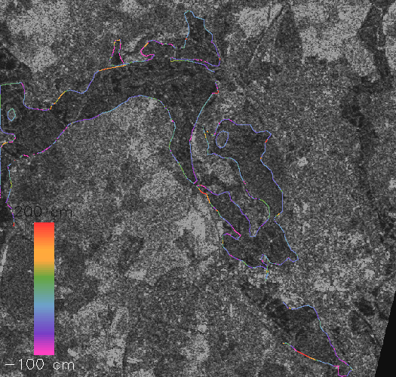

(a)
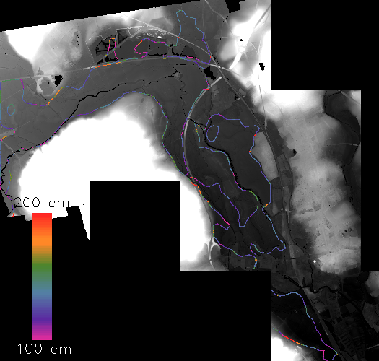

(b)

Fig. 1. Waterline conditioned on SAR and LiDAR data overlain on (a) SAR data, (b) LiDAR data. The colors represent the difference in height of the waterline from the local mean waterline heights (after [4]).

the upstream input flow rate. Topographic data of the channel and floodplain are required to act as bathymetry in the model. Dense and accurate Digital Terrain Models (DTMs) of the floodplain can be acquired using LiDAR. A further requirement is for bottom friction factors for the channel and floodplain. Typically these have to be left as free parameters in the model which have to be calibrated, with a single friction factor being specified for the whole of the floodplain and a different one for the channel. However, we have developed a method of estimating spatially-varying friction factors in the floodplain directly using LiDAR data [6]. This is based on LiDAR post-processing to segment the raw LiDAR Digital Surface Model into a ‘bare-earth’ DTM and a vegetation height map. Whilst many schemes have been developed for LiDAR post-processing, this is specifically aimed at flood modeling, and estimates heights for the short vegetation which may cover a substantial fraction of the floodplain. For floodplains experiencing relatively shallow inundation, resistance due to vegetation will dominate the boundary friction term, so that it becomes important to map short as well as tall vegetation heights.
The segmenter first estimates the underlying low frequency trends in the data by interpolating through local height minima. The detrended height image is then segmented on the basis of its local height standard deviation. Regions of short vegetation should have low standard deviations, and regions of tall vegetation larger values. The image is thresholded into regions of short, intermediate and tall vegetation. Short vegetation less than 1.2m high includes crops and grasses, intermediate vegetation includes hedges, and tall “vegetation” greater than 5m high includes trees and buildings. Short vegetation heights are calculated using an empirically-derived relationship between LiDAR standard deviation and measured crop height, and are accurate to about +-14cm. Hedge and tree heights are derived by subtracting the ground heights from the canopy returns, and are accurate to about 10%. The topographic height map is constructed by subtracting an empirically-determined fraction of the vegetation height from the original data in regions of crops, and by interpolation between ground hits elsewhere. A height accuracy of +-17cm is achieved in regions of short vegetation, though this accuracy falls off on steep slopes, and in wooded regions due to poor penetration of the LiDAR through the canopy.
The vegetation height map was used to estimate a friction coefficient at each of the model’s finite element nodes. The centroids of the elements surrounding a node form a polygon containing a number of different vegetation regions. Empirical relationships were used to relate vegetation heights to friction factors f_{i}. The values of f_{i} depended on the vegetation height and the water depth and velocity at that point. The mean friction factor for the node was calculated as a weighted sum of the f_{i} for each region [6].
A difficulty encountered was that important surface features such as hedges often occupied only a small part of the polygon in which they were contained, so that their contributions to local friction were diluted. Ideally what is required from a mesh generator is smaller elements where the friction surface changes rapidly (e.g. along hedges). An improved mesh generator was developed that identifies tall and intermediate vegetation such as hedges and trees in the LiDAR segmentation, and decomposes the mesh in the vicinity of these features to allow smaller nodes with higher friction factors in these areas [7].
The method was tested using a 1 in 50 year flood event which occurred on the river Severn near Shrewsbury, U.K., in October 1998. The flood extent was extracted from a RADARSAT-1 image using the snake algorithm, and the observed extent was used to validate the flood extent modeled using a TELEMAC-2D model applied over a 19-km reach, which used spatially-distributed floodplain friction values. The differences in the observed and modeled flood waterline heights proved to be not significant at the 1% significance level (Fig. 2). This gives confidence that, for this event at least, spatially-distributed floodplain friction determined from LiDAR can aid in the accurate modeling of flood extent.

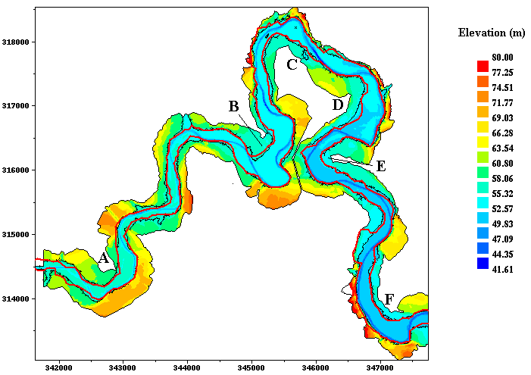

Fig. 2. Model (black) and SAR (red) flood extents superimposed on bottom topography (after [6]).

FLOOD DETECTION IN URBAN AREAS
Flooding is a major hazard in rural and urban areas worldwide, but it is in urban areas that the impacts are most severe. In order to be able to predict the risk of flooding in urban areas for an event of a given magnitude, accurate urban flood inundation models are required. This in turn requires observations of urban flood extent, in order to validate the extents predicted by urban flood models.
In rural areas, 2D flood models have been successfully validated using flood extents determined from SAR data, typically ERS and ASAR. However, these have too low a resolution for use in urban areas. This situation has recently improved as the number of operational SARs and their spatial resolutions have increased. The high resolution TerraSAR-X, RADARSAT-2, ALOS PALSAR and the first three of the COSMO-SkyMed satellites have recently been launched. This section describes an investigation of the ability of TerraSAR-X to detect flooded urban regions [8].
An ideal data set existed for this study. A 1 in 150 year flood took place on the lower Severn around Tewkesbury, U.K., in July 2007, which resulted in substantial flooding of urban areas. Tewkesbury lies at the confluence of the Severn, flowing in from the NW, and the Avon, flowing in from the NE. Twelve cm of rain fell in a single day, and about 1500 homes in Tewkesbury were flooded. The peak of the flood occurred on 22 July and the river did not return to bank-full until 31 July. On 25 July TerraSAR-X acquired a 3m resolution image of the region, and DLR posted a map showing an estimate of flood extent (mainly in rural areas) superimposed on the radar image on the website of the International Charter of Space and Major Disaster (www.disasterscharter.org). Fig. 3 shows a sub-image of the Tewkesbury area. Although the satellite was still in its commissioning phase, the image shows incredible detail of the urban infrastructure. In addition, aerial photography acquired near the time of the TerraSAR-X overpass could be used to validate the urban flood extent determined by TerraSAR-X. The data set also included LiDAR data of the un-flooded area from the Environment Agency of England and Wales (EA).
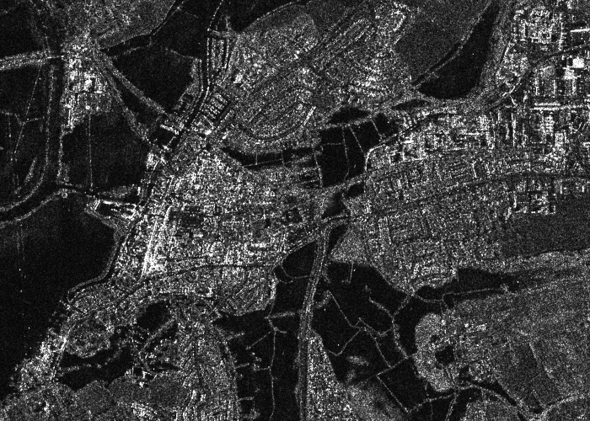

Fig. 3. TerraSAR-X image of Tewkesbury flooding on 25th July 2007 showing urban areas (3m resolution, dark areas are water, © DLR 2007)
(after [8]).

These data were used to estimate the degree to which TerraSAR-X could detect flooded urban areas. Due to the side-looking nature of SAR, substantial areas of ground surface would be unseen by TerraSAR-X due to radar shadowing and layover caused by buildings. The DLR SETES SAR simulator was used in conjunction with the LiDAR data to identify regions of the TerraSAR-X image in which flood-water would not be visible due to the presence of shadow or layover due to buildings or taller vegetation. SETES produced separate binary images of shadow and layover, which were combined to form a single image showing shadow and layover regions. This showed that many of the older parts of the town containing narrow streets and higher buildings contained significant areas in which flooding in the streets would not be visible, whereas many of the more modern parts of the town had been less densely constructed, and flooding would be more visible in these areas.
The snake algorithm was used to delineate the flood extent in the rural and urban areas. In order to ensure that the snake boundary was smoothly-varying in height along the reach, the snake was generated using both the TerraSAR-X image and the LiDAR DTM. The snake was successful at delineating the flood in the rural areas, but poor at detecting urban flooding. There were several reasons for this, one of which was that the snake needs to have a reasonably constrained curvature, but there were some very high curvatures in the narrow streets. As a result, a hybrid approach was adopted in which the flood extent in rural areas was delineated using the snake, but a simpler region-growing technique was used in the urban areas. The two methods were linked because the simpler one was initialized using knowledge of the snake waterlines in the rural areas. Seed regions having low backscatter were identified in the urban areas using supervised classification based on training areas for water and non-water. The seed pixels were required to have heights less than a spatially-varying height threshold determined from nearby snake waterlines heights. The seed regions were grown by adding adjacent pixels that were not so dark. Areas of shadow or layover were masked out.
Fig. 4 shows the correspondence between the flood extent determined by TerraSAR-X and the flood extent from the aerial photos in Tewkesbury, superimposed on the LiDAR (from which all but the main urban areas have been masked out). 76% of urban water pixels were correctly classified by TerraSAR-X, with the associated rate of urban non-water incorrectly classified as water being 25%. These rates were achieved when shadow and layover were masked out, but perhaps a more pertinent rate is the fraction of urban flood extent visible in the aerial photos that was detected by TerraSAR-X. In this case, only 58% of urban water pixels were correctly detected, with a false positive rate of 19%. But many of the additional aerial photo water pixels in the shadow/layover regions were adjacent to water pixels that had already been detected by TerraSAR-X. These results implied that, at least for this event, TerraSAR-X was good at identifying those flooded urban areas that were visible to the SAR, and reasonably good at identifying all flooded urban pixels. The next step will be to estimate the degree to which the TerraSAR-X urban flood extent enables a 2D flood inundation model to predict the correct urban flood extent, by constraining the friction parameters in the urban areas.
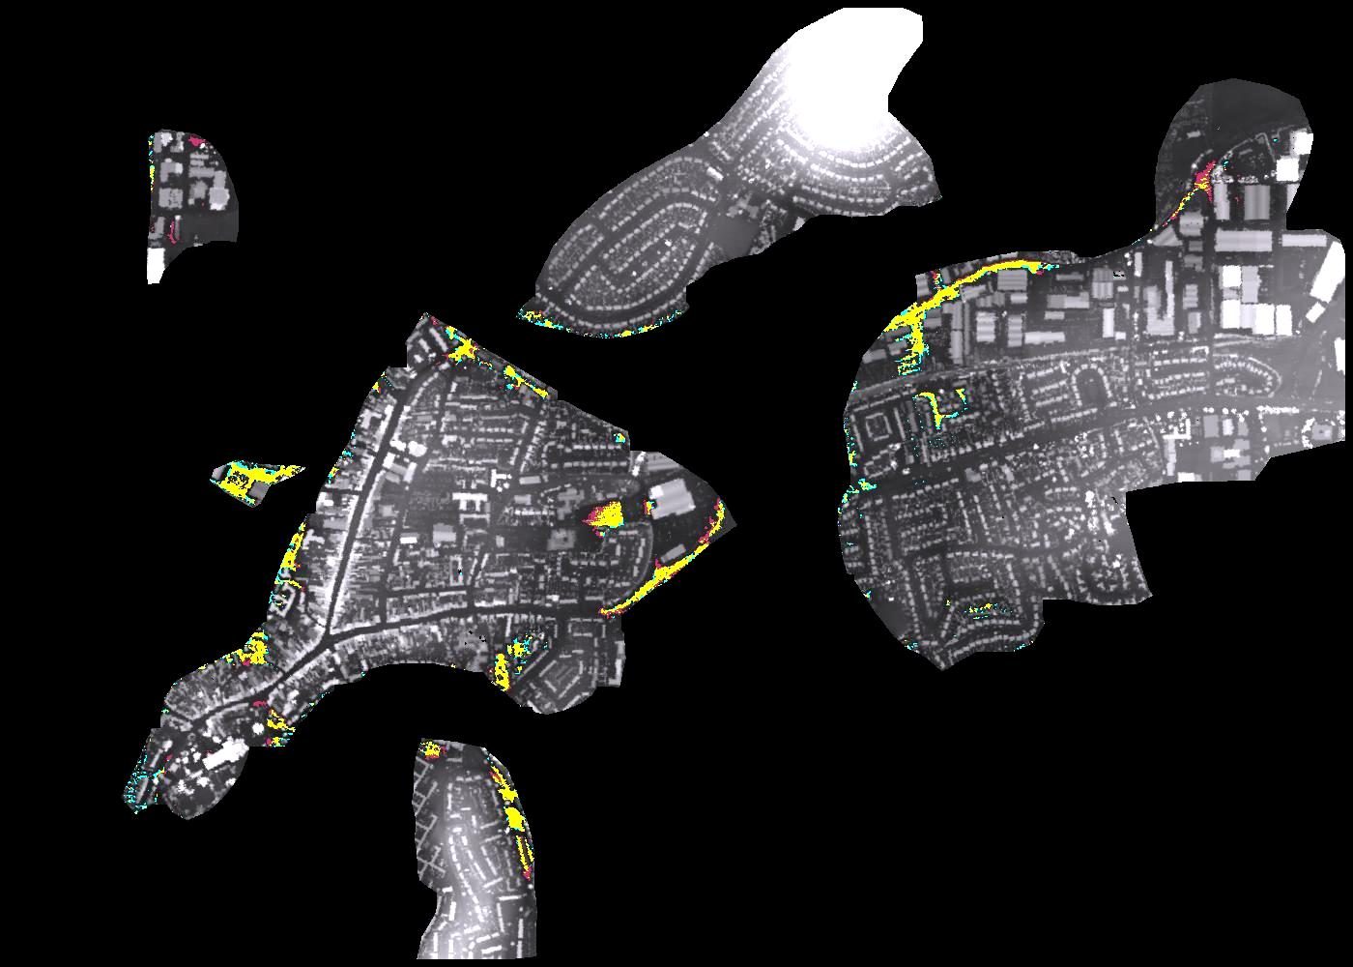

Fig. 4. Correspondence between TerraSAR-X and aerial photo flood extents in main urban areas of Tewkesbury, superimposed on LiDAR (yellow = wet in SAR and aerial photo, red = wet in SAR only, green = wet in aerial photo only) (after [8]).

CONCLUSION
The foregoing has hopefully illustrated the wide variety of ways in which remotely sensed data are currently being utilised in flood inundation models. Anticipated developments in data sources in the near future mean that the ongoing revolution in the production of data for inundation models is likely to proceed for some time yet. A number of topics for future research to better meet the data requirements of inundation modellers can be visualised. The number of operational SARs bodes well for the production of SAR image sequences for future flooding events, which should make possible more data assimilation studies providing more rigorous model validation than that using single SAR scenes. Full waveform LiDAR data need to be processed to produce more realistic topographic data in urban areas. Improved flow gauging is likely to be a critical research need in the coming decade, and one possibility using remote sensing may be to image the flood using a SAR with an along-track interferometric capability, allowing measurement of water surface velocity from which flow rate may be inferred. Networks of low cost sensors measuring water depth and velocity and connected using wireless computing and GSM technology (e.g. [9]) may also provide an additional source of model validation data to complement that available through remote sensing.
Acknowledgment
Thanks are due to the EA for the provision of LiDAR data.
References
- M.J.Smith, E.P. Edwards, G. Priestnall and P.D. Bates, “Exploitation of new data types to create Digital Surface Models for flood inundation modelling,” FRMRC Research report UR3, June 2006. 78pp, 2006.
- G. Schumann, P. D. Bates, M.S. Horritt, P. Matgen and F. Pappenberger “Progress in integration of remote sensing derived flood extent and stage data and hydraulic models,” Reviews of Geophysics (submitted).
- M.S. Horritt, D.C. Mason and A.J. Luckman, “Flood boundary delineation from synthetic aperture radar imagery using a statistical active contour model,” Int. J. Remote Sensing, vol. 22(13), pp. 2489-2507, 2001.
- D.C. Mason, M.S. Horritt, J.T. Dall’Amico, T.R. Scott and P.D. Bates, “Improving river flood extent delineation from synthetic aperture radar using airborne laser altimetry,” IEEE. Trans. Geoscience Rem. Sens, vol. 45, no. 12, pp. 3932-3943, 2007.
- D.C. Mason, P.D. Bates and J.T. Dall’Amico, “Calibration of uncertain flood inundation models using remotely sensed water levels,” J. Hydrology, vol. 368, pp. 224-236, 2009.
- D.C. Mason, D.M. Cobby, M.S. Horritt and P.D. Bates, “Floodplain friction parameterization in two-dimensional river flood models using vegetation heights derived from airborne scanning laser altimetry”, Hydrological Processes, vol. 17, pp. 1711-1732, 2003.
- D.M. Cobby, D.C. Mason, M.S. Horritt and P.D. Bates, “Two-dimensional hydraulic flood modelling using a finite element mesh decomposed according to vegetation and topographic features derived from airborne scanning laser altimetry”, Hydrological Processes, vol. 17, pp. 1979-2000, 2003.
- D.C. Mason, R. Speck, B. Devereux, G. Schumann, J. Neal and P.D. Bates (submitted). “Flood detection in urban areas using TerraSAR-X”, IEEE. Trans. Geoscience Rem. Sens.
- J.C. Neal, P.M. Atkinson, and C.W. Hutton, “Flood inundation model updating using an ensemble Kalman filter and spatially distributed measurements”, Journal of Hydrology, vol. 336, pp. 401-415, 2007.

 Manuscript received June 5, 2009. This work was supported in part by the U.K. EPSRC Flood Risk Management Research Consortium (FRMRC) Programme and the U.K. NERC Flood Risk from Extreme Events (FREE) Programme. David C. Mason is with the Environmental Systems Science Centre, University of Reading, Reading RG6 6AL, U.K. (phone: +44-118-378-8743; fax: +44-118-6413; e-mail: dcm@ mail.nerc-essc.ac.uk). Matthew S. Horritt is with Halcrow Group Ltd., London W6 7BY, U.K. Rainer Speck is with DLR Oberpfaffenhofen, Wessling, Germany. Paul D. Bates is with the School of Geographical Sciences, University of Bristol BS8 1SS, U.K.

