Very slow embryonic and larval development in the Antarctic limpet Nacella polaris

Lloyd S. Peck, Sabrina Heiser and Melody S. Clark
British Antarctic Survey, Natural Environment Research Council, High Cross, Madingley Rd, Cambridge, CB3 0ET.

Corresponding author:
Prof L.S. Peck
British Antarctic Survey
High Cross
Madingley Rd
Cambridge
CB23 7PR
UK

Abstract

Cold polar marine species have very slow embryonic and larval development rates. Antarctic echinoids, bivalve molluscs and brooding gastropods develop up to 12 times slower than temperate and tropical species, departing from Arrhenius relationships and outside the normal Q₁₀ of 2-3 associated with 10°C reductions in biochemical reaction rates. The slowing of development at temperatures around 0°C has been reported previously to be much greater than for other parts of the global marine temperature range. Here we spawned and reared embryos and larvae of the Antarctic limpet Nacella polaris at 0.6°C to the post-torsional veliger stage. Spawned eggs were 221 µm in diameter. Development rates were three times slower than any previously reported for patellogastropod limpets, with first division at 2.5 h post fertilisation, the gastrula stage being reached after 55 h, hatching occurring after 70-75 h and the trochophore stage being reached after around 100 h. This marked slowing of development around 0°C matches that previously reported for other polar taxa. This supports the hypothesis that there is a cold marine physiological transition to markedly slower physiological rates at temperatures near 0°C. The transition is especially apparent here for development, but has also been reported for growth, both of which involve significant protein synthesis.

Keywords: polar, low temperature, concinna, ecology, mollusc

Introduction
The early life history stages of marine invertebrates are critically important because they are usually the stages where mortality is highest and the individuals most vulnerable to predation (Pechenik 1999). Because of this there is selection pressure for these stages to be as short as possible and development to proceed rapidly (Pechenik 1999; Vaugn and Allen 2010; Marshall et al. 2012). Many factors can affect rates of development, including density (Przeslawski et al. 2012), diet (Pechenik and Tyrell 2015), salinity (Bashevkin and Pechenik 2015), and pH (Byrne 2011). The factor that has received the most attention, however, and produces the clearest signal across latitudes and between taxa is temperature (Hoegh-Guldberg and Pearse 1995; Pechenik 1999). Around 100 years ago the principles governing the effect of temperature on biological processes were elucidated by Arrhenius and van’t Hoff. The latter developed the concept of the Q₁₀ where changes in rate for a 10°C temperature rise are compared. These two methods are still the cornerstone of much temperature biology.
For tropical and temperate species the effect of temperature on development from fertilisation to hatching has been shown to fit Arrhenius relationships (Peck 2016), and Q₁₀ values are in the expected range of 1-4, for echinoids (Bosch et al. 1987; Stanwell-Smith and Peck 1998), bivalve molluscs (Peck et al. 2007) and brooding gastropod molluscs (Peck et al. 2006a). Polar species, living close to or below 0°C, however, develop significantly more slowly than the relationship for temperate and tropical species in all of the species studied, including those noted above and asteroids (Pearse 1969; Stanwell-Smith and Peck 1998) and isopods (Wägele 1987). Most studies have showed a slowing of at least x5-x10 compared to temperate species. This departure from Arrhenius relationships has recently also been demonstrated for growth rates across latitudes in echinoids, and for the time taken to complete processes associated with feeding (the Specific Dynamic Action of feeding, or SDA, duration) (Peck 2016). Such a departure is, however, not present in routine oxygen consumption and SDA peak height leading to the conclusion that the mechanism producing the unexpected slowing is associated with protein synthesis, and possibly protein folding (Peck, 2016). In this study we aimed to evaluate development in the Antarctic patellid limpet Nacella polaris (Hombron & Jacquinot 1841), and frequently known by its junior synonym Nacella concinna (Strebel 1908). This species is a broadcast spawning gastropod. Detailed studies of development rate across latitudes have been published in echinoids (Bosch et al. 1987; Stanwell-Smith and Peck 1998), broadcast spawning bivalve (Peck et al. 2007) and brooding gastropod molluscs (Peck et al. 2006a). This species was chosen for this study in part to allow a comparison with published data on changes in development rate across latitudes for other taxa.
Nacella polaris is one of the most abundant benthic invertebrates in the Southern Ocean, occurring from the intertidal down to depths of over 100 m (Powell 1951). It grazes biofilms on hard substrata and individuals have been shown to have decreasing shell height and thickness with increasing depth (Hoffman et al. 2010). A large homogenous population occurs along the Antarctic Peninsula, but there is significant genetic differentiation between this population and those on the South Orkney Islands and South Georgia, although some gene flow exists between these populations (Hoffman et al. 2011). Hoffman et al. (2011) also identified deep water and large ocean currents as barriers to gene flow in this species.
The spawning period for N. polaris has been reported to be between mid November and mid December at Signy Island, South Orkney Islands (Picken 1980, Stanwell-Smith and Clarke 1998). Spawning is characterised by stacking behaviour where individuals climb onto the shells of other limpets forming stacks several animals high, which enhances synchrony and proximity of gametes during spawning (Picken and Allen 1983; Stanwell-Smith and Clarke 1998; Powell et al. 2001). At Rothera Point, Adelaide Island juvenile recruitment occurs from late January through to March and the free-swimming planktonic veliger larval stage lasts for 1–2 months (Bowden et al. 2006).

The aims of this study were to make possibly the first evaluation of the timing of major embryonic and larval developmental stages in a broadcast spawning Antarctic marine gastropod mollusc; to compare developmental rates in N. polaris with those of related taxa from lower latitudes; and to calculate the likely duration of the pelagic phase in this species.

Methods
In a preliminary experiment, stacking limpets were collected from sites between 5 m and 10 m depth in Hangar Cove, Rothera Point, Adelaide Island, Antarctic Peninsula (67° 33.85′S, 68° 07.50′W) on the 16th of February 2012 and 28th of January 2014. In 2012, spawning occurred in three individuals (two males, one female) following two days of repeated 3°C temperature shocks (cycles of raising water temperature abruptly to 3°C for 3 h and then replacing water in tanks with clean 0°C seawater). Development was followed until the trochophore stage when experiments were halted for logistic reasons. In 2014, after 5 days of repeated 3°C temperature shock treatments, two females released eggs. No males spawned. Two males were therefore strip spawned and the sperm mixed before being used to fertilise eggs. Developmental stages were reached at the same time as in the 2012 trials, but development continued to the post-torsional veliger stage, and the timing of development described in this paper is from the 2014 trials.
Before fertilising eggs concentrated sperm were mixed with seawater to make a milky/grey solution. Eggs were gently mixed with this solution for 3 mins and subsequently left to stand for 45 mins. The sperm solution was then decanted and the eggs washed 3 times on a 50 µm mesh sieve using clean 1 µm filtered seawater. Washed eggs were placed in 5 L beakers in densities that formed a monolayer on the bottom of the beakers which were filled with seawater and covered with cling film. Eggs were washed with clean seawater every 48 h and moved to clean beakers every five days. After hatching, swimming larvae were siphoned into clean beakers and this process was repeated at five day intervals.
Larval dimensions were measured using a calibrated eyepiece graticule in a Leica Laborlux S microscope with x10 eyepiece and objective lenses. Photographs were taken on the same microscope using a Nikon D7000 camera.
Water temperature at the start was 1.2°C, which declined during the trials to 0.3°C following ambient fluctuations, and the mean was 0.6°C ± 0.07 (se, n=18, Table 1).
Rates of development were compared using the Q₁₀ statistic of van’t Hoff. Here the rates of a biological process measured at different temperatures are compared by standardising the difference to a 10°C temperature change using the equation:
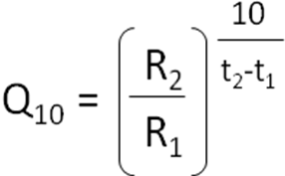
Where R₂ and R₁ are biological process rates at temperatures t₂ and t₁ respectively (Schmidt-Nielsen, 1980).

Results
The egg diameter of newly spawned eggs was 221 µm (± 1.24 se, n = 20). The first division was equal, and completed within 2 hours, and fertilisation was 96% (48/50). Cleavage in later divisions was spiral resulting in a blastula in 45-50 h and a gastrula in 55-60 h (Table 1) that was rotating in the egg membrane by 67 h post-fertilisation (Fig 1A). Hatching occurred between 70 and 80 h post fertilisation with more than 50% hatched by 74 h (Table 1). After hatching early gastrulae swam throughout the water column. Development then proceeded to a recognisable early trochophore after 95-100 h, with a fully formed prototroch (Fig 1B). These larvae swam actively up into the water column and formed loose aggregates near the surface, but they ceased swimming when disturbed. There was possibly phototaxis at this point as aggregates were often in the brightest areas of the culture vessels, but phototaxis was not tested. The fully developed trochophore stage was reached after around 150 h (Table 1). At this stage larvae swam very actively, often aggregating near the surface, and had a prominent apical tuft of cilia. The shell gland and foot rudiment were also visible (Fig 1C).

From the trochophore stage development proceeded to an early veliger at around 200 h post-fertilisation. This larva had a fully developed velum and apical tuft of cilia and a developing prototroch. By 250 h post-fertilisation the prototroch had developed to cover most of the body below the velum, the cilia in the velum had grown longer, and the foot was visible (Fig 1D). The 350 h old larva had completed torsion, was capable of fully retracting into the larva shell, and had a prominent foot and operculum (Table 1, Fig 1E). Larvae were maintained in cultures for another 100 hours, when the velum was still a single girdle, and not bifurcated, eye spots had not yet developed and cephalic tentacles were also yet to develop.

Discussion

Embryonic and larval development observed here for N. polaris followed a very similar pattern to that described for other patellid gastropods, such as Patella vulgata (Smith 1935, Damen and Dictus 1994) and also for vetigastropods, including members of the genus Haliotis (Crofts 1937, Peck 1983, Vandenbiggelar 1993). Development progressed initially from fertilised egg to blastula and gastrula stages, when hatching occurred. The gastrula stage was followed by the classic patellogastropod trochophore with prominent prototroch and long apical tuft of cilia that were swimming in the water column for 4-5 days. After this, early and post-torsional veliger larval stages were achieved before this study ended after 19 days. It is not known how much more time would have been required for larvae here to reach the settlement stage, but most prosobranchs develop into a veliger with a bilobed velum, eye spots and cephalic tentacles before settlement (Hyman 1992, Buckland-Nicks et al. 2002). In patellid limpets (Kay and Emlet 2002) and haliotids (Crofts, 1937, Peck, 1983, Vandenbiggelar 1993), the latest stage here, the post-torsional veliger stage is reached in a little less than half the time needed for completion of the larval stage and metamorphosis to juveniles. This indicates that N. polaris larvae may be in the water column for around a further 20-25 days before settling on the seabed, making their total planktonic phase between 40 and 45 days. These timings match well with the observation that pelagic veligers of this species are present in the water column at Rothera Point for 1-2 months (Bowden et al. 2006).

Development and temperature
Development rates of marine ectotherms vary predictably with temperature, both within species and between species across latitudes (Bosch et al. 1987; Zimmerman and Pechenik 1989; Clarke 1992; Hoegh-Guldberg and Pearse 1995; Stanwell-Smith and Peck 1998; Peck et al. 2006b; 2007; Peck 2016). Studies of Antarctic species have consistently shown that the slowing of development around 0°C is greater as temperature declines than anywhere else on the temperature continuum of continental shelf marine sites for echinoderms (Bosch et al. 1987; Stanwell-Smith and Peck 1998) and molluscs (Peck et al. 2006b; 2007; Peck 2016). The development time quoted here to reach the trochophore stage in N. polaris of 90-100 h at 0.6°C compares with 12 h for Lottia persona at 19.5°C (Kolbin and Kulikova 2011), 24 h for Limalepeta lima at 16°C and 12 h for Haliotis tuberculata at 21°C (Peck 1983). When times taken to reach the post-torsional veliger stage are compared for patellogastropods and vetigastropods across latitudes from the tropics to the poles, a steady increase in development times occurs as temperatures decline from 25°C -30°C down to values below 10°C (Fig 2). The value for N. polaris at 0.6°C is, however, over 5.5 times longer than the next longest time. A commonly used method to estimate change in a biological rate with temperature is the van‘t Hoff Q₁₀. Data here for patellid gastropods are sparse for this type of analysis, but when comparisons are made between development rates between 20°C-30°C and those between 10°C-20°C in Fig. 2 the Q₁₀ is 3.28. When data for development rates between 10°C-20°C are compared to Lottia digitalis at 8.75°C the Q₁₀ is 1.76, and the comparison for N. polaris at 0.6°C (394 h) and L. digitalis (62 h) produces a Q₁₀ of 8.11. Most biological processes double to treble in rate for each 10°C rise in temperature, and the normal range of Q₁₀ for biological processes is 1-4 (Schmidt-Nielsen 1980; Clarke 1983; Peck 2002; Peck et al. 2006b). A Q₁₀ of 8.11 for the slowing of development in N. polaris compared to temperate patellids suggests that the impact on rates is not a direct effect of temperature on biochemical reactions, but is due to another factor. The pattern here is very similar to those previously shown for echinoderms (Bosch et al. 1987; Stanwell-Smith and Peck 1998), Bivalve molluscs (Peck et al. 2007) and brooding gastropods (Peck et al. 2006a; Peck 2016). In all these groups development rates are slowed dramatically in polar species, similar to the patterns seen in Fig 2 here and, in all cases, the slowing is beyond the normally expected direct effects of temperature on biological systems.

Temperature normally affects biological reactions by altering the energy status of the molecules involved in the reaction (Hochachka and Somero 2002). To complete a reaction a molecule requires a certain level of energy, called the activation energy. At any given time only a proportion of the population of molecules have sufficient energy and, within normal environmental temperature ranges, the proportion of molecules with sufficient energy increases with temperature, and the rate at which biological reactions are completed thus also increases (Hochachka and Somero 2002, Peck 2016). The effect of temperature on activation energies is such that reaction rates usually increase by two to three times for each 10°C rise in temperature. The underlying relationship is the one identified by Arrhenius (1889) where the logarithm of the reaction rate is directly proportional to the inverse of absolute temperature. Peck (2016) showed that development rates of temperate and tropical brooding gastropod molluscs followed Arrhenius predictions, but that rates for polar species around or below 0°C were significantly slower than expected. He further showed that growth in echinoids, and the time taken to complete post-prandial processes (the Specific Dynamic Action, SDA) were all significantly slower in polar species than would be predicted from Arrhenius relationships for temperate and tropical species, which he called a cold marine physiological transition (CMPT) to a slower state. These processes all require large amounts of protein synthesis. This, combined with the fact that routine metabolic rates and scope for activity do not appear to be slowed beyond predictions from Arrhenius relationships for lower latitude species led Peck (2016) to argue that the slowing was due to low temperature problems associated with protein synthesis.

The rate that a protein is synthesised is markedly sensitive to the density and viscosity of the surrounding medium (Somero 2004; Graziano 2014). The density of seawater is highest, and its dynamic viscosity changes more at temperatures around and below 0°C than at warmer temperatures (Sharqawy et al. 2010). Protein stability also declines at low temperature (Hochachka and Somero 2002), and there are good data from many different avenues of research indicating that the stability of proteins in polar marine species living around or below 0°C is lower than for temperate and tropical species (Place and Hofmann 2005; Fraser et al. 2007; Clark et al. 2008; Clark and Peck 2009; Shin et al. 2014; Peck 2016). These factors would suggest that the slowing of growth, development and SDA duration are likely due to problems associated with the manufacture and stability of proteins at low temperature.

Overall development in the Antarctic limpet N. polaris follows a very similar pattern to other patellogastropods through blastula, gastrula, trochophore and veliger stages. The development rates observed here are, however, markedly slower than those for warmer water species. A clear pattern of dramatically slowed development rates has now been demonstrated across a wide range of taxa in polar marine ectotherms. Peck (2016) has suggested that this extra slowing, along with similar slowing in growth and the duration of the SDA is part of a cold marine physiological transition (CMPT) to a slower state. In this state the markedly slower physiological rates are likely to be due to the effects of increased water viscosity and density near zero that impact protein stability and the efficiency of protein synthesis and folding. The implications of this for adaptation studies and also for responding to changing environments are great and require high priority for research in the near future.

Acknowledgements
We thank the British Antarctic Survey dive team, and boatmen at Rothera station for support in animal collection and Ali Massey for assistance with laboratory equipment. The work was supported by core funding from the Natural Environment Research Council of the UK.

References
Arrhenius SA (1889) Über die Dissociationswärme und den Einflusß der Temperatur auf den Dissociationsgrad der Elektrolyte. Z Physik Chem 4:96–116
Bashevkin SM, Pechenik JA (2015) The interactive influence of temperature and salinity on larval and juvenile growth in the gastropod Crepidula fornicata. J Exp Mar Biol Ecol 470:78–91
Bosch I, Beauchamp KA, Steele ME, Pearse JS (1987) Development, metamorphosis, and seasonal abundance of embryos and larvae of the Antarctic sea urchin Sterechinus neumayeri. Biol Bull 173:126–135
Bowden DA, Clarke A, Peck LS, Barnes DKA (2006) Antarctic sessile marine benthos: colonisation and growth on artificial substrata over 3 years. Mar Ecol Prog Ser 316:1–16
Buckland-Nicks J, Gibson G, Koss R (2002) Phylum Mollusca: Gastropoda. In: Young CM (ed) Atlas of Marine Invertebrate Larvae. Academic Press, San Diego, pp 261-287
Byrne M (2011) Impact of ocean warming and ocean acidification on marine invertebrate life history stages: vulnerabilities and potential for persistence in a changing ocean. Oceanogr Mar Biol Annu Rev 49:1–42.
Clark MS, Peck LS (2009) HSP70 heatshock proteins and environmental stress in Antarctic marine organisms: a mini-review. Mar Genomics 2:11–18
Clark MS, Fraser KPPF, Peck LS (2008) Lack of an HSP70 heat shock response in two Antarctic marine invertebrates. Polar Biol 31:1059-1065
Clarke A (1983) Life in cold water: the physiological ecology of polar marine ecotherms. Oceanogr Mar Biol Annu Rev 21:341–453
Clarke A (1992) Reproduction in the cold: Thorson revisited. Invert Reprod Dev 22:175-184
Courtois De Viçose G, Viera MP, Bilbao A, Izquierdo MS (2007) Embryonic and larval development of Haliotis tuberculata coccinea Reeve: an indexed micro-photographic sequence. J Shellfish Res 26(3):847–854
Crofts DR (1937) The development of Haliotis tuberculata, with special reference to organogenesis during torsion. Phil Trans R Soc B 208:219-268
Damen P, Dictus WJAG (1994) Cell lineage of the prototroch of Patella vulgata (gastropoda, mollusca). Dev Biol 162:364-383
Fraser KPP, Clarke A, Peck LS (2007) Growth in the slow lane: protein metabolism in the Antarctic limpet Nacella concinna (Strebel, 1908). J Exp Biol 210:2691-269
Graziano G (2014) On the mechanism of cold denaturation. Phys Chem ChemPhys 16:21755–21767
Hochachka PW, Somero GN (2002) Biochemical Adaptation. Oxford University Press, Oxford.
Hoegh-Guldberg O, Pearse JS (1995) Temperature, food availability and the development of marine invertebrate larvae. Amer Zool 35:415–425
Hoffman JI, Peck LS, Hillyard G, Zieritz A, Clark MS (2010) No evidence for genetic differentiation between Antarctic limpet Nacella concinna morphotypes. Mar Biol 157:765-778
Hoffman JI, Clarke A, Linse K, Peck LS. (2011) Effects of brooding and broadcasting reproductive modes on the population genetic structure of two Antarctic gastropod molluscs. Mar Biol 158:287-296
Hombron JB, Jacquinot CH (1841) Suite de la description de quelques mollusques, provenant de la campagne de l'Astrolabe et de la Zélée. Annales des Sciences Naturelles 2. Zoologie 16:190-192
Hyman LH (1992) The Invertebrates: Mollusca 1. International Books and Periodicals Supply, Delhi.
Kay MC, Emlet RC (2002) Laboratory spawning, larval development, and metamorphosis of the limpets Lottia digitalis and Lottia asmi (Patellogastropoda, Lotiidae). Invertebr Biol 121:11-24
Kolbin KG (2006) Reproduction and development of the limpet Limalepeta lima (Dall, 1918) (Gastropoda: Lepetidae). Russian J Mar Biol 32:265-267
Kolbin KG, Kulikova VA (2011) Reproduction and larval development of the limpet Lottia persona (Rathke, 1833) (Gastropoda: Lottiidae) Russian J Mar Biol 37:239-242
Koppen CL, Glascock JR, Holyoak AR (1996) Spawning and larval development of the ribbed limpet, Lottia digitalis (Rathke, 1833). The Veliger 39:241-243
Lu JY, Chen ZS, Wu JY, Zeng H, Su GH (2001) Embryonic development of abalone (Haliotis diversicolor Reeve). Acta Zool Sinica 47:317-323
Marshall DJ, Krug PJ, Kupriyanova EK, Byrne M, Emlet RB (2012) The Biogeography of Marine Invertebrate Life Histories. Annu Rev Ecol Evol Syst 43:97–114
Pearse JS (1969) Slow developing demersal embryos and larvae of the Antarctic sea star Odontaster validus. Mar Biol 3:110-116
Pechenik JA (1999) On the advantages and disadvantages of larval stages in benthic marine invertebrate life cycles. Mar Ecol Prog Ser 177:269–297
Pechenik JA, Tyrell AS (2015) Larval diet alters larval growth rates and post-metamorphic performance in the marine gastropod Crepidula fornicata. Mar Biol 162:1597–1610
Peck LS (1983) An investigation into the growth and early development of the ormer, Haliotis tuberculata (L.). PhD thesis, CNAA, Portsmouth Polytechnic
Peck LS (2002) Ecophysiology of Antarctic marine ectotherms: limits to life. Polar Biol 25:31-40.
Peck LS (2016) A cold limit to adaptation in the sea. Trends Ecol Evol 31 (1), 13-26
Peck LS, Clarke A, Chapman AL (2006a) Metabolism and development of pelagic larvae of Antarctic gastropods with mixed reproductive strategies Mar Ecol Prog Ser 318:213-220
Peck LS, Convey P, Barnes DKA (2006b) Environmental constraints on life histories in Antarctic ecosystems: tempos, timings and predictability. Biol Rev 81:75-109
Peck LS, Powell DK, Tyler PA (2007) Very slow development in two Antarctic bivalve molluscs, the infaunal clam, Laternula elliptica and the scallop Adamussium colbecki. Mar Biol 150:1191-1197
Picken GB (1980) Distribution, growth, and reproduction of the Antarctic Limpet Nacella (Patinigera) concinna (Strebel, 1908). J Exp Mar Biol Ecol 42:71–85
Picken GB, Allen D (1983) Unique spawning behaviour by the Antarctic limpet Nacella (Patinigera) concinna (Strebel, 1908). J Exp Mar Biol Ecol 71(3):283-287
Place SP, Hofmann GE (2005) Constitutive expression of a stress-inducible heatshock protein gene, hsp70, in a phylogenetically distant Antarctic fish. Polar Biol 28:261–267
Powell AWB (1951) Antarctic and subanctarctic Mollusca: pelecypoda and gastropoda. Discovery Reports (USA) 26:49–196
Powell DK, Tyler PA, Peck LS (2001) Effect of sperm concentration and ageing on fertilization success in the Antarctic clam Laternula elliptica and the Antarctic limpet Nacella concinna. Mar Ecol Prog Ser 215:191-200.
Przeslawski R, Perino L, Padilla DK (2012) Effects of larval density and food rations on the larval development of an ecologically important bivalve (Mercenaria mercenaria). Molluscan Res 32:27-35
Schmidt-Nielsen K (1980) Animal Physiology, second edition. Cambridge University Press, Cambridge
Sharqawy MH, Lienhard V JH, Zubair SM (2010) The thermophysical properties of seawater: A review of existing correlations and data. Desalin Water Treat 16:354–380
Shin SC, Kim SJ, Lee JK, Ahn DH, Kim MG, Lee H, et al. (2012) Transcriptomics and comparative analysis of three Antarctic notothenioid fishes. PLoS One 7(8):e43762.
Smith FGW (1935) The development of Patella vulgata. Phil Trans R Soc B 225:95–125
Somero GN (2004) Adaptation of enzymes to temperature: searching for basic ‘strategies’. Comp Biochem Physiol 139:321–333
Stanwell-Smith D, Clarke A (1998) The timing of reproduction in the Antarctic limpet Nacella concinna (Strebel, 1908) (Patellidae) at Signy island, in relation to environmental variables. J Mollus Stud 64:123–127
Stanwell-Smith DP, Peck LS (1998) Temperature and embryonic development in relation to spawning and field occurrence of larvae of 3 Antarctic echinoderms. Biol Bull 194:44–52
Strebel H (1908) Dei Gastropoden. Wissenschaftliche Ergebn. Schwedisch Sudpolar-Expedition, 1901–1903 6:1–112
Vandenbiggelar JAM (1993) Cleavage pattern in embryos of Haliotis tuberculata (archaeogastropoda) and gastropod phylogeny. J Morphol 216:121-139
Vaugn D, Allen JD (2010) The peril of the plankton. Integr Comp Biol 50:552–570.
Wägele JW (1987) On the reproductive biology of Ceratoserolis trilobitoides (Crustacea: Isopoda): latitudinal variation of fecundity and embryonic development. Polar Biol 7:11-24
Wong E, Davis AR, Byrne M (2010) Reproduction and early development in Haliotis coccoradiata (Vetigastropoda: Haliotidae). Invert Reprod Dev 54:77-87
Zimmerman KM, Pechenik JA (1989) How does temperature affect relative rates of growth and differentiation in the marine gastropod Crepidula plana. Am Zool 29:A174-A174

Figure Legend

Figure 1. Images of developmental stages of the Antarctic limpet Nacella polaris. A. Rotating gastrula, 67 h post-fertilisation (diameter = 223 µm); B. Early trochophore, 99 h post-fertilisation (max dimension = 227 µm); C. Trochophore larva, 154 h post-fertilisation (max dimension = 230 µm); D. Early Veliger, 258 h post-fertilisation (max dimension 228 µm); E. Post-torsional veliger larvae, 376 h post-fertilisation (shell length 280 µm).
Figure 2. Time taken to reach the post-torsional shelled veliger stage for a range of patellogastropods and vetigastropods, all of which are broadcast spawners. Data shown are identified with species and references on figure by numbers above data points where: b = Lottia digitalis (mean of Kay and Emlet 2002 and Koppen et al. 1996); c = L. asmi (Kay and Emlet 2002); e = L. persona (Kolbin and Kulikova 2011); d = Limalepeta lima (Kolbin 2006); h = Haliotis tuberculata coccinea (Courtois De Viçose et al. 2007); f = H. tuberculata (Peck 1983); g = H. coccoradiata (Wong et al. 2010); H. diversicolor (Lu et al. 2001); and a = Nacella polaris (this study). More than one source was available for L. digitalis, and for this species the value shown is the mean for time to shelled veliger and the mean of the temperatures quoted in the two studies cited above. Development times to post-torsional veliger for temperate and tropical species were strongly correlated with temperature (time (h) = 84.1 – 2.80Temperature(°C ), r² = 0.73, F = 19.67, 1,6 d.f., P = 0.004). The time predicted from this relationship to be needed to reach the post-torsional veliger stage at 0°C is 84.1 h (s.e. = 12.1; 95% C.I. = 54.4294, 113.73). The value for N. polaris is significantly longer than this, and hence significantly slower than predicted from the relationship for temperate and tropical species.
Table 1. Times required for embryos and larvae of Nacella polaris to develop from fertilisation of eggs to various developmental stages. Data presented in the first three columns show the time from fertilisation, the temperature of the water in the experimental cultures and the developmental stage reached. The final column gives comments and further data, such as the proportions of the measured embryos and larvae that had reached any given stage; the numbers of individuals evaluated, and observations of larval behaviour and morphology.
Time post fertilisation (h) | Water temperature | Developmental stage | Comments
2.5 | 1.2 | 2 cells | 96% of eggs divided (Counts: 48 of 50, 46 of 50, 50 of 50)
7.5 |  | 4 cells | 50% of embryos at 4 cell stage (31 of 50, 24 of 50, 20 of 50). 2.5% of eggs not developing (2/50, 3/50, 0/50, 0/50), and unfertilised. Others at 2 cells
20 | 1.1 | 16 cells | 82% at 16 cells, 3.5% unfertilised, 15% at 8 cells (counts of n=41, n=31, n=46, n=46, n=35). Embryos washed on 50 µm mesh
28 |  | 32 cells | 90% of embryos at 32 cell stage (45/50 at 32 cells, 4/50 at 16 cells, 1 unfertilised; 43/50 at 32 cells, 6/50 at 16 cells, 1 unfertilised; 47/50 at 32 cells, 3/50 at 16 cells)
46 |  | 128 cell blastula | 92% of embryos at 128 cell stage (44/50, 45/50, 49/50). Others developing abnormally or unfertilised.
52 | 0.9 | Late blastula/early gastrula | Embryos elongating, blastopore visible. No counts done. Embryo diameter = 221µm (se = 1.24, n = 20)
55 |  | Gastrula | 84% of embryos at gastrula stage (40/50, 4 unfertilised, 4 malformed; 44/50, 2 unfertilised, 4 malformed
67 |  | Rotating gastrula | 70% rotating (35/50 rotating, 8 not rotating, 2 unfertilised, 5 malformed). Embryos washed on 50 µm mesh
74 |  | Larvae hatching | 36/50 hatched, 10 rotating in egg, 4 malformed, 0 unfertilised).
79 | 0.9 | Swimming gastrula | Metachronal rhythm visible (39/50 swimming strongly, 7 swimming slowly, 4 malformed, 0 unfertilised eggs remaining)
92 |  | Elongated gastrula/early trochophore | Larvae swimming strongly, cultures washed by siphoning through 50 µm mesh and replacing with clean seawater.
99 |  | Early trochophore | Larvae swimming up in water column, forming loose aggregations
104 | 0.6 | Trochophore | Apical plate, prototroch and invagination site visible
116 | 0.6 | Trochophore | Larvae swimming throughout water column of beaker. Larvae siphoned into clean beakers and egg debris discarded.
126 | 0.5 | Trochophore | Larvae swimming rapidly. Apical tuft and metachronal ciliary wave visible on light microscope in living larvae.
147 | 0.6 | Trochophore | Larvae aggregating near surface, most within 1 cm of surface of beakers.
154 | 0.3 | Trochophore | Trochophores elongating, apical tuft prominent
172 | 0.3 | Trochophore | Internal structure visible in trochophores under light microscope. Apical tuft ⅓ to ½ of overall body length
178 | 0.4 | Trochophore | Larvae swimming very rapidly. Rapid cessation of swimming when disturbed. Apical tuft ½ length of body.
190 |  | Late trochophore | Larvae elongating with clear anterior and posterior lobes and pronounced prototroch. Larvae spread through beaker some near bottom.
210 | 0.3 | Early veliger | Velum prominent, large apical tuft visible and early shell developing. Larvae spread through water column
236 | 0.5 | Early veliger | Velum prominent, large apical tuft visible, shell covering more than half of the body. Larvae spread throughout water column
258 | 0.5 | Early veliger | Larvae mostly near bottom of culture vessels.
349 | 0.5 | Post-torsion veliger | Operculum present, larvae retract into shell when disturbed. Larvae spread through water column some near bottom of culture vessels
376 | 0.5 | Post-torsional veliger | Operculum present, larvae retract into shell when disturbed. Larvae spread through water column, some near bottom
398 | 0.5 | Post-torsional veliger | Larvae as before
450 | 0.4 | Post-torsional veliger | Larvae morphologically as before, most now near bottom of culture vessels

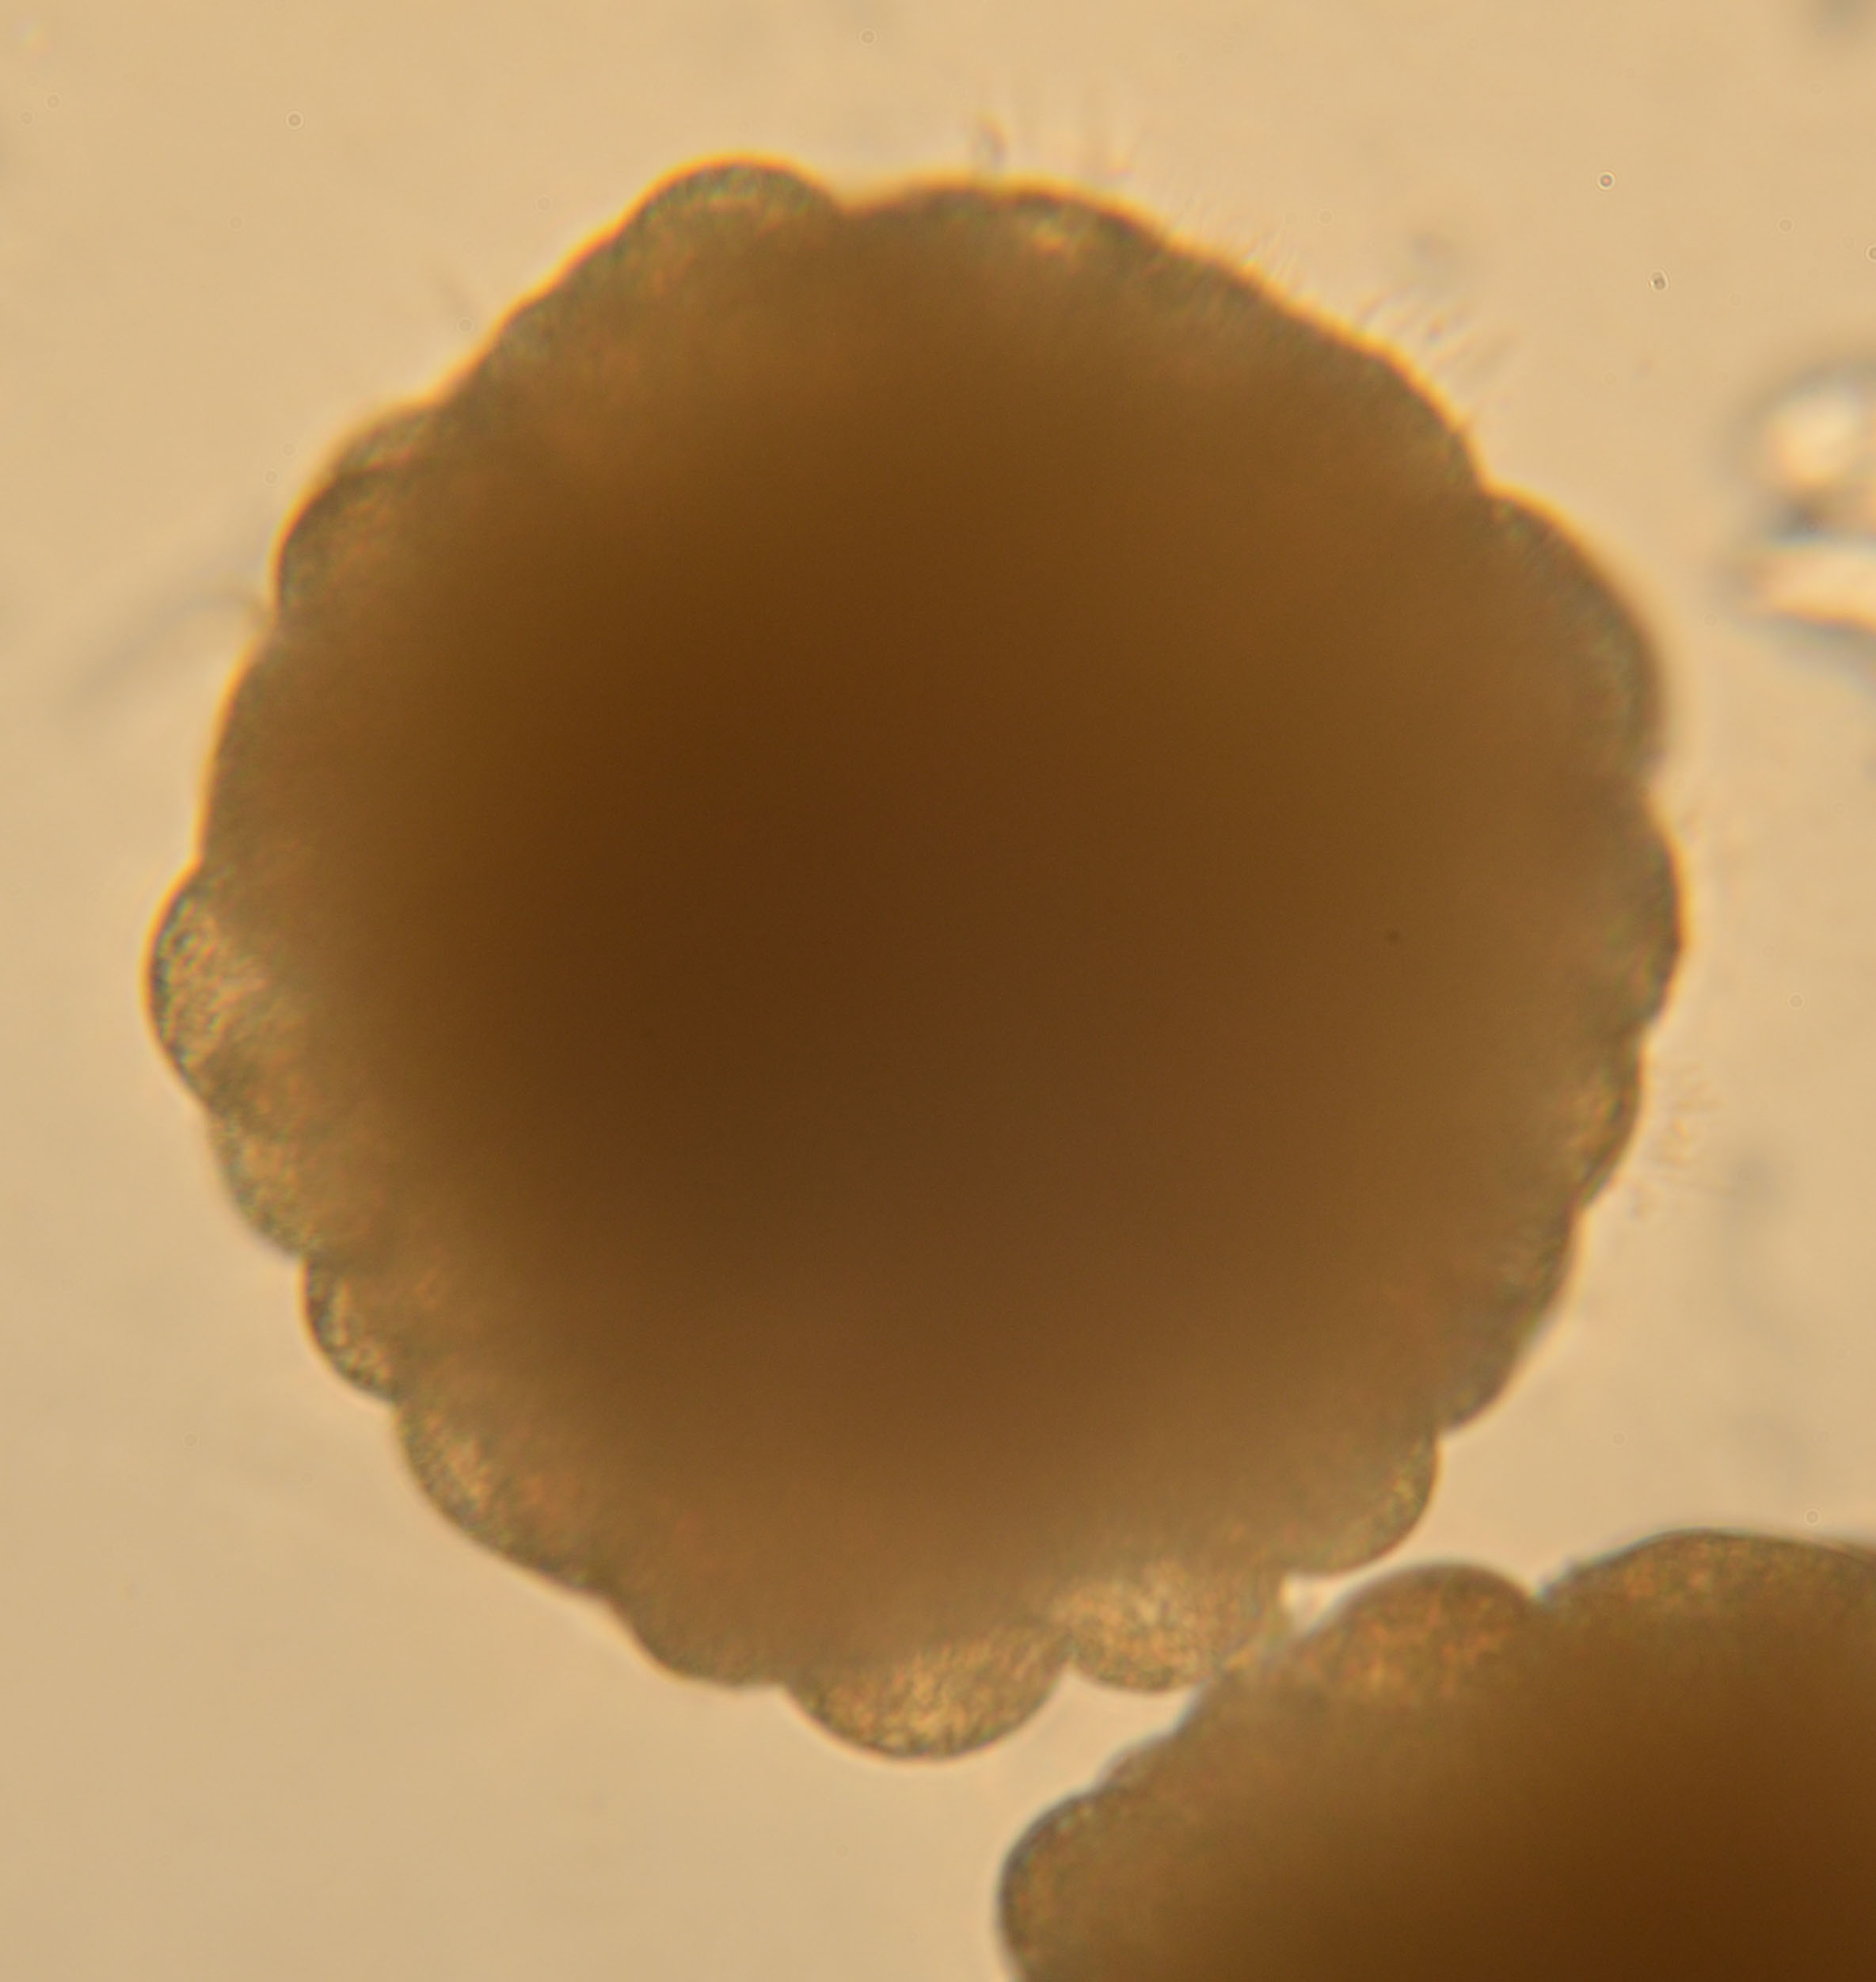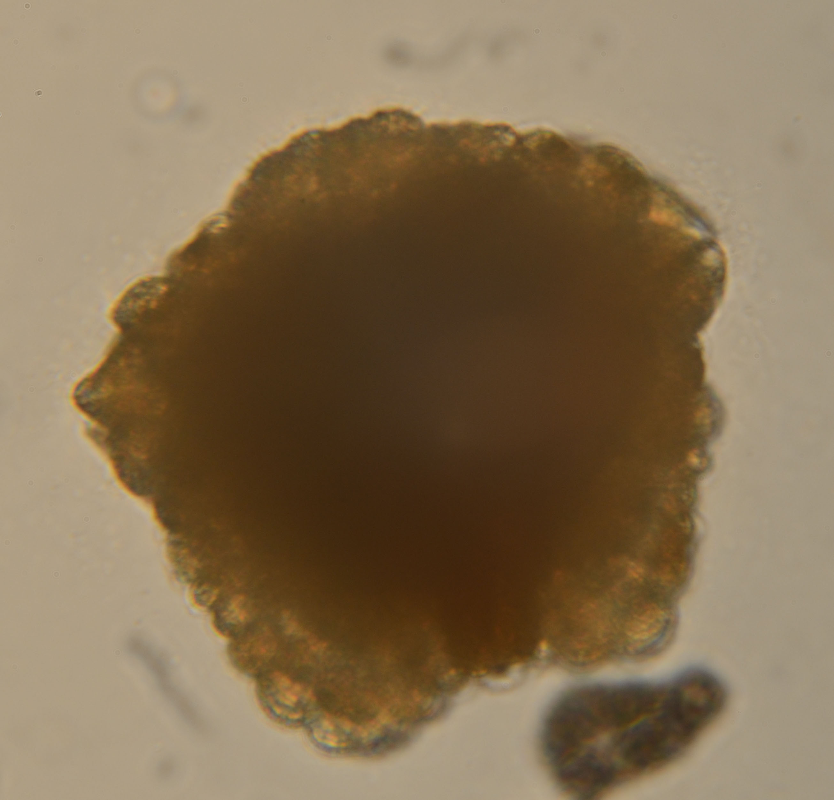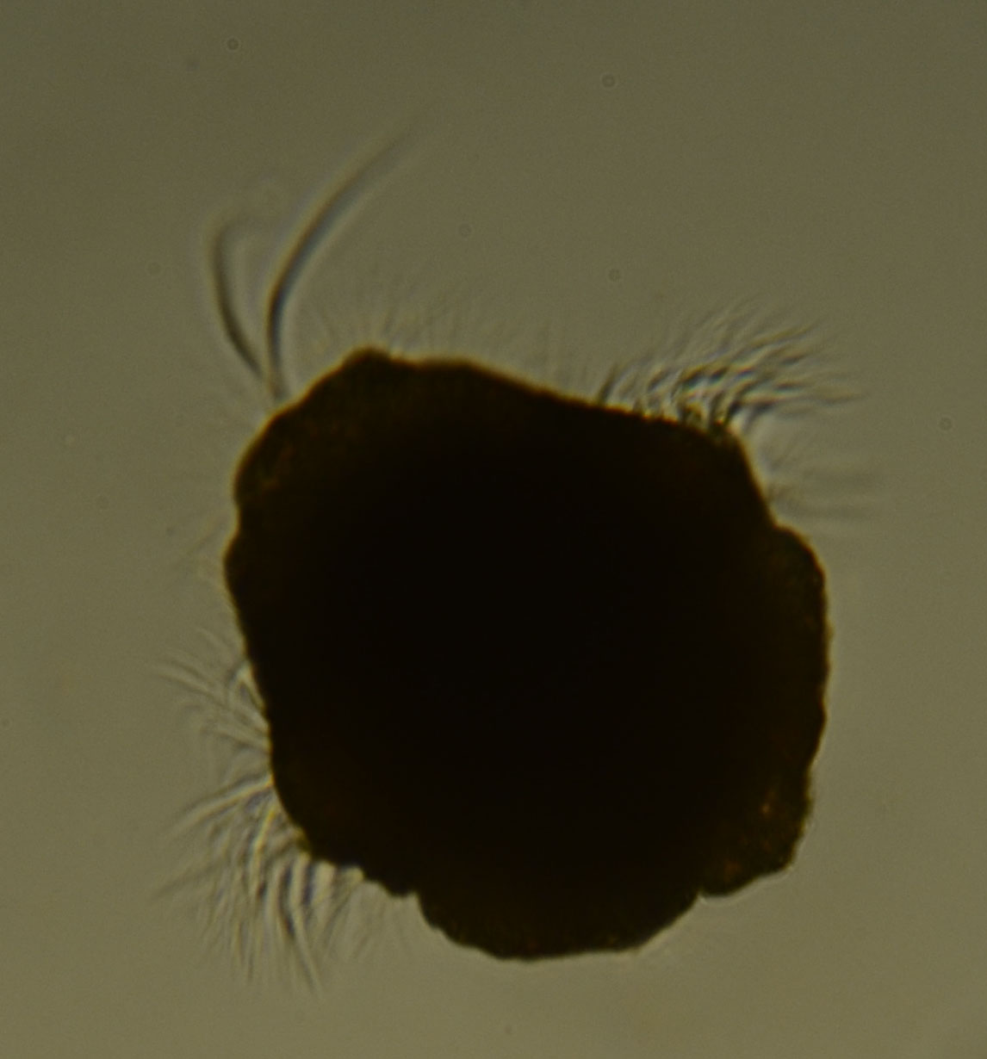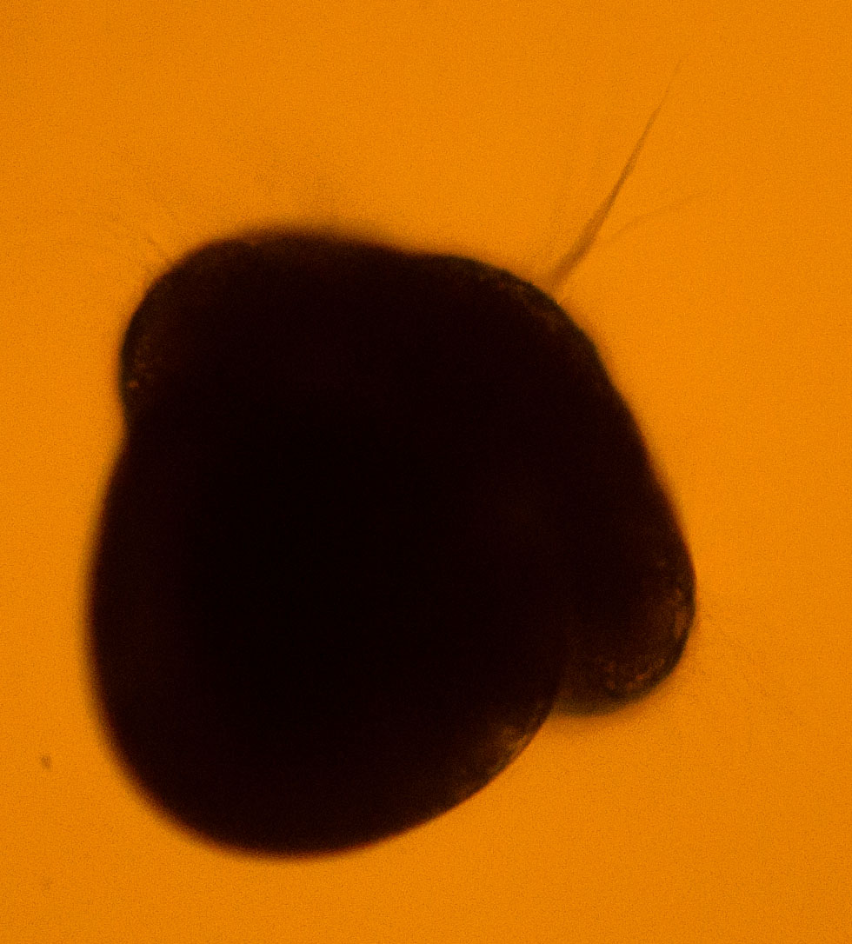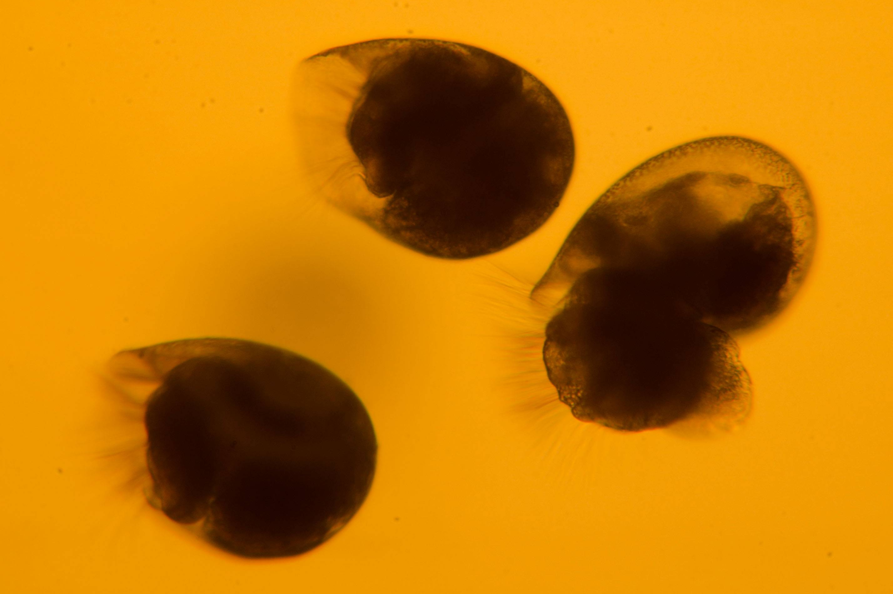
A
B
C
D
E

Figure 1

Figure 2

