History of the development of Miscanthus as a bioenergy crop: from small beginnings to potential realisation
John Clifton-Brown^{1*}, Kai Schwarz² and Astley Hastings³

¹Institute of Biological, Environmental and Rural Sciences (IBERS), Aberystwyth University, Gogerddan, Aberystwyth, Wales, SY23 3EQ, United Kingdom.
²Julius Kühn-Institut, Bundesallee 50, D-38116 Braunschweig, Germany.
³Institute of Biological and Environmental Science, University of Aberdeen, 24 St Machar Drive, Aberdeen, Scotland, AB24 3UU, United Kingdom.
*Corresponding author
e-mail: jhc@aber.ac.uk
Tel. 01970 823191
Keywords:
Bioenergy, Miscanthus, Plant ecophysiology, Crop modelling, C₄ photosynthesis, perennial grasses.

Abstract
Miscanthus, a genus of perennial C₄ grasses from Eastern Asia has strong biomass potential combining high dry matter yields, perennial growth, efficient use of nitrogen and water, and good disease resistance, making it one of the leading energy crops. We recount the history of Miscanthus research in Europe, starting with the introduction of ‘Giganteus’ in 1935 to Denmark. In 1989 Mike Jones, of Trinity College Dublin, initiated Miscanthus research in Ireland and coordinated field trials in Europe in some of the earliest eco-physiological experiments that led to a better understanding of the exceptional performance of this C₄ plant in temperate climates. These included the first Miscanthus field trial in Ireland, planted in 1990 in Cashel, Co. Tipperary, the output of which was used to parameterize the growth model MISCANMOD with the clone M. x giganteus. This model was developed later into a powerful and flexible Fortran version (MiscanFor) that is now used to predict Miscanthus crop performance in different soils under current and future climate conditions. A brief discussion of the recent changes in the socio-economic-environment drivers for bio-energy crops is also included. The long term research programmes for improving the breeding and agronomy of Miscanthus as a renewable energy source are now reaching commercial maturity and will hopefully aid in our attempts to de-carbonise energy producing systems and to mitigate the impacts of climate change.

Introduction
Of the available candidates for use as bioenergy crops C₄ species have some of the highest potential and recorded productivities of all terrestrial plants ; however, the majority of C₄ species are of tropical or subtropical origin and are poorly ‘adapted’ to growing in cool and temperate climates such as those found in much of Northern Europe. An exception to this is Miscanthus, a perennial rhizomatous grass genus that appears to be more suited to growing under cooler conditions .
The approximate geographic distributions of Miscanthus species throughout Eastern Asia are shown in figure 1. The species with the most wide-ranging distribution is M. sinensis, stretching from Hebei province, just south of Beijing, to Hong Kong, including Korea, Taiwan and N. Japan to the Ryukus Islands. In contrast M. sacchariflorus has a more restricted distribution than M. sinensis, though it embraces a very wide range of climates from Russia, N. China, Korea and Japan (Honshu). The distribution of M. floridulus is confined to latitudes below 30° N, since it is relatively frost sensitive. For M. lutarioriparius, often classified as M. sacchariflorus, the distribution is more restricted in the vicinity of the Yangtze River system. M. transmorrisonensis, which is morphologically similar to M. sinensis, is found at high altitudes (> 2500m) in Taiwan where snow is frequent. M. longiberbis is a South Korean endemic species and it has been proposed that it forms a link between other members of section Kariyasua and M. sacchariflorus . M. tinctorius is similar to M. longiberbis but has no awns and is used as a traditional yellow colour dye in Japan. M. nudipes and M. nepalensis have only two anthers and are sometimes treated as an independent genus, Diandranthus . They are mainly distributed around the Himalayan region discontinuously from other Miscanthus members.
The basic chromosome number of section Miscanthus is 19 . Diploid and tetraploid forms of Miscanthus are the most common.

Early years: From 1935 to 1992
European interest in Miscanthus for horticultural purposes began in the early 20th century. Collections made in 1935 by the Danish botanist, Askel Ølsen in Japan resulted in the introduction of a genotype that grew rapidly under Danish environmental conditions. This genotype was cloned and spread through horticultural groups throughout Denmark and Germany, where it became a common ornamental plant in herbaceous borders. In the 1960’s Ernst Pagels, a horticulturalist in Northern Germany (near Oldenburg) built up a collection of Miscanthus accessions, which flowered readily under northern European climates and some produced seed. Pagels inter-crossed fertile accessions, to produce well known ornamental clonal hybrids such as Silber Feder (Silver Feather, silvery panicles that reflect the light), Variegatus (longitudinal chlorotic (white / yellow) leaf stripes), Zebrinus (stripes across the leaf) and Goliath (taller with reddish shiny panicles). The vigorous Danish clone was called Miscanthus sinensis var Giganteus . The potential for Giganteus as an industrial feedstock was first recognised in the 1960s by a Danish business man interested in Miscanthus as a source of fibre for paper making. He established a 1000m² plot trial in 1967 in Jutland.
Subsequent morphological analyses of M. x giganteus led to the conclusion that this genotype was a hybrid between M. sacchariflorus and M. sinensis and was named M. x giganteus . Cytological investigations showed that M. x giganteus was indeed a naturally occurring, inter specific hybrid but the exact parents remain unknown. Hodkinson and Renvoize provided M. x giganteus with a Latin description making this name compliant with the procedures of ICBN (International Code of Botanical Nomenclature (http://www.iapt-taxon.org).
Scientists Poul Erik Brander, Jens Bonderup Kjeldsen and others from Denmark organised several Asian germplasm collection trips in Japan in the 1980’s. Collections made in Japan in 1983, from Honshu Island, were planted in nurseries in Hornum, Denmark. They selected germplasm that was most appropriate for thatching as a more robust replacement for imported common reed (Phragmites australis). These collections pre-dated the need for material transfer agreements required under the Convention on Biological Diversity (CBD) so that Danish Institute of Agricultural Sciences (DIAS) colleagues, Uffe Jørgensen and Jens Kjeldsen, shared the their germplasm collections openly with other researchers in Europe including Wageningen (NL), Braunschweig (Germany), Skåne (Sweden) and Dublin (Ireland). Consequently, the selected genotypes from these accessions became part of the core germplasm used in a number of European Miscanthus projects.
The earliest replicated plot yield trials with ‘Giganteus’ were planted in 1983 on sandy soil in Hornum, and were measured every year . In wet years, autumn yields were 15 to 25 tonnes of dry matter per hectare (t DM ha⁻¹). Small stands of ‘Giganteus’ were also planted in what was then East and West Germany a few years later. The plantations in the East were grown to make glasshouse shading mats instead of the previously used common reed. Plantations established by Prof. Ständer in Western Germany were highly productive, with reported yields >25 t DM ha⁻¹ y⁻¹ . Franz Alt, a well-known German TV presenter, publicised the bioenergy potential of Miscanthus in a documentary programme and a book . Prof. Ständer is well known for his statement ‘I have seen the future, grass growing 4m tall that can fuel power stations’ and this stimulated widespread European interest in Miscanthus as a bioenergy crop. The German energy company, Veba Oel, subsequently set up a project to explore industrial and energy uses for Miscanthus. Multi-location growth trials at 20 sites distributed throughout Germany were established from rhizomes imported from Denmark in 1990. The stand areas varied from 0.1 to 0.3 ha and were established on what was considered marginal as well as on highly productive land types. A large trial of 25 ha was planted close to Wesel in Nordrhein-Westfalen as a basis for testing harvest technologies and as feedstock for industrial and energy applications. The Veba Oel multi-location trials showed both the potential and the limitations of Giganteus in Germany. Yields of more than 25 t DM ha⁻¹ were measured at sites with loamy soils, warm summer temperatures and adequate water supply. Giganteus plantations in Fichtelgebirge and Schwarzwald at 500 m and 800 m above sea level, respectively, did not survive the first winter. The presence of standing water for 6 to 8 weeks on a peat soil during winter also resulted in severe plant losses (>50% of the plants) and halved average yields from the 15 t DM ha⁻¹ achieved before flooding. The Veba Oel trials also showed that Giganteus takes between 3-4 years to establish and achieve maximum and stable yields.
Around 1990, Choren, a company located in Freiberg, Germany, started experiments on the conversion of biomass to liquids using gasification and the Fischer-Tropsch process, with Miscanthus biomass as one of the feed-stocks. This resulted in a pilot plant producing bio-diesel that was operational from 1998 to 2004 . This was funded by Volkswagen, Daimler, Lichtblick and Shell. Although Veba Oel invested primarily in Fischer-Tropsch conversion of biomass to hydrogen, they also worked on direct thermal conversion by combustion and the use of Miscanthus as a raw material for the paper and pulp industries.
In 1989, a joint EU funded research programme with partners in Denmark, the UK and Ireland was initiated and led by Mike Jones from Trinity College Dublin. Replicated plot trials were planted with Danish M. x giganteus (known as clone Hornum) in Cashel (Ireland) and Essex (UK) in 1990. The first Cashel Miscanthus trial (Cashel Site 1, Trial 1) was planted on poorly drained low quality, wet pasture land. Cashel site 1 was selected as representative of ‘marginal’ land, which would be available for energy crops without conflict with food production. Despite a pre-ploughing herbicide application of glyphosate to destroy the vegetation, weed control following planting in Trial 1 was poor and the first year plants measured in autumn reached no more than 0.75 m in height, with about 3 shoots (or tillers) per plant and even after the second growing season, the biomass of the weeds between the plants was probably higher than that of M. x giganteus (4 t DM ha⁻¹). It was only after the third growing season that impressive growth rates (in terms of shoot height) were observed (see Fig. 2). Meanwhile in Essex, where the plot trial was planted on higher grade arable land with low weed competition, growth rates during early establishment, based on autumn measurements of height and tiller number, was approximately double that at Cashel . In 1991, Cashel Trial 2 was planted to compare a) two different ‘marginal’ soil types: the poorly draining land at site 1, and an free draining stony ground beside a gravel pit (Site 2), and b) establishment rates from plug plants produced from rhizomes and in vitro tillering. As with Trial 1, growth rates in Trial 2 were slow in the first year even though more effective weed control was achieved. Trial 2 showed that rhizome propagated plants produced ~20% taller plants with 80% less tillers, than the in vitro propagated plants. In Trial 2 almost half of the in vitro plants failed to survive the first winter whilst the plantlets raised from rhizomes performed better, with ~90% survival. By comparison in Braunschweig, Germany, first year growth of M. x giganteus, where the growing season temperature (May to September) was more than 2°C warmer than in the UK and Ireland resulted in canopy heights from 1.5 to 2 m.

Scientific development years: From 1992 to 2004
As food production in Europe was well ahead of requirements in the early 1990’s farmers were ‘encouraged’ through EU legislation and associated subsidies to stop production on 10% of their land. Farmers ‘set-aside’ their less productive land and, as a consequence, this was available for bio-energy crops. In 1992, a large EU AIR programme consortium project, known as the ‘European Miscanthus Productivity Network’ (EMPN) was initiated with an Irish co-ordinator, Sean McCarthy from Hyperion Energy Systems (Cork, Ireland). Mike Jones provided the technical lead and designed the multi-location trialling network with ~15 trial sites across Europe. To provide the relatively large numbers of plants needed for the EMPN project M. x giganteus was microprogated by in vitro tillering . The in vitro culture conditions were optimised to maximise the tillers grown per multiplication cycle and consequently micropropagated ‘plug’ plants had 3x the tiller numbers of plants produced by rhizome splitting.
As part of the EMPN, a new replicated Miscanthus productivity trial with 3 levels of nitrogen fertiliser (0, 60, 120 kg N ha⁻¹) was planted in Cashel, Ireland in 1993 on arable grade land. Transplant success was almost 100% in Cashel, and at most locations in Europe. However, in spring 1994, only 17 % of the plants in Cashel emerged. Since winter soil temperatures rarely fell below zero, there was at this time, no obvious explanation for these over winter losses. The surviving plants were re-planted at the original spacing and from the second year onwards, no further losses occurred. Subsequently harvestable yields climbed to reach a level ~20% higher than that on the lower quality grassland site (14 t DM ha⁻¹ y⁻¹ from 1994 to 2000).
In several other EMPN field trial locations, first winter losses were also reported (Germany and Belgium) and this stimulated a series of experiments on the effects of low temperature. It was thought that losses were highest in field locations with warm periods during the winter months followed by short colder intervals . It was hypothesised with soil temperatures above 10°C at a depth of 5 cm that growth from the overwintering rhizomes would beinitiated too early in late winter or early spring. This would both reduce the cold tolerance of the rhizome and expose young shoots to frost damage. Low temperature acclimation experiments in chambers were performed to test changes in freezing tolerance with pre-treatment at 2°C for different durations (1, 2 and 4 weeks). Quantifying the LT₅₀’s (Lethal temperature to kill 50%) for rhizome death experimentally was a lot more complex than originally envisaged and data which showed clear acclimation effects was never published; however, important experience was gained for later experiments (Clifton-Brown pers com).
In June 1997, multi-location trials with fifteen genotypes were planted at five sites in Europe as part of the European Miscanthus Improvement project (EMI) led by Iris Lewandowski from Hohenheim, Stuttgart, Germany. In January 1998, as a part of this project, overwintering rhizomes were collected from the field near Stuttgart and their cold tolerance assessed. The LT₅₀ of M. x giganteus rhizomes harvested in January was estimated to be -3.5°C. Other genotypes were also tested, and these identified superior frost tolerance in two M. sinensis hybrids (LT₅₀, -6.5°C) . These LT₅₀’s were used to explain the overwinter losses of genotypes in EMI . However, it became clear later that this was not the full explanation for the observed winter losses because developmental maturity and acclimation effects had not been determined.
In the mid 1990’s a group led by Steve Long at the University of Essex, UK was focussing on an understanding of the process of low temperature tolerance in photosynthesis. Exceptionally high rates of photosynthesis per unit leaf area were reported for M. x giganteus both in climate chamber experiments and in the field . Meanwhile Mike Jones’s group were working on the impacts of early canopy development through screening for genotypic variation in the thermal requirements for leaf extension rate. The significant variations in leaf expansion rate at low but above freezing temperatures (5 -15°C) were incorporated into an early version of a Miscanthus growth model, to assess the theoretical impact on yield (Clifton-Brown and Jones, 1997).
These studies in the mid 1990’s on the thermal responses of the leaf extension rate of different genotypes were important for future breeding programs as the length of the growing season can be extended if the newly emerged shoots are frost (sub-zero) tolerant. To this end, an air frost exposure experiment focussed on newly emerged leaves from selected EMI genotypes was carried out and differences in leaf frost sensitivity were assessed . Thermal time and frost tolerance parameters were included in a further version of the growth model to explore the potential for extending the growing season and these showed that potential increases in yield were >20% .
Early canopy development has long been a target for yield improvement through extension of the growing season . The environmental conditions required to initiate spring shoot emergence have long been assumed to be predicted by accumulated temperature above a minimum base temperature (thermal time) . However, in the development of the MiscanFor model , it was found that to match experimental plant growth data from multi-location trials emergence had to be delayed until the spring equinox to replicate the growth curve. This indicated some photoperiodic-sensitivity, which has subsequently been shown in chamber experiments that vary with genotype.
Over the years, field observations of plots during periods of low rainfall were starting to build up a picture of Miscanthus responses to water deficits. Clearly, M. x giganteus, despite being a C₄ plant, is sensitive to water deficits and if it is grown on lower grade lands the occurrence of water deficits could be an important issue, even in generally wet climates such as Ireland. In the EMI field trial near Stuttgart, during a dry period in August 1998 water-deficit induced leaf senescence in M. x giganteus was more pronounced than in other EMI genotypes (Fig. 3). A controlled environment experiment was then performed to compare the physiological responses to different water deficits in three diverse genotypes. Whilst whole plant water use efficiency (WUE) was 40% higher than in C₃ plants (11.5-14.2 g DM kg H₂O), as expected there were no significant differences in WUE among the three genotypes. Interestingly, M. x giganteus failed to control transpiration under water shortages through active stomatal closure. This explained the higher levels of senescence observed in the field in August 1998 during a drought (Fig. 3). The consequences of the lack of stomatal regulation depended on the severity and length of the period of water shortage. These observations and experiments would become important inputs for the models needed to project feedstock availability spatially and into the future.
In 1997 an EU Concerted Action led by Mike Jones was established to produce a review of the then current state of the art of Miscanthus in Europe. This subsequently formed the basis for ‘Miscanthus: Fuel and Fibre’ published by James and James in 2001 . The chapters covered agronomy, utilisation options and economic analyses by a range of contributors and has been a one stop reference book for those starting any research on Miscanthus for the past decade.
The suggestion to develop a practical Miscanthus yield model to project feedstock availability had originally come from Mike Jones in 1993. To this end, measurements of leaf area index, light interception and standing dry matter were made intensively on the Cashel trial, which had reached physiological maturity in 1994. These measurements were used to derive the light extinction coefficient ‘k’ and the radiation use efficiency . Estimates for the yield potential without limitation were mapped from 20 synoptic weather stations in Ireland . As discussed above, water availability clearly limits production potential and in these early stages of development the best approximation that could be made of ‘rain-fed yields’ used an approach based on an estimate of daily soil moisture deficits following methods developed by Aslyng aand used in a grass growth . Although these methods are rather simplistic, they produced realistic projections from very limited input data. Gridded climate, soils and land use data at European level were becoming available in the early 2000’s. These were used as inputs to an extended model, and the 2003 version of the model ‘MISCANMOD’ was used to project both the potential (without water limitation) and the rain fed yields across Europe. The yield projections based on mean historical climate data (1960-1990) and mature yields (3 years old or more) measured at multiple sites proved the model was producing a reasonable fit with observed yields. MISCANMOD was used to predict the M. x giganteus yield potential of 10% of the agricultural land for the then EU 15 member states . The projections included a 30% discount for the yield losses associated with over winter death and the loss of senescent leaves.
Developing Commercial interest

As economic policies to promote the development of energy crops were introduced in Europe in the mid to late 1990s, private sector interest began to develop. In Germany, TINPLANT Biotechnik und Pflanzenvermehrung GmbH started a breeding programme
aimed at bringing alternative hybrids, superior to M. x giganteus, to the market. While Dr. Ralph Pude in Bonn started the Miscanthus society (Internationale Vereinigung für Miscanthus und mehrjährige Energiegräser (MEG) e.V, www.Miscanthus.de) as a vehicle to translate research into commercial reality. In 1999 in Germany, Frank Möller pioneered the higher value use of Miscanthus in light natural sandwich (LNS) construction materials in a private-public funded project. This material was 50% less dense and on a mass basis was stronger than solid wood or plywood. The product idea was acknowledged by an award from lower Saxony in Germany but it failed to attract sufficient investment to commercialise it .
In the UK commercial scale agronomy and the harvest chains required to deliver biomass crops suitable for a variety of end users were pioneered by several start-up companies who developed the methodology for rhizome planting of M. x giganteus and offered growers contracts with power station end users.
Subsequently commercial interest in Miscanthus moved to the USA and Steve Long moved from Essex to Urbana-Champaign in 2000 bringing his European experience of Miscanthus to Illinois. Steve began with field experiments with M. x giganteus in 2001 with plants cloned from material in the Chicago Botanic Garden. The trial plantings in Illinois established rapidly under the much warmer summer conditions than in Europe and plot yields in excess of 50 t DM ha⁻¹ were reported from small quadrats . Although the sampling procedure was scientifically acceptable for inter-comparison between different species (the trial compared Miscanthus with Switchgrass), yield upscaling probably exaggerated the field scale harvestable yield. Another issue in reporting yield was the December harvest time, which is too early for attaining a well senesced, dry crop, low in nutrients, which is suitable for combustion purposes. Even so, with spring harvestable yield potentials of 30 t DM ha⁻¹ y⁻¹, the work demonstrated the huge potential to produce lignocellulosic biomass from Miscanthus in the mid-west USA and extended knowledge of its ability to produce large biomass volumes in different climates .
Breeding and modelling: 2004 – present
In 2004, John Valentine, a plant breeder in the Institute for Grassland and Environmental Research (IGER) Aberystwyth, started a Miscanthus breeding programme in the UK funded by DEFRA and he was joined by John Clifton-Brown. Miscanthus germplasm collections made in the late 1990’s by ADAS and Kew gardens were already in the field in the UK, and these combined with accessions used in EMI and EMN projects provided the starting genetic ‘capital’ for breeding.
In 2007, in the USA, in response to increasing political interest in biofuel development British Petroleum announced an international competition to establish an Energy Biosciences Institute (EBI). The winning bid came from a Berkeley-Illinois coalition, headed by Chris Somerville and Steve Long. The Illinois’ Miscanthus programme was a centre-piece of this effort and the support facilitated an explosion of knowledge on the crop in the USA from genomics and molecular understanding of chilling tolerance to ecosystem services, pests and diseases. A core activity of the Institute is in developing the technologies for converting lignocellulose, from crops such as Miscanthus into next generation transport biofuels. Seven years on, the Institute has over 300 peer-reviewed publications from economics and legal analyses to engineering solutions and molecular analysis, as well as several patents ranging from new feedstock germplasm to efficient fermentation of the sugars derived from hemicellulose.
Meanwhile in Europe it had become clear that although the yield estimates of MISCANMOD were useful, further developments were necessary to make predictions for future production in a changing climate as required by the ongoing IPCC (Intergovernmental Panel on Climate Change) assessments. Mike Jones and John Clifton-Brown were approached by Pete Smith, the leader of an IPCC modelling group in Aberdeen, to convert MISCANMOD to the standard FORTRAN used by meteorologists. Astley Hastings in Pete Smith’s group re-programmed the excel MISCANMOD into FORTRAN, calling the improved model ‘MiscanFor’. In addition, multiple improvements were made to the original model, in particular the addition of a more fundamental sub-model for calculating plant available soil water and its impacts on biomass growth as well as day-length sensitivity, radiation use efficiency and temperature-dependent leaf expansion rate. The new process descriptions in MiscanFor were derived from the ever increasing availability of good field trial data (Hastings et al., 2008). The model-predicted yields were validated against the measured spring harvest dry matter (Fig. 4). Further yield maps were produced of the future potential of M. x giganteus under the emissions scenarios produced by the IPCC. Shell, who also had established a biofuels research project, commissioned the Aberdeen group to further develop the MiscanFor model for in-house use for predicting Miscanthus biomass yields.
In the US, specialist genomics companies recognised the opportunity to breed Miscanthus with improved traits for higher yields and more effective downstream processing-ability.. The Californian Biotech Company, Mendel Bioscience, became associated with the EBI and started to develop a commercial Miscanthus breeding programme in the US, first in California and later in Illinois. Mendel Bioscience reached out to Europe and bought Germany’s ‘Tinplant’ Miscanthus breeding programme in 2008. Selections from the Tinplant breeding programme were brought to Canada for trialling. Meanwhile, another Californian based Biotech Company, CERES Inc., began to invest in the European Miscanthus breeding efforts in Aberystwyth in the UK. In 2007, CERES scientists Richard Flavell and Emily Heaton started a breeding partnership with Aberystwyth.
Box: Steps in a Miscanthus breeding programme.
Miscanthus breeding programmes necessarily have different stages, which culminate in the release of commercial hybrids with tailored agronomy.
- The first is the collection and characterisation of diverse germplasm with traits that could confer advantages in novel hybrids. A breeding programme requires a broad range of germplasm collected across a range of latitudes, climates and geographic locations, where the target species occurs to maximise the opportunity to capture a full range of trait diversity.
- The second is Hybridization. Miscanthus is predominantly outbreeding, due to genetic self-incompatibility mechanisms where very low seed numbers are produced via self-pollination. For small quantities of seed, paired crosses are made by bagging together panicles from selected parents. For larger quantities of seed, crosses are performed in isolation chambers or in field plots. In either case, a paired cross often results in seed set on both parents. The quantities of seed produced from a cross depend on many factors including sexual compatibility, flowering synchronicity, humidity, temperature, and plant health. Synthetic varieties are used as the main approach to produce varieties that preserve heterozygosity and minimize inbreeding. A synthetic variety was defined by Allard as “a variety that is maintained from open-pollinated seed following its synthesis by hybridisation in all combinations among a number of selected genotypes”.
- The third step is ex-situ phenotypic characterization of wild germplasm and new hybrids in a range of climates, which is important to understand genotype x environment interactions. Field evaluations of diverse germplasm in both spaced plots and multi-location trials are used to characterize novel accessions for yield potential and chemical composition. As Miscanthus is a perennial, selections of outstanding crosses can only be made reliably after the second growing season. Phenotyping depends on the co-ordination of researchers at different sites and the implementation of standard protocols to ensure comparable inter-site comparisons.
- In the fourth phase, large scale demonstration trials are used to develop the agronomic practices that are needed to successfully establish, manage and harvest the crop. Since Miscanthus biomass at harvest is low density, compression into pellets and high density baling are being developed to improve storage and transport before the crop is used. Traits such as stem diameter are expected to define the most economic method for biomass densification and will consequently feed back into the selection of parents for hybridization.
[end of box]
Starting in 2007, Aberystwyth-led (IGER, later IBERS) Asian germplasm collection missions have assembled one of the largest ex-situ Miscanthus germplasm collections outside Asia. Selection and breeding work has been undertaken with partners in USA, UK and Europe in a number of interlinked projects and the broad steps are outlined in Box. 1. Since 2011, the project GIANT-LINK a £6.4m project between public (UK BBSRC and DEFRA) and private partners (CERES, Blankney Estates, E.ON and NFU) have taken Miscanthus breeding forward rapidly. In 2013, the seed production of unique parental combinations, discovered through earlier test crosses in Aberystwyth, was started at the field scale by CERES in the USA. These new seed-based hybrids are being trialled in the UK and Europe at a wide range of sites with differing climates and soils with institutional and commercial partners. In the UK, a strong market for Miscanthus has been established by Terravesta Ltd., experts in fuel chain logistics for both large-scale power generation and smaller-scale local heat schemes.

The long term view… reflections on the past to building the future
Stand establishment
One of the barriers for utilising M. x giganteus in Ireland and northern Europe has been the slow establishment rate. The early Cashel trials required four years before a significant crop yield was reached and, in addition, some of the EMN field trial locations (including Cashel Trial 3) failed to over-winter in 1993, even though soil temperatures did not fall below the LT₅₀ derived from rhizome freezing tests (-3.5°C) Clifton-Brown and Lewandowski, 2000a). The physiological explanation for the overwinter losses lies in insufficient/negligible rhizome growth in the first growing season that would ensure successful overwintering. There are two possible reasons for this. Firstly, rhizome growth may have been inhibited by both in vitro hormones that stimulate tillering and result in short bushy transplants, which do not produce rhizomes. Secondly, the summer soil temperatures in some locations may have been below those needed to initiate significant rhizome growth. Amalgamated field experience is showing that in locations where summer soil temperatures do not exceed ~20°C for at least 2 weeks in the first year stand establishment is unsatisfactory and overwintering losses are likely. In the UK and Ireland, poorly established rhizome planted crops with planting gaps produced lower yields than expected. This problem was solved in 2011 by increasing the weight of the planted rhizomes about 5 times (approx. 100 g FW), but this approach has increased the establishment costs from £1700+/-£100 to £2300, making planting costs an economic barrier for many potential growers.
Recently, experiments using plastic films developed for maize have been used to establish Miscanthus in the UK. Unpublished results show that this accelerates M. x giganteus establishment so much that mature ‘ceiling’ yields can be reached within three years in the UK, and even possibly in two, depending on local climate and inter-annual variation in climate. Trials in high rainfall areas or on water retentive soils in the UK and Ireland, showed that although Miscanthus took from 3 to 4 years to establish fully, production levels of >12 t DM ha⁻¹ were achievable
Stand productive lifespan
Economically viable stand lifespan of the crop depends on many biological factors including planting density and germplasm type as well as production costs, product value and the future availability of improved varieties. In the long term Cashel (Ireland) trial 1 harvestable yields were measured annually from the second year until the 16th year after planting. The long term pattern of yields had three distinct phases: the first phase was a yield building phase (1991 to 1993), with a progressive increase in yield up to an autumn value of ~16 t DM ha⁻¹ y⁻¹. The second phase was a more stable period (1994 to 2000) when autumn yields averaged 17 t DM ha⁻¹ y⁻¹ whilst the final phase (2001 and 2005) was associated with a period of lower yields with an average value of 11.5 t DM ha⁻¹ y⁻¹ . To date, annual yield estimates generated from MISCANMOD/ MiscanFor with daily climate data have been limited to the highly productive second phase and the inter-annual variations during this period. Yield series for sixteen M. x giganteus sites in Europe (including Cashel) have been collated recently . Lesur et al. (2013) detected a decline in yield in stands greater than 10-12 years old depending on environment and initial planting density and proposed an ‘age related’ regression model for M. x giganteus. However, Lesur et al.’s (2013) model did not consider the effects of inter-annual variation in weather/climate or differences in initial planting density. To date there is very limited knowledge on stand longevity for genotypes other than M. x giganteus. The gross morphological differences in M. sacchariflorus, with a creeping rhizome and M. sinensis, with a compact rhizome, would be expected to influence the productive lifespan. At present all that is known is that wild M. sacchariflorus, which forms closed canopy stands in China have been harvested annually for about the past 30 years for paper production , and there does not appear to be any concern about yield decline. In contrast, wild M. sinensis rarely forms closed canopy stands since it grows on slopes and banks around field margins. Plot trials of M. sinensis ‘Goliath’ were planted in 2009 at three different densities (4, 2 and 1 plant m⁻²) in Aberystwyth but it is still too early to detect a yield decline (Paul Robson, pers. comm.). The productive lifespan of novel interspecific M. sacchariflorus and M. sinensis hybrids produced by European breeding are being tested in multi-location trials. The oldest were eight years old in 2014 and, to date there is no detectable yield decline (Clifton-Brown et al. unpublished).
Abiotic stress tolerance
Although, there are water use efficiency benefits of C₄ photosynthesis in Miscanthus the evidence for the sensitivity of M. x giganteus to water stress continues to be confirmed year on year from trials in many locations. Interestingly, less sensitivity was found in some other Miscanthus genotypes tested in the EMI programme that were found to regulate transpiration rate under water deficits through ‘active’ stomatal regulation . The predicted inter-annual variation due to water deficits obtained from MiscanFor (version 2008) was about 20% across Europe . Current research programmes are also working on tolerance to salinity and extremes of temperature. As expected wide variations in abiotic stress tolerance are being found in germplasm accessions collected over a wide climatic range in Asia. Genotypes with enhanced tolerance are being brought into crosses with parents known to produce high yielding progeny with the objective of breeding new hybrids with improved abiotic stress tolerance that can be grown on a wide range of lower grade land types.

Carbon mitigation from using Miscanthus as an energy feedstock
Carbon mitigation is the sum of fossil fuel carbon emissions displaced minus the carbon cost of growing Miscanthus and producing a useable fuel plus the soil carbon sequestration or loss. Of the variables that have been incorporated into a lifecycle analysis (LCA) model Miscanthus stand establishment rate and canopy longevity are crucial inputs. Depending on soil type, climate and previous land use, soil carbon changes can both add or detract from the overall carbon mitigation. Mike Jones initiated life cycle analysis (LCA) for various uses of Miscanthus, from a biomass fuel to a feedstock for producing biogas, biodiesel, methanol and ethanol, to assess if it did indeed reduce emissions . This work included the impacts on soil carbon stocks associated with land use change from arable to Miscanthus and from grassland to Miscanthus .

Future Prospects in Europe
The agricultural land areas that can be devoted to energy crops such as Miscanthus depend on a plethora of factors. For the last century increasing global food demands have been met by improving yields on the better grade lands through intensification, which increasingly combines modern molecular breeding and agronomy. The challenge is to make modern agricultural intensification sustainable. This has been the subject of the Royal Society’s Report ‘Reaping the Benefits’ , which concludes that intensification should continue sustainably through increased investment in crop science.

Lovett et al. , in the UK, attempted with a ‘constraint mapping’ approach implemented in GIS to calculate the potential land resource for energy crops. The seven constraints include 1. Roads, rivers, lakes and urban areas 2. Slopes >15%, 3. Areas of cultural heritage 4. Designated areas (e.g. national parks), 5. Woodlands, 6. Peat soils and 7. Natural habitats; these were combined to produce ‘prohibition’ areas at a spatial resolution of 1ha. In the UK, land is graded according to its versatility in agriculture usage. Grades 1 and 2 are the highest quality lands, and these should not be used for energy crops because they comprise a relatively small area of the UK that is regarded as essential for the production of food crops. The less productive land grades 3, 4 and 5 make up the vast majority of the UK agricultural area. Applying the prohibition mask from the constraints, Lovett et al. (2014) calculated that 8.5 Mha in the UK could be potentially considered for energy crops but the proportion of this that could be used without reducing the UK’s capacity to produce food is a subject of much debate. It is generally agreed that growing energy crops on 10% of this land (i.e. 850 Kha) is a realistic target, which is unlikely to reduce food production capacity. Clearly, as Miscanthus is not always the appropriate choice of energy crop due to thermal limitations on establishment, insufficient water availability, harvest logistics, available market etc. we project that Miscanthus is likely to occupy about half of the 850 Kha i.e. ~400 Kha. This is similar to an earlier conservative estimate of 350 Kha, for energy crop deployment in England , which has been widely reported in government reports such as the UK’s Bioenergy Review 2012. The areas available vary country by country. In Ireland, grassland accounts for 60% the agricultural land. This is used largely for livestock production. It is possible in the future that a shift towards healthier diets with less meat and milk, could release significant pasture land available for energy crops. At present most agree that there is enough land to make a substantial contribution to the renewable energy mix, bringing alternative income streams to farmers. These are complex issues for agricultural policy makers and evidence needs to be weighed up carefully to produce policies that balance the demands on land use for fuel/energy, food and social amenity purposes.
Why has the uptake of Miscanthus as a bioenergy crop been so small in the UK, Ireland and the EU to date? From the farmer’s perspective, a farmer will choose to grow crops that provide the best return on their land. The decision to grow Miscanthus as a bioenergy crop depends on economic viability. In Ireland, the enthusiastic pioneer Miscanthus growers stimulated by The Bioenergy Scheme (www.agriculture.gov.ie) found themselves without a market. In the UK a strong market for Miscanthus biomass has been established by the coal burning giant, Drax Power Ltd, which produces 7-10% of UK electricity. To future-proof their business, Drax plans to convert three out of four 1.5 GW boilers to biomass by 2015, burning wood pellets from the US and domestically produced biomass. Ten year contracts with growers have been established with Terravesta Ltd. giving grower confidence.
Current work on developing seed based propagation, the use of plastic coverings and new varieties will reduce the cost and speed up establishment and thereby improve the economics of growing the crop. Selective breeding to produce the optimum traits for end use such as lower chlorine and ash concentrations for biomass fuel and gasification or reduced lignin for ethanol fermentation and anaerobic digestion will increase the value of the crop. Seed propagation will also enable a rapid increase in planted area to be achieved in a timely fashion to make a meaningful contribution to Europe’s energy needs. But ultimately bio-energy’s penetration of the market will depend on the price and availability of fossil fuels and the value that humanity places upon reduced to regulategreenhouse gas emissions.

Tribute and Acknowledgements
This paper has developed from a presentation given by JC-B at a symposium organised in Trinity College Dublin to mark the retirement of Mike Jones in November 2011.
Mike Jones’ Miscanthus achievements include 1) the initiation of the first Miscanthus field trials in Ireland at Cashel, 2) the first controlled environment experiments to screen genotypes for variation in low temperature leaf expansion, 3) inter comparison of classical and molecular taxonomy to explore biodiversity (not discussed here), 4) the foundations for the climate driven growth models MISCANMOD / MiscanFor and 5) the use of GIS for spatial analysis of yield and yield potential. Mike contributed to the management of multi-location trials in the EU and the development of Miscanthus research in Illinois that fuelled the Miscanthus research boom in the past decade.
JC-B and AH are currently funded by DEFRA, BBSRC, EU and CERES through various projects. K-U S, is a part time staff member of JKI; thanks to Prof. Joerg Greef (director of JKI) for his ongoing support. JC-B is grateful to his long suffering family and those working on the Ballinamona Farm, Cashel who have assisted with these trials, in particular Peter, Petronelle and Henry Clifton-Brown.

References
Adati, S. 1958. Studies on the genus Miscanthus with special reference to the Japanese species useful for breeding purposes as a fodder crop. Bulletin of the Faculty of Agriculture, Mie University 17, 1-112.
Adati, S., Shiotani, I. 1962. The cytotaxonomy of the genus Miscanthus and its phylogenic status. Bull. Fac. Agric. Mie University 25, 1-24.
Allard, R.W. 1960. Principles of Plant Breeding. New York. London: Wiley International Edition, John Wiley &Sons, Inc. .
Alt, F. 1992. Schilfgras statt Atom - Neue Energie für eine friedliche Welt: München, Piper-Verlag,.
Anon. 1989. German 'Wunderplant' claims exaggerated, say British scientists. Conservation Now?, 9.
Aslyng, H.C. 1965. Evaporation, Evapotranspiration and water balance investigations at Copenhagen 1955-64. Acta Agriculturae Scandinavica 15, 284-300.
Beale, C.V., Baker, M.G., Farage, P.K., Humphries, S.W., Long, S.P. 1996a. Miscanthus Productivity Network Final Report from University of Essex, Colchester, UK. Hyperion, Cork.
Beale, C.V., Bint, D.A., Long, S.P. 1996b. Leaf photosynthesis in the C4-grass Miscanthus x giganteus, growing in the cool temperate climate of southern England. Journal of Experimental Botany 47, 267-273.
Blades, T., Rudloff, M., Schulze, O. 2005. Sustainable SunFuel from CHOREN’s Carbo-V® Process (CHOREN Industries – Freiberg, Germany). ISAF XV. San Diego.
Brereton, A.J., Keane, T. 1982. The effect of water on grassland and productivity in Ireland. Irish Journal of Agricultural Research 21, 227-248.
Christian, D.G., Haase, E. 2001. Agronomy of Miscanthus. In: Jones MB, Walsh M, eds. Miscanthus - for Energy and Fibre. London: James and James (Science Publishers), 21-45.
Clifton-Brown, J.C. 1997. The importance of temperature in controlling leaf growth of Miscanthus in temperate climates. PhD, Trinity College Dublin.
Clifton-Brown, J.C., Lewandowski, I. 2000a. Overwintering problems of newly established Miscanthus plantations can be overcome by identifying genotypes with improved rhizome cold tolerance. New Phytologist 148, 287-294.
Clifton-Brown, J.C., Lewandowski, I. 2000b. Water use efficiency of three different Miscanthus genotypes grown in pots with limited and unlimited water suppy (Abstract only). Biology and Environment 100B, 188.
Clifton-Brown, J.C., Lewandowski, I. 2000c. Overwintering problems of newly established Miscanthus plantations can be overcome by identifying genotypes with improved rhizome cold tolerance. New Phytologist 148, 287-294.
Clifton-Brown, J.C., Neilson, B., Lewandowski, I., Jones, M.B. 2000. The modelled productivity of Miscanthus x giganteus (GREEF et DEU) in Ireland. Industrial Crops and Products 12, 97-109.
Clifton-Brown, J.C., Lewandowski, I., Bangerth, F., Jones, M.B. 2002. Comparative responses to water stress in stay-green, rapid- and slow senescing genotypes of the biomass crop, Miscanthus. New Phytologist 154, 335-345.
Clifton-Brown, J.C., Stampfl, P., Jones, M.B. 2004. Miscanthus Biomass Production for Energy in Europe and its Potential Contribution to Decreasing Fossil Fuel Carbon Emissions. Global Change Biology 10, 509-518.
Clifton-Brown, J.C., Breuer, J., Jones, M.B. 2007. Carbon mitigation by the energy crop, Miscanthus. Global Change Biology 13, 2296–2307.
Dohleman, F.G., Heaton, E.A., Leakey, A.D., Long, S.P. 2009. Does greater leaf-level photosynthesis explain the larger solar energy conversion efficiency of Miscanthus relative to switchgrass? Plant, Cell and Environment 32, 1525-1537.
Dondini, M., Hastings, A., Saiz, G., Jones, M.B., Smith, P. 2009. The potential of Miscanthus to sequester carbon in soils: comparing field measurements in Carlow, Ireland to model predictions. Global Change Biology Bioenergy 1, 413-425.
Farage, P., Blowers, D., Long, S., Baker, N. 2006. Low growth temperatures modify the efficiency of light use by photosystem II for CO₂ assimilation in leaves of two chilling-tolerant C-4 species, Cyperus longus L. and Miscanthus x giganteus Plant Cell and Environment 29, 720-728.
Farrell, A.D., Clifton-Brown, J.C., Lewandowski, I., Jones, M.B. 2006. Genotypic variation in cold tolerance influences yield of Miscanthus. Annals of Applied Biology 149, 337-345.
Greef, J.M., Deuter, M. 1993. Syntaxonomy of Miscanthus x giganteus GREEF et DEU. Angewandte Botanik 67, 87-90.
Hastings, A., Clifton-Brown, J., Wattenbach, M., Stampfl, P., Mitchell, C.P., Smith, P. 2008. Potential of Miscanthus grasses to provide energy and hence reduce greenhouse gas emissions. Agronomy for Sustainable Development 28, 465-472.
Hastings, A., Clifton-Brown, J., Wattenbach, M., Mitchell, P., Smith, P. 2009. The development of MISCANFOR, a new Miscanthus crop growth model: towards more robust yield predictions under different climatic and soil conditions. Global Change Biology Bioenergy 1, 154-170.
Hastings, A., Yeluripati, J.B., Hillier, J., Smith, P. 2012. Chapter 12 – Biofuel crops and greenhouse gases. In: Singh BP, ed. Biofuel Crop Sustainability: John Wiley & Sons, Ltd, Oxford, UK. , DOI: 10.1002/9781118635797.ch9781118635712.
Heaton, E., Voigt, T., Long, S.P. 2004. A quantitative review comparing the yields of two candidate C-4 perennial biomass crops in relation to nitrogen, temperature and water. Biomass & Bioenergy 27, 21-30.
Heaton, E.A., Dohleman, F.G., Long, S.P. 2008. Meeting US biofuel goals with less land: the potential of Miscanthus. Global Change Biology 14, 2000-2014.
Hirayoshi, I., Nishikawa, K., Kato, R., Kitagawa, M. 1955. Cytogenetical studies on forage plants. (III) Chromosome numbers in Miscanthus. Japanese Journal of Breeding 5, 49-50 (in Japanese).
Hirayoshi, I., Mitsuishi, S. 1956. Wild growing forage plants of the far east, especially Japan, suitable for breeding purposes. Part 1. Karyological study in Miscanthus Bull. Fac. Agric. Mie Univ. 12, 1-10 (in Japanese).
Hodkinson, T.R., Renvoize, S. 2001. Nomenclature of Miscanthus xgiganteus (Poaceae). Kew Bulletin 56, 759-760.
Ibaragi, Y. 2003. The Taxonomy of Diandranthus (Poaceae). Acta Phytotaxonomica et Geobotanica 54, 109-125.
Ibaragi, Y., Oshashi, H. 2004. A taxonomic study of Miscanthus section Kariyasua (Gramineae). The Journal of Japanese Botany 79, 4-22.
Jones, M.B., Leafe, E.L., Stiles, W. 1980. Water-Stress in Field-Grown Perennial Ryegrass .1. Its Effect on Growth, Canopy Photosynthesis and Transpiration. Annals of Applied Biology 96, 87-101.
Jones, M.B., Walsh, M., eds. 2001. Miscanthus - for Energy and Fibre. London: James and James (Science Publishers).
Jones, M.B. 2011. C₄ species as energy crops. C₄ photosynthesis and related CO₂ concentrating mechanisms, Advances in photosynthesis and respiration Vol. 32. Dordrecht, The Netherlands: Springer, 379-397.
Jonkanski, F. 1995. Miscanthus - The future biomass crop for the energy industry. In: Chartier P, Beenackers AACM, Grassi G, eds. Biomass for energy, environment, agriculture and industry, Vol. 1. Oxford: Elsevier, 372-379.
Jørgensen, U. 1995. Low cost and safe establishment of Miscanthus. In: Chartier P, Beenackers AACM, Grassi G, eds. Biomass for Energy, Environment, Agriculture and Industry. Oxford: Elsevier, 541-547.
Jørgensen, U., Schwarz, K.-U. 2000. Why do basic Research? A lesson from commercial exploitation of Miscanthus. New Phytologist 149, 190-193.
Lesur, C., Jeuffroy, M.H., Makowski, D., Riche, A.B., Shield, I., Yates, N., Fritz, M., Formowitz, B., Grunert, M., Jorgensen, U., Laerke, P.E., Loyce, C. 2013. Modeling long-term yield trends of Miscanthus x giganteus using experimental data from across Europe. Field Crops Research 149, 252-260.
Linde-Laursen, I.B. 1993. Cytogenetic analysis of Miscanthus 'Giganteus', an interspecific hybrid. Hereditas 119, 297-300.
Long, S.P., Farage, P.K., Garcia, R.L. 1996. Measurement of leaf and canopy photosynthetic CO2 exchange in the field. Journal of Experimental Botany 47, 1629-1642.
Lovett, A., Sunnenberg, G., Dockerty, T. 2014. The availability of land for perennial energy crops in Great Britain. Global Change Biology Bioenergy 6, 99-107.
Lovett, A.A., Sunnenberg, G.M., Richter, G.M., Dailey, A.G., Riche, A.B., Karp, A. 2009. Land use implications of increased biomass production identified by GIS-based suitability and yield mapping for miscanthus in England. BioEnergy Research 2, 17-28.
Monsi, M., Saeki, T. 1953. Über den lichtfaktor in den Pflanzengesellschaften und seine Bedeutung für die Stoffproduktion. Japanese Journal of Botany 14, 22-52.
Monteith, J.L. 1977. Climate and the efficiency of crop production in Britain. Philosophical Transactions of the Royal Society B281, 277-294.
Morison, J.I.L., Piedade, M.T.F., Mueller, E., Long, S.P., Junk, W.J., Jones, M.B. 2000. Very high productivity of the C₄ aquatic grass Echinochloa polystachya in the Amazon floodplain confirmed by net ecosystem CO₂ flux measurments. Oecologia 125, 400-411.
Nielsen, P.N. 1987. Vegetative propagation of Miscanthus sinensis 'Giganteus'. Saertryk af Tidsskrift for Planteavl 91, 361-368.
Peacock, J.M. 1975. Temperature and leaf growth in Lolium perenne 1. The thermal microclimate: its measurement and relation to crop growth. Journal of Applied Ecology 12, 99-114.
Stampfl, P., Clifton-Brown, J.C., Jones, M.B. 2007. European-wide GIS-based modelling system for quantifying the feedstock from Miscanthus and the potential contribution to renewable energy targets. Global Change Biology 13, 2283–2295.
Styles, D., Jones, M.B. 2008. Miscanthus and willow heat production - An effective land-use strategy for greenhouse gas emission avoidance in Ireland? Energy Policy 36, 97-107.
The_Royal_Society. 2009. Reaping the benefits: Science and the sustainable intensification of Global Agriculture. London, pp 73.
Xi, Q., Jezowkski, S. 2004. Plant resources of Triarrhena and Miscanthus species in China and its meaning for Europe. Plant Breeding and Seed Science 49, 63-77.
Zatta, A., Clifton-Brown, J., Robson, P., Hastings, A., Monti, A. 2013. Land use change from C3 grassland to C4 Miscanthus: effects on soil carbon content and estimated mitigation benefit after six years. Global Change Biology - Bioenergy, DOI: 10.1111/gcbb.12054.

Figures
(also in Powerpoint slides if that is easier)
Fig. 1. Geographical distribution of the major Miscanthus species. The origin of M. x giganteus is in sympatric zone where M. sinensis and M. sacchariflorus distributions overlap in Japan. Taken from: Clifton-Brown JC, Renvoize SA, Chiang Y-C, Ibaragi Y, Flavell R, Greef JM, Huang L, Hsu TW, Kim D-S, Hastings A, Schwarz KU, Stampfl P, Valentine J, Yamada T, Xi Q, Donnison I (2011) Developing Miscanthus for Bioenergy. In: Halford N G, Karp A (eds) Energy Crops. Royal Society of Chemistry, pp 301-321
Fig. 2. Cashel Trial 1 planted in 1990 on low grade pasture land at 2 plants m⁻², photographed on a) 1st July, b) 21st September 1996 .
Fig. 3. Phenotypic response to water deficits in a) M. x giganteus (EMI-3), b) M. sacchariflorus (EMI-5) and c) M. sinensis (EMI-6) during a drought period in August 1998 (planted in May 1997).
Fig 4. MiscanFor modelled and observed peak Autumnal yields of Miscanthus x giganteus dry matter (Mg ha⁻¹), n=36, for all available European sites from Ireland, UK, Sweden, Denmark, Germany, Netherlands, France, Portugal, Spain, Italy and Greece and the USA. Taken from: Hastings A, Clifton-Brown J, Wattenbach M, Mitchell P, Smith P (2009) The development of MISCANFOR, a new Miscanthus crop growth model: towards more robust yield predictions under different climatic and soil conditions. Global Change Biology Bioenergy 1: 154-170.

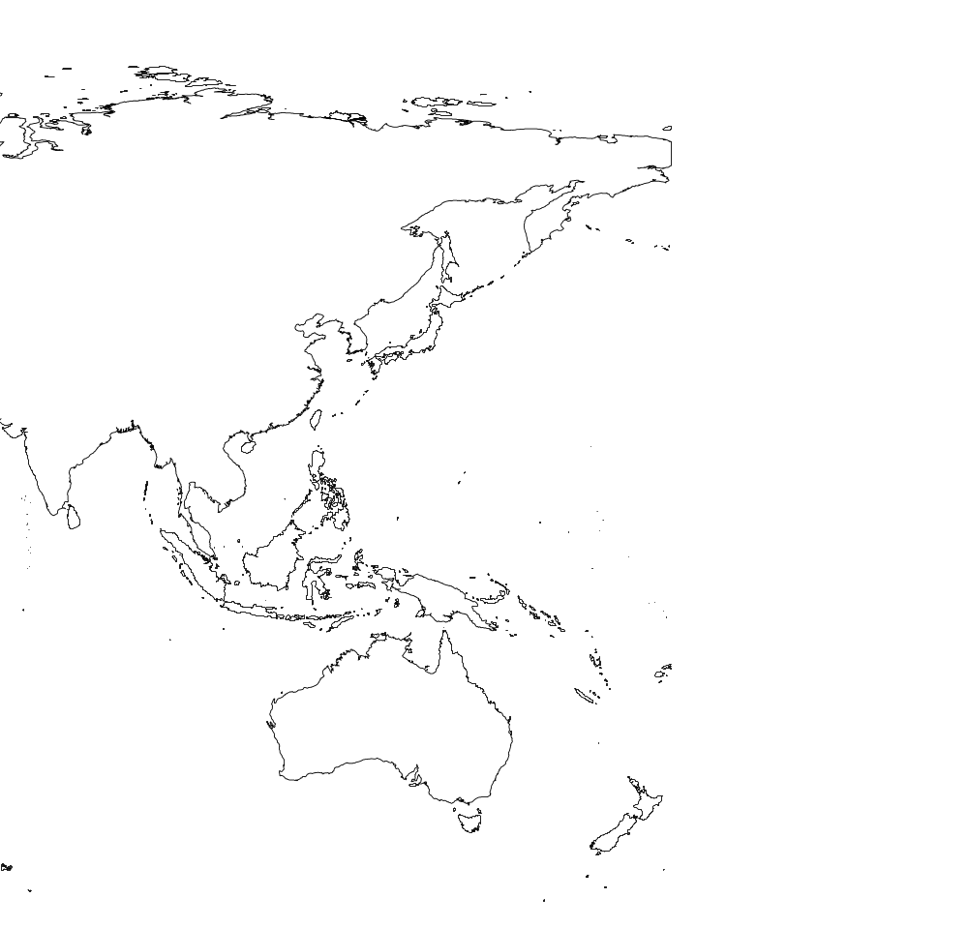
M. nudipes
M. nepalensis
M. transmorrisonensis
M. tinctorius
M. oligostachyus
M. floridulus
M. sacchariflorus
M. sinensis
M. longiberbis
M. lutarioriparius

Fig. 1.

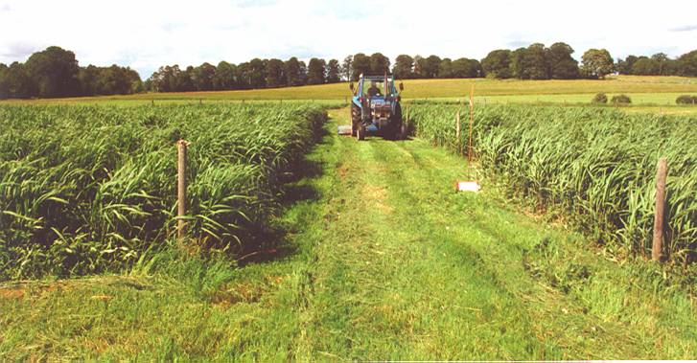
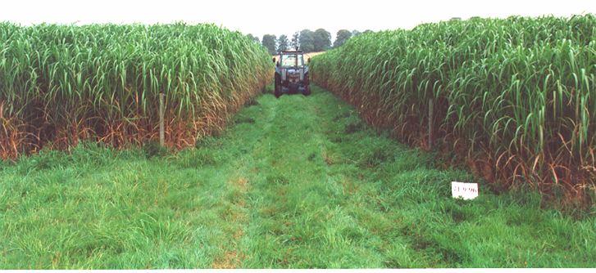
a)
b)

Fig. 2.

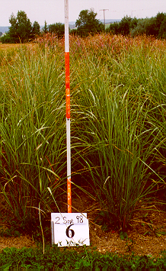
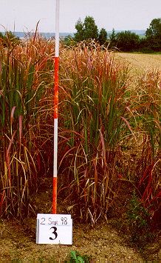
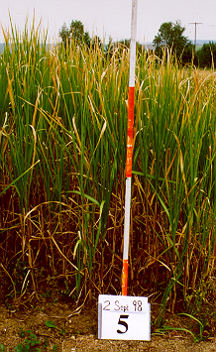
a)
b)
c)

Fig. 3.

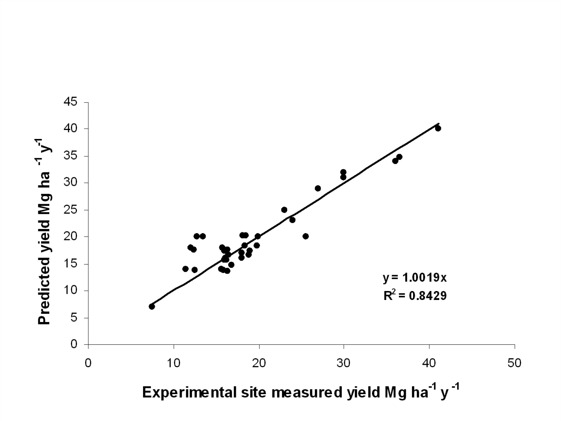
Fig. 4.

