Measuring what matters
Overview
The current research aimed to identify areas of recovery specific to Group Analytic Psychotherapy (GAT) in order to facilitate the development of a suitable patient reported outcome measure (PROM) for this therapeutic modality.
Two focus groups comprising respectively of 4 Group Analytic therapists or 4 service users were asked about components of recovery that they felt were specific to receiving GAT. Thematic Analysis (as described by Braun and Clarke, 2006) was employed to explore their views. Three overarching themes emerged from these groups: improvement in intrapsychic and interpsychic relationships; improvement in quality of life; improvement in functionality and symptom reduction. A conceptual model emerged with regards to how those themes could inform the development on a GAT specific patient reported outcome measure.
Introduction
Although GAT had been found to be efficacious in ameliorating clinical symptoms and improving psychological functioning for a number of conditions such as Eating Disorders (Athanasions 2013; Ciano et al. 2002), Personality Disorders (Lorentzen et al. 2015), Post-Traumatic Stress Disorder (Tucker and Price 2007) and Complex Grief (Kipnes et al. 2002). it is not considered to have a strong evidence base and is, hence, not a National Institute of Health and Care Excellence (NICE) approved therapy.
The relatively limited number of efficacy studies conducted so far suggest that people who have successfully completed GAT are subsequently less reliant on other mental health services and their GP as well as having sustained improvements in their functioning and symptoms (which in some cases was superior to the improvement in those who had received medication) (Conway et al. 2003; Heinzel et al. 2000; Knijnik, et al, 2008; Lorentzen et al. 2015; Mendelssohn, 2015). Lorentzen et al. (2015) also found that short-term GAT was more efficacious for sustained improvements in symptomology and functioning for those without personality disorder whereas those with personality disorder continued to improve in long-term groups. Heinzel et al. (2000) invited 979 participants to rate their improvements on a Likert scale as well as comment on their physical health, mental health, work attendance, visits to hospital and social functioning at the beginning, middle and post receiving GAT or individual therapy. They found people had significantly improved in all areas and maintained these improvements over 2 years from receiving GAT in particular.
Lorentzen, (2014) argues that despite the research interest, GAT focused studies typically used qualitative methods without following up with quantitative measures or used unsuitable or multiple PROMs in quantitative studies to capture recovery markers. As can be seen from Table 1 a plethora of outcome measures have been used in GAT studies to examine (a) change in symptoms of specific diagnoses (e.g. Shulman and Ben-Artzi, 2003); (b) internal alterations like confidence/autonomy (e.g. Barkham et al. 1996); (c) psychosocial functioning (e.g. Cooper et al. 1982) and process issues (e.g. Burlingame et al. 2018; Piper, et al. 2001). Studies have typically used at least two PROMs simultaneously and still have not captured all the multifaceted recovery outcomes from GAT (e.g. Athanassios, 2013). Some studies also used over 3 PROMs and this is also felt to be too many outcome measures to simultaneously administer, which can be fatiguing for service users and practitioners (Blackmore et al. 2012; Sales and Alves, 2016).
Accurately capturing key markers of change in GAT and measuring its’ efficacy through existing PROMs poses significant challenges due to the approach’s specific focus on structural change rather than clinical symptomatology (Hagtvet and Hoglend, 2008). It also has particular characteristics such as its group format, integrative nature and heterogeneous clinical application to consider (Billow, 2017) that can make it difficult to capture the broad range of areas in which service users recover (Blackmore et al. 2012; Schlapobersky, 2016). A further challenge is that some concepts are not as easy to conceptualise within a PROM, such as being connected and a sense of ‘belongingness’ to other group members (Friedman, 2013).
The lack of a PROM that clearly captures markers of therapeutic change in GAT has contributed to the limited number of available efficacy studies (Blackmore et al. 2012; Schlapobersky, 2016). Berghout et al. (2012) suggest further examination of interpersonal functioning which is generally slower to change than symptomology. Von Fraunhofer (2008) additionally argues that we need to look at recovery/therapeutic change indicators, such as service users becoming more mature and independent long-term. Considering the estimated cost-effectiveness of GAT (Schlapobersky, 2016) and its potential therapeutic benefits (Lorentzen, 2006; Horneland et al. 2011; Henton, 2012), the development of a stronger evidence base for GAT, and its subsequent inclusion into national practice guidelines, would be crucial in order to secure the approach’s long-term sustainability. This highlights the necessity of developing a suitable PROM that is acceptable to service users, therapists and commissioners. In order to facilitate this, nevertheless, a more in-depth understanding of how individuals improve in GAT is required. Hence, this study aims to explore what therapists and service users view as markers of therapeutic change achieved during GAT.
Method
Data was collected through the use of two focus groups: one comprising of service users and the other of therapists. Service commissioners were also invited to participate in a separate focus group but only 2 expressed an interest, which is not sufficient to proceed with a focus group (Braun and Clarke, 2013; Krueger and Casey, 2016). Focus groups were chosen because they are an ideal platform to gain an in-depth understanding of recovery/therapeutic change from subjective viewpoints (Patton, 2002). They also provide useful insights into issues pertaining to quality and are frequently used to produce measurement tools (Krueger and Casey, 2016). Although Haigh (2012) highlights the necessity of service users to be included in research, he acknowledges that there is still a power imbalance in the service user movement whereas the purpose of GAT is non-authoritarian. The replication of the non-authoritarian feel of GAT constitutes an additional reason why a focus group was chosen over individual interviews (Patton, 2002).
The focus groups were separate for the therapists and service users to reduce bias and each focus group consisted of 4 participants. It is recommended that 3-4 participants are used for focus groups where there is some expertise which could be argued for the service user and therapist groups (Braun and Clarke, 2013). Despite the small sample size, it is argued that the expertise within this group would facilitate theory saturation (Bryman, 2012). These focus groups occurred in National Health Service (NHS) settings as they were NHS service users and therapists. The therapists and service users were from separate NHS Trusts to help overcome bias.
A semi-structured interview was used for all focus groups as it allows flexibility for participants to respond (Krueger and Kasey, 2016). The principal researcher designed the semi-structured interview schedule upon consultation with their research collaborators to ensure that there were no leading questions and that they were understandable. The focus groups started by asking participants generally what they felt was important in recovery and what they felt was specific to GAT recovery. The questions were selected to have an open and varied response (Braun and Clarke, 2013). In order to enhance the trustworthiness of the study, focus group members were invited back following to check their responses (Lincoln and Guba, 1985)
Procedure:
Service users receiving GAT at a local NHS Trust were sent an invitation letter, study information sheet and an expression of interest (EoI) sheet. Participants were then contacted upon receipt of an EoI reply, asked if they had any questions and if they felt they would be interested in participating. Written consent was obtained from those who expressed a wish to participate (this was obtained upon entry to the study). The therapists also underwent this process with their relevant NHS trusts which were different trusts to the one the service users were recruited from. Due to there being a limited number of commissioners in post they were invited from all the 4 NHS Trusts used in this study. The consent form was very explicit in stating how audio recordings were kept in line with the Data Protection Act (1998) and local NHS policies as well as any published results being anonymised.
Focus groups started with designated questions from a semi-structured interview for each of the groups. All focus groups were audio recorded using an encrypted Dictaphone and transcribed. Following partaking in a relevant focus group (i.e. the one with therapists or service users) the transcribed results were analysed using inductive TA as described by Braun and Clarke (2006). Participant focus groups were then invited back to check their responses to enhance trustworthiness (Lincoln and Guba, 1985)
Data Analysis
Inductive Thematic Analysis (TA) was chosen as the method of analysis due to the exploratory nature of the research question on recovery outcomes markers for GAT (Patton, 2002). TA is a method that identifies analyses and reports patterns in data. The six stages of TA by Braun and Clarke (2006; 2013) were applied which are: becoming familiar with the data; producing initial codes; searching for themes; reviewing the themes; labelling and defining the themes and generating a thematic map of the data.
Trustworthiness
A detailed description of the analysis process in the results section has been used to enhance the transparency of how the data was analysed (Lincoln and Guba, 2000). The themes were member checked with the focus groups to enhance ownership (Lincoln and Guba, 2000). They were also triangulated with the academic supervisor for this study for trustworthiness (Jonsen and Jehn, 2009).
Ethics
This study adhered to the British Psychological Society (BPS) (2009) Code of Ethics and the Health and Care Professions Council (HCPC) (2016) Code of Ethics. Ethical clearance was granted from the NHS Research Ethics Committee. Research and Development approval was additionally granted from four NHS Trusts and University ethical clearance was granted. As described above informed, written consent was obtained from all participants (BPS, 2009; HCPC, 2016).
Findings
The 4 participants in each of service user and therapist group are referred to as Service User 1 to 4 (SU1, SU2, SU3, SU4) and Therapist 1 to 4 (T1, T2, T3, T4) respectively. They have been termed this way to orient the reader to which focus group participant the quote is from. The results were viewed from the contextualist epistemological stance; meaning that findings were embedded in objective reality whilst simultaneously accounting for the influence of social context. Three overarching themes emerged, with a total of ten sub-themes within them (please see Figure 1 below for a summary). In addition to considering the frequency of quotes to identify patterns in the data, saliency was considered. Saliency considers a quotes’ importance in advancing understanding matters in addition to its frequency (Buetow, 2010). The themes are presented in a data-driven manner reflecting the inductive approach which enabled the participants’ voices through the use of quotes, to shape the emergence of overarching themes, main themes and sub-themes.

Figure 1 Thematic map

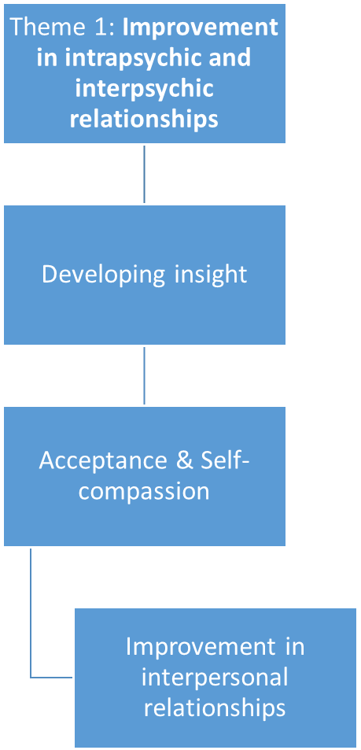

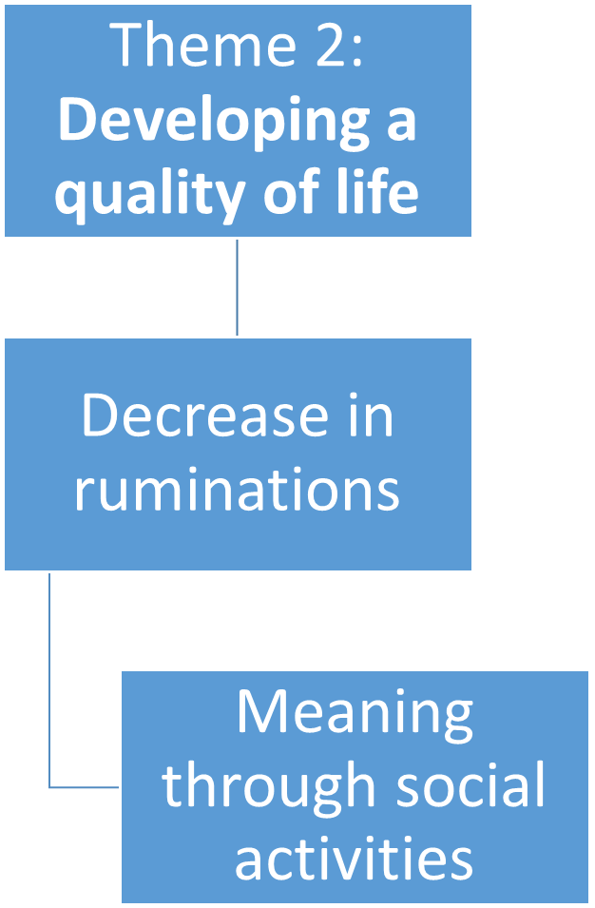

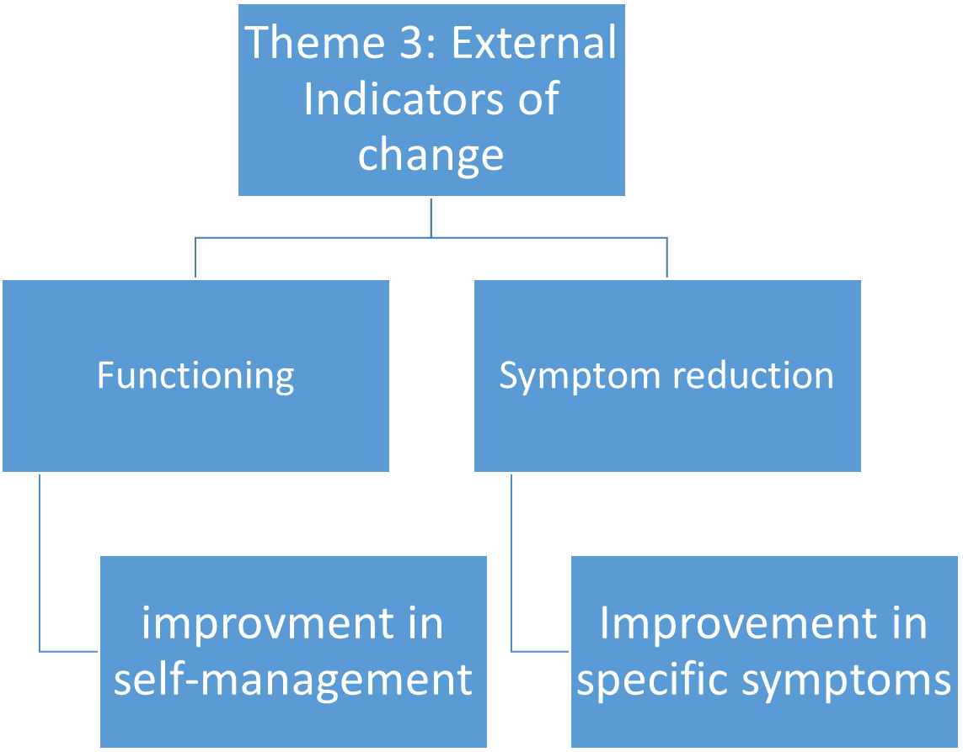

Theme 1: Improvement in intrapsychic and interpsychic relationships.
Both service users and therapists identified developing insight as being an important aspect of recovery. For service users, having insight into their strengths and weaknesses was considered to be an indication that they were developing a more holistic view of themselves. For therapists, becoming more self-aware through insight was viewed as helping service users develop a sense of agency in how they react to events that happen to them, thus, promoting therapeutic change Both groups made reference to how through the process of insight service users gained a deeper awareness of how early relationship patterns had repeated in their adult relationships and how this related to their symptoms.
“What she means by that is that actually it’s about meeting other people’s needs, not hers. So it…. is routed in a relationship…. It really is that translation of the symptom into something relational” - T2
For service users and therapists alike this sense of acceptance was considered to be an important indicator of therapeutic change with some service users identifying self-acceptance as a gradual process requiring time, thus, highlighting its development nature. Therapists further identified that service users become less self-critical and more compassionate towards themselves which they considered a positive sign of recovery.
“I feel differently about myself as a person and much more accepting and you know I think that helps me pick myself up quicker when I go right down […] Acceptance is a huge part of recovery whatever issues you’ve got really” – SU2
“Being comfortable with themselves on their own and in presence of others” - T1
Participants in both groups identified that an important outcome of GAT was helping individuals to moderate or change their responses, thinking patterns or behaviours in relation to their relationships outside of therapy.
“Managing my, my emotional response to situations and relationships and stuff like that, particularly was important in all sorts of relationships was …and sometimes learning to kind of hold back” – SU2
“I’ve started changing the way I react to my husband and that’s caused a lot less arguments in the house” - SU1
Service users also identified that managing relationships better and becoming more resilient in relationships was an important marker of change. Therapists discussed how others notice how service users have changed and how this being formally recognised can change their future interaction with others.
“Her daughters say to her “you’ve really changed mum” The older one who’s at uni said “I wish you’d been like this when I’d been at home” – T2
“Not everyone’s going to like me.. erm and you know I’m going to stop trying to please everybody” - SU2
Participants identified learning to manage relationships within the group through listening and getting support from others. Therapists discussed that service users used opportunities, made small changes and changed ingrained relational patterns by remaining to work through any difficulties in addition to learning alternative ways of managing conflict.
“Working with conflict and recovery which is very therapeutic which they can take into their lives with all their family or whoever so you know” - T3
Overall, service users highlighted in this main theme that the development of insight, acceptance and self-compassion as well as changes in external relationships was a key part of their recovery.

Theme 2: Quality of life
The theme quality of life emerged from both focus groups and was related to the increase in confidence and sense of empowerment, on the one hand, and decreases in rumination and feelings of isolation, on the other. Participants in both groups identified that an increase in quality of life provides individuals with a sense of direction enabling them to make further changes. Service users and a therapist in the follow up group identified that what constitutes good quality of might vary for each person but that a sense of meaning was a common denominator. SU3 and T3 especially emphasised the importance of meaning and the value of being with other people and social engagement.
“There are different aspects of the quality of life such as having a meaningful job, hobbies, volunteering or relationships [...] For me it’s quality of life which can vary from one person to another” – SU3
“I think it’s something about the value of being with other people and doing something with meaning ………The idea about hobbies and something that has meaning for other people I think that’s it really so choirs would fit the bill” - T3
Decreases in rumination was identified as an important indicator for an improved quality of life. Although the service user group identified that their worries still remain, these had less of an impact on them.
“I’m not in the past thinking about that and that I’m not projecting into the future, that I’m as much as possible, in the here and now” – SU4
“My worrying is still an issue but not as bad as it was” – SU1
The therapist group identified that service users developed a greater sense of belonging and purpose as a part of their recovery process.
”…… they probably don’t come in looking for belonging do they in any conscious way but that’s what everyone finds which is terribly healing in a way. And they’re looking for …..contact with other people…..relationships and ….a sense of …… belonging …..and purpose” – T3
Becoming actively involved in society and social activities and hobbies/interests was identified as important aspect of recovery in GAT. Overall, service users and therapists highlighted that work/education/volunteering arose as a component of functioning and identified this as a key to recovery; particularly roles with social components or the work activities holding personal value and meeting to service users.
“Getting into work or voluntary work or you know society is like a very important aspect of recovery isn’t it? That people often make steps along that path while they’re in the group in different ways” - T3
“So for me it was getting back to work. That happened fairly early on… – C2
Theme 3: External Indicators of change.
This overarching theme was comprised of changes in functioning and improvements in presenting issues/diagnoses. Participants discussed how they were more able to manage in various spheres such as their activities of daily living, social life/hobbies/interests and work/education as a result of receiving GAT. They also reported that they were able to be more independent from external services. Overall, participants I both groups identified functioning in work/education was a meaningful marker of recovery with T1 discussing how a service user become more independent in their activities of daily living.
“I’ve got myself showered and dressed and pots done and if that’s all I’ve done that’s great because if I couldn’t get myself out of bed before then that’s really good” – SU3
“Never having got out of home, never had a life, never having had a dog never, having claimed benefits, never having no relationships……………And today he was able to say that because he’s moved house” – T1
Changes in attitude to medication was also considered important marker of recovery/therapeutic change. This could be a reduction in medication, discontinuation of medication (approved) or being compliant with prescribed medication(s).
“For someone recovery might be not being on medication anymore but for someone else it might be actually being on medication and taking medication regularly” – SU4
“You know there’s one patient who’s doing fine in the group. Reducing Quetiapine for years and she’s now down to reducing- she’s now down to –“ – T4
“I’ve come off the heaviest medication that I was on and that I’ve accepted that I still need to take what I’m taking” – SU2
Participants in the service user group discussed managing themselves and coping as well as modifying their expectations of themselves was a component of recovery. They discussed that seeing that they were coping/managing helped them move forwards, while modifying their expectations of themselves was a sign they were moving to recovery/therapeutic change.
“Trying to manage my expectations of myself into something realistic..” – SU2
“People get offered ……how to manage being human. How can I manage being myself?” – SU1
One therapist spoke about reduction in risk taking being a sign of recovery. Service users corroborated this in their focus group identifying their self-harm and suicide risk taking behaviours had reduced since commencing GAT. This overall suggests that service users and therapists felt their risk of suicide, self- harm behaviours or behaviours that could result in being in an inpatient setting had reduced. Three service users corroborated this in their focus group as they identified that their self-harm and suicide risk taking behaviours had reduced since commencing GA.
“I was overdosing all the time in attempts to end my life and I’ve not overdosed for years now. For the most part my suicidal thoughts don’t progress into plans and stuff like that now” – SU2.

Discussion
The present study addresses Von Fraunhofer’s (2008) and Berghout et al.’s (2012) call to further explore recovery/therapeutic change indicators and markers of interpersonal functioning in GAT, hence, making an innovative contribution to the field. The findings of this study propose a conceptual framework of therapeutic changes that can be used as a guide for developing a future PROM that will accurately capture markers of therapeutic recovery/therapeutic change not only for GAT but for other interventions as well. This framework appears to consist of three interrelated components.

Component 1: Both groups identified how service users’ capacity for insight aided them in achieving therapeutic change as it helped to recognise unhelpful relational patterns. This aligns with research that demonstrates that recognition of internal relational patterns is a key aim of psychodynamically based therapies such as GAT (Lau and Kristensen, 2007; Lorentzen and Rudd, 2014). Interestingly, developing the capacity for insight appears to be related to service users developing a greater sense of acceptance towards themselves and others and becoming more self-compassionate. This aligns with research that shows that being accepting of one’s strengths and viewing oneself more holistically as opposed to either all good or all bad helped service users to engage in therapy (Tarrier, 2010) which, in turn, improves their interpersonal relationships. As such, such aspects need to be captured within an outcome measure.
Component 2: Participants discussed how developing a sense of quality of life and meaning is a key component of therapeutic change. It is argued that a quality of life provides individuals with a sense of direction which could enable them to make further external changes (Lundqvist, Svedin, Hansson & Broman, 2006; Mendelssohn, 2015). Participants discussed that learning to manage worries was a key indicator of recovery for them. They also described that it could be a sign that they are not doing as well as they were if they found their worries increased. Excessive worrying (also termed rumination) is argued to be an issue that occurs as part of many clinical conditions where thoughts are time consuming, repetitive and potentially unpleasant (Kircanski, Thompson, Sorenson, Sherdell and Gotlib, 2015). Being able to manage and/or reduce worries as part of recovery could, therefore, be argued to improve quality of life (Green and Latchford, 2012). Service users feeling more integrated in society due to feeling to possess meaning and purpose through belonging to a group, working and/or partaking in social activities is argued to be a key outcome of GAT that facilitates long-term recovery (Schlaobersky, 2016). Finally, feeling more included in society and having a sense of meaning seems to link to an improved quality of life and therapeutic progress.
Component 3: Overall, changes in daily functioning and improvements in presenting issues were identified to be key markers of change. Both focus groups identified being able to manage various components within their lives was beneficial and that being able to overcome any setbacks increased their confidence. Although participants had diverse presentations, what was interesting to note is that despite this diversity service users reported a reduction in clinical symptoms for their respective condition. Both focus groups identified that the improvement of service user’s daily functioning, reduction in medications and a developing a more compliant attitude towards their medication were important markers of therapeutic change.

As can be seem from the above, it appears that recovery/change consists of many interrelated interpersonal and intrapersonal (acceptance, insight, self-compassion and improvement is interpersonal relationships), quality of life (decreases in rumination as well as developing meaning through social activities) and external indicators of change (improved functioning in activities of daily living; improvements in presenting problems and self-management) components which can be viewed as markers of therapeutic change. The original contribution of this study is that those are areas are also identified as markers of therapeutic changes by both service users and therapists and, thus, are important components to capture in an outcome measure.
The findings of the present study, once followed up with the quantitative component for refinement purposes, can contribute to the development of a pragmatic PROM that is fit for purpose is one of the requirements for therapy studies to enter large scale studies such as RCTs (Blackmore et al. 2012; Kroenke et al. 2015); hence contribute to the development of an evidence base for GAT (Burlingame et al. 2016; Horneland et al. 2011; Kennard, 2012; Potter, 2012).
At this point it should be noted that one PROM which is currently under development is the Recovering Quality of Life (ReQoL) which is a generic recovery measure developed by service users and clinicians (Keetharuth et al. 2018). It examines areas such as hopefulness, trust and confidence and can be used by service users and clinicians (Keetharuth, et al. 2018). The present study adds to the ReQoL by further highlighting that developing insight, acceptance of self and others, self-compassion and developing as sense of meaning through social activities are also important aspects of therapeutic change and should be captured in a PROM.

References (full list available at request of authors)

Athanassios A (2013) Group analysis and eating disorders: a study of the therapeutic impact of group-analytic psychotherapy on women suffering from anorexia and bulimia nervosa. Group Analysis 46(2): 41-56.

Barkham M, Mellor-Clark, J, Connell, J, & Cahill, J (2006) A core approach to practice-based evidence: a brief history of the origins and applications of the CORE-OM and CORE system. Counselling and Psychotherapy Research 6: 3-15.

Berghout C, Zevalkink J, Katzko M and de Jong J (2012) Changes in symptoms and interpersonal problems during the first 2 years of long-term psychoanalytic psychotherapy and psychoanalysis. Psychology and Psychotherapy: Theory, Research and Practice 85(2): 203-219.

Billow R (2017) Relational Group Psychotherapy: An Overview: Part I: Foundational Principles and Practices. Group Analysis 50(1): 6-22.

Blackmore C, Tantam D, Parry G and Chambers E (2012) Report on a Systematic Review of the Efficacy and Clinical Effectiveness of Group Analysis and Analytic/Dynamic Group Psychotherapy. Group Analysis 45(1): 46-69.

Burlingame GM, Seebeck JD, Janis RA, Whitcomb KE, Barkowski S, Rosendahl J and Strauss B (2016) Outcome differences between individual and group formats when identical and nonidentical treatments, patients, and doses are compared: A 25-year meta-analytic perspective. Psychotherapy, 53(4): 446–461.

Burlingame GM, Whitcomb KE, Woodland SC, Olsen JA, Beecher M. and Gleave R, (2018) The effects of relationship and progress feedback in group psychotherapy using the Group Questionnaire and Outcome Questionnaire–45: A randomized clinical trial. Psychotherapy, 55(2): 116-121.

Ciano R, Rocco P, Angarano A, Biasin E and Balestrieri M. (2002) Group-Analytic and Psychoeducational Therapies for Binge-Eating Disorder: An Exploratory Study of Efficacy and Persistence of Effects. Psychotherapy Research 12(2): 231-239.

Conway S, Audin K, Barkham M, Mellor-Clark J and Russell S (2003) Practice-Based Evidence for a Brief Time-Intensive Multi-Modal Therapy Guided by Group-Analytic Principles and Method. Group Analysis 36(3): 413-435.

Fjeldstad A, Høglend P and Lorentzen S (2016) Presence of personality disorder moderates the long-term effects of short-term and long-term psychodynamic group therapy: A 7-year follow-up of a randomized clinical trial. Group Dynamics: Theory, Research, and Practice 20(4): 294-309.

Friedman, R (2013) Individual or Group Therapy? Indications for Optimal Therapy. Group Analysis 46(2):164-170.

Hagtvet K. and Hoglend P. (2008) Assessing Precision of Change Scores in Psychodynamic Psychotherapy: A Generalizability Theory Approach. Measurement and Evaluation in Counseling and Development 41(3): 162-178.

Haigh R. (2012) Being Economical with the Evidence. Group Analysis 45(1):70-83.

Heinzel R, Breyer F and Klein T (2000) Outpatient Psychoanalytic Individual and Group Psychotherapy in a Nationwide Catamnestic Study in Germany. Group Analysis 33(3): 353-372.

Horneland M, Børnes DS, Høbye K, Knutsen H and Lorentzen, S (2012) Can the Clinician–Researcher Gap be Bridged? Experiences from a Randomized Clinical Trial in Analytic/Dynamic Group Psychotherapy. Group Analysis 45(1): 84-98.

Keetharuth A, Brazier J, Connell J, Bjorner J, Carlton J, Taylor Buck E, Ricketts T, McKendrick K, Browne J, Croudace T, Barkham M. (2018) Recovering Quality of Life (ReQoL): a new generic self-reported outcome measure for use with people experiencing mental health difficulties. The British Journal of Psychiatry 212(1): 42-49.

Kipnes D, Piper W and Joyce A (2002) Cohesion and Outcome in Short-Term Psychodynamic Groups for Complicated Grief. International Journal of Group Psychotherapy 52(4): 483-509.

Knijnik D, Salum G, Blanco C, Moraes C, Hauck S, Mombach C, Strapasson A, Manfro G. and Eizirik C. (2008) Defense Style Changes With the Addition of Psychodynamic Group Therapy to Clonazepam in Social Anxiety Disorder. The Journal of Nervous and Mental Disease 197(7): 547-551.

Kroenke K, Monahan P and Kean J (2015) Pragmatic characteristics of patient-reported outcome measures are important for use in clinical practice. Journal of Clinical Epidemiology 68(9): 1085-1092.

Lau M and Kristensen E (2007) Outcome of systemic and analytic group psychotherapy
for adult women with history of intrafamilial childhood sexual abuse: a randomized controlled study. Acta Psychiatrica Scandinavica 116(2): 96-104.

Lorentzen S (2006) Special Section: Contemporary Challenges for Research in Group
Analysis. Group Analysis 39(3): 321-340.

Lorentzen S (2014) Group Analytic psychotherapy: Working with affective, anxiety and
personality disorders. Routledge: London.

Lorentzen S and Rudd T (2014) Group therapy in public mental health services: approaches, patients and group therapists. Journal of Psychiatric and Mental Health Nursing 21(3): 219-225.

Lorentzen S, Ruud T, Fjeldstad A and Høglend, P (2015) Personality disorder moderates outcome in short- and long-term group analytic psychotherapy: A randomized clinical trial. British Journal of Clinical Psychology 54(2): 129-146.

Lundqvist G, Svedin C, Hansson K and Broman I (2006) Group Therapy for Women Sexually Abused as Children. Journal of Interpersonal Violence 21(12): 1665-1677.

Macdonald J, Sinason V and Hollins S (2003) An interview study of people with learning disabilities' experience of, and satisfaction with, group analytic therapy. Psychology and Psychotherapy: Theory, Research and Practice 76(4): 433-453.

Mendelssohn F (2015) Universals of Treatment in Different Cultures. Some Notes on the Problems of Transcultural Group Analytic Training Programmes. Group Analysis 48(1): 61-73.

Piper WE, McCallum M, Joyce AS, Rosie JS and Ogrodniczuk JS (2001). Patient personality and time-limited group psychotherapy for complicated grief. International Journal of Group Psychotherapy 51(4): 525-552.

Potter J (2012) Research in Group Analysis: Commissioning the Systematic Review. Group Analysis 45(1): 3-14.

Sales C and Alves P (2016) Patient-centred assessment in psychotherapy: A review of individualised tools. Clinical Psychology: Science and Practice 23(3): 265-283.

Schlapobersky J (2016) From the couch to the circle - group-analytic psychotherapy in practice. London: Routledge.

Shulman S, Rozen-Zvi R, Almog Z, Fennig S and Shavit-Pesach T (2017) Effects of Group Psychotherapy on Young Adults’ Romantic and Career Functioning. Group Analysis 50(1): 70-90.

Tucker S and Price D (2007) Finding a home: group psychotherapy for traumatized
refugees and asylum seekers. European Journal of Psychotherapy and Counselling 9(3): 277-287.

von Fraunhofer N (2008) What's in it For Me?' The Development from Immature to Mature Dependence in Groups. Group Analysis 41(3): 278-290.

