Internal and near-surface electromagnetic fields for a chiral cylinder with arbitrary monochromatic illumination
Bing Yanª, Huayong Zhang^{b}, Jianyong Zhang^{c}, Renxian Li^{d}
ª School of Information and Communication Engineering, North University of China, Taiyuan 030051, Shanxi, China
^{b} School of Electronics and Information Engineering, Anhui University, Hefei, Anhui 230039, China
^{c} School of Science and Engineering, Teesside University, Middlesbrough, UK
^{d} School of Physics and Optoelectronic Engineering, Xidian University, Xi’an, 710071, China

A semi-analytical solution is proposed to the electromagnetic scattering by an infinite chiral circular cylinder with arbitrary monochromatic illumination. The scattered and internal fields are expanded in terms of appropriate cylindrical vector wave functions, and their expansion coefficients are determined by virtue of the boundary conditions and the projection method. As a demonstration of the theoretical procedure, the normalized internal and near-surface field intensity distributions are evaluated for a fundamental Gaussian beam, and the scattering properties are discussed briefly for different chirality parameters

Keywords:
Scattering; Chiral circular cylinder; Arbitrary monochromatic illumination; Normalized field intensity distribution
- Introduction
Currently, the electromagnetic (EM) properties of chiral media have been investigated extensively, to quote a few related works in [1-5]. Undoubtedly, one of the basic problems to analyze the interaction between EM waves and chiral media is to describe the EM scattering by chiral objects. Among all the studies, especially those analytical ones, a chiral cylinder is one of the most widely used theoretical models. The pioneering work has been done by Bohren on the EM plane wave scattering by an optically active cylinder [6]. Under normal illumination of a TE or TM plane wave, an efficient recursive eigenfunction solution has been presented by Kluskens et al. to a multilayered chiral circular cylinder [7]. In our recent papers, the scattering of an on-axis fundamental Gaussian beam striking an infinite chiral circular cylinder and coated chiral circular cylinder has been examined, by applying explicit EM field expansions in terms of the cylindrical vector wave functions (CVWFs) and the generalized Lorenz-Mie theory (GLMT) [8, 9]. In this paper, we will consider the general case of an arbitrary focused EM beam, and concentrate on the internal and near-surface EM fields.
The paper is organized as follows. In section 2, a semi-analytical theoretical scheme is given for calculating the scattered fields by an infinite chiral circular cylinder illuminated by an arbitrary focused EM beam. In section 3, numerical results of the normalized internal and near-surface field intensity distributions (FIDs) are presented for a fundamental Gaussian beam. Section 4 is the conclusion.
- Formulation
As schematically shown in Fig.1, an infinite chiral circular cylinder of cross section radius $r_{0}$, embedded in free space, is attached to the Cartesian coordinate system $\text{Oxyz}$. A focused EM beam propagates within the $\text{xOz}$ plane and along the positive $z^{'}$ axis in the system $O^{'}x^{'}y^{'}z^{'}$ (EM beam coordinate system). Origin $O$ is at $(0,0,z_{0})$ in $O^{'}x^{'}y^{'}z^{'}$, and the axis $O^{'}z^{'}$ has an angle $β$ with respect to the axis $\text{Oz}$. In this paper, a time dependence of $\text{exp}(−iωt)$ is assumed for the EM fields.
Fig.1. Geometry of the scattering problem
The scattered EM fields by the chiral circular cylinder can be represented in infinite series of the CVWFs of the third kind in $\text{Oxyz}$, as follows [8, 9]:
$E^{s}=E_{0}\sum_{m=−∞}^{∞}{\int{[α_{m}(ζ)m_{mλ}^{(3)}+β_{m}(ζ)n_{mλ}^{(3)}}]e^{\text{ihz}}dζ}$ (1)
$H^{s}=−{\text{iE}}_{0}\frac{1}{η_{0}}\sum_{m=−∞}^{∞}{\int{[α_{m}(ζ)n_{mλ}^{(3)}+β_{m}(ζ)m_{mλ}^{(3)}}]e^{\text{ihz}}dζ}$ (2)
where $k_{0}=ω\sqrt{μ_{0}ε_{0}}$ and $η_{0}=\sqrt{μ_{0}/ε_{0}}$ are respectively the free space wave number and characteristic impedance, and $λ=k_{0}\text{sin}ζ$, $h=k_{0}\text{cos}ζ$.
The constitutive relations for a chiral medium can be described by [8-11]
$D=ε_{0}ε_{r}E+iκ\sqrt{μ_{0}ε_{0}}H$ (3)
$B=μ_{0}μ_{r}H−iκ\sqrt{μ_{0}ε_{0}}E$ (4)
where $κ$, $ε_{r}$ and $μ_{r}$ are respectively the chirality parameter, relative permittivity and permeability of the chiral medium.
The EM fields within the chiral circular cylinder (internal fields) can be accordingly expanded into the CVWF series, in the following form [8, 9]
$E^{w}=E_{0}\sum_{m=−∞}^{∞}{\int{}}$ (5)
$H^{w}=−i\frac{E_{0}}{η}\sum_{m=−∞}^{∞}{\int{}}$ (6)
where $λ_{±}=k_{±}\sqrt{1−h^{2}/k_{±}^{2}}$, $η_{0}\sqrt{μ_{r}/ε_{r}}=η$ and $k_{±}=k_{0}(\sqrt{μ_{r}ε_{r}}±κ)$.
It should be noted that $k_{−}$ will be expressed by $k_{−}=\left|k_{−}\right|e^{iπ}$ in the following formulas and numerical experiments when it is a negative real number.
The boundary conditions require the continuity of the tangential components of the EM fields over the circular cylinder surface, which can be expressed as
$\left.\begin{matrix}\hat{r}×(E^{s}+E^{i})=\hat{r}×E^{w} \\ \hat{r}×(H^{s}+H^{i})=\hat{r}×H^{w}\end{matrix}\right\}\begin{matrix} & \text{at} & r=r_{0}\end{matrix}$ (7)
where $E^{i}$ and $H^{i}$ represent the electric and magnetic fields of the incident focused EM beam, and $\hat{r}$ is the unit outward vector to the circular cylinder surface.
Substituting Eqs. (1), (2) and Eqs. (5), (6) into Eq. (7), we can have
$\begin{aligned}\hat{r}×E_{0}\sum_{m=−∞}^{∞}{\int{[α_{m}(ζ)m_{mλ}^{(3)}+β_{m}(ζ)n_{mλ}^{(3)}}]e^{\text{ihz}}dζ}+\hat{r}×E^{i}|_{r=r_{0}} \\ =\hat{r}×E_{0}\sum_{m=−∞}^{∞}{\int{}} \\ \end{aligned}$ (8)
$\begin{aligned}\hat{r}×E_{0}\sum_{m=−∞}^{∞}{\int{[α_{m}(ζ)n_{mλ}^{(3)}+β_{m}(ζ)m_{mλ}^{(3)}}]e^{\text{ihz}}dζ}+\hat{r}×{iη}_{0}H^{i}|_{r=r_{0}} \\ =\hat{r}×\frac{η_{0}}{η}E_{0}\sum_{m=−∞}^{∞}{\int{}} \\ \end{aligned}$ (9)
If Eqs. (8) and (9) are respectively multiplied (dot product) with $\hat{z}e^{−{\text{ih}}_{1}z}e^{−im^{'}φ}$ and $\hat{φ}e^{−{\text{ih}}_{1}z}e^{−im^{'}φ}$, where $h_{1}=k_{0}\text{cos}ψ$, and then integrated over the circular cylinder surface (projection method) [11], we can obtain
$\begin{aligned}ξ\frac{d}{dξ}H_{m}^{(1)}(ξ)α_{m}(ζ)+\frac{\text{hm}}{k_{0}}H_{m}^{(1)}(ξ)β_{m}(ζ)−[ξ_{+}\frac{d}{{dξ}_{+}}J_{m}(ξ_{+})+m\frac{h}{k_{+}}J_{m}(ξ_{+})]χ_{m}(ζ) \\ −[ξ_{−}\frac{d}{{dξ}_{−}}J_{m}(ξ_{−})−m\frac{h}{k_{−}}J_{m}(ξ_{−})]τ_{m}(ζ)=(\frac{1}{2π})^{2}\frac{ξ}{E_{0}}\int{\text{dz}}\int{\hat{r}×E^{i}⋅\hat{z}e^{−\text{im}φ}e^{−\text{ihz}}dφ}\end{aligned}$ (10)
$\begin{aligned}ξ^{2}H_{m}^{(1)}(ξ)β_{m}(ζ)−\frac{k_{0}}{k_{+}}ξ_{+}^{2}J_{m}(ξ_{+})χ_{m}+\frac{k_{0}}{k_{−}}ξ_{−}^{2}J_{m}(ξ_{−})τ_{m} \\ (\frac{1}{2π})^{2}\frac{1}{E_{0}}(k_{0}r_{0})^{2}\text{sin}ζ\int{\text{dz}}\int{\hat{r}×E^{i}⋅\hat{φ}e^{−\text{im}φ}e^{−\text{ihz}}dφ}\end{aligned}$ (11) $\begin{aligned}\frac{\text{hm}}{k_{0}}H_{m}^{(1)}(ξ)α_{m}(ζ)+ξ\frac{d}{dξ}H_{m}^{(1)}(ξ)β_{m}(ζ)−\frac{η_{0}}{η}[ξ_{+}\frac{d}{{dξ}_{+}}J_{m}(ξ_{+})+m\frac{h}{k_{+}}J_{m}(ξ_{+})]χ_{m}(ζ) \\ +\frac{η_{0}}{η}[ξ_{−}\frac{d}{{dξ}_{−}}J_{m}(ξ_{−})−m\frac{h}{k_{−}}J_{m}(ξ_{−})]τ_{m}(ζ)={iη}_{0}(\frac{1}{2π})^{2}\frac{ξ}{E_{0}}\int{\text{dz}}\int{\hat{r}×H^{i}⋅\hat{z}e^{−\text{im}φ}e^{−\text{ihz}}dφ}\end{aligned}$(12)
$\begin{aligned}ξ^{2}H_{m}^{(1)}(ξ)α_{m}(ζ)−\frac{η_{0}}{η}\frac{k_{0}}{k_{+}}ξ_{+}^{2}J_{m}(ξ_{+})χ_{m}−\frac{η_{0}}{η}\frac{k_{0}}{k_{−}}ξ_{−}^{2}J_{m}(ξ_{−})τ_{m} \\ {iη}_{0}\frac{1}{E_{0}}(\frac{1}{2π})^{2}(k_{0}r_{0})^{2}\text{sin}ζ\int{\text{dz}}\int{\hat{r}×H^{i}⋅\hat{φ}e^{−\text{im}φ}e^{−\text{ihz}}dφ}\end{aligned}$ (13)
where $ξ={λr}_{0}$, and $ξ_{±}=λ_{±}r_{0}$.
The derivation of Eqs. (10)-(13) is straightforward by using the $r$, $φ$ and $z$ components of the EM fields and CVWFs, and by considering the following simple formulas
$\int{e^{i(m−m^{'})φ}dφ}=\left\{\begin{matrix}\begin{matrix}2π, & m=m^{'}\end{matrix} \\ \begin{matrix}0, & m≠m^{'}\end{matrix}\end{matrix}\right.$ (14)
$\int{e^{{\text{ik}}_{0}(\text{cos}ζ−\text{cos}ψ)z}}\text{dz}=2π\frac{δ(ψ−ζ)}{k_{0}\text{sin}ζ}$ (15)
In fact, the above theoretical procedure can be easily validated as follows. If we have the incident EM fields expanded in terms of the CVWFs as usual as in Eqs. (1), (2) of [8, 9], we can readily obtain the relations among the expansion coefficients of the incident focused EM beam, scattered and internal fields by substituting such expansions into Eqs. (10)-(13) and by using Eqs. (14), (15), which is equivalent to Eqs. (21)-(24) in [8] derived by an exact analytical solution based on the GLMT.
The unknown expansion coefficients of the scattered and internal fields $α_{m}(ζ)$, $β_{m}(ζ)$, $χ_{m}(ζ)$ and $τ_{m}(ζ)$ can be determined by solving the system consisting of Eqs. (10)-(13), for which the integrals including $E^{i}$ and $H^{i}$ ought to be numerically evaluated, e. g. by the well-known Simpson’s $1/3$ rule in our programming with MATLAB [11]. In the following calculations for a fundamental Gaussian beam, to ensure a better accuracy of convergence (three or more significant figures) we truncate the infinite integral over $z$ be setting $z=−{Nλ}_{0}$ to ${Nλ}_{0}$, where the truncation number $N$ is approximated by $\text{15}$ and $λ_{0}$ is the wavelength of the incident Gaussian beam.
3. Numerical results
In this section, we will focus on the normalized internal and near-surface FIDs, respectively defined as
${\left|E^{w}/E_{0}\right|}^{2}={\left|E_{r}^{w}\right|}^{2}+{\left|E_{φ}^{w}\right|}^{2}+{\left|E_{z}^{w}\right|}^{2}$ (16)
and
${\left|(E^{i}+E^{s})/E_{0}\right|}^{2}={\left|E_{r}^{i}+E_{r}^{s}\right|}^{2}+{\left|E_{φ}^{i}+E_{φ}^{s}\right|}^{2}+{\left|E_{z}^{i}+E_{z}^{s}\right|}^{2}$ (17)
where the subscripts $r$, $φ$ and $z$ represent the $r$, $φ$ and $z$ components of the electric fields.
As an example of numerical experiments, the normalized internal and near-surface FIDs in the $\text{xOz}$ plane are shown in Fig.2 for a chiral circular cylinder under illumination of a fundamental Gaussian beam following the Davis-Barton third-order corrected expression (see Appendix).
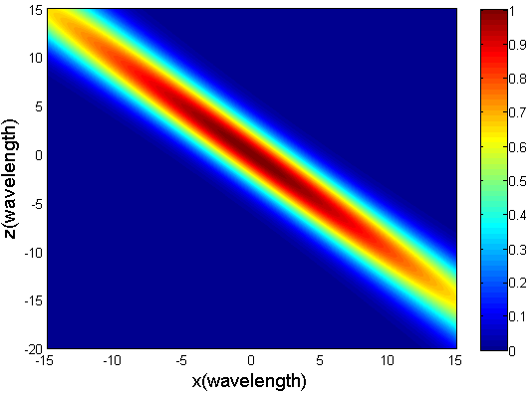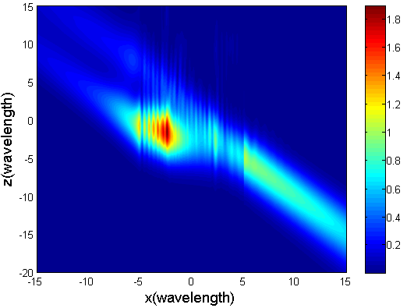
(a) (b)

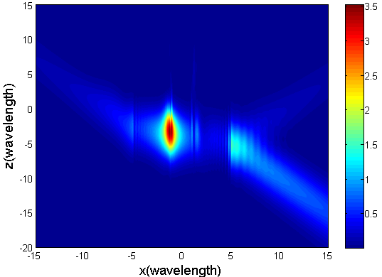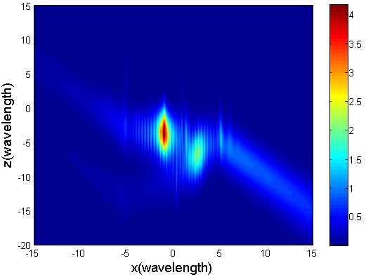

- (d)
Fig.2. Normalized internal and near-surface FIDs for a chiral circular cylinder illuminated by a ${\text{TEM}}_{\text{00}}^{(x)}$ mode Gaussian beam ($w_{0}=3λ_{0}$, $z_{0}=0$, $r_{0}=5λ_{0}$, $β=π/4$, $ε_{r}=2$, $μ_{r}=1$) (a) Gaussian beam, (b) chirality parameter $κ=0\text{.}5$, (c) $κ=2$, (d) $κ=2\text{.}5$.
In Fig. 2 (b) ($k_{±}>0$, $λ_{±}>0$), two focused beams appear due to the transmission of two eigenwaves (right–handed and left-handed Beltrami waves within the chiral medium) out of the chiral cylinder. For the chirality parameter in Fig. 2 (c) ($k_{+}>0$, $k_{−}<0$, $λ_{+}>0$), $λ_{−}$ becomes an imaginary number for $ζ=β=π/4$. As a result, the right-handed Beltrami wave corresponding to $k_{−}$ is attenuated quickly in the chiral cylinder, and only one focused beam appears for the left–handed Beltrami wave propagation. In Fig. 2 (d) ($k_{+}>0$, $k_{−}<0$, $λ_{+}>0$), $λ_{−}$ is a negative real number for $ζ=β=π/4$, and we can see that the chiral cylinder supports a negative phase-velocity (NPV) propagation.
4. Conclusion
Based on the EM field expansions in terms of the CVWFs, the boundary conditions and projection method, an approach to compute the scattering of a focused EM beam by an infinite chiral circular cylinder is given and theoretically verified. For incidence of a fundamental Gaussian beam, the normalized internal and near-surface FIDs show that, for different chirality parameters, such phenomena as the beam splitting effect, transmission attenuation and NPV propagation can be observed. In theory, this semi-analytical scheme is applicable for an arbitrary focused EM beam if its explicit descriptions are known.
Appendix
Third-order corrected expressions for the EM field components of a ${\text{TEM}}_{\text{00}}^{(x)}$ mode focused beam in $O^{'}x^{'}y^{'}z^{'}$, developed by Barton and Alexander, are written as [12-14]
$E_{x^{'}}=E_{0}[1+s^{2}({\text{iQ}}^{3}ρ^{4}−Q^{2}ρ^{2}−2Q^{2}ξ^{2})]ψ_{0}e^{iζ/s^{2}}$ (A1)
$E_{y^{'}}=−E_{0}s^{2}2Q^{2}{\text{ξηψ}}_{0}e^{iζ/s^{2}}$ (A2)
$E_{z^{'}}=E_{0}[s2Qξ+s^{3}(2{\text{iQ}}^{4}ρ^{4}ξ−6Q^{3}ρ^{2}ξ)]ψ_{0}e^{iζ/s^{2}}$ (A3)
$H_{x^{'}}=−\frac{E_{0}}{η_{0}}H_{0}s^{2}2Q^{2}{\text{ξηψ}}_{0}e^{iζ/s^{2}}$ (A4)
$H_{y^{'}}=\frac{E_{0}}{η_{0}}[1+s^{2}({\text{iQ}}^{3}ρ^{4}−Q^{2}ρ^{2}−2Q^{2}η^{2})]ψ_{0}e^{iζ/s^{2}}$ (A5)
$H_{z^{'}}=\frac{E_{0}}{η_{0}}[s2Qη+s^{3}(2{\text{iQ}}^{4}ρ^{4}η−6Q^{3}ρ^{2}η)]ψ_{0}e^{iζ/s^{2}}$ (A6)
where $ξ=x^{'}/w_{0}$, $η=y^{'}/w_{0}$, $ζ=z^{'}/({\text{kw}}_{0}^{2})$,$ρ^{2}=ξ^{2}+η^{2}$, $Q=1/(i−2ζ)$, $s=1/({\text{kw}}_{0})$ and $ψ_{0}(ξ,η,ζ)=\text{iQ}\text{exp}(−{iρ}^{2}Q)$ are the nondimensional parameters, and $w_{0}$ is the beam waist radius.
Eqs. (A1)-(A6) are for a focused EM beam having an $\text{exp}(−iωt)$ time dependence used in this paper after our careful derivation.
References
- M. Yokota, S. He, T. Takenaka, Scattering of a Hermite-Gaussian beam field by a chiral sphere, J. Opt. Soc. Am. A 18 (2001) 1681–1689.
- T. G. Mackay, A. Lakhtakia, Simultaneous negative- and positive-phase-velocity propagation in an isotropic chiral medium, Microw. Opt. Technol. Lett. 49 (2007) 1245-1245.
- M. Mackowski, L. Kolokolova, W. Sparks, T-matrix approach to calculating circular polarization of aggregates made of optically active materials, J. Quant. Spectrosc. Radiat. Transf. 112 (2011) 1726–1732.
- D. Worasawate, J. R. Mautz, E. Arvas, Electromagnetic scattering from an arbitrarily shaped three-dimensional homogeneous chiral body, IEEE Trans. Antennas Propag. 51 (2003) 1077–1084.
- A. Semichaevsky, A. Akyurtlu, D. Kern, D. H. Werner, M. G. Bray, Novel BI-FDTD Approach for the Analysis of Chiral Cylinders and Spheres, IEEE Trans. Antennas Propag. 54 (2006) 925–932.
- C. F. Bohren, Scattering of electromagnetic waves by an optically active cylinder, J. Colloid Interface Sci. 66 (1978) 105–109.
- M. S. Kluskens and E. H. Newman, Scattering by a multilayer chiral cylinder, IEEE Trans Antennas Propag 39 (1991) 91–96.
- Y. M. Zhai, H. Y. Zhang, Y. F. Sun, On-axis Gaussian beam scattering by a chiral cylinder, J. Opt. Soc. Am. A 29 (2012) 2509–2513.
- B. Yan, C. H. Liu, H. Y. Zhang, Y. Shi, Transmission of Gaussian beam through a coated chiral cylinder, Optics Communications 338 (2015) 261–264.
- Q.C. Shang, Z.S. Wu, T. Qu, Z.J. Li, L. Bai, L. Gong, Analysis of the radiation force and torque exerted on a chiral sphere by a Gaussian beam, Opt. Express 21 (2013) 8677–8688.
- W. J. Wang, Y. F. Sun, H. Y. Zhang, Scattering of arbitrarily shaped beam by a chiral object, Optics Communications 385 (2017) 54–58.
- L.W. Davis, Theory of electromagnetic beam, Phys. Rev. A 19 (1979) 1177–1179.
- J. P. Barton, D. R. Alexander, Fifth-order corrected electromagnetic field components for a fundamental Gussian beam, J. Appl. Phys. 66 (1989) 2800-2802.
- J. P. Barton, Electromagnetic-field calculations for a sphere illuminated by a higher-order Gaussian beam. I. Internal and near-field effects, Applied optics 36 (1997) 1303-1311.

