Fine-scale in situ measurement of riverbed nitrate production and consumption in an armored permeable riverbed

Katrina Lansdown^{1,2,*}, Catherine M. Heppell¹, Matteo Dossena², Sami Ullah^{3a}, A. Louise Heathwaite³, Andrew Binley³, Hao Zhang³ and Mark Trimmer^{2*}
¹ School of Geography, Queen Mary University of London, Mile End Road, London E1 4NS, England
² School of Biological and Chemical Sciences, Queen Mary University of London, Mile End Road, London E1 4NS, England
³ Lancaster Environment Centre, Lancaster University, Lancaster LA1 4YQ

*Corresponding authors: m.trimmer@qmul.ac.uk and k.lansdown@qmul.ac.uk
ª Present address: School of Physical and Geographical Sciences, Keele University, Keele ST5 5BG, England

ABSTRACT: Alteration of the global nitrogen cycle by man has increased nitrogen loading in waterways considerably, often with harmful consequences for aquatic ecosystems. Dynamic redox conditions within riverbeds support a variety of nitrogen transformations, some of which can attenuate this burden. In reality, however, assessing the importance of processes besides perhaps denitrification is difficult, due to a sparseness of data, especially in situ where sediment structure and hydrologic pathways are intact. Here we show in situ within a permeable riverbed, through injections of ¹⁵N-labelled substrates, that nitrate can either be consumed through denitrification, or produced through nitrification, at a previously unresolved fine-scale (cm). Nitrification and denitrification occupy different niches in the riverbed, with denitrification occurring across a broad chemical gradient whilst nitrification is restricted to more oxic sediments. The narrow niche width for nitrification is in effect a break point, with the switch from activity ‘on’ to activity ‘off’ regulated by interactions between subsurface chemistry and hydrology. Although maxima for denitrification and nitrification occur at opposing ends of a chemical gradient, high potential for both nitrate production and consumption can overlap when groundwater upwelling is strong.

INTRODUCTION
The anthropogenic near doubling of bioavailable fixed nitrogen (N) has undoubtedly put huge pressure on the environment,¹ particularly within the hydrosphere, where surplus N affects the ecology, quality and value of aquatic ecosystems.^{2, 3} Some fixed-N can be removed in anoxic zones within the landscape by microbial N₂ production (both denitrification,^{1, 4} the reduction of nitrate (NO₃⁻) to N₂ gas, and anaerobic ammonium oxidation (anammox)^{5, 6}). Riverbeds, with their high surface area-to-volume ratios,⁷ are recognised hotspots of N transformation.⁸
Uncertainty about the different pathways of NO₃⁻ production and consumption in the riverbed hampers efforts to upscale N dynamics from the patch to the reach and ultimately the entire catchment.^{4, 9} Very few direct measurements of riverbed nitrification, oxidation of ammonium (NH₄⁺) to NO₃⁻, exist as research has concentrated on the activity of only the superficial sediments¹⁰⁻¹³ or simply equated NO₃⁻ ‘surplus’ relative to a conservative tracer with nitrification.^{14, 15} Although denitrification has been more heavily studied, use of the acetylene block technique which inhibits nitrification, destroying any coupling between NO₃⁻ production and consumption,^{16, 17} has been wide spread.¹⁶⁻¹⁸ Further, the acetylene block assay is specific to denitrification, other pathways of nitrate consumption, e.g. dissimilatory nitrate reduction to ammonium (DNRA) or anammox are not quantified.¹⁹ Equating NO₃⁻ ‘deficit’ relative to a conservative tracer with denitrification has also been used extensively,²⁰⁻²³ ignoring all other mechanisms of NO₃⁻ attenuation as per the acetylene block technique. Neither of these methods, therefore, can accurately quantify true rates of denitrification.^{24, 25}
More recently, ¹⁵N and N₂-to-argon ratios have been employed to quantify in situ rates of denitrification^{12, 15, 26-28} but these mainly target superficial sediments,²⁹ although unlike nitrification, there are some examples of direct denitrification measurement deeper within the riverbed.³⁰⁻³² The focus on N transformations at the riverbed surface is likely because biogeochemical activity, intensified through groundwater- surface water exchange, is often restricted to these shallow sediments.³³⁻³⁵ Groundwater – surface water exchange can, however, influence sediments much deeper in the riverbed, e.g. >5cm,^{32, 36, 37} stimulating NO₃⁻ reduction particularly within groundwater-fed rivers.^{38, 39} Yet, how nitrate production and consumption is oriented along upwelling flow paths in groundwater-fed rivers is relatively unknown, compared with along horizontal flow pathways,^{15, 27} for example.
Riverbed N cycling was originally conceptualized as a mosaic of processes occurring over small spatial scales, i.e. at the scale of individual grains, denitrification, nitrification, DNRA, sorption, assimilation and N₂-fixation proceed within adjacent micro-sites of oxia and anoxia.¹⁴ Yet there are no direct measurements to support this hypothesis. The riverbed was then seen as NO₃⁻ source or sink, depending upon the balance between rates of sediment metabolism and the supply of organic matter from the river above.^{35, 40} Recent studies have shown that subsurface hydrology can also influence NO₃⁻ production and consumption, proposing that N transformations are separated by residence time along m-scale flow paths, with nitrification dominating where oxygenated surface waters enter the riverbed, and denitrification occurring further along flow pathways once oxygen has been respired.^{15, 41} Yet denitrification can be enhanced where surface water enters the riverbed,³³ suggesting that, perhaps, N dynamics could better be described by inclusion of fine-scale heterogeneity within larger scale separation of net NO₃⁻ consumption or production along flow pathways, for example.
We contend that whilst overall, the physical, chemical and microbial controls on NO₃⁻ production and consumption are largely understood, the measurement of such processes and the validation of these controls in situ in the riverbed, where both hydrologic and redox environment are intact, is severely lacking. Our objective, therefore, was to examine how physical and chemical environments within a groundwater-fed, permeable riverbed influence nitrification, denitrification and DNRA. Rather than distinct zonation of nitrate production and consumption along flow pathways, we hypothesised that fine-scale physico-chemical heterogeneity will lead to patches of nitrification and denitrification overlapping within the riverbed.

EXPERIMENTAL PROCEDURES
Study site and hydrologic setting. We conducted our study in the River Leith (Cliburn, England; Supporting Figure 1) within a 200m reach used for a larger parent project (implications of groundwater-surface water connectivity on riverbed N transformations). Here, the River Leith meanders through a narrow predominantly agricultural floodplain, where a series of riffle and pool sequences characterize the channel and sediments consist of loose gravelly alluvium overlying unconsolidated sandstone bedrock;⁴² although some sections of the riverbed are armored by cobbles and coarse gravels. Much of the reach examined is actively gaining groundwater⁴² which, although below targets set in the EU-Water Framework Directive, has higher NO₃⁻ concentrations than the river itself.⁴³ Previous research at this site had demonstrated a potential for riverbed NO₃⁻ attenuation,^{38, 43} but no in situ measurements had been attempted to date.
We selected two riffles with markedly different subsurface hydrology and redox conditions, where previous research had linked the fate of NO₃⁻ in this riverbed to its connectivity with the overlying river.^{42, 44} One riffle was characterized by strong vertical flux of groundwater towards the river (VF), whilst subsurface hydrology within the other was a mixture of horizontal (either lateral inputs from the riparian zone and/or hyporheic exchange flows) and vertical fluxes (HF-VF; Supporting Figure 1 and Supporting Table 1). Fieldwork was performed under base flow conditions (<0.1 m³ s⁻¹; see hydrograph in Supporting Figure 1) on three separate occasions, 10-13 July, 8-11 August and 11-15 September 2010, with measurements (below) repeated during each campaign. Measurement of vertical hydraulic gradients across the riffles was performed within 72 hours of push-pull measurements as part of more detailed hydrologic investigations (see ref. 42 for further information of site hydrology).
In situ measurement of riverbed nitrate consumption or production. Published technologies for quantifying N transformations in situ^{32, 45, 46} were not fit for our requirements of fine-scale depth resolution within an armored riverbed, so we developed a bespoke stainless steel mini-probe system based upon the design of ref. 45. Each probe is comprised of a needle (Stainless Tube & Needle Co. Ltd., UK) within stainless steel pipe, with a luer-lock connection screwed into the top of the assembly (Figure 1a). The needle terminates in the middle of a 1cm screened interval, inside which a coarse filter (glass-fiber wadding) prevents blockage. Dead volume of each probe is ~0.2mL. Probes were inserted into the riverbed either by hand or with a mallet and rod, with an attachment that protected the luer-lock connection. Probes were inserted through a collar placed on the sediment surface and secured at different depths by wing-nuts. Four collars surrounding piezometer nests used for measurement of hydraulic gradients⁴² were installed within each hydrologic setting. Interference from neighboring probes was avoided by arranging the probes so that their vertical separation was greater than the resolution of the measurement (probe spacing was ≥8cm; measurement resolution was ± ~2cm, see Results). We also performed measurements in three stages, probes <10cm, probes <20cm and finally probes >20cm, as the direction of subsurface flow was predominantly upwelling.
Prior to the injection of ¹⁵N (see below) a sample of porewater was collected by syringe⁴⁵ to measure background concentrations of NO₃⁻ and NO₂⁻ (NO_{χ}⁻), NH₄⁺, chloride and sulphate, as well as the natural abundance ¹⁵N content of N₂, NO_{χ}⁻, and NH₄⁺. Porewater for ion analysis was preserved by filtering (0.2μm polypropylene membrane, VWR International, UK) and freezing for later chemical analysis (see below). Porewater for ¹⁵N-N₂ analysis was gently transferred to small gas-tight vials (750µL, Chromacol, UK) and bacterial activity inhibited by addition of zinc chloride (25µL, 7 mol L⁻¹). We also measured ambient dissolved oxygen (O₂) concentration, pH and temperature. Oxygen measurements were performed with a calibrated, fast response micro-electrode (50µm, Unisense, Denmark). Temperature and pH were measured with a VWR-100 pH meter. Porewater was slowly transferred via a three-way stop cock from the collection syringe into an open syringe barrel containing the O₂ electrode or pH probe. We determined the amount of O₂ contamination that occurred during sample transfer to be approximately 10 µmol L⁻¹, and corrected all measured O₂ concentrations accordingly. ⁴⁷
Rates of denitrification, DNRA and nitrification were quantified through injection of 15mL of ¹⁵N-labelled NO₃⁻ or NH₄⁺ at cm-resolution from 3 to 40 cm depth in the riverbed using a syringe. The injection phase lasted < 30 seconds per probe. For denitrification and DNRA measurements, the tracer solution contained ¹⁵NO₃⁻ (98 atom % ¹⁵N, Sigma Aldrich) at the same concentration as ambient porewater ¹⁴NO₃⁻ and was bubbled with oxygen-free nitrogen gas to mimic ambient O₂ conditions. Here, the porewaters are high in ¹⁴NO₃⁻, so to avoid increasing the NO₃⁻ concentration further at the ¹⁵N-labelling required to distinguish denitrification from anammox (¹⁵NO₃⁻:¹⁴NO₃⁻>~0.6, see ref. 47 ), we used artificial river water⁴⁸ as the matrix for the tracer solution. The artificial river water was tailored to match the major ion chemistry of the River Leith but contained additional KCl (final concentration of ~4 mmol L⁻¹) for determination of tracer loss by advective flow. For nitrification measurements, the tracer deliberately contained a higher concentration of NH₄⁺ than most ambient porewater (median NH₄⁺ concentration = 3 μmol L⁻¹, maximum = 207 μmol L⁻¹ see Table 1 cf. 120 μmol L⁻¹ of 98 atom % ¹⁵N (Sigma Aldrich) in the tracer) to prevent NH₄⁺ limitation and to provide a detectable signal against the high-background of NO₃⁻. As a result, our measurements reflect the potential of different patches in the riverbed to nitrify and the prevailing ambient conditions that maintain that potential in situ. Porewater samples (5mL) were collected using a luer-lock syringe immediately after tracer injection and over time for a maximum duration of 2h for each experiment (n=4). The recovered porewaters were analysed for production of ¹⁵N-N₂ (denitrification), ¹⁵N-NH₄⁺ (DNRA) or ¹⁵N-NO_{χ}⁻ (nitrification) and chloride concentration.
Laboratory analyses. For gas analysis, a helium headspace was introduced to the gas-tight vials and, after equilibration, the ¹⁵N-N₂ content determined by mass spectrometry (Finnigan MAT DeltaPlus; Thermo-Finnigan).⁴⁷ The mass spectrometer was calibrated with N₂ in a helium headspace added to air-equilibrated water at 22°C and the mass charge ratios for m/z 28, m/z 29, and m/z 30 (²⁸N₂, ²⁹N₂, and ³⁰N₂) were measured.⁴⁷ Precision as a coefficient of variation was better than 1%. The ¹⁵N-NH₄⁺ content of samples was determined as ¹⁵N-N₂ (as above) following micro-diffusion and hypobromite oxidation of NH₃.⁴⁹ The ¹⁵N-NO_{χ}⁻ content of the samples was determined as ¹⁵N-N₂ (as above) following reduction of NO₃⁻ to NO₂⁻ with cadmium and treatment with sulfamic acid, adapted from ref. 50. For nitrification and DNRA measurements, standards of varying ¹⁵N atom % of NO₃⁻ or NH₄⁺, respectively, were used for calibration.
Nitrate, chloride and sulphate concentrations were determined through Ion Chromatography (Dionex ICS2500, USA). The detection limit and precision was 3 µmol L⁻¹ ± 3%, 2 µmol L⁻¹ ± 1%, and 5 µmol L⁻¹ ± 1% for NO₃⁻, chloride and sulphate, respectively. Ammonium and NO₂⁻ were measured using a segmented flow auto analyser (Skalar San⁺⁺, Breda, The Netherlands) and standard colorimetric techniques, with a detection limit and precision of 0.3 µmol L⁻¹ ± 5% for NH₄⁺ and 0.1 μmol L⁻¹ ± 1% for NO₂⁻.
Rate calculation. As the ¹⁵N tracer freely mixed with ambient ¹⁴NO₃⁻ we measured denitrification by the production of both ²⁹N₂ and ³⁰N₂. The effect of anammox on the production of ²⁹N₂ was ignored as there was little evidence of anammox activity in previous laboratory experiments with recovered sediments³⁸ and parallel measurements, in the larger piezometer network, revealed no difference in the distribution of ¹⁵N in either the N₂O or N₂ pool.⁴⁷ Production of ²⁹N₂ or ³⁰N₂ was quantified as excess above natural abundance, adapted from ref. 51:
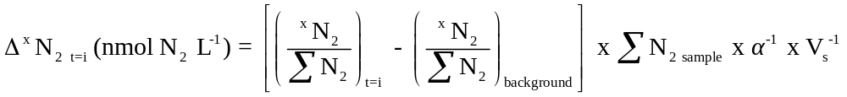 (1)
where Δ^{x}N₂ is the amount of excess ²⁹N₂ or ³⁰N₂ in the recovered porewater at time=i; ^{x}N₂/ ΣN₂ represents the ratio of the ²⁹N₂ or ³⁰N₂ mass spectrometer signal to the total N₂ signal (ΣN₂ = ²⁸N₂ + ²⁹N₂ + ³⁰N₂) for either time series or background samples; α is the calibration factor (signal: nmol N₂ vial⁻¹); and V_{s} is the volume of porewater in the gas-tight vial (L vial⁻¹). ‘Excess’ concentrations of ²⁹N₂ and ³⁰N₂ in the tracer solution were also calculated via Eq. 1 (where t=i is the tracer) to allow correction for loss through advective flow as follows:⁵²
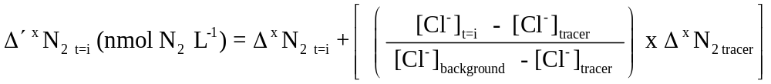 (2)
where: Δ′ ^{x}N₂ is the concentration of ²⁹N₂ or ³⁰N₂ at time=i corrected for the loss of ¹⁵NO₃⁻ tracer or ¹⁵N labelled products via advective flow; Δ ^{x}N₂ _{t=i} and Δ ^{x}N₂ tracer are the excess of concentration of ²⁹N₂ or ³⁰N₂ calculated from Eq. 1 in the time series samples and tracer solution, respectively; and [Cl⁻] is the concentration of chloride in the tracer solution (tracer), ambient porewater (background), and porewater collected over time following the injection of ¹⁵N (t=i).
The rate of ²⁹N₂ and ³⁰N₂ production (p²⁹N₂ or p³⁰N₂) was calculated by linear regression of Δ′ ^{x}N₂ t=i against time. Rates of denitrification, DNRA or nitrification were calculated according to ref. 53:
(3)
where N₂ for DNRA or nitrification measurements comes from the chemical oxidation of ¹⁵NH₄⁺ or ¹⁵NO_{χ}⁻ to N₂ prior to analysis (as above).
Statistical analysis. All statistics were performed in R.⁵⁴ We used scatterplots for an initial inspection of the potential explanatory variables of denitrification and nitrification in the riverbed and then principal component analysis (PCA) to generate a simpler, smaller subset of variables⁵⁵ for use in both further graphical and statistical (linear and non-linear regression) exploration (see Supporting Information for a full and detailed explanation).

RESULTS
Porewater chemistry and velocity. On average, the riverbed concentration of NO₃⁻ was higher than that in the overlying surface water and tended to be even greater when groundwater upwelling was strong (Table 1). Ammonium concentrations were low in the surface water and riverbed where groundwater upwells, e.g. < 2 µmol L⁻¹, but porewater often contained >10µmol L⁻¹ ammonium. The riverbed was generally under-saturated in O₂ (average ± standard deviation = 37±26 %). Depth profiles of chloride indicated that the surface downwelling was restricted to <5cm where groundwater upwelling was strong, but could influence deeper sediments (< ~12cm) where porewater flow consisted of both horizontal and vertical water fluxes (Figure 2a,b).
In the initial exploration of the relationships between denitrification and nitrification with all measured variables, nitrite concentrations were typically at or below the limit of detection (<0.1µmol L⁻¹) and pH, chloride and sulphate blocked data into the two hydrologic settings. As a result, NO₃⁻, NH₄⁺, ΔO₂, depth and porewater velocity (estimated through the decay of tracer-chloride concentrations over time, see Figure 1c) were selected for use in the PCA. Here, ΔO₂ represents the amount of O₂ consumed and is calculated as:
ΔO₂ (μmol L⁻¹) = Measured O₂ (μmol L⁻¹) – Air equilibrated O₂ (μmol L⁻¹) (4)
where air-equilibrated O₂ is that at ambient temperature and pressure. The PCA reduced the number of explanatory variables to two principal components which, together, explained 71% of the variance in the dataset (Supporting Table 2). Chemical parameters (NH₄⁺, ΔO₂, NO₃⁻) loaded strongly onto the first principal component, whereas physical factors (depth, porewater velocity) loaded strongly onto the second. As such, we took the principal components to represent either a chemical or physical gradient, with low scores on each representing either an accumulation of NH₄⁺ and consumption of NO₃⁻ and O₂, or deep sediments with slow porewater velocity, respectively.
Where subsurface hydrology was dominated by strong vertical upwelling, the chemical gradient was narrower (range = -0.8 to 2.2; Figure 2c). In contrast, the chemical gradient was more variable within the HF-VF setting (range = -4.9 to 1.0; Figure 2c); particularly within top 15cm where, although scores were lower, on average, almost the entire range was found. There was little difference in porewater velocity between the two hydrologic settings (VF and HF-VF; Table 1) and, as depth of sediments examined did not vary, there was no difference in their physical gradient scores .
Measurement resolution and tracer dilution. Tracer injected into the riverbed was diluted by ambient porewater, such that the composition of the ‘sphere of influence’ was 81% tracer and 19% ambient porewater, on average, at the start of the push-pull measurement. Accordingly, each tracer injection influenced approximately 50 cm³ of sediment (s.d. = 10cm³) and, assuming a sediment porosity of 0.35 (unconsolidated sandstone), the vertical resolution of each measurement was ~2.3cm. Chloride elevated through the injection of the tracer returned to ambient levels within 2-3h (Figure 1c). There was no consistent difference between the N₂ concentration or isotopic composition of the background porewater samples and the deoxygenated tracer solution (see Supporting Figure 2).
In situ measurement of riverbed nitrate consumption or production. Denitrification was the major pathway of NO₃⁻ consumption, peaking at 1828 nmol ¹⁵N-N₂ L⁻¹ h⁻¹ (median = 231 nmol ¹⁵N-N₂ L⁻¹ h⁻¹, n=138; Figure 2d). Surprisingly, the potential for nitrification was also very high (0-8497 nmol ¹⁵N-NO_{x}⁻ L⁻¹ h⁻¹, median = 1581 nmol ¹⁵N-NO_{x}⁻ L⁻¹ h⁻¹, n =137; Figure 2e,f). We observed the potential for both the production and consumption of NO₃⁻ within the same volume of sediment, with positive results for both denitrification and nitrification in 93% of our measurements (Figure 3). Although active, the potential to reduce NO₃⁻ via DNRA was not as strong as denitrification or nitrification, reaching 181 nmol ¹⁵N-NH₄⁺ L⁻¹ h⁻¹ (median = 3 nmol ¹⁵N-NH₄⁺ L⁻¹ h⁻¹) and as only a subset of samples were quantified (n=63), it is not considered further.
In a simple sense, the rate of denitrification decreased with depth in the riverbed (Figure 2d). In contrast to denitrification, the potential for nitrification decayed with depth in the riverbed only when groundwater upwelling was dominant (Figure 2e). In the presence of both horizontal and vertical water fluxes, nitrification potential was highest at 15-20cm below the sediment surface (Figure 2f). Beyond the initial, simple relationship with depth (Akaike Information Criterion, AIC, of 1961.2), denitrification could better be described as a linear function of porewater chemistry and physical characteristics (AIC=1814.8 see Supporting Table 3). Fastest rates of denitrification were associated with low chemical scores and high physical scores (reduced chemical conditions and shallow sediments with fast porewater velocity, respectively) regardless of subsurface hydrologic setting (Figure 4a,b). In contrast to the relatively simple behaviour observed for denitrification, the relationship between nitrification and the riverbed chemical gradient was far more complex. Within sediments characterized by both horizontal and vertical water flux, nitrification increased as porewaters became more oxidized whilst, under strong groundwater upwelling, nitrification potential increased as porewaters became more reduced (i.e. a positive and negative relationship with chemical gradient score, respectively; Table 2). There was, in effect, a chemical ‘breakpoint’ below which nitrification potential was effectively nil (Figure 4c). Nitrification only varied significantly with riverbed physical gradients under strong groundwater upwelling, with highest activity observed in shallow sediments with fast porewater velocity (Figure 4d); though there are exceptions to the model.

DISCUSSION
Biogeochemical insight at a new resolution. Here we have revealed for the first time, within an armored, permeable riverbed, the fine-scale patterns of both nitrate consumption and its production through denitrification and nitrification, respectively. Direct measurement of nitrification potential within sediments below the bed surface is, to our knowledge, the first of its kind. Previous subsurface denitrification measurements have either involved large volumes of sediment >10L,^{32, 56} lacked depth resolution,³¹ or focussed solely on horizontal flow pathways¹⁵ or fine sediments below macrophytes.⁴⁵ Consideration of both NO₃⁻ production and multiple pathways of NO₃⁻ consumption builds upon the conceptual model of NO₃⁻ dynamics presented in ref. 39.
We are confident that we were able to truly measure nitrification, denitrification and DNRA as, except where rates were 0 (n=4, 6 and 17, respectively), ¹⁵N enrichment in the product of the reaction was always in excess of the precision of the mass spectrometer (0.1‰ in delta notation, also see Figure 1d). Also the sequential injections of ¹⁵NO₃⁻ followed by ¹⁵NH₄⁺ did not affect our results as porewater chemistry returned to ambient conditions within ~3h, whilst ~24h separated these measurements. Further, mixing of native porewater with the injected tracer allowed investigation of N cycling under conditions approaching those that would occur naturally in the riverbed. If the injection of the tracer had destroyed ambient chemistry, then there would be no structure to, or variation in, the nitrification and denitrification activity, which was clearly not the case (Figure 2d-f and Figure 4). Through measurement of nitrification and denitrification at multiple depths we have captured a gradient of riverbed physico-chemical conditions within which there was overlap between the two processes, but also a marked difference in niche width for each process.
Fine-scale controls on riverbed nitrate production and consumption. Denitrification occupied a broad niche in the riverbed, with maximum activity in reduced shallow sediments with fast porewater velocity (Figure 4a,b). In contrast, nitrification exhibited clear breakpoint⁵⁷ ‘on’ or ‘off’ behaviour and, overall, its potential niche was narrower (Figure 4c,d). For denitrification it is, perhaps, not surprising that its activity was enhanced at the reduced end of the chemical gradient,^{15, 19, 39, 58} but of greater interest were the substantial rates of denitrification we measured in seemingly well oxygenated sediments (chemical gradient = -0.2 to +2.2 in this study, but also see refs. 33 and 59). For example, even when the concentration of oxygen in the porewater was more than 200 µmol L⁻¹ O₂ (~60% of air-saturation), denitrification could still be measured at up to 652 nmol ¹⁵N-N₂ L⁻¹ h⁻¹ (median = 154 nmol ¹⁵N-N₂ L⁻¹ h⁻¹, n=32). The concentration of NO₃⁻ within the riverbed was predominantly in excess of that considered limiting for denitrification (median = 456 µmol L⁻¹ cf. 70-285 µmol L⁻¹ ref. 60). Hence, denitrification activity here either implied that the denitrifiers were selectively consuming NO₃⁻ in the presence of O₂, i.e. ‘obligate denitrifiers’,⁶¹ or that their activity was confined to anoxic microsites^{14, 33, 59} – whose structure, if present, remained hidden, even at the resolution captured here (± ~2cm).
For nitrification potential we suggest that the limited niche of activity within a permeable riverbed represents the fine balance between, on the one hand, the supply of O₂ and NH₄⁺ or its precursor organic substrates, and, on the other, the ultimate depletion of O₂ due to direct oxidation or ammonification of those very substrates; here modelled as a bell-shaped curve in Figure 4c. Outside of the niche for nitrification, activity is constrained by substrate availability, when the chemical environment was more reduced than the niche for nitrification (chemical gradient < -1.2, n = 23), activity was inhibited, not by the availability of NH₄⁺, but by a lack of O₂^{59, 62} (see Supporting Figure 3). In contrast, when the chemical environment approached the upper limit of the niche for nitrification (chemical gradient >2), the decrease in nitrification potential likely resulted from lower ambient NH₄⁺concentrations. This latter scenario would, in effect, represent conditions out of the riverbed, i.e. those in the overlying water, where limited residence time would restrict ammonification.
Spatial distribution of nitrate production and consumption within groundwater-fed streams. Overall, rates of denitrification and nitrification decreased with depth in the riverbed, although depth alone was not a good predictor of activity (Figure 2d-f). Inherent within the spread of depths examined are gradients in porewater chemistry and velocity which ultimately drive the relationship between either nitrification or denitrification and depth. Within gaining reaches, deep sediments and upwelling groundwater are often low in bioavailable organic carbon.³⁹ Accordingly, downwelling of surface water likely dominates the supply of bioavailable organic carbon to the subsurface, fuelling aerobic respiration and, subsequently, processes such as denitrification.^{33, 39} Previous laboratory based experiments with sediments recovered from along our study reach showed denitrification to be heterotrophic but limited by the supply of bioavailable carbon.³⁸ Here, the decrease of in situ rates of denitrification with depth could also be explained if denitrification was reliant upon supply of organic carbon from the river above.
As for denitrification, decay in nitrification potential with depth would be expected within a permeable bed, because activity will depend upon a supply of ammonium, or its precursor organic substrates, derived from the river above or other allochthonous sources (e.g. the riparian zone).^{33, 40} This nitrification-depth relationship was true where groundwater upwelling was strong but where the riverbed was characterized by a mix of horizontal and vertical water fluxes, nitrification potential peaked, not at the riverbed surface, but at ~15cm depth, just below the depth of surface water downwelling (see Figure 2 and also ref. 42 where ‘Site C’ is HF-VF in this paper). Here we suggest that horizontal flows arising from hyporheic exchange, or the riparian zone ^{42, 44}, create heterogeneous chemical environments within the porewater (Figure 2c) by supplying bioavailable organic carbon to the upper riverbed. Furthermore, it would appear that ammonification within these shallow sediments generates NH₄⁺ (porewater concentrations are greater than both upwelling groundwater and surface water concentrations) at the expense of O₂; inhibiting nitrification, but creating conditions that stimulate denitrification if sufficient NO₃⁻ is available. It is not until these reduced porewaters, with their accumulated NH₄⁺, interact with upwelling, oxygenated groundwater, that nitrification can proceed.^{59, 62} As a consequence of this, patches of maximum NO₃⁻ production and consumption are spatially distinct within the riverbed (Figure 2d,f).⁶⁰ When groundwater upwelling was strong, however, patches of maximum NO₃⁻ production and consumption could overlap, as here, development of chemical gradients within the porewater was likely hampered by the restricted ingress of surface water which would ultimately limit the supply of precursor substrates.
Up-scaling patch-scale measurements. We have focussed on processes at the patch-scale, however conversion of our denitrification rates per volume of porewater to areal units (i.e. integration of activity from 3-40cm) compare very favourably with reach-scale measurements in similar streams (median = 80 μmol N-N₂ m⁻² h⁻¹ for this study cf. agricultural streams in ref. 28, median = 60 μmol N m⁻² h⁻¹). It would appear that our approach which required <£5 of ¹⁵NO₃⁻ for 138 measurements could be up-scaled to an areal rate, which in the example cited above would require application of >£400,000 of ¹⁵NO₃⁻ for one denitrification rate. As with any such extrapolation of data, up-scaling from the patch to reach-scale should be undertaken with caution, however £100,000’s for a single measurement is prohibitive to routine research programmes.⁶³ In addition, working at the finer patch-scale has highlighted that N cycling in a permeable riverbed is heterogeneous at the cm-scale, and such complexity should be incorporated into conceptual understanding of nitrogen dynamics, as well as future research.

SUPPORTING INFORMATION AVAILABLE
The location of the field site and a conceptual model of the hydrologic settings; additional data supporting the described relationships between nitrification and its substrates; plus a full description of the statistical analyses are provided as supporting information. This information is available free of charge via the internet at http://pubs.acs.org.

ACKNOWLEDGEMENTS
We thank Ian Sanders for his assistance with the design and manufacture of the mini-probe system used in this research and Bo Thamdrup for suggesting the method of NOx to N₂ conversion. This work was funded by a Natural Environment Research Council grant awarded to Lancaster University (NE/F006063/1) and Queen Mary University of London (NE/F004753/1). We acknowledge the Eden Rivers Trust and Lowther Estates in facilitating access to the site, the Environment Agency (England & Wales) in giving consent to establishing the experimental set-up in the river , and Lancaster University for installing and maintaining the physical hydrology instrumentation in the river. MD acknowledges the AXA Research Fund for financial support. The comments from two anonymous reviewers have helped strengthen this manuscript.

REFERENCES
1. Galloway, J. N.; Dentener, F. J.; Capone, D. G.; Boyer, E. W.; Howarth, R. W.; Seitzinger, S. P.; Asner, G. P.; Cleveland, C. C.; Green, P. A.; Holland, E. A.; Karl, D. M.; Michaels, A. F.; Porter, J. H.; Townsend, A. R.; Vörösmarty, C. J. Nitrogen cycles: past, present, and future. Biogeochemistry 2004, 70, 153 - 226.
2. Dodds, W. K.; Bouska, W. W.; Eitzmann, J. L.; Pilger, T. J.; Pitts, K. L.; Riley, A. J.; Schloesser, J. T.; Thornbrugh, D. J. Eutrophication of U.S. Freshwaters: Analysis of potential economic damages. Environ. Sci. Technol. 2009, 43 (1), 12 - 19.
3. Carmargo, J. A.; Alonso, A. Ecological and toxicological effects of inorganic nitrogen pollution in aquatic ecosystems: A global assessment. Environ. Int. 2006, 32 (6), 831 - 849.
4. Seitzinger, S.; Harrison, J. A.; Böhlke, J. K.; Bouwman, A. F.; Lowrance, R.; Peterson, B.; Tobias, C.; Drecht, G. V. Denitrification across landscapes and waterscapes: A synthesis. Ecol. Appl. 2006, 16 (6), 2064-2090.
5. Thamdrup, B. New Pathways and Processes in the Global Nitrogen Cycle. Annu. Rev. Eco. Evol. S. 2012, 43 (1), 407-428.
6. Francis, C. A.; Beman, J. M.; Kuypers, M. M. New processes and players in the nitrogen cycle: the microbial ecology of anaerobic and archaeal ammonia oxidation. ISME J. 2007, 1 (1), 19-27.
7. Peterson, B. J.; Wollheim, W. M.; Mulholland, P. J.; Webster, J. R.; Meyer, J. L.; Tank, J. L.; Marti, E.; Bowden, W. B.; Valett, H. M.; Hershey, A. E.; McDowell, W. H.; Dodds, W. K.; Hamilton, S. K.; Gregory, S.; Morrall, D. D. Control of nitrogen export from watersheds by headwater streams. Science 2001, 292, 86 - 90.
8. McClain, M. E.; Boyer, E. W.; Dent, C. L.; Gergel, S. E.; Grimm, N. B.; Groffman, P. M.; Hart, S. C.; Harvey, J. W.; Johnston, C. A.; Mayorga, E.; McDowell, W. H.; Pinay, G. Biogeochemical hot spots and hot moments at the interface of terrestrial and aquatic ecosystems. Ecosystems 2003, 6 (4), 301-312.
9. Boulton, A. J.; Datry, T.; Kasahara, T.; Mutz, M.; Stanford, J. A. Ecology and management of the hyporheic zone: Stream–groundwater interactions of running waters and their floodplains. J. N. Am. Benthol. Soc. 2010, 29 (1), 26 - 40.
10. Webster, J. R.; Mulholland, P. J.; Tank, J. L.; Valett, H. M.; Dodds, W. K.; Peterson, B. J.; Bowden, W. B.; Dahm, C. N.; Findlay, S.; Gregory, S. V.; Grimm, N. B.; Hamilton, S. K.; Johnson, S. L.; Martí, E.; McDowell, W. H.; Meyer, J. L.; Morrall, D. D.; Thomas, S. A.; Wollheim, W. M. Factors affecting ammonium uptake in stream - an inter-biome perspective. Freshwater Biol. 2003, 43 (8), 1329 - 1352.
11. Mulholland, P. J.; Tank, J. L.; Sanzone, D. M.; Wollheim, W. M.; Peterson, B. J.; Webster, J. R.; Meyer, J. L. Nitrogen cycling in a forest stream determined by a ¹⁵N tracer addition. Ecol. Monogr. 2000, 70 (3), 471 - 493.
12. Dodds, W. K.; Beaulieu, J. J.; Eichmiller, J. J.; Fischer, J. R.; Franssen, N. R.; Gudder, D. A.; Makinster, A. S.; McCarthy, M. J.; Murdock, J. N.; O'Brien, J. M.; Tank, J. L.; Sheibley, R. W. Nitrogen cycling and metabolism in the thalweg of a prairie river. J. Geophys. Res.-Biogeo. 2008, 113, G04029.
13. Hamilton, S. K.; Tank, J. L.; Raikow, D. F.; Wollheim, W. M.; Peterson, B. J.; Webster, J. R. Nitrogen uptake and transformation in a mid western U.S. stream: A stable isotope enrichment study. Biogeochemistry 2001, 54, 297 - 340.
14. Triska, F. J.; Duff, J. H.; Avanzino, R. J. The role of water exchange between a stream channel and its hyporheic zone in nitrogen cycling at the terrestrial aquatic interface. Hydrobiologia 1993, 251 (1-3), 167 - 184.
15. Zarnetske, J. P.; Haggerty, R.; Wondzell, S.; Baker, M. A. Dynamics of nitrate production and removal as a function of residence time in the hyporheic zone. J. Geophys. Res.-Biogeo. 2011, 116, G01025.
16. Duff, J. H.; Triska, F. J. Denitrification in sediments from the hyporheic zone adjacent to a small forested stream. Can. J. Fish. Aquat. Sci. 1990, 47 (6), 1140-1147.
17. Baker, M. A.; Vervier, P. Hydrological variability, organic matter supply and denitrification in the Garonne River ecosystem. Freshwater Biol. 2004, 49 (2), 181 -190.
18. Pinay, G.; O'Keefe, T. C.; Edwards, R. T.; Naiman, R. J. Nitrate removal in the hyporheic zone of a salmon river in Alaska. River Res. Appl. 2009, 25 (4), 367-375.
19. Burgin, A. J.; Hamilton, S. K. Have we overemphasized the role of denitrification in aquatic ecosystems? A review of nitrate removal pathways. Front. Ecol. Environ. 2007, 5 (2), 89 - 96.
20. Triska, F. J.; Kennedy, V. C.; Avanzino, R. J.; Zellweger, G. W.; Bencala, K. E. Retention and transport of nutrients in a third-order stream in northwestern California: Hyporheic processes. Ecology 1989, 70 (6), 1893-1905.
21. Hill, A. R.; Labadia, C. F.; Sanmugadas, K. Hyporheic zone hydrology and nitrogen dynamics in relation to the streambed topography of a N-rich stream. Biogeochemistry 1998, 42 (3), 285 - 310.
22. Istok, J. D.; Humphrey, M. D.; Schroth, M. H.; Hyman, M. R.; O'Reilly, K. T. Single-well, "Push-Pull" test for in situ determination of microbial activities. Ground Water 1997, 35 (4), 619 - 631.
23. Snodgrass, M. F.; Kitanidis, P. K. A method to infer in situ reaction rates from push-pull experiments. Ground Water 1998, 36 (4), 645 - 650.
24. Duff, J. H.; Triska, F. J., Nitrogen biogeochemistry and surface-subsurface exchange in streams. In Streams and Groundwaters; Jones, J. B., Mulholland, P. J., Eds.; Academic Press: San Diego 2000; pp 197 - 220.
25. Groffman, P. M.; Altabet, M. A.; Böhlke, J. K.; Butterbach-Bahl, K.; David, M. B.; Firestone, M. K.; Giblin, A. E.; Kana, T. M.; Nielsen, L. P.; Voytek, M. A. Methods for measuring denitrification: Diverse approaches to a difficult problem. Ecol. Appl. 2006, 16 (6), 2091 - 2122.
26. Laursen, A. E.; Seitzinger, S. P. Measurement of denitrification in rivers: an integrated, whole reach approach. Hydrobiologia 2002, 485 (1-3), 67 - 81.
27. Kennedy, C. D.; Genereux, D. P.; Corbett, D. R.; Mitasova, H. Relationships among groundwater age, denitrification, and the coupled groundwater and nitrogen fluxes through a streambed. Water Resour. Res. 2009, 45 (9), W09402.
28. Mulholland, P. J.; Helton, A. M.; Poole, G. C.; Hall Jr, R. O.; Hamilton, S. K.; Peterson, B. J.; Tank, J. L.; Ashkenas, L. R.; Cooper, L. W.; Dahm, C. N.; Dodds, W. K.; Findlay, S. E. G.; Gregory, S. V.; Grimm, N. B.; Johnson, S. L.; McDowell, W. H.; Meyer, J. L.; Valett, H. M.; Webster, J. R.; Arango, C. P.; Beaulieu, J. J.; Bernot, M. J.; Burgin, A. J.; Crenshaw, C. L.; Johnson, L. T.; Niederlehner, B. R.; O'Brien, J. M.; Potter, J. D.; Sheibley, R. W.; Sobota, D. J.; Thomas, S. M. Stream denitrification across biomes and its response to anthropogenic nitrate loading. Nature. 2008, 452 (7184), 202 - 206.
29. Stelzer, R. S.; Bartsch, L. A.; Richardson, W. B.; Strauss, E. A. The dark side of the hyporheic zone: Depth profiles of nitrogen and its processing in stream sediments. Freshwater Biol. 2011, 56 (10), 2021-2033.
30. Böhlke, J. K.; Antweiler, R. C.; Harvey, J. W.; Laursen, A. E.; Smith, L. K.; Smith, R. L.; Voytek, M. A. Multi-scale measurements and modeling of denitrification in streams with varying flow and nitrate concentration in the upper Mississippi River basin, USA. Biogeochemistry 2009, 93 (1-2), 117-141.
31. Burgin, A. J.; Hamilton, S. K. NO₃⁻ - driven SO₄²⁻ production in freshwater ecosystems: Implications for N and S cycling. Ecosystems 2008, 11, 908 - 922.
32. Clilverd, H. M.; Jones Jr, J. B.; Kielland, K. Nitrogen retention in the hyporheic zone of a glacial river in interior Alaska. Biogeochemistry 2008, 88 (1), 31-46.
33. Holmes, R. M.; Jones Jr, J. B.; Fisher, S. G.; Grimm, N. B. Denitrification in a nitrogen-limited stream ecosystem. Biogeochemistry 1996, 33 (2), 125 - 146.
34. Baker, M. A.; Valett, H. M.; Dahm, C. N. Organic carbon supply and metabolism in a shallow groundwater ecosystem. Ecology 2000, 81 (11), 3133 - 3148.
35. Findlay, S. Importance of surface-subsurface exchange in stream ecosystems: The hyporheic zone. Limnol. Oceanogr. 1995, 40 (1), 159 - 164.
36. Storey, R. G.; Howard, K. W. F.; Williams, D. D. Factors controlling riffle-scale hyporheic exchange flows and their seasonal changes in a gaining stream: A three-dimensional groundwater flow model. Water Resour. Res. 2003, 39 (2), 1034.
37. Fischer, H.; Kloep, F.; Wilzcek, S.; Pusch, M. T. A river's liver - microbial processes within the hyporheic zone of a large lowland river. Biogeochemistry 2005, 76 (2), 349-371.
38. Lansdown, K.; Trimmer, M.; Heppell, C. M.; Sgouridis, F.; Ullah, S.; Heathwaite, A. L.; Binley, A.; Zhang, H. Characterization of the key pathways of dissimilatory nitrate reduction and their response to complex organic substrates in hyporheic sediments. Limnol. Oceanogr. 2012, 57 (2), 387 - 400.
39. Stelzer, R. S.; Bartsch, L. A. Nitrate removal in deep sediments of a nitrogen-rich river network: A test of a conceptual model. J. Geophys. Res.-Biogeo. 2012, 117 (G2), G02027.
40. Jones Jr, J. B.; Holmes, R. M. Surface-subsurface interactions in stream ecosystems. Trends Ecol. Evol. 1996, 11 (6), 239-242.
41. Zarnetske, J. P.; Haggerty, R.; Wondzell, S. M.; Bokil, V. A.; González-Pinzón, R. Coupled transport and reaction kinetics control the nitrate source-sink function of hyporheic zones. Water Resour. Res. 2012, 48 (11), W12999.
42. Binley, A.; Ullah, S.; Heathwaite, A. L.; Heppell, C. M.; Byrne, P.; Lansdown, K.; Trimmer, M.; Zhang, H. Revealing the spatial variability of water fluxes at the groundwater-surface water interface. Water Resour. Res. 2013, 49 (7), 3978-3992.
43. Krause, S.; Heathwaite, L.; Binley, A.; Keenan, P. Nitrate concentration changes at the groundwater-surface water interface of a small Cumbrian river. Hydrol. Processes 2009, 23 (15), 2195 - 2211.
44. Heppell, C.; Heathwaite, A. L.; Binley, A.; Byrne, P.; Ullah, S.; Lansdown, K.; Keenan, P.; Trimmer, M.; Zhang, H. Interpreting spatial patterns in redox and coupled water-nitrogen fluxes in the streambed of a gaining river reach. Biogeochemistry 2013, 1-19.
45. Sanders, I. A.; Trimmer, M. In situ application of the ¹⁵NO₃– isotope pairing technique to measure denitrification in sediments at the surface water–groundwater interface. Limnol. Oceanogr.: Methods 2006, 4, 142 - 152.
46. Whitmire, S. L.; Hamilton, S. K. Rapid removal of nitrate and sulfate in freshwater wetland sediments. J. Environ. Qual. 2005, 34 (6), 2062 – 2071.
47. Trimmer, M.; Nicholls, J. C. Production of nitrogen gas via anammox and denitrification in intact sediment cores along a continental shelf to slope transect in the North Atlantic. Limnol. Oceanogr. 2009, 54 (2), 577 - 589.
48. Smart, R. M.; Barko, J. W. Laboratory culture of submersed freshwater macrophytes on natural sediments. Aquat. Bot. 1985, 21 (3), 251 - 263.
49. Risgaard-Petersen, N.; Revsbech, N. P.; Rysgaard, S. Combined microdiffusion-hypobromite oxidation method for determining nitrogen-15 isotope in ammonium. Soil Sci. Soc. Am. J. 1995, 59 (4), 1077 - 1080.
50. Chen, D.; Chalk, P. M.; Freney, J. R. Release of dinitrogen from nitrite and sulphamic acid for isotope ratio analysis of soil extracts containing nitrogen-15 labelled nitrite and nitrate. Analyst 1990, 115 (4), 365-370.
51. Thamdrup, B.; Dalsgaard, T. The fate of ammonium in anoxic manganese oxide-rich marine sediment. Geochim. Cosmochim. Acta 2000, 64 (24), 4157 - 4164.
52. Huygens, D.; Trimmer, M.; Rutting, T.; Müller, C.; Heppell, C. M.; Lansdown, K.; Boeckx, P., Biogeochemical N cycling in wetland ecosystems: Nitrogen-15 isotope techniques. In Methods in Biogeochemistry of Wetlands; DeLaune, R. D., Reddy, K. R., Richardson, C. J., Megonigal, J. P., Eds.; Soil Science Society of America: Wisconsin 2013; pp 553-592.
53. Nielsen, L. P. Denitrification in sediment determined from nitrogen isotope pairing. FEMS Microbiol. Ecol. 1992, 86, 357 - 362.
54. R Development Core Team R: A language and environment for statistical computing, R Foundation for Statistical Computing,: Vienna, Austria, 2012. http://www.R-project.org
55. Everitt, B.; Hothorn, T., An introduction to applied multivariate analysis with R. In Use R!; Gentleman, R., Hornik, K., Parmigiani, G., Eds.; Springer: New York 2011.
56. Addy, K.; Kellogg, D. Q.; Gold, A. J.; Groffman, P. M.; Ferendo, G.; Sawyer, C. In situ push-pull method to determine ground water denitrification in riparian zones. J. Environ. Qual. 2002, 31 (3), 1017-1024.
57. Sonderegger, D. L.; Wang, H.; Clements, W. H.; Noon, B. R. Using SiZer to detect thresholds in ecological data. Front. Ecol. Environ. 2009, 7 (4), 190-195.
58. Mulholland, P. J.; Hall, R. O.; Sobota, D. J.; Dodds, W. K.; Findlay, S. E. G.; Grimm, N. B.; Hamilton, S. K.; McDowell, W. H.; O'Brien, J. M.; Tank, J. L.; Ashkenas, L. R.; Cooper, L. W.; Dahm, C. N.; Gregory, S. V.; Johnson, S. L.; Meyer, J. L.; Peterson, B. J.; Poole, G. C.; Valett, H. M.; Webster, J. R.; Arango, C. P.; Beaulieu, J. J.; Bernot, M. J.; Burgin, A. J.; Crenshaw, C. L.; Helton, A. M.; Johnson, L. T.; Niederlehner, B. R.; Potter, J. D.; Sheibley, R. W.; Thomas, S. M. Nitrate removal in stream ecosystems measured by N-15 addition experiments: Denitrification. Limnol. Oceanogr. 2009, 54 (3), 666-680.
59. Sheibley, R. W.; Duff, J. H.; Jackman, A. P.; Triska, F. J. Inorganic nitrogen transformations in the bed of the Shingobee River, Minnesota: Integrating hydrologic and biological processes using sediment perfusion cores. Limnol. Oceanogr. 2003, 48 (3), 1129 - 1140.
60. Sheibley, R. W.; Jackman, A. P.; Duff, J. H.; Triska, F. J. Numerical modeling of coupled nitrification–denitrification in sediment perfusion cores from the hyporheic zone of the Shingobee River, MN. Adv. Water Resour. 2003, 26 (9), 977-987.
61. Tiedje, J. M., Ecology of denitrification and dissimilatory nitrate reduction to ammonium. In Ecology of denitrification and dissimilatory nitrate reduction to ammonium; Zehnder, A. J. B., Ed. John Wiley and Sons: New York 1988.
62. Kemp, M. J.; Dodds, W. K. The influence of ammonium, nitrate and dissolved oxygen concentration on uptake, nitrification and denitrification rates associated with prairie stream substrata. Limnol. Oceanogr. 2002, 47 (5), 1380 - 1393.
63. Trimmer, M.; Grey, J.; Heppell, C. M.; Hildrew, A. G.; Lansdown, K.; Stahl, H.; Yvon-Durocher, G. River bed carbon and nitrogen cycling: State of play and some new directions. Sci. Total Environ. 2012, 434, 143-158.

Figures and Tables
Figure 1: Schematic of probes used for push pull measurements within an armored permeable riverbed (a, not to scale) and a photograph of probes installed within collars (b). Changes in chloride concentrations over time (c) indicate mixing of the tracer (4000μM) with ambient porewater and loss of tracer through advection. Data shown are average values from the VF hydrologic setting, n = 22, 27 and 27 for 3-10cm, 11-20cm and 21-40cm, respectively, with error bars of 1 standard deviation and an exponential trend line fitted through each series. Panel d shows a typical time series of ¹⁵N-N₂ production over time following the injection of ¹⁵NO₃⁻ and includes both raw and advective flow corrected values (white and black symbols, respectively). Solid lines are linear trend lines applied to the data in order to calculate denitrification rates. 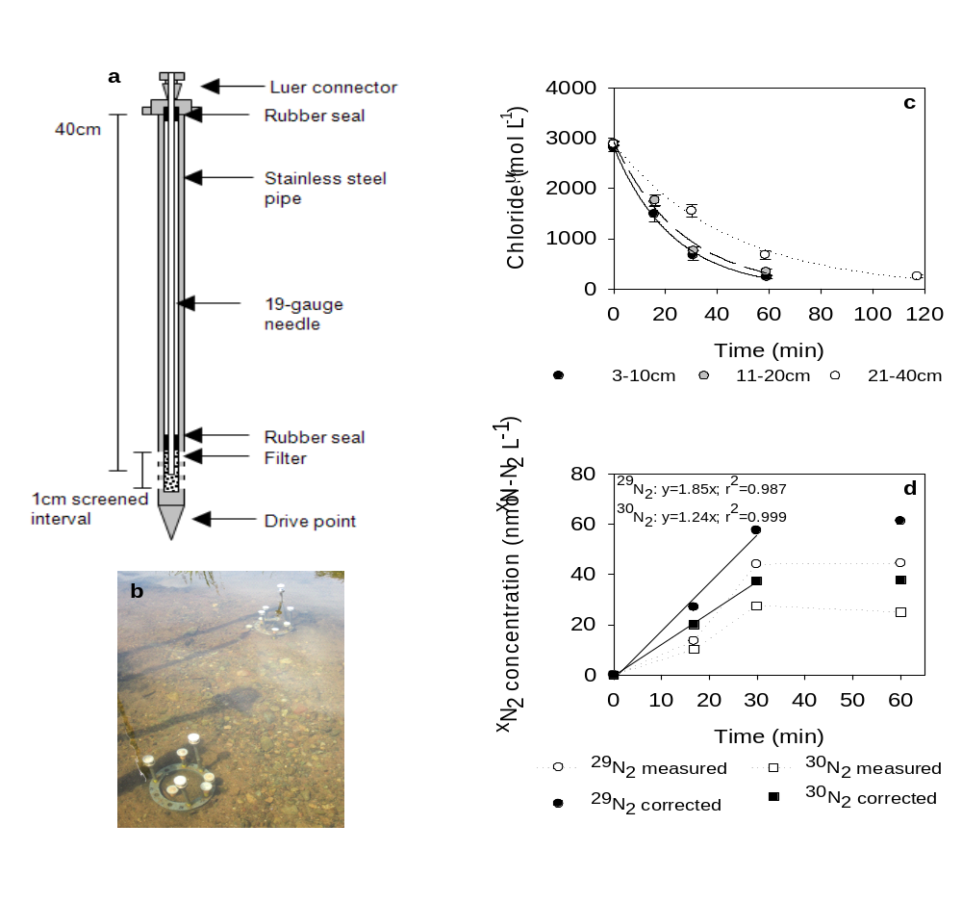
Figure 2: Depth profiles of chloride concentrations (a,b) denitrification (d) and nitrification potential (e,f) in a permeable riverbed. Panel c is a summary of principal component 1 scores (chemical gradient). Data plotted grouped by hydrologic setting, n = 76 and 62 and for vertical flux and horizontal and vertical fluxes, respectively. Each data point is plotted at the depth at which the measurement was centred, but does incorporate sediment ± ~2cm. For Panel c, whiskers indicate maximum and minimum values, the 1st and 3rd quartile are the limits of the box and the median is shown as a straight line. For Panel d the solid line is a linear mixed effects model fitted to the data.
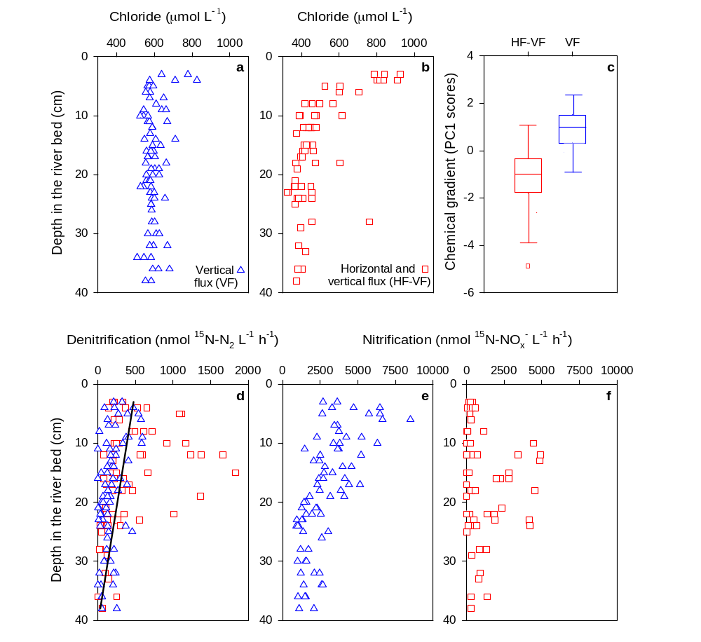
Figure 3: Bubble plot illustrating the overlap between denitrification (DEN, blue) and nitrification (NIT, orange) activity occurring within the space defined by our chemical and physical gradients (n = 138 for each process). Chemical and physical gradients were obtained through principal component analysis (see Methods and Supporting Information), where reduced chemical conditions are low scores on the chemical gradient axis, and a combination of deep sediments and slow porewater velocity are low scores on the physical gradient axis. The intensity of either denitrification or nitrification is proportional to the respective size of each bubble.
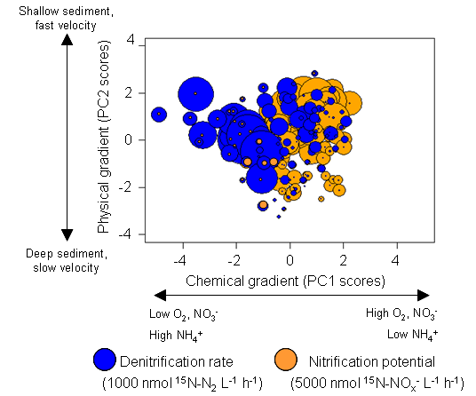
Figure 4: Relationships between denitrification activity (n=138) or nitrification potential (n=137) and porewater chemistry (a,c) or physics (b,d) under contrasting hydrologic settings within a permeable riverbed. Low scores on the chemical gradient axis represent reduced chemical conditions, whilst a combination of deep sediments and slow porewater velocity are low scores on the physical gradient axis. Black lines are models applied to the entire dataset; the dashed line in panel c indicates where the model has been extrapolated which would, in effect, represent the overlying river water where nitrification would be undetectable on our measurement time-scale of a few hours (see Table 2).
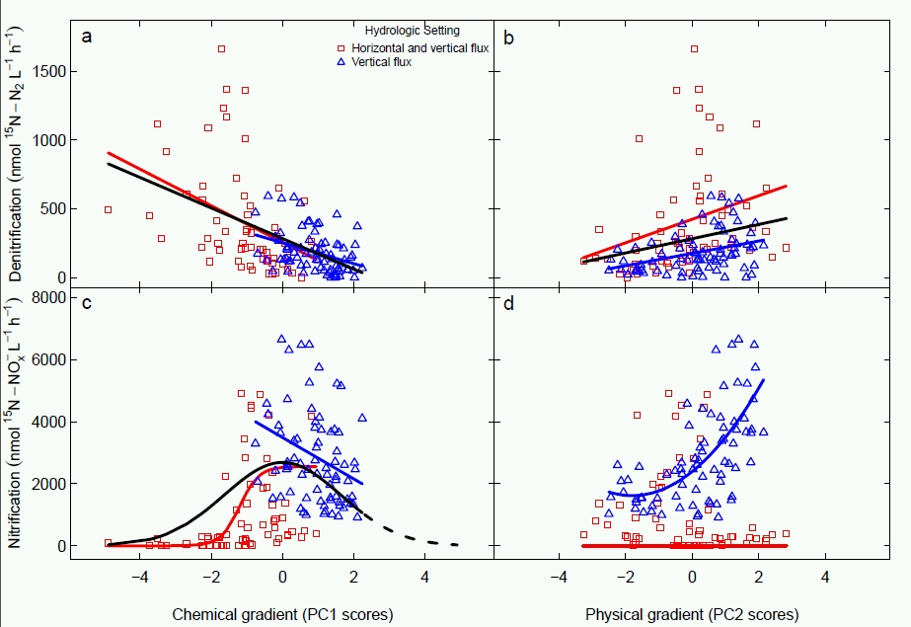
Table 1: Summary of the hydrology and ambient porewater chemistry within the bed of the River Leith and chemical characteristics of the surface water.
 | Hydrologic setting
 | VF | HF-VF | Surface water§
Nitrate (µmol L⁻¹)* | 143-518 (451) | <3-168 (48) | 92-137 (120)
Ammonium (µmol L⁻¹)* | <0.3-13.9 (2.6) | <0.3-207 (9.0) | <0.3-6.6 (1.1)
Dissolved oxygen (µmol L⁻¹)* | 18-323 (148) | 10-377 (50) | 288-572 (400)
Chloride (µmol L⁻¹)* | 508-826 (583) | 323-924 (433) | 780-1061 (844)
Porewater velocity (min)* † | 32-247 (96) | 29-211 (72)
*Data are minimum – maximum values, with the median value given in parenthesis, of samples collected from 3 to 40cm depth in the riverbed prior to ¹⁵N injections, n=76 and 62 for VF and HF-VF, respectively. †The time take for chloride concentrations elevated by the injection of the tracer to return to ambient concentrations was used as a proxy for porewater velocity. §Surface water data are minimum – maximum values, with the median value given in parenthesis, of samples collected prior to ¹⁵N injections (n=6).
Table 2: Summary of regression models used to examine relationships between denitrification or nitrification and chemical or physical gradients within a permeable riverbed. Gradients, obtained through principal component analysis, and hydrologic setting are as per Figure 2 and main body text. Full details of the statistical approach are given in the Supporting Tables 3 to 5).
Process | Model type | Gradient (hydrologic setting) | Estimate  (std. error) | p-value
Denitrification | Linear | Chemical | -88.9 (13.9) | <0.001
Denitrification | Linear | Physical | 50.6 (9.5) | <0.001
Nitrification | Linear | Chemical (VF) | -891 (225) | <0.001
Nitrification | Non-linear* | Chemical-a (HF-VF) | 2554 (175) | <0.001
Nitrification | Non-linear* | Chemical-b (HF-VF) | 0.01 (0.03) | 0.708
Nitrification | Non-linear* | Chemical-c (HF-VF) | 3.71 (2.26) | 0.103
Nitrification | Non-linear† | Chemical-a | 2687 (227) | <0.001
Nitrification | Non-linear† | Chemical-b | -0.43 (0.07) | <0.001
Nitrification | Non-linear‡ | Physical-a (VF) | 2393 (164) | <0.001
Nitrification | Non-linear‡ | Physical-b (VF) | 863 (146) | <0.001
Nitrification | Non-linear‡ | Physical-c (VF) | 240 (91) | 0.010
Nitrification | Linear | Physical (HF-VF) | -115 (102) | 0.259
Model formulae are as follows: *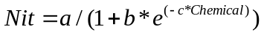, †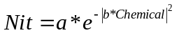and ‡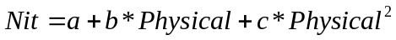.

ABSTRACT ART / TOC ART


