Screening for drought tolerance in Salvia spp. and Helichrysum petiolare: a way to select low maintenance ornamental plants

M. Caser¹, B. Ruffoni², V. Scariot¹

¹ Department of Agronomy, Forest and Land Management, University of Turin, Via Leonardo da Vinci 44, 10095, Grugliasco, Torino; e-mail matteo.caser@unito.it; tel +39 011 6708935; fax +39 011 6708798.
² CRA-FSO, Ornamental Species Research Unit, Corso Inglesi 508, 18038 Sanremo, IM, Italy.

Keywords: osmotic stress, aromatic plants, urban horticulture, water regime

Abstract
Recent urban green design strategies rely on the use of plants with low maintenance costs. Thus, the study of drought tolerance in ornamental species is of considerable interest. In this work rooted cuttings of Salvia dolomitica Codd., Salvia sinaloensis Fern., and Helichrysum petiolare (Hiliard & B.L. Burtt) were subjected to five irrigation treatments (T₁=20%, T₂=40%, T₃=60%, T₄=80%, and T₅=100% of container water capacity - CC) for a total of two months. During this period, to evaluate their recovery responses, all plants were taken back two times for 14 days to the optimal regime of irrigation. Visual plant damages, chlorophyll concentration (SPAD values), leaf area, and growth index were evaluated twice a week. In general, these traits decreased as water stress was intensified. The highest visual damage values and the lowest growth variation were observed in plants subjected at T₁. In this stress condition, S. dolomitica and in S. sinaloensis reached a damage value superior to 75% after 16 and 46 days, respectively. In H. petiolare plants, leaf area was significantly reduced already by T₂. Slight differences on visual damages among plants at T₃, T₄, and T₅ were showed. Rewatering was effective for all three species only in plants stressed at T₃ and T₄. Overall, the tested species showed a general tolerance at moderate drought stress and their use in urban horticulture for low maintenance green areas appears feasible.

INTRODUCTION
Water is the most abundant molecule on earth but its availability is often a limiting factor. Water deficit and salt stresses are global issues to ensure survival of agricultural crops and sustainable food production (Jaleel et al., 2007a). Tolerance to abiotic stresses is very complex, due to intricate interactions between stress factors and various molecular, biochemical, and physiological phenomena affecting plant growth and development (Razmjoo et al., 2008). Drought stress reduces plant growth by affecting various physiological and biochemical processes, such as photosynthesis, respiration, translocation, ion uptake, carbohydrates, nutrient metabolism, and growth promoters (Jaleel et al., 2008b; Farooq et al., 2008). It is characterized by reduction of water content, diminished leaf water potential and turgor loss, closure of stomata and decrease in cell enlargement and growth (Smirnoff, 1993; Jaleel et al., 2007b; Jaleel et al., 2008).
Drought stress tolerance is seen in almost all plants but its extent varies from species to species or even within. A better understanding of the morpho-anatomical and physiological basis of changes in water stress resistance could be used to select or create new varieties with a better productivity under water stress conditions (Nam et al., 2001; Martinez et al., 2007).
Recent urban green design strategies rely on the use of plants with low maintenance costs. Especially medicinal and aromatic plants are frequently used in urban layout, for their specific adaptability, ground cover characteristics, and decorative leaf, flowers, and fruits. Thus, the study of drought tolerance in aromatic species is of considerable interest.
Studies on Salvia splendens and S. officinalis were presented by Burnett et al. (2005) and Abreu and Munné-Bosch (2008). Few species of the genus Helichrysum are known for their use in urban design (Arslan and Yanmaz, 2010) and for their drought tolerance (Soad et al., 2010).
In this work, the responses of S. dolomitica Codd., S. sinaloensis Fern., and Helichrysum petiolare (Hiliard & B.L. Burtt) to different water regimes were investigated.

Materials and methods

Plant materials and experimental design
Plants of S. dolomitica, S. sinaloensis, and H. petiolare were grown in the glasshouse of the University of Turin (Italy), clonally multiplied by cuttings, and placed in 9 cm containers filled with peat and perlite (70:30). Substrate moisture was maintained at specific levels of container capacity (CC). When plants reached at least 20 cm in height were transferred to a controlled room (25°C, 60% U.R., 300 PAR and 16h photoperiod).
Plants were subjected to five irrigation regimes: T₁=20%, T₂=40%, T₃=60%, T₄=80%, and T₅=100% of container capacity (CC). The experiment lasted for a total of 60 days: from day 1 to day 16 to the first stress trial, from day 17 to day 30 to the first recovery phase with optimal regime of irrigation (T₅), from day 31 to day 46 to the second stress trial, and from day 47 to day 60 to the second recovery phase under optimal regime of irrigation (T₅).

Observation and statistics
For each species, six plants per irrigation treatment was analysed. To assess plant quality, leaf damage was visually evaluated using five classes (visual damage class: 0 = 0%; 1 = 1-25%; 2 = 26-50%; 3 = 51-75%; 4 = 76-100% leaf area). The Chlorophyll Meter SPAD-502 Konica Minolta (Nieuwegein, The Netherland) was used to indirectly measures of leaf chlorophyll content and plant quality (Smith et al., 2004). To assess growth variation leaf area (k*length*width; k=0.75; Ruget et al., 1996), and growth index (GI; Π*{[(D'+D'')/2]/2}²*H; Hidalgo and Harkess, 2002) were calculated. All parameters were recorded twice a week.
Data were subjected to the analysis of variance (ANOVA) by using Ryan–Einot–Gabriel–Welsch’s multiple step-down F (REGW-F) test, (P≤0.05). The Kruskal-Wallis test was used to investigate differences in visual leaf damages. All statistical analyses were performed using SPSS statistical package (version 17.0; SPSS Inc., Chicago).

Results and discussion
Salvia spp.
In Figure 1 and 2 the responses of S. dolomitica and S. sinaloensis to the five irrigation regimes are reported. Concerning visual leaf damages (Fig. 1a), S. dolomitica showed after the first stress trial the highest damages (= 4.00) under severe stress (20% CC), reaching the complete death of plants. Irrigation with 40% CC induced intermediate damages, ranging from 2.00 to 2.50. Effects of moderate drought stresses (T₃ and T₄) did not differ statistically from the control during the first stress trial and subsequent recovery phase. Starting from the second stress trial, plants irrigated with 60% and 80% CC showed an increase of leaf damages (1.00 and 1.33 values, respectively). At the end of the experiment, effects of the latter were similar to T₂, highlighting intermediate damages between control and 20% CC water regime. In S. sinaloensis the highest damages (=4.00) were reached after the second stress trial in plants subjected to T₁. After the first stress trial, plants irrigated with 40% and 20% CC showed leaf damages higher than value 2.00. On the other hand, T₄ and T₅ water regimes allowed to maintain value 0.00. Differences were highlighted only after the second stress trial. In particular, at the end of the experiment, leaf damages not exceed 1.50 for T₃ and T₄, showing that irrigation with at least 60% CC not compromises the aesthetic values of this species.
Irrigation regime effects on chlorophyll content were observed in both species only in plants subjected to T₁ at the same time point in which leaf damages are equal to 4.00 (Fig. 1b and 2b). No differences were detected for the other treatments. This result suggests that in Salvia, SPAD readings could be useful for the selection of the health status under drought conditions.
Leaf area was significantly influenced by drought stress (Fig. 1c). In S. dolomitica plants, irrigation with 20% CC reduced significantly leaf area in comparison with 100% CC after the first stress trial. After the second stress trial, T₂ and T₄ water regimes induced the lowest leaf area (6.53 and 7.04 cm², respectively) in comparison with T₅ and T₃ (10.14 and 9.41 cm², respectively). After the second recovery phase, irrigation with 40 % CC induced the lowest leaf area reduction. Similar results were reported by Bettaieb et al. (2009) in S. officinalis. In S. sinaloensis after the first stress trial were observed significant differences among treatments (Fig. 2c). Plants at 100% and 80% CC reached leaf areas superior than others and this trend was maintained for all the experiment. After the second stress trial, plants in T₁ and T₂ showed the lowest leaf areas (1.85 cm² and 1.88 cm², respectively) and no effect of the followed recovery phase was observed. Plants in T₃ showed intermediate values and not statistically differ from T₄ and T₅.
With the aim to better describe how severe drought stress can influence the vegetative phase of the studied species the Growth Index was calculated (GI; Fig. 1d and 2d). For both species irrigation with 20% and 40% CC induced the lowest GI during all the experiment. In S. dolomitica after the first stress trial T₅ and T₄ reached the highest values with 13013 GI and 12518 GI, and T₃ an intermediate value of 8611. After the second stress trial, plants subjected to T₃ and T₄ do not differ statistically, showing intermediate GI values between T₅ and T₂. Similarly, S. sinaloensis plants irrigated with 100% and 80% CC showed the highest GI during all the experiment, in particular at the days 16, 46, and 60. Instead, for all the experiment, plants at T₃ presented intermediate GI values while, at T₁ and T₂ the lowest.
By the comparison of all the presented results, it is possible to highlight the tolerance to moderate drought stress of these species. Previous research (Eakes et al., 1991; Burnett et al., 2005) found that imposing a mild drought stress to induce osmotic adjustment improved the drought tolerance of S. splendens during postproduction. But, this condition resulted in reductions of plant size and not prolonged the shelf life during the recovery phase. Similarly, Abreu and Munné-Bosch (2008) demonstrated that induced drought was involved in decreasing leaves aesthetic quality of S. officinalis. For this reason, as described by Cervelli (2011), the studied species represent new sources for urban horticulture. Moreover, in a way to select for drought tolerance, their use for low maintenance green areas appears feasible.

Helichrysum petiolare
H. petiolare showed statistical differences in visual leaf damages after the first stress trial (Fig. 3a). Plants subjected to T₁, T₂, and T₃ presented values superior than 2.00, showing a range of damages between 25 % and 75 % of total plants. An increase of damage values was then detected in T₁ and T₂ after the second stress trial, reaching value 4.00 (complete death of plants) at day 60. Moderate drought stress (T₃ and T₄) did not compromise aesthetic values of the plants. In fact, after the second recovery phase, visual damages were similar to the control.
As well as for S. dolomitica and S. sinaloensis, H. petiolare plants subjected to severe drought stress (20% CC) showed a statistical increase of SPAD values at the same time point in which was reached value 4.00 of leaf damages (Fig. 3b). During all the experiment no differences were individuated for the other treatments.
Drought stress was effective in the reduction of leaf area only after the second stress trial (Fig. 3c). A general decrease of leaf area was observed. At the day 46 at T₁ and T₂ the lowest leaf area of 0.87 cm² and 2.12 cm² was recorded while leaf areas at T₃ and T₄ were intermediate (2.77 cm² and 3.33 cm², respectively). After the second recovery phase plants at T₃, T₄, and T₅ watering regimes looked similar, highlighting the ability of this species to survive till 60 % CC. The growth index was generally not affected by different drought conditions (Fig. 3d). By miming different possible water conditions is evident the aptitude of this species to survive in semi drought conditions. The results allowed to indicate the minimum irrigation regime for the cultivation of H. petiolare in urban areas.

CONCLUSIONS
The present study demonstrated the adaptability of S. dolomitica, S. sinaloensis, and H. petiolare to moderate drought stress, showing positive tolerance with at least 60 % CC, while, sub-irrigation (20 % and 40 % CC) inhibited the growth of studied species and induced severe leaf damages, compromising their ornamental values and health status.
Morphological studies can provide objective information to be used as a tool to improve the vegetation management in urban areas and consequently avoiding the potential vulnerabilities associated with global climate change. Therefore, the possibility to maximize water saving need to be considered. The knowledge of specific water requirement of the presented species represents a way for scheduling irrigation programs.

Acknowledgements
This research was funded by the INTERREG-ALCOTRA 2007-2013 Project “AROMA” (n. 68).
The authors gratefully acknowledge Claudio Cervelli for supplying plants; Paolo Lo Turco for its clonal support; and Martina Costa for her practical help.

Literature Cited

Abreu M.E. and Munné-Bosch S. 2008. Salicylic acid may be involved in the regulation of drought-induced leaf senescence in perennials: A case study in field-grown Salvia officinalis L. plants. Env Exp Bot 64: 105-112.
Arslan M. and Yanmaz R. 2010. Use of ornamental vegetables, medicinal and aromatic plants in urban landscape design. Acta Hort 881: 207-211.
Bettaieb I., Zakhama N., Wannes W.A., Kchouk M.E. and Marzouk B. 2009. Water deficit effects on Salvia officinalis fatty acids and essential oils composition. Sci Hort 120: 271-275.
Burnett S.E., Pennisi S.V., Thomas P.A. and van Iersel M.W. 2005. Controlled drought affects morphology and anatomy of Salvia splendens J Am Soc Hort Sci 130: 775–781.
Cervelli C. 2011. Salvie. Caratteristiche, usi e coltivazione. Eds: Edizioni Ace2, pag 288. ISBN 9788890579004.
Eakes D.J., Wright R.D. and Seiler J.R. 1991. Moisture stress conditioning effects on Salvia splendens ‘Bonfire’. J. Am. Soc. Hort. Sci. 116: 716–719.
Farooq M., Basra S.M.A., Wahid A., Cheema Z.A., Cheema M.A. and Khaliq A. 2008. Physiological role of exogenously applied glycinebetaine in improving drought tolerance of fine grain aromatic rice (Oryza sativa L.). J Agron Crop Sci 194: 325–333.
Hidalgo P.R. and Harkess R.L. 2002. Earthworm castings as a substrate amendment for chrysanthemum production. HortScience 37: 1035-1039.
Jaleel C.A., Manivannan P., Kishorekumar A., Sankar B., Gopi R., Somasundaram R. and Panneerselvam R. 2007a. Alterations in osmoregulation, antioxidant enzymes and indole alkaloid levels in Catharanthus roseus exposed to water deficit. Colloids Surf B: Biointerfaces 59: 150–157.
Jaleel C.A., Manivannan P., Sankar B., Kishorekumar A., Gopi R., Somasundaram R. and Panneerselvam R. 2007b. Water deficit stress mitigation by calcium chloride in Catharanthus roseus; effects on oxidative stress, proline metabolism and indole alkaloid accumulation. Colloids Surf. B: Biointerfaces 60: 110–116.
Jaleel C.A., Sankar B., Murali P.V., Gomathinayagam M., Lakshmanan G.M.A. and Panneerselvam R. 2008. Water deficit stress effects on reactive oxygen metabolism in Catharanthus roseus; impacts on ajmalicine accumulation. Colloids Surf. B: Biointerfaces 62: 105–111.
Martinez J.P., Silva H., Ledent J.F. and Pinto M. 2007. Effect of drought stress on the osmotic adjustment, cell wall elasticity and cell volume of six cultivars of common beans (Phaseolus vulgaris L.). European J Agron 26: 30–38.
Nam N.H., Chauhan Y.S. and Johansen C. 2001. Effect of timing of drought stress on growth and grain yield of extra-short-duration pigeonpea lines. J Agric Sci 136: 179–189.
Razmjoo K., Heydarizadeh P. and Sabzalian M.R. 2008. Effect of salinity and drought stresses on growth parameters and essential oil content of Matricaria chamomile. Int J Agric Biol 10: 451–454.
Ruget F., Bonhomme R. and Chartier M. 1996. Estimation simple de la surface foliaire de plantes de mais en croissance. Agronomie 16: 553-562.
Smirnoff N. 1993. The role of active oxygen in the response of plants to water deficit and desiccation. New Phytol 125: 27–58.
Smith B.R., Fisher P.R. and Argo W.R. 2004. Growth and pigment content of container-grown Impatiens and Petunia in relation to root substrate pH and applied micronutrient concentration. HortScience 39: 1421–1425.
Soad M.M., Lobna I. and Farahat M.M. 2010. Influence of foliar application of pepton on growth, flowering and chemical composition of Helichrysum bracteatum plants under different irrigation intervals. Oz J Appl Sci 3: 143-155.

Figures

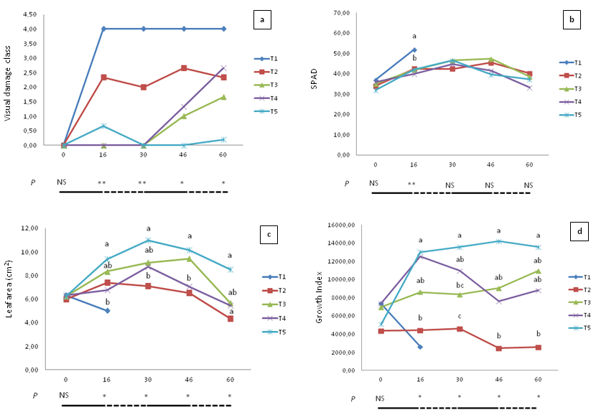

Figure 1. S. dolomitica responses to five irrigation regime (T₁ = 20 %, T₂ = 40 %, T₃ = 60 %, T₄ = 80 % and T₅ = 100 % of container capacity). a) Observed average values, fitted with Kruskal Wallis test (NS = non significant; * P<0.05; ** P<0.001), of visual leaf damages. The effect of the five irrigation regimes on SPAD values (b), leaf area (c), and growth index (d) over the experiment. The solid line indicates the period of water stress while, the dashed line the recovery. Means followed by the same letter do not differ significantly, according to REGW-F test (NS = non significant; * P<0.05; ** P<0.001).

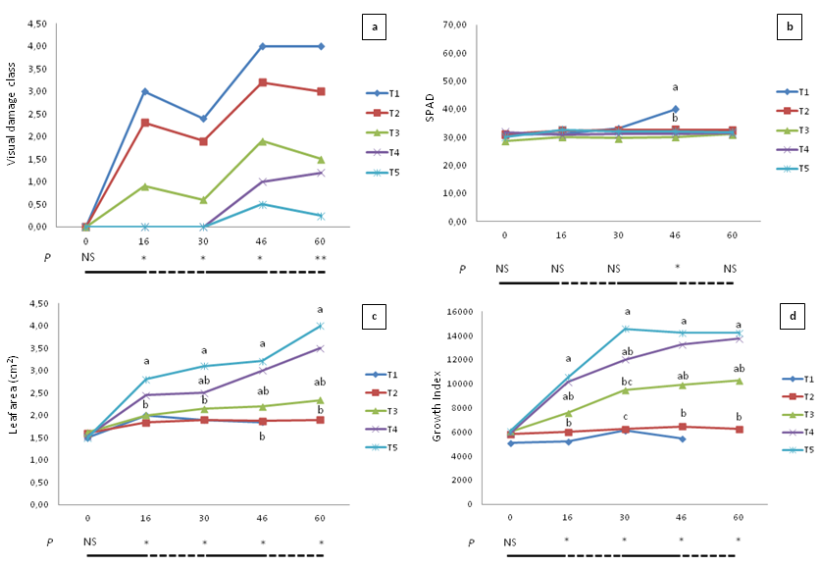

Figure 2. S. sinaloensis responses to five irrigation regime (T₁ = 20 %, T₂ = 40 %, T₃ = 60 %, T₄ = 80 % and T₅ = 100 % of container capacity). a) Observed average values, fitted with Kruskal Wallis test (NS = non significant; * P<0.05; ** P<0.001), of visual leaf damages. The effect of the five irrigation regimes on SPAD values (b), leaf area (c), and growth index (d) over the experiment. The solid line indicates the period of water stress while, the dashed line the recovery. Means followed by the same letter do not differ significantly, according to REGW-F test (NS = non significant; * P<0.05; ** P<0.001).

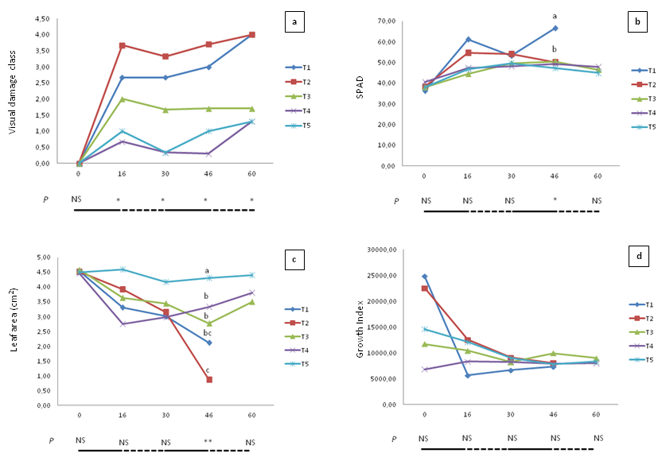

Figure 3. H. petiolare plants responses to five irrigation regime (T₁ = 20 %, T₂ = 40 %, T₃ = 60 %, T₄ = 80 % and T₅ = 100 % of container capacity). a) Observed average values, fitted with Kruskal Wallis test (NS = non significant; * P<0.05; ** P<0.001), of visual leaf damages. The effect of the five irrigation regimes on SPAD values (b), leaf area (c), and growth index (d) over the experiment. The solid line indicates the period of water stress while, the dashed line the recovery. Means followed by the same letter do not differ significantly, according to REGW-F test (NS = non significant; * P<0.05; ** P<0.001).

