A COMPARATIVE ANALYSIS OF INTRAORAL 3D DIGITAL SCANNERS FOR RESTORATIVE DENTISTRY
S. Logozzo*, G. Franceschini, A. Kilpelä, M. Caponi , L. Governi ,L. Blois
*corresponding author, via settevalli, 11/E24 – 06129 Perugia (Italy); sililog@hotmail.com; tel.+390755284501; +390755284511; +393487142939; fax +390755284530.

Silvia Logozzo
Mechanical Engineer, Doctorate Researcher - Department of Mechanics and Industrial Technologies – University of Florence (Italy)
Giordano Franceschini
Mechanical Engineer, Professor - Department of Industrial Engineering – University of Perugia (Italy)
Ari Kilpelä
Electric/Electronic Engineer, PhD, Assistant Professor – Department of Electrical and Information Engineering - University of Oulu (Finland)
Michele Caponi
Electronic Engineer, PhD, Researcher at IRIDE LTD Research Laboratory – Perugia (Italy)
Lapo Governi
Mechanical Engineer, PhD, Assistant Professor - Department of Mechanics and Industrial Technologies – University of Florence (Italy)
Luciano Blois
Civil Engineer, PhD, Assistant Professor - Department of Energy and Environment – University G. Marconi of Rome (Italy)
ABSTRACT
Today, intra-oral mapping technology is one of the most exciting new areas in dentistry since three-dimensional scanning of the mouth is required in a large number of procedures in dentistry such as restorative dentistry and orthodontics. Nowadays, ten intra-oral scanning devices for restorative dentistry have been developed all over the world. Only some of those devices are currently available on the market; the others are still passing the clinical testing stages. All the existing intraoral scanners try to face with problems and disadvantages of traditional impression fabrication process and are driven by several non-contact optical technologies and principles. The aim of the present publication is to provide an extensive review of the existing intraoral scanners for restorative dentistry with particular attention to the evaluation of working principles, features and performances.

K-WORDS
Intraoral scanner, digital impression, restorative dentistry.

INTRODUCTION
The introduction of CAD/CAM concepts into dental applications was the brainchild of Dr. Francois Duret in his thesis presented at the Université Claude Bernard, Faculté d’Odontologie, in Lyon, France in 1973, entitled “Empreinte Optique” (Optical Impression). In detail he developed and patented a CAD/CAM device in 1984. The developed system was presented at the Chicago Midwinter Meeting in 1989 by fabricating a dental crown in 4 hours (1, 2). Digital impressions have been introduced, and successfully used, for a number of years in orthodontics, as well, including Cadent’s IOC/OrthoCad, DENTSPLY/GAC’s OrthoPlex, Stratos/Orametrix’s SureSmile, and EMS’RapidForm but the introduction of the first digital intraoral scanner for restorative dentistry was in the 1980s by a Swiss dentist, Dr. Werner Mörmann, and an Italian electrical engineer, Marco Brandestini, that developed the concept for what was to be introduced in 1987 CEREC® by Sirona Dental Systems LLC (Charlotte, NC) as the first commercially CAD/CAM system for dental restorations (1, 3). Ever since research and development sectors at a lot of companies have improved the technologies and created in-office intraoral scanners that are increasingly user-friendly and produce precisely fitting dental restorations. These systems are capable of capturing three-dimensional virtual images of tooth preparations; from such images restorations may be directly fabricated (using CAD/CAM systems) or can be used to create accurate master models for the restorations in a dental laboratory (1). Nowadays, ten intra-oral scanning devices for restorative dentistry are available all over the world: four of them are made in USA, two in Israel, two in Germany and one in Italy, in Switzerland and in Denmark. Generally speaking such scanners try to face with problems and disadvantages of traditional impression fabrication process such as, in particular, mould instability, plaster pouring, laceration on margins, geometrical and dimensional discrepancy between the die and the mould. The main advantages in the employment of those devices are: high fidelity models, creation of 3D archives and surgery simulation and a process simplification. Existing devices are driven by several non-contact optical technologies such as confocal microscopy, optical coherence tomography, photogrammetry, active and passive stereovision and triangulation, interferometry and phase shift principles. Basically, all these devices combine some of the cited imaging techniques to minimize the noise source related to the scanning inside an oral cavity as, for example: optical features of the target surfaces (translucency and the different reflectivity of the target materials as teeth, gums, preparations, resins, etc.), wetness and random relative motions. Also several typologies of structured light sources and optical components are employed. The ten existing intra-oral scanning devices for restorative dentistry are listed below:
1) CEREC® – by Sirona Dental System GMBH (DE)
2) iTero – by CADENT LTD (IL)
3) E4D – by D4D TECHNOLOGIES, LLC (US)
4) Lava™C.O.S. – by 3M ESPE (US)
5) IOS FastScan – by IOS TECHNOLOGIES, INC. (US)
6) DENSYS 3D – by DENSYS LTD. (IL)
7) DPI-3D – by DIMENSIONAL PHOTONICS INTERNATIONAL, INC. (US)
8) 3D Progress – by MHT S.p.A. (IT) and MHT Optic Research AG (CH)
9) directScan – by HINT - ELS GMBH (DE)
10) trios – by 3SHAPE A/S (DK)
Only some of these are already commercially available. As already mentioned, even if a lot of advantages in taking digital impressions are attainable, there subsist also some disadvantages related to the existing devices. For example it is often necessary to apply some coatings on the teeth to minimize the noise of the measurement and to rest the camera wand on a tooth to get a steady focus. Moreover, the 3D virtual model is often reconstructed by post-processing single images (acquired from a single perspective); accordingly the reconstruction is not performed in real time with a continuous data capture. Furthermore, data about the accuracy of the available instruments is missing. The aim of the present publication is the evaluation of all these existing devices with particular attention to the working principles they are based on, their features and performances.

STATE OF THE ART AND COMPARATIVE ANALYSIS OF THE TECHNOLOGICAL ALTERNATIVES

- CEREC® by Sirona Dental System GMBH (DE)
CEREC® (an acronym for Chairside Economical Restoration of Esthetic Ceramics) was introduced by Sirona Dental System GMBH (DE) in 1987, and it has undergone a series of technological improvements, culminating in the CEREC AC® powered by BlueCam®, launched in January 2009.
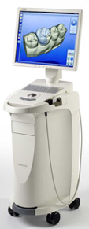
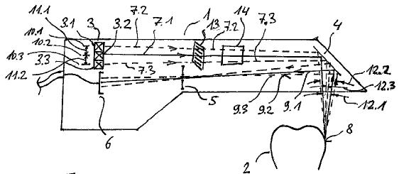
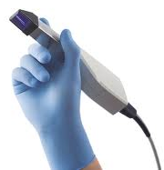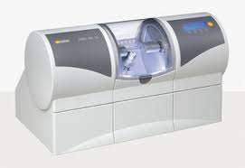
Figure 2 - The CEREC® Figure 3 - The in-office
Bluecam’s wand (24) milling unit (25)

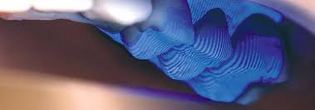
Figure 1 - The new Figure 4 - The CEREC AC BlueCam Figure 5 – CEREC scanning system (6)
CEREC® AC Bluecam (23) shorter wavelength blue light source (26)

The latest versions of the CEREC® system (see Figure 1 and 2) are capable of producing inlays, onlays, crowns, laminate veneers, and even bridges and combine a 3D digital scanner with a milling unit (view Figure 3) to create in-office dental restorations from commercially available blocks of ceramic or composite material in a single appointment (1).
The latest version of the milling centre, CEREC inLab® MC XL (see Figure 3), is capable of milling a crown in as little as 4 minutes. CEREC® systems may be described as measurement devices that operate according to the basic principles of confocal microscopy (3, 4) and according to the active triangulation technique (3, 5 and 6). A camera projects a changing pattern of blue light onto the object (see Figure 4) using projection grids that have a transmittance random distribution and which are formed by sub regions containing transparent and opaque structures (7). Moreover, by means of elements for varying the length of the optical path it is possible, for each acquired profile, to state specific relationship between the characteristic of the light and the optical distance of the image plane from the imaging optics (3, 4). A light source 3 (see figure 5) produces an illumination beam 7.1, 7.2, 7.3, that is focused onto the surface of the target object 2. An image sensor 6 receives the observation beam 9.1, 9.2, 9.3 reflected by the surface of the target object. A focusing system 5 focuses the observation beam onto the image sensor 6. The light source 3 is split into a plurality of regions 3.1, 3.2, 3.3 that can be independently regulated in terms of light intensity (6). Thus, the intensity of light detected by each sensor element is a direct measure of the distance between the scan head and a corresponding point on the target object (3). As a disadvantage of the system, the triangulation technique requires a uniform reflective surface since different materials (as dentin, amalgam, resins, gums) reflect light differently. It means that it is necessary to coat the teeth with opportune powders before the scanning stage to provide uniformity in the reflectivity of the surfaces to be modelled.
The earlier versions of CEREC® employed an acquisition camera with an infrared laser light source. The latest version employs blue light-emitting diodes (LEDs); the shorter-wavelength intense blue light projected by the blue LEDs allows for greater precision of the output virtual model (see Figure 4). The images are distortion-free, even at the periphery, so that multiple images (e.g. of a complete quadrant) can be stitched together with great accuracy. The CEREC® AC Bluecam boasts an automatic shake detection system which ensures that images are acquired only when the camera is absolutely firm. It is possible to capture a complete half arch in less than a minute. The new CEREC® AC Bluecam offers image stabilization systems. It means that the practitioner does not have to rest the camera wand on a tooth to get a steady focus and the camera automatically captures an image when the wand is motionless, avoiding the need for a pedal button (as the previous model required). Furthermore, it is now possible to scan full arches, while earlier versions of the device made a single image from one perspective. At the end of the scanning stage, the preparation is shown on the monitor and can be viewed from every angle to focus or magnify areas of the preparation. The “die” is virtually cut on the virtual model, and the finish line is delineated by the dentist directly on the image of the die on the monitor screen. Then, a CAD system, called “biogeneric”, provides a proposal of an idealized restoration and the dentist can make adjustments to the proposed design using a number of simple and intuitive on-screen tools. Once the dentist is satisfied with the restoration, he can mount a block of ceramic or composite material of the desired shade in the milling unit and proceeds with fabrication of the physical restoration. During the design stage of the process the use of colour-coded tools to determine the degree of interproximal contact helps to ensure finished restorations that require minimal, if any, adjustments before cementation. If the dentist has a standalone CEREC AC® system and he can not perform in-office fabrications of restorations, he can forward the digital impression data, using CEREC Connect®, directly to the dental laboratory (1).

- iTero by CADENT LTD (IL)
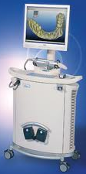
The Cadent iTero digital impression system by Cadent LTD, IL (see Figure 6) came into the market in early 2007. iTero system employs a parallel confocal imaging technique (see Figure 7 and 8) (8). As shown in Figure 9, an array of incident red laser light beams 36, passing through a focusing optics 42 and a probing face (Figure 7 and 8), is shone on the teeth. The focusing optics defines one or more focal planes forward the probing face in a position which can be changed by a motor 72.
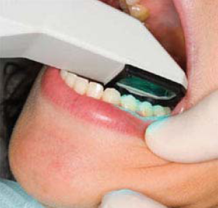
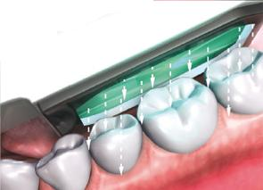

Figure 6 - Figure 7 - Figure 8 -
iTero digital impression system (1) iTero system’s wand (1) iTero uses parallel confocal technology (10)

The beams generate illuminated spots on the structure and the intensity of returning light rays is measured at various positions of the focal plane determining spot-specific positions (SSP) yielding a maximum intensity of the reflected light beams, data is generated which is representative of the topology of the three dimensional structure of the teeth (8, 9).
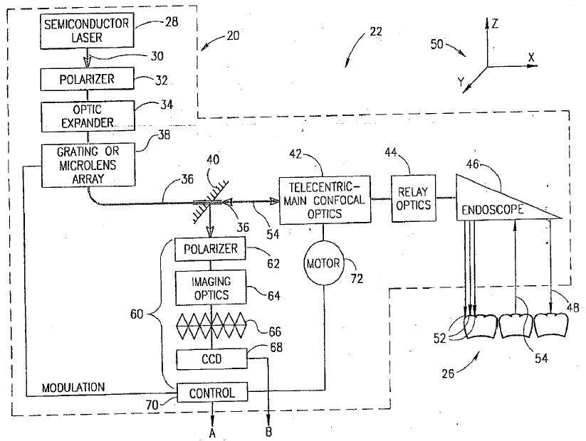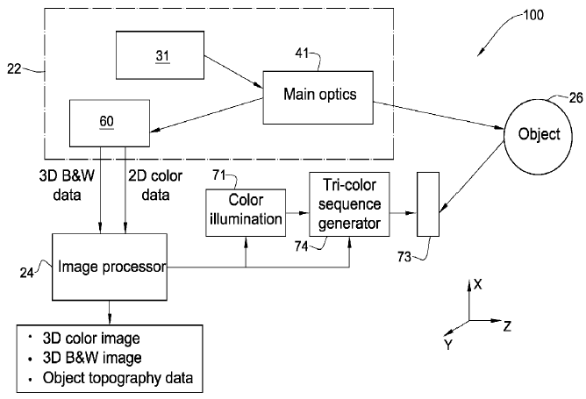
Figure 9 – iTero scanning system (8) Figure 10 – iTero colour imaging system (11)

Using this technique iTero captures all structures and materials found in the mouth without the need to apply any reflective coating to the patient’s teeth (10). The SSP is always a relative position as the absolute position depends on the position of the sensing face. However, the generation of the surface topology does not require knowledge of the absolute position, as all dimensions in the cubic field of view are absolute. By determining surface topologies of adjacent portions from two or more different angular locations and then combining such surface topologies, a complete three-dimensional representation of the entire structure may be obtained (9). While the ability of the iTero camera to scan without the need for powders that coat the teeth may be advantageous, it necessitates the inclusion of a colour wheel into the acquisition unit itself (see Figure 10), resulting in a camera with a larger scanner head than the other systems (1). In fact a two-dimensional (2D) colour image of the 3D structure of teeth is also taken at the same angle and orientation with respect to the structure. As a consequence, each X-Y point on the 2D image corresponds to a similar point on the 3D scan having the same relative X-Y values. The imaging process (Figure 10) is based on illuminating the target surface with three differently-coloured illumination beams (one of red, green or blue light) combinable to provide white light, capturing a monochromatic image of the target portion of teeth, corresponding to each illuminating radiation, and combining the monochromatic images to create a full colour image. The three differently-coloured illumination beams are provided by means of one white light source optically coupled with colour filters. The filters are arranged on sectors of a rotatable disc coupled to a motor (11). Capturing the digital impression follows a consistent series of steps for every impression. When tissue management has been confirmed, the operator is guided through a series of scanning steps. This include five scans of the prepared area: occlusal, lingual, buccal, and interproximal contacts of the adjacent teeth (1). This takes the operator approximately 15 or 20 seconds per prepared tooth. Then buccal and lingual 45°- angle views of the remaining teeth in the quadrant or arch and opposing arch are obtained. When these scans (at least 21) are complete, the patient is asked to close into centric occlusion and a virtual registration is scanned. Overall, complete upper and lower quadrant scans and the virtual bite registration can take less than 3 minutes time (1). When the digital impression has been completed, the clinician can select from a series of diagnostic tools to evaluate the preparation and complete the impression itself. A margin line tool is available to assist in viewing the clearly defined margin (12). The completed digital impression is sent via a HIPAA-compliant wireless system to the Cadent facility and the dental laboratory. Upon review by the laboratory, the digital file is output to a model by Cadent. Finally, the model is milled from a proprietary blended resin (1).

- E4D by D4D Technologies LLC (US)
The E4D Dentist system was introduced by D4D Technologies LLC (Richardson, TX) in early 2008. It consists of a cart (Figure 11) containing the design centre (computer and monitor) and laser scanner head (Figure 11), and a separate milling unit (Figure 11).
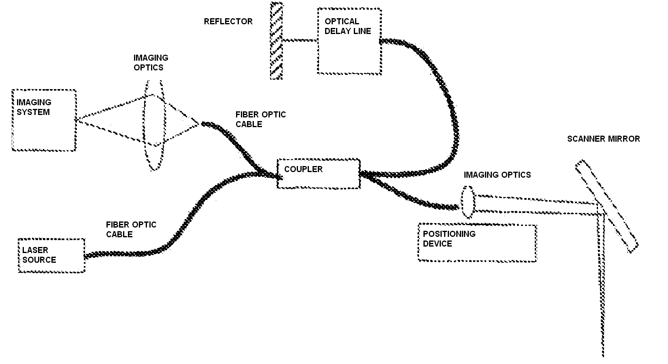
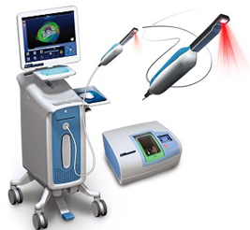

Figure 11- E4D Dentist system, wand and milling unit (27) Figure 12- E4D scanning system (13)

The IntraOral Digitizer is configured as an optical coherence tomography (OCT) or confocal sensor. The laser digitizer includes a laser source coupled to a fiber optic cable, a coupler and a detector (Figure 12). The coupler splits the light from the light source into two paths. The first path leads to the imaging optics, which focuses the beam onto a scanner mirror, which steers the light to the surface of the prepared tooth. The second path of light from the light source via the coupler is coupled to the optical delay line and to the reflector. This second path of light (reference path) is of a controlled and known path length, as configured by the parameters of the optical delay line. Light is reflected from the surface of the object, returned via the scanner mirror and combined by the coupler with the reference path light from the optical delay line. The combined light is coupled to an imaging system and imaging optics via a fiber optic cable. By utilizing a low coherence light source and varying the reference path by a known variation, the laser digitizer provides an Optical Coherence Tomography (OCT) sensor or a Low Coherence Reflectometry sensor. The focusing optics is placed on a positioning device in order to alter the focusing position of the laser beam and to operate as a confocal sensor (13). A series of imaged laser segments on the object from a single sample position interlace between two or multiple 3D maps of the sample from essentially the same sample position. The time period to measure each interlaced 3D map is reduced to a short interval and relative motion effects between the intra-oral device and the patient are reduced. The interlaced 3D maps may be aligned with software to produce an effective single view dense 3D point cloud that has no motion induced inaccuracies or artefacts. The motion of the operator between each subframe may be tracked mathematically through reference points in the dataset itself. The operator motion is removed in subsequent analysis (13). The E4D does not require the use of a reflective agent (powder) to enable the capture of fine detail on the target site in most cases. The scanner must be held a specific distance from the surface being scanned—this is achieved with the help of rubber-tipped “boots” that extend from the head of the scanner (1). The user holds down the foot pedal while centring the image and when the desired area is centred on the on-screen bulls eye, the pedal is released and the image is captured. A diagram on the monitor shows the user how to orient the scanner to obtain the next image. As successive pictures are taken, they are wrapped around the 3D model to create a model called by the CEREC Company “ICEverythingTM model”. The touch screen monitor enables the dentist to view the preparation from various angles and ensure its accuracy. It is not necessary to scan the opposing arch.
An occlusal registration is created with impression material, trimmed, and then placed on top of the prepared tooth. The scanner captures a combination of the registration material and the neighbouring teeth that are not covered by the material. This data is used to design restorations with proper occlusal heights. The design system of the E4D is then capable of auto detecting and marking the finish line on the preparation. Once this landmark is approved by the dentist, the computer uses its Autogenesis™ feature to propose a restoration, chosen from its anatomical libraries. As with the CEREC® system, the operator is provided with a number of intuitive tools to modify the restoration proposal. When the final restoration is approved, the design centre transmits the data to the milling machine so the dentist is able to fabricate the completed restoration (1).

- Lava™ Chairside Oral Scanner (C.O.S.) by 3M ESPE (US)
The Lava™ Chairside Oral Scanner (C.O.S.) was created at Brontes Technologies in Lexington, Massachusetts, and was acquired by 3M ESPE (St. Paul, MN) in October 2006. The product was officially launched in February 2008. The Lava C.O.S. system (Figure 13, 14) consists of a mobile cart containing a CPU, a touch screen display, and a scanning wand.
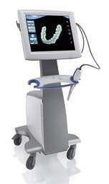
The Lava C.O.S. camera contains a highly complex optical system comprised of 22 lens systems and 192 blue LED cells The Lava C.O.S. wand has a 13.2-mm wide tip and weighs 14 ounces (390 g) (Figure 14) (1). The Lava C.O.S. has introduced an entirely new method of capturing 3D data based on the principle of active wavefront sampling with structured light projection. This scanning method has been named “3D-in-Motion technology” by 3M ESPE. This scanning system provides an active three-dimensional imaging system that includes an off-axis rotating aperture element placed either in the illumination path or in the imaging path of an optical apparatus (14).

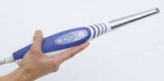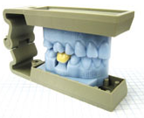
Figure 13- Lava C.O.S. (28) Figure 14- Lava C.O.S.’s wand (29) Figure 15- Impression From 3M Lava COS (30)
Figure 16 illustrates the principle of a three-dimensional imaging system having an off-axis aperture in the imaging path (14). To understand the theory employed in the Lava™ C.O.S. imaging systems, Figure 17 illustrates the concept of measuring out-of-plane coordinates of object points by sampling the optical wavefront, with an off-axis rotating aperture element, and measuring the defocus blur diameter. The system includes a lens 140, a rotating aperture element 160 and an image plane 18A. The single aperture avoids overlapping of images from different object regions hence it increases spatial resolution. The rotating aperture allows taking images at several aperture positions and this can be interpreted as having several cameras with different viewpoints, which generally increases measurement sensitivity. The aperture movement makes it possible to record on a CCD element a single exposed image at different aperture locations. To process the image, localized cross-correlation can be applied to reveal image disparity between image frames. As shown in Figure 17, at least two image recordings on the image plane 18A at different angles of rotation of the aperture 160 are used to generate the measured displacement for target object 8A. The separate images are captured successively as the aperture rotates to position #1 at time t and position #2 at time t+At. The rotation centre of the image gives the in-plane object coordinates as follows: $X_{0}=\frac{{\text{-xZ}}_{0}(\text{L-f})}{\text{fL}}$ $Y_{0}=\frac{{\text{-yZ}}_{0}(\text{L-f})}{\text{fL}}$ (1)
where X₀,Y₀, are the in-plane object coordinates, f is the focal length of the lens objective, L is the depth of in-focus object points (focal plane), R is the radius of the circle along which the off-axis pupil is rotating, and d is the diameter of a circle along which the relevant out-of-focus point is moving on the image plane 18A as the aperture is rotated. The magnitude of the pattern movement represents the depth information (Z₀) measured from the lens plane. Z₀, can be evaluated from two Snell's lens laws for in-focus and out-of-focus object points and by using similar triangles at the image side (14):
$Z_{0}=\frac{1}{L}+\frac{d(\text{L-f})}{\text{2RfL}}$ (2)
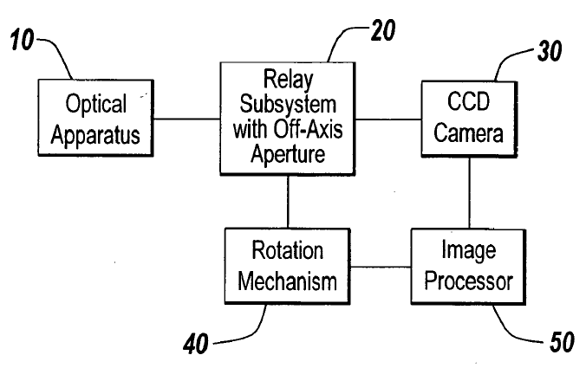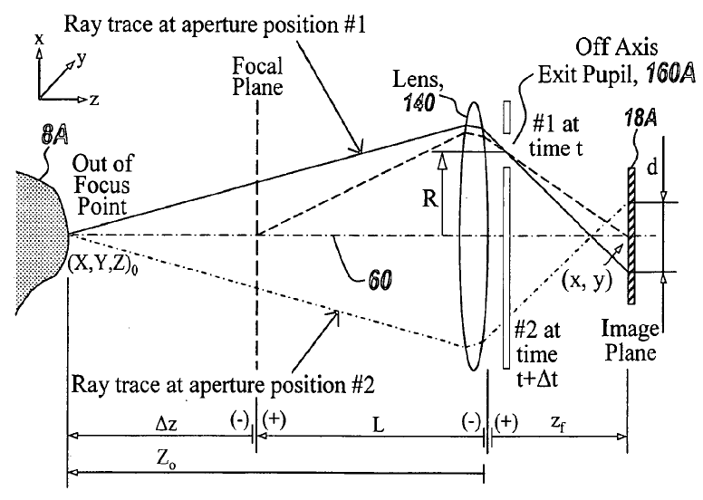
Figure 16 – Lava C.O.S. system (14) Figure 17 – Rotation of the aperture mechanism (14)

The Lava C.O.S. allows capturing 3D data in a video sequence and models the data in real time (approximately 20 3D datasets per second). After the preparation of the tooth and gingival retraction, the entire arch is dried and lightly dusted with powder to locate reference points for the scanner. During the scan, a pulsating blue light emanates from the wand head and an on-screen image of the teeth appears instantaneously. The “stripe scanning” is completed as the dentist returns to scanning the occlusal of the starting tooth. The dentist is able to rotate and magnify the view on the screen, and can also switch from the 3D image to a 2D view (the dentist can view these images while wearing 3D glasses). When the dentist confirms the scan a quick scan of the rest of the arch is obtained. If there are holes in the scan in areas where data is critical, the dentist simply scans that specific area and the software patches the hole. The patient is then instructed to close into the maximum intercuspal position (MIP), the buccal surfaces on one side of the mouth are powdered, and a scan of the occluding teeth is captured. The maxillary and mandibular scans are then digitally articulated on the screen. Then the dentist sends the data via internet to the laboratory technician, who employs customized software to digitally cut the die and mark the margin. 3M ESPE receives the digital file, generates a stereolithography (SLA) model (see Figure 16) and sends it to the laboratory (1).

- IOS FastScan™ by IOS Technologies Inc. (US)
IOS Technologies, Inc. was founded in early 2007 with the objective of bringing it's proprietary intra-oral scanning and digital impression technology to market. IOS Technologies is currently in final development of the IOS FastScan™ Digital Impression and Modelling System (Figure 18) and in July 2010 announced the IOS FastScan intraoral digital scanner had been advanced from prototype to production version and was proving successful in clinical beta testing. Glidewell Laboratories (CA) has been the main clinical testing facility for IOS Technologies' IOS FastScan. This initial testing has delivered promising consistency for a variety of dental applications, most notably with model-free CAD/CAM manufacture of BruxZir® Solid Zirconia crowns & bridges. The system’s major advantage over competitors is its wand (Figure 19). In fact “The IOS FastScan™ is the only system in which the camera moves within the wand,” explains Dr. Michael DiTolla, Glidewell Laboratories’ Director of Clinical Education & Research. In fact IOS FastScan laser moves automatically on a track within the wand so the dentist only has to hold the wand in three positions (buccal, lingual and occlusal) to scan full arch (10). Like Lava C.O.S. and iTero, IOS FastScan is a standalone scanner, so the dentist will have to work with a laboratory; but all the other companies require to send them the data because the data output format is landlord, and they charge about $25 for each sent virtual impression. IOS FastScan specializes in outputting data in sterolithography (STL) format, an open source data format that all the laboratories can recognize, open and manipulate. IOS FastScan gives the dentist the option of sending the data to IOS Laboratories to create a model at a charge of about $10 for each virtual impression, but if the dentist has a favourite laboratory he can send the virtual impression directly there. IOS FastScan system is based on the principle of active triangulation according to Schleimpflug imaging principle with sheet of light projection (15). Figure 20 shows an exemplary dental scanner head 80 that uses a polarizing multiplexer as in IOS FastScan™ system. The wand projects a laser sheet onto the teeth and then utilizes the polarizing multiplexer to optically combine multiple views of the profile illuminated by the sheet of laser light. The scanner head 80 uses a laser diode 70 to create a laser beam that passes through a collimating lens 71 which is followed by a sheet generator lens 72 that converts the beam of laser light into a sheet of laser light. The sheet of laser light is reflected by the folding mirror 73 and illuminates the surface of the target tooth. The system combines the light from two perspectives onto a single camera using passive or active triangulation (15). The system can be configured to achieve the independence of lateral resolution and depth of field. In order to achieve this independence, the imaging system, must be physically oriented so as to satisfy the Scheimpflug principle. The Scheimpflug principle is a geometric rule that describes the orientation of the plane of focus of an optical system wherein the lens plane is not parallel to the image plane. This enables sheet of light based triangulation systems to maintain the high lateral resolution required for dental applications while providing a large depth of focus (16). The 3D scanner probe sweeps a sheet of light across one or more surfaces of teeth, where the sheet of light projector and imaging aperture within the scanner probe rapidly moves back and forth along all or part of the full scan path, and displaying a near real-time, live 3D preview of the digital 3D model of the scanned dentition. A 3D preview display provides feedback on how the probe is positioned and oriented with respect to the patient's dentition (16).
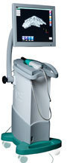
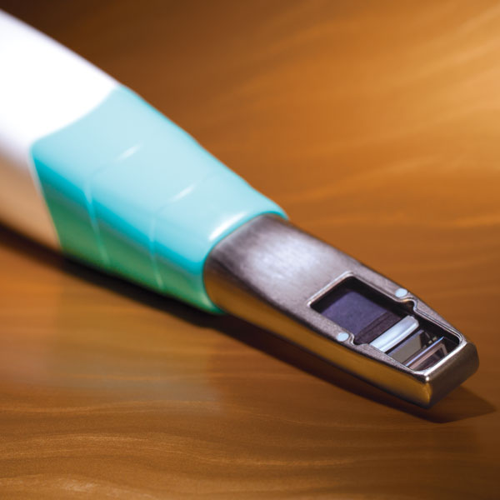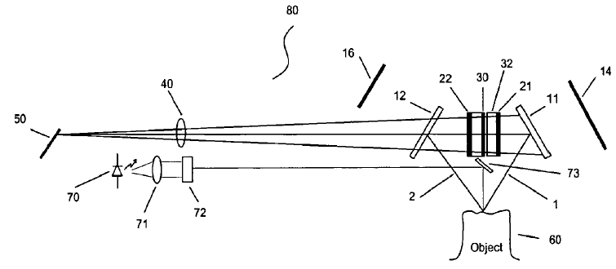
Figure 18- IOS FastScan™ (31) Figure 19- IOS FastScan™’s wand (32) Figure 20 – IOS Fastscan scanning system (15)

IOS FastScan™ includes a scanner to capture colour and translucency information along with a three dimensional shape of the dentition. The system also includes a computer aided design (CAD) module to receive the colour and translucency information and the 3D shape to render a colour accurate representation of the prosthesis. The colour, translucency and surface information is combined in a single digital prescription which is electronically transferred to a laboratory or CAD/CAM system for fabrication (17). The virtual model can be trimmed, the margin can be marked, and the die quickly and easily ditched using the IOS FastScan™ Dental CAD software.

- Densys3D by DENSYS LTD (IL)
Densys3d is a chair-side, standalone unit, comprising of a PC, a flat screen and a small hand held intra-oral camera, created by DENSYS LTD (Migdal Ha'Emeq, Israel). In February 2007 Densys announced that it would introduce an intra-oral camera and system for orthodontics and restorative applications with a very fast scanning system in which the acquisition of the picture would take only milliseconds and the dentist could map the patient's mouth within 90 seconds.
In June 2007 Densys3d has begun clinical trials with its intra-oral camera and system that has been in laboratory tests until then achieving an average accuracy of 30 microns. In February 2009 Densys3d has begun the process for FDA approval of its intra-oral camera and system for use in orthodontics and restorative dentistry. The camera arm uses visible light and produces a small ASCII file enabling open file architecture for easy integration to third party CAD/CAM machines. The scanning system has the smallest and lightest wand in the market weighing approximately 100 g. Densys ensures that its scanning system has the easiest to use software in the market, the fastest computation and the most accurate and robust wand in the market with full interproximal scan coverage. Using the system dentists will be able to create and store small-sized files in real-time, that are ready for immediate export to an in-clinic CAD CAM system or to a CAD CAM system in remotely located laboratory. Densys3d system employs the principle of active stereophotogrammetry with structured light projection. The intra-oral scene is illuminated by a 2D array of structured illumination points. 3D models are obtained from the single image by triangulation with a stored image of the structured illumination onto a reference surface such as a plane.
The goals of the employed technology are to facilitate 3D intra-oral modelling for dental applications while requiring minimal apparatus and without relying on surface detail of the objects to be modelled and to minimize the effect of movement of the patient, the practitioner, and the apparatus during the procedure of 3D intra-oral imaging.
Densys 3D utilizes a single camera. To obtain the 'z' information, the intra-oral scene is illuminated by a 2D image of structured illumination projected from a first angle with respect to the intra-oral scene. Then the camera is positioned at a second angle with respect to the intra-oral scene, to produce a normal image containing two-dimensional "x-y" information as seen at that second angle. The structured illumination projected from a photographic slide superimposes a 2D array of patterns over the intraoral scene and appears in the captured image. The "z" information is then recovered from the camera image of the scene under the structured illumination by performing a triangulation of each of the patterns in the array on the single image with reference to an image of the structured illumination projected on a reference plane, which was also illuminated from the first angle. In order to unambiguously match corresponding points in the image of the intra-oral scene and in the stored image, the points of the structured illumination are spatially-modulated with two-dimensional random patterns which have been generated and saved in a projectable medium (as a photographic slide). Random patterns are reproducible, so that the patterns projected onto the intra-oral scene to be imaged are the same as the corresponding patterns in the saved image (18).

- DPI - 3D by Dimensional Photonics International, Inc. (US)
Dimensional Photonics International, Inc. (DPI) is a leading developer of advanced three-dimensional (3D) measurement and shape capture technology. Originally conceived at Massachusetts Institute of Technology (MIT) Lincoln Laboratory in the late 1990s, the proprietary technology is today among the most accurate and versatile 3D scanning technologies.
The Company's latest development efforts have been focused on DPI/O, a small, handheld, real-time, intra-oral scanner for digital impressions. Of course, DPI's proprietary technology does not require the use of powder to accurately capture the topography of single teeth or a full arch. The device is passing the prototype testing phase and it is not still available on the market. DPI - 3D is an accordion fringe interferometry (AFI) principle based intra-oral imaging system (20).
It is compact and substantially insensitive to relative motion of the device and the objects to be measured. Accordion Fringe Interferometry (AFI) is a revolutionary technology that extends traditional linear laser interferometry to three dimensions. The original work on AFI was done at the MIT Lincoln Laboratory (the Federally Funded Research and Development Center of the Massachusetts Institute of Technology (MIT)). All of the MIT-developed AFI patents are exclusively licensed by MIT to DPI for all fields-of-use worldwide. A broad range of "industrial applications" of the technology has been sub-licensed to FARO Technologies, Inc.
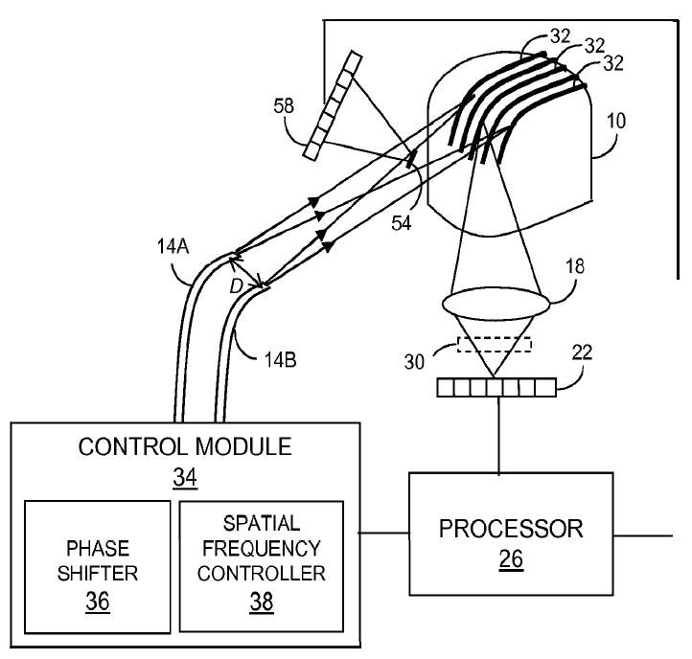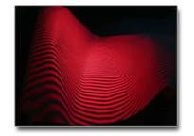
Figure 21 – the AFI imaging device (20) Figure 22- the interference pattern created by AFI technology (33)

AFI employs light from two point sources to illuminate an object with an interference fringe pattern (Figure 21 and 22). A high precision digital camera is used to record the curvature of the fringes. The degree of apparent fringe curvature coupled with the known geometry between the camera and laser source enable the AFI algorithms to digitize the surface of the object being scanned. AFI offers many advantages over older "white light" scanners as lower sensitivity to ambient light variations and noise, very high accuracy, large projector depth of field, enhanced ability to scan shiny and translucent surfaces and the ability to scan without targets and photogrammetric systems.
Although the device utilizes AFI measurement techniques as described in Shirley and Mermelstein, 1999 (19), it does not use a grating and lens to generate coherent point sources of radiation as in other AFI configurations. Instead, radiation is emitted from a pair of single mode optical fibers (Figure 22) and is used to illuminate target objects with interferometric fringes. Consequently, movement of a macroscopic grating which requires several milliseconds or more to effect a phase shift is unnecessary. A fiber-based phase shifter is used to change the relative phase of the radiation emitted from the exit ends of the two optical fibers in a few microseconds or less. Optical radiation scattered from surfaces and subsurface regions of illuminated objects is received by a detector array. Electrical signals are generated by a detector array in response to the received radiation. A processor receives the electrical signals and calculates three-dimensional position information of object surfaces based on changes in the relative phase of the emitted optical radiation and the received optical radiation scattered by the surfaces. The device utilizes a source of optical radiation having a wavelength between about 350 nm and 500 nm to reduce measurement error associated with penetration of the incident radiation into the subsurface regions of translucent objects (20).

- 3D Progress by MHT S.p.A. (IT) and MHT Optic Research AG (CH)
3D Progress produced by MHT (Medical High Technologies) S.p.A. and created by MHT Optic Research AG (CH), is a light-weight, portable digital impression system that connects to a PC via USB 2.0 cable (Figure 23). MHT Optic Research AG and MHT S.p.A was founded in 1995 by Markus Berner, a Swiss engineer, and Carlo Gobbetti, an Italian businessman and entrepreneur. Their mission was to develop a revolutionary new device to accurately and consistently measure the colour parameters of teeth, and compare them with existing shade standards. MHT has now been selling this innovative system, SpectroShade throughout the world since March 2001. 3D Progress is not still commercially available and it is passing the clinical testing phase. It will be, probably, ready for the market in a few months. Apart from being available for purchasing, in North America it will be also available for a low monthly rental fee and commercialized by Clōn 3D Employee as “Progress IODIS (an acronym of Intra Oral Digital Impression System)”. Another authorized distributor will be the company Oratio BV, of Netherlands, that will commercialize the device as “CYRTINA® Intraoral Scanner”.
3D Progress performs the digital impression taking less than 1/10th of a second for a single scan with a typical scanning speed of 14 scan/second (depending on the PC), so it can scan a full-arch in under 3 minutes. The scanner will not normally require powdering of the translucent surfaces. An opaquefier will be needed in any case while scanning highly reflective surfaces, as, for example, implant scan abutments and markers. Scans are output first in a point cloud and then, as a final output, in a common STL format as a surface file, compatible with most CAD platforms. The main technical features of the 3D Progress components are: a smart Pixel Sensor that enables fast and accurate scanning, an automatic real time stitching of each single scan, the possibility to pause/stop the scan in each moment, an automatic (or semi-automatic) margin line detection, a USB 2.0 PC connection. 3D Progress works as a confocal microscope combined with Moireé effect detection. A focal plane is shifted by moving a movable lens, located as far distal as possible to thus achieve a compact configuration of the optical system. Unlike the optical system for a prior art confocal microscope as shown in Figure 24, in the system used in 3D Progress (Figure 25) the first lens 4, distal from the object, is moved through three different positions (each identified as 4a, 4b and 4c) so the focal plane 7 at the object 6 is shifted to positions each identified as 7a, 7b and 7c.
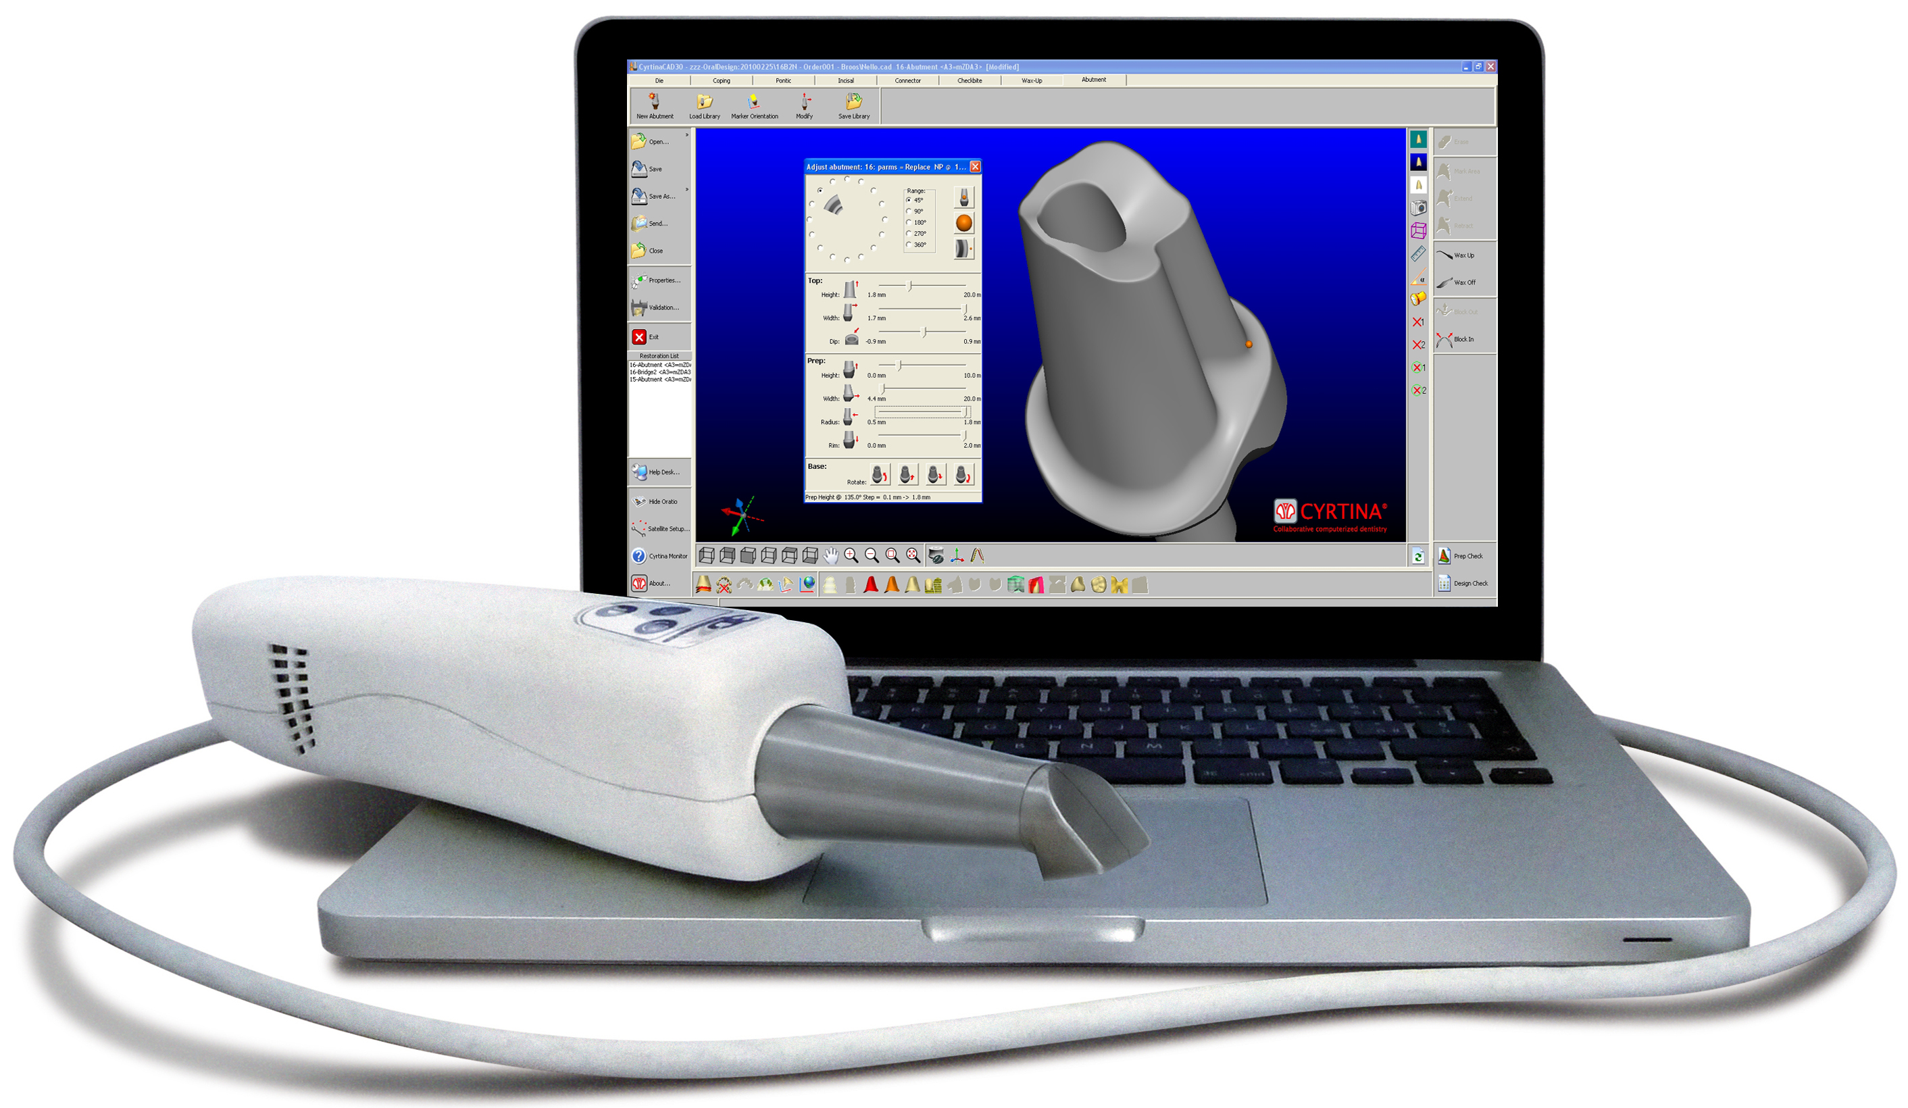
The light rays reflected at each focal plane 7a, 7b and 7c pass through the lens assembly 4, 5, 8 and are deflected at the beam splitter 2 in the direction of the second lens 5 where the image of the object 6 is detected in the focal plane 7.

Figure 23- 3D Progress portable system (34)

To attain the necessary imaging quality in all focal planes 7a, 7b and 7c an aspherical lens is employed as the movable lens thus the focal plane is not actually a plane but a curved surface and the scanned surfaces appear distorted: flat surfaces and straight lines appear curved, and the magnifications and curvatures at each position in the image differ. So it is necessary to compensate such distortions. The theoretical distortions are known, since the shape of the image surface was computed by the optimization program, the result of which can be used to compensate the distortions. The curvatures can be mapped and approximated by a mathematical function such as e. g., a polynomial (21).
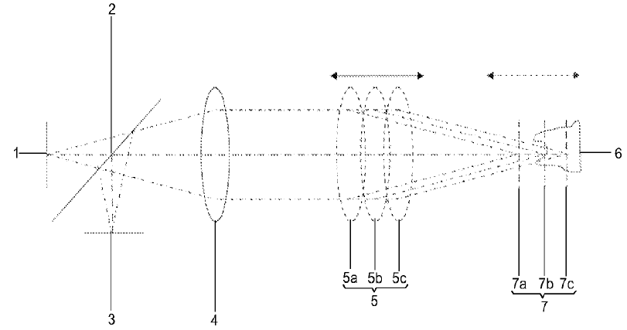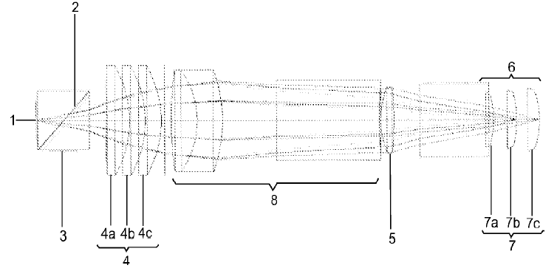
Figure 24- optics for a confocal microscope as in prior art Figure 25- optics for a confocal microscope as in 3D Progress

- DirectScan by HINT – ELS GMBH (DE)
The Hint-ELs® GmbH was founded in 2000. The manager, Josef Hintersehr, has been working on the automation of dental technology since 1990, using CAD/CAM technology as the core of his work. The first serial product of the Hint-ELs® DentaCad System was introduced in 1998. Hint-ELs® digitizer systems (HiScan and HiScanµ) were developed in co-operation with the Fraunhofer Institute for Applied Optics and Precision Engineering, Jena (Germany).
The measuring system is based on the principle of human stereoscopic vision and on the principle of the linear projection: if straight lines are projected onto an object the lines will be curved around the object. This distortion of the lines allows conclusions to be drawn about the surface contour. The goal of this development has been a system for the exact measurement of single teeth and complete arches so, at the end of 2010 the company Hint-ELs® announced, for the first quarter of 2011, the launch of its directScan (Figure 26), a new intra-oral scanner provided for the digital impression taking, developed in co-operation with the researchers at the Fraunhofer Institute for Applied Optics and Precision Engineering (Figure 27).
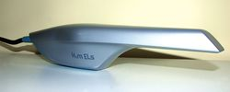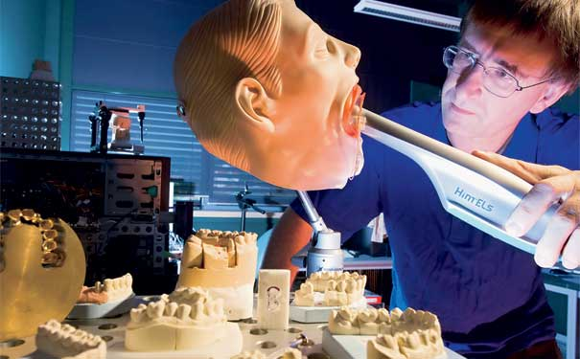
Figure 26-Hint-ELs ® directScan’s wand (35) Figure 27- Researcher Peter Kuhmstedt scans a model's mouth (36)

Hint-ELs ® DirectScan offers a measurement accuracy in the range 12-15 microns thus resulting more precise with respect tp many of the “popular” desktop scanning. The optical scanner takes a rapid sequence of pictures from various angles every 200 milliseconds, recording the surface and shape of every tooth or gap. The dentist then inputs the images into 3D software, which conducts a pixel-precise comparison to map the patient’s mouth. The output data of the intra-oral scanner can be placed in the standard STL file format and can be processed with both the CAD/CAM components of Hint-ELs and with other open systems. Afterwards the scan data can be automatically transferred via internet to a partner laboratory with a CAM machine. According to the manufacturer no dongle or license fees or update costs are paid when using the Hint-ELs DirectScan. The design software includes a virtual articulator and allows the modelling of fully anatomical inlays, crowns and large-span bridges. Even a partial anatomical reduction is possible.

- TRIOSTM by 3Shape A/S (DK)
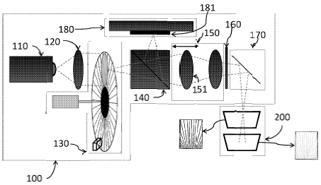
In December 2010 3Shape announced the launch of a new patient-friendly and high-performance intraoral scanning solution named TRIOSTM. 3Shape has developed a scanner solution that is accurate, fast and contains many ground-breaking features so the company is patenting a number of key functionalities of TRIOSTM. 3Shape has presented TRIOSTM at the International Dental Show (IDS) 2011 in Cologne, Germany in March. The highly acclaimed dental provider Heraeus Kulzer has signed up as the first partner and distributor for the TRIOSTM solution. The TRIOSTM system works according to the principle of confocal microscopy, with a fast scanning time. The light source provides an illumination pattern to cause a light oscillation on the object. The variation/oscillation in the pattern may be spatial and/or it may be time varying. The system realizes a variation of the focus plane of the pattern over a range of focus plane positions while maintaining a fixed spatial relation of the scanner and the object (view Figure 28). When a time varying pattern is applied a single sub-scan can be obtained by collecting a number of 2D images at different positions of the focus plane and at different instances of the pattern. As the focus plane coincides with the scan surface at a single pixel position, the pattern will be projected onto the surface point in-focus and with high contrast, thereby giving rise to a large variation, or amplitude, of the pixel value over time. For each pixel it is thus possible to identify individual settings of the focusing plane for which each pixel will be in focus. Then it is possible to transform the contrast information vs. position of the focus plane into 3D surface information, on an individual pixel basis. The 3D surface structure of the probed object is determined by finding the plane corresponding to an extremum in the correlation measure for each sensor in the camera's sensor array.
Figure 28 – Trios scanning system (22)

A fundamental characteristic of the system is the variation of the focal plane without moving the scanner in relation to the object being scanned. The focal plane should be continuously varied in a periodic fashion with a predefined frequency, while the pattern generation means, the camera, the optical system and the object being scanned is fixed in relation to each other. Further, the 3D surface acquisition time should be small enough to reduce the impact of relative movement between probe and teeth (22). The scanning system has the property of telecentricity in the space of the object being scanned and it is possible to shift the focal plane while maintaining telecentricity and magnification.

CONCLUSIONS
As a conclusion maybe you wish to know which intraoral scanning device is the best one. We think it is not possible to state this now, also because a lot of the examined devices are not commercially available and they are not still presented to the market. We shall wait their next presentation e.g. at the Chicago Midwinter Meetings or at the IDS / Cologne and only years of testing and competition will state which device works best. As a brief summary of the article we can consider the following comparative table.
Intraoral scanner | Company | Working principles | Light source | Imaging type | Necessity of coating | In-office milling | Output format | Commercial availability
CEREC®AC-Bluecam | Sirona Dental System GMBH (DE) | Active triangulation and confocal microscopy | Visible blue light | Multiple images | yes - titanium dioxide | yes | Landlord | Available
iTero | Cadent LTD (IL) | Parallelal confocal microscopy | Red Laser | Multiple | none | no | Landlord and STL | Available
E4D | D4D Technologies, LLC (US) | Optical coherence tomography and confocal microscopy | Laser | Multiple | occasionally | yes | Landlord | Available
Lava™C.O.S. | 3M ESPE (US) | Active wavefront sampling | Pulsating Visible blue light | Video | yes - titanium dioxide | no | Landlord | Available
IOS FastScan | IOS Technologies, INC. (US) | Active triangulation and Schleimpflug principle | Laser | 3 images | yes | no | STL | Not Available
DENSYS 3D | Densys LTD. (IL) | Active stereophotogrammetry | Visible light | 2 images | not disclosed | no | ASCII | Not Available
DPI-3D | Dimensional Photonics International, INC. (US) | Accordion fringe interferometry (AFI) | Wavelength 350 – 500 nm | Multiple images | none | no | Not disclosed | Not Available
3D Progress | MHT S.P.A. (IT) - MHT Optic Research AG (CH) | Confocal microscopy and Moireé effect | not disclosed | 3 images | occasionally | no | STL | Not Available
directScan | HINT - ELS GMBH (DE) | Stereoscopic vision | not disclosed | Multiple images | not disclosed | no | STL | Not Available
trios | 3Shape A/S (DK) | Confocal microscopy | not disclosed | Multiple images | not disclosed | no | Not disclosed | Not Available

REFERENCES

Birnbaum NS, Aaronson HB, Stevens C, Cohen B: 3D Digital Scanners: A High-Tech Approach to More Accurate Dental Impressions. Inside Dentistry; 2009; 5: 70-74.

Duret F and Termoz C, inventors: Method of and apparatus for making a prosthesis, especially a dental prosthesis. US Patent 4663720; 2010 May 5.

Brandestini M, Moermann WH, inventors: Method and apparatus for the three dimensional registration and display of prepared teeth. US Patent 4837732; 1989.

Schwotzer A, inventor: Measuring device and method that operates according to the basic principles of confocal microscopy. US Patent 2007/0296959; 2007.

Thiel F, Pfeiffer J, Fornoff P, inventors: Apparatus and method for optical 3D measurement. International Publication WO 2008/092791 A1; 2008.

Schmidt V, inventor: 3D dental camera for recording surface structures of a measuring object by means of triangulation. International Publication WO 2010/012838 A1; 2010.

Faulstich A, inventor: Optical projection grid, scanning camera comprising an optical projection grid and method for generating an optical projection grid. US Patent 2010/0026963 A1; 2010.

Babayoff N and Glaser-Inbari I, inventors: Imaging a three-dimensional structure by confocal focussing an array of light beams. International Publication WO 00/08415; 2000, Feb 17.

Babayoff N and Glaser-Inbari I, inventors: Method and apparatus for imaging three-dimensional structure. US Patent 2007/0109559; 2007, May 17.

Harrison L: Digital impressions competition booming. DrBicuspid.com; 2009, March 31: http://www.drbicuspid.com/index.aspx?sec=sup&sub=rst&pag=dis&ItemID=301650

Babayoff N, inventor: Method and apparatus for colour imaging a three-dimensional structure. US Patent 2010/0208275 A1; 2010, Aug 19.

Jacobson B: Taking the headache out of impressions. Dentistry Today 2007; 26(9):74-76

Quadling H, Quadling M, Blair A, inventors: Laser digitizer system for dental applications. US Patent 2010/0060900 A1; 2010, Mar 11.

Hart DP, Lammerding J, Rohaly J, inventors: 3-D Imaging System. US Patent 2004/0155975 A1; 2004, Aug 12.

Trissel RG, inventor: Polarizing multiplexer and methods for intra-oral scanning. US Patent 2007/0047079 A1; 2007, Mar 1.

Durbin DM, Durbin DA, inventors: Systems and methods for 3D previewing. US Patent 2009/033108 A1; 2009, Mar 12.

Durbin DM, Durbin DA, Dymek MJ, Warden L, inventors: 3D dental shade matching and apparatus. US Patent 2009/0133260 A1; 2009, May 28.

Ernst MM, Neta U, Cohen C, Geffen M, inventors: Three-dimensional modeling of the oral cavity. US Patent 2008/0273773 A1; 2008, Nov 6.

Shirley LG, Mermelstein MS inventors: Apparatus and methods for surface contour measurement. US Patent 5870191; 1999, Feb 9.

Dillon RF, Zhao B, Judell NHK, inventors: Intra-oral three-dimensional imaging system. International Publication WO 2009/058656 A1; 2009, May 7.

Berner M, inventor: Optical system for a confocal microscope. US Patent 2010/0085636 A1; 2010, Apr 8.

Fisker R, Öjelund H, Kjær R, Van Der Poel M, Qazi AA, Hollenbeck KJ, inventors: Focus scanning apparatus. International Publication WO 2010/145669 A1; 2010, Dec 23.

http://www.sirona.com/ecomaXL/index.php?site=SIRONA_COM_cerec_nl_2009-01

http://www.dentalblogs.com/archives/administrator-2/sirona-introduces-cerec%C2%AE-ac-powered-by-bluecam/

http://www.forb.it/viewdoc.asp?co_id=29

http://www.cerecwerx.com/cerec_photos.html

http://www.dentalproductsreport.com/articles/show/dpr0309_cl_money-saving-technology

http://dlpmagazine.com/articles/show/dlp0211_CE-YYD-COS

http://solutions.3m.co.za/wps/portal/3M/en_ZA/3M-ESPE/dental-professionals/solutions/dental-lab/lava-cos/

http://www.benco.com/About/News/Making_the_Switch_to_the_Lava_C_O_S_.aspx

http://www.prweb.com/releases/glidewell-dental-lab/ios-fastscan/prweb4313694.htm

http://mobile.glidewelldental.com/mobile/dentist/chairside-magazine/2011-v6-1/featured-articles/dr-d-clinical-tips.aspx

http://www.dphotonics.com/technology

http://www.cyrtina.nl/index.php?option=com_content&view=section&layout=blog&id=7&Itemid=5&lang=it

http://www.ddn-online.net/info/index.php?cat=5&id=88

http://scienceillustrated.com.au/blog/medicine/new-scanner-takes-3d-photos-of-your-teeth/

