ABSTRACT
The thesis entitled "Synthesis and Conformational Studies of Sugar Amino Acid based Peptidomimetics, total synthesis of Bitungolide-F and studies directed towards the total synthesis of 15G256γ" consists of three chapters.
CHAPTER-I: Deals with the synthesis and conformational studies of sugar amino acid based peptidomimetics.
This chapter is further divided into two parts:
PART-A: Describes the synthesis and conformational studies of 3,4-di-O-myristoylated
furanoid sugar amino acid containing analog of Leu-enkephalin.
PART-B: Describes the synthesis and conformational studies of 3,4-di-O-acylated-furanoid sugar amino acid containing analogs of the receptor binding inhibitor of vasoactive intestinal peptide.
CHAPTER-II: Describes the total synthesis of Bitungolide-F.
CHAPTER-III: Describes the studies directed towards the total synthesis of 15G256γ.
CHAPTER-I
PART-A: Synthesis and conformational studies of 3,4-di-O-myristoylated furanoid
sugar amino acid containing analog of Leu-enkephalin.
For the development of peptides as novel therapeutic agents, it is essential to get them delivered efficiently to their specific sites of action. In this connection, the transport of peptides across cell membranes through hydrophobic barriers assumes great importance and has attracted considerable attention in recent years. Peptides with low membrane permeability have been modified covalently by attaching fatty acid moieties to their C- or N-termini to increase their abilities to penetrate the cells’ lipid membranes. As part of our ongoing project on sugar amino acid based molecular designs, we were interested in developing O-acylated furanoid sugar amino acids as novel peptide building blocks to find out their effects on peptide conformation and their roles in getting the peptides delivered into the cells. The advantages of sugar amino acids as building blocks are largely due to their protected/unprotected ring hydroxyl groups that can influence the hydrophobic/hydrophilic nature of the peptides derived from them. Acylation of the hydroxyl groups of a glucose-derived furanoid sugar amino acid (Gaa) with n-butanoyl, n-octanoyl and myristoyl groups furnished compounds 1-3, respectively. Insertion of one of these acylated Gaas’ 3 into the Gly-Gly segment of Leu-enkephalin led to the di-O-myristoylated analog 4 (Scheme-1). In Part-A of Chapter-I we describe the synthesis of the acylated derivatives 1-3 of Gaa as novel peptide building blocks and the detailed conformational analysis of the di-O-myristoylated Gaa 3 containing Leu-enkephalin analog 4 by various NMR techniques and constrained molecular dynamics (MD) simulation studies.
To prepare the dipeptide isosters 1-3, we started our synthesis from 3,4-di-O-benzyl-1,2:5,6-di-O-isopropylidine-D-Mannitol (5), which was prepared from D-Mannitol in two steps following the reported procedures (Scheme-2). Controlled deprotection of compound 5 with conc.HCl in MeOH gave the desired diol 6 in 66% yield (based on recovered starting material). The diol when treated with p-toluenesufonyl chloride in presence of triethylamine and catalytic amount of 4-dimethylaminopyridine (DMAP), underwent monotosylation at the primary hydroxyl group giving tosylate intermediate 7 which was treated immediately with NaN₃ in DMF at 80 ºC resulting in the nucleophilic displacement of sulfonate with the azido group, giving the azide intermediate 8 in 95% yield. Deprotection of compound 8 with conc.HCl in MeOH gave the desired triol 9 in 66% yield. Now, the triol is selectively tosylated with p-toluenesufonyl chloride in pyridine and catalytic amount of DMAP to give monotosyl product 10. Further reaction of 10 with K₂CO₃ in MeOH afforded the furanoid compound 11 in 75% yield. Next, the azide group was reduced to amine by using TPP in MeOH, protected in situ with Boc₂O to furnish the Boc protected compound 12 in 80% yield. Oxidation of 12 with CrO₃-py in the presence of acetic anhydride and t-butanol provided the t-butyl ester of the D-gluconic acid 13 in 70% yield. Removal of the Bn-protective groups was achieved by hydrogenation using Pd(OH)₂-C as catalyst to get a diol intermediate 14 in 85% yield. The diol 14 was acylated by reacting with n-butanoic acid in the presence of 1,3-dicyclohexylcarbodiimide (DCC) and a catalytic amount of DMAP to give the diacylated product 15 in 65% yield. Treatment of 15 with trifluoroacetic acid (TFA) deprotected both the C- and N-termini and the N-terminal was again protected using Boc₂O to furnish the desired product 1 in 80% yield. The same protocol was used to prepare the di-O-octanoyl derivative 2 and the di-O-myristoylated product 3.
Di-O-myristoylated derivative of Gaa 3 was used in the synthesis of the Leu-enkephalin analog 4 following standard solution phase peptide synthesis methods using 1-ethyl-3-(3-(dimethylamino)propyl)carbodiimide hydrochloride (EDCI) and 1-hydroxybenzotriazole (HOBt) as coupling agents and dry DMF and/or CH₂Cl₂ as solvents. While the tert-butoxycarbonyl (Boc) group was used for N-protection, the C-terminal was protected as a methyl ester (OMe). Deprotection of the former was done in TFA-CH₂Cl₂ (1:1). In the racemization free fragment condensation strategy that was followed, compound 3 was first coupled with the dipeptide H-Phe-Leu-OMe 16 as efficiently as with any normal amino acid using the reagents mentioned above to give the tripeptide Boc-Gaa(Myr₂)-Phe-Leu-OMe (Myr = myristoyl) 17 in 70% yield (Scheme-3). After removal of the Boc-protection, the resulting tripeptide, H-Gaa(Myr₂)-Phe-Leu-OMe 18, was reacted with Boc-Tyr(2-Br-Z)-OH and subsequently hydrogenated using Pd(OH)₂-C in EtOAc to furnish the final peptide 4 in 60% yield. The final product 4 was purified by standard silica gel column chromatography and fully characterized by spectroscopic methods earlier to the conformational studies.
Scheme-3
Conformational Studies:
Conformational analysis of the purified peptidomimetic 4 was carried out by extensive NMR studies including TOCSY and ROESY experiments and molecular dynamics (MD) studies. Variable-temperature studies were carried out between 30 and 70 °C in DMSO-d₆ to measure the temperature coefficients (Δδ/ΔT) of the amide proton chemical shifts, which were used to determine their involvement in intramolecular hydrogen bonds.
These studies revealed that the compound 4 established a well-defined β-turn structure in DMSO-d₆ with an intramolecular hydrogen bond between PheNH → TyrCO (Figure 1). The observed 10-membered H-bond between AA^{i+1}-NH → AA^{i−1}-CO (AA^{i} is Gaa) is similar to those reported by Chakraborty et al earlier in benzyl-protected Gaa oligomers and by Fleet et al in acetate- and acetonide-protected ones.
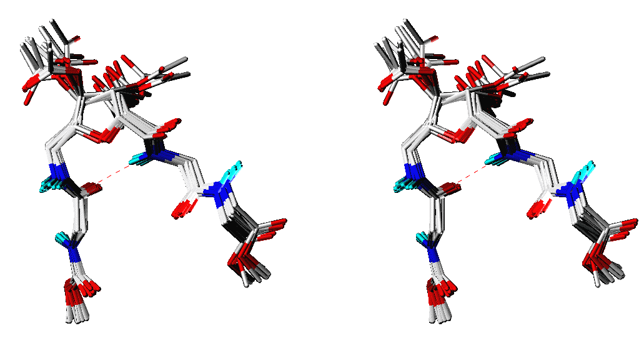
Figure 1
Left: Schematic representation of the proposed structure of 4 with some of the prominent long-range rOes seen in its ROESY spectrum.
Right: Stereoview of the 12 backbone-superimposed energy-minimized structures of 4, sampled during 20 cycles of the 120 ps constrained MD simulations following the Simulated Annealing protocol. For clarity in viewing, only the backbones are shown here omitting the amino acid side-chains, fatty acid chains and all hydrogens except the amide protons

It is worth noting here that unlike in sugars with free hydroxyls, where an unusual pseudo β-turn with a 9-membered H-bond was observed between AA^{i+2}-NH → AA^{i}-C3OH (AA^{i} is Gaa), in the fatty acylated furanoid sugar amino acid containing peptide 4, we observed a 10-membered H-bond between AA^{i+1}-NH → AA^{i−1}-CO (AA^{i} is Gaa).

PART-B: Synthesis and conformational studies of 3,4-di-O-acylated furanoid sugar amino acid containing analogs of the receptor binding inhibitor of vasoactive intestinal peptide.
Receptors for Vasoactive Intestinal Peptide (VIP), a widely distributed naturally occurring neuropeptide, are over-expressed on a variety of malignant tumor cells that are also associated with the synthesis and secretion of detectable levels of the VIP by the malignant cells themselves. VIP acts as a growth factor and plays a dominant role in the sustained or indefinite proliferation of cancer cells. Therefore VIP receptor binding inhibitors have the potential to arrest the growth of malignant cells. The peptide sequence Leu¹-Met²-Tyr³-Pro⁴-Thr⁵-Tyr⁶-Leu⁷-Lys⁸ 1 is known to be one such VIP receptor binding inhibitor. The role of this octapeptide as a VIP receptor binding inhibitor and its anti cancer activities in combination with other neuropeptide analogs have been well established. Several novel analogs of this peptide containing α,α-dialkylated amino acids and its lipoconjugates have been synthesized and tested for their anti cancer activities. Earlier we have developed several analogs of this octapeptide 1 by replacing some of its amino acids by dideoxy furanoid sugar amino acids. Many of these analogs, like the tetrapeptide 2, showed either retention or enhancement of biological activities.
However, for the development of peptides as novel therapeutic agents, it is essential to get them delivered efficiently to their specific sites of action. To achieve this, many peptides have been modified covalently by attaching fatty acid moieties to their C- or N-termini. As part of our ongoing project on sugar amino acid based molecular designs, we were interested in developing 3,4-di-O-acylated derivatives of the peptide 2 for its improved therapeutic applications. It was also essential for us to ensure that the acylated analogs do not deviate from the bioactive conformation of the native peptide. In this connection, we were interested to synthesize the acylated derivatives 3-5 of the VIP receptor binding inhibitor 2 and to establish the detailed conformational analysis of the di-O-caprylated analog 4 by various NMR techniques and constrained molecular dynamics (MD) simulation studies.
For the synthesis of the peptidomimetic 4, we started from 6, which was prepared from D-Mannitol by the known procedure (Part-A, Chapter-I). Treatment of 6 with trifluoroacetic acid (TFA) deprotected both the C- and N-termini and the N-terminal was again protected using Fmoc-OSu to furnish the Fmoc-Gaa(OCOR)₂-OH 7 in 82-85% yield. The Fmoc-Gaa(OCOR)₂-OH 7 was used in the synthesis of VIP receptor inhibitor analogs 3-5 by standard solution phase peptide synthesis methods using 1-ethyl-3-(3-(dimethylamino)propyl)carbodiimide hydrochloride (EDCI) and 1-hydroxybenzotriazole (HOBt) as coupling agents and dry CH₂Cl₂ as solvent. The tripeptide Fmoc-Gaa(OCOR)₂-Tyr(^{t}Bu)-Leu-OMe 8 was prepared by the condensation of the Fmoc protected free acid 7 with the dipeptide H-Tyr(^{t}Bu)-Leu-OMe following the above protocol in 70-75% yield. Deprotection of the N-terminal of the tripeptide 8 with 20% piperidine in dry CH₂Cl₂ and coupling of the resulting free amine with Boc-Met-OH gave the required peptides 3-5 in 72-80% yield. The final products were purified by standard silica gel column chromatography and fully characterized by spectroscopic methods earlier to the conformational studies (scheme-1).
Scheme-1
Conformational Studies:
Conformational analysis of the purified peptidomimetic 4 was carried out by extensive NMR studies including TOCSY and ROESY experiments and molecular dynamics (MD) studies. Variable-temperature studies were carried out between 30 and 70 °C in DMSO-d₆ to measure the temperature coefficients (Δδ/ΔT) of the amide proton chemical shifts, which were used to determine their involvement in intramolecular hydrogen bonds.
These studies revealed that the compound 4 established a well-defined β-turn structure in DMSO-d₆ with an intramolecular hydrogen bond between TyrNH → MetCO. The prominent rOes observered for peptidomemtic 4 and the results of the constrained MD simulations studies were shown in Figure-2.
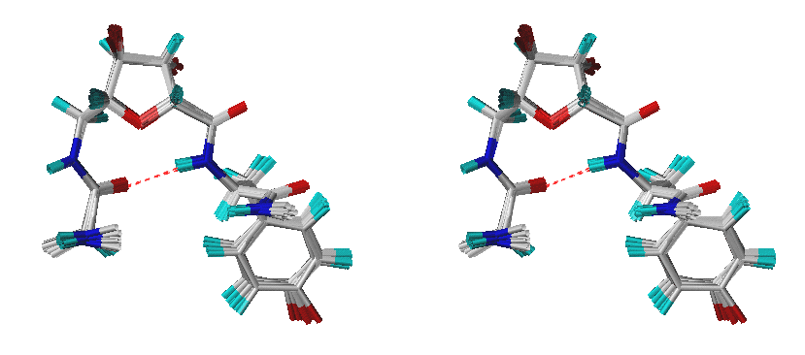

Figure 2

Left: Pictorial representation of possible roe cross peaks in the peptide 4.
Right: Stereoview of the 11 backbone-superimposed energy-minimized structures sampled during 20 cycles of the 120ps constrained MD simulations following the Simulated Annealing protocol. For the sake of clarity in viewing, only the backbones are shown here omitting the amino acid side chains, and fatty acid chains.

In conclusion, structural analysis of the di-O-caprylated Gaa containing analog of the receptor binding inhibitors of vasoactive intestinal peptide by various NMR techniques and constrained molecular dynamics (MD) simulation studies established a well-defined β-turn structure in DMSO-d₆ with an intramolecular hydrogen bond between TyrNH → MetCO, similar to that seen earlier in 2.
CHAPTER-II
Total synthesis of Bitungolide-F:
Bitungolide-F (1) is one of the metabolites isolated from the Indonesian sponge theonella cf.swinhoei (family theonellidae). The bitungolides are a new class of Theonella metabolites that inhibit dual-specificity phosphatase VHR. When bitungolides were assayed against 3Y1 rat normal fibro blast cells, a cytotoxic effect was observed at 10 μg/mL. The structures of bitungolides are elucidated by spectroscopic data and X-ray diffraction analysis.
We have successfully achieved the first total synthesis of Bitungolide-F in optically pure form following an efficient, convergent approach. The retro synthesis is shown in Scheme-1.
Scheme-1
It was envisioned from Scheme-1, that 2 which could be obtained from 4 via ring-closing metathesis, can be subjected to Horner-Wadsworth-Emmons reaction followed by functional transformations to lead to 1. The precursor 4 could easily be obtained by protection group manipulation of 5, and which in turn could be derived by a stereoselective 1,3-anti reduction using Evans’ protocol from 6. The keto phosphonate 8 and the aldehyde 7 would provide 6. While 8 could easily be obtained from the commercially available S-(-)-malic acid, 7 could be prepared from a diastereoselective aldol reaction of L-phenyl alanine derived chiral auxiliary 9 and an aldehyde 10. Aldehyde 10 could be easily prepared from commercially available (R)-(-)-3-hydroxy-2-methylpropionate 11.
Synthesis of aldehyde 10 commenced with the TBDPS protection of commercially available (R)-(-)-3-hydroxy-2-methylpropionate 11 to give 12, which on LiBH₄ reduction, followed by Swern oxidation gave aldehyde 10. Crimmin’s modified Evans Syn-aldol reaction between aldehyde 10 and the chiral oxazolidinone 9, gave the aldol product which upon subsequent reductive removal of chiral auxiliary followed by protection yielded compound 13 and was further treated with TBAF to give free alcohol which on oxidation under Swern conditions provided 7 (Scheme-2).
Scheme-2
For the synthesis of phosphonate 8, we started from S-(-)-malic acid, in which both the carboxyl groups were methylated using MeOH and cat. conc. H₂SO₄. Selective reduction of the C1-methyl ester using BH₃:DMS and cat. NaBH₄ gave 14. Selective protection of primary hydroxyl as TBDPS ether and secondary as TES ether furnished compound 15 which was reacted with the phosphonate 16 to give 8 (Scheme-3).
Ketophosphonate 8 and aldehyde 7 were coupled using LiCl and DIPEA to give 17, which was subjected to hydrogenation in the presence of Pd/C followed by the deprotection of TES to furnish compound 6. Hydroxy directed 1,3-anti reduction of the keto alcohol 6 using Me₄NBH(OAc)₃ following Evans’ procedure furnished compound 18 with excellent diastereoselectivity (>20:1). Deprotection of TBDPS using TBAF gave the triol 19. The primary hydroxyl of the resulting triol 19 was selectively protected as TBS ether followed by protection of secondary hydroxyls as TIPS ethers using TIPSOTf resulting in the compound 20. PMP opening of 20 was achieved selectively from the less hindered side by using DIBAL-H to give the primary alcohol 21. One cabon homologation of 21 using Wittig olefination followed by deprotection of PMB with DDQ furnished compound 22 which was acrylated using acrylolyl chloride gave the compound 4 (Scheme-4).
Scheme-4
RCM reaction of the diene 4 using Grubbs’ 1st generation catalyst furnished the unsaturated lactone 23 which when subjected to TBS deprotection by using cat. CSA followed by the oxidation of primary hydroxyl using Dess-Martin periodinane to give the aldehyde 2. Horner-Wadsworth-Emmons olefination reaction between the aldehyde 2 and phosphonate 3 (prepared by refluxing cinnamyl bromide and P(OEt)₃) gave 24 which when subjected to desilylation using HF:Py complex furnished the target molecule 1 (Scheme-5).
Our synthetic Bitungolide-F (1) showed a specific rotation value of [α]_{D}²⁶ = -42.8 (c 0.035, CHCl₃); [lit value: [α]_{D}²⁷ = + 43.0 (c 0.45, CHCl₃)] to confirm that the natural isomer is the enantiomer of 1 and was identical in all other respects (¹H NMR, ¹³C NMR, Mass and IR spectroscopic data) with the natural one. In conclusion we have successfully achieved the total synthesis of Bitungolide-F (1) and established its absolute configuration.
CHAPTER-III
Studies directed towards the total synthesis of 15G256γ:
15G256γ (1) is one of the lipodepsipeptide isolated from the marine fungus Hypoxylon Oceanicum. The molecule is a 13 membered macrocycle containing D-glutamate, L-serine, rare amino acid β–ketotryptophan and 2,4-dimethyl-3-oxy-dodecanoic acid. The compound 1 showed strong anti-fungal activity. The structure determination of 15G256γ was achieved by ¹H NMR, ¹³C NMR and mass spectroscopic analysis.
The Yamaguchi macro lactonization approach was contemplated to construct the macrocyclic ring of 15G256γ 1. Retrosynthetic analysis (Scheme-1) reveals that an acyclic precursor like 2 was ideally suited to carry out the planned Yamaguchi reaction. Coupling the aliphatic fatty acid unit 3 with the tripeptide fragment 4 could easily assemble compound 2. The 2,4-dimethyl-3-oxy-dodecanoic acid fragment 3 could easily be obtained from the epoxide 5 and that in turn could be prepared from the chiral auxiliary coupled decanoic acid 6. It was envisioned that the other crucial tripeptide 4 could be prepared following the usual solution phase peptide synthesis methods by the coupling of protected D-glutamic acid 7 with the dipeptide 8. The compound 8 could easily be obtained by the coupling of L-trytophan derived 9 and L- serine derived 11.
Scheme-1
The synthesis started with the coupling of D-phenyl alanine based chiral auxiliary 12 and C₉H₁₉CO₂H to give the compound 6, which was then subjected to diastereoselective alkylation using NaHMDS and MeI to furnish compound 13 with excellent diastereoselectivity (>98% de). Reductive removal of the chiral auxiliary using LiBH₄ and oxidation gave the aldehyde 14. Two-carbon homologation of the aldehyde 14 followed by reduction with DIBAL-H produced the allylic alcohol 15.
Sharples asymmetric epoxidation of the allylic alcohol provided the epoxide 5 which was opened with Me₂CuLi and subsequent oxidative cleavage of the minor 1,2-diol with NaIO₄ gave 16. The diol 16 was subjected to routine protecting group manipulations to get 17, which when subjected to a two-step oxidation sequence provided the aliphatic acid fragment 3 (Scheme-2).
For the synthesis of the tripeptide fragment 4, we started by coupling compound 9 and 11 (prepared by treating Boc-Ser(OBn)-OMe with TFA) using EDCI and HOBt to get the dipeptide 18 which was converted to 19 by oxidation at β-carbon using DDQ followed by transesterification with K₂CO₃ and allylic alcohol. Boc deprotection of 19 using TFA provided 8 as its TFA salt. Peptide coupling of the amine 8 and acid 7 (prepared in two steps by following the reported procedure) using EDCI and HOBt as coupling agents provided the tripeptide 4 (Scheme-3).
Scheme-3
Treatment of compound 4 with TFA provided the free amine as its TFA salt which was coupled with the acid 3 using EDCI and HOBt to provide 20. Desilylation of 20 was achieved using CSA followed by deallylation using Pd[PPh₃]₄ to give the seco acid 2.
Scheme-4
Many efforts made for cyclizing the seco acid using Yamaguchi macro lactonization procedures in different conditions met with complete failure or decomposition of the starting material (Scheme-4).
After the major setback in the macrolactonization step, we thought that the preparation of the deoxo analog 21 would help in achieving the total synthesis of 1. The retro synthesis for the deoxo analog 21 is shown in the Scheme-5.
Compound 3 was converted into its methyl ester using CH₂N₂ followed by the deprotection of TBS by CSA to give the compound 27 which was subjected to saponification using LiOH giving 23. Treatment of compound 28 with TFA provided the free amine as its TFA salt 26 which was coupled with the acid 9 using EDCI and HOBt followed by the Boc deprotection using TFA to furnish the amine 25 as its TFA salt. Peptide coupling of the acid 7 and the amine 25 using EDCI and HOBt provided the tripeptide 24, which was deprotected at the N-terminus with TFA and coupled with 23 to give the seco acid 22 (Scheme-6).
Now the stage is set for the crucial macrolactonization reaction. But the attempts resulted in no cyclized product (Scheme-7). This setback forced us to follow the macrolactamization method.
Scheme-7
Scheme-8
The retrosynthesis for the macrolactamization approach for the synthesis of the target compound 21 is shown in Scheme-8. Compound 29 could be prepared by coupling compounds 30 and 31. Compound 30 could easily be obtained by coupling the compound 32 and 33. Compound 31 could easily be prepared by usual solution phase peptide synthesis methods using acid 7 and amine 34.
Selective protection of the primary hydroxyl of 20 as TBS ether followed by the DCC, DMAP mediated coupling of the resulting alcohol with Boc-Ser(OBn)-OH 32 gave compound 35 which on further desilylation gave the compound 30. On the other hand dipeptide fragment 31 was prepared by coupling the amine 34 and acid 7 using EDCI and HOBt followed by deallylation using Pd[PPh₃]₄ (Scheme-9).
Scheme-9
Compound 30 was subjected to Boc deprotection using TFA to give the free amine and was coupled to the acid 31 in the presence of EDCI and HOBt to furnish the target compound 29. Oxidation of primary hydroxyl of 29 using SO₃:Py resulted in an unidentified product (Scheme-10).
This failure forced us to prepare the compound 36 whose retrosynthesis is shown in Scheme-11. We assumed that the oxidation of 30 to acid and further coupling might give better results in attaining the target compound 21.
The synthesis started from the two-step oxidation sequence of the primary alcohol 30 to furnish the desired acid fragment 37. Compound 38 was subjected to Boc deprotection using TFA to give the free amine and was coupled with the acid 37 in the presence of EDCI and HOBt to furnish the compound 40, which was deprotected at the N-terminus using TFA and coupled with 39 using EDCI and HOBt as coupling agents to give the compound 36 (Scheme-12).
Deallylation of the compound 36 using Pd[PPh₃]₄ in THF resulted in an unidentified compound (Scheme-13). Many attempts to deprotect the allyl ester met with complete failure leaving the total synthesis still elusive.

Scheme-13

