Chapter-I
(General introduction
Tuberculosis is a dreadful disease caused by bacteria called Mycobacterium tuberculosis and responsible for more human deaths than any other single infectious disease. It is estimated that, about one third of the world’s population is infected with this disease. According to World Health Organization, approximately 8 million people contact TB annually with almost 2 million deaths. Furthermore, treatment of this disease caused by resistant bacteria is more difficult in immuno-compromised patients such as those infected with human immunodeficiency virus (HIV). For these reasons, there is an overwhelming need to develop novel antimycobacterial agents with different mechanism of action aimed at a better understanding of antimycobacterial resistance
Chapter-II
Synthesis and Antimycobacterial Evaluation of nitroheterocyclic Based 1,2,4-Benzothiadiazines

The importance of nitrofurans and the isosteric nitrothiophenes as antimicrobial agents is well documented. Although a lot of work has been done on these heterocycles, they still remained an active area of research interest. The antimicrobial activity of nitroheterocycles is mainly due to the metabolic reduction of their nitro group by a class of enzymes called nitroreductases.

Sulfonamide derivatives have demonstrated potential antibacterial, anticancer, anti-inflammatory activities in the literature and benzothiadiazines can be considered as cyclic sulfonamide class of molecules. These compounds have been extensively studied as potassium channel openers. Moreover, this ring system has also been known for antimicrobial activity. Based on these findings, recently we have reported the synthesis and evaluation of antimycobacterial activity of these molecules by coupling with pyrazine carboxylic acid derivatives. Keeping the importance of the nitroheterocycles in mind and in continuation of our studies on antimycobacterials particularly benzothiadiazines, herein we have reported the synthesis of 5-nitrofuran, 5-nitrothiophene and arylfuran coupled benzothiadiazines and evaluated them for their antimycobacterial and antibacterial activities.

Table 1. Antibacterial activity and antimycobacterial activity of 3-benzothiadiazinyl hydrazone (5a-g) and hydrazide derivatives (7a-k) (MIC in μg/mL)

Compd | M. tuberculosis H₃₇Rv | S. aureus | E. coli | P. aeruginosa | B. Subtilis
5a | 8 | 37.5 | 18.75 | 150 | 37.5
5b | 8 | 37.5 | 37.5 | 150 | 18.75
5c | 8 | 37.5 | 18.75 | 150 | 9.37
5d | 16 | 18.75 | 18.75 | 150 | 18.75
5e | 4 | 18.75 | 18.75 | 150 | 18.75
5f | 1 | 75 | 37.5 | 150 | 37.5
5g | 4 | 37.5 | 18.75 | 150 | 37.5
7a | 32 | 37.5 | 18.75 | 150 | 18.75
7b | 32 | 150 | 18.75 | 150 | 18.75
7c | 8 | 37.5 | 18.75 | 150 | 75
7d | 4 | 37.5 | 18.75 | 150 | 18.75
7e | >100 | 18.75 | 37.5 | 75 | 37.5
7f | >100 | 9.37 | 18.75 | 150 | 18.75
7g | >100 | 18.75 | 75 | 150 | 37.5
7h | >100 | 75 | 18.75 | 150 | 37.5
7i | >100 | 18.75 | 18.75 | 75 | 37.5
7j | >100 | 75 | 75 | 150 | 37.5
7k | >100 | 18.75 | 18.75 | 150 | 37.5
NF | -- | 18.75 | 18.75 | 150 | 18.75
RMP | 0.12 | - | - | - | -
INH | 0.5 | - | - | - | -
NF, Nitrofurantoin; RMP, Rifampicin; INH, Isoniazid.

Chapter –III
Section-A
Synthesis and Biological Evaluation of a New Series of Benzothiazole-Benzothiadiazine Conjugates As Antibacterial Agents

Benzothiazole derivatives have shown diverse biological properties such as antibacterials, anticancer, antirheumatic, anti-inflammatory etc. Basing on the importance of benzothiazoles and benzothiadiazines, an attempt has been made to synthesize new hybrids of benzothiadiazines and benzothiazoles with the aim of improving the efficacy of the antibacterial activity.
The synthesized compounds have also been evaluated for their DNA gyrase inhibition. Some of the tested compounds have exhibited moderate gyrase inhibitory activity in comparison to ciprofloxacin, thus indicating the possibility of somewhat similar mode of action. As far as we know, this is the first report for the DNA gyrase inhibition of these new hybrids. Therefore, we have investigated the molecular docking studies of these compounds in comparison to the ciprofloxacin using GOLD v 2.0 program and shown in ball and socket model (Fig. 2 and 3). Binding energy of benzothiazole hybrids with DNA gyrase is found to be 21.95 kcal/mol as compared to ciprofloxacin 42.31 kcal/mol. Moreover, one of the oxygen S=O (1.604 Å) atom of sulfone group is forming hydrogen bonding with minor groove of DNA, whereas two hydrogen bonds are formed, one from the C=O (1.622 Å) oxygen atoms of ring and another from the acid group C=O (2.196 Å) between minor groove of DNA. However, it requires further detailed investigations for a larger number of compounds of this type of ring system to provide a clear understanding of the mechanism of action for this new class of hybrids.

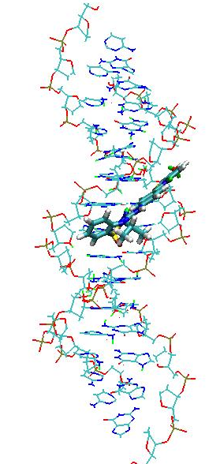

Figure 2. Molecular docking of benzothiazole hybrid (9f) into DNA gyrase, one of the oxygen of sulfone group participates in hydrogen bonding with minor groove of the DNA.

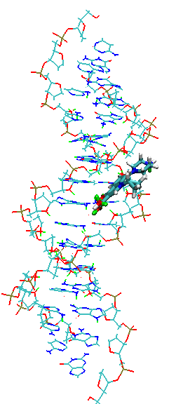

Figure 3. Molecular docking of ciprofloxicin into DNA gyrase, oxygen atoms of two C=O groups, one from the ring and another from the acid group are forming hydrogen bondings with minor groove of the DNA.

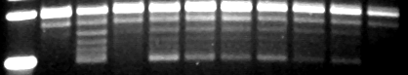
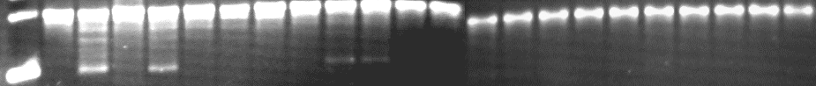
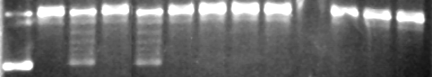
1 2 3 4 5 6 7 8 9
1 2 3 4 5 6 7 8 9
1 2 3 4 5 6 7 8 9
R
S
R
S
R
S
(a)
(c)
(b)

Figure 1. DNA gyrase supercoiling inhibition assay. The assays were performed as described general procedure section. The enzyme was incubated with indicated concentrations of the compounds before the addition of rest of the components. In all the figures (1a, 1b and 1c) lane1: supercolied DNA, lane2: relaxed DNA substrate, lane 3: supercoiling reaction, lane 4: supercoiling reaction in presence of 10 mg/ml ciprofloxacin. 5% DMSO was used as a solvent control in supercoiling reaction in lane 5. (a) 50 mg/ml of compounds 9g, 9f, 9e and 9d were used in lanes 6, 7, 8 and 9 respectively. (b) 40 mg/ml of compounds 9g, 9f, 9e and 9d were used in lanes 6, 7, 8 and 9 respectively. (c) 30 mg/ml of compounds 9g, 9f, 9e and 9d were used in lanes 6, 7, 8 and 9 respectively. R- relaxed DNA, S – supercoiled DNA.

Table 1. Antibacterial activity of 3-[4-(1,3-benzothiazol-2-yl)anilino]-4-alkyl-1,4-dihydro-1λ⁶,2,4-benzothiadiazine-1,1-diones (9a-g) (MIC in μg/mL)
Compd | X | Y | R | Gram positive |  | Gram negative |  |  | DNA gyrase  (MIC μg/mL).
 |  |  |  | BS | SA |  | EC | PA
9a | H | H | C₂H₅ | 18.75 | 18.75 |  | 9.37 | 150 |  | -
9b | H | Cl | CH₃ | 18.75 | 9.37 |  | 9.37 | 150 |  | -
9c | H | H | CH₃ | 18.75 | 18.75 |  | 9.37 | 150 |  | -
9d | H | H | (CH₃)₂CH | 75 | 18.75 |  | 75 | 150 |  | 30
9e | Br | H | (CH₃)₂CH | 18.75 | 18.75 |  | 37.5 | 150 |  | 30
9f | OH | H | (CH₃)₂CH | 37.5 | 18.75 |  | 37.5 | 150 |  | 30
9g | OH | H | CH₃ | 18.75 | 9.37 |  | 37.5 | 150 |  | 30
Amp |  |  |  | 18.75 | 9.37 |  | 9.37 | 150 |  | -
Cipro |  |  |  | - | - |  | - | - |  | 10
The organisms tested are as follows: BS = Bacillus subtilis, SA = Staphylococcus aureus, EC = Escherichia coli, PA = Pseudomonos aeruginosa. Amp = ampicillin; Cipro = ciprofloxacin; -, not tested.

a new series of 3-[4-(1,3-benzothiazol-2-yl)anilino]-4-alkyl-1,4-dihydro-1 λ⁶,2,4-benzothiadiazine-1,1-diones derivatives (9a-g) has been synthesized and evaluated for their antibacterial activity. Most of the compounds were found to be equipotent in activity with ampicillin against all the bacterial strains tested.These findings will assist the researchers in the development of new class cyclic sulfonamide based antibacterial agents
Chapter –III
Section - B
Design, Synthesis And Anti bacterial Activity Of Novel Quinolone Hybrids
Quinolones are synthetic antibacterial compounds based on a 4-quinolone skeleton. Fluoroquinolones have been clinically successful and are used to treat bacterial infections in both community and hospital settings. Quinolones target bacterial type II topoisomerases, generally DNA gyrase in Gram-negative bacteria and DNA topoisomerase IV in Gram-positive bacteria. Most of the quinolones currently on the market or under development have only moderate activity against many Gram-positive cocci, including Staphylococci and Streptococci. This insufficient activity has not only limited their use in infections caused by these organisms, such as respiratory tract infections, but has also been believed to be one of the reasons for the rapidly developing quinolone resistance. Therefore, recent efforts have been directed toward the synthesis of new benzothiazole derived quinolone antibacterials that can provide improved Gram-positive antibacterial activity, some of the quinolone based structure are

ChapterIVA
Section -A
Oxathioacetalization, thioacetalization and transthioacetalization of carbonyl compounds by N-bromosuccinimide: selectivity and scope
The protection of carbonyl compounds as acetals, dithioacetals and oxathioacetals is an important aspect of the total synthesis of complex natural products. Among these, oxathioacetals and dithioacetals are important because they are considered more stable than the corresponding O,O-acetals under acidic conditions and are also useful in organic synthesis as acyl carbanion equivalents in C-C bond forming reactions.2 Moreover, S,S-acetals can be used as intermediates for the conversion of the carbonyl function to the parent hydrocarbons. In view of the potential applications of 1,3-oxathiolanes and thiolanes, it is important to search for newer and efficient synthetic methodologies for the preparation of these compounds. In general they are prepared by protic or Lewis acid-catalyzed condensation of carbonyl compounds with 2-mercaptoethanol, thiols and dithiols.10 Transthioacetalization of acetals is a useful transformation for the preparation of S,Sacetals and in comparison with thioacetalization of carbonyl compounds, it is a faster and cleaner reaction
In spite of a number of reports employing conventional catalysts for the protection of carbonyl compounds, the search for new catalysts is still actively pursued to address such problems as harsh reaction conditions and poor chemoselectivity. In addition, environmental and economic considerations have prompted us to redesign these commercially important processes. As a result, there is further scope to explore mild and efficient methods for oxathioacetalization and transthioacetalization. N-Bromosuccinimide (NBS) is an important reagent not only for bromination, but also for a range of other reactions. Depending upon the nature of the reactant and reaction conditions in solution, NBS reacts differently with many organic compounds and recently, we have reported dithioacetalization of carbonyl compounds using NBS.

Table 1. Oxathioacetalization of carbonyl compounds
Entry | Product | Time | Yield %
a |  | 2.0 | 75
b |  | 2.5 | 80
c |  | 2.0 | 70
d |  | 2.5 | 75
e |  | 2.0 | 76
f |  | 2.0 | 68
g |  | 2.5 | 63
h |  | 1.5 | 73
i |  | 3.0 | 80
j |  | 2.5 | 78
k |  | 3.0 | 58
l |  | 3.0 | 64

Table 2.
Thioacetalization and trans thioacetalization of carbonyl compounds
Entry | Acetal (1) | Product (2) | Time (min) | Yield (%)
a |  |  | 10 | 91
b |  |  | 12 | 87
c |  |  | 15 | 90
d |  |  | 10 | 78
e |  |  | 10 | 90
f |  |  | 20 | 75
g |  |  | 20 | 85
h |  |  | 20 | 73
i |  |  | 15 | 80
j |  |  | 25 | 57
k |  |  | 20 | 85
l |  |  | 25 | 79

Section - B

Bi(OTf)₃-Catalyzed regioselective ring opening of epoxide with phenols: facile synthesis of 1,3-diaryloxy-2-propanols
Substituted aryl oxiranes undergo the facile ring opening with phenols in presence of catalytic amount of bismuth (III) triflate to afford 1,3-diaryloxy-2-propanols in excellent yields under mild conditions. Bismuth (III) triflate is relatively non-toxic, easy to handle and inexpensive, which makes this procedure particularly attractive for large scale synthesis

The high regioselectivity in the epoxide ring opening with bismuth (III) triflate can be explained by the in situ formation of complex between epoxide and bismuth (III) triflate, which undergoes SN² attack of phenols at less hindered C-3 carbon to give secondary alcohol exclusively (Scheme 2). In the present investigation among the various solvents examined for the epoxide ring opening with phenols, dichloromethane was better solvent under these conditions. However, in the absence of bismuth (III) triflate the reaction did not proceed even under reflux conditions and prolonged reaction time (1, 2 days).

