DEMO: A wireless router for “free” Public Access Internet Service for Government Digital Services
Althaff Mohideen, Hassan Hamdoun, Gorry Fairhurst, Fiona Williams, Lorna Philip and John Farrington
dot.rural Digital Economy hub, University of Aberdeen
Aberdeen
UK
{althaff.mohideen, hassan.hamdoun, g.fairhurst, fiona.williams, l.philip, j.farrington }@abdn.ac.uk

ABSTRACT
The Public Access Wi-Fi Service (PAWS) project is developing innovative methods and service models to enable ubiquitous access to online services in support of the UK Government’s Digital by Default policy. This is expected to enable the benefits of the Digital Economy to extend to Government Services. To gain these benefits requires digital access to be available to all citizens. In a country where most already have some form of broadband, the challenge to be studied in PAWS is how to give access to the final hard-to-reach citizens scattered across the UK.

The project has defined a service model built around a wireless PAWS router that supports a multi-level service model, combining high-speed access (e.g. to government services), with ubiquitous (e.g. free) access to traditional Internet services. The platform has been deployed in a 12 month pilot and has been instrumented to collect usage data from the pilot sites to shed light on actual service requirements, user perception of a limited but free service and to enable deeper understanding of whether it is commercially viable to offer such services to people in the UK. This demonstration will showcase the PAWS router and demonstrate the services that it offers.
Keywords
Public Internet Access, WiFi communications, Traffic classes Government digital services, Digital Economy.

INTRODUCTION
The PAWS project leverages techniques such as rate-limiting, active queue management and differentiated service classes to provide a free Internet access for those with no broadband service. The project tasks and funding relate to different but complimentary deployment scenarios.
Rural-PAWS, the focus of this demo, seeks to serve households in hard-to reach locations using commercial satellite access service.
A public-access model can be provided over the same commercial ISP service, but makes the service publicly accessible to anyone registered with the system. These services provide high-speed access to government services and ubiquitous access to traditional Internet services.
A sister project, (which we will call Urban PAWS) explores how existing broadband connectivity can be shared to provide “free” access to government online services in densely populated urban areas ( Figure 3).The Urban context places different constraints – capacity is generally provided by cable circuits. The higher density of existing users suggests that most locations already have some form of (paid) connectivity, and Urban-PAWS therefore explores whether capacity for existing users can be exploited to provide Internet services.

1.1 Pilot for the PAWS Access Model
The PAWS scenarios have therefore led to three access models: i) Rural Household access ii) Public community access and iii) Urban Household access.
A Rural-PAWS pilot started in April 2014 by providing Internet connection to four households, of ten individuals in rural Shropshire on the English/Welsh border using satellite connectivity. The pilot sites were selected to focus on households who had never used the Internet and those without available infrastructure in the area.
The network service used a commercial broadband satellite terminal, with an indoor unit, and a customised router, providing wireless Internet access for each household and one public access location at a camp-site. At the University of Aberdeen PAWS Management Server (PMS) provides operation and planning support for the PAWS service; enabling updates, management and monitoring of the PAWS routers. In autumn 2014, it is expected this service will be rolled-out ten additional locations.

TECHNOLOGIES AND INNOVATIVE FEATURES
A goal of the PAWS platform is to protect commercial services by limiting the service it offers for personal web access, email, etc – while providing full speed access to Government services. This requires differentiated traffic processing for Internet flows.

2.1 Whitelisted Services
Internet traffic to be sent over PAWS is classified (Figure 1) into 3 traffic classes: Expedited Forwarding (EF) for prioritised traffic (whitelisted/Government services), essential network services required to keep the network operational, (Assured Forwarding (AF42)), and Less than Best Effort (CS1) for all other “free” traffic. This classification is achieved in the PAWS router by marking the DSCP bits in the IP header and applying Netfilter classification rules. The rules for classifying the packets use a self-learning Whitelisting system (a custom-built application for OpenWrt firmware (Whitelister) - Figure 2); using CURL to identify government online services and other standard services based on Pointer Record (PTR) or Canonical name (CNAME) or Header-location.
Once classified, traffic is assigned a per-hop-behaviour treatment. Hierarchical Token Bucket (HTB) is used to rate limit the traffic while Fair-Queue Controlled Delay (FQ-CoDel) is used for traffic prioritisation in contention.

Public Access Authentication
When PAWS is provided in a public location, users need to be authenticated with the system. Each PAWS router supports an authentication client. Upon connecting to public the Wi-Fi service, a registration is requested with essential data (name, postcode, age group, gender and device-type). An interceptor package (Chilli) provides an intermediary to restrict Internet access prior to registration and authentication. Remote Access Dial-In User Service (RADIUS) with Password Authentication Protocol (PAP) for authentication. Successful registrants are automatically issued with unique authentication credentials, to be used to authenticate and access the service.

Traffic Statistics and Measurements
The PAWS platform records a range of statistics showing usage of the system. This data allows researchers to quantify the performance offered for each traffic class and to determine appropriate per hop behavior treatments to realise the classes.
Data can also analyze the usage pattern. The Logger system (custom built for the PAWS router- Figure 3) records traffic data, and measures the number of packets/min, number of bytes/min, total packets per day for each traffic class.

LESSONS LEARNED
- The use of Open source platforms extended the capability to build a flexible and stable system that supports the requirements of future Internet services.
- The open source platform has allows evolution of the initial system to allow bug fixing, learning new technologies and to enhance statistics collection.
- We will showcase the benefits of focusing on inter-operable, expandable, highly reliable and stable integrated system design and development.

THE DEMO
Two poster presentations will show the Rural and Urban system architectures. Three different systems will be showcased.
- Rural model: This will demonstrate traffic classification and service differentiation in real time.
- Public access model: Allowing people in the vicinity to use their own devices to register to a demo service and experience the different PAWS services e.g. by access to both Government services and Internet access.
- Urban model: Demonstrated to show how the existing Internet can be shared with fellow citizens to strictly access government services.

TECHNICAL REQUIREMENTS FOR THE DEMO
The following is requested at the venue of DE2014:
- A table to demonstrate the platform components located in demo area with a minimum of 1m x 3m size.
- Two chairs.
- One 13A mains power strip with 5 power sockets.
- One SSID to distribute the PAWS WiFi signal.
- An Internet (Ethernet) connection configured to assign
DHCP for IPv4 addresses.
- Two poster boards to display project posters for the Urban and Rural Scenarios

ACKNOWLEDGEMENTS
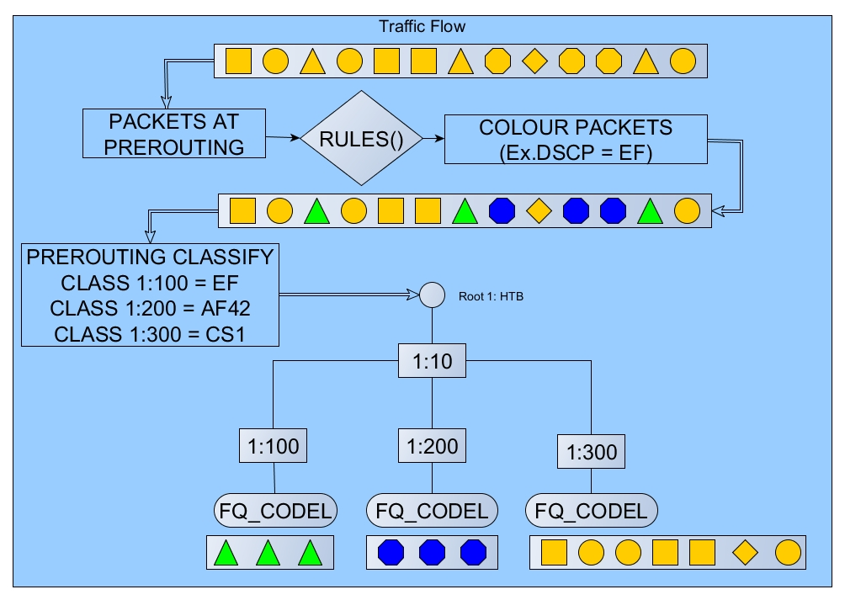
The research described here is supported by the award made by the RCUK Digital Economy programme to the dot.rural Digital Economy Hub at University of Aberdeen; award reference: EP/G066051/1.
Figure 1: PAWS Traffic Classifier
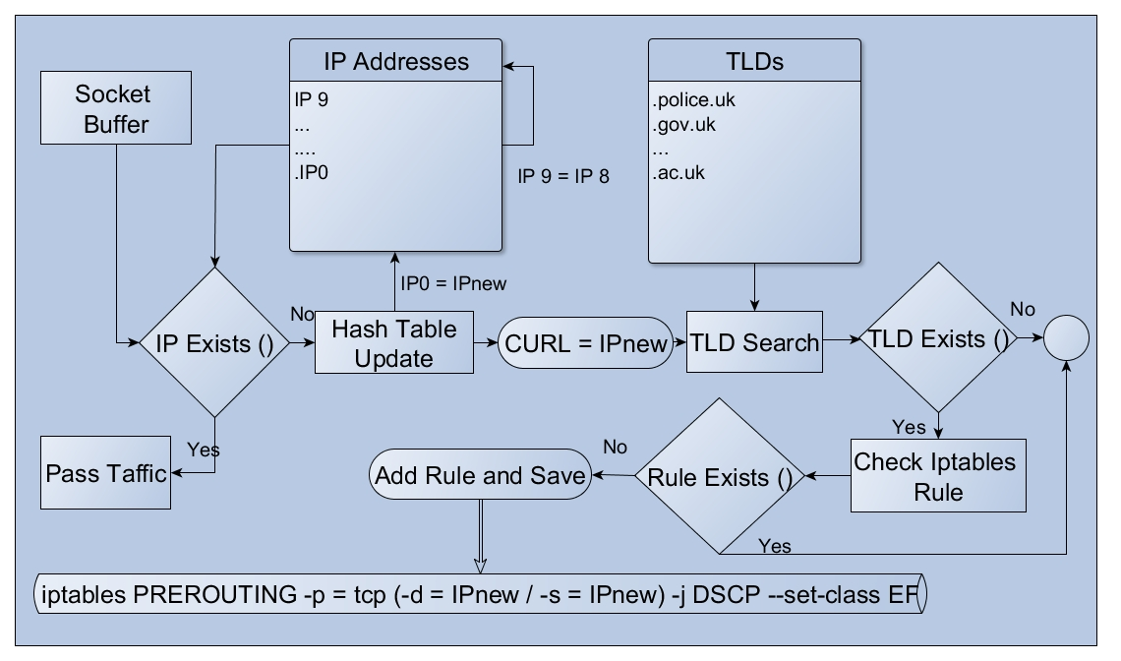
Figure 2: PAWS Router Whitelister
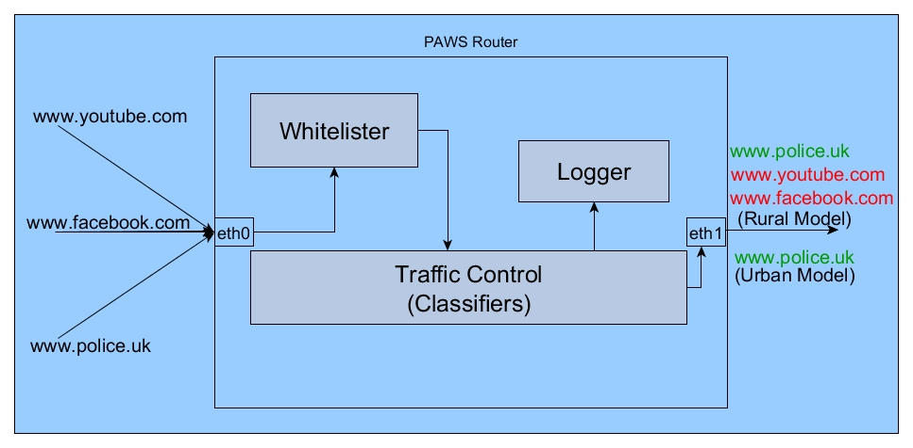
Figure 3: PAWS Rural/Urban Household Router with Whitelisting System

