Sensitivity analysis of the eigenvalue problem for general dynamic systems with application to bridge deck flutter

Piotr Omenzetter

Abstract
The mathematical models governing the dynamics of various engineering systems, such as airplane wings and bridge decks subjected to aerodynamic forces, mechanical and civil structures interacting with fluid or soil, or systems with time delays, yield transcendental eigenvalue problems. In this work, a general transcendental eigenvalue problem is first formulated and a biorthogonality relationship between eigenvectors is derived. Then, the sensitivities of eigenvalues and eigenvectors with respect to a system parameter are obtained. The method is employed to analyze in detail a transcendental eigenvalue problem arising in the analysis of a bridge deck subjected to aerodynamic forces. The sensitivities of eigenvalues and eigenvectors are successfully used to improve the performance of an iterative method used for solving the eigenvalue problem.

CE database subject headings: Aerodynamics, Bridges, Dynamics, Eigenvalue problem, Eigenvalues, Flutter, Modal analysis, Sensitivity analysis

Introduction
Understanding the dynamics of a physical system often requires the solution of an eigenvalue problem or modal analysis. In many studies of dynamic systems, only inertia, viscous damping, gyroscopic, stiffness and circulatory forces are of importance (Meirovitch 1990), and such systems can be modeled using linear, time invariant equations of motion. More generally, a broader class of dynamic systems may be described with linear, time invariant state space formulations. The corresponding eigenvalue problems are of the form of matrix linear or quadratic polynomials in the eigenvalue, for which well-established and efficient solution techniques exist. The physics of some systems are, however, such that although the governing equations of motion remain linear and time invariant, the eigenvalue problem is no longer in the form of a polynomial but a more general, or transcendental, form. Examples of such systems include airfoils and bridge decks subjected to self-excited aerodynamic forces leading to flutter instability (Theodorsen 1935); systems with transport, technological, communication or computational time delays encountered in feedback control, hydraulics, and, outside mechanics, in a wide range of problems spanning transportation engineering, chemical engineering, population dynamics, communication networks and electrical circuits (Niculescu 2001); and, finally, soil structure (Wolf 1991) and fluid structure interaction (Wolf and Paronesso 1992). The above systems quite often depend on certain parameters, such as wind velocity, delay time or soil stiffness. Therefore, it is of interest to analyze changes in the dynamic properties as these parameters vary, e.g. to establish a relationship between eigenvalues and the parameters. The computation of derivatives of eigensolutions with respect to the parameters is referred to as sensitivity analysis.

Among other disciplines, eigenvalue problems for general dynamic systems have attracted particular attention from researchers specializing in flutter analysis. Frazer (1946) proposed viewing flutter analysis as a transcendental eigenvalue problem with a pair of real eigenvalues, and Murthy (1992) proposed a method to automate such an analysis. These studies were, however, restricted to real eigenvalues only, and thus the methods enabled only solution for the critical frequency and wind speed when steady state sinusoidal motions occur. There is also an extensive and growing volume of literature on the sensitivity of complex-valued eigensolutions due to changes in system parameters (Adhikari and Friswell 2001; Chouchane et al. 2007; Friswell and Adhikari 2000; Lee et al. 1996; Ma et al. 2010; Tang et al. 1996; Taylor and Kane 1975; Weng et al. 2011; Xia et al. 2010; Xu et al. 2009) but the most general eigenvalue problems considered were quadratic in the eigenvalue. Several researchers (Barboni et al. 1999; Beldica et al. 1998; Hernandez and Jurado 1999; Jurado and Hernandez 2004; Kapania et al. 1991) used the concept of sensitivity of eigensolutions to study the changes in critical flutter frequency and wind speed due to variations in design parameters of airfoils or bridge decks. This study considers a transcendental eigenproblem, where complex eigenvalues are permitted, and establishes biorthogonality conditions for eigenvectors. Also, sensitivities of complex eigenvalues and eigenvectors with respect to a single parameter are derived. The sensitivities are used to estimate changes in eigensolutions due to changes in system parameters, and to enhance an iterative procedure for solving a generalized eigenproblem. The method is applied to study the effect of aerodynamic forces on the modal properties of a simple bridge deck model.

Sensitivity analysis of the eigenvalue problem for a general dynamic system

Eigenvalue problem for a general dynamic system
The direct eigenvalue problem for a general dynamic system that depends on a single parameter  may be expressed using the following equation:
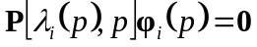 (1)
In the above equation, 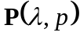 is a square matrix that depends on parameters and . Parameter includes in its range eigenvalues and can, therefore, assume complex values. Parameter is, on the other hand, usually real, representing system or design parameters, although this restriction is not required in the present theory. It is assumed that is infinitely differentiable with respect to and continuously differentiable with respect to. The solutions to the direct eigenvalue problem, i.e. eigenvalues and right eigenvectors, are denoted by 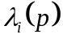 and 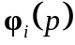, respectively, where is a positive integer. Because of the general form of matrix , for a given value of , the eigenvalue problem may have no solutions, a finite number of solutions, or an infinite number of solutions. It is assumed that the eigenvalues are non-repeated. The corresponding adjoint eigenvalue problem is
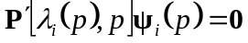 (2)
where 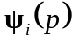 is the left eigenvector. The apostrophe character “'” is used to denote the conjugate transpose of a vector or matrix. (It is noted that for Hermitian problems, i.e. when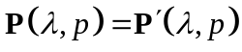, the direct and adjoint eigenvalue problem coincide and the right and left eigenvectors are the same resulting in corresponding simplifications of the derivations and formulas that follow.) As parameter assumes different values, not only matrix changes but the eigenvalues and eigenvectors vary as well, becoming functions of the parameter.

The two well-known special cases of the general eigenvalue problem of Eq. (1) are the linear eigenvalue problem stemming from state space representations:
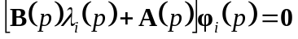 (3)
and the quadratic eigenvalue problem:
(4)
where 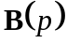, 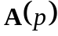, 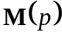, 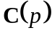, and 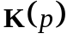 are all square matrices.

The right and left eigenvectors can only be determined up to a multiplicative complex constant. To cope with this ambiguity, the eigenvectors are often normalized. Of interest are also biorthogonality relationships between eigenvectors corresponding to different eigenvalues. The derivation presented below establishes a normalization formula and biorthogonality properties for the eigenvalue problems of Eqs. (1) and (2).

Consider two eigenvalue-eigenvector triples 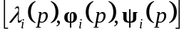 and 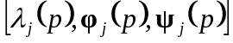. Writing the direct eigenvalue problem of Eq. (1) for eigenvalue and the adjoint problem of Eq. (2) for 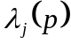, and premultiplying the first equation by 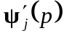, and transposing and postmultiplying the second equation by yields:
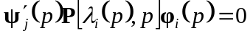 (5)
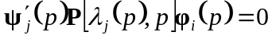 (6)
Expanding Eq. (6) using Taylor’s series in the neighborhood of yields:
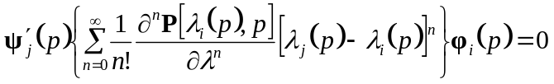 (7)
Subtracting subsequently Eq. (5) from Eq. (7) leads to
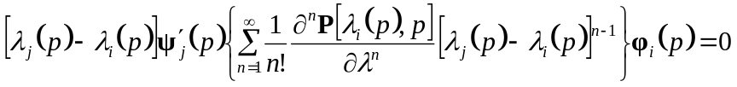 (8)
Thus, the biorthogonality relationship between eigenvectors corresponding to different eigenvalues can be proposed as:
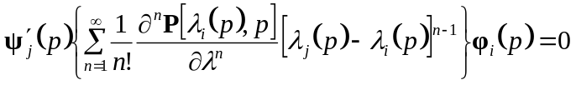, 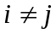 (9)
Equation (9) also yields biorthogonality relationships for the linear and quadratic eigenproblems of Eqs. (3) (Meirovitch 1990) and (4) (Yang 1994):
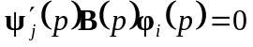, (10)
, (11)
Assuming now that 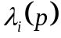 and correspond to the same mode, i.e. they are equal, Eq. (8) is an identity irrespective of the value of the part in the braces. In addition, all terms of the expression in the braces, excluding the one with the first derivative 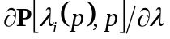, disappear. One can then assume the following normalization of the right and left eigenvectors:
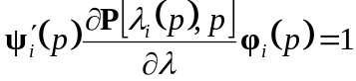 (12)
The well-known normalization criteria for the linear and quadratic eigenvalue problems of Eqs. (3) (Meirovitch 1990) and (4) (Yang 1994), can then be derived from Eq. (12) as follows:
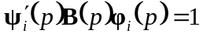 (13)
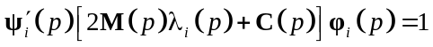 (14)

Sensitivity analysis of eigenvalue problem
Sensitivity analysis aims at establishing formulas for changes in eigenvalues and eigenvectors due to small changes in parameters defining the system. Starting with the eigenvalue problem of Eq. (1) and differentiating it with respect to parameter yields:
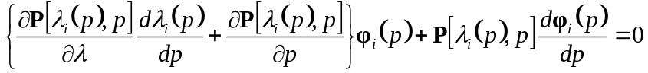 (15)
Premultiplying Eq. (15) by 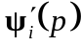 and using the normalization of Eq. (12) yields a formula for eigenvalue sensitivity:
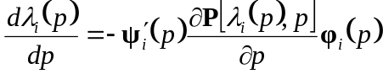 (16)
Equation (15) also yields a formula for the right eigenvector sensitivity:
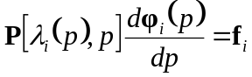 (17)
where can easily be determined form Eq. (15). Matrix 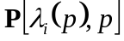 is, however, singular and hence the total solution for the right eigenvector sensitivity comprises a particular part 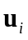and a homogenous part 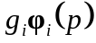 (Friswell and Adhikari 2000; Nelson 1976):
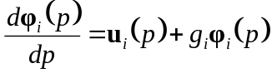 (18)
where 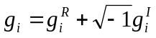 is an arbitrary complex constant. (Note hereafter superscripts and respectively denote real and imaginary parts of the variables at hand.) In order to compute the particular solution and fix constant 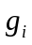 in the homogenous solution several different procedures have been proposed (Adhikari and Friswell 2001; Lee et al. 1996; Nelson 1976), in this research the one by Tang et al. (1996) is adopted. First, the particular solution can be found as
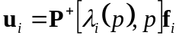 (19)
where 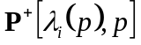 is the Moore-Penrose inverse (Campbell and Meyer 1991). To determine the value of it is proposed that a weighted inner product of with itself be kept constant:
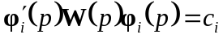 (20)
where 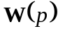 is any square matrix for which 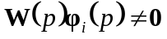. Equation (20) is first differentiated with respect to :
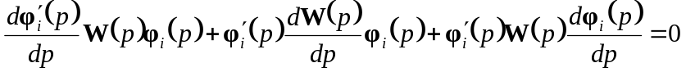 (21)
Equation (18) is then substituted into Eq. (21) yielding:
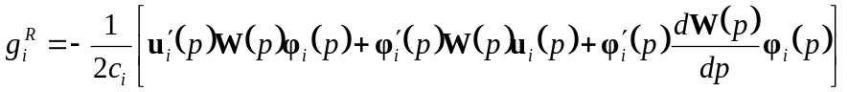 (22)
The final task is to solve for the imaginary part of . To that end, one chooses a component of , denoted by 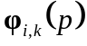, with a non-vanishing real part and restricts the corresponding component 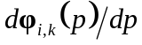 to be real. To satisfy this requirement, one writes the kth line of Eq. (18) and concludes that 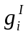 must equal:
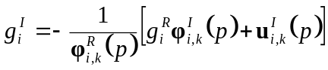 (23)

The sensitivity of the left eigenvector can be obtained in a similar way. Differentiating Eq. (2) with respect to parameter , gives an equation for the left eigenvector sensitivity. One then writes the total solution for the left eigenvector sensitivity as (Friswell and Adhikari 2000):
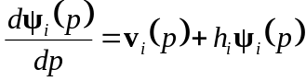 (24)
where 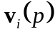 is the particular solution and is an arbitrary complex constant. To determine the value of the normalization formula of Eq. (12) is differentiated with respect to and Eq. (24) is substituted. The value of constant is then determined as
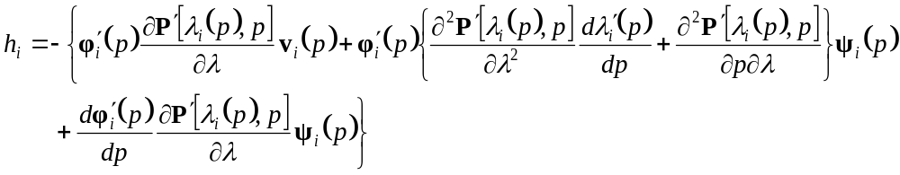
(25)

Finally, using first order Taylor’s expansion in the neighborhood of , approximations of eigenvalues and eigenvectors at 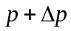 can be found using the following equations:
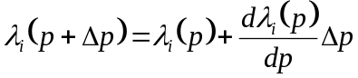 (26)
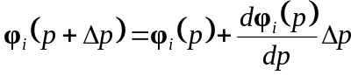 (27)
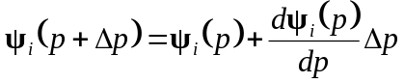 (28)

If the sole purpose of sensitivity analysis is to find eigensolutions at given those at , Eqs. (26) – (28) can reasonably be expected to be sufficient for small values of 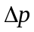 or when eigensolutions do not change dramatically with . If, however, none of these assumptions are true, sensitivity analysis can only provide a rough estimation of eigensolutions. Moreover, if one is interested in tracing the behavior of modes as the parameter varies in a wide range, assuming values , 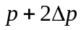, etc., the accumulation of errors at each step can lead to significant loss of accuracy. In such cases, it may be necessary to improve the approximations offered at each step by the sensitivity analysis, treating them only as initial estimates.

The basic criterion for to be an eigenvalue is that the following matrix determinant vanishes:
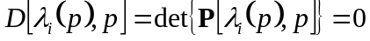 (29)
This is not generally true when a sensitivity based estimation of eigenvalue is used, and a better approximation of can be found by forcing 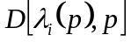 closer to zero. Using Newton’s method the following iterative scheme (Murthy 1992) can be set up:
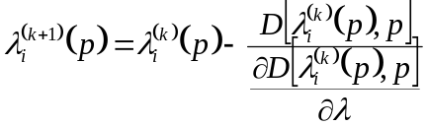 (30)
where superscripts 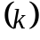 and 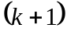 denote iteration steps. The derivative of the determinant can conveniently be computed using the trace theorem (Lancaster 1964):
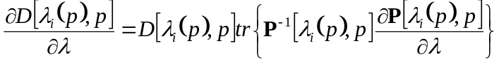 (31)
where 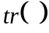 denotes the trace operation. The iterative procedure is terminated if a predetermined convergence criterion is reached, or matrix becomes singular. Note that in the iterative procedure the determinant does not have to be explicitly computed. Improved estimates of the eigenvectors can efficiently be computed at the time the iterative scheme of Eq. (30) converges using the inverse iteration method (Ipsen 1997):
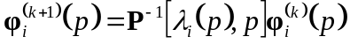 (32)
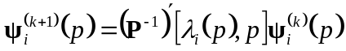 (33)
For the case when matrix is already singular, the eigenvectors can be obtained as null spaces of and 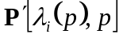, respectively.

Application to flutter of bridges
During vibrations of multi degree of freedom mechanical systems, such as airfoils or decks of long span bridges, significant self-excited aerodynamic forces can be induced. These forces are motion dependent, i.e. they are proportional to accelerations, velocities and displacements of the system. However, they also lag behind system’s motions and the extent of the lag depends in a complex manner on the ratio of motion frequency and wind velocity (Theodorsen 1935). The aerodynamic forces modify system matrices and influence its eigenvalues and eigenvectors. In particular, they may render the system unstable and cause ever increasing, divergent oscillations in the flutter phenomena. The early developments in analytical flutter analysis were focused on finding the critical wind speed and oscillation frequency when flutter develops (Scanlan and Rosenbaum 1951; Simiu and Scanlan 1986). However, dynamic properties and responses of systems for wind velocities below the critical flutter condition are also of interest. For example, in analysis and design of long-span bridges it is useful to establish changes in the structure’s modal properties for wind speed varying in a certain range, which can be useful in studies of buffeting response.

An analytical description of self-excited aerodynamic forces for steady state sinusoidal motions was proposed by Theodorsen (1935). He used the potential flow theory and assumed that the airfoil was a flat plate. His solution introduced the frequency dependent circulatory function. Edwards (1977) extended Theodorsen’s solution to arbitrary motions applying the concept of analytical continuation of the circulatory function. Advances in analytical and computational techniques enabled efficient and accurate theoretical predictions of aerodynamic forces for various streamlined bodies such as airplane wings (Albano and Rodden 1969). Bridge decks, however, are often bluff bodies of unique shapes and their aerodynamics are determined experimentally in wind tunnels. Scanlan and Tomko (1971) proposed a formulation for experimentally established aerodynamic forces acting on a bridge deck using frequency dependent functions or flutter derivatives.

An important development fostering flutter analysis was the introduction of a modeling method that transforms the description of aerodynamic forces in frequency domain into time domain. Roger (1977) approximated aerodynamic force coefficients by rational functions of Laplace variable, and applying the inverse Laplace transform derived a state-space, frequency independent aerodynamic equation of motion. The first applications of rational function approximation to bridge flutter were in the nineties (Wilde et al. 1996). Although this analytical method has been gaining popularity (Boonyapinyo et al. 1999; Chen et al. 2000; Omenzetter et al. 2002; Wilde and Fujino 1998), the more traditional, frequency domain flutter formulation is still widely used by bridge engineers and researchers (Kwon and Park 2004; Nissen et al. 2004; Zhang and Brownjohn 2004).

This study is concerned with the mode tracing problem, i.e. finding the changes in eigenvalues and eigenvectors of a bridge deck model as the mean wind velocity varies in a wide range. The method is similar to the one proposed by Dung et al. (1998) who also used an iterative search for eigensolutions at a new wind speed based on the known modal properties at the previous wind speed. The contribution of this paper is the use of the information provided by the sensitivity analysis at each wind speed.

Detailed aerodynamic analyses of long-span bridges require complex multi-degree-of-freedom bridge models that utilize either modal analysis or finite element formulations, as well as more realistic, experimentally determined aerodynamic forces. However, it can be argued that simplified models using only two or three modes and/or flat-plate approximation of aerodynamic forces still offer valuable insights into the aerodynamics of bridges. They are particularly useful when testing new numerical approaches and/or providing proofs of concept for new technologies because they enable capturing and focusing on the problem essence (Chen and Kareem 2003; Kwon and Park 2004; Omenzetter et al. 2002; Wilde and Fujino 1998; Wilde et al. 2001). A simple, two degree of freedom model of a bridge deck (Omenzetter et al. 2000a; 2000b) used in this study is shown in Fig. 1. The vector of displacements 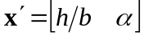 comprises the heaving motion , and pitching motion . The width of the deck is 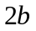. The springs 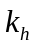 and 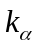 represent structural translational and rotational stiffness, respectively. The mean wind velocity is denoted by . The equation of motion for such a system can be written as follows:
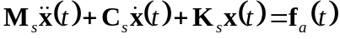 (34)
where , 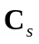 and  are structural mass, damping and stiffness matrices, respectively, 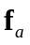 denotes the vector of self-excited aerodynamic forces, and is the time variable. (Note that other external forces, e.g. wind buffeting, have been ignored as they are irrelevant for this study.) The self-excited aerodynamic forces 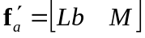, comprising lift force and pitching moment , can be written in the Laplace domain in the following form (Omenzetter et al. 2000a):
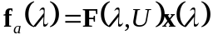 (35)
where 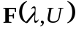 is a square matrix, and 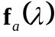 and 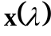 are Laplace transforms of 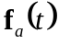 and 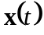, respectively.

Matrix cannot generally be exactly represented as a second order polynomial in to yield a quadratic eigenvalue problem of Eq. (4). Thus clearly, taking the Laplace transform of Eq. (34) results in a general eigenvalue problem of Eq. (1) with the mean wind speed playing the role of parameter . Application of rational function approximation (Omenzetter et al. 2000a) to can reduce the eigenvalue problem to the state-space form of Eq. (3), which in turn can be solved directly by standard techniques for all values of without using to the mode tracing and sensitivity analysis. Hence, in such a case, the benefits of using the proposed technique are not obvious. Nevertheless, mode tracing enables focusing just on the selected important modes of the structure and limits the number of eigenvalues to be computed. This feature may be desirable when studying complex, multi degree of freedom dynamic models resulting, e.g. from modal decomposition (Chen et al. 2000) or finite element method formulations (Omenzetter et al. 2002).

A more interesting and challenging is the case when the aerodynamic equation of motion is formulated without the use of a rational function approximation. Here, the eigenvalue problem remains in the general form of Eq. (1) and an iterative search for eigensolutions is unavoidable. The proposed sensitivity analysis can then be expected to reduce the number of iterations required at each wind speed value by providing a better estimation of the starting value for iterations.

To check the performance of the proposed method the two degree of freedom bridge deck model is studied with the following numerical values: the mass of the deck 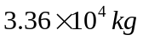, the second moment of inertia 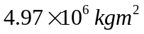, the vertical stiffness 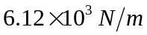, and the rotational stiffness 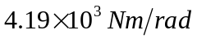. Mechanical damping of the system is ignored. The self-excited aerodynamic forces are formulated using Theodorsen’s theory (Theodorsen 1935) and are expressed as (Omenzetter et al. 2000a):
(36)
Function 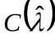 is the generalised Theodorsen function (Edwards 1977):
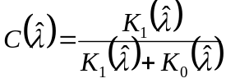, 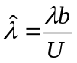 (37)
where is the so-called complex reduced frequency. Functions 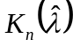 are the modified Bessel functions of the second kind of order (Abramowitz and Stegun 1972). Appendix I provides a full list of differential formulas used in the computations.

Results of mode tracing for wind velocity ranging from 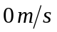 to 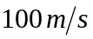 with a step of 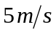 are shown in Figs. 2-4. Figure 2 shows changes of the two eigenvalues with wind speed. The eigenvalues correspond to two modes: mode 1 that is heaving dominant for low wind speeds, and mode 2 that is pitching dominant for low wind speeds. Notably, the system becomes dynamically unstable between 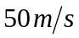 and 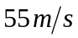 when the eigenvalue of mode 2 crosses over to the positive real half plane. The changes in the mode shapes are depicted in Figs. 3 and 4 for mode 1 and 2, respectively. Only the right eigenvectors are shown. For mode 1, the heaving component was fixed to be always real, while for mode 2 it was the pitching component. Remarkable changes in mode shapes can be seen as the wind velocity increases, e.g. the pitching dominant mode 2 becomes heaving dominant above , and mode 1, while remaining heaving dominant, develops a considerable pitching component. The phase lags between the heaving and pitching and their changes are also significant.

Selected aspects of the method’s accuracy and performance are discussed using the bridge deck example. First, the accuracy of the sensitivity analysis alone is examined in Table 1, which compares eigenvalue estimates obtained using sensitivity analysis [Eq. (26)] to their exact values found through iterative procedure of Eq. (30) at different wind speeds. The iterations were terminated when the relative difference in eigenvalues from two consecutive steps was smaller than 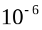. As can be seen the largest relative errors are only slightly higher than 2% for mode 1 and about 0.9% for mode 2, showing good accuracy of the sensitivity analysis. Decreasing the wind velocity step can further reduce error.

Another aspect of the performance of the proposed method is the number of iterations required to achieve a desired accuracy of eigenvalues and eigenvectors. It is possible to estimate initially the eigenvalue at 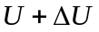 without using the sensitivity information as 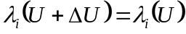 and improve the estimate through the iterative procedure of Eq. (30). However, because the sensitivity analysis should generally offer - at the expanse of additional computations - a better initial estimate of the eigenvalues, the number of iterations in both cases can be used to compare the performance of the two approaches. Such a comparison is shown in Table 2. It can be observed that the use of sensitivity analysis helps to reduce the number of iterations for almost all the shown wind speeds. The improvement is particularly strong for mode 1, where in some cases the numbers of iterations drop from 5 to 3.

Conclusions
A transcendental eigenvalue problem for general dynamic systems has been studied. First, a biorthogonality relationship between eigenvectors has been derived and it has been shown that the biorthogonality relationships of linear and quadratic eigenproblems are its special cases. Then, the sensitivities of eigenvalues and eigenvectors with respect to a system parameter have been derived. The sensitivities can be used for quick estimates of the changes in the eigensolution due to variations in the system parameter without directly solving a new eigenproblem. They can also offer an advantage for exact, iterative solution to transcendental eigenvalue problems by providing a better initial estimates of eigenvalues and eigenvectors for a new system parameter value, and thereby reducing the numbers of iterations. The method has been employed to solve a transcendental eigenvalue problem arising in the analysis of a bridge deck subjected to aerodynamic forces. This numerical example has demonstrated that the sensitivity analysis yields good approximation of the eigensolution and can help to improve performance of iterative eigensolution methods.

Appendix I
The following differential relationships are used in the study of a bridge deck model with self-excited aerodynamic forces described by Theodorsen’s theory:
(A.1)
(A.2)
(A.3)
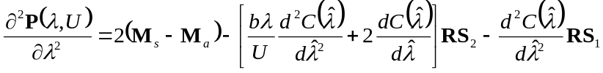 (A.4)
(A.5)
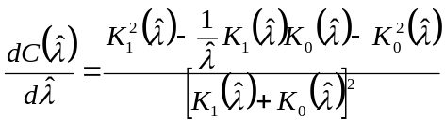 (A.6)
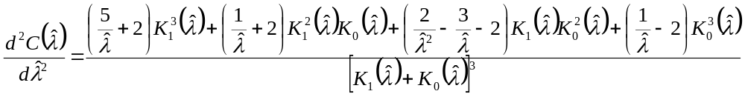
(A.7)

References
Abramowitz, M., and Stegun, I. A. (1972). Handbook of mathematical functions with formulas, graphs and mathematical tables, Wiley, New York.
Adhikari, S., and Friswell, M. I. (2001). "Eigenderivative analysis of asymmetric non-conservative systems." International Journal for Numerical Methods in Engineering, 51(6), 709-733.
Albano, E., and Rodden, W. P. (1969). "Doublet-lattice method for calculating lift distributions on oscillating surfaces in subsonic flows." AIAA Journal, 7(2), 279-285.
Barboni, R., Mannini, A., and Gaudenzi, P. (1999). "On the use of the P-TFE method for panel flutter optimization." Computers and Structures, 70, 109-117.
Beldica, C. E., Hilton, H. H., and Yi, S. (1998). "Sensitivity study of viscoelastic, structural and piezo-electric damping for flutter control." Proceedings of the 1998 39th AIAA/ASME/ASCE/AHS/ASC Structures, Structural Dynamics, and Materials Conference and Exhibit and AIAA/ASME/AHS Adaptive Structures Forum. Part 2 (of 4), Apr 20-23 1998, Long Beach, CA, USA, 1304-1314.
Boonyapinyo, V., Miyata, T., and Yamada, H. (1999). "Advanced aerodynamic analysis of suspension bridges by state-space approach." Journal of Structural Engineering, 125(12), 1357-1366.
Campbell, S. L., and Meyer, C. D. Jr. (1991). Generalized inverses of linear transformations, Dover, New York.
Chen, X., and Kareem, A. (2003). "Curve veering of eigenvalue loci of bridges with aeroelastic effects." Journal of Engineering Mechanics, 129(2), 146-159.
Chen, X., Matsumoto, M., and Kareem, A. (2000). "Time domain flutter and buffeting response analysis of bridges." Journal of Engineering Mechanics, 126(1), 7-16.
Chouchane, M., Guedria, N., and Smaoui, H. (2007). "Eigensensitivity computation of asymmetric damped systems using an algebraic approach." Mechanical Systems and Signal Processing, 21(7), 2761-2776.
Dung, N. N., Miyata, T., Yamada, H., and Minh, N. N. (1998). "Flutter responses in long span bridges with wind induced displacement by the mode tracing method." Journal of Wind Engineering and Industrial Aerodynamics, 77 & 78, 367–379.
Edwards, J. W. (1977). "Unsteady aerodynamic modelling for arbitrary motions." AIAA Journal, 15, 593-595.
Frazer, R. A. (1946). "Bi-variate partial fractions and their applications to flutter and stability problems." Proceedings of Royal Society of London A, 185, 465-484.
Friswell, M. I., and Adhikari, S. (2000). "Derivatives of complex eigenvectors using Nelson's method." AIAA Journal, 38(12), 2355-2357.
Hernandez, S., and Jurado, J. A. (1999). "Structural design and sensitivity analysis of ultra long span bridges with aeroelastic constraints." Optimization in Industry II Conference - 1999, Jun 6-11 1999, Banff, Alb., Canada, 197-204.
Ipsen, C. F. (1997). "Computing of eigenvector with inverse iteration." SIAM Review, 39(2), 254-291.
Jurado, J. A., and Hernandez, S. (2004). "Sensitivity analysis of bridge flutter with respect to mechanical parameters of the deck." Structural and Multidisciplinary Optimization, 27, 272–283.
Kapania, R. K., Bergen, F. D. O., and Barthelemy, J.-F. M. (1991). "Shape sensitivity analysis of flutter response of a laminated wing." AIAA Journal, 29(4), 611-612.
Kwon, S.-D., and Park, K.-S. (2004). "Suppression of bridge flutter using tuned mass dampers based on robust performance design." Journal of Wind Engineering and Industrial Aerodynamics, 92(11), 919-934.
Lancaster, P. (1964). "Algorithms for lambda matrices." Numerische Mathematic, 6, 388-394.
Lee, I. W., Jung, G. H., and Lee, J. W. (1996). "Numerical method for sensitivity analysis of eigensystems with non-repeated and repeated eigenvalues." Journal of Sound and Vibration, 195(1), 17-32.
Ma, Z., Xie, H., and Hu, Y. (2010). "A new iterative method for many eigenpair partial derivatives " Applied Mathematics and Computation, 217(5), 1991-1996
Meirovitch, L. (1990). Dynamics and control of structures, Willey, New York.
Murthy, D. V. (1992). "Solution and sensitivity analysis of a complex transcendental eigenproblem with pairs of real eigenvalues." International Journal for Numerical Methods in Engineering, 33, 115-129.
Nelson, R. B. (1976). "Simplified calculation of eigenvector derivatives." AIAA Journal, 14(9), 1201-1205.
Niculescu, S. I. (2001). Delay effects on stability, Springer, Berlin.
Nissen, H. D., Sorensen, P. H., and Jannerup, O. (2004). "Active aerodynamic stabilisation of long suspension bridges." Journal of Wind Engineering and Industrial Aerodynamics, 92(10), 829-847.
Omenzetter, P., Wilde, K., and Fujino, Y. (2000a). "Suppression of wind-induced instabilities of a long span bridge by a passive deck-flaps control system: Part I: Formulation." Journal of Wind Engineering and Industrial Aerodynamics, 87(1), 61-79.
Omenzetter, P., Wilde, K., and Fujino, Y. (2000b). "Suppression of wind-induced instabilities of a long span bridge by a passive deck-flaps control system: Part II: Numerical simulations." Journal of Wind Engineering and Industrial Aerodynamics, 87(1), 81-91.
Omenzetter, P., Wilde, K., and Fujino, Y. (2002). "Study of passive deck-flaps flutter control system on full bridge model. I: Theory." Journal of Engineering Mechanics, 128(3), 264-279.
Roger, K. (1977). "Airplane math modelling methods for active control design." AGARD-CP-228 Structural Aspects of Active Controls, Advisory Group for Aerospace Research and Development.
Scanlan, R., and Tomko, J. (1971). "Airfoils and bridge flutter derivatives." Journal of Engineering Mechanics Division, ASCE, 97, 1717-1737.
Scanlan, R. H., and Rosenbaum, R. (1951). Introduction to the study of aircraft vibration and flutter, Macmillan, New York.
Simiu, E., and Scanlan, R. H. (1986). Wind effects on structures: an introduction to wind engineering, Wiley, New York.
Tang, J., Ni, W. M., and Wang, W. L. (1996). "Eigensolutions sensitivity for quadratic eigenproblems." Journal of Sound and Vibration, 196(2), 179-188.
Taylor, D. L., and Kane, T. R. (1975). "Multiparameter quadratic eigenproblems." Journal of Applied Mechanics, 42, 478-483.
Theodorsen, T. (1935). "General theory of aerodynamic instability and the mechanism of flutter." Report No. 496, National Advisory Committee for Aeronautics, Washington, DC.
Weng, S., Xia, Y., Xu, Y., and Zhu, H. (2011). "An iterative substructuring approach to the calculation of eigensolution and eigensensitivity." Journal of Sound and Vibration, 330(14), 3368-3380
Wilde, K., and Fujino, Y. (1998). "Aerodynamic control of bridge deck flutter by active surfaces." Journal of Engineering Mechanics, 124(7), 718-727.
Wilde, K., Fujino, Y., and Masukawa, J. (1996). "Time domain modelling of bridge deck flutter." Structural Engineering/Earthquake Engineering, JSCE, 13, 93s-104s.
Wilde, K., Omenzetter, P., and Fujino, Y. (2001). "Suppression of bridge flutter by active deck-flaps control system." Journal of Engineering Mechanics, 127(1), 80-89.
Wolf, J. P. (1991). "Consistent lumped parameter model for unbounded soil: Physical representation." Earthquake Engineering and Structural Dynamics, 20, 11-32.
Wolf, J. P., and Paronesso, A. (1992). "Lumped parameter model and recursive evaluation of interaction forces of semi-infinite uniform fluid channel for time domain dam-reservoir analysis." Earthquake Engineering and Structural Dynamics, 21, 811-831.
Xia, Y., Weng, S., Xu, Y. L., and Zhu, H. P. (2010). "Calculation of eigenvalue and eigenvector derivatives with the improved Kron's substructuring method." Structural Engineering and Mechanics, 36(1), 37-55.
Xu, Z. H., Zhong, H. X., Zhu, X. W., and Wu, B. S. (2009). "An efficient algebraic method for computing eigensolution sensitivity of asymmetric damped systems." Journal of Sound and Vibration, 327(3-5), 584-592.
Yang, B. (1994). "Modal controllability and observability of general mechanical systems." Proceedings of the 1994 ASME Winter Annual Meeting, New York, 363-370.
Zhang, X., and Brownjohn, J. M. W. (2004). "Effect of relative amplitude on bridge deck flutter." Journal of Wind Engineering and Industrial Aerodynamics, 92(6), 493-508.

Figure captions and table titles

Fig 1. Two degree of freedom bridge deck model.
Fig 2. Changes of bridge deck model eigenvalues with wind speed.
Fig. 3. Changes of right eigenvector of mode 1 with wind speed: a) magnitudes, b) phase.
Fig. 4. Changes of right eigenvector of mode 2 with wind speed: a) magnitudes, b) phase.

Table 1. Comparison of eigenvalues obtained via sensitivity and exact analyses.
Table 2. Comparison of number of iterations to obtain exact eigenvalues with and without sensitivity analysis.
Table 1. Comparison of eigenvalues obtained via sensitivity and exact analyses.

Wind speed  (m/s) | Eigenvalues
Wind speed  (m/s) | Exact 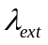  (rad/s) | Sensitivity 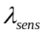  (rad/s) | Error  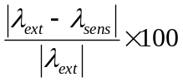  (%)
Mode 1
10 | -0.0098+0.4240i | -0.0093+0.4237i | 0.14
20 | -0.0240+0.4277i | -0.0233+0.4276i | 0.15
30 | -0.0446+0.4324i | -0.0434+0.4322i | 0.28
40 | -0.0788+0.4395i | -0.0758+0.4390i | 0.68
50 | -0.1527+0.4478i | -0.1429+0.4493i | 2.09
60 | -0.3132+0.4224i | -0.3029+0.4270i | 2.15
70 | -0.5266+0.4075i | -0.5286+0.4007i | 1.06
80 | -0.7203+0.4291i | -0.7234+0.4274i | 0.42
90 | -0.8935+0.4612i | -0.8953+0.4606i | 0.18
100 | -1.0549+0.4970i | -1.0559+0.4967i | 0.09
Mode 2
10 | -0.0037+0.9098i | -0.0035+0.9112i | 0.16
20 | -0.0092+0.8922i | -0.0089+0.8941i | 0.21
30 | -0.0162+0.8585i | -0.0162+0.8610i | 0.29
40 | -0.0207+0.8026i | -0.0218+0.8060i | 0.45
50 | -0.0058+0.7193i | -0.0114+0.7216i | 0.85
60 | 0.0469+0.6447i | 0.0469+0.6399i | 0.75
70 | 0.0912+0.5940i | 0.0937+0.5934i | 0.43
80 | 0.1154+0.5463i | 0.1180+0.5462i | 0.48
90 | 0.1180+0.5020i | 0.1206+0.5007i | 0.56
100 | 0.1048+0.4714i | 0.1056+0.4693i | 0.47
Table 2. Comparison of number of iterations to obtain exact eigenvalues with and without sensitivity analysis.
Wind speed  (m/s) | Number of iterations
Wind speed  (m/s) | Mode 1 |  | Mode 2
Wind speed  (m/s) | Without sensitivity analysis | With sensitivity analysis | Without sensitivity analysis | With sensitivity analysis
10 | 3 | 2 | 3 | 3
20 | 3 | 2 | 3 | 3
30 | 3 | 2 | 4 | 3
40 | 3 | 3 | 4 | 3
50 | 4 | 3 | 4 | 3
60 | 5 | 3 | 4 | 3
70 | 5 | 3 | 4 | 3
80 | 5 | 3 | 4 | 3
90 | 5 | 3 | 4 | 3
100 | 5 | 3 | 3 | 3

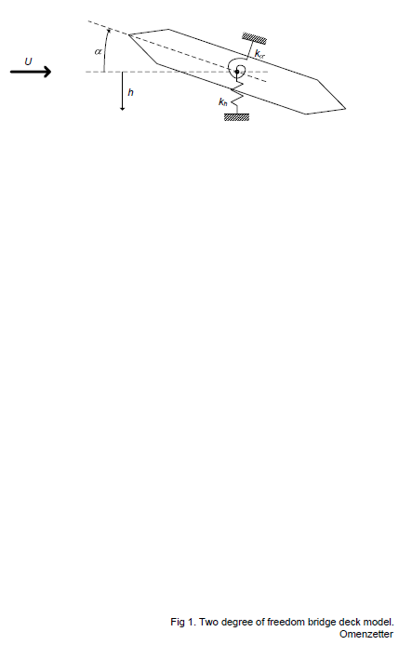
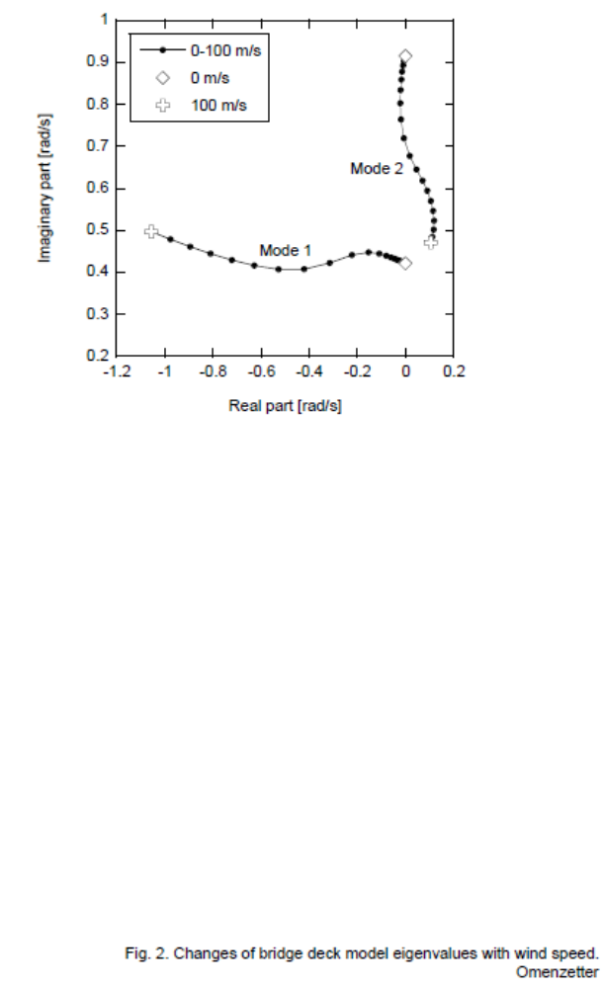
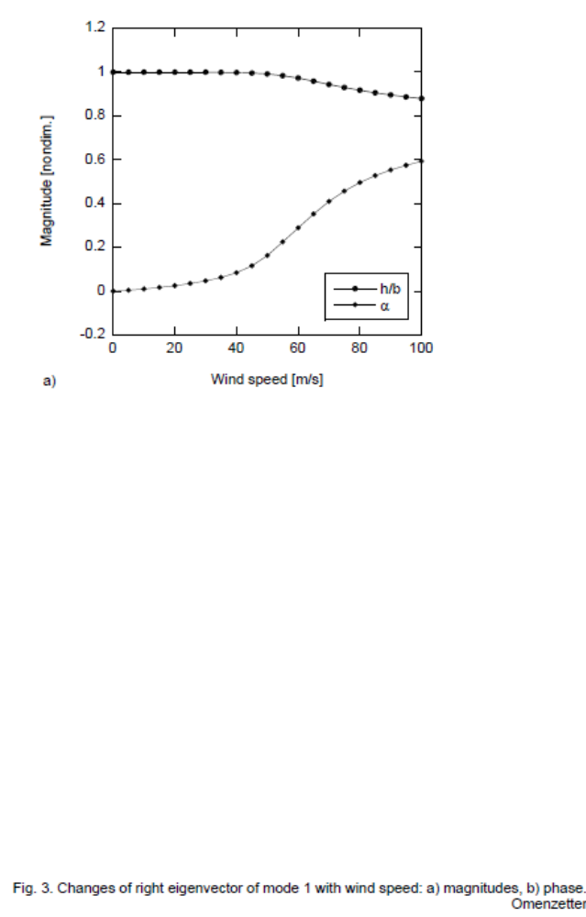
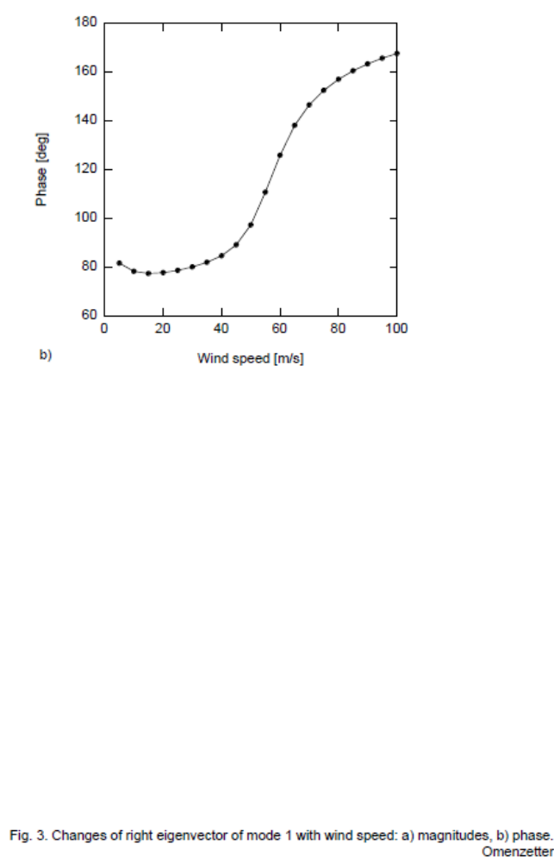
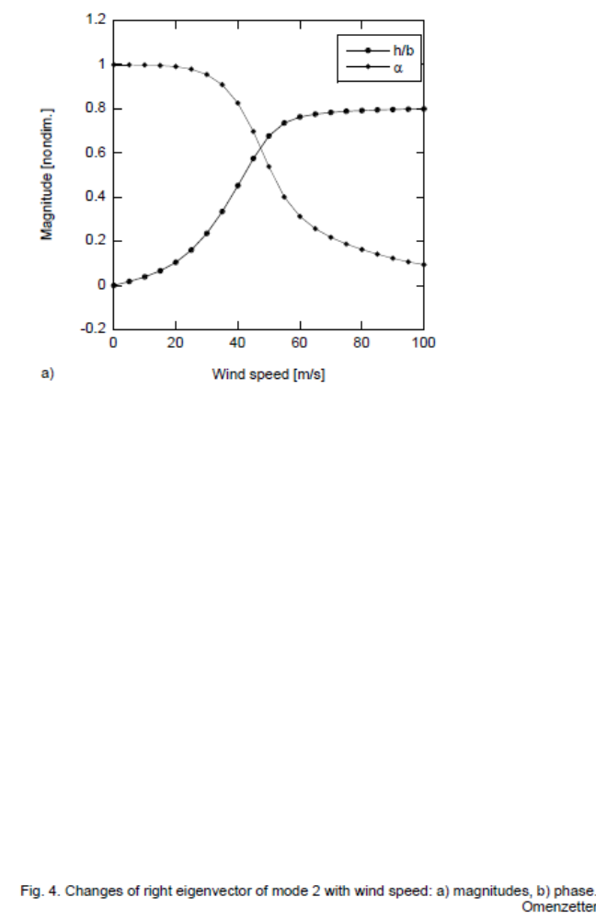
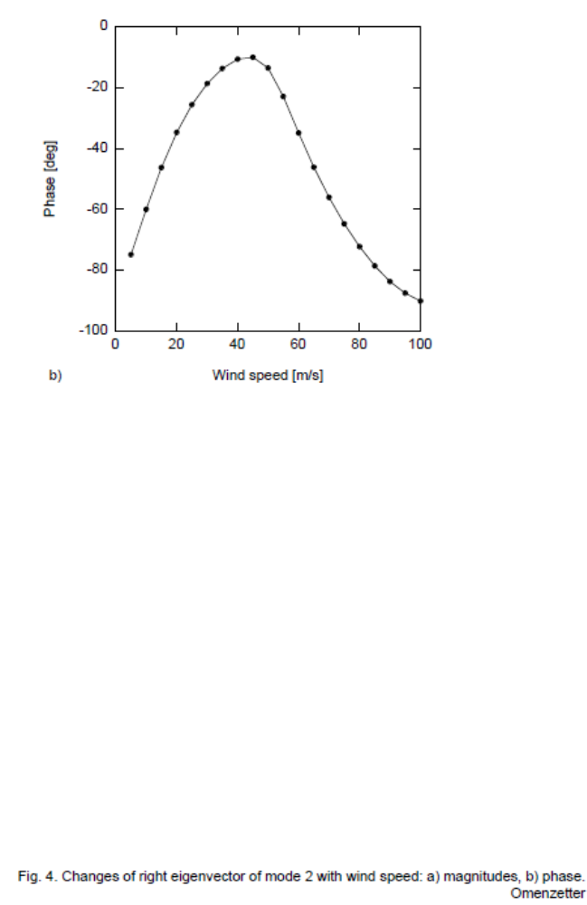

Senior Lecturer, Dept. of Civ. and Envir. Engrg., The University of Auckland, Private Bag 92019, Auckland Mail Centre, Auckland 1142, New Zealand. E-mail: p.omenzetter@auckland.ac.nz

