Prospective Associations of Accelerometer-Measured Physical Activity and Sedentary Time with Incident Cardiovascular Disease, Cancer, and All-Cause Mortality

Authors and Affiliations:
Paddy C. Dempsey, PhD^{1,2}; Tessa Strain, PhD¹; Kay-Tee Khaw, MB¹; Nick Wareham, MBBS, PhD¹; Søren Brage; PhD¹; Katrien Wijndaele, PhD¹

¹ MRC Epidemiology Unit, Institute of Metabolic Science, University of Cambridge, Cambridge, UK.
² Physical Activity & Behavioural Epidemiology Laboratories, Baker Heart & Diabetes Institute, Melbourne, Australia.

Corresponding Author:
Dr. Paddy C. Dempsey
MRC Epidemiology Unit, University of Cambridge School of Clinical Medicine, Box 285 Institute of Metabolic Science, Cambridge Biomedical Campus, Cambridge CB2 0QQ, United Kingdom
E: Paddy.Dempsey@mrc-epid.cam.ac.uk

Running title: Objective Activity, Incident Disease and Mortality

Keywords: Physical activity; Sedentary Behavior; Cardiovascular disease; Mortality; Cancer; Aging; Lifestyle; Public health

Data Availability/Sharing Statement: Participant summary statistics are available at doi: [TO BE ADDED]. Individual-level data are available from the EPIC Norfolk Management Committee (contact via epic-norfolk@mrc-epid.cam.ac.uk) for researchers who meet the criteria for access to confidential data.

Manuscript submitted as a Research Letter for Circulation, which requires a word count limit of 800 words, 1 Table or Figure, and a maximum of 5 references. Supplemental details are provided for Reviewers’ perusal.

Insufficient moderate-to-vigorous-intensity physical activity (MVPA) and high volumes of sedentary time (ST) have both been associated with increased risk of all-cause mortality, cardiovascular disease (CVD), and some cancers¹. However, epidemiological evidence has mostly relied on self-reported physical activity (PA) measures, which are prone to reporting bias and measurement error. Cohort studies incorporating objective assessments of PA are emerging²⁻⁴; but few investigate relationships of accelerometer-measured PA and ST with clinical endpoints, particularly incident CVD, and include both men and women⁵. Additionally, the relevance of light-intensity physical activity (LIPA) in this context, which is an important contributor to total physical activity and may be a more feasible target for middle-to-older aged adults, remains unclear. Here, we examine the prospective associations of accelerometer-measured PA and ST with incident CVD (primary outcome), incident cancer, and all-cause mortality.

Participants were from the European Prospective Investigation into Cancer and Nutrition-Norfolk study, a population-based cohort of 25,639 adults aged 40-79, resident in Norfolk, UK. Between 2004-2016, 7,820 participants attending in-clinic assessments wore an accelerometer (ActiGraph GT1M/GT3X+) on their right hip for seven days during waking hours. We excluded those with <4 days of sufficient wear time (>10h/d; n=134) or missing covariate data (n=19). Those with prevalent CVD (n=2,083), cancer (n=629), or either CVD or cancer (n=2,488) were excluded from the CVD, cancer, and all-cause mortality analyses, respectively.

Cox proportional hazards regression was used to model non-linear associations (using splines) of total PA (average accelerometer counts-per-min/day; measure of total PA volume), MVPA (min/day; ≥2020 counts/min), light-intensity physical activity (LIPA; hr/day; 100-2019 counts/min) and ST (hr/day; <100 counts/min) with total (non-fatal or fatal) incident CVD (ICD9 401–448 or ICD10 I10–I79), cancer (ICD9 140-280 or ICD10 C00-C97) and all-cause mortality. Outcome status was ascertained via hospital admissions and death certificates through 31-March-2016 for incident CVD and cancer and through 31-March-2018 for all-cause mortality. The Norwich District Ethics Committee provided ethical approval and all participants gave written informed consent.

Key findings are summarized in the Figure. A total of 1,106 incident CVD, 516 incident cancer, and 339 all-cause mortality events occurred for n=5,585, n=7,052 and n=5,249 participants, respectively. Mean age at baseline was 68.9 (SD, 7.2) years, mean BMI 26.5 (SD, 4.1), and 58.5% were female.
Adjusting for sex and wear-time (Model 1; Figure), higher levels of total PA and MVPA were associated with lower incident CVD risk in a non-linear manner; following an initially steeper decrease in hazard ratios, there was a flattening of the relationships. Associations persisted for total PA and MVPA (Model 2) following adjustment for relevant covariates and ST (in MVPA models). Associations with LIPA were attenuated following covariate and MVPA adjustment (Model 2), although levels <3hr/day were still associated with higher risk. For ST, positive associations with incident CVD were observed, with a steeper relationship beyond 11 hr/day (Model 1); however, this association was attenuated following adjustments for covariates and MVPA (Model 2).

For incident cancer and all-cause mortality, associations generally followed similar directions to incident CVD (Figure). However, associations for total PA and MVPA were less consistent and tended towards the null, after an initial steep decrease in hazard ratios. Consistently strong and approximately linear associations were observed for LIPA (inverse) and ST (positive), with only slight attenuation after adjustment for covariates and MVPA.

Overall, hazard ratios were not meaningfully altered in further modelling that adjusted for potential mediators or confounders (waist circumference or BMI) and diet quality. Sensitivity analyses that excluded early cases or deaths within 2 years of follow-up (data not shown) resulted in some attenuation of associations in fully-adjusted models – mostly for incident CVD and at the more extreme ends of each exposure. Attenuations in these models seem to largely be attributable to reduced sample size and events considering the widening of the confidence intervals, but some reverse causality bias, among other unknown factors, may also be at play.

Other potential limitations worth noting include the single time-point measure of PA and use of uniaxial rather than triaxial accelerometry. However, this study provides important contributions to the paucity of literature²⁻⁵ on accelerometer-measured PA and ST with clinical health outcomes – particularly for incident CVD – in a cohort of middle-to-older aged women and men. Results generally support current PA recommendations focusing on increasing total PA and MVPA to reduce the risk for chronic disease and early death, with some variation across exposures and between outcomes in terms of dose-response relationships, likely due to a lack of statistical power at higher activity levels. They also provide some endorsement for reducing high volumes of ST and increasing LIPA to further augment risk reduction – particularly for incident cancer and all-cause mortality. Findings may be especially relevant to middle-to-older aged adults, given their high volumes of ST and poor adherence to MVPA guidelines. Building upon this evidence-base remains a key priority for informing more specific and targeted PA guidelines, interventions, and clinical or public health action.

Funding sources
The EPIC-Norfolk study (DOI 10.22025/2019.10.105.00004) has received funding from the Medical Research Council (MR/N003284/1 and MC-UU_12015/1) and Cancer Research UK (C864/A14136). PCD is supported by a National Health and Medical Research Council of Australia research fellowship (#1142685). PCD, TS, SB, KW and NJW are supported by the UK Medical Research Council [grant numbers MC_UU_12015/1 and MC_UU_12015/3].

Conflict of Interest Disclosures
None.

References
1. Piercy KL, Troiano RP, Ballard RM, Carlson SA, Fulton JE, Galuska DA, George SM and Olson RD. The Physical Activity Guidelines for Americans. JAMA. 2018;320:2020-2028.
2. LaCroix AZ, Bellettiere J, Rillamas-Sun E, Di C, Evenson KR, Lewis CE, Buchner DM, Stefanick ML, Lee IM, Rosenberg DE, LaMonte MJ. Association of Light Physical Activity Measured by Accelerometry and Incidence of Coronary Heart Disease and Cardiovascular Disease in Older Women. JAMA Netw Open. 2019;2:e190419.
3. Lee IM, Shiroma EJ, Evenson KR, Kamada M, LaCroix AZ and Buring JE. Accelerometer-Measured Physical Activity and Sedentary Behavior in Relation to All-Cause Mortality: The Women's Health Study. Circulation. 2018;137:203-205.
4. Diaz KM, Howard VJ, Hutto B, Colabianchi N, Vena JE, Safford MM, Blair SN and Hooker SP. Patterns of Sedentary Behavior and Mortality in U.S. Middle-Aged and Older Adults: A National Cohort Study. Annals of Internal Medicine. 2017;167:465-475.
5. Evenson KR, Wen F and Herring AH. Associations of Accelerometry-Assessed and Self-Reported Physical Activity and Sedentary Behavior With All-Cause and Cardiovascular Mortality Among US Adults. American Journal of Epidemiology. 2016;184:621-632.

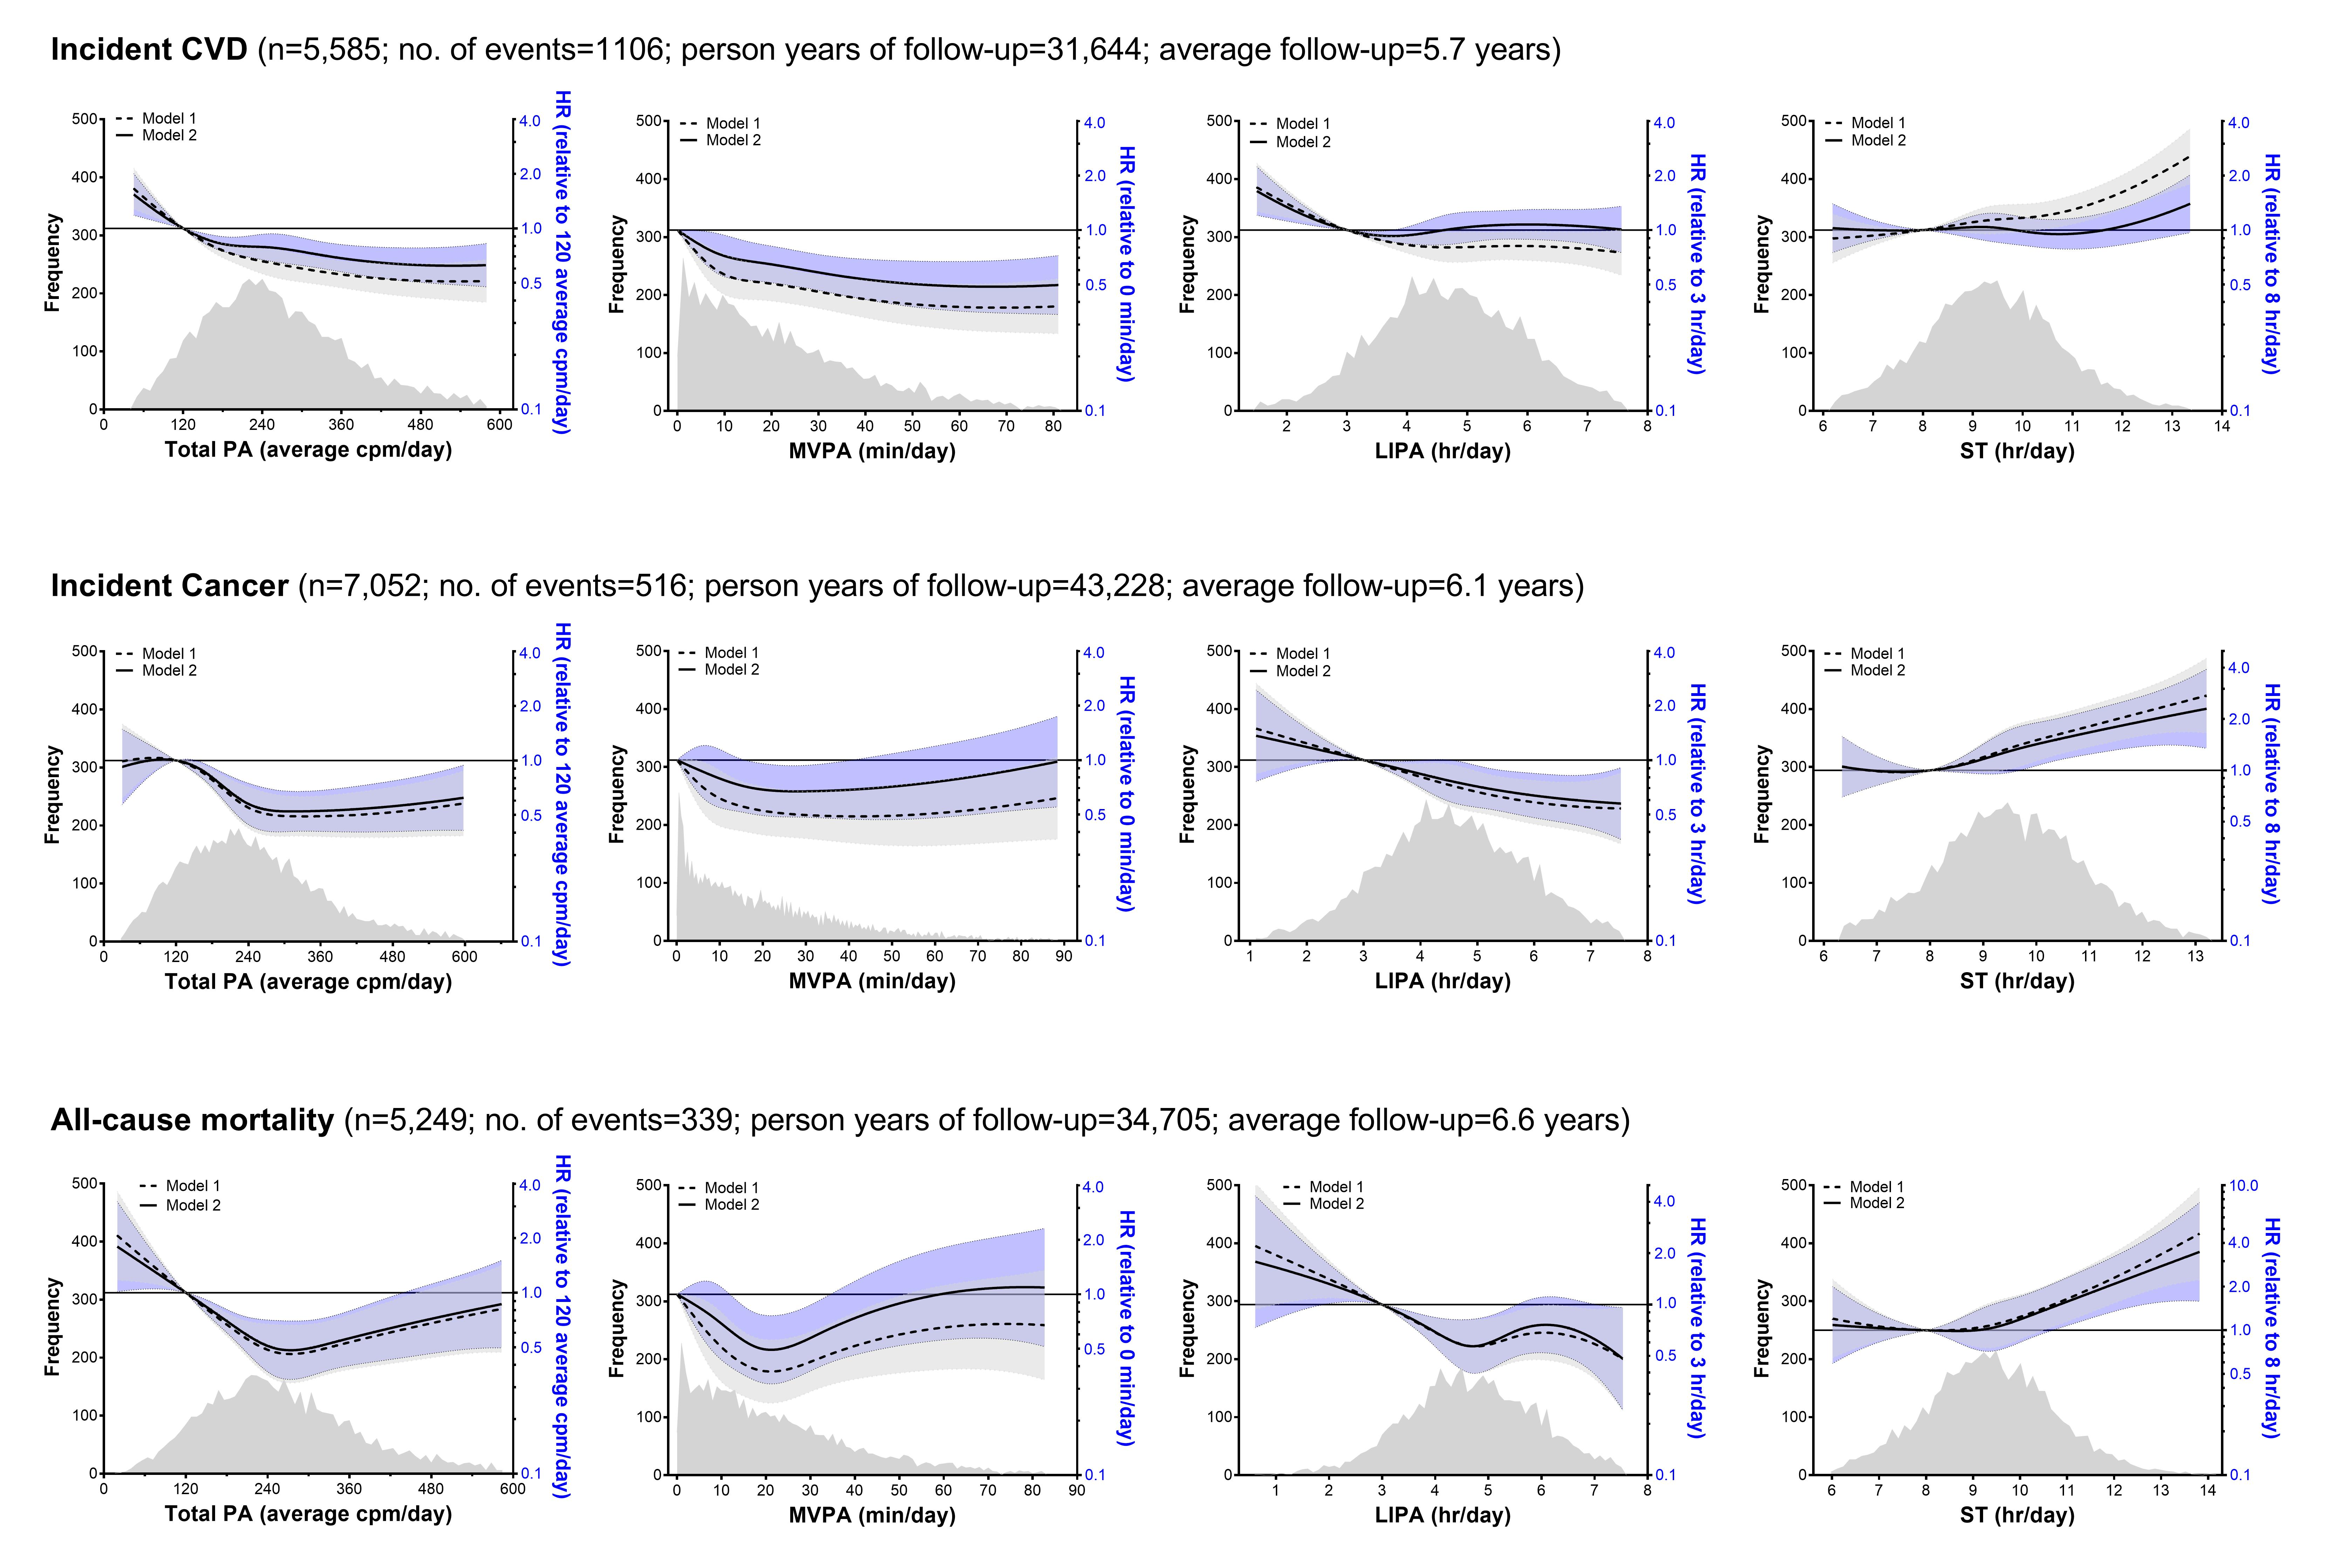
Figure. Baseline exposure distribution and hazard ratios (HR; 95% confidence intervals) for incident cardiovascular disease (CVD), incident cancer, and all-cause mortality by physical activity and sedentary time.
Participants with a baseline history of stroke/myocardial infarction (incident CVD models), cancer (incident cancer models), or either CVD or cancer (all-cause mortality models) were excluded.
Model 1: adjusted for sex and accelerometer wear-time (using age as the underlying timescale).
Model 2: model 1 + additionally adjusted for education level; social class; smoking status; alcohol intake; baseline history of diabetes or taking diabetes medications, medication for hypertension/dyslipidemia/depression, family history of CVD (stroke/myocardial infarction), diabetes, or cancer. In model 2, analyses of MVPA and LIPA are mutually adjusted, while analyses of ST are adjusted for MVPA.
Data were fitted using restricted cubic splines (3 evenly-spaced knots) and results are shown between the 1st and 99th percentiles of the relevant exposure. Reference values chosen for each exposure approximated the 10th percentile (Total PA=120 average cpm/day; MVPA=0 min/day; LIPA=3 hr/day; ST=8 hr/day). Covariates that violated the proportional hazard assumptions were included as baseline strata. Time-to-event was defined as the time from exposure baseline to the first event or end of follow-up.

Additional Table. Descriptive characteristics at baseline by incident cardiovascular disease, cancer, and all-cause mortality.

 |  | Incident CVD |  |  |  | Incident Cancer |  |  |  | All-Cause Mortality
Characteristics |  | Non-cases (n=4479) | Cases (n=1106) |  | Non-cases (n=6536) |  | Cases (n=516) |  |  |  | Non-cases (n=4910) | Cases (n=339)
Follow-up time (years), mean±SD |  | 6.3 ± 2.8 | 3.1 ± 2.2 |  | 6.3 ± 2.8 |  | 3.5 ± 2.4 |  |  |  | 6.7 ± 2.8 | 5.3 ± 2.8
Female gender, n (%) |  | 2,701 (60.3) | 566 (51.2) |  | 3,676 (56.2) |  | 227 (44.0) |  |  |  | 2,902 (59.1) | 159 (46.9)
Age (years), mean±SD |  | 68.3 ± 7.0 | 71.5 ± 7.4 |  | 69.9 ± 7.6 |  | 72.4 ± 7.7 |  |  |  | 68.4 ± 7.0 | 75.1 ± 7.5
Education level, n (%)
 | None | 984 (22.0) | 321 (29.0) |  | 1,621 (24.8) |  | 140 (27.1) |  |  |  | 1,132 (23.1) | 102 (30.1)
 | General Certificate of Education (GCE) Ordinary Level | 580 (12.9) | 125 (11.3) |  | 809 (12.4) |  | 49 (9.5) |  |  |  | 624 (12.7) | 41 (12.1)
 | GCE Advanced Level | 2,022 (45.1) | 485 (43.9) |  | 2,916 (44.6) |  | 242 (46.9) |  |  |  | 2,211 (45.0) | 149 (44.0)
 | Bachelor’s degree, and above | 893 (19.9) | 175 (15.8) |  | 1,190 (18.2) |  | 85 (16.5) |  |  |  | 943 (19.2) | 47 (13.9)
Social class, n (%)
 | Unemployed | 39 (0.9) | 8 (0.7) |  | 63 (1.0) |  | 2 (0.4) |  |  |  | 44 (0.9) | 1 (0.3)
 | Non-skilled | 87 (1.9) | 26 (2.4) |  | 140 (2.1) |  | 12 (2.3) |  |  |  | 97 (2.0) | 10 (2.9)
 | Semi-skilled | 492 (11.0) | 129 (11.7) |  | 747 (11.4) |  | 57 (11.0) |  |  |  | 544 (11.1) | 47 (13.9)
 | Skilled | 1,625 (36.3) | 399 (36.1) |  | 2,405 (36.8) |  | 167 (32.4) |  |  |  | 1,795 (36.6) | 116 (34.2)
 | Manager | 1,822 (40.7) | 454 (41.0) |  | 2,615 (40.0) |  | 233 (45.2) |  |  |  | 1,991 (40.5) | 138 (40.7)
 | Professional | 414 (9.2) | 90 (8.1) |  | 566 (8.7) |  | 45 (8.7) |  |  |  | 439 (8.9) | 27 (8.0)
Cigarette smoking, n (%)
 | Current | 282 (6.3) | 56 (5.1) |  | 388 (5.9) |  | 41 (7.9) |  |  |  | 282 (5.7) | 32 (9.4)
 | Former | 1,773 (39.6) | 506 (45.8) |  | 2,771 (42.4) |  | 239 (46.3) |  |  |  | 1,999 (40.7) | 162 (47.8)
 | Never | 2,424 (54.1) | 544 (49.2) |  | 3,377 (51.7) |  | 236 (45.7) |  |  |  | 2,629 (53.5) | 145 (42.8)
Alcohol intake (units/week), median (IQR) |  | 4.0 (1.0-10.0) | 3.0 (0.0-8.0) |  | 4.0 (1.0-9.5) |  | 4.0 (0.5-9.0) |  |  |  | 4.0 (1.0-10.0) | 3.0 (0.0-8.0)
Baseline history of diabetes or taking diabetes medications, n (%) |  | 85 (1.9) | 61 (5.5) |  | 239 (3.7) |  | 39 (7.6) |  |  |  | 119 (2.4) | 22 (6.5)
Anti-hypertensive medication, n (%) |  | 551 (12.3) | 492 (44.5) |  | 1,880 (28.8) |  | 200 (38.8) |  |  |  | 906 (18.5) | 98 (28.9)
Lipid-lowering medication, n (%) |  | 421 (9.4) | 258 (23.3) |  | 1,170 (17.9) |  | 132 (25.6) |  |  |  | 580 (11.8) | 65 (19.2)
Anti-depressant medication, n (%) |  | 235 (5.2) | 86 (7.8) |  | 397 (6.1) |  | 38 (7.4) |  |  |  | 272 (5.5) | 29 (8.6)
Family history of CVD (stroke, myocardial infarction), n (%) |  | 2,019 (45.1) | 587 (53.1) |  | 3,200 (49.0) |  | 263 (51.0) |  |  |  | 2,276 (46.4) | 178 (52.5)
Family history of cancer, n (%) |  | 1,756 (39.2) | 440 (39.8) |  | 2,574 (39.4) |  | 213 (41.3) |  |  |  | 1,924 (39.2) | 127 (37.5)
Family history of diabetes, n (%) |  | 574 (12.8) | 133 (12.0) |  | 899 (13.8) |  | 72 (14.0) |  |  |  | 629 (12.8) | 38 (11.2)
Waist circumference (cm), mean±SD |  | 92.7 ± 12.0 | 96.2 ± 11.9 |  | 94.7 ± 12.5 |  | 97.2 ± 11.4 |  |  |  | 93.3 ± 12.0 | 95.9 ± 12.5
Body mass index (kg/m²), mean±SD |  | 26.3 ± 4.0 | 27.3 ± 4.3 |  | 26.9 ± 4.3 |  | 27.2 ± 4.3 |  |  |  | 26.5 ± 4.1 | 26.5 ± 4.5
ActiGraph accelerometer
 | Valid wear days*, mean±SD | 6.7 ± 0.6 | 6.6 ± 0.6 |  | 6.6 ± 0.6 |  | 6.7 ± 0.6 |  |  |  | 6.7 ± 0.6 | 6.7 ± 0.6
 | Valid wear-time, hr/day*, mean±SD | 867.6 ± 60.9 | 869.2 ± 60.4 |  | 865.1 ± 61.9 |  | 859.6 ± 58.6 |  |  |  | 869.2 ± 60.3 | 850.7 ± 65.7
 | ST (cpm <100), hr/day, mean±SD | 9.3 ± 1.4 | 9.3 ± 1.4 |  | 9.5 ± 1.4 |  | 9.8 ± 1.5 |  |  |  | 9.3 ± 1.4 | 9.9 ± 1.6
 | LIPA (cpm 100-2019, hr/day, mean±SD | 4.7 ± 1.3 | 4.8 ± 1.3 |  | 4.6 ± 1.3 |  | 4.2 ± 1.4 |  |  |  | 4.8 ± 1.3 | 4.0 ± 1.4
 | MVPA (cpm ≥2020), min/day median (IQR) | 19.5 (8.9-34.0) | 12.7 (4.7-26.6) |  | 16.0 (6.3-30.6) |  | 11.3 (3.2-25.3) |  |  |  | 19.0 (8.7-33.1) | 7.7 (1.7-20.9)
 | Total physical activity, average cpm/day, mean±SD | 265.1 ± 120.0 | 272.8 ± 119.2 |  | 251.1 ± 120.2 |  | 219.0 ± 120.6 |  |  |  | 270.7 ± 118.6 | 197.9 ± 123.3

*Valid wear days are days with ≥10 h of valid wear-time (convention for compliant wear⁶). Data from the GT1M and GT3X+ accelerometers were harmonized using standard approaches to produce virtually identical results during standardized movements (i.e. activity volume and intensity) and making them suitable for combined analyses.
ST= sedentary time. LIPA= light-intensity physical activity. MVPA= moderate-to-vigorous intensity physical activity. CVD= cardiovascular disease. cpm= counts per minute.
For participants who attended both the 3rd and 4th in-clinic assessment visits (baseline) between 2004-2016 and wore an accelerometer, data from their earliest visit (i.e. 3rd visit) was used as baseline.

1. Migueles JH, Cadenas-Sanchez C, Ekelund U, Delisle Nystrom C, Mora-Gonzalez J, Lof M, Labayen I, Ruiz JR and Ortega FB. Accelerometer Data Collection and Processing Criteria to Assess Physical Activity and Other Outcomes: A Systematic Review and Practical Considerations. Sports medicine (Auckland, NZ). 2017;47:1821-1845.

Supplementary Material Information

Study: Prospective Associations of Accelerometer-Measured Physical Activity and Sedentary Time with Incident Cardiovascular Disease, Cancer, and All-Cause Mortality
Journal Name: Circulation
Authors: Paddy C Dempsey*^{1,2}, Tessa Strain, Kay-Tee Khaw, Nick Wareham, Søren Brage, Katrien Wijndaele
*Corresponding Author email: Paddy.Dempsey@mrc-epid.cam.ac.uk
¹ MRC Epidemiology Unit, Institute of Metabolic Science, University of Cambridge, Cambridge Biomedical Campus, Cambridge, UK.
² Baker Heart and Diabetes Institute, Melbourne, VIC, Australia.

