Development of model structural dampers for dynamic centrifuge testing
J. Boksmati & S.P.G. Madabhushi
Schofield Centre, Department of Engineering
University of Cambridge, UK

N.I. Thusyanthan
Chief Engineer
Atkins, UK

ABSTRACT: Supplemental energy dissipation devices are often selected based on the fixed base response of structures. There is limited knowledge regarding the actual seismic performance of these buildings with regard to soil-structure interaction. This paper discusses the development and testing of miniature viscous dampers capable of fitting into structural models for dynamic centrifuge testing. An electromagnetic shaker was utilised to test the miniature dampers under high frequency small stroke conditions, similar to those expected during shaking in the centrifuge. Three damping fluids have been investigated; H68 oil, H32 oil, and water. Different piston stroke frequencies were applied for each of the fluids being tested. The miniature viscous dampers were successful in dissipating energies at small strokes. However, the damper setup seems to possess some inherent stiffness in addition to its viscous behaviour. Cavitation and entrapped air plays a critical role in limiting the effect of fluid viscosity on the damping behaviour for the small strokes and high frequencies being applied.

Introduction
Project design engineers are usually tasked with developing earthquake mitigation plans to accomplish specific seismic performance objectives set by the client. The plan essentially highlights how the structure will provide the necessary capacity to meet the predicted seismic demand; this is often an interplay between the structure’s kinetic energy, elastic deformations, inelastic deformations, and material hysteretic damping. Critical infrastructure assets and other key projects often have very stringent performance objectives. In many cases, clients demand operational continuity post-earthquakes, and request maintenance to be limited to non-structural components in their assets.
One traditional design approach would be to dissipate the seismic energy through elastic deformations within the structural frame. However, this usually results in uneconomical designs in which the structural member sizes are governed by a low probability event rather than more frequent actions. There is an increasing trend in industry to incorporate supplemental damping devices into structural frames as means of enhancing the seismic capacity of structures. Kasai (2016) conveniently classifies these supplemental devices as being either hysteretic (displacement-based), viscous (velocity-based), or visco-elastic. Other forms of supplemental damping, such as base isolation and tuned-mass dampers, have also been investigated and implemented in industry.
Unfortunately, the bulk of the research in the field of supplemental damping has been primarily driven by structural engineering. There is very limited input from geotechnical engineers about how soil flexibility influences the performance of structures equipped with these devices.
Recent centrifuge work by Jabary & Madabhushi (2015) highlighted potential drawbacks in setting the tuned mass damper frequency to the fixed-base natural frequency of structures. Jabary & Madabhushi (2015) concluded that a tuned-mass damper tuned to the soil-structure natural frequency outperforms that which is tuned to the fixed-base natural frequency. This finding raises questions about the performance of the other damping devices under real soil-structure conditions.



Figure 1. New Education Building retrofit at the University of Canterbury, New Zealand. (Victor Seismic 2017)
Among the several damping technologies listed earlier, viscous dampers have proven to be quite a popular option in projects requiring better storey-drift control and energy dissipation. Their dependency on velocity implies that the damping forces generated are out-of-phase with the applied seismic accelerations, hence, minimising any influence the additional damping forces may have on the structural members (Lee & Taylor 2001). In fact, their dependence on velocity allows them to mitigate both floor accelerations and storey shears simultaneously (Symans & Constantinou 1998). A wealth of knowledge about the performance of viscously damped buildings originates from intensive research programs, such as Kasai et al. (2010) and Chang et al. (2008), who investigated scaled down prototypes founded on rigid foundations. A review of current literature has shown very limited efforts towards understanding the effects of soil flexibility on the overall viscously damped structural response. Numerical and analytical evidence by Li et al. (2015), Zhou et al. (2012), and Zhao et al. (2017) has hinted towards a drop in damper efficiencies with softer ground. Dynamic centrifuge testing of model scale sway frames with these miniature dampers can provide vital insight into how seismic performance of real buildings could be improved by such devices. This paper will focus on the development and testing of miniature dampers under high frequency small stroke conditions using a Ling-200 series electromagnetic shaker.

Physical modelling

Model structures
Two identical model scale structures were constructed for the purpose of this investigation. The frames were fabricated using 6082-T6 aluminium alloy plates assembled to represent a two degree of freedom system. Figures 2 and 3 illustrate the dimensions and cross-section of the model frames. One model has been fitted with side plates to hold miniature dampers in place, while the other frame was used as an undamped control reference. The stiffness and mass distribution in the physical models were proportioned to achieve fixed base natural frequencies of 52 Hz and 119 Hz model scale.
At the intended centrifuge acceleration of 50g, the models would represent a fixed-base prototype with natural frequencies of 1.0 Hz and 2.38 Hz respectively. The choice of replicating a moderately flexible prototype was necessary to ensure practical inter-storey drift magnitudes during centrifuge shaking. The floor displacements at model scale had to be large enough to trigger proper viscosity induced damping behaviour from the miniature dampers. Otherwise, for very small damper piston movements (i.e. stroke), friction at the piston-seal interfaces would dominate the damping mechanism. In an attempt to further promote damper piston movements, the miniature dampers were positioned horizontally in-line with the floor displacements. The stocky aspect ratio of the model frames and the large raft foundations helped promote inter-storey shear deformations and damper activation by lowering the centre of gravity to minimise possible rocking during shaking.

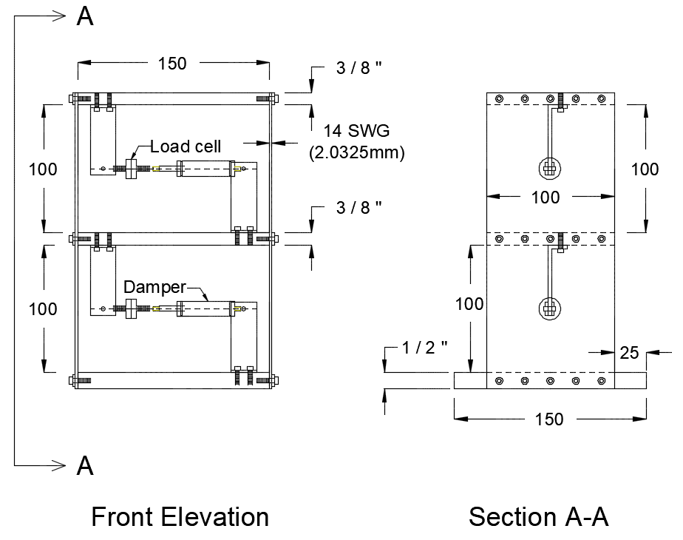

Figure 2. Cross-sectional view of the centrifuge model frames. All dimensions are in mm unless otherwise noted.

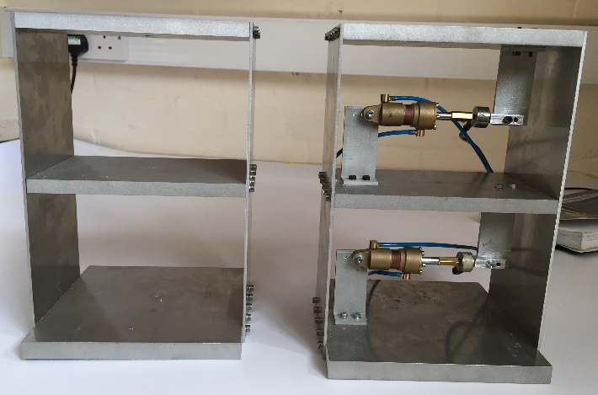

Figure 3. Damped and undamped models fully assembled with miniature dampers in place.

Impact testing was conducted on the two model frames to determine their as-built natural frequencies. The models were clamped at their base and subjected to small lateral impulses using a hammer. Figure 4 presents the results of a Fast-Fourier Transform conducted on normalised roof acceleration traces for both models. Data from each frame was normalised relative to the peak accelerations to account for the different magnitudes of hits applied during impact. The structures exhibited a fundamental frequency of 41.7 Hz and 42 Hz for the undamped and damped frames respectively. This marked a 29 % approximate drop in stiffness when comparing that of the fabricated models to that which has been assumed in design. This drop in stiffness is attributed to the partial fixity provided by the single row of bolts used for the floor-to-wall connection detail.
Table 1 summarises the dynamic characteristics of the two structural frames. The damped model is approximately 2 % stiffer than the undamped model. This minor variation in stiffness is the result of different tightening torques applied to the frame bolts during assembly. The additional connections fitted to support the miniature dampers in the damped model increased the frame’s hysteretic damping. This increase in damping ratio suppressed the occurrence of a second mode as shown in Figure 4.

Table 1. Dynamic properties of the centrifuge models.
 | Undamped | Damped
Mode 1 | 41.7 Hz | 42 Hz
Mode 2 | 114 Hz | -
Damping ratio, ξ
Mode 1 | 1.06 % | 3.7 %

Figure 4. FFT of normalised roof accelerations for both structures during impact testing.

At a centrifuge acceleration of 50g, the 42 Hz damped model represents a prototype building with 0.84 Hz fundamental frequency. Using the equation provided in Eurocode 8 (BS EN 1998-1) for predicting structural natural periods, and assuming a steel structural frame with C_{t} = 0.085, the model frames represent a 34m tall building (9-storey structure).
(1)
where T₀ = fundamental period of structure, C_{t} = structural frame constant, and H = effective height.

Miniature dampers
Model-scale hydraulic cylinders were procured from a supplier who specialises in manufacturing small-scale components for R/C (remote control) applications. The cylinders were slightly modified from their initial configuration to better simulate the internal components of passive dampers. Essentially, an O-ring seal originally installed around the piston head has been removed to create an annular gap between the piston head and damper body. This annular gap effectively acts as an orifice as the piston head moves in and out of the damper. Figure 5 shows a schematic representation of the damper setup. The actual setup can be seen in Figure 6.

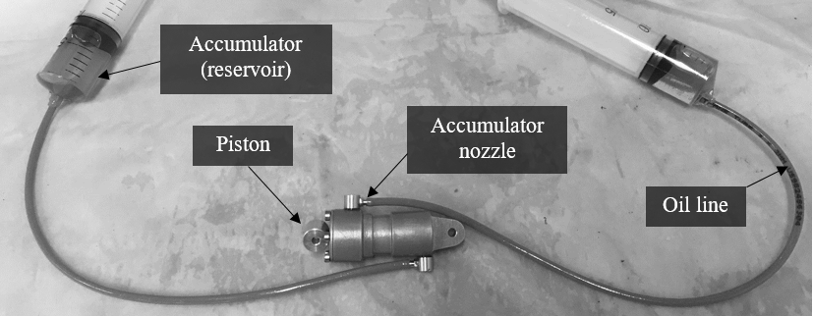

Figure 6. Actual damper setup.

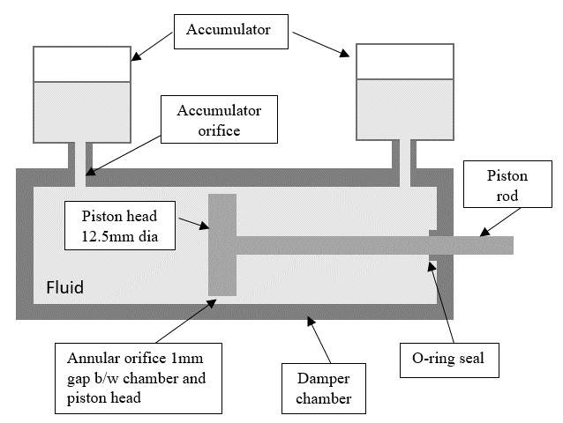

Figure 5. Schematic representation of the damper setup.

The modular construction of the cylinders allowed access to all the internal components of the damper, and provided flexibility for testing different damping fluids. During the development phase, three types of fluids were investigated; H68 hydraulic oil, H32 hydraulic oil, and water. Table 2 gives the basic fluid properties at room temperature for the three fluids.

Table 2. Fluid properties of the different fluids tested.
 | H68 Oil | H32 Oil | Water
Density (kg/m³) | 865 | 857 | 1000
Kinematic viscosity @20⁰C | 220 cSt | 87 cSt | 1 cSt

Damper characterisation

Test setup
Prior to testing the dampers in the centrifuge, it was important to understand, and where possible, replicate the conditions that these miniature dampers will experience during a dynamic centrifuge test. The first challenge was that these miniature dampers had to function under very small strokes (in the order of a few millimetres). The second challenge was that the strokes would be occurring at frequencies higher than what is typically experienced by prototype dampers in real structures. As illustrated earlier, the damped model frame has a fundamental fixed-base frequency of 42 Hz (model-scale). Hence, any base input motion applied in the centrifuge would trigger damper strokes at frequencies close to that range. A special setup, utilising a Ling-200 series shaker, was used to characterise damper behaviour under small stroke, high frequency inputs. The damper was clamped by a stand on one side, and connected to the shaker on the other. A function generator was used to drive the mechanical shaker at different frequencies. The experimental setup was instrumented with a tension-compression load cell to record the damping forces generated during vibration. A MEMS accelerometer was positioned on the damper piston to record piston acceleration traces with time. From this data, and through band-pass filtering and integration, piston velocities and stroke magnitudes were derived.

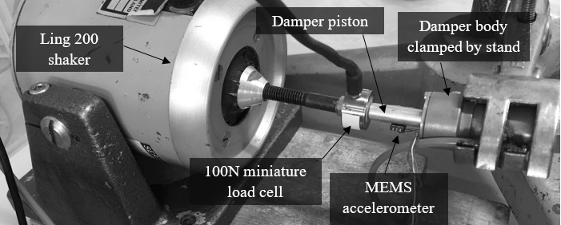

Figure 7. Experimental setup for testing miniature dampers at high frequency, small strokes.

Results and Discussions

Ideal viscous behaviour
Force-velocity and force-displacement plots are essential to characterising any damper performance. Ideally, viscous dampers are velocity dependant devices, with a force-velocity relationship governed by the equation:
(2)
where F = damping force, c = damping coefficient, V = velocity, and α = velocity exponent.
The velocity exponent is a function of piston head valving and orifice design in a damper (Duflot & Taylor 2008). Figure 8 shows the typical viscous damper characteristics for different velocity exponents. Linearity in the force-velocity relationship tends to simplify the selection and design process of dampers in a structure (Lee & Taylor 2001). However, most practical applications favour dampers with velocity exponents less than 1 (Lee & Taylor 2001). These nonlinear dampers generate greater damping forces at lower velocities compared to linear dampers (Hwang, 2002). Moreover, they exhibit a force cap with increasing velocity, which helps protect structural members from excessive forces during intensive shaking. The hysteresis in the force-displacement plot represents energy dissipated per cycle of piston movement.

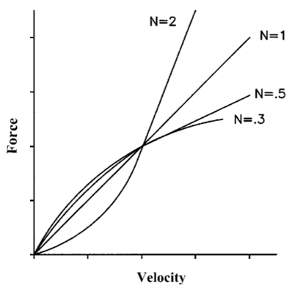

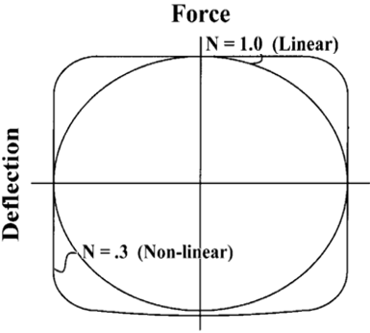

Figure 8. Variation of force-velocity and force-displacement response of viscous dampers with different velocity exponents (Adapted from Lee and Taylor, 2001)

For ideal viscous dampers which are purely velocity dependant, force displacement loops are perfect ellipses. The smoothness of the ellipse is a function of the velocity exponent.

Effect of input frequency
The shaker was set at four different frequencies for each of the fluids being investigated to examine the effect of input frequency on the damping behaviour.
The force traces have been filtered to remove very high frequency spikes for a clearer illustration of the force-velocity and force-displacement patterns observed. These spikes in force are attributed to contact between the moving coil assembly driving the damper, and the permanent magnet in the shaker. A low-pass filter was applied in MatLab setting the frequency cut-offs at 200 Hz, 250 Hz, 300 Hz, and 350 Hz for the 20 Hz, 30 Hz, 40 Hz, and 50 Hz frequencies being investigated.
Unlike the ideal behaviour presented earlier, the force-velocity plots for H68 oil shown in Figure 9 display considerable hysteresis in velocity. This implies that a portion of the input energy going into the damper gets stored rather than fully dissipated (i.e. the damper possesses some stiffness). At the 20 Hz and 30 Hz frequencies, there was a clear separation between the acceleration branch and deceleration branch of the compression stroke. Interestingly, this separation was not as excessive during the rebound portion of the cycle.

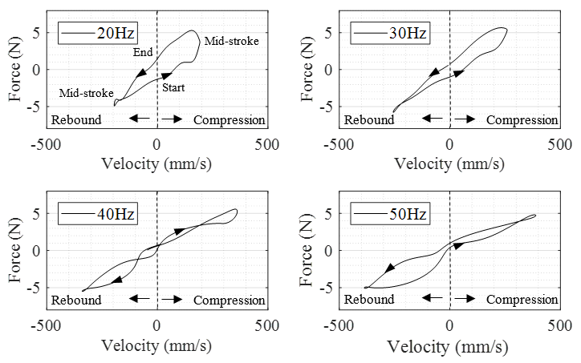
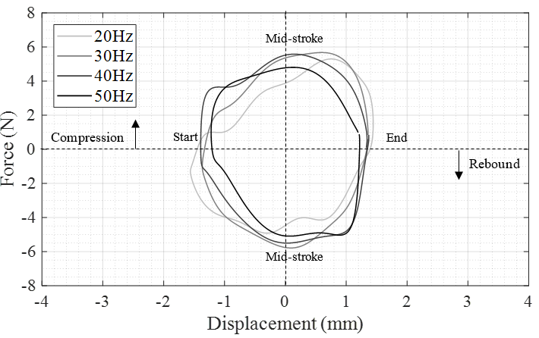

Figure 9. Force-velocity and force-displacement for H68 oil.

The very high frequency strokes applied by the shaker caused local cavitation and air bubbles to form in the oil at the vicinity of the piston head.
At 40 Hz and 50 Hz, the problem of oil cavitation becomes worse and the force-velocity traces become highly irregular for both compression and rebound strokes. This is mainly induced by the inconsistent viscous behaviour of foamed oil flowing around the piston head. A noticeable drop in gradient of the force-velocity plots, hence damping efficiency, can be observed as frequency increases from 20 Hz to 50 Hz.
Symans & Constantinou (1998) observed the same trend and attributed this to speed incompatibility between the accumulator nozzle discharging oil to the accumulator and the dynamic piston displacements at high frequencies. This lag accentuates the effect of fluid compressibility in the overall damper response. Foamed oil is more compressible that de-aired oil, which explains the substantial hysteresis observed in velocity. Jiao et al. (2017) go a step further and associate the drop in damper efficiency to the shear thinning properties of the damping fluid.

Effect of fluid viscosity
Comparing the force-velocity plots for H68 oil and water in Figure 10, both damping fluids exhibit hysteresis in velocity. However, the lag between damping force and piston velocity was noticeably smaller for water than that for the H68 hydraulic oil. This highlights the adverse effects that cavitation can have on the damping response in oils.

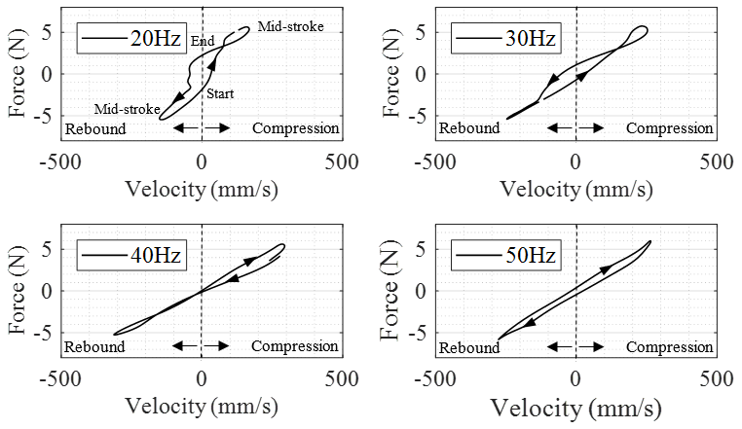
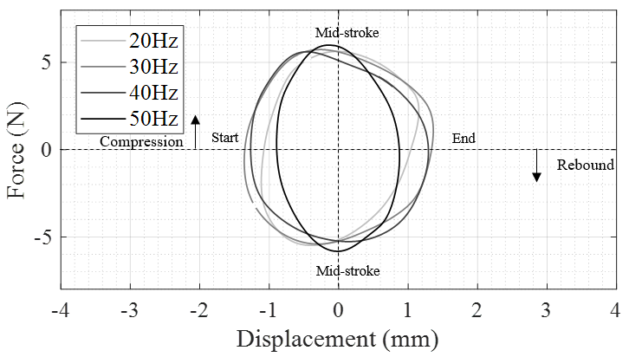

Figure 10. Force-velocity and force-displacement for water.

Basically, the more viscous H68 oil was not capable of flowing fast enough through the narrow orifice around the piston to match the high frequency strokes applied. This initiated local cavitation in the oil and resulted in a rather chaotic and unpredictable response from the foamed oil. Less viscous water flows around the piston head with lower resistance which limited the initiation of cavitation. The net result was a more predictable and smoother force-velocity relationship.

Centrifuge test Results
Testing the miniature dampers at 1g using the Ling-200 shaker has proven that the devices are indeed capable of dissipating work at high frequency small-stroke inputs. Nevertheless, the damping efficiency of the devices seems to be hindered by cavitation and foaming of oil. In an attempt to evaluate the model damper performance under enhanced g-level, the damped and undamped structural frames presented in Figure 3 were embedded into dry Hostun sand (HN-31 80% relative density) and simultaneously tested at 50g. The damped model was equipped with dampers filled with H68 hydraulic oil. Roof acceleration results for 0.6 Hz (30 Hz model scale) sinusoidal input motion of 0.12g magnitude are presented in Figure 11.

Figure 11. Prototype structural accelerations for model frames embedded in dense sand test at 50g experiencing 0.6 Hz (30 Hz model scale) sinusoidal input motion.

The model dampers have successfully reduced peak roof accelerations in the damped frame compared to its undamped counterpart. A substantial reduction in the free vibration phase can also be observed when comparing the damped and undamped frame responses at the end of the base excitation.

Figure 12. Force-velocity plots for damper on the first floor and on the ground floor during steady-state cycles. Force in model scale.

Damper force-velocity plots during two steady state cycles are presented in Figure 12. Damping coefficients in the centrifuge (i.e. slope of the force-velocity plots) was much higher than its 30 Hz counterpart at 1g. It is believed that the enhanced g-level increased the oil pressure difference generated across the piston head in the dampers during piston motion. Hysteresis in velocity was still observed.

Conclusions
An electromagnetic shaker was utilised to determine the damping characteristics of three different damping fluids (H68 oil, H32 oil, water) at four different frequencies (20, 30, 40, and 50 Hz).
As frequency increased, an overall decrease in the damping coefficient was observed for the hydraulic oils tested. This was attributed to the formation of air bubbles and foaming of the oil at high frequencies.
Despite the force-velocity lag which has been recorded for all the fluids tested, the miniature dampers have been quite successful in dissipating energy at very small strokes and high frequencies. The model dampers were tested in the centrifuge as part of a two-degree of freedom frame embedded in dense dry sand. The enhanced g-levels resulted in higher damping coefficients than at 1g. However, lag between damping forces and velocity was still observed.

references
BS EN 1998-1:2004 Eurocode 8: Design of structures for earthquake resistance.
Chang, K., Lin, Y. and Chen, C. (2008) ‘Shaking Table Study on Displacement-Based Design for Seismic Retrofit of Existing Buildings Using Nonlinear Viscous Dampers’, 134(April), pp. 671–681.
Duflot, P. & Taylor, D. (2008) ‘Experience and Practical Considerations in the Design of Viscous Dampers’, in Footbridge 2008: Third International Conference.

Hwang, J. (2002) Seismic Design of Structures with Viscous Dampers, International Training Programs for Seismic Design of Building Structures. Taiwan.
Jabary, R.N. & Madabhushi, S.P.G., 2015. Tuned mass damper effects on the response of multi-storied structures observed in geotechnical centrifuge tests. Soil Dynamics and Earthquake Engineering, 77, pp.373–380.

Jiao, S., Tian, J., Zheng, H., Hua, H. (2017) ‘Modeling of a hydraulic damper with shear thinning fluid for damping mechanism analysis’, JVC/Journal of Vibration and Control, 23(20), pp. 3365–3376.
Kasai, K. et al. (2010) ‘Full-scale shake table tests of 5-story steel building with various dampers’, in 7th International Conference on Urban Earthquake Engineering (7CUEE) & 5th International Conference on Earthquake Engineering (5ICEE). Tokyo, pp. 11–22.
Kasai, K. (2016) ‘Performance of Seismic Protective Systems for Super-Tall Buildings and Their Contents’, International Journal of High-Rise Buildings, 5(3), pp.155–165.
Lee, D. & Taylor, D. P. (2001) ‘Viscous damper development and future trends’, Structural Design of Tall Buildings, 10(5), pp. 311–320. doi: 10.1002/tal.188.
Li, P., Yang, J. and Lu, X. (2015) ‘Study on Influence Effect of Vicious Dampers Considering Soil-Structure Dynamic Interaction’, in 6th International Conference on Advances in Experimental Structural Engineering. Illinois.
Symans, M. D. & Constantinou, M. C. (1998) ‘Passive Fluid Viscous Damping Systems for Seismic Energy Dissipation’, ISET Journal of Earthquake Technology, pp. 185–206.
Victor Seismic, 2017. Case Studies. [Online] Available at:
https://www.victorseismic.co.nz/case-studies-0
Zhao, X. et al. (2017) ‘Optimal Design of Viscoelastic Dampers in Frame Structures considering Soil-Structure Interaction Effect’, Shock and Vibration, Volume 17
Zhou, Y., Guo, Y. and Yong, Z. (2012) ‘Influence of Soil-Structure Interaction Effects on the Performance of Viscous Energy Dissipation Systems’, 15th World Conference on Earthquake Engineering (15WCEE).

