Collaborative Security Mechanism in Detecting Intrusion Activity

Faizal M. A., Mohd Zaki M, Shahrin S., Siti Rahayu S., Robiah Y.
Faculty of Information Technology and Communication
Univeristi Teknikal Malaysia Melaka,
Durian Tunggal, Melaka,
Malaysia

faizalabdollah@utem.edu.my, zaki.masud@utem.edu.my, shahrinsahib@utem.edu.my, sitirahayu@utem.edu.my, robiah@utem.edu.my

Abstract-The rapidly increasing array of Internet-scale threats is a pressing problem for every organization that utilizes the network. Organizations often have limited knowledge as well as capability to detect and respond to these threats. The sharing of information related to probes and attacks is a facet of an emerging trend toward ‘’collaborative security’’. Collaborative security mechanism provide network administrator with a valuable tool in this increasingly hostile environment. This research paper proposed a new Collaborative Security Model which incorporated existing mechanism such as prevention by using firewall or any network devices, detection by using Intrusion Detection System (IDS), response by correlating any log files gathered from multiple devices and forensic which tracing the activity of the intrusion. The model integrates and compensates the advantages and disadvantages of each mechanism in order to create a strong defensive model for the network infrastructure.
Index Terms-Collabrative security, Prevention, Detection, Forensic

- Introduction

In recent years, the Internet and networks has seen a great increase in its role in the society especially the government and business sector. During these times, we also witness more sophisticated attack launched by intruders, these might be motivated by financial and political objectives. The types of attacks are generated using tools and exploit scripts which are freely available on the internet and widely used by novice malicious users to launch an attack inside the network. Mc Hugh also provide further evidence by stating that “anyone can attack Internet site using readily made available intrusion tools and exploit script that capitalize on widely known vulnerabilities [1]. Therefore the increase in the number of the exploit tools may have influenced the number of novice attackers inside the internet as shown in Figure 1.
This can be shown from the report generated by Cybersecurity, Malaysia [2] in which there is a significant impact to the number of reported incidence due to security breaches as depicted in figure 2. Therefore in ensuring the network security, a strong mechanism that provides confidentially, integrity and availability should be deploy to protect the network infrastructure [3].
Nowadays, there is several security tools available on the market, in which can be used to strengthen the defensive mechanism of the network. Despite of the promises given by the security tools it is still not enough to depend solely on one specific tool as it will not enough to do all the security control mechanism at once. In order to achieve an effective security control in protecting the network, a defensive mechanism should support the preventive, detective and responsive countermeasures [3]. In fulfilling this matter, a network administrator can counter the intrusion problem and help them to look for known and potential threats in the network traffic and/or audit data recorded by the host by simply referring to one device.
Therefore, this paper will propose collaborative security model that can help to increase the security mechanism inside the network. The collaborative security model can be used as guidelines in real environment to seek the best security architecture for the organization. The sharing of information related to probes and attacks is a facet of an emerging trend toward ‘’collaborative security’’. Collaborative security mechanism provide network administrator with a valuable tool in this increasingly hostile environment.
The collaborative security model is focuses on the security control which are prevention, detection and response. This paper also propose a new element in the security control mechanism which the forensic element. Recognizing the real intruder inside the organization may help to reduce the possibilities of losses. At the same time increase the collaborative security mechanism for each of the devices such as intrusion detection system, log generation from multiple devices and rules for filtering as the first defenses of the network.
This paper is organized as follows. Section 2 discusses about the proposed collaborative security model in general. The detail explanation of the proposed model is defined in Section 3. Finally, Section 4 presents the conclusion and possible future extension of the work.

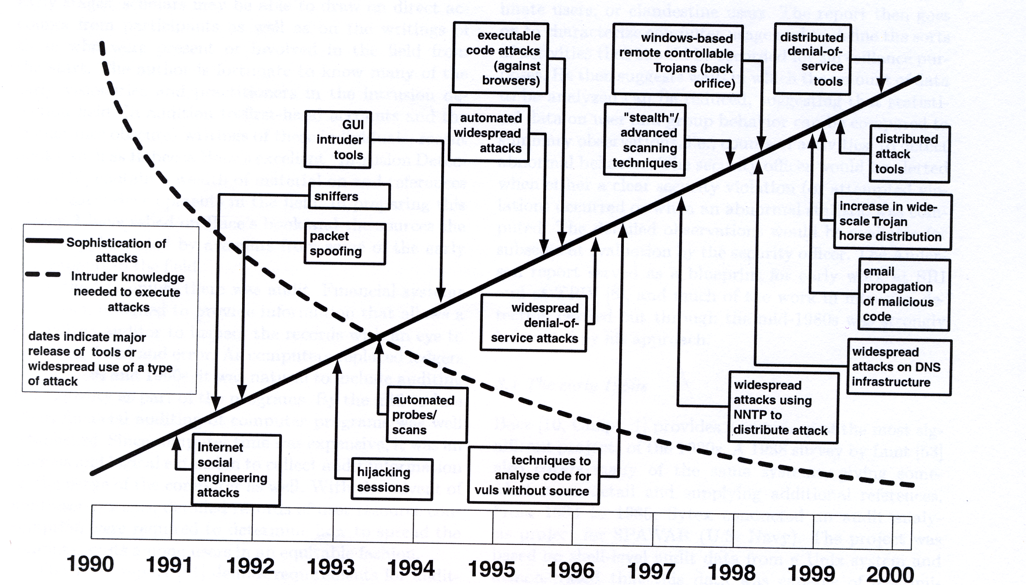
Fig. 1. Trend of exploit script

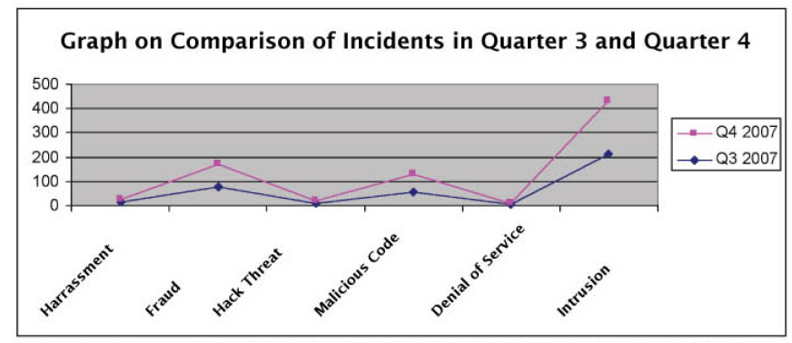
Fig. 2. Incident Statistic on Quarter 3 and Quarter 4 in 2007

- Collaborative Security Model

The collaborative security model is based on the security control mechanism as proposed in [3]. The actual security control only adapted prevention, response and detection as an element to protect the organization from intrusion or any malicious activity. It is not sufficient if considering only one element in the defense countermeasure because each of them has their own weaknesses. In Prevention, the devices need an input on the malicious activity to be prevented and this input can only be supplied by the Detection element. The response element is generated by multiple devices and used as an audit trail to investigate the activity in the network. The log generated by these devices is in different format thus there is a difficulty in correlating the information. Whereas the information gathered from the response element will be no used if there is no action taken in responds to the information gathered. This is where the forensic element takes its responsibility in which it help the administrator to trace the event from the data gathered in the previous elements. Hence the forensic element can be feedback as an input to the first and second element of the Collaborative Security Model. The complete proposal of the Collaborative Security Model is illustrated in figure 3.

Prevention
Detection
Response
Forensic
Fig. 3. Collaborative Security Mechanism

IDS have the capabilities to analyze the network traffic and recognize incoming and on-going intrusion. Unfortunately the combination of fast attack and slow attack detection module for anomaly detection in real time may slow down the detection process. In real time network, early detection of fast attack detection can prevent any further attack and reduce the unauthorized access on the targeted machine. Although fast attack detection increased the accuracy of detection but IDS still need further improvement in order to reduce the fast alarm. Therefore, correlating data among different logs to improve intrusion detection systems accuracy is needed. The existing alert correlation techniques had been reviewed and analyzed which are similarities based, Predefined Attack Scenarios, Pre-Requisites and Consequence of Individual Attack and Statistical Causal Analysis Technique. From the analysis, six capability criteria have been identified to improve the current alert correlation technique. They are capability to do alert reduction, alert clustering, identify multistep attack, reduce false alert, detect known attack and detect unknown attack. Therefore, the comparison of various techniques needs to be analyzed to find the most suitable log correlation technique for detecting the attackers. The accurate log generated by IDS using fast attack and alert correlation technique can further use as a source of evidence for forensic investigation in order to trace the origin of potential attack. Details on each element will be discussed in detail in the next section.

- Collaborative Security Element

This section introduces and discussed the Collaborative Security element in details. The comparison of the existing control security mechanism and the proposed Collaborative Security is introduced in this section.

- Prevention and Detection

The detection method used by the network intrusion detection system can be classified as anomaly based system and signature based system. Both of these detection methods are used by the intrusion detection system which, have their own drawback in detecting the intrusion activity.
Signature based NIDS have a major drawback in identifying the new intruder in the network. It is because signatures based NIDS depend on the intrusion pattern that have been declared inside a database of the intrusion detection system. If there is a new attack inside the network and the signature of the new attack has not been stated inside the database, thus the system will not be able to detect this new attack [4]. This problem arises because signature based network intrusion detection system relies on sets of predefined rules that are provided by administrator, automatically created by the system, or both [5]. Generating new rules need a deep knowledge and skills from administrator. However, not many administrators have such deep knowledge and skills to generate new signature [6].
Meanwhile, in anomaly based approach, the intruder detection attempts to model the expected behavior of objects (users, processes, network hosts and the like). Any action that does not correspond to expectation is considered suspicious. The strength of these methods lies in their ability to differentiate normal user behavior, anomalous acceptable behavior, and intrusive behavior [5]. The anomaly based detection has difficulties to determine the threshold value by which behavior must deviate from a profile in order to be considered as possible attack [7], [8], and [9].
Consecutively, to improve the detection process in the Collaborative Security Element a new detection method by segregating anomaly module into two different modules which are fast attack module and slow attack module is introduced [10], [11], and [12]. The capability of each module may contribute to the effectiveness of the proposed model.

- Response

In improving the response element in the proposed Collaborative Security model a new alert correlation techniques were developed in order to improve the correlation issues. The proposed criterion analyzed [13] is according to the capability criteria as listed below:

1. Capability to do alert reduction
2. Capability to do alert clustering
3. Capability to identify multi-step attack.
4. Capability to reduce false alert.
5. Capability to detect known attack
6. Capability to detect unknown attack

Alert reduction is required in order to overcome the problem of alert flooding or large amount of alert data generated by multiple devices. This capability is to reduce troubleshooting process especially when analyzing the exact attacker in the environment. The second criteria is the alert clustering in which it can cluster multiple related alerts and at the same time reduce the number of alert by ignoring the similar alert generated by different sensors.
The third criterion is capable to detect multi-step attack as the attacker behavior nowadays is becoming more sophisticated. For fourth criteria have the capability to reduce false alarm as this false alarm reduction criterion is important as it closely related to alert flooding issue. The fifth and sixth criterion can detect both known and unknown attack as it is required to ensure that the alert generated will overcome the issue of alert flooding and false alert.

- Forensic

In the Forensic element, the model proposed a new tracing technique which is illustrated in figure 4. It consists of three elements: victim, attacker and IDS [14]. For the victim it consist of Victim tracing algorithm which analyze the victim personal firewall, security log, system log and application log from the correlation log derived from the previous element. The same algorithm is applied to the attacker machine in order the true attacker. The alert generated from the detection element also becomes an input to this process. As a result the integration between all this elements may produce accurate information about the attacker and can be used as an input to the prevention element.

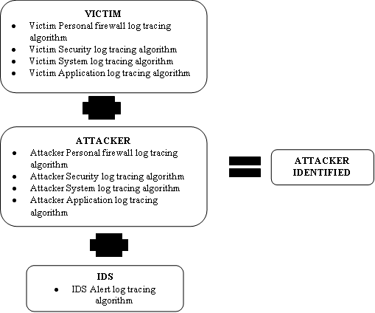

Fig. 4. Proposed Tracing Technique

- Conclusion and Future Work

In this study the researcher has proposed a new model for Collaborative Security which integrates the existing security control mechanism and adding a new element which can improve the current implementation of network security countermeasures. Each element has been reviewed and added with a new technique that can improve the existing defensive method which eliminates the current weaknesses. Currently the research group is in the process of integrating each element into one integrated system and in the future will evaluate and asses the proposed model in the real network environment.

References

[1] McHugh J., Christie A., Allen J. 2000. “Defending Yourself: The Role of Intrusion Detection System”. Proceeding of IEEE, Software, 2000.
[2] CyberSecurity Malaysia. “E-Security Volume 13-(Q4/2007)”. Technical Report for e-Security, CyberSecurity Malaysia, MOSTI, 2007.
[3] Mark Merkow and Jim Breithaupt. Information Security Principal and Practice. Pearson Prentice Hall, New Jersey, USA.
[4] Kingsly Leung & Christopher Leckie. “Unsupervised Anomaly Detection in Network Intrusion Detection Using Cluster”. In Proceeding of 28th Australian Computer Science Conference, 2005.
[5] James Cannady. “Artificial Neural Network for Misuse Detection”. In Proceeding of National Information System Security, 1998.
[6] Koike, H. & Ohno, H. “Snortview:Visualization System of Snort Logs”. In Proceeding of ACM VizSEC/DMSEC’04, 2004
[7] Chris Herringshaw. “Detecting Attack on Networks”. IEEE Industry Trends. 2004
[8] Roberson, S., Sigel, V.E., Miller, M & Stolfo, J.S. ”Surveillance Detection in High Bandwidth Environment.” In Proceeding of the DARPA Information Survivability Conference and Exposition (DISCEX’03), IEEE, 2003.
[9] Xin, W.J, Ying, W.Z. & Kui, D. “A Network Intrusion Detection System Based on the Artificial Neural Networks.” In Proceeding of the 3rd International Conference on InforSecu04, ACM, China, 2004
[10] Faizal M. A., Mohd Zaki M., Shahrin S., Robiah Y, Siti Rahayu S., Nazrulazhar B. “Threshold Verification Technique for Network Intrusion Detection System.” International Journal of Computer Science and Information Security, Vol 2, No. 1, 2009, ISSN 1947-5500, USA, 2009
[11] Faizal MA., Asrul HY., Shahrin S. “An Earlier Detection Framework for Network Intrusion Detection System”. In Proceeding of the Second International Conference on Advances in Information Technology, Bangkok, 1 – 2 November 2007.
[12] Shahrin S., Faizal MA., Asrul HY. “Toward Early Detection of Network Intrusion”. In Proceeding of Information Technology and National Security Conference, Riyard, 1-4 December 2007, Saudi Arabia.
[13] Robiah Yusof, Siti Rahayu Selamat, Shahrin Sahib. ” Intrusion Alert Correlation Technique Analysis for Heterogeneous Log”. International Journal of Computer Science and Network Security, Vol 8, No. 9, pp 132-138, 2008.
[14] Siti Rahayu S., Robiah Y., Shahrin S., Faizal M. A., Mohd Zaki M, Irda R. “Tracing Technique for Blaster Attack.”. International Journal of Computer Science and Information Security, Vol 4, No 1, pp 1-8, 2009.

