RESEARCHES ON THE INFLUENCE OF RISKS IN INDUSTRIAL ORGANIZATIONS’ PROCESSES WHEN IMPLEMENTING QUALITY-RISK INTEGRATED MANAGEMENT SYSTEMS

RADU O-D., MURARU-IONEL C., SFIRU R., CODRUZ P., SORICA C., CRISTEA L.
INMA Bucharest / Romania
E-mail: diana10.cristea@gmail.com

Keywords: company, production, industrial

ABSTRACT

The concept of the integrated quality-risk management system can be defined as a set of methodologies, associated processes that invariably use human resources, material and financial resources, equipments and knowledge, in order to meet the objectives aimed at satisfying all interested parties.
In the conditions of fulfilling the integrated management system, it will bring many economic and financial benefits in order to reduce the consumption of resources and increase the profit. If implemented correctly, the quality-risk integrated management system will include all business competencies in a systematic environment that will deliver on the mission of the organization, contribute to increasing benefits, optimize resource consumption, and reduce costs to maintain multiple integrated management systems.

INTRODUCTION

In the current economy, any business presents risks with a different impact factor, which leads to a reduction in the profit of the organization, with implications for achieving the performance and the development of the organization. It is therefore appropriate to identify the risks, to estimate the likelihood of their occurrence and their impact and finally to develop improvement opportunities for diminishing the influence of unfavorable factors [3, 4].
Within the integrated management system is considered the approach of all component systems in a unitary form for the purpose of simplifying the documents of the audit mode in which the certification is unique. The overall approach of the integrated management system has the advantage of looking at the organizational system, the interactions between the processes and the consequences generated by the specific factors specific to the component standards.
Obstacles encountered by organizations in defining the objectives and goals proposed are often the result of non-compliance with the quality, environment, safety and health conditions of personnel, information security, etc. The need to integrate these areas has defined the establishment of a integrated management system [5].
The integrated quality-risk management is based on the principle of P.D.C.A. (Plan-Do-Check-Act), which establishes the following actions:
- Planning (P) to establish objectives and processes necessary to achieve results in accordance with customer requirements and organization policy;
- Perform (D) to implement processes within the organization;
- Check (C) to monitor and measure processes and products as compared to product policies, objectives and requirements, and report results;
- Act (A) to considered to continuously improve process performance.
As far as the risk that organizations have to assume, they get new dimensions. Peter Drucker has identified four categories of activity risk [2]:
- risks that we have to assume, as they are inherent in the nature of our activity;
- risks that we allow ourselves to assume;
- risks that we cannot assume;
- risks that we cannot afford to assume.
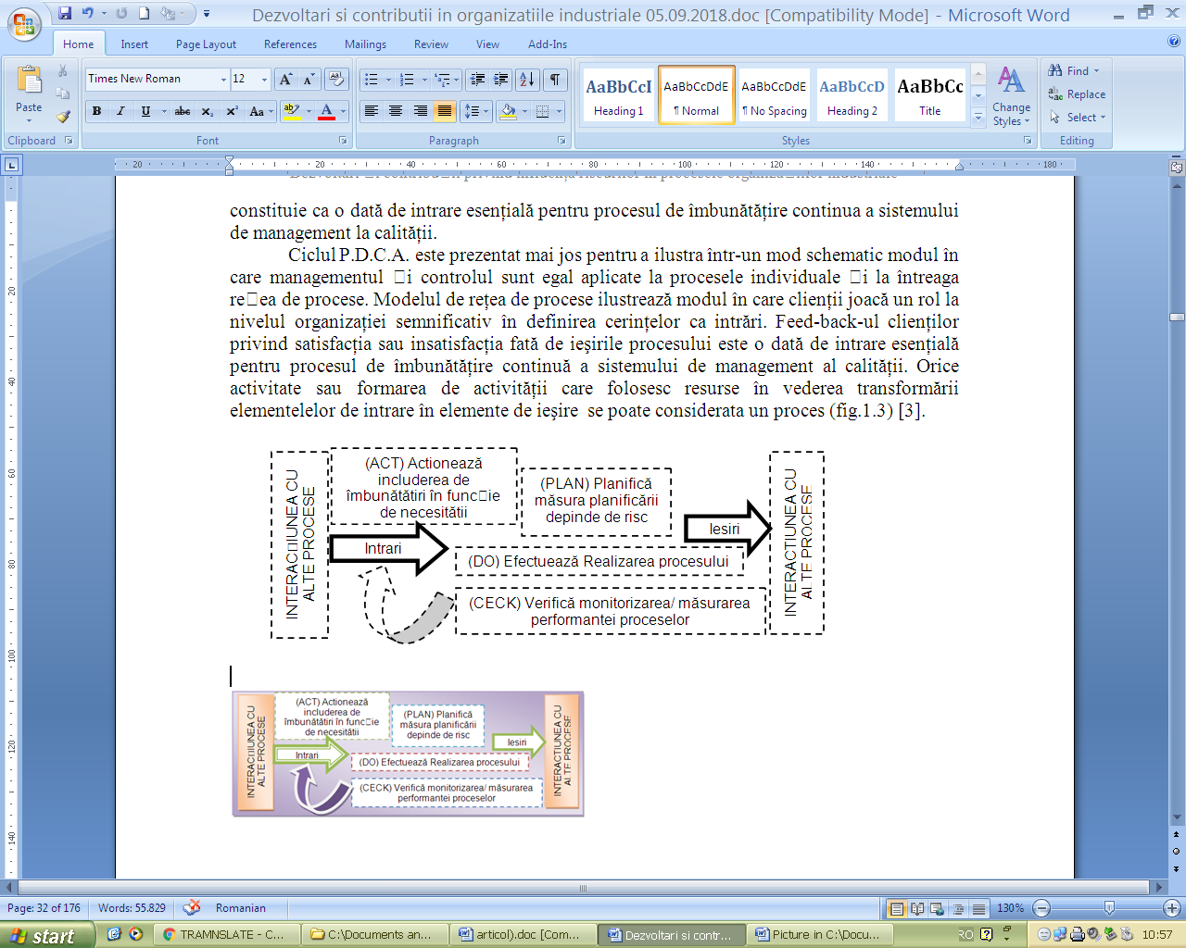
Figure 1. Succession and Process Interactions P.D.C.A.

In this situation, the risk management and implicitly the restriction of the phenomena disturbing the activity of the economic agents compares the substantiation of the two magnitudes between the correlation and the risk management.
The P.D.C.A. is presented below to illustrate in a schematic way how management and control are equally applied to individual processes and the entire process network. The process network model illustrates how customers play a significant role in the organization's definition of requirements as inputs. Customers' feedback on satisfaction or dissatisfaction with process outcomes is an essential input to the process of continuous improvement of the quality management system.
Any activity or activity formation using resources to transform the input elements into output elements can be considered as a process (Fig. 1) [1].
The main advantage of the process-based approach is the management and control of the interaction between processes and the interfaces between functions within an organization. The process-based approach introduces horizontal management by crossing the barriers between different functional relationships, focusing efforts on the organization's main goals and improving process interface management.
Risk diagnosis is part of proactive, preventive and practical management methods. In industrial organizations, this method can be viewed with skepticism, just as other managerial methods have had this reaction at first but as a way of working, implemented in our attitude of managers and in the culture of the organization, can have great effects on the health and vitality of the organization and implicitly, of the human factor.
Economic transactions, like all our actions, involve some element of risk. In some cases the risk does not significantly affect the performed operations and can be ignored. In some situations, the degree of risk of a transaction can seriously affect the compartment of the implications.
Diagnosing risks involves knowing and evaluating the organization's skills considering the associated risks.
An organization's risk diagnosis should answer the following questions:
- What are unforeseen events occurring in the system?
- What is the probability of an unwanted event occurring?
- What are the consequences associated with the occurrence of an event?
- What are the criteria for deciding?
- How can we intervene in the event of an unwanted event occurring to diminish the associated consequences?
- What are the necessary data for risk assessment and development of risk control models? empirical approach to the organization creates a framework for protecting the organization from emerging new risks, increasingly studying and learning. Risk diagnosis is the basis for resolving the risk issue.
- Key processes in risk diagnosis are to identify all potential risk sources that can significantly affect the results and the evaluation process [7]. In times of rapid change, new sources of risk may arise. Therefore, the external environment of the organization must be continuously assessed including changes that may affect the organization in its evolution.
For the industrial system, risk and quality have become two essential and indissociable priorities. The rationales behind this concept are [7]:
- critical review of processes often reveals functions such as incidents and accidents. It is essential to address these issues globally by identifying solutions integrating maintenance, quality, reliability and security aspects;
- security is an essential component of quality in the organization's processes and one of the bases of any approach to quality management. For employees, workplace and security actions, credibility of the new management mode adopted by managers;
- buyers become more demanding than product quality. They formulate a set of requirements on the reliability and mentality, economic, synergistic and sanegetic of products, their compatibility with other products;
- at international level, the quality of products and services is assessed in close connection with quality of life. To reduce the negative environmental impact of some products, regulations, mandatory standards relating to the protection of life, human health and the environment are introduced;
- more and more complex processes require a new computer assisted quality-caq approach;
- the issue of risk lies in the fact that we live in a ricochet civilization that redefines itself within the organization's space defined by the coordinates: efficiency, environment, maintenance, reliability, security, quality, excellence, etc.;
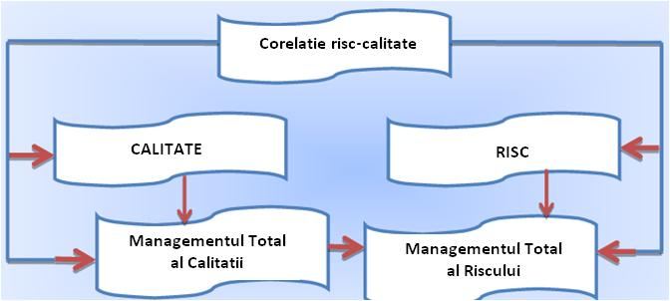
Figure 2 - Fundamentals of Quality-Risk Correlation

The need to carry out risk assessment at national and international level.
Within the international context, most EU Member States have developed risk assessment methodologies adopted in national legislation and already in place.
Since 2010, the European Commission has initiated a process to create a unique risk-based methodological framework that will allow the development of common European strategies and policies based on comparable EU-wide results in order to improve the capacity of Member States to respond through preventive, preparedness and intervention measures for identified risks.
The objectives of the lines set by the European Commission are [6]:
- Apply good practice, international standards to develop common risk assessment approaches;
- Establishment of a risk assessment tool, especially in the field of disaster management;
- The way of prioritizing and allocating investments in the prevention, preparation and establishment of rehabilitation measures;
- To increase the level of awareness of the population regarding disaster prevention measures;
- Transmitting information to establish a European-level disaster-assistance capacity database.

MATERIAL and method

Referring to the opinion of several industrial organizations, which have undergone certification of an integrated quality-environment-health and occupational safety management system, the implementation of such a system should consider the following aspects:
- Top management that will have to base the aspects of quality, environmental protection and health;
- The industrial organization must appreciate the improvement of the relevant process for the quality of products and services and the contact with the environment as indispensable strategic aspects for achieving the competitive advantages;
- The industrial organization proposes to act as a social model in the area;
- Integration of the systems into a single quality-risk management system through the efficient operation of the quality management system according to ISO 9001.
Risk management principles
Risk management facilitates a structured and systematic approach to decision-making. The value and strength of the risk management approach lies in the fact that it can combine different assessment and consultation techniques, combining into a set that gives consistency to the decision-making process. Risk management gives any organization the ability to better understand how operations are performed and the ability to respond effectively to internal and external changes [20].
In order to be as effective as possible, the risk management system in industrial organizations must use and apply the following principles presented below:
P.1. Risk management creates and protects value. Risk management contributes to the demonstrable fulfillment of objectives and performance improvements (eg health and occupational safety, security, legal and regulatory requirements, public acceptance, environmental protection and product quality, project management, operational efficiency, leadership and reputation).
P.2. Risk management is an integral part of all organizational processes. Risk management is part of management responsibilities and an integrated part of organizational processes, considering change management processes.
P.3. Risk management is part of the decision-making process. Risk management helps decision makers make informed decisions. Risk management can help prioritize actions and discuss different action alternatives. In the last instance, risk management can help with decisions whether a risk is unacceptable or whether the treatment of the risk is appropriate and effective.
P.4. Risk management explicitly addresses uncertainty. Risk management deals with those aspects of the decision-making process that are uncertain, with the nature of these uncertainties and how it can be addressed.
P.5. Risk management is systematic, structured and timely. A systematic, time-based and structured approach to risk management helps achieve consistent and effective, comparable and reliable results.
P.6. Risk management is based on the best available information. Entries to the risk management process are based on sources of information such as experience, feedback, observation, forecasting and expert judgment. However, decision-makers should be informed and should consider any limitations or modeling used or the possibility of divergent opinions among experts.
P.7. Risk management is customized. Risk management is adapted to the context of internal and external organization and to the risk-benefit of each industrial system.
P.8. Risk management considers human and cultural factors. Risk management at the organization level must recognize the perceptions, capacities and intentions of individuals outside or inside the system that can facilitate or hinder their realization.
P.9. Risk management is transparent and participatory. The timely and timely involvement of interested parties, especially decision-makers at all levels of the industrial system, ensures that risk management remains relevant and up-to-date. Involvement also allows stakeholders to be properly represented and to have their views considered when establishing risk criteria.
P.10. Risk management is dynamic, interactive and responsive to change. At the level of the industrial system, internal and external events occur, changing the context and knowledge, monitoring and reviewing activities, emerging emerging risks, some changing, and others disappearing. Consequently, the organization must ensure that risk management continually senses risks and responds to changes.

results and discussions

The research underlined that although the importance of scientific application of risk management is clearly underestimated, academic competence identifies opportunities specific to the Romanian business environment, which could be frustrated by adapting the mission and management of Romanian organizations to the requirements imposed by the globalization of business and the internationalization of firms.
Industrial organizations consider it important to understand the needs and expectations of stakeholders, given their effect on the organization's ability to consistently deliver quality products and services that meet customer requirements and at the same time ensure the fulfillment of applicable legal requirements and regulations. Once identified, the organizations will monitor and analyze stakeholder information and their relevant requirements, and will set up measures to deliver quality products and services in the context of compliance with applicable applicable regulations.

Table 1
Interested Parties | Expectations
Performance management | - clear legislative framework, predictable to ensure high compliance and a minimum level of sanctions  - financial capacity to ensure a high level of performance and organizational development, as well as increasing the prestige of the organization;  - competent staff at all levels;  - internal organizational climate based on professional competence, ethics and integrity, collegiality, honesty and accountability
Process owners (heads of organizational structures) | - clearly regulated organization and functioning framework;  - sufficient resources for conducting processes under conditions of efficiency, efficiency and economy;  - efficient communication and reporting system;
Competing companies | - knowing strengths and weaknesses of competition  - know the performance of the competitive environment  - competition environment based on mutual respect
Hierarchically superior authorities, regulators | - compliance with the legislation in force;  - understand the legal requirements for reporting irregularities in the application of the legal regulations  - promptness and compliance in the application of legal requirements
Quality Management System Certification System | - ensure the organization, functioning and legal framework for maintaining the organization's certification;  - compliance with the legal framework and documentation necessary for the assessment, reporting according to the requirements of the body;  - identification of meconformities and corrective actions;  - ensure the monitoring of the actions, the evaluation of the results and the establishment of improvement and correction measures.

CONCLUsions

The results of the researches made allow to highlight the following conclusions:
- Quality can have a dynamic character both due to restructuring, modernization and the promotion of technical progress, on the one hand, and on the other hand due to the increasing demands of consumers on quality. The quality function must include all the activities involved in that activity and this means that it includes all the processes in the industrial organization;
- Risk management should be a present or at least talk about any industry organization. The size of the implementation effort will vary from organization to organization, depending on the field of activity and size. By anticipating future events, the benefits can be immense: certainty about market conditions, competitive advantage, understanding of the internal and external environment in which the organization operates, anticipating crisis situations, avoiding frauds;
- any recording of a risk must be accompanied by an appropriate record of it. In fact, well before the risk identification process begins, an appropriate registration system needs to be developed and implemented.
- Once the risks have been identified, all relevant data should be inserted for use in the analysis process of the following period as a reference point.
- The implementation of the integrated quality-risk management system is a desideratum for all organizations, reflecting its maturity. The results of poor quality are reflected by: unjustified costs of additional checks, checks and repairs, scrap, materials and funds to be replaced, customer complaints costs, customer loss and ultimately reputation.
- The implementation of the quality-risk integrated management system has a special importance in the activity of the industrial organizations within the industrial system, because by knowing the phenomena, preventive measures can be taken to diminish further effects.

Bibliography

1. Barnea C., 1992 - Managementul întreprinderilor mici şi mijlocii, Revista „Adevărul Economic”, nr. 17;
2. Drucker P., 2001 - Management strategic, p.154, Editura Teora, ISBN 973-20-0056-2.
3. Mandru L, Begu L-S., 2008 - Corelaţia între atitudinea faţă de risc şi funcţia de utilitate”, Simpozionul International al Clubului Economistilor Braşoveni, Editura Didactică şi Pedagogică, ISBN 978-973-302- 473-6,
4. Mândru L., Mândru E., 2010 - Corelatia calitate-risc în procesele economico-industriale”, revista „Meridian Ingineresc”, Editura Universitatii Tehnice a Moldovei, nr.1, ISSN 1683-853X, 2010.
86 World Economic Forum, Global Risks 2011, p.1.,Sixth Edition”, 2011.
5. Avram S-E, 2009 - Simpozionul Impactul Acquis-ului comunitar asupra echipamentelor si tehnologiilor de mediu, Agigea.
6 *** International Organization for Standardization/ Standardul SR EN ISO 9001:2015 – Sisteme de Management al Calității. Principii fundamentale si vocabular.
7. ***Risk Assessment and Mapping Guidelines, p.7.SEC, 2010.

