DNA-minor groove binding agents as anti-tubercular probes. Old tools for a new challenge?
Federico Brucoli*



Leicester School of Pharmacy, Faculty of Health and Life Sciences, De Montfort University, The Gateway, Leicester LE1 9BH, United Kingdom
Abstract: Tuberculosis, an ancient infectious disease caused by Mycobacterium tuberculosis, ranks as one of the top ten killers worldwide. The limited number of validated targets and scarce therapeutic options demand that renewed efforts should be made to identify tuberculosis drugs with novel mechanisms of action. To this end, mycobacterial DNA might represent a potential target for the development of effective anti-tubercular compounds. In particular, the minor groove of DNA offers an important recognition site for small-molecules that can be programmed to bind to this region in a sequence-selective manner to disrupt mycobacterial transcription factors activity and ultimately cause bacterial cell death.
This review describes the structural features of the DNA-minor groove, the requirements for small-molecules to bind to this site and the remarkable biophysical and antibacterial properties of DNA-minor groove binding agents, including netropsin, distamycin and their poly-heterocyclic analogues, diamidines, benzimidazole-containing molecules, duocarmycins and pyrrolo[2,1-c][1,4]benzodiazepines (PBDs). Furthermore, the ability of selected heterocyclic-polyamides and PBDs to significantly inhibit the growth of pathogenic, slow-growing M. tuberculosis and other non-pathogenic mycobacterial strains is highlighted. In summary, DNA-minor groove binding agents may serve as molecular scaffolds for the design of highly efficient probes to treat M. tuberculosis infections.
Keywords: DNA-minor groove; Mycobacterium tuberculosis; pyrrolobenzodiazepine; heterocyclic polyamides; netropsin; distamycin; tuberculosis drug discovery.

1. INTRODUCTION
Tuberculosis (TB) is a serious infectious disease caused by the Mycobacterium tuberculosis (Mtb) bacterium and ranks as one of the top ten leading causes of death worldwide [1, 2]. The World Health Organisation (WHO) estimated that in 2016 10.4 million people were infected with TB and 1.7 million people died from this disease [1, 2]. The majority of cases and deaths occurred in India, which bears the highest TB burden, followed by Indonesia, China, Philippines, Pakistan, Nigeria, and South Africa [1]. In recent times, Europe has also witnessed a TB resurgence [3] that is partially ascribable to migrants’ fluxes from high-incidence TB regions [4]. In UK alone, 6000 new cases were reported in 2014 and large outbreaks in London contributed to the high TB incidence in this capital city [5].
The eradication of TB is particularly problematic in low- and middle-income countries [6] due to the rise of HIV-TB co-infection, and multi-drug (MDR) and extensively-drug (XDR) resistant TB. The treatment of drug-sensitive, pulmonary TB is lengthy and complex, consisting of a combination of isoniazide (INH), rifampin (RIF), pyrazinamide (PZA) and ethambutol (EMB) given daily over a period of 6-9 months. As patients often do not strictly adhere to this drug regimen, Mtb strains can easily acquire resistance, resulting in over 480 000 cases of MDR-TB occurring every year globally [1, 6].
One of the targets set by WHO with its newly adopted Sustainable Development Goals is to end the TB epidemic by 2035 [7, 8]. Therefore, new, cost-effective therapeutic agents with novel mechanisms of action for drug-susceptible and drug-resistant TB need to be discovered and tested in Phase II or Phase III trials. Low commercial interest, poor funding availability and few drug discovery efforts were behind the lack of new medicines to treat TB for over forty years [9]. However, the trend has now changed and two new drugs, bedaquiline [10] and delamanid [11], were approved in 2012 by FDA and 2013 by EMA, respectively. A critical mass, comprised of research and development capacity and funds, is currently being generated by collaborative public–private partnerships led by, amongst others, the Lilly foundation [12], GSK [13] and non-profit organisations, such as the TB Alliance, with the aim to kick-start new models of conducting TB drug discovery campaigns.
Availability of the complete M. tuberculosis genome in 1998 [14] has led to the discovery of crucial biochemical targets and novel hit-compounds continue to be identified through target-based screenings [15]. However, very few hits are progressed as leads in clinical trials and several targets, which were deemed promising, failed to be therapeutically viable options [16]. As a result, there is still a limited number of validated TB targets for anti-tubercular probes [17]. These include, but are not limited to, cell wall biosynthesis enzymes, such as the enoyl-acyl carrier protein reductase InhA (inhbited by isoniazide) [18], and decaprenylphosphoryl-β-D-ribose oxidase Dpre1 (inhibited by benzothiazinones) [19]. The DNA-directed RNA polymerase enzyme (inhibited by RIF) [20] and the b subunit of the respiratory cytochrome bc₁ complex QcrB [21] (inhibited by lansoprazole [22] and imidazopyridine Q203 [23]). The trehalose monomycolate membrane transporter MmpL3 [24] (inhibited by EMB-diamine derivative SQ109) [25] and the ATP synthase proton pump (inhibited by bedaquiline) [26].
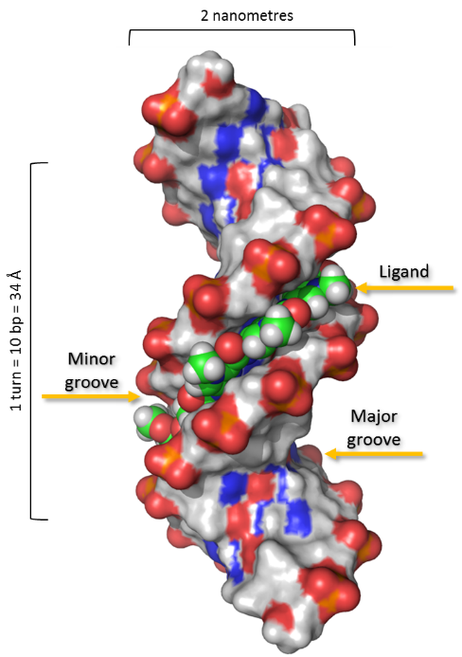
Mycobacterial DNA, on the other hand, is a target not fully explored in TB drug discovery [27]. In particular, the DNA-minor groove represents a remarkable site of recognition, offering a number of hydrogen bond donor and acceptor moieties that can be attacked by small-molecule anti-infective agents, ultimately leading to transcription factors blockade [28]. During the past three decades, the DNA-minor groove has been the focus of in-depth investigations [29] and, capitalising on the wealth of structural information generated on this target, one can employ DNA sequence-selective programmable molecules [30] to develop novel anti-tubercular drugs. There are, however, apparent drawbacks related to the potential use of DNA-minor groove binding agents against mycobacterial infections. These compounds cannot readily discriminate between host and bacterial nucleic acids and it has been estimated that a ligand should unequivocally recognise 14-16 base pairs in order to target a single gene promoter [31, 32], thus resulting in high molecular-weight compounds with unfavourable physicochemical properties and poor bioavailability. Nevertheless, mycobacterial-DNA selectivity can be obtained by incorporating minor groove binding agents in to drug delivery systems that allow them to selectively kill the tubercle bacilli within infected macrophages, resulting in null toxicity to the host cells. In addition, smaller ligands, such as hairpin pyrrole-imidazole polyamides, which have reduced site specificity (4-6 base pairs) and enhanced cell-permeability, are still capable of recognising a number of DNA motifs and repress gene transcriptions [33, 34, 35]. More importantly, the main strength of DNA-minor groove ligands lies in their intrinsic ability to form close interactions with the groove’s walls and floor and remain undetected by DNA repair enzymes. This factor might overcome drug-resistance issues normally related with front-line anti-tubercular drugs.
This review focuses on the structural features of the DNA minor-groove and the salient factors affecting its recognition by small-molecules. The antimicrobial profiles of selected DNA-minor groove binding agents will be discussed and the potential of these remarkable “chemical tools” as promising anti-tubercular probes will be highlighted.
1.1. DNA minor-groove structure and factors affecting recognition
DNA is a flexible macromolecule consisting of two right-handed polynucleotide chains running in opposite directions to form a double-stranded helix, giving rise to the major (11.6 Å-wide and 8.5 Å-deep) and minor (6.0 Å-wide and 8.2 Å-deep) grooves (Figure 1) [32]. In the predominant and most stable intracellular form of DNA, B-DNA, each base pair is rotated at an angle of 36° with respect to adjacent pairs, resulting in ten base pairs per helical turn spaced by 3.4 Å [37]. The floors of both grooves are comprised of the edges of consecutive base pairs running along the helical axis, whilst the two sugar phosphate backbones form the walls on either side. The wider major groove is richer in information compared to the minor groove, with the former offering more hydrogen bond donating (HBD) and accepting (HBA) functional groups. Most of DNA-binding regulatory proteins selectively bind into the major groove, although this rule is not obeyed by RNA polymerases and the TATA binding protein (TBP) that utilise the minor groove as a binding site [38].
The floor of the minor groove offers fewer recognition sites for bulky proteins and its narrower size allows for a preferential association with DNA-binding ligands of less than 1000 Da in size. Therefore, synthetic or naturally-occurring small molecules engage more favourably with the usually unoccupied DNA-minor groove, only causing subtle changes in the three-dimensional structure of the DNA helix [39, 40].

Figure 1. Structure distamycin (2) bound to a 12-mer DNA-duplex containing a central 5′-AAATAT-3′ region. The major and minor grooves are clearly visible, with distamycin attaining a good fit in the minor channel of the DNA-dodecamer [36].

There are many factors contributing to the molecular recognition in the DNA-minor groove, including the charge, shape, flexibility, chirality and functional groups of the ligands along with their DNA sequence-selectivity [40]. The DNA-minor groove floor, which is a convex surface formed by the base pairs edges, is complemented by the crescent-like shape of minor groove binders. As a result, the site recognition capabilities of these agents can be severely affected if their chirality is altered, with racemates often demonstrating poor binding.

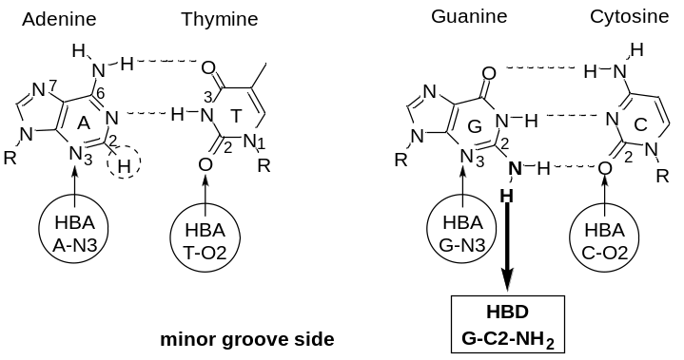
Figure 2. A diagram showing hydrogen bonds formed between the Watson-Crick base pairs (dashed lines), potential hydrogen bond donating (HBD) and accepting (HBA) functional groups (circles) at the edges of AT and GC base pairs, and the guanine C2-NH₂ group (squared box) protruding into the minor groove. Van der Waals interactions may also take place between the ligand and base protons such as adenine C2-hydrogen atoms (dashed circle).

The stereochemistry and availability of the ligands’ HBD and HBA groups also have an impact on minor groove recognition. Once the molecules are positioned in the minor groove, their HBD and HBA groups determine the correct alignment with specific base pairs.
DNA-minor groove adenine-thymine (AT)-rich tracts are narrower compared to guanine-cytosine (GC)-rich regions and most of DNA-minor groove binding agents show general AT selectivity. Ligands snugly insert in the tighter AT environment and, since they are positively charged, are further attracted by the negative potential associated with AT-rich regions of the minor groove [31, 32, 41, 42]. Conversely, the negative potential of the major groove is located in GC-containing DNA stretches. Thermodynamic studies revealed that part of the binding energy for the groove binding process is produced by the displacement of water molecules from the minor groove [43]. AT-binding preference can also be influenced by steric factors, including base pairs groups’ stereochemistry and minor groove dimensions. For example, the protrusion of the guanine C2-NH₂ groups into the DNA minor groove may cause severe steric hindrance to ligand binding, naturally favouring AT-sites recognition (Figure 2). At the same time, the guanine amino group represents an important minor-groove recognition element that can be targeted by ligands ad hoc designed to bind to this structural feature [40, 44, 45].
1.2. DNA-minor groove binding agents: mode of action and antimicrobial activity
DNA-minor groove binding agents can be broadly divided in two main groups according to the type of interactions, i.e., non-covalent or covalent, established with the DNA base pairs [46, 47]. Ligands that bind non-covalently to DNA bases, through reversible electrostatic interactions, such as van der Waals forces, hydrogen bonding and hydrophobic effects, include heterocyclic peptides netropsin and distamycin, diamidines and benzimidazole-containing compounds. On the other hands, ligands such as pyrrolo[2,1-c][1,4]benzodiazepines (PBDs) and duocarmycins bind to the DNA minor groove nucleobases in an irreversible manner via covalent binding. Netropsin [48] (1, net) and distamycin [49, 50, 51] (2, dis), isolated from cultures of Streptomyces netropsis and S. distallicus respectively, were the first agents discovered to selectively bind to the DNA-minor groove (Figure 3). The chemical structures of net and dis consist of N-terminal guanidine (net) or formyl (dis) groups, two (net) or three (dis) N-methylpyrrole carboxamide units and a C-terminal propylamidine tail. These polyamides bear the complementary crescent-shaped geometry and planar molecular structure required to follow the DNA helix curvature. As a result, net and dis tightly insert into the DNA minor groove [52] reversibly binding to four-five AT base pairs and causing minor distortion to the DNA structure. The high binding affinity of these molecules is derived from bifurcated hydrogen bonds between the amidic hydrogens of the N-methyl-pyrrole carboxamide units and N3 of adenines and O2 of thymines in AT stretches [53], thus providing the correct orientation for strong van der Waals interactions with the groove walls (Figure 4). Distamycin (2) exhibits concentration-dependent DNA binding modality, forming either non-covalent 1:1 or 2:1 ligand:DNA complexes. In the 2:1 motif, two molecules of distamycin bind side-by-side in the minor groove in an antiparallel head-to-tail orientation [54]. Conversely, netropsin (1) only forms 1:1 adducts with DNA. This is probably due to the repulsion of the cationic ends of the molecule.

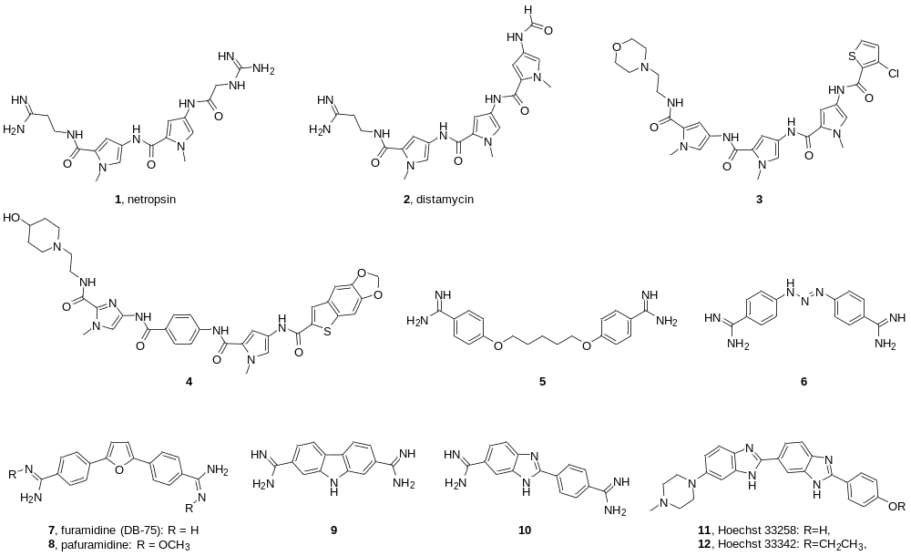
Figure 3. Examples of AT-sequence selective antimicrobial agents that non-covalently bind in to the DNA-minor groove.

Although possessing remarkable DNA sequence-specificity and exhibiting a wide range of antibiotic activities against bacteria, fungi and viruses [55], 1 and 2 were revealed to be generally inactive as antitumour agents and too toxic for clinical use as antimicrobials. However, their molecular frameworks served as the starting point for the synthesis of reversible DNA-minor groove binding agents with enhanced antibiotic and anticancer activities, and improved DNA sequence-selectivity. Exploiting the antiparallel 2:1 binding mode of pyrrole-imidazole polyamides and their ability to discriminate between AT and GC base pairs, a large number of “lexitropsins”, or information-reading polyamides [39] were synthesised, resulting in molecules with binding affinity equivalent to native DNA-binding control proteins [31, 33, 37]. Lexitropsins emerged as a potential new class of antibiotics able to target bacterial promoters and artificially regulate gene expression. Many research groups and biotech companies produced DNA sequence-selective polyamides for antimicrobial therapeutic intervention. For example, AT-sequence heteroaromatic polyamides 3 and 4 synthesised in early 2000 by Genesoft showed encouraging anti-microbial activity against methicillin-resistant Staphylococcus aureus (MRSA) strains [56, 57], although they did not grant further clinical progression as antibiotics due to their poor pharmacology and toxicology profiles. Pentamidine (5) and berenil (6, diminazene aceturate), which are diamidines that reversibly bind to AT-sequences within the minor groove, have found significant clinical use against human and animal trypanosomiasis, respectively [58, 59]. Pentamidine’s analogue furamidine (7, DB75) was initially studied as an antiprotozoal probe to treat human African trypanosomiasis (HAT) and its N-methoxy prodrug pafuramidine (8) was the first HAT drug to enter clinical trials, although its development was halted due to severe renal toxicity [60]. Further examples of diamidines include bisamidine carbazole dication 9, which was active against opportunistic infections in immune-compromised subjects. Interestingly, this ligand, albeit containing a planar structure typical of DNA intercalators, acts as DNA-minor groove binding agents [61]. Benzimidazole-containing 4′,6′-diamidino-2-phenylindole (10, DAPI) and its derivatives Hoechst 33258 (11) and 33342 (12) are nucleic acids fluorescent stains with high binding affinity for AT-rich sequences spanning three AT base pairs. Since their discovery, these compounds exhibited interesting anti-microbial and anti-trypanosomal activities [62], although they were never been translated into drugs due to their significant side-effects in vivo [63].
PBDs have been extensively investigated over the last 40 years, due to their significant antitumour and antimicrobial properties. The first PBD to be isolated from Streptomyces cultures was anthramycin (13) [64, 65], and since then several other naturally-occurring PBDs have been discovered (Figure 5). Multiple synthetic routes were devised to access these remarkable compounds and a wide range of PBD monomeric and dimeric analogues were produced in the past decades, resulting in well-defined structure-activity relationship (SAR) data and extensive knowledge on their physicochemical characteristics [66].

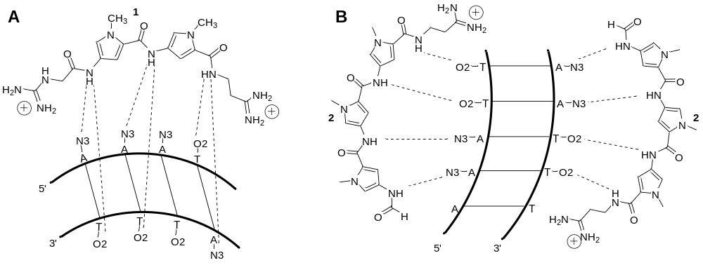
Figure 4. Schematic representations of A) the binding of netropsin (1) to a duplex-DNA with bifurcated hydrogen bonds (HBs); and B) the 2:1 complex between distamycin (2) and a duplex-DNA with N-terminal formamido units of each distamycin molecule pointing toward the 5'-end of the contacted strand. Dashed lines indicate HBs between the polyamides NH-amide groups and N3 of adenines and O2 of thymines.

All PBD molecules are comprised of a tricyclic ring system, consisting of fused aromatic (A), diazepine (B) and a pyrrole (C) rings (Figure 5). The C-ring can either be saturated, endo-unsaturated at C2-C3 position or exo-unsaturated at C2. Ring A can be either aromatic or heteroaromatic and the imine group at C11 can be removed to yield diones. All bioactive naturally occurring and synthetic PBDs possess (S)-stereochemistry at the chiral C11a position, providing the right-handed twist required to snugly fit in the DNA-minor groove [67, 68]. The mechanism by which PBDs interact with DNA involves an irreversible binding to guanine residues in the DNA-minor groove [69]. This results in the formation of a covalent aminal linkage between the C2-amino group of guanines and the C11 of PBDs and further non-covalent interactions with adjacent bases in the DNA minor groove. The PBD unit was demonstrated to bind with the C-ring positioned toward the 5’-end of the alkylated guanine and the A-ring positioned towards 3′-end, favouring a 5′-purine-guanine-purine motif [70].
Both naturally occurring PBDs, such as porothramycin B (14) and RK-1441A/B isolated from Streptomyces spp. Cultures [71, 72], and PBDs of synthetic origin have been reported to exhibit remarkable antibacterial activity against aerobic and anaerobic Gram-positive, but not Gram-negative, bacteria. MRSA strains were found to be particularly susceptible to the antimicrobial activity of PBD dimers 15 (SJG-136) and 16 (ELB-21) and PBD-biaryl conjugates (i.e., 17, MPB-Im-PBD) [73 – 76]. PBD dimeric molecules are structurally based on tomaymycin (18) units tethered through inert alkyldioxy linkers and form DNA interstrand crosslinks [77], whereas PBD-biaryl conjugates consist of PBD units attached through a 4-hydroxybutyrate linkers to heterocyclic chains containing fused aromatic or heteroaromatic rings.
Duocarmycins are highly potent antitumor antibiotics also isolated from cultures of Streptomyces spp. These compounds exert their biological effects through alkylation of adenine N3 at the 3′-end of AT-rich sequences in the DNA minor groove [78 – 81]. Recently, less toxic indolecarboxamide duocarmycin analogues, tafuramycin A [82] and centanamycin (19) [83], were synthesised and evaluated for anti-plasmodial activity. Centanamycin was significantly active against blood stage malarial infections, affecting the plasmodium genomic DNA modification [82].
1.3. Anti-tubercular activity of selected DNA-minor groove binding agents
Given their excellent antibacterial and antiparasitic activities, it is anticipated that DNA-minor groove binding agents can be utilised, with adequate improvements, to treat M. tuberculosis infections. As tuberculosis chemotherapeutic options are still scarce, the use of anti-tubercular probes that exclusively bind to mycobacterial DNA and disrupt the transcription factors machinery might represent an attractive therapeutic strategy [84]. Distamycin-related heterocyclic polyamides and PBD derivatives, such as PBD-dimers, PBD-5,11-diones (PBD-diones) and C8-linked PBD-heterocyclic polyamide conjugates (PBD-polyamide conjugates), were reported to have remarkable growth inhibitory activity against several mycobacterial strains (Figure 6). As PBDs’ mode of binding involves selective alkylation of guanine bases within the minor groove, these molecules are clearly predisposed to target the GC-rich mycobacterial DNA. Recently, we have screened a library of PBD-polyamide conjugates against slow-growing pathogenic Mtb H₃₇Rv and Mycobacterium bovis strains, and a panel of Gram-positive and –negative bacteria, including Escherichia coli K12, Pseudomonas putida KT2442 and Rhodococcus sp. RHA1 [85].

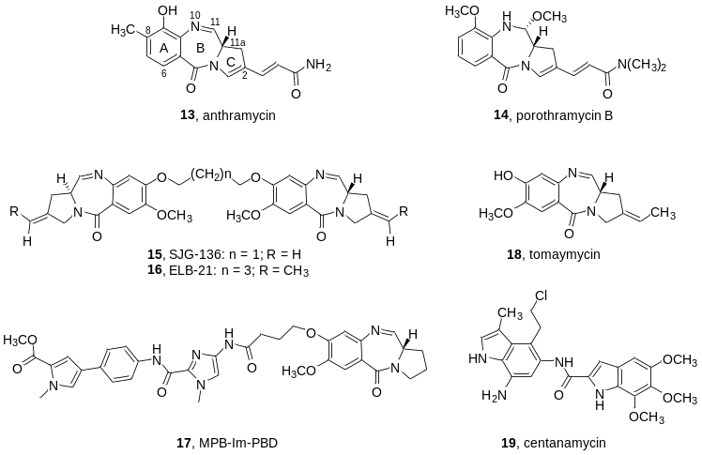
Figure 5. DNA-minor groove alkylating agents with reported antibiotic properties. Naturally-occurring, monomeric, dimeric and C8-polyamyde conjugated PBDs (13-18), and duocarmycin-derivative centanamycin (19).

The PBD-conjugates showed a notable degree of selectivity towards the mycobacterial strains and possessed significant anti-tubercular properties. Py-Py-PBD (20) produced MICs of 0.08 and 0.04 µM against Mtb and M. bovis, respectively. Py-Py-Th-PBD (21), which also inhibited the growth of both mycobacterial strains at sub-micromolar level, bound with high affinity, at a concentration of 0.5 µM, to the 5′-AAACGT region of a DNA fragment [86] containing symmetrical hexonucleotide sequences with a broad range AT and GC base pair combinations. Remarkably, PBD-conjugate 21, which was tested against Mtb grown in aerobic and hypoxic conditions in both acidic and pH-neutral media, showed growth inhibitory activity at 5.1 µg/mL against 19-day-old hypoxic non-replicating (NR) Mtb cultures with 1.8 log₁₀ CFU reduction on day 21 at pH 7.3. PBD 21 was particularly effective against 5-day-old aerobic cells at pH 7.3, with CFU reduction (>6.8 log₁₀) on day 21 at 5.1 µg/mL being identical to that of rifampin at 8 µg/ml, thus qualifying this compound as a promising lead against aerobic and NR, dormant Mtb [87]. Further examples of mycobacterial-active PBDs include PBD dimers and PBD-diones, which lack the alkylating N10-C11 imino-group and therefore bind non-covalently into the DNA-minor groove. PBD-dione 22, synthesised through solid-phase combinatorial approaches, effectively arrested in vitro the growth of both Mtb H₃₇Rv and isoniazid-resistant Mtb strains, with MIC values in the range of 1.0 µg/mL [88]. PBD-dimer 16 showed cidal activity against a range of nontuberculous, rapidly growing mycobacteria including Mycobacterium aurum, M. smegmatis, M. fortuitum, M. abscessus, and M. phlei with MICs of 0.5 µg/mL [89]. As part of our ongoing efforts to investigate the recognition properties and biological activity of novel heterocyclic peptides, we have synthesised and evaluated the anti-tubercular activity of a library of polyamides containing biaryl-units placed at the N-terminal of the distamycin structure [36, 90]. The biaryl-motifs were introduced to cause minimum distortion to the DNA helix and meet the requirement of “phasing”, which is the three-dimensional matching between the repeating units of the ligand and corresponding DNA bases [39, 91]. Biaryl-units are also considered privileged structures that might confer antibacterial activity [92] and specific DNA-recognising capabilities (i.e., affinity to DNA G-quadruplex structures) [93] to suitable molecular frameworks. Our experiments showed that dithiophene-containing polyamide 23 inhibited the growth of Mtb H₃₇Rv and M. bovis producing MICs of 5.2 µM and 40 µM, respectively, whereas thiazole-pyrazole-including polyamide 24, albeit showing less efficacy against the H₃₇Rv strain, bound with strong affinity to the 5′-ACATA sequence of a DNA fragment with diverse AT / GC base pair arrangements [36, 86]. One of the latest advances in the deployment of DNA-minor groove binding agents as anti-tubercular probes is represented by the distamycin-derived polyamides designed by Suckling and co-workers [94 – 99]. These compounds bind non-covalently in the groove [100] and are known to display bactericidal activity against a wide range of infectious organisms, such as Gram-positive bacteria, Clostridium difficile, chloroquine-susceptible and -resistant Plasmodium falciparum and Trypanosoma brucei brucei [101]. Recently, H₃₇Rv-active heterocyclic polyamides were encapsulated in non-ionic surfactant vesicles to improve the delivery of the compounds in Mtb-infected macrophages. Vesicle-bound polyamides 24 and 25 exhibited notable intracellular Mtb growth inhibitory efficacy, with MIC₅₀ values in the region of 4 µM, and minimum macrophage cytotoxicity [102].
*Address correspondence to this author at the Leicester School of Pharmacy, Faculty of Health and Life Sciences, De Montfort University, The Gateway, Leicester, LE1 9BH; Tel: ++44-116-257-7443; E-mail: Federico.brucoli@dmu.ac.uk

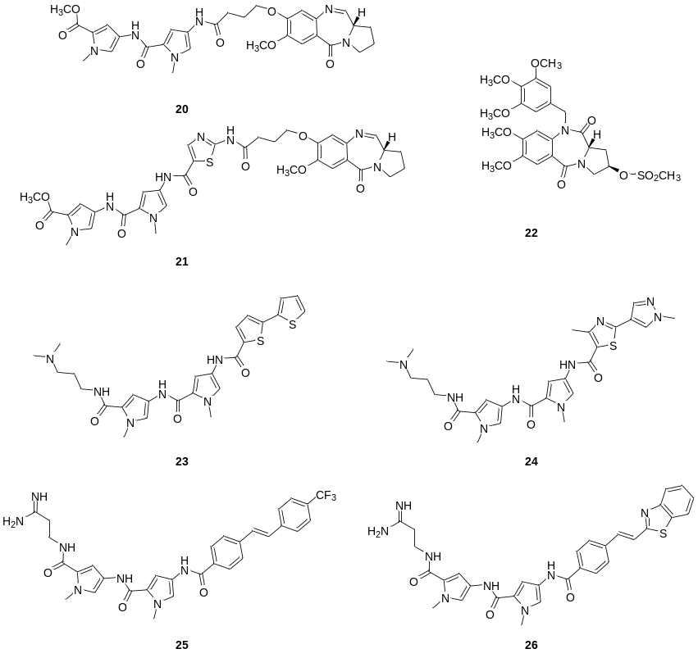
Figure 6. Covalent and non-covalent DNA-minor groove binding agents with reported anti-tubercular activity.

CONCLUSION
DNA-minor groove represents an attractive and well-characterised intracellular target that is presently underexploited in tuberculosis drug discovery. Small-molecule ligands endowed with antimycobacterial activity and DNA sequence-selectivity might effectively be employed to recognise functional groups offered by the DNA-minor groove and exert bactericidal effects in a unique manner different from existing TB drugs. This could be a successful strategy in fighting tuberculosis, as directing efforts at mycobacterial targets not currently used might overcome TB drug resistance. Ligands snugly inserted in to DNA-minor groove escape repair surveillance mechanisms of enzymes that sense DNA-duplex helix distortions, causing DNA replication blockade and bacterial cell death. DNA-minor groove agents can be programmed to bind with high affinity to predetermined DNA regions and have crucial prerequisites required by anti-tuberculosis drugs, including the ability to penetrate the M. tuberculosis thick cell envelope, evade potential efflux pump activity and metabolic inactivation, reach the target and elicit whole-cell growth inhibitory activity. Indeed, it is not infrequent that active-hits emerged from target-based screening as potent M. tuberculosis enzymes’ inhibitors were lately found to lack whole-cell growth inhibitory activity, due, for instance, to the inability to permeate the tubercle bacillus membrane barrier. Furthermore, drug-delivery systems specifically designed to decrease promiscuous host/bacterial DNA interactions might enable DNA-minor groove binding agents to attain therapeutic selectivity by only targeting the tubercle bacilli with no toxicity to the cellular hosts.
The significance of DNA-minor groove binding agents in anti-infective therapy is growing and these well-established chemical tools, which have long been studied to “read” DNA sequences and modulate transcription factors activity, can be effectively applied to develop new DNA-targeted TB drugs.
ACKNOWLEDGEMENTS
Dr Randolph Arroo is thanked for proof reading the manuscript.
REFERENCES
[1] World Health Organization Global tuberculosis report 2017. 2017.
[2] Dheda, K.; Barry, C. E.; Maartens, G. Tuberculosis. The Lancet 2016, 387, 1211-1226.
[3] Jackson, C.; Abubakar, I. Ending tuberculosis in risk groups in Europe: challenges from travel and population movement. Eurosurveillance 2017, 22.
[4] Beaute’, J.; Dara, M.; Colombani, P. d.; Ehsani, S.; Gozalov, O.; Hovanesyan, A.; Kodmon, C.; Molnarova, B.; Boom, M.; van der Werf, M J Tuberculosis surveillance and monitoring in Europe 2017. Tuberculosis surveillance and monitoring in Europe 2017. 2017.
[5] Smith, C. M.; Maguire, H.; Anderson, C.; Macdonald, N.; Hayward, A. C. Multiple large clusters of tuberculosis in London: a cross-sectional analysis of molecular and spatial data. ERJ Open Research 2017, 3, 98.
[6] Bhargava, A.; Menzies, D. Current Options in Treatment and Issues in Tuberculosis Care in Low-and Middle-Income Countries. In Handbook of Global Tuberculosis Control Springer: 2017; pp 99-116.
[7] Uplekar, M.; Weil, D.; Lonnroth, K.; Jaramillo, E.; Lienhardt, C.; Dias, H. M.; Falzon, D.; Floyd, K.; Gargioni, G.; Getahun, H. WHO's new End TB Strategy. The Lancet 2015, 385, 1799-1801.
[8] World Health Organization Gear up to end TB: introducing the end TB strategy. 2015.
[9] Zumla, A.; Nahid, P.; Cole, S. T. Advances in the development of new tuberculosis drugs and treatment regimens. Nat. Rev. Drug Discov 2013, 12, 388.
[10] Diacon, A. H.; Pym, A.; Grobusch, M.; Patientia, R.; Rustomjee, R.; Page-Shipp, L.; Pistorius, C.; Krause, R.; Bogoshi, M.; Churchyard, G.; Venter, A.; Allen, J.; Palomino, J. C.; De Marez, T.; van Heeswijk, Rolf P G; Lounis, N.; Meyvisch, P.; Verbeeck, J.; Parys, W.; de Beule, K.; Andries, K.; Neeley, D. F. M. The Diarylquinoline TMC207 for Multidrug-Resistant Tuberculosis. N. Engl. J. Med. 2009, 360, 2397-2405.
[11] Ryan, N. J.; Lo, J. H. Delamanid: first global approval. Drugs 2014, 74, 1041-1045.
[12] Shelby, P. W. Collaborative public–private initiatives targeting multidrug-resistant tuberculosis (MDR-TB) supported by the Lilly MDR-TB Partnership: experiences in 2012–2016. J. Healthc. Leadersh. 2017, 9, 47-57.
[13] Ballell, L.; Bates, R. H.; Young, R. J.; Alvarez‐Gomez, D.; Alvarez‐Ruiz, E.; Barroso, V.; Blanco, D.; Crespo, B.; Escribano, J.; González, R. Fueling Open‐Source Drug Discovery: 177 Small‐Molecule Leads against Tuberculosis. ChemMedChem 2013, 8, 313-321.
[14] Cole, S.; Brosch, R.; Parkhill, J.; Garnier, T.; Churcher, C.; Harris, D.; Gordon, S. V.; Eiglmeier, K.; Gas, S.; Barry, C. 3. Deciphering the biology of Mycobacterium tuberculosis from the complete genome sequence. Nature 1998, 393, 537-544.
[15] Mdluli, K.; Kaneko, T.; Upton, A. The tuberculosis drug discovery and development pipeline and emerging drug targets. Cold Spring Harb Perspect Med 2015, 5, a021154.
[16] Cooper, C. B. Development of Mycobacterium tuberculosis Whole Cell Screening Hits as Potential Antituberculosis Agents: Miniperspectives Series on Phenotypic Screening for Antiinfective Targets. J. Med. Chem. 2013, 56, 7755-7760.
[17] Singh, V.; Mizrahi, V. Identification and validation of novel drug targets in Mycobacterium tuberculosis. Drug Discov. Today 2017, 22, 503-509.
[18] Rožman, K.; Sosič, I.; Fernandez, R.; Young, R. J.; Mendoza, A.; Gobec, S.; Encinas, L. A new ‘golden age’ for the antitubercular target InhA. Drug Discov. Today 2017, 22, 492-502.
[19] Piton, J.; Foo, C. S.; Cole, S. T. Structural studies of Mycobacterium tuberculosis DprE1 interacting with its inhibitors. Drug Discov. Today 2017, 22, 526-533.
[20] Wehrli, W. Rifampin: mechanisms of action and resistance. Rev. Infect. Dis. 1983, 5, S411.
[21] Berube, B. J.; Parish, T. Combinations of respiratory chain inhibitors have enhanced bactericidal activity against Mycobacterium tuberculosis. Antimicrob. Agents Chemother. 2018, 62, 1677.
[22] Rybniker, J.; Vocat, A.; Sala, C.; Busso, P.; Pojer, F.; Benjak, A.; Cole, S. T. Lansoprazole is an antituberculous prodrug targeting cytochrome bc1. Nat. Commun. 2015, 6. 7659.
[23] Pethe, K.; Bifani, P.; Jang, J.; Kang, S.; Park, S.; Ahn, S.; Jiricek, J.; Jung, J.; Jeon, H. K.; Cechetto, J. Discovery of Q203, a potent clinical candidate for the treatment of tuberculosis. Nat. Med. 2013, 19, 1157-1160.
[24] La Rosa, V.; Poce, G.; Canseco, J. O.; Buroni, S.; Pasca, M. R.; Biava, M.; Raju, R. M.; Porretta, G. C.; Alfonso, S.; Battilocchio, C. MmpL3 is the cellular target of the antitubercular pyrrole derivative BM212. Antimicrob. Agents Chemother. 2012, 56, 324-331.
[25] Protopopova, M.; Hanrahan, C.; Nikonenko, B.; Samala, R.; Chen, P.; Gearhart, J.; Einck, L.; Nacy, C. A. Identification of a new antitubercular drug candidate, SQ109, from a combinatorial library of 1, 2-ethylenediamines. J. Antimicrob. Chemother. 2005, 56, 968-974.
[26] Matteelli, A.; Carvalho, A. C.; Dooley, K. E.; Kritski, A. TMC207: the first compound of a new class of potent anti-tuberculosis drugs. Future Microbiol. 2010, 5, 849-858.
[27] Bolhuis, A.; Aldrich-Wright, J. R. DNA as a target for antimicrobials. Bioorg. Chem. 2014, 55, 51-59.
[28] Barrett, M. P.; Gemmell, C. G.; Suckling, C. J. Minor groove binders as anti-infective agents. Pharmacol. Ther. 2013, 139, 12-23.
[29] Cai, X.; Gray, P. J.; Von Hoff, D. D. DNA minor groove binders: back in the groove. Cancer Treat. Rev. 2009, 35, 437-450.
[30] Dervan, P. B.; Doss, R. M.; Marques, M. A. Programmable DNA binding oligomers for control of transcription. Curr. Med. Chem. Anticancer Agents 2005, 5, 373-387.
[31] Dervan, P. B. Molecular recognition of DNA by small molecules. Bioorg. Med. Chem. 2001, 9, 2215-2235.
[32] Neidle, S. DNA minor-groove recognition by small molecules. Nat. Prod. Rep. 2001, 18, 291-309.
[33] Chenoweth, D. M.; Dervan, P. B. Allosteric modulation of DNA by small molecules. Proc. Natl. Acad. Sci. U. S. A. 2009, 106, 13175-13179.
[34] Hidaka, T.; Pandian, G. N.; Taniguchi, J.; Nobeyama, T.; Hashiya, K.; Bando, T.; Sugiyama, H. Creation of a synthetic ligand for mitochondrial DNA sequence recognition and promoter-specific transcription suppression. J. Am. Chem. Soc. 2017, 139, 8444-8447.
[35] Padroni, G.; Parkinson, J. A.; Fox, K. R.; Burley, G. A. Structural basis of DNA duplex distortion induced by thiazole-containing hairpin polyamides. Nucleic Acids Res. 2017, 46, 42-53.
[36] Brucoli, F.; Guzman, J. D.; Maitra, A.; James, C. H.; Fox, K. R.; Bhakta, S. Synthesis, anti-mycobacterial activity and DNA sequence-selectivity of a library of biaryl-motifs containing polyamides. Bioorg. Med. Chem. 2015, 23, 3705-3711.
[37] Reddy, B.; Sharma, S. K.; Lown, J. W. Recent developments in sequence selective minor groove DNA effectors. Curr. Med. Chem. 2000, 8, 475-508.
[38] Kornberg, R. D. The molecular basis of eukaryotic transcription. Proc. Natl. Acad. Sci. U. S. A. 2007, 104, 12955-12961.
[39] Lown, J. W. DNA recognition by lexitropsins, minor groove binding agents. J. Mol. Recognit. 1994, 7, 79-88.
[40] Neidle, S. Principles of Small Molecule-DNA Recognition. Principles of Nucleic Acid Structure 2008, 1, 132-203.
[41] Bailly, C.; Chaires, J. B. Sequence-specific DNA minor groove binders. Design and synthesis of netropsin and distamycin analogues. Bioconjug. Chem. 1998, 9, 513-538.
[42] Pullman, A.; Pullman, B. Molecular electrostatic potential of the nucleic acids. Q. Rev. Biophys. 1981, 14, 289-380.
[43] Rentzeperis, D.; Marky, L. A.; Dwyer, T. J.; Geierstanger, B. H.; Pelton, J. G.; Wemmer, D. E. Interaction of minor groove ligands to an AAATT/AATTT site: correlation of thermodynamic characterization and solution structure. Biochemistry (N. Y. ) 1995, 34, 2937-2945.
[44] Satam, V.; Babu, B.; Porte A.; Savagian, M.; Lee, M.; Smeltzer, T.; Liu Y.; Ramos, J.; Wilson, W.D.; Lin, S.; Kiakos, K.; Hartley, J. A.; Lee, M. Synthesis and DNA binding properties of 1-(3-aminopropyl)-imidazole-containing triamide f-Im∗ PyIm: A novel diamino polyamide designed to target 5′-ACGCGT-3′. Bioorg. Med. Chem. Lett., 2012, 22, 5898-902.
[45] Bruce, C.D.; Maddi, M.; Ferrara, J.L.; Manka, Z.S.; Davis, J.R. Dynamic hydrogen bonding and DNA flexibility in minor groove binders: molecular dynamics simulation of the polyamide f‐ImPyIm bound to the Mlu1 (MCB) sequence 5′‐ACGCGT‐3′ in 2: 1 motif. J. Mol. Recognit., 2015, 28, 325-337.
[46] Nelson, S.M.; Ferguson, L.R.; Denny, W.A. Non-covalent ligand/DNA interactions: minor groove binding agents. Mutat. Res-Fund. Mol. M., 2007, 623, 24-40.
[47] Hurley, L. H. DNA and its associated processes as targets for cancer therapy. ‎Nat. Rev. Cancer 2002, 2, 188.
[48] Finlay, A. C.; Hochstein, F. A.; Sobin, B. A.; Murphy, F. X. Netropsin, a new antibiotic produced by a Streptomyces. J. Am. Chem. Soc. 1951, 73, 341-343.
[49] Arcamone, F.; Penco, S.; Orezzi, P.; Nicolella, V.; Pirelli, A. Structure and synthesis of distamycin A. Nature 1964, 203, 1064.
[50] Garbesi, A.; Capobinanco, M. L.; Colonna, F. P.; Tondelli, L.; Arcamone, F.; Manzini, G.; Hilbers, C. W.; Aelen, J. M.; Blommers, M. J. L-DNAs as potenital antimessenger oligonucleotides: a reassessment. Nucleic Acids Res. 1993, 21, 4159-4165.
[51] Baraldi, P.G.; Nûnez, M.C.; Espinosa, A.; Romagnoli, R. Distamycin A as stem of DNA minor groove alkylating agents. Curr. Top. Med. Chem., 2004, 4, 231-239.
[52] Kopka, M. L.; Yoon, C.; Goodsell, D.; Pjura, P.; Dickerson, R. E. The molecular origin of DNA-drug specificity in netropsin and distamycin. Proc. Natl. Acad. Sci. U. S. A. 1985, 82, 1376-1380.
[53] Coll, M.; Frederick, C. A.; Wang, A. H.; Rich, A. A bifurcated hydrogen-bonded conformation in the d (AT) base pairs of the DNA dodecamer d (CGCAAATTTGCG) and its complex with distamycin. Proc. Natl. Acad. Sci. U. S. A. 1987, 84, 8385-8389.
[54] Pelton, J. G.; Wemmer, D. E. Structural characterization of a 2: 1 distamycin Ad (CGCAAATTGGC) complex by two-dimensional NMR. Proc. Natl. Acad. Sci. U. S. A. 1989, 86, 5723-5727.
[55] Baraldi, P. G.; Bovero, A.; Fruttarolo, F.; Preti, D.; Tabrizi, M. A.; Pavani, M. G.; Romagnoli, R. DNA minor groove binders as potential antitumor and antimicrobial agents. Med. Res. Rev. 2004, 24, 475-528.
[56] Gross, M.; Burli, R.; Jones, P.; Garcia, M.; Batiste, B.; Kaizerman, J.; Moser, H.; Jiang, V.; Hoch, U.; Duan, J. Pharmacology of novel heteroaromatic polycycle antibacterials. Antimicrob. Agents Chemother. 2003, 47, 3448-3457.
[57] Hu, W.; Burli, R. W.; Kaizerman, J. A.; Johnson, K. W.; Gross, M. I.; Iwamoto, M.; Jones, P.; Lofland, D.; Difuntorum, S.; Chen, H. DNA binding ligands with improved in vitro and in vivo potency against drug-resistant Staphylococcus aureus. J. Med. Chem. 2004, 47, 4352-4355.
[58] Barrett, M. P.; Boykin, D. W.; Brun, R.; Tidwell, R. R. Human African trypanosomiasis: pharmacological re‐engagement with a neglected disease. Br. J. Pharmacol. 2007, 152, 1155-1171.
[59] Kuriakose, S.; Uzonna, J. E. Diminazene aceturate (Berenil), a new use for an old compound? Int. Immunopharmacol. 2014, 21, 342-345.
[60] Wilson, W. D.; De Koning, H. P.; Olson, C. A.; Pohlig, G. Diamidines for human African trypanosomiasis. Curr. Opin. Investig. Drugs 2010, 11, 876-883.
[61] Tanious, F. A.; Wilson, W. D.; Patrick, D. A.; Tidwell, R. R.; Colson, P.; Houssier, C.; Tardy, C.; Bailly, C. Sequence‐dependent binding of bis‐amidine carbazole dications to DNA. FEBS J. 2001, 268, 3455-3464.
[62] Williamson, J.; McLaren, D. J. Effects of DAPI, a new diamidine trypanocide, on the ultrastructure of Trypanosoma rhodesiense. Trans. R. Soc. Trop. Med. Hyg. 1978, 72, 660-661.
[63] Disney, M. D.; Stephenson, R.; Wright, T. W.; Haidaris, C. G.; Turner, D. H.; Gigliotti, F. Activity of Hoechst 33258 against Pneumocystis carinii f. sp. muris, Candida albicans, and Candida dubliniensis. Antimicrob. Agents Chemother. 2005, 49, 1326-1330.
[64] Leimgruber, W.; Stefanović, V.; Schenker, F.; Karr, A.; Berger, J. Isolation and characterization of anthramycin, a new antitumor antibiotic. J. Am. Chem. Soc. 1965, 87, 5791-5793.
[65] Leimgruber, W.; Batcho, A. D.; Schenker, F. The structure of anthramycin. J. Am. Chem. Soc. 1965, 87, 5793-5795.
[66] Antonow, D.; Thurston, D.E. Synthesis of DNA-interactive pyrrolo [2, 1-c][1, 4] benzodiazepines (PBDs). Chem. Rev. 2010, 111, 2815-2864.
[67] Mantaj, J.; Jackson, P. J.; Rahman, K. M.; Thurston, D. E. From Anthramycin to Pyrrolobenzodiazepine (PBD)‐Containing Antibody–Drug Conjugates (ADCs). Angew. Chem. Int. Ed. 2017, 56, 462-488.
[68] Thurston, D.E.; Bose, D.S. Synthesis of DNA-Interactive Pyrrolo [2, 1-c][1, 4] benzodiazepines. Chem. Rev., 1994, 94, 433-465.
[69] Hartley, J.A. The development of pyrrolobenzodiazepines as antitumour agents. Expert Opin. Invest. Drug, 2011, 20, 733-744.
[70] Jackson, P. J.; Rahman, K. M.; Thurston, D. E. The use of molecular dynamics simulations to evaluate the DNA sequence-selectivity of G–A cross-linking PBD–duocarmycin dimers. Bioorg. Med. Chem. Lett. 2017, 27, 102-108.
[71] Tsunakawa, M.; Kamei, H.; Konishi, M.; Miyaki, T.; Oki, T.; Kawaguchi, H. Porothramycin, a new antibiotic of the anthramycin group: production, isolation, structure and biological activity. J. Antibiot. (Tokyo) 1988, 41, 1366-1373.
[72] Osada, H.; Ishinabe, K.; Yano, T.; Kajikawa, K.; Isono, K. New Pyrrolobenzodiazepine Antibiotics, RK-1441A and B I. Biological Properties. Agric. Biol. Chem. 1990, 54, 2875-2881.
[73] Smellie, M.; Bose, D. S.; Thompson, A. S.; Jenkins, T. C.; Hartley, J. A.; Thurston, D. E. Sequence-selective recognition of duplex DNA through covalent interstrand cross-linking: kinetic and molecular modeling studies with pyrrolobenzodiazepine dimers. Biochemistry 2003, 42, 8232-8239.
[74] Rosado, H.; Rahman, K. M.; Feuerbaum, E. A.; Hinds, J.; Thurston, D. E.; Taylor, P. W. The minor groove-binding agent ELB-21 forms multiple interstrand and intrastrand covalent cross-links with duplex DNA and displays potent bactericidal activity against methicillin-resistant Staphylococcus aureus. J. Antimicrob. Chemother. 2011, 66, 985-996.
[75] Rahman, K. M.; Rosado, H.; Moreira, J. B.; Feuerbaum, E. A.; Fox, K. R.; Stecher, E.; Howard, P. W.; Gregson, S. J.; James, C. H.; de la Fuente, M.; Waldron, D. E.; Thurston, D. E.; Taylor, P. W. Antistaphylococcal activity of DNA-interactive pyrrolobenzodiazepine (PBD) dimers and PBD-biaryl conjugates. J. Antimicrob. Chemother. 2012, 67, 1683-1696.
[76] Basher, M. A.; Rahman, K. M.; Jackson, P. J. M.; Thurston, D. E.; Fox, K. R. Sequence-selective binding of C8-conjugated pyrrolobenzodiazepines (PBDs) to DNA. Biophys. Chem. 2017, 230, 53-61.
[77] Jenkins, T. C.; Hurley, L. H.; Neidle, S.; Thurston, D. E. Structure of a covalent DNA minor groove adduct with a pyrrolobenzodiazepine dimer: Evidence for sequence-specific interstrand crosslinking. J. Med. Chem. 1994, 37, 4529-4537.
[78] Sugiyama, H.; Lian, C.; Isomura, M.; Saito, I.; Wang, A. H. Distamycin A modulates the sequence specificity of DNA alkylation by duocarmycin A. Proc. Natl. Acad. Sci. U. S. A. 1996, 93, 14405-14410.
[79] Boger, D. L.; Yun, W. Reversibility of the duocarmycin A and SA DNA alkylation reaction. J. Am. Chem. Soc. 1993, 115, 9872-9873.
[80] Takahashi, I.; Takahashi, K.; Ichimura, M.; Morimoto, M.; Asano, K.; Kawamoto, I.; Tomita, F.; Nakano, H. Duocarmycin A, a new antitumor antibiotic from Streptomyces. J. Antibiot. 1988, 41, 1915-1917.
[81] Patil, P. C.; Satam, V.; Lee, M. A Short Review on the Synthetic Strategies of Duocarmycin Analogs that are Powerful DNA Alkylating Agents. Anticancer Agents Med. Chem. 2015, 15, 616-630.
[82] El-Deeb, I. M.; Rose, F. J.; Healy, P. C.; von Itzstein, M. A versatile synthesis of “tafuramycin A”: A potent anticancer and parasite attenuating agent. Org. Biomol. Chem. 2014, 12, 4260-4264.
[83] Yanow, S. K.; Purcell, L. A.; Pradel, G.; Sato, A.; Rodriguez, A.; Lee, M.; Spithill, T. W. Potent antimalarial and transmission-blocking activities of centanamycin, a novel DNA-binding agent. J. Infect. Dis. 2008, 197, 527-534.
[84] González, A.; Fillat, M. F.; Lanas, A. Transcriptional regulators: valuable targets for novel antibacterial strategies. Future Med. Chem. 2018, 10, 541-560.
[85] Brucoli, F.; Guzman, J. D.; Basher, M. A.; Evangelopoulos, D.; McMahon, E.; Munshi, T.; McHugh, T. D.; Fox, K. R.; Bhakta, S. DNA sequence-selective C8-linked pyrrolobenzodiazepine–heterocyclic polyamide conjugates show anti-tubercular-specific activities. J. Antibiot. 2016, 69, 843-849.
[86] Hampshire, A. J.; Rusling, D. A.; Broughton-Head, V. J.; Fox, K. R. Footprinting: a method for determining the sequence selectivity, affinity and kinetics of DNA-binding ligands. Methods 2007, 42, 128-140.
[87] Iacobino, A.; Giannoni, F.; Fattorini, L.; Brucoli, F. Activity of DNA-targeted C8-linked pyrrolobenzodiazepine–heterocyclic polyamide conjugates against aerobically and hypoxically grown Mycobacterium tuberculosis under acidic and neutral conditions. J. Antibiot. 2018, doi: 10.1038/s41429-018-0068-5. [Epub ahead of print].
[88] Kamal, A.; Reddy, G. S. K.; Raghavan, S. Solid-phase synthesis of pyrrolo [2, 1-c][1, 4] benzodiazepine-5, 11-diones. Bioorg. Med. Chem. Lett. 2001, 11, 387-389.
[89] Hadjivassileva, T.; Thurston, D. E.; Taylor, P. W. Pyrrolobenzodiazepine dimers: novel sequence-selective, DNA-interactive, cross-linking agents with activity against Gram-positive bacteria. J. Antimicrob. Chemother. 2005, 56, 513-518.
[90] Brucoli, F.; Howard, P. W.; Thurston, D. E. Efficient solid-phase synthesis of a library of distamycin analogs containing novel biaryl motifs on SynPhase Lanterns. J. Comb. Chem. 2009, 11, 576-586.
[91] Reddy, B. P.; Sondhi, S. M.; Lown, J. W. Synthetic DNA minor groove-binding drugs. Pharmacol. Ther. 1999, 84, 1-111.
[92] Burli, R.W.; Baird, E.E.; Kaizerman, J.A.; McMinn, D.L. Biaryl compounds having anti-infective activity. U.S. Patent 7,498,349, March 3, 2009.
[93] Rahman, K. M.; Reszka, A. P.; Gunaratnam, M.; Haider, S. M.; Howard, P. W.; Fox, K. R.; Neidle, S.; Thurston, D. E. Biaryl polyamides as a new class of DNA quadruplex-binding ligands. Chem. Comm. 2009, 4097-4099.
[94] Barrett, M. P.; Gemmell, C. G.; Suckling, C. J. Minor groove binders as anti-infective agents. Pharmacol. Ther. 2013, 139, 12-23.
[95] Suckling, C.J. Molecular recognition and physicochemical properties in the discovery of selective antibacterial minor groove binders. J. Phys. Org. Chem. 2008, 21, 575-583.
[96] Suckling, C. J. Minor groove binders 1998–2004. Expert Opin. Ther. Pat. 2004, 14, 1693-1724.
[97] Khalaf, A. I.; Pitt, A. R.; Scobie, M.; Suckling, C. J.; Urwin, J.; Waigh, R. D.; Fishleigh, R. V.; Young, S. C.; Wylie, W. A. The synthesis of some head to head linked DNA minor groove binders. Tetrahedron 2000, 56, 5225-5239.
[98] Khalaf, A. I.; Anthony, N.; Breen, D.; Donoghue, G.; Mackay, S. P.; Scott, F. J.; Suckling, C. J. Amide isosteres in structure-activity studies of antibacterial minor groove binders. Eur. J. Med. Chem. 2011, 46, 5343-5355.
[99] Suckling, C. From multiply active natural product to candidate drug? Antibacterial (and other) minor groove binders for DNA. Future Med. Chem. 2012, 4, 971-989.
[100] Alniss, H. Y.; Salvia, M.; Sadikov, M.; Golovchenko, I.; Anthony, N. G.; Khalaf, A. I.; MacKay, S. P.; Suckling, C. J.; Parkinson, J. A. Recognition of the DNA minor groove by thiazotropsin analogues. ChemBioChem 2014, 15, 1978-1990.
[101] Scott, F. J.; Nichol, R. J.; Khalaf, A. I.; Giordani, F.; Gillingwater, K.; Ramu, S.; Elliott, A.; Zuegg, J.; Duffy, P.; Rosslee, M.; Hlaka L.; Kumar S.; Ozturk M, Brombacher F.; Barrett M.; Guler R.; Suckling C. J. An evaluation of Minor Groove Binders as anti-fungal and anti-mycobacterial therapeutics. Eur. J. Med. Chem. 2017, 136, 561-572.
[102] Hlaka, L.; Rosslee, M.; Ozturk, M.; Kumar, S.; Parihar, S. P.; Brombacher, F.; Khalaf, A. I.; Carter, K. C.; Scott, F. J.; Suckling, C. J. Evaluation of minor groove binders (MGBs) as novel anti-mycobacterial agents and the effect of using non-ionic surfactant vesicles as a delivery system to improve their efficacy. J. Antimicrob. Chemother. 2017, 72, 3334-3341.

Received: March 20, 2014 Revised: April 16, 2014 Accepted: April 20, 2014

