A Deviation in BG dynamics during liver transplantation comparing ICU patients: an model-based approach

J. Homlok¹, B. Benyó¹, J. G. Chase²
¹Department of Control Engineering and Information Technology, Budapest University of Technology and Economics, Budapest, Hungary, homlokj@iit.bme.hu
²Department of Mechanical Engineering, University of Canterbury, Christchurch, New Zealand

Abstract
A proper glycemic control would beneficial affect on the outcomes of the liver-transplantation. Model based validated tight glycemic control protocol, STAR exists for ICU treatments. The validated metabolic model ICING for STAR differ in the blood glucose dynamics. By localizing the places of the extraordinary LT patients dynamics we can specify modifications on the ICU patient model. Based on the analyzes of ICING model, these dynamics mainly occurs in the 1) pre-anhepatic phase at the beginning of the surgery, 2) at the portal vein reperfusion and 3) in the post-anhepatic phase before 500 minutes from the reperfusion.

1 Introduction
Validated models exist to describe the blood glucose (BG) metabolism's variability for ICU patients [1-3]. Model-based tight glycemic control (TGC) protocols can maintain the normoglycemic state in ICU patients. Avoiding the severe variability of blood glucose, as well hypoglycemia and hyperglycemia, which can be a projecting factor for mortality [1, 6]. STAR (Stochastic TARget) is a validated [14, 23] TGC protocol, based on model ICING (Intensive Control Insulin-Nutrition- Glucose). The method is already set to clinical application on ICU in Christchurch, (New Zealand), Liege (Belgium) [7], Gyula (Hungary) [8, 9] for MICU (medical intensive care unit) , CICU (cardiac intensive care unit) and specific patient cohort as well [10]. Our aim is the extension of the method for other specific patient-cohort; liver transplantation (LT). However the benefits of the normoglycemic state for these patients is not yet completely proven [11, 12].
Budapest Transplantation Clinic (BTC) provided measurement data from 23 patients, undergoing orthotopic liver transplantation (oLT); the blood glucose concentration, surgery events and times, feeding and insulin therapy. The most of the Patients were suffered in alcoholic cirrhosis.
The criteria of the effective STAR control is an appropriate model, which can describe the metabolic changes over time. This paper describes a model based retrospective analyzes, to define those BG behaviors, where the modifications on ICING, aiming the hepatic transplant application are necessary. During Liver transplantation the metabolic system faces alternations in blood glucose dynamic, which don't occurs on “standard” ICU, preliminary studies report about the loss of endogenous glucose input or the too high rate non-insulin mediated glucose removal or both [13-15].
This article is addressed for analyzing and quantizing those phenomena, which occur generally during the LT and the model is not built up to deal with their dynamics. Knowing the trends of deviations in BG and in time allow us to make adjustments on the metabolic model to follow the real metabolic process.

2 Methods

2.1 Data & Surgery
23 LT-Patients' data were obtained from the Budapest Transplantation Clinic. Surgery events, blood glucose concentration and administered exogenous insulin and nutrition were recorded.

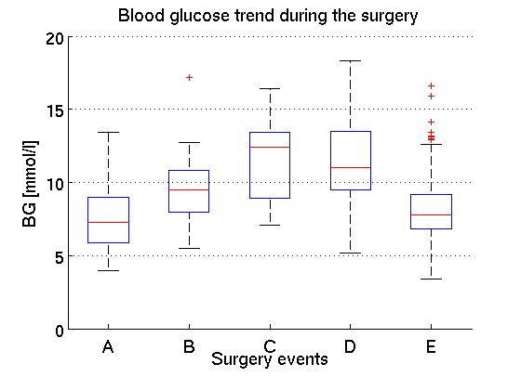
Image 1. describes the trend of the Blood glucose concentration in the certain surgery phases A (pre-anhepatic phase), B (anhepatic phase), C (reperfusion between the unclamping of portal vein and hepatic artery), D (post-anhepatic phase I. [13, 15] ) and E (post-anhepatic phase II.)

The nutrition was provided in parenteral way, the goal feed was 4 [g/hr] according to the hospital protocol, the insulin were administered in infusion.
The oLT can divided into several phases (Image 1.); the pre-anhepatic (pre-AH) phase (dissection of the porta hepatic), the anhepatic (AH) phase (clamping of the blood supplies) and the post-anhepatic phase (post-AH) winch begins with the reperfusion through unclamping the porta vein the hepatic artery and vena cava.
The anhepatic (AH) states lasted 80±25 [min], the time between the portal vein's and hepatic artery's unclamping was 54±29 [min] the administered nutrition 0.3281±0.2418 [mmol/l] for the whole surgery, 0.3083±0.2136 [mmol/l] 0.2112±0.1962 [mmol/l] for the AH states and the timespan between the unclamping the portal vein and hepatic artery. Except the parenteral nutrition the patients didn't received any feeding.

2.2 Model
The ICING model (Equation (1)-(4)) describes a three- compartment system which contains the insulin changes $\left(\overset{˙}{I}\right)$ in the blood in the interstitium$\left(\overset{˙}{Q}\right)$ and the glucose $\left(\overset{˙}{G}\right)$changes [1]. The Blood Glucose changes arises from the glucose releases as well the uptakes in terms of physiological constants like endogenous glucose production (EGP), non-insulin mediated glucose uptake by the central nervous system (CNS), and other organs (Pg). The exogenous input is due to the parenteral nutrition (Pn) in our case. The glucose uptake by the cells is evaluated retrospectively, by integration method with taking in account the interstitial insulin- and blood glucose concentration. The glucose uptake of the cells is also characterized by the insulin sensitivity SI, which indicates the ability of the body for the present insulin's utilization rate. The method for SI value's estimation was validated with independent clinical data [16, 17].
Setting up a stochastic model on the SI value changes, can predict the patient-status; the ability for insulin utilization, enabling a designed intervention of exogenous insulin and nutrition, maintaining a normoglycemic state with a certain probability. As the method were validated, the non-physiological range of SI (i.e. SI <0) shows an extraordinary state, where this model's population constants for EGP and Pg, that are effective in Glycemic Control for MICU & CICU fail.

$$\overset{˙}{G}=−p_{G}⋅G\left(t\right)−\text{SI}⋅G\left(t\right)\frac{Q\left(t\right)}{1{\text{+α}}_{G}⋅Q\left(t\right)}+\frac{\text{EGP}−\text{CNS+PN}\left(t\right)}{V_{G}}$$ | (1)
$$\overset{˙}{I}=\frac{−n_{L}⋅I\left(t\right)}{1{\text{+α}}_{I}⋅I\left(t\right)}−n_{K}I\left(t\right)−n_{I}\left(I\left(t\right)−Q\left(t\right)\right)+\frac{u_{\text{ex}}\left(t\right)}{V_{I}}+\left(1−x_{L}\right)\frac{u_{\text{en}}}{V_{I}}$$ | (2)
$$\overset{˙}{Q}{\text{=n}}_{I}\left(I\left(t\right)−Q\left(t\right)\right)−n_{c}\frac{Q\left(t\right)}{\left(1{\text{+α}}_{G}\right)Q\left(t\right)}$$ | (3)
$$u_{\text{en}}{\text{=k}}_{1}⋅{\text{G+k}}_{2}$$ | (4)
(In equation (1) only the parenteral feeding was considered, due to the BTC' feeding-regime.)

2.3 Model based assessment of the clinical data
The proper values for the physiological parameter-changes are not available, however their (EGP, Pg) direct measurement would be beneficial. The measurement- methods are highly restricted [18-20] due to the surgical and physiological conditions. The SI variability conveys information about the metabolic processes, as well as the alternations of physiological parameters [21].
The SI value is limited because of trivial physiological considerations; it can't drop above 1e-7 [-].

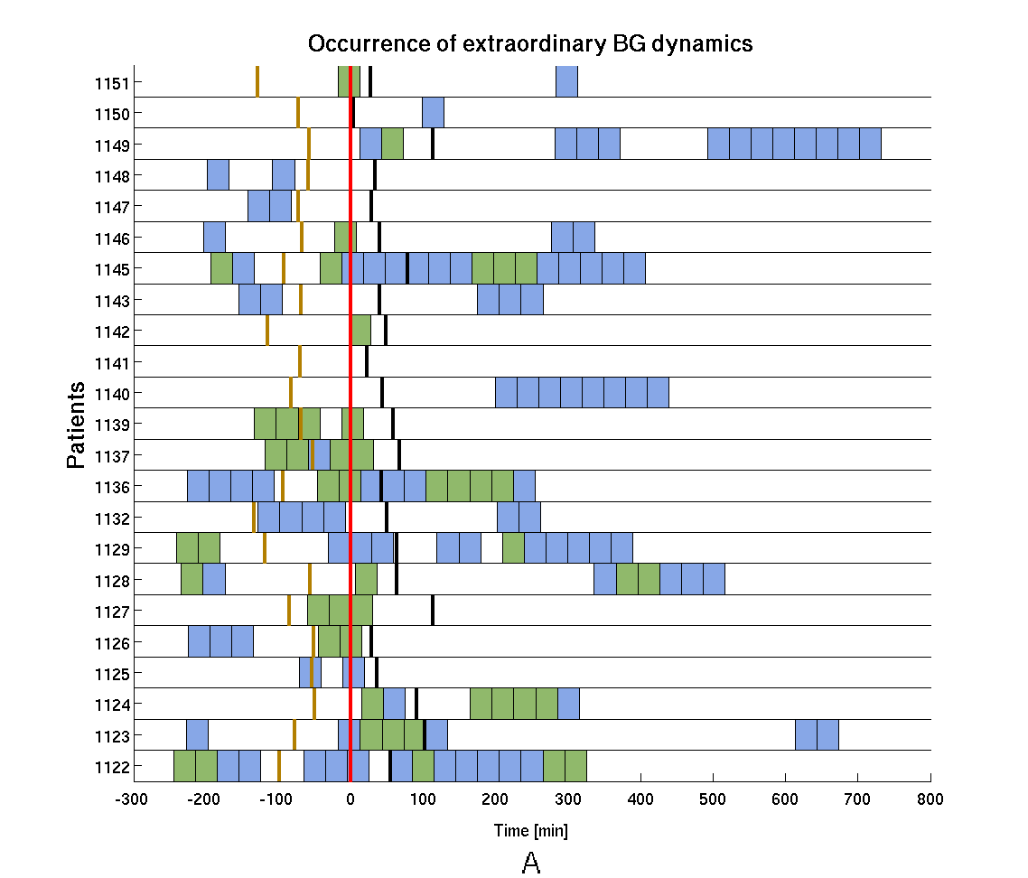
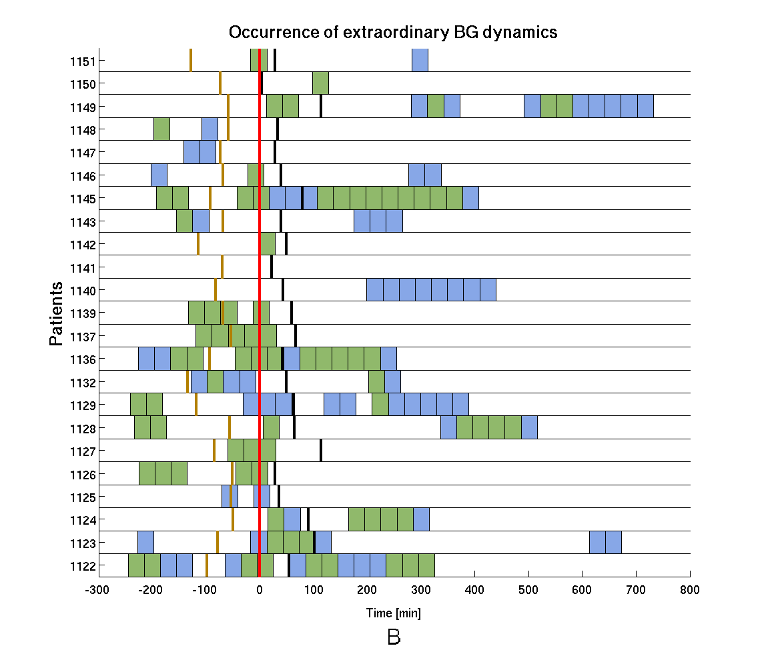
Image 2. A-B Occurrence of the extraordinary BG dynamics. The surgery events; a) beginning of the anhepatic phase is signed by brown line, b) the portal vein reperfusion by red, c) the hepatic artery unclamping by black lines. The green boxes represent the places where the absolute deviations reach >2 mmol/L over 1 hour in 2.A and >1 mmol/L over 1 hour in 2.B.

$$\text{BG=}\int{\text{SI}}⋅G\left(t\right)⋅\frac{Q\left(t\right)}{Q\left(t\right)⋅\left(1\text{+α}\right)}\text{dt}$$ | (5)

The non-physiological range of the SI value (SI<0) let us know the deviations' features, through the SI related term's integration over the related timespan (Equation 5).

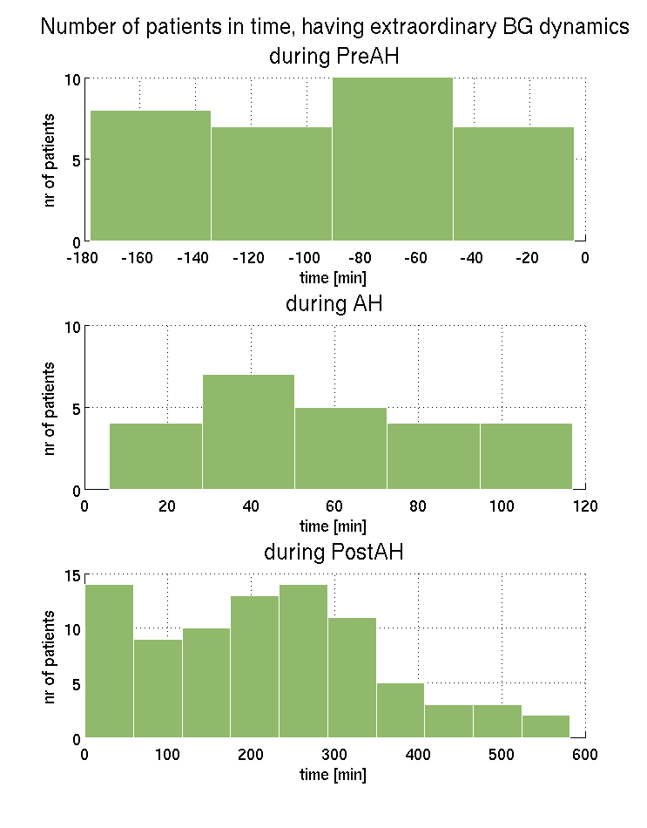
Image 3. The histogram shows the extraordinary BG dynamics' frequency in time, during the following surgery phases; the pre-anhepatic phase until the hepatectomy, the anhepatic phase from the hepatectomy until the portal vein reperfusion, and the post-anhepatic phase from portal vein reperfusion.

3 Results
The fitting ability of the model for the LT use was analyzed on Image 2. by indicating the times, where the BG dynamics deviate from the MICU (medical intensive care unit) or CICU (cardiac intensive care unit). Each line represents a patient along the vertical axis, the horizontal axis shows the time. The patients data were shifted to t=0 portal vein reperfusion. Almost every patient episode shows an extraordinary BG glucose dynamics. By integrating the SI related term (equation 5), we obtained also quantitative differences between LT patients and validated ICU patient model. A threshold value was set to distinguish the dynamics more nuanced. The threshold value 2 mmol/l BG input above the validated ICU patients (Image 2. A) shows the importance of the portal vein reperfusion. It points on 11 patients, with higher extra BG input above the threshold value 2 mmol/l (Image 2. A), as 5 patients can be accounted to the pre-anhepatic phase and 6 ones to the post-anhepatic phase with similar behavior. In some cases due to the not appropriate interpolation between blood glucose samples the the integration intervals overlap two phases (anhepatic and portal vein unclamping at patients 1125, 1139, 1146, 1151).
Iage 3 shows the tendencies for each phases seperately, with an increased case number for the portal vein reperfusion and 250 minutes after it.

4 Discussion

In the pre-anhepatic phase the general deviations are caused by stress response for surgery interventions.
The reperfusion by the release of portal vein clamp causes general a rapids rise of BG causing a severe hyper- glycemia, the phenomenon is well known among clinicians [22, 23]. Based on the data also in the post anhepatic phase, a critical time interval can be defined accounts to 500 minutes after portal vein unclamping.
For accurate models and model-based glycemic control in hepatic-transplant we need to find accurate pG and EGP because it is from these results clearly not the same as general MICU and CICU patients. Where metabolism is extraordinary compared to a validated ICU patient model, EGP or PG or both very different.

5 Acknowledgements
This work was supported by the Hungatian National Scientific Research Foundation, Grants No. T80316 and T82066 and EU FP7 IRSES eTime Grant No. 318943. Research-work if József Homlok is supported by the Scholarship of Gedeon Richter Plc. The authors thank for Csaba Turi and János Fazakas for their work in collecting and systematizing the measurements data and the times of substantial stages during the surgery.

6 References
[1] J. Lin et al. A physiological Intensive Control Insulin-nutrition-glucose (ICING) model validated in critically ill patients: Computer Methods and Programs in Biomedicine 102, 20111.
[2] J. Blaha et al.: Comparison of three Protocols for Tight Glycemic Control in Cardiac Surgery Patients, Diabetes Care. 32(5), 2009.
[3] J. L. Dickson et al.: External validation and sub-cohort analysis of stochastic forecasting models in NICU cohorts: Biomedical Signal Processing and Control, 8(4), 2013.
[4] J.S. Krinsley, Glycemic variability: a strong independent predictor of mortality in critically ill patients, Crit Care Med, vol. 36, pp. 3008-13, 2008.
[5] M. Egi et al. Variability of blood glucose concentration and short term mortality in critically ill patients, Anesthesiology, vol. 105, pp. 244-52, 2006.
[6] L. M. Fisk et al. STAR development and protocol comparison, IEEE Trans Biomed Eng. 59(12) 2012.
[7] S. Penning et al.: First pilot trial of the STAR-Liege protocol for tight glycemic control in critically ill patients
[8] A. Illyés et al. : A tálplálási értékek biztosítása és optimális glükóz kontroll (stressz indukálta hyperglikémiával társuló kritikus állapotú betegek esetén) STAR protokollal: Aneszteziológia és intenzív terápia 43 (Suppl. 1), 2013.
[9] B. Benyó et al. : Advanced feeding regime combined with STAR protocol on ICU patients: Minimally Invasive Therapy & Allied Technology 22 (Suppl. 1.), 2013.
[10] J. L. Dickson et al.: Development and optimisation of stochastic targeted (STAR) glycaemic control for pre-term infants in neonatal intensive care: Biomedical Signal Processing and Control, v8(2). 2013.
[11] J. B. Ammori et al.: Effect of Intraoperative Hyperglycemia During Liver Transplantation, Journal of Surgical Research 140, 2007.
[12] A. Wallia et al. Pos-transplant hyperglycemia is associated with increased risk of liver allograft rejection: Transplantation, 89(2), 2010.
[13] J. Homlok, J. G. Chase, Cs. Turi, B. Benyó: Comparison of Model Based and Clnical Blood Glucose Evolution during and after Anhepatic Status: Biomedizinische Technik 58 (Suppl 1.) Paper online, 2013.
[14] J. Homlok, B. Benyó, J. G. Chase: Patient specific modelling on blood glucose dynamics during liver transplantation: Abstracts from the 25th Conference of The Innovation and Technology, iSMIT 2013, Baden-Baden, Germany. Minimally Invasive Therapy & Allied Technologies 22 (Suppl. 1) p. 23, 2013

[15] J. Homlok et al. : Altered blood glucose dynamics during and after anhepatic phase of liver transplantation: a model-based approach: INES 2013, IEEE 17th International Conference on Intelligent Engineering Systems. Monte de la Cruz, Costa Rica, 2013.
[16] Chase et al
[17] Mcauley et al.
[18] M. Ichimiya et al. Insulin and glucagon levels in living related liver transplntation: their interactionwith the recovery of graft liver function: Transpl. Int. 8, 1995.
[19] T. L. B. Lauritsen et al. The effect of hepatectomy on glucose homeostasis in pig and in man: Journal of Hepatology 36, 2002.
[20] S. E. Joseph et al. Renal Glucose Production Compensates for the Liver During the Anhepatic Phase of Liver Transplantation: Diabetes, vol. 49, 2000.
[21] C. G. Pretty, A. J. Le Compte, J. G. Chase, G. M. Shaw, J.-C. Presier, S. Penning, T. Desaive: Variability of Insulin sensitivity during the first 4 days of critical illness: implications for tight glycemic control: Annals of Intensive Care, 2:17, 2012
[22] S. V. Mallett, et al.: Prognostic significance of blood glucose levels during liver transplantation: Anesthesology V 67, No 3A, 1987.
[23] T. Kiuzchi et al.: Implications of Host Pancreatic Hormones in the Restart of Grafted Liver, Hepatology, Vol 21 No. 6, 1995.

