Optimal coupling of waste and concentrated solar for the constant production of electricity over a year

Ester de la Fuente, Mariano Martín

Department of Chemical Engineering. University of Salamanca. Plz. Caídos 1-5. 37008. Salamanca (Spain)

Abstract
In this paper we address the integration of a biogas-based gas turbine with a concentrated solar power facility for the constant production of electricity over a year long. The process is modeled as a superstructure embedding both technologies and a heat exchanger network that produces the steam from the gas turbine flue gas and the molten salts to be used in a regenerative Rankine cycle. For the constant production of 25 MW in the South of Spain, the steam turbine is the one responsible for producing the power, while the gas turbine operates mostly as a combustion chamber. The low yield to power of the waste and the allocation of the plant results in an excess of capacity during summer of about 50%. The production cost of electricity is 0.17€/kWh with an investment of 380 M€, but the excess of capacity during summer can allow the production of chemicals.

Keywords: Renewable Power, Waste, Solar Energy, Multiperiod optimization

1.-Introduction
Electricity is running current societies and further use of electric means of transportation will increase our dependency on this form of energy. The transition from fossil-based power to renewable based one faces an important challenge, the variability of the largest resource on Earth. Solar availability is highly volatile, it is subjected to seasonality in the longer term, but weather also results in hourly or subhourly fluctuations. Meeting power demand over time requires the use of integrated systems to help mitigate the variation in power production from solar, either via Photovoltaics (PV) or Concentrated Solar Power (CSP). Short term variation has typically been solved by using thermal storage where a heat transfer fluid is heated up during the sun hours are used over the entire day such as the case of CSP plants.¹⁻² However, longer term operation is more challenging. Electricity storage using batteries shows difficulties related to their limited capacity.³ However, the use of chemical systems provides an interesting alternative. Apart from the possibility of chemical storage of solar or wind power producing methane⁴⁻⁵ or ammonia⁶⁻⁸ the integration of power plants with biomass or waste fuelled facilities is an interesting alternative to evaluate. Weekman⁹ and Yaun and Chen¹⁰ presented perspectives on the integration possibilities among renewable resources. The combination of biomass with solar energy is becoming a reality at the level of pilot plant with the use of biomass to obtain the power that sun cannot produced at certain times.¹¹ Vidal and Martín¹² optimized the operation of a facility that used biomass gasification as buffer technology to operate a CSP facility. The coupling of the two technologies was allowed either using the thermal energy in hot streams or the use of a syngas furnace to heat up the molten salts that produced the steam used in the steam turbine or the parallel production of power from a syngas-based gas turbine and the steam turbine. The flue gas from the gas turbine was no further used. This integration allowed constant power production and the possibility of storing power in the form of hydrogen as energy vector if solar availability was enough to meet the demand. In spite of a large investment cost, power production cost was competitive. Biomass gasification yields a syngas that is very interesting as intermediate for the production of a large number of chemicals.¹³ The diversification of the use of biomass limits its availability as a source of power in favour of the production of chemicals to substitute crude oil as source. Waste, on the other hand, is plentiful and the current production rate represents a challenge in terms of its treatment and processing. Developed societies generate 0.5 t/hab and year. The volume itself and the composition require careful evaluation for its disposal or further use. Recent studies on the potential of biogas reveal the possibility of meeting the demand of natural gas in the regions evaluated out of their own waste resources.¹⁴ León and Martín¹⁵ evaluated the power production from different waste sources, manure from different animals, as well as the possibility of producing a fertilizer. The need to obtain credit out of the digestate and the difficulties in disposing it led to the study of nutrient recovery technologies including the production of a fertilizer that is easy to use, struvite.¹⁶ The facilities developed considered the use of the biogas produced from the anaerobic digestion of manure to be used within an integrated system consisting of a Brayton cycle coupled with a Rankine cycle to further use the hot temperature flue gas exiting the gas turbine. Thus, the use of waste within power industry via anaerobic digestion can be considered for its integration with CSP plants to mitigate the variability in solar availability. It is therefore interesting to evaluate the possibility of using that flue gas for the production of steam when solar availability is not enough. Solar and biogas have also been integrated to provide energy for other operations such as sludge drying¹⁷ or the use of solar energy to assist heat and power production from biogas.¹⁸
In this paper a mathematical optimization framework is developed for the integration of waste and concentrated solar power within a renewable based power plant. The system considers waste anaerobic digestion and a gas turbine to produce power from residues. The hot flue gas is further used and integrated within a CSP. The flue gas and/or the heat transfer fluid, molten salts, can be used for the production of the steam required by the steam turbine of a regenerative Rankine cycle. The rest of the paper is organized as follows. Section 2 describes the process and the integration between the two natural resources considered. Section 3 presents the main modeling features of the different units. Section 4 discusses the solution procedure for this multi-period MINLP problem. Finally, Section 5 presents the results, including a sensitivity study on the topology selection, the plant operation ending with an economic evaluation for estimating the electricity production cost.

2. Overall Process Description

The process consists of five sections: Biogas production and purification, gas turbine, solar collection technologies, heat exchanger network and Rankine cycle, see Figure 1.
Waste and water are fed to a digestor. The mixture is anaerobically digested for 25 days to produce biogas and a digested substrate, digestate. The digestate is no further processed in this work as it has already been studied previously.¹⁶ The biogas is sent to purification to remove CO₂ and traces of NH₃, using Pressure Swing Adsorption (PSA), and to eliminate the H₂S in a fixed-bed reactor. Once biomethane is obtained, a Brayton cycle is used to produce power. The gas turbine is modelled consisting of a biomethane compression section, air compression section, combustion chamber and expansion. The flue gas is further used in a heat exchanger network to produce steam to for a regenerative Rankine cycle.
The CSP facility consists of three sections such as, the heliostat field including the receiver and the molten salts storage tanks, a heat exchanger network and the steam turbine. The salts are used to generate superheated steam to be used in a steam turbine following a regenerative Rankine cycle.
The steam is generated in a system of three heat exchangers where it is first heated up to saturation and then evaporated. In order for both hot streams, the molten salts and the flue gas, to be used a system of heat exchangers in parallel is considered so that the superstructure will allow the selection of the use of any of the two sources of energy. For heating up and evaporating water, the entire flow of the molten salts is used while only a fraction was used for reheating and overheating the steam. However, the higher temperature of the flue gas suggests a different lay out. The entire flow is used for overheating the steam before feeding the high-pressure turbine whereas it is split to reheat the steam before feeding it into the medium pressure turbine and to heat-up and evaporate the water from the deaerator. In the second stage of the turbine, a fraction of the steam is extracted at a medium pressure and it is used to heat up the condensate. The rest of the steam is finally expanded to an exhaust pressure, condensed and recycled. A cooling tower will be used to cooldown the cooling water.
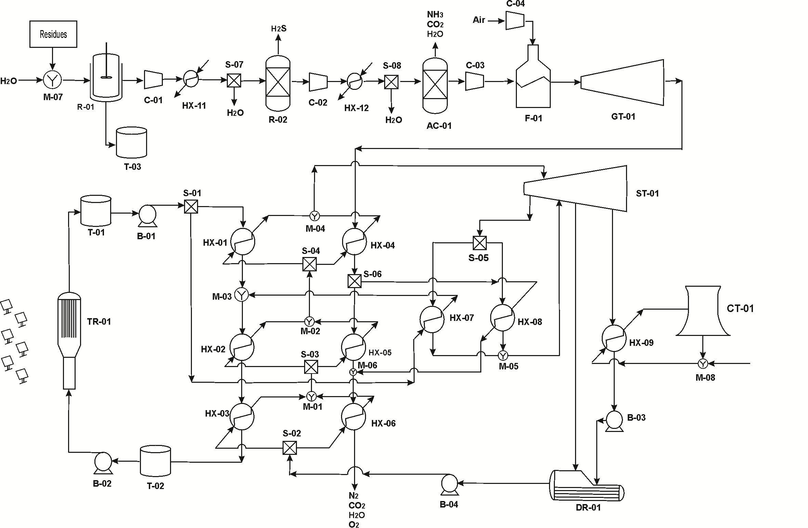
Figure 1.- Integrated power plant.

There are a number of trade–offs related to the availability of energy, the large availability of waste and its low yield versus the variability in solar energy that will be evaluated using the framework developed.
3. Process model.

The different options involved in the production of hydrogen are modelled using mass and energy balances, short–cut methods, experimental based correlations, rules of thumb, design equations and reduced order models. The model is written in terms of the total mass flows, component mass flows, component mass fractions, and temperatures of the streams in the network. These are the main variables whose values have to be determined from the optimization. In this section we present the main assumptions used for modelling the units. The components in the system correspond to the ones in the set J = { Wa, CO₂, CO, O₂, N₂, H₂S, NH₃, CH₄, SO₂}

3.1.-Biogas based section
This section has been developed in previous works and therefore no further details are provided here for the sake of brevity. Mass and energy balances are used to model the digestor.¹⁵ A standard digester of 6000m³ is considered. The compressors are modelled assuming polytropic behaviour. We assume an efficiency of 0.85 and k =1.4 based on rules of thumb¹⁹ with T(ºC) and P in kPa. Experimental data shows almost 100% removal yield for H₂S using a fixed bed of Fe₂O₃ that removes. The stoichiometry of the reaction allows modelling this stage.
Fe₂O₃ + 3H₂S → Fe₂S₃ + 3 H₂O
Rules of thumb allow computing the removal ratios for CO₂ and ammonia in the PSA system. Finally, the gas turbine (T_{GasTurbine}) is modelled as consisting of a multistage compression stage for the biomethane and the air, where final pressure is one of the major operating variables, a combustion chamber, where methane is burned is modelled assuming an adiabatic operation, and an expansion section that is modelled assuming polytropic behaviour.
3.2.-Concentrated solar plant
This section consists of the heliostats field and the molten salts storage tanks. The operation is mostly monthly dependent since we assume that the tanks buffer the operation over a day long. We consider a mixture of 60% NaNO₃ and 40% KNO₃ as heat transfer fluid. The heliostats redirect solar to the receiver. Its typical size ranges from 70 to 150 m². In our case we consider an average value of 120m². To be on the safe side we consider a field efficiency of 55% based on previous work.¹
In order to compute the number of heliostats, for an expected power capacity and considering the annual radiation during the sun hours, we calculate the area needed in the heliostat field, given by Eq (1)-(2).
(1)
(2)
The heliostat field provides the energy over time as given by eq. (3). To simplify the notation, we avoid the use of the index presenting the "time period":
(3)
The energy collected in the heliostat field is only produced during the sun hours of a day. Thus, the energy available at the receiver is given by Eq (4):
(4)
The molten salts are fed to the receiver at 290ºC and are heated up to 565 ºC using the energy collected from the concentrated solar radiation. Thus, the flow of the salts in and out of the collector is given by Eq (5):
(5)
The salts flow rate in the power cycle should be lower or equal to the maximum flow generated at the receiver with a correction factor given by the ratio between the sun hours in a day and the continuous operation of the plant, as presented in Eq (6):
(6)
We assume that there are no losses in the salts closed cycle, which is modeled using Eq (7):
(7)
3.3.-Rankine cycle section
Mass and energy balances are used to describe the thermodynamics of the regenerative Rankine cycle. Two systems are designed in parallel so that either a flow of molten salts or flue gas are used to produce overheated steam and reheat the steam from the first body of the turbine. Each one of the heat exchangers HX1-HX9 shown in Figure 1 are modelled using mass and energy balances as follows, where “a” refers to the flue gas section and “b” to the molten salts section:
(8)
HX3-HX6 heat up the steam up to its saturation point. To ensure saturation conditions, the temperature at the inlet of HX2-HX5 that given by Antoine equation at the operating pressure of the turbine, eq. (9)
(9)

The pair HX2-HX5 is in charge of evaporating the water stream. No pressure drop is assumed. Finally, HX1-HX4 overheat the steam before it is fed to the turbine. The turbine is modelled as in previous works.^{1,12} We consider that the turbine consists of three bodies and all of them are modelled similarly. The expansion of the steam in the different bodies of the turbine is assumed to have an isentropic efficiency of 0.9.²⁰ Therefore, the stream exiting the first body, Turbine1, can be calculated using eqs. (10)-(12)

(10)

Where
(11)

T* represents the isoentropic temperature after the expansion. And the entropy is as follows:

(12)

To enforce that the output of the turbine is superheated steam we use Eq (13).
(13)

(14)

The energy that is obtained in the first body of the turbine is given by Eq (15):

(15)

The stream as superheated vapor is heated up again in HX7-HX8 using a fraction of the total flow of molten salts stored in Tank1 or a fraction of the flue gas from the gas turbine. Next, the superheated steam is fed to the second body of turbine.

In the second body, Turbine2, of the turbine there is another expansion to a lower pressure. Part of the stream is sent to DR-01 while the rest is used in the third body of the turbine, Turbine3, where it is expanded to the exhaust pressure. This last pressure ranges from 0.05 bar to 0.31 bar. The stream splitter after the second body of the turbine is modelled by Eq (16):
(16)

This stream is used to reheat up the condensate from the turbine in HX10,
(17)
The condensate comes from HX9 where the exhaust steam is condensed using typically a cooling tower ²¹ or an air cooler.²² The stream exiting HX10 must be liquid so that it is compressed using a pump up to P_{turb1}. To enforce this we impose Eq (18):
(18)
T_{turb2min} corresponds to the saturated temperature at the pressure of the stream extracted from the medium pressure section of the turbine. It is computed using Antonine correlation.
The total energy obtained in the steam turbine is the sum of the ones generated at the sections of the turbine, low, medium and high pressure, eq. (19):

(19)

4.-Solution procedure
The superstructure of the integration of the CSP and the waste-to-energy facility consists of a system of 400 eqs and 800 variables per period, a month, that is solved maximizing eq. (20) on a monthly basis over a year long. The main decisions are the operating conditions at the various units, pressures, temperatures, flow rates as well as the selection of the better resource integration, the use of the biogas to produce power in the gas turbine and/or the further use of the flue gas in the production of steam for the regenerative Rankine cycle. The objective function is given by eq. (20) involving the net power production and the annualized cost (K=1/3) of the mayor units such as the solar field, the digestor and the linearized cost of the gas and steam turbines.
Z= 0.05*(W_{(Turbgas)}+W_{Total}-W_{(Comp1)}-W_{(Comp2)}-W_{(Comp3)}-W_{(Comp4)})*24*334
-(120·AreaTotal+365*6000*N_{digestor}+(335.27*(W_{(Turbgas)})+36.211)-( 270.5* W_{Total} +2·10⁶))*(K) (20)
A particular case of study is presented for an allocation in the South of Spain, Badajoz, characterized by large poultry availability and solar incidence. This region already has hybrid facilities based on fossil resources. Although the results are presented for this particular allocation and waste, the framework is general and can be used for further evaluation of the integration of additional waste resources in different allocations. Table 1 shows the monthly solar incidence for the allocation selected.

Table 1.- Plant operating conditions^{23,24}
MONTH | kWh/m²·day | Day | Sun(h/day)
J | 4.07 | 31 | 9.76
F | 4.74 | 28 | 10.70
M | 5.85 | 31 | 11.90
A | 5.97 | 30 | 13.20
May | 6.67 | 31 | 14.30
June | 8.56 | 30 | 14.80
July | 9.15 | 31 | 14.60
Aug | 8.31 | 31 | 13.60
Sep | 6.60 | 30 | 12.40
Oct | 4.44 | 31 | 11.20
Nov | 3.76 | 30 | 10.00
Dec | 3.34 | 31 | 9.48

5.-Results
5.1.-Plant operation
The analysis is based on a plant with a production capacity of 25 MW coproduced from solar concentration and waste. In a region in the northern hemisphere such as the one selected in the study, Badajoz (Spain), summer corresponds to a period of high solar incidence. For the production of the 25 MW in Figure 2 it can be seen that the use of waste reaches a minimum in July. In that month solar energy by itself can produce the required power. However, along the year complementing this resource with waste is required to secure the production of power. November and December show the larger consumption of waste, around 2.5 kg/s. As a result, Figure 3 shows the number of digesters operating over the year. A total of 4 digesters are required during the months with lower solar incidence, January, November and December. However, over the rest of the year, there is an excess of capacity in the form of biogas that can be stored or used as described in previous works to produce chemicals that can be stored.²⁵ Waste will be available but may not be needed to meet the power demand.

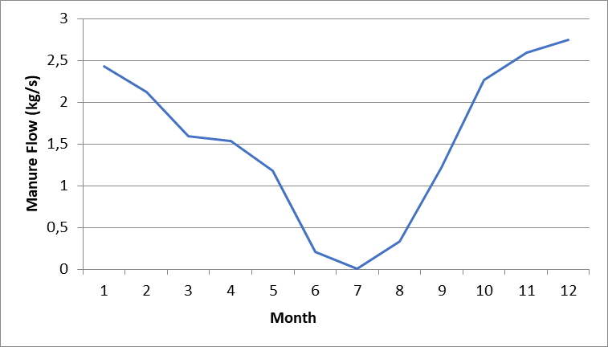
Figure 2.- Profile of the consumption of waste

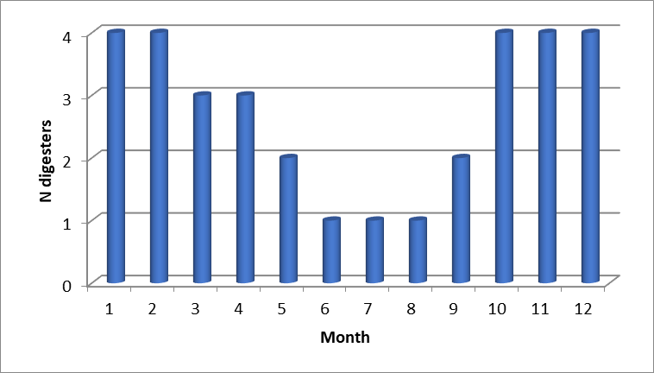
Figure 3.- Profile of the use of digesters

Figure 4 shows the use of the two turbine systems within the flowsheet. The gas turbine is mostly used as a furnace to burn the biogas generating a high temperature stream to produce steam. As a result most of the power is actually produced in the steam turbine. The two heat exchanger networks, that which uses the molten salts as well as that using the hot flue gas, are in operation over the entire year. Figure 5 shows a detail of the actual production in the facility. The consumption of power is related to the compressor system of the gas turbine.This selfconsumption is another reason for using the gas turbine as a furnace more than as a proper gas turbine. During July there is no need for biogas and as a result, only the steam turbine is used. The steam turbine will be operating at a lower capacity during summer because there is no power consumption involved in processing the biogas. We assume that there is a negligible effect of the load on the turbine efficiency based on the data on fan perfomance as a function of the load available in the literature.²⁶
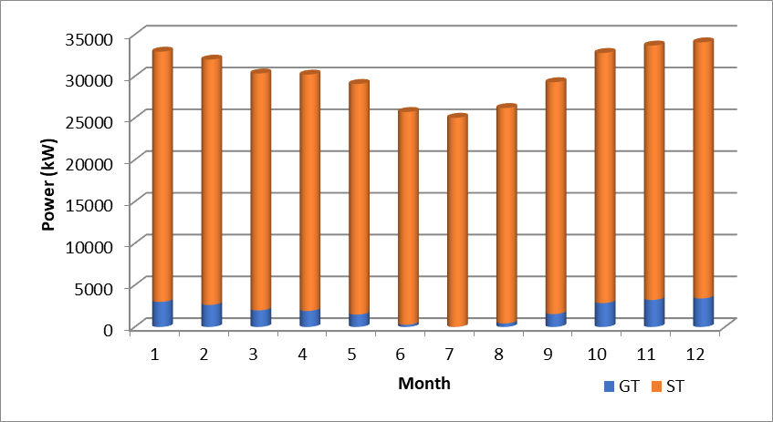

Figure 4.- Contribution of the gas turbine (GT) and the steam turbine (ST) to the total power produced over time

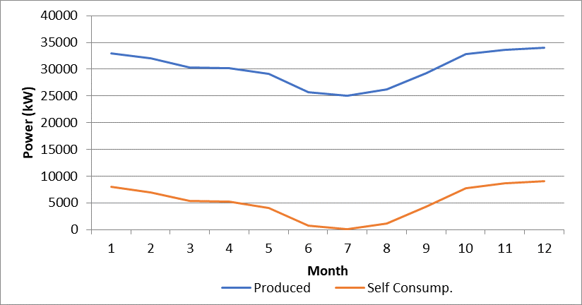
Figure 5.- Selfconsumption of energy over time

Finally, Figure 6 shows the share of the power produced by each of the resources to meet the demand of 25 MW. Only in Decemeber 50% of the power is produced by each source. Therefore, the system has an actual capacity of around 50% additional resources in the central months of the year where only one, Solar, is used. There are around 12 MW of additional capacity in summer. However, the flexibility during winter is limited. The ratio between power and thermal energy generated is around 50%, larger the months when biogas is used.
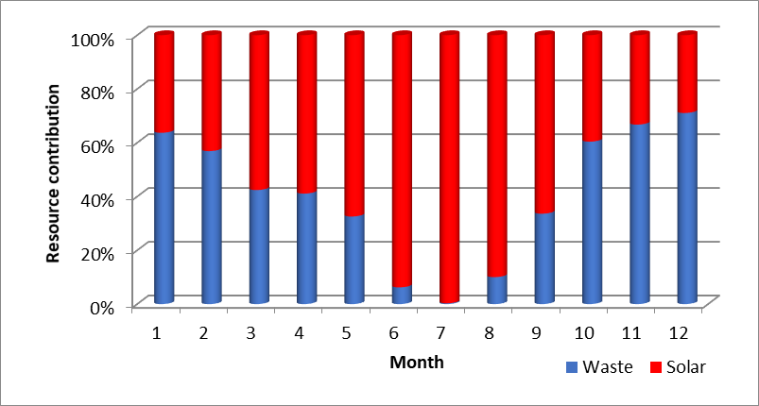
Figure 6.- Share of power produced by each of the resources, solar and waste.

5.2.-Economic evaluation.
The operating regime is assumed to be the entire year. Note that the power market typically dictates when the different technologies contribute to the grid. For the operating of this facility, it is assumed that the power production is constant so that the usage of waste and solar energy depends on their availability, mostly that of solar. The trade-off is given by the investment between the digestor and the solar field.
The investment cost estimation is performed using the factorial method.²⁷ It relies on the equipment cost, updated from Matche.^{28,29} We consider the units described in the flowsheet given by Figure 1. The digester cost is assumed to be 365 €/m³, ¹⁴ and the heliostat costs are 120 €/m². ¹ We assume that each heliostat has an area of 120 m². The installed equipment is assumed to represent 1.5 times the equipment cost but for the solar field. Piping, isolation, instrumentation and utilities represent 20 %, 15 %, 20 % and 10 % of the equipment cost respectively. Land and buildings cost are assumed to be 8 M€, and the load of molten salts is priced at 0.665 €/kg. ¹ These items add up to the fix cost (319 M€). The fees represent 3 % of the fix cost, other administrative expenses and overheads and the plant layout represent 10 % of the direct costs (fees plus fix capital) and 5 % of the fix cost respectively. The plant start-up cost represents 15 % of the investment. The investment adds up to 380 M€. Figure 7 shows the breakdown of the unit costs by sections of the facility. The two most important contributions correspond to the solar field and the turbine with once third of the total each. Another interesting feature is the fact that the molten salts storage tanks to maintain the operation of the facility overnight represent 33% of the total cost of the heat exchanger network. The digestion step only represents 7.5% since the reactors, although expensive, are only civil engineering work.

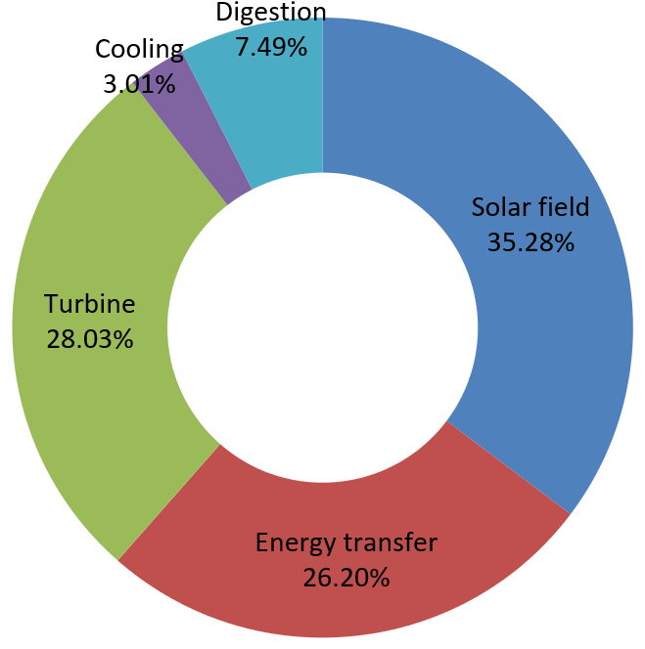
Figure 7.- Breakdown of the cost by sections

An interesting comparison that is performed with power production facilities is the investment per kW installed. The integrated facility evaluated in this paper shows a ratio of 15291 €/kW, more than twice the investment per kW installed than a standalone CSP plant 7000€/kW,¹ but capable of providing constant electricity production over time. Therefore, that is the price for securing the production capacity. Unfortunately, it is also more expensive than fossil-based technologies which range from 1000-4000 €/kW. The comparison with other renewables is difficult to establish since the estimations for solar or wind facilities for 2030 are from 2000-4000 €/kW, but the facilities are not designed with backup units to provide constant electricity production.³⁰
Furthermore, we estimate the production cost of the electricity. Note that neither credit is assumed from the digestate, that can be used as fertilizer,¹⁴ nor for the additional production capacity of biogas. The reason for not considering the credit out of the digestate is the uncertainty in its market value and demand. Thus, a conservative assumption of zero additional income out of it is assumed in this work. For the average annual cost, we consider the labour costs (0.5% of investment), equipment maintenance (2.5 % of fix costs), amortization (linear with time in 20 years), taxes (1 % investment), overheads (1 % investment) and administration (5 % of labour, equipment maintenance, amortization, taxes and overheads). Figure 11 presents the contribution of the different items to the production cost of electricity before credits. The production costs are 0.17 €/kWh, slightly higher than the values reported for the CSP facility of similar sized operating alone¹ that shows a production costs of around 0.15 €/kWh but that secures constant production using renewable resources. That additional 10% cost is that due to securing the continuous production of power over time.

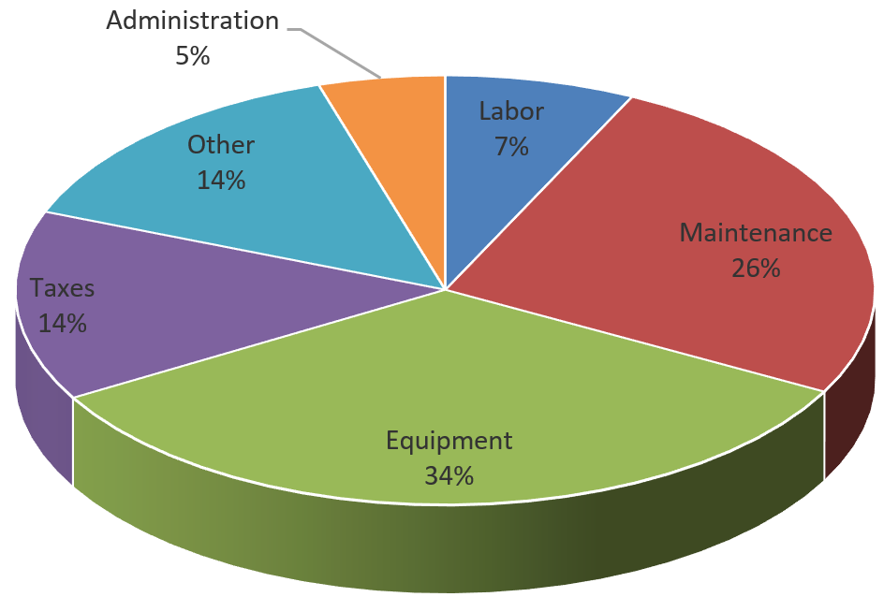
Figure 8.- Share of the production costs.

The investment cost of novel technologies decreases with time as they become mature. It is expected that the solar field costs will be far lower over time as well as the cost of digesters. Figure 9 shows a sensitivity analysis on the effect of the cost of these units on the investment per kW installed. With the expected decrease in heliostat costs over the next 30 years, down to 50 €/m²,³¹ 10% decrease in the values of €/kW produced are expected but they will still be larger than current technologies or even other renewables such as wind. Furthermore, a decrease in the investment cost for digesters has also been analyzed. 50% reduction in the investment costs for the digesters represents an additional 10% decrease in the investment per kW produced.
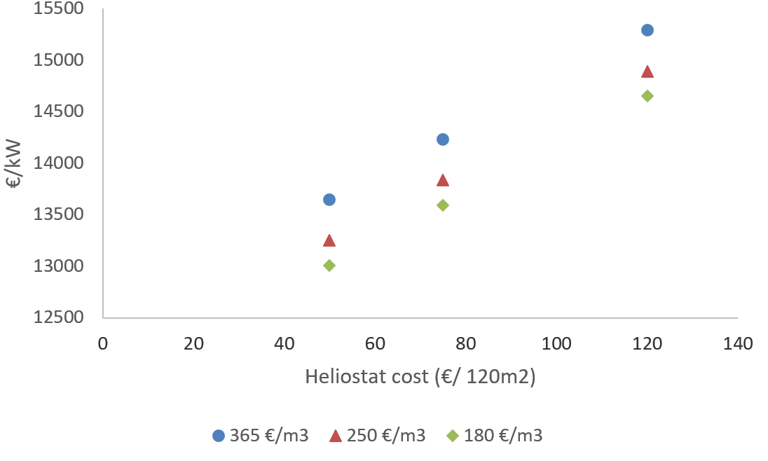
Figure 9.- Sensitivity study on digester and heliostats cost

5.3.-Scale up and down: Comparison with the standalone facility and use of lignocellulosic biomass.
Previous work by Vidal and Martín¹² provided a different integration solution. In that case the use of lignocellulosic biomass allowed the design of a facility more than 10 times larger, 340 MW, based on larger biomass availability and its easier transporation. In terms of the process, the two sections of the facility were also coupled differently than in this work. The biomass section could provide thermal energy to heat up the molten salts when the solar energy was not enough or the biomass-based syngas was used to produce power in a gas turbine. The solution suggested this last alternative, since thermal energy from syngas burning and the use of the hot streams from the gasifier had a lower efficiency. Therefore, the gas and the steam turbines operated in parallel to maintain the power production capacity of 340 MW resulting in electricity production prices of 0.073 €/kWh with an investment of 3225 M€. The excess of syngas capacity during summer was used for the production of hydrogen, an interesting asset.
In the case presented in this paper, the superstrcuture is different since the molten salts are only heated up using solar energy and both the flue gas from the gas turbine and the molten salts produce steam for the Rankine cycle. Note that the biogas has a different composition compared to syngas that conditions its usage. In syngas both CO and hydrogen can be burned while in biogas only methane is a fuel. For a direct comparison with this work a scale up study is required. The scale up methodology was described in previos work.^{8,32} It is assumed that he intensive variables of the process remain the same and only the flow, mass and energy flows, are scaled up and with them the equipment size. Rules of thumb on the maximum standard unit size apply, that dictate the need to duplicate a unit.¹⁹ Thus, the investment and production costs as well as the need for digesters is computed. A range of production capacifies from 10 MW to 340 MW are evaluated. The number of digesters is almost linear with the production capacity, but for the lowest ones where that linearity in the investment cost is lost, see Figure 10. Eqs (21)-(22) show the electricity production cost and the investment as a function of the facility sizes fitting the results in Figure 10.
C_{Electricity} (€/kWh)= 0.2418 · (Power(MW))^{-0.106} (21)
Investment (M€) = 11.814 (Power(MW)) +93.356 (22)
For the same production capacity as the integration of lignocellulosic biomass and CSP, the electricity production cost when using waste results in 0.133 €/kWh and an investment cost of 4083 M€, almost twice the production cost and 25% larger investment required. Note that no credit is assumed from the excess capacity of biogas due to the uncertainty in its use to be on the save side.
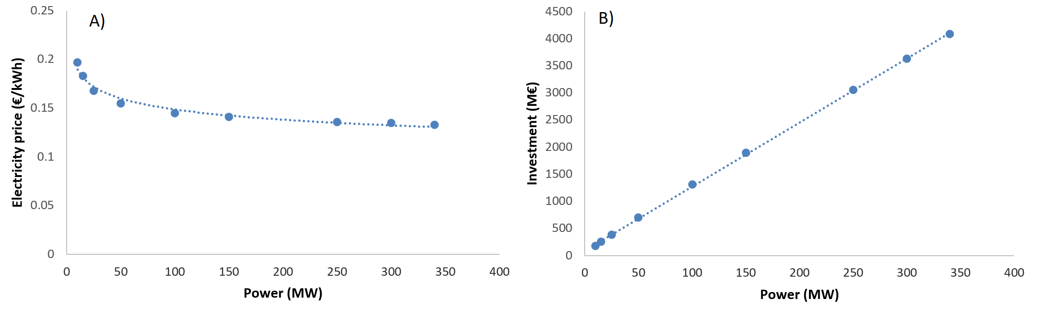
Figure 10.- Scale up/down on the economic parameters: A) production Cost; B) Investement cost.

For this facility to achieve the same production capacity more than 50 digesters of 6000 m³ each are required to process a peak of around 40 kg/s of manure, that is far larger biogas facility than any. Therefore, waste integration is intended for small facilities in remote agricultural areas where both solar and waste are availlable. Furthermore, beyond 50MW the economies of scale already show a production cost for leectricity within 10% of the minimum.
Finally, comparing the scaled-up equations of this facility, eqs. (21) -(22) with the ones obtained for the stand alone one,¹ it is possible to see that better economies of scale are found for the stand alone plant compared to the integrated. The main reason is the presence of digesters whose cost and number, but for small facilities, scales almost linear with the production capacity.

6.-Conclusions.
A superstructure for the integration of waste to power and a solar facility has been proposed embedding anaerobic digestion and a Brayton Cycle and a concentrated solar power plant. The hot flue gas from the gas turbine is integrated within the regenerative Rankine cycle of the CSP plant. The solution of the multiperiod optimization problem decides on the use of each energy source.
The low yield to power of the waste, poultry manure, and the allocation of the plant results in an excess of capacity during summer of about 50% so that the demand of 25 MW is met in winter. The steam turbine is the one responsible for producing the power, while the gas turbine operates as a combustion chamber mostly. The production cost to secure power production are 5% larger than the ones of the stand-alone plant, 0.17 €/kWh. However, the investment increases by 50% to 380 M€. The advantage is the additional capacity of production of biogas that can be stored or further used to produce chemicals that will be an asset to the flexibility of the process. The digestate can be also a source of additional income. The large number of units involved makes difficult that the future lower costs of heliostats result in large investment savings per kW installed.
The formulation is useful to evaluate trade-offs related to the location of the plant as function of the availability of the raw materials, solar energy and waste. This integration is preferable for small facilities due to the high cost of shipping the waste.

Acknowledgments
The authors acknowledge PSEM3 group and JCYL under grant SA026G18

7.-Nomenclature

area_{sup}: Superficial area provided by the heliostat field (m²)
Area_{helio}: Area of a heliostat (m²)
C_{i} : Cost €/kg of species i
fc_{(J,unit,unit1)} Mass flow of component J from unit to unit1 (kg/s)
H_{b,(unit,unit1)} Enthalpy of the stream at the state b from the stream from unit to unit1 (kJ/kg)
H_{steam(isoentropy)} Enthalpy of the stream at the if the expansion is isentropic (kJ/kg)
n_{i}: Flow of component i (kmol/s)
N_{days}: Number of days of the particular month
N_{helios}: Number of heliostats
Operating: Operating hours in a year /6450/
Power: Mean power (MW)
P_{i}: Partial pressure of species i (Pa)
Q_{(unit)} Energy at unit (kW)
radiation Average annual radiation in the sun hours Mwh per m² and day
rad_{annual} Average annual radiation MWh/m²
rend_{field} Field efficiency /0.55/
rend_{helio} Heliostat efficiency /0.9/
salts: Component salt.
s_{b(unit,unit1)} Entropy the stream at the state b for the stream from unit to uni1 kJ/kg·K
sun_{hour} Hours of sun a day /10.9/
T_{(unit,unit1)} Temperature of the stream from unit to unit 1 (ºC)
W_{(unit)} Work generated or needed at unit (kW)

Z: Objective function (€/s)

Units
Src: Source;
Snk: Sink.
AC: Adsorption Column.
B: Bomb.
C: Compressor.
DR: Deaerator.
F: Furnace.
GT: Gas Turbine.
HX: Heat Exchanger.
M: Mix.
R: Reactor.
S: Split
ST: Steam Turbine.
T: Tank.
TR: Tower Receiver.

Subindexes

NH₃: Ammonia
CO: Carbon Monoxide
CO₂ : Carbon dioxide
H₂: Hydrogen.
H₂S: Hydrogen Sulfide
H₂O: Water
Steam
Electricity

Symbol

η: Isentropic efficiency
η_{helios}: Efficiency of the heliostats

8.-References.

[1] Martín L, Martín M Optimal year-round operation of a Concentrated Solar Energy Plant in the South of Europe App. Thermal Eng. 2013; 59:627-633.

[2] Martin M. Optimal annual operation of the dry cooling system of a Concentrated Solar Energy Plant in the South of Spain. Energy 2015; 84: 774-782

[3] Dunn B, Kamth H, Tasacon JM. Electrical Energy Storage for the Grid: A Battery of Choices. Science, 2011; 334(6068): 928-935.

[4] Davis W, Martín M. Optimal year-round operation for methane production from CO₂ and Water using wind and/or Solar energy. J. Cleaner Prod. 2014; 80: 252-261.

[5] Davis W, Martín M Optimal year-round operation for methane production from CO₂ and Water using wind energy. Energy 2014; 69: 497-505

[6] Pfromm PH. Towards sustainable agriculture: Fossil-free ammonia. J. Renew. Sust. Energ. 2017; 9: 034702 doi: 10.1063/1.4985090

[7] Sánchez A, Martín M, Optimal renewable production of ammonia from water and air, J. Clean. Prod.. 2018, 178, 325-342.

[8] Sánchez, A., Martín, M (2018) Scale up and Scale down issues of renewable Ammonia plants: Towards modular design. Sust. Prod. Consumpt. 2018; 16: 176-192

[9] Weekman VW. Gazing into an energy crystal ball. CEP June 2010; 23-27

[10] Yuan Z, Chen B. Process Synthesis for Addressing the Sustainable Energy Systems and Environmental Issues. AIChE J. 2012 ,58 (11), 3370-3389

[11] Sanz, D (2012) Combining solar and biomass for 24h of energy (In Spanish)
http://energiasrenovadas.com/combinar-solar-y-biomasa-para-24-horas-de-energia/

[12] Vidal M, Martín M. Optimal coupling of biomass and solar energy for the production of electricity and chemicals..Comp. Chem. Eng. 2015; 72: 273-283

[13] Martín M, Grossmann IE. On the systematic synthesis of sustainable biorefineries Ind. Eng. Chem. Res. 2013; 52 (9) : 3044-3064

[14] Taifouris MR, Martín M Multiscale scheme for the optimal use of residues for the production of biogas across Castile and Leon, J. Cleaner Prod. 2018; 185: 239-251

[15] León E, Martín M. Optimal production of power in a combined cycle from manure based biogas Energ. Conv. Manag. 2016; 114: 89–99

[16] Martín Hernández E, Sampat A, Martín M, Zavala. V Optimal integrated facility for waste processing. Chem. Eng. Res. Des. 2018; 131: 160-182

[17] Fraia S, Figaj RD, Massarotti N, Vanoli L. An integrated system for sewage sludge drying through solar energy and a combined heat and power unit fueled by biogas. Energy. Conv. Manag. 2018; 171: 587-603

[18] Su B, Han W, Chen Y, Wang Z, Qu W, Jin H Performance optimization of a solar assisted CCHP based on biogas reforming. Energ. Conv Manag. 2018; 171: 604-617

[19] Walas SM. Chemical Process Equipment. Selection and Design Butherworth Heinemann. Elsevier. Oxford UK. 1990

[20] Nezammahalleh H. Farhadi F, Tanhaemami M. Conceptual design and techno-economic assessment of integrated solar combined cycle system with DSG technology. Solar Energy 2010; 84: 1696–1705

[21] Martin M, Martín M. Cooling limitations in power plants: Optimal multiperiod design of natural draft cooling towers. Energy 2017; 135: 625-636

[22] Luceño JA, Martín M Two-step optimization procedure for the conceptual design of A-frame systems for solar power plants. Energy. 2018; 165: 483-500

[23] AEMETb, Agencia Estatal de Meteorología, Valores climatológicos normales. 2018. [En línea], [consulta 6-05-2018]. Disponible en: http://www.aemet.es/es/serviciosclimaticos/datosclimatologicos/valoresclimatologicos

[24] ASDC, ATMOSPHERIC SCIENCE DATA CENTER, NASA Surface meteorology and Solar Energy-Available Tables. 2018. Last accessed April 2018
https://eosweb.larc.nasa.gov/cgi-bin/sse/grid.cgi?&num=175130&lat=39.113&submit=Submit&hgt=100&veg=17&sitelev=&email=skip@larc.nasa.gov&p=grid_id&p=swvdwncook&p=avg_dnr&p=daylight&p=T10M&p=Q10M&step=2&lon=-5.396

[25] Hernández B, Martín M. Optimal Process operation for biogas reforming to methanol: effects of dry reforming and biogas composition. Ind. Eng. Chem. Res. 2016; 55 (23): 6677–6685.

[26] Montes MJ, Abánades A., Martínez-Val JM. Performance of a direct steam generation solar thermal power plant for electricity production as a function of the solar multiple. Sol. Energy 2009; 83: 679-689.

[27] Sinnot RK. Coulson and Richardson, Chemical Engineering. 3ªEd. Butterworth Heinemann, Singapore. 1999.

[28] Martín M, Grossmann IE. Energy optimization of lignocellulosic bioethanol production via gasification AIChE J. 2011; 57(12):3408- 3428.

[29] Matche (2014) http://www.matche.com/prod03.htm. (last accessed March 2018)

[30] ATSE (2001) New Power Cost Comparisons Levelized Cost of Electricity for a Range of New Power Generating Technologies. www.garnautreview.org.au/update-2011/commissioned-work/new-power-cost-comparisons.pdf (last accessed July 2013).

[31] Mehos, M., Turchi, C., Jorgenson, J., Denholm, P., Ho, C., Armijo, K. 2016. On the Path to SunShot: Advancing Concentrating Solar Power Technology, Performance, and Dispatchability. Golden, CO: National Renewable Energy Laboratory. NREL/TP-5500-65688. http://www.nrel.gov/docs/fy16osti/65688.pdf.

[32] Martín, M. Artifical vs natural reuse of CO2 for DME production. Are we getting any closer? Engineering. 2017; 3(2): 166-170

Corresponding author. Tel.: +34 923294479 Email address: mariano.m3@usal.es

