Title: Relating Magnox and international waste glasses.
Authors: Thomas L. Goût¹,*, Mike T. Harrison², Ian Farnan¹
¹Department of Earth Sciences, University of Cambridge, Downing Street, Cambridge, CB2 3EQ, UK.
²National Nuclear Laboratory, Central Laboratory, Sellafield, Seascale, Cumbria, CA20 1PG, UK.
*Corresponding author:
Email address: tlg29@cam.ac.uk (T. Goût).
Declarations of interest: none
Keywords
Lithium; Boron; Sodium; NMR; International Simple Glass; Nuclear Waste Glass
Abstract
Magnox and international radioactive waste glasses observe significantly different aqueous dissolution behaviours. Previously, the effects of Li on the kinetics of dissolution and B network of analogues of a complex Magnox waste glass were investigated (Li-Mg-EM). Here, an “International Simple Glass” with Li substituted for Na at two ratios (Li-ISG) was fabricated to compare the aqueous durability of Magnox and international glasses. ¹¹B MAS-NMR, ²³Na MAS-NMR, ⁶Li-¹H CP-NMR and SEM studies are presented. The ^{III}B/^{IV}B ratio and the role of Na in the pristine glasses varied insignificantly with the Li:Na ratio. Further, the B network of Li-ISG was shown to leach congruently. Li, Na and Mg-containing secondary phases were present for Li-Mg-EM, whilst no precipitates were observed for Li-ISG. Li in ISG was shown to be detrimental but further substitution of Li improved long-term aqueous durability, which was attributed to a Li-Na mixed alkali effect for Li-ISG but not Li-Mg-EM.

Introduction
In the UK, highly radioactive liquor formed as a by-product from the reprocessing of spent nuclear fuel is immobilised in a chemically durable borosilicate glass matrix [1–3]. If these vitrified products are to be permanently disposed of in a geological disposal facility (GDF), the behaviour of the waste packages underground over a timespan of at least one million years needs to be considered [4]. It is expected that in this time groundwater will breach the numerous barriers of the GDF and corrode the radioactive waste glass. Consequently, the safety of a GDF is partly dependent upon the aqueous durability of the products it will contain. As such, the safety case for disposing of UK radioactive waste glasses within a GDF is dependent upon developing a thorough understanding of the kinetics and mechanisms of waste product dissolution and the evolution of waste product microstructure over geological timescales.
A wealth of aqueous dissolution knowledge currently exists for the French simulant R7T7-type waste glass SON68, with numerous experiments having been conducted to investigate the kinetics of dissolution and altered layer formation in leached samples spanning periods of up to three decades under a variety of conditions [5–18]. Similarly, a significant number of sophisticated dissolution experiments and structural studies have taken place on International Simple Glass (ISG) [7,19–25], a six-component analogue of SON68 proposed as a common benchmark composition to be studied internationally [26]. However, UK simulant Magnox waste glasses have been shown to have a lower aqueous durability than their French equivalents [27–32]. This is attributable to differences in composition and secondary phase precipitates: a Magnox waste glass of 25 wt.% waste loading (MW25) nominally contains 4.5 wt.% MgO and no CaO [33], whilst SON68 contains no MgO but 4.0 wt.% CaO [27].
In a previous study, the effects of substituting Li for Na in the simplified six-component analogue of MW25 (Mg-EM) at different Li to Na ratios (Li-Mg-EM) were investigated [34]. It was shown that whilst the Li-Mg-EM glasses had poorer aqueous durability than Mg-EM under the test conditions used, further increasing the Li to Na ratio in Li-Mg-EM had no impact on the residual rate of alteration. Further, ^{III}B species were shown to leach more readily than ^{IV}B at 90 °C at long duration in the Li-Mg-EM glasses [34]. The present study aims to investigate the effects of Li on the aqueous dissolution of SON68 through substituting Li for Na in the six-component Li-free analogue ISG to produce two seven-component analogues (Li-ISG). Differences in dissolution behaviour between the Li-Mg-EM and Li-ISG glasses may then be reconciled with differences in composition and glass structure.
Whilst batches of Li-Mg-EM were fabricated at Li:Na ratios of 1.0 and 1.5 (Li50Na50-Mg-EM and Li60Na40-Mg-EM respectively) [34], SON68 contains less Li than MW25. Therefore, Li-ISG batches were fabricated at Li:Na ratios of 0.4 and 0.9 (Li29Na71-ISG and Li47Na53-ISG respectively) with the aims of representing realistic and excess Li-contents respectively. Li-ISG batches were fabricated such that the elemental molar fraction of alkali metals and the molar fractions of all other elements were the same as in ISG (Table I).

Experimental

Fabrication
Owing to the large mass of glass required for these experiments, two batches of each Li29Na71-ISG and Li47Na53-ISG were produced (Table I). Precursor powders (Al₂O₃, B₂O₃, CaO, Li₂CO₃, Na₂O, SiO₂ and ZrO₂) were first dried before being place into a 90 %-Pt 10%-Rh 200 mL crucible. In the test pour, powders were heated to 1300 °C and then poured onto a steel plate coated in a graphite release agent. Whilst this temperature was selected for consistency with the original ISG methodology [26], the presence of Li in Li-ISG at this temperature resulted in the formation of significant amounts of muscovite (Supp. Fig. 1). Therefore, Li-ISG precursors were heated to 700 °C, held for three hours, and then heated to 1450 °C before the crucible was water quenched. The glass was then crushed and remelted under the same procedure without the three-hour dwell. The Li29Na71-ISG and Li47Na53-ISG batches were then annealed at 510 °C and 500 °C respectively for two hours before being cooled at 50 °C/h. All annealed batches were optically clear.
Table I: Nominal atomic percent (at.%) compositions of the Li-ISG compositions and ISG [26]. For comparison, the nominal composition of Mg-EM [35] and the Li-Mg-EM compositions [34] are also given.
 | Nominal at.%
 | ISG compositions |  |  | Mg-EM compositions
Element | ISG | Li29Na71 | Li47Na53 | Mg-EM | Li50Na50 | Li60Na40
Al | 5.80 | 5.80 | 5.80 | 4.87 | 4.87 | 4.87
B | 24.11 | 24.11 | 24.11 | 27.58 | 27.58 | 27.58
Ca | 4.32 | 4.32 | 4.32 | 0.00 | 0.00 | 0.00
La | 0.00 | 0.00 | 0.00 | 1.72 | 1.72 | 1.72
Li | 0.00 | 5.46 | 9.05 | 0.00 | 7.69 | 9.23
Mg | 0.00 | 0.00 | 0.00 | 6.54 | 6.54 | 6.54
Na | 19.10 | 13.64 | 10.05 | 15.38 | 7.69 | 6.15
Si | 45.37 | 45.37 | 45.37 | 43.91 | 43.91 | 43.91
Zr | 1.30 | 1.30 | 1.30 | 0.00 | 0.00 | 0.00

Batches were crushed with an agate mortar and pestle then sieved using 75 µm and 150 µm stainless steel test sieves. Magnetic particles were removed and the glass was washed using absolute ethanol following the ASTM product consistency test type B (PCT-B) protocol. Ethanol was used where the original protocol called for deionised water as to prevent alteration of the glass powders before the dissolution experiments. The washed batches were dried overnight at 90 ± 2 °C.

Wasteform characterisation

Compositional characterisation
Three pristine pieces of each annealed glass batch were mounted in epoxy resin, polished using successive diamond pastes down to 3 µm and then analysed for Si concentrations using electron probe microanalysis (EPMA). A Cameca SX100 electron microprobe with 15 keV acceleration voltage, beam current of 20 nA and 10 µm beam diameter were used. Diopside was used to calibrate the instrument for Si. Each piece of glass was analysed using 13 or 14 randomly spaced spots, for 40 spots analysed per batch. Powders were acid digested using HF and HNO₃ and then analysed alongside a set of plasma standards using solution-based inductively coupled plasma optical emission spectroscopy (ICP-OES, Department of Chemistry, University of Sheffield) to provide the concentrations of all non-Si elements in the Li-ISG batches.

Physical characterisation
An Ohaus Pioneer analytical balance with weigh-below hook was used to measure the density of three large pristine annealed glass pieces of each Li-ISG batch using Archimedes’ principle. The particle size distributions of washed and sized batches were analysed using a Malvern Instruments Mastersizer E. Approximately 25000 to 55000 particles were analysed for each batch using an enclosed cell filled with ethanol dispersant. Particles from 1.2 to 600.0 µm were analysed. To ensure consistency, a sample analysed in past runs was reanalysed and the Li-ISG particle size distributions were adjusted to this value accordingly. X-ray powder diffraction (XRD) took place on a Bruker D8 Advance X-ray diffractometer with Cu Kα₁ radiation. Pristine fines and samples leached for 16 weeks were placed onto a low background sample holder, where they were analysed for angles between 10 ° and 60 ° (2θ).

Dissolution methodology
Both Li-ISG compositions were leached in static batch dissolution experiments at 40.0 ± 0.1 °C and 90.0 ± 0.1 °C for 7, 14, 28 and 112 d (± 2 %). Experiments took place using 4.00 ± 0.04 mL of type one deionised water (18.2 MΩ.cm at 25.0 °C) leachant and 0.399 ± 0.001 g washed and sized glass powder per leaching vessel to achieve a glass surface area to leachant volume (SA/V) ratio of between 2093 and 2171 m⁻¹, assuming a spherical particle diameter of 112.5 µm and depending upon the density of the glass batches. The leachant pH was allowed to vary freely throughout the experiments. Each composition for each leaching duration and temperature consisted of samples leached in triplicate with duplicate blanks. Stainless steel reaction vessels containing 5 mL PTFE liners and caps were used as the leaching vessels and were placed into aluminium blocks inside pre-heated block heaters (Grant Instruments).
At the end of each leaching duration, the leaching vessels were briefly allowed to cool before leachates were filtered using 0.45 µm nylon filters (Whatman, Puradisc) attached to 10 mL syringes (BD Plastipak) and tubing (PFA, Savillex). From each filtered leachate, a 0.1 mL aliquot was diluted 100 times using 9.9 mL 1 wt.% HNO₃ (Teflon double distilled, diluted using type one deionised water) for inductively coupled plasma mass spectrometry (ICP-MS) analysis. Centrifuge tubes were weighed whilst empty as well as before and after adding the sample to calculate a dilution factor for each sample. An aliquot of approximately 1.1 mL of each filtered leachate underwent pH analysis on a FE20 FiveEasy benchtop pH meter with Mettler Toledo LE438 pH electrode, which had been calibrated before each sampling interval using 10.05 and 7.00 ± 0.01 pH NIST traceable buffer solutions. For blanks, the pH meter was calibrated using 4.01 and 7.00 ± 0.01 pH NIST traceable buffers after the pH of all the samples had been measured. Solid samples were dried overnight at 90 ± 2 °C.
The concentrations of isotopes of all constituent elements of Li-ISG (⁷Li, ¹¹B, Na, Al, ²⁹Si, ⁴³Ca, ⁹⁰Zr) as well as ⁵⁶Fe, ⁶⁶Zn and ²⁰⁸Pb within the leachates were analysed using ICP-MS (Perkin-Elmer, NexION 350D). Standard mode was used to analyse ²⁰⁸Pb, whilst all other isotopes were analysed using kinetic energy discrimination with a He gas filled collision cell. Calibration standards were externally verified using SPS-SW2 (Spectrapure Standards) at a dilution factor of ten, a 10 ng/mL standard (SCP Science) and another set of calibration standards ranging from 0.01 to 100 ng/mL. Normalised releases (NL_{i}) for each element, i, were then calculated by treating the ICP data following the calculations section of the PCT methodology, as shown in Equation 1 [36]: after correcting the leachate concentrations of each element for dilution factors, blank concentrations and the volumes of leachant lost during the experiments for each element (C_{i}^{Sample}), these concentrations were normalised to their respective elemental mass fractions within the pristine glass (f_{i}) and the SA/V used for each individual leaching vessel. The NL_{i} allows for comparisons to be made with other compositions which were leached under different SA/V ratios and provides a means of comparing how congruently glass species are released into solution.
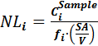 (1)

NMR
¹¹B and ²³Na solid state magic angle spinning nuclear magnetic resonance (MAS-NMR) and ⁶Li-¹H cross-polarisation (CP) NMR spectroscopy took place at room temperature on a Varian Infinity Plus spectrometer with 11.7 T magnet. Single pulse ¹¹B and ²³Na experiments provide details on the structure of the B network and Na respectively in the pristine glasses and after leaching. ⁶Li-¹H CP experiments selectively probed Li in the altered layers or secondary phases through transferring proton nuclear magnetic polarisation to neighbouring ⁶Li atoms at the ⁶Li Larmor frequency via a through space coupling for NMR detection [37].
Single pulse ¹¹B and ²³Na Bloch decay experiments took place on pristine ISG (supplied by Savannah River National Laboratory, USA), all washed and sized pristine Li-ISG batches and one leached sample randomly selected from each triplicate for each Li-ISG composition leached at each temperature for each leaching duration. Additionally, ²³Na experiments also took place on pristine Mg-EM [35], all pristine Li-Mg-EM batches and one sample from each leached Li-Mg-EM triplicate at each temperature for each leaching duration; with ¹¹B experiments having taken place on these samples in a previous study [34]. Experiments used a spectrometer frequency of 160.32 MHz and 132.18 MHz for ¹¹B and ²³Na respectively with a small pulse angle. For all samples except the ISG ¹¹B experiment, between 50 and 150 mg of sample was loaded into a 4.0 mm zirconia rotor then spun at 10.0 ± 0.1 kHz in a 4.0 mm MAS probe. ¹¹B spectra consisted of 240 Bloch decays following a π/14 pulse (0.4 µs) with a recycle delay of 6 s and were referenced to the liquid scale (15% BF₃.OEt₂ in CDCl₃) using powdered NaBH₄ at -42.05 ppm. For ISG, a 2.5 mm MAS probe with zirconia rotor was used at a spin speed of 20.0 ± 0.1 kHz and 256 Bloch decays were acquired following a π/14 pulse (0.5 µs), with all other settings remaining the same as in the Li-ISG ¹¹B experiments. ²³Na spectra consisted of between 1000 and 2000 Bloch decays following a π/15 pulse (1.2 µs) with a recycle delay of 6 s and were referenced to 0.1 M NaCl in deionised water at 0.0 ppm. Tests demonstrated these were non-saturating conditions for both the ¹¹B and ²³Na experiments.
⁶Li-¹H CP experiments initially took place on Li50Na50-Mg-EM and Li29Na71-ISG leached at 40 and 90 °C for 16 weeks. As a signal was found in the Li-Mg-EM samples but not in the Li-ISG, further CP experiments subsequently took place on pristine Li50Na50-Mg-EM to ensure ambient proton adsorption onto the glass structure was not resulting in a measurable signal. Between 100 and 160 mg of sample was loaded into a 7.5 mm silicon nitride rotor containing a PTFE liner which was in turn placed in a 7.5 mm double resonance MAS probe. Static spectra were acquired for each sample. Experiments took place at a spectrometer frequency of 73.54 MHz for ⁶Li and 499.72 MHz for ¹H. A π/2 pulse (8.0 µs) was found for ¹H using RTV silicone and a recycle delay of 3 s was used. Powdered LiOH was used to optimise contact time and matching conditions. Spectra consisted of between 75000 and 250000 repetitions and were referenced to ⁶Li in 1.0 M ⁶LiCl (95.77% ⁶Li atoms) in deionised water at 0.0 ppm.

SEM
Scanning electron microscopy (SEM) was used to investigate how the glass surface evolved throughout dissolution in both the Li-ISG and Li-Mg-EM compositions. All samples except the 90 °C leached Li-Mg-EM samples were analysed uncoated on a FEI QEMSCAN 650F Scanning Electron Magnetic Microscope at a high vacuum, accelerating voltage of 3.00 kV, spot size of 1.0 and working distance of 4.5 mm. Secondary electron (SE) images for each sample were acquired using an Everhart-Thornley detector at horizontal field widths (HFW) of between 414 and 1.66 µm. The 90 °C leached Li-Mg-EM samples were instead analysed uncoated at a low vacuum, accelerating voltage of 20.00 kV, spot size 4.0 and working distance of 13.0 mm with a low vacuum secondary electron detector (LFD) so that EDX analysis could also take place.

Results

Fabricated compositions
All fabricated compositions were measured to within 10 % of their respective targets for all elements (Table II), with the exceptions of Li for Li29Na71-ISG Batch 2 and Li47Na53-ISG Batch 2 which were within 12.5 % of their respective targets. All batches were shown to be amorphous using XRD (Supp. Fig. 2).
Table II: The measured oxide wt.% compositions of the two batches of each Li-ISG composition given next to their respective nominal compositions and the technique used to measure that oxide. Errors are given to a conservative 5 % for the ICP-OES measurements, as all reported RSD values were less than 5 %. Errors are given to one standard deviation for the EPMA measurements as calculated from the 40 spots analysed.
 |  | Nominal oxide wt.% |  | Measured oxide wt.%
Technique | Oxide | Li29Na71-ISG | Li47Na53-ISG | Li29Na71  Batch 1 | Li29Na71  Batch 2 | Li47Na53  Batch 1 | Li47Na53  Batch 2
ICP-OES | Al2O3 | 6.21 | 6.28 | 6.41 ± 0.13 | 6.37 ± 0.13 | 6.33 ± 0.13 | 6.33 ± 0.13
ICP-OES | B2O3 | 17.60 | 17.82 | 16.84 ± 0.34 | 16.58 ± 0.33 | 17.74 ± 0.35 | 17.81 ± 0.36
ICP-OES | CaO | 5.09 | 5.15 | 5.01 ± 0.10 | 4.84 ± 0.10 | 5.01 ± 0.10 | 4.83 ± 0.10
ICP-OES | Li2O | 1.71 | 2.87 | 1.61 ± 0.03 | 1.50 ± 0.03 | 2.67 ± 0.05 | 2.52 ± 0.05
ICP-OES | Na2O | 8.87 | 6.61 | 8.63 ± 0.17 | 8.29 ± 0.17 | 6.65 ± 0.13 | 6.25 ± 0.13
EPMA | SiO2 | 57.17 | 57.87 | 58.48 ± 0.45 | 58.9 ± 0.45 | 58.44 ± 0.59 | 58.46 ± 0.36
ICP-OES | ZrO2 | 3.36 | 3.40 | 3.17 ± 0.06 | 3.15 ± 0.06 | 3.26 ± 0.07 | 3.07 ± 0.06

Densities and geometries
The densities of ISG and the Li29Na71-ISG batches were within error of one another, with the Li47Na53-ISG batches having a density approximately 0.020 g/cm³ lower (Table III). Whilst this is consistent with the view that the density of the glass decreases as Li₂O of a lower molar volume (14.866 cm³/mol) is substituted for Na₂O (27.304 cm³/mol) on a molar basis in the oxide precursors [38], ISG and Li29Na71-ISG have a bigger difference in their Li contents than Li29Na71-ISG and Li47Na53-ISG but observe no associated change in density. That is, if the decrease in density is simply the result of an oxide of lower molar volume being substituted into the composition, a difference in density should also be visible between ISG and Li29Na71-ISG. The densities of Li50Na50-Mg-EM and Li60Na40-Mg-EM were 2.513 ± 0.059 gcm⁻³ and 2.517 ± 0.030 gcm⁻³ respectively [34].
Table III: Measured densities of the Li-ISG batches. For comparison, the density of ISG taken from another study is given [7]; as this study gave no error for this density measurement and reported the density to two decimal places, it has been assigned an error of 0.010. Errors on the Li-ISG batches are given to one standard deviation. Two of the three Li29Na71-ISG Batch 1 density measurements appeared unrealistic and were omitted, but the error is still given as one standard deviation calculated from these values.
 | Li29Na71-ISG  Batch 1 | Li29Na71-ISG  Batch 2 | Li47Na53-ISG  Batch 1 | Li47Na53-ISG  Batch 2 | ISG
Measured Density (g/cm³) | 2.501 ± 0.059 | 2.506 ± 0.003 | 2.483 ± 0.003 | 2.480 ± 0.005 | 2.500 ± 0.010
Particle size distributions appeared highly consistent across all Li-ISG batches, with all median particle sizes being within 2.0 µm of one another and an average median particle size of 144.72 µm (Supp. Table I). Whilst higher than the ideal median spherical particle diameter of 112.5 µm, this is attributed to the presence of needle-shaped particles and demonstrates the efficacy of the washing methodology.

Leachate compositions
The concentrations of all glass species within the leachates except Al at 40 °C and Ca were above detection limits and greater than the average blank concentration plus three standard deviations. Average blank concentrations were below detection limits for Li, B, Si and Zr, less than 0.07 µg/mL for Na and Al, and less than 1.25 µg/mL for Ca. Triplicate sample RSD values of less than 10 % were observed for all but two triplicates for Li, B, Na and Si.
The normalised releases of mobile glass species (Li, B and Na) and Si for Li-ISG are plotted in Fig. 1 alongside the normalised releases for ISG and SON68 at 90 °C, which have been taken from another study for comparison [7]. Commonly B is used as a tracer for glass dissolution as it is not expected to be incorporated into any secondary phases [39]. Whilst both Li-ISG batches demonstrated poorer aqueous durability than ISG and SON68 (except at 7 and 14 d) at 90 °C (Fig. 1a), interestingly the B releases of Li29Na71-ISG were higher than those of Li47Na53-ISG at all times at 40 °C and all times except 14 d at 90 °C. However, this discrepancy may be attributed to the large error associated with the Li47Na53-ISG releases at this time. Further, the difference between the residual rates of B release of the Li-ISG compositions appeared marginally larger at 90 °C than at 40 °C. This demonstrates that whilst the substitution of Li for Na into ISG had a negative impact on aqueous durability, the further substitution of more Li for Na towards an equimolar ratio not only improves initial aqueous durability but also had a subtle positive effect on long-term aqueous durability as measured through the residual release rates of B.
The difference in normalised Li releases between the Li-ISG compositions at 40 °C (Fig. 1b) was considered negligibly small, as was consistent with the 90 °C Li releases of the Li-ISG compositions converging after 7 d; demonstrating that the Li releases were unaffected by the changing Li:Na ratio. Notably, both the initial Li releases and the residual Li release rates from the Li-ISG compositions were significantly higher than from SON68. The normalised Na releases (Fig. 1c) of Li29Na71-ISG were higher than those of Li47Na53-ISG at 90 °C with the exception of at 14 d. Similarly, the 40 °C Na releases of the Li-ISG compositions were initially equal but the Na releases from Li29Na71-ISG remained higher after 14 d. Again, the differences between the residual rates of Na release of the two Li-ISG compositions appeared subtle at both temperatures, with a lower residual rate of Na release for Li47Na53-ISG which resembled that of SON68 at 90 °C. Further, the Na releases from Li47Na53-ISG and Li29Na71-ISG were within error of those of SON68 at 90 °C throughout dissolution and until 112 d respectively. However, despite showing similar initial releases, the residual rates of Na release from both Li-ISG compositions at 90 °C were noted to be significantly lower than those of ISG.
The normalised Si releases (Fig. 1d) at 90 °C of the Li-ISG compositions remained equal to each other throughout dissolution at values similar to those of ISG, whilst at 40 °C the releases of Li29Na71-ISG remained negligibly higher until 112 d; demonstrating Si saturation is achieved in solution after 7 d at 90 °C and 28 d at 40 °C, whilst Li-Mg-EM displayed Si saturation conditions after 14 d at 90 °C and 7 d at 40 °C [34]. The pH of the leachates of both Li-ISG compositions at both temperatures were noted to be within error of one another throughout dissolution (Supp. Fig. 3). It was noted the releases of B from the Li-ISG compositions were frequently an order of magnitude lower than those of the Li-Mg-EM compositions [34], as illustrated by the estimated fraction of B leached (Table IV).
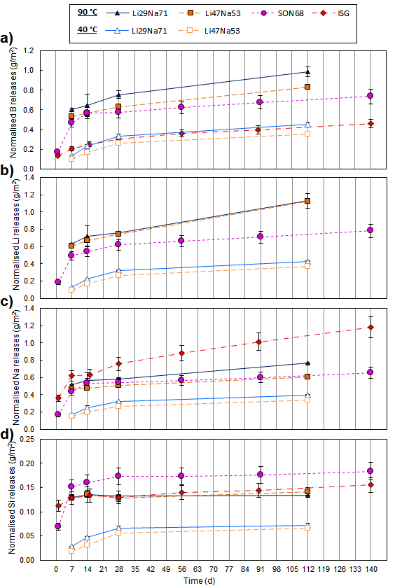
Figure 1: Normalised elemental releases of B (a), Li (b), Na (c) and Si (d) for the Li-ISG compositions. For comparison, the normalised releases for ISG and SON68 taken from another study are displayed [7]. Errors are given to one standard deviation for the Li-ISG batches, as calculated from the triplicate values. ISG and SON68 were assigned an error of 10 % due to errors on each measurement being unavailable [7].
Table IV: Estimated percentage of B leached from each Li-ISG and Li-Mg-EM composition for each leaching duration at each temperature. Values were calculated from the pristine glass compositions (Table II and [34]), the masses of glass used, the concentrations measured in solution and the volumes of leachant used [34]. Values are reported as the average percentage of B released for each triplicate, with errors given to one standard deviation.
 | Leaching time |  | 7 d | 14 d | 28 d | 112 d
% B released from the glass | 40 °C | Li50Na50  -Mg-EM | 1.54 ± 0.10 % | 2.13 ± 0.16% | 3.15 ± 0.40% | 7.67 ± 0.84%
% B released from the glass | 40 °C | Li60Na40  -Mg-EM | 1.98 ± 0.20% | 2.83 ± 0.25% | 3.85 ± 0.45% | 7.28 ± 1.16%
% B released from the glass | 40 °C | Li29Na71  -ISG | 0.25 ± 0.03% | 0.46 ± 0.05% | 0.65 ± 0.06% | 0.87 ± 0.09%
% B released from the glass | 40 °C | Li47Na53  -ISG | 0.19 ± 0.02% | 0.33 ± 0.04% | 0.54 ± 0.03% | 0.69 ± 0.08%
% B released from the glass | 90 °C | Li50Na50  -Mg-EM | 15.11 ± 1.81 % | 19.14 ± 1.49% | 24.80 ± 6.21% | 26.11 ± 4.44%
% B released from the glass | 90 °C | Li60Na40  -Mg-EM | 21.14 ± 1.89% | 24.78 ± 2.64% | 22.87 ± 2.75% | 26.25 ± 2.08%
% B released from the glass | 90 °C | Li29Na71  -ISG | 1.28 ± 0.08% | 1.38 ± 0.29% | 1.60 ± 0.15% | 2.10 ± 0.19%
% B released from the glass | 90 °C | Li47Na53  -ISG | 1.14 ± 0.11% | 1.21 ± 0.11% | 1.36 ± 0.11% | 1.79 ± 0.08%

The B network
In the ¹¹B MAS-NMR spectra of borate and borosilicate glasses, the different electric field gradients of ^{IV}B and ^{III}B species result in a narrow Gaussian ^{IV}B peak (0 ppm) being well resolved from a ^{III}B doublet consisting of non-ring (17 ppm) and ring (11 ppm) contributions [35]. The area under each peak is directly proportional to the number of atoms in that environment and therefore allows for quantification of the proportion of ^{III}B to ^{IV}B units. ¹¹B spectra were normalised to the intensity of their ^{IV}B peak such that changes in the proportion of ^{III}B to ^{IV}B would be visible through changes in the size or shape of the ^{III}B doublet. Quantification of the proportion of ^{III}B to ^{IV}B took place using DMFIT software [40] with two Gaussian peaks to account for the observed asymmetric distribution resonances from the ^{IV}B site (Supp. Fig. 4); the second peak was not assigned any additional structural importance and the area under both ^{IV}B peaks were merely added. Non-ring and ring ^{III}B species were fitted separately using peaks of quadrupole coupling constants which have been reported for their respective resonances [41,42]. Observed sidebands were fitted using a first-order spinning sideband manifold to take into account the first-order satellite transition sidebands which fall under the ^{IV}B peak [35].
No significant change in the proportion of ^{III}B to ^{IV}B units with a changing Li:Na ratio was observed in the Li-ISG pristine ¹¹B spectra (Fig. 2a) and quantification demonstrated all batches had ^{III}B and ^{IV}B molar fractions within error of one another; the lower proportion of ^{III}B to ^{IV}B associated with Li29Na71-ISG Batch-1 (Blue line, Fig. 2a) and minor discrepancies in the ^{III}B/^{IV}B ratios between batches are attributable to the B to alkali metal ratio varying slightly between glass batches (Table II). Quantification of the ISG spectrum demonstrated it contained a lower ^{III}B/^{IV}B ratio than the Li-ISG batches (Supp. Table II). However, if this effect was solely caused by the substitution of Li for Na, a similar effect would be expected to be visible between the two Li-ISG compositions as well. The Li-ISG compositions displayed a lower ^{III}B/^{IV}B ratio than the Li-Mg-EM compositions (Fig. 2b), likely due to the lower B to total alkali metal ratios of the Li-ISG compositions (Table I). However, this is also consistent with the observation that if Mg were substituted for Ca, the ^{III}B/^{IV}B ratio would increase due to the higher ionic field strength of Mg [35].
The ¹¹B spectra of the leached Li-ISG samples displayed no change in the ^{III}B/^{IV}B ratio with dissolution time for both compositions at 40 °C (Fig. 3) or at 90 °C (Supp. Fig. 5). Quantification of the 90 °C leached spectra agreed with this observation, displaying a negligible decrease in the fraction of ^{III}B units after leaching (Supp. Table II). However, quantification of the 40 °C leached spectra displayed a 1.4 percentage point increase in the fraction of ^{III}B units at 7 d for both Li-ISG compositions (Supp. Table II). As this temporary increase is not visible (Fig. 3), this difference is also considered negligible and within the error of the fits. This is consistent with the 40 °C leached Li-Mg-EM ¹¹B spectra, which demonstrated no change in the ^{III}B/^{IV}B ratio after leaching, but is not consistent with the 90 °C Li-Mg-EM ¹¹B spectra, which displayed a significant decrease in the ^{III}B/^{IV}B ratio after 112 d.
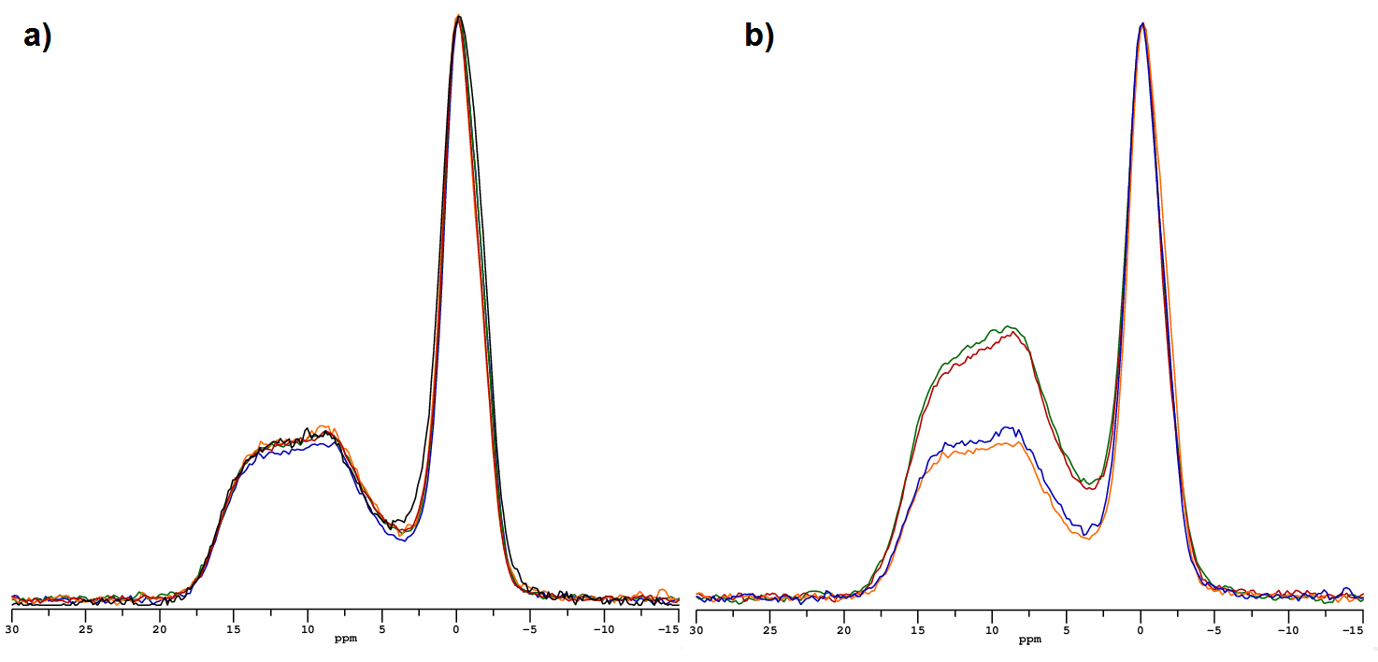
Figure 2:¹¹B MAS-NMR spectra of the four pristine Li-ISG batches (Li29Na71 Batch 1: Blue, Li29Na71 Batch 2: Green, Li47Na53 Batch 1: Orange, Li47Na53 Batch 2: Red) and ISG (Black) (a), and the two Li-ISG compositions (Li29Na71: Orange, Li47Na53: Blue) compared with the two Li-Mg-EM compositions (Li50Na50: Green, Li60Na40: Red) [34]. The Li60Na40-Mg-EM spectrum was shifted +0.1 ppm to correct for referencing error. Spectra were normalised to their ^{IV}B peaks.
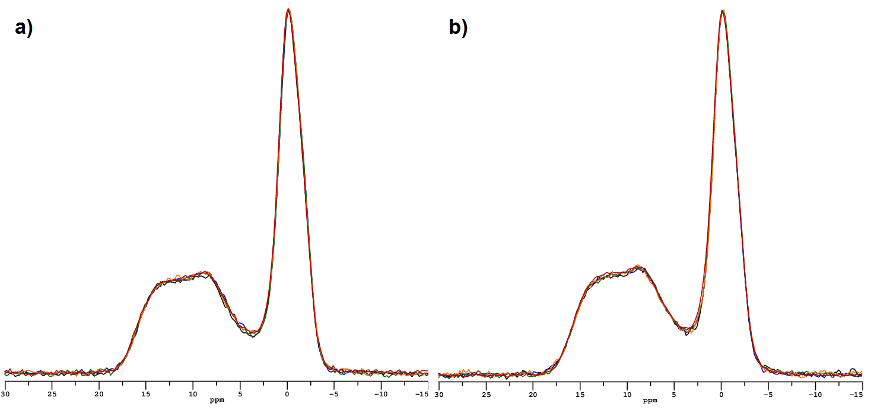
Figure 3: ¹¹B MAS-NMR spectra of pristine Li29Na71 Batch 1 (Black) and leached at 40 °C (7 d: Blue, 14 d: Green, 28 d: Orange and 112 d: Red) (a) and pristine Li47Na53 Batch 1 (Black) and leached at 40 °C (7 d: Blue, 14 d: Green, 28 d: Orange and 112 d: Red) (b). Spectra were normalised to their ^{IV}B peaks.

Na and Li
²³Na MAS-NMR of the all pristine Li-ISG (Fig. 4a) and Li-Mg-EM batches (Fig. 4b) displayed no change with the Li:Na ratio. Similarly, all of the pristine Li-ISG and Li-Mg-EM compositions displayed near-identical ²³Na spectra (Supp. Fig. 6). A small shift (approximately +1.5 ppm) was observed for ISG and Mg-EM relative to Li-ISG and Li-Mg-EM respectively (Fig. 4). However, this shift is considered negligible in terms of structural change; a conclusion which is supported by the Li-ISG and Li-Mg-EM spectra being near-identical.
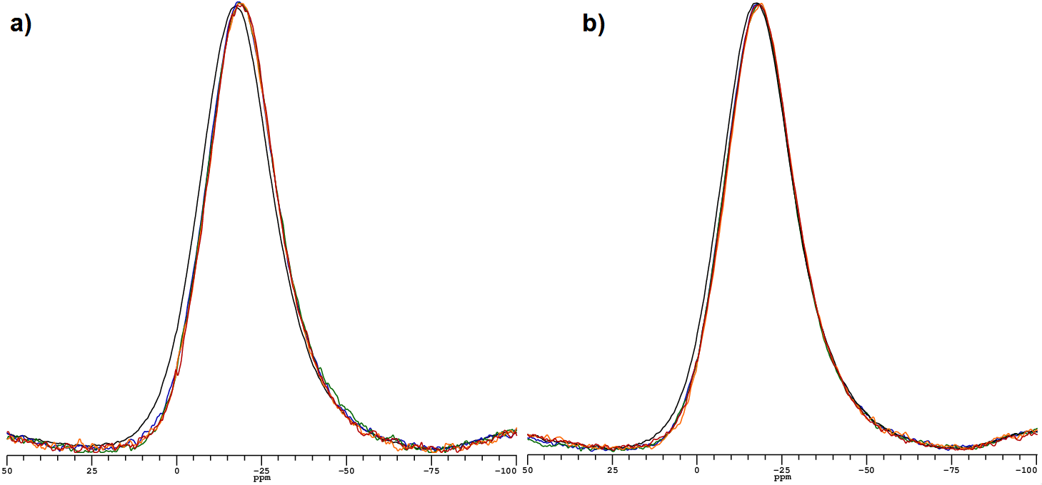
Figure 4: ²³Na MAS-NMR spectra of the pristine glasses: ISG (Black) and the four Li-ISG batches (Li29Na71 Batch 1: Blue, Li29Na71 Batch 2: Green, Li47Na53 Batch 1: Orange, Li47Na53 Batch 2: Red) (a), and Mg-EM (Black) and the four Li-Mg-EM batches (Li50Na50 Batch 1: Blue , Li50Na50 Batch 2:Green, Li60Na40 Batch 1: Orange, Li60Na40 Batch 2: Red) (b). The Li47Na53-ISG spectrum was shifted by -0.2 ppm to correct for a referencing error. Spectra were normalised to the same intensity.
For both Li-ISG compositions, there was no change in the ²³Na MAS-NMR spectra after leaching at both 40 °C (Supp. Fig. 7c and d) and 90 °C (Fig. 5c and d). Similarly, no signal was observable in the ⁶Li-¹H CP-NMR spectra of Li29Na71-ISG leached for 112 d at 40 and 90 °C. This demonstrates that Na and Li were not incorporated into secondary phases in masses large enough to be detectable. XRD revealed no detectable crystalline phases after dissolution at either temperature for both Li-ISG compositions (Supp. Fig. 2).

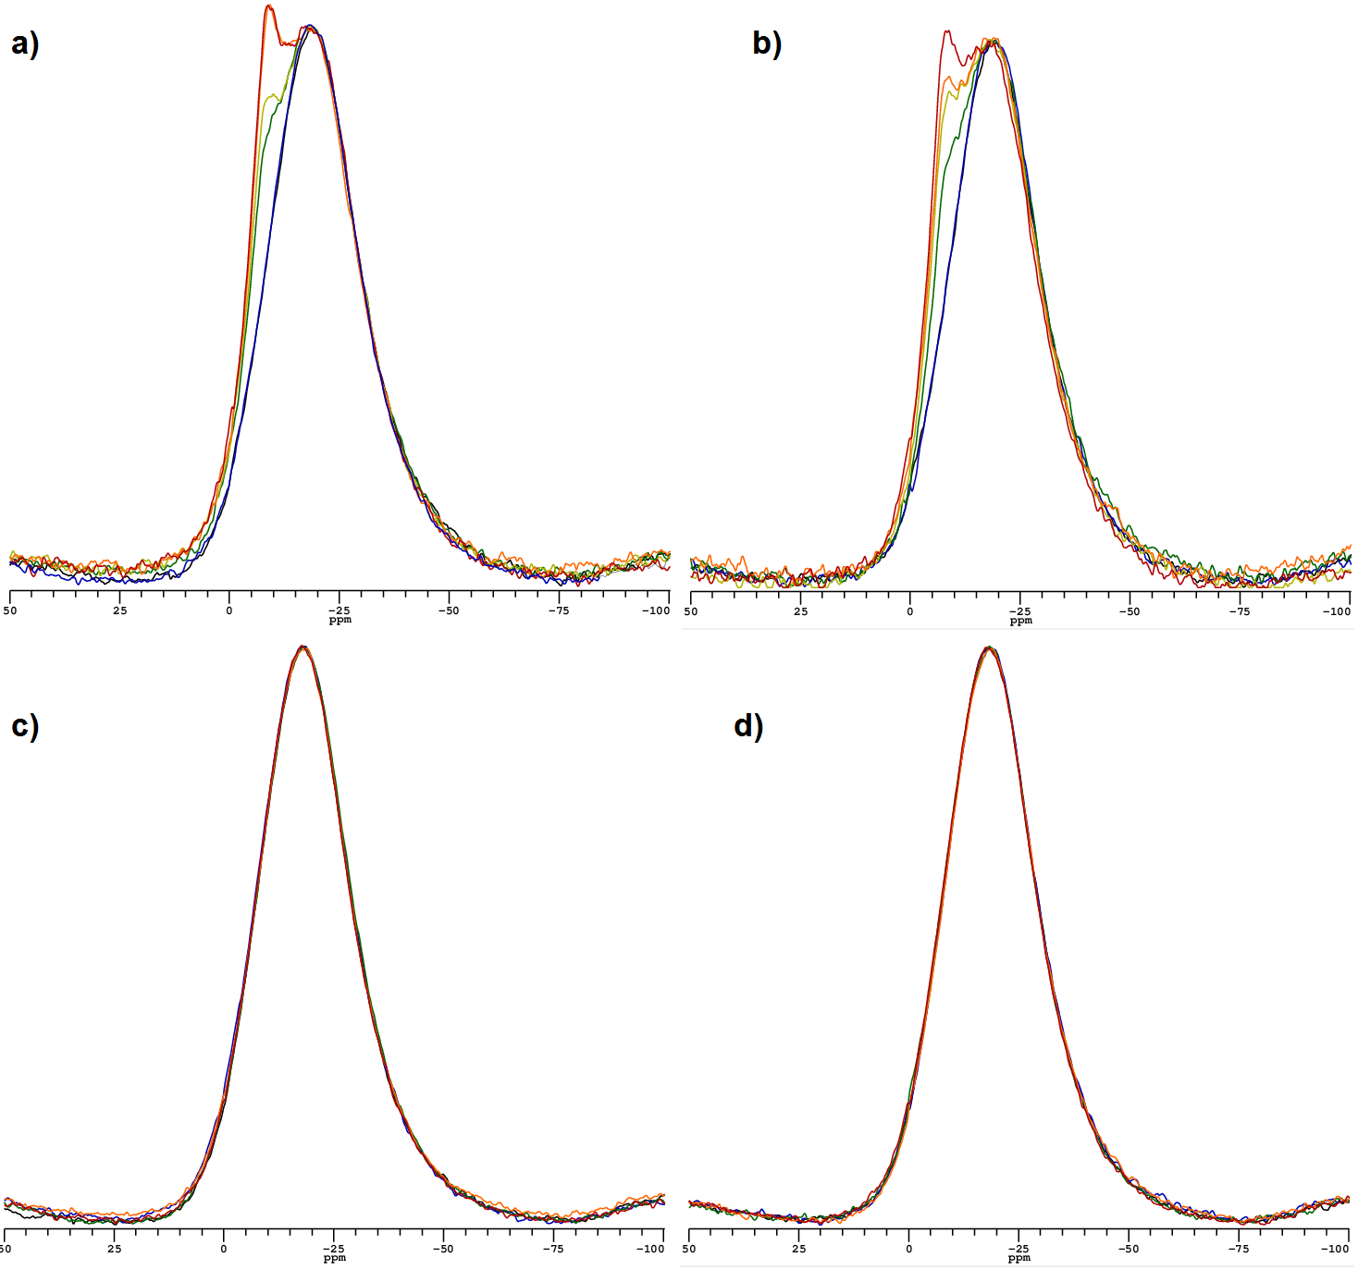
Figure 5: ²³Na MAS-NMR spectra of pristine and leached at 90 °C Li50Na50-Mg-EM (a), Li60Na40-Mg-EM (b), Li29Na71-ISG (c) and Li47Na53-ISG (d). Coloured lines represent for the Li-Mg-EM glasses: pristine batch 1 (black), pristine batch 2 (blue), 7 d leached (green), 14 d leached (yellow), 28 d leached (orange) and 112 d leached (red). For the Li-ISG glasses: pristine (black), 7 d leached (blue), 14 d leached (green) 28 d leached (orange) and 112 d leached (red). Spectra were normalised to the intensity of the main (approximately -20 ppm) peak.
Interestingly, a peak was visible at approximately -7.3 ppm in the ²³Na MAS-NMR spectra of both Li-Mg-EM compositions leached at 90 °C, with an intensity that increased with dissolution time (Fig. 5a and b), but not at 40 °C (Supp. Fig. 7a and 7b); suggesting this peak represented an alteration product. The nutation behaviour of this peak suggested it had a very small or zero electric field gradient and as such corresponded to a cubic Na site. Quantification of the ²³Na spectra took place using Igor Pro software (Wavemetrics). Firstly, the pristine Li50Na50-Mg-EM spectrum was fit using two peaks (one exponentially modified Gaussian distribution and one Lorentz distribution); these lines were not assigned separate meanings but rather were used to obtain a good fit of the quadrupolar Na line shape. Leached spectra were then fit using an additional Lorentz peak (Example in Supp. Fig. 8). To quantify the spectra, the area under the peak at approximately -7.3 ppm was multiplied by 0.4 [43] and the amount of Na in each site was calculated from the quantified pristine glass spectrum and measured composition. Assuming the B releases provide a measure of the fraction of glass altered, an estimated Na release was calculated from the fraction of glass altered and the mass of Na in precipitates at each leaching interval at 90 °C (Table V) and at 40 °C (Supp. Table III) was estimated. Whilst such an assumption ignores differences in the mechanisms by which B and Na are expected to leach from glasses [8], the estimated masses of Na in precipitates for the Li-Mg-EM compositions at 90 °C were either within error or greater than those from the ²³Na spectra quantifications; thereby agreeing with the view that significant masses of Na were being incorporated into alteration products [7]. For the Li-ISG compositions leached at 90 °C (Table V) and all compositions leached at 40 °C (Supp. Table III), the estimated masses of precipitated Na were either negligibly small or within error of zero. That is, the extent of dissolution for all compositions leached at 40 °C and the Li-ISG compositions leached at 90 °C appeared to be insufficient for a second Na peak to be visible.
Table V:Table comparing the percentage B released from the glass (taken from Table IV), the estimated concentrations of Na in solution, the measured concentrations of Na in solution, the difference between the estimated and measured concentrations presented in mg/L and mg and the quantification of the 90 °C leached and pristine ²³Na MAS-NMR spectra (Fig. 5). Errors are given to one standard deviation propagated from the triplicate concentration measurements, pristine glass compositions, glass masses and leachant volumes used.
Leaching time at 90 °C |  | 7 d | 14 d | 28 d | 112 d
Li50Na50  -Mg-EM | % glass altered (From B releases) | 15.11 ± 1.81 % | 19.14 ± 1.49% | 24.80 ± 6.21% | 26.11 ± 4.44%
Li50Na50  -Mg-EM | Estimated [Na] in solution (mg/L) | 545.5 ± 85.4 | 691.6 ± 80.3 | 854.1 ± 240.3 | 901.1 ± 184.5
Li50Na50  -Mg-EM | [Na in solution] (mg/L) | 391.0 ± 21.2 | 467.7 ± 12.9 | 554.7 ± 96.3 | 598.4 ± 63.1
Li50Na50  -Mg-EM | Difference (mg/L) | -154.5 ± 106.6 | -223.9 ± 93.2 | -299.4 ± 336.6 | -302.8 ± 247.6
Li50Na50  -Mg-EM | Estimated precipitated (mg) | 0.62 ± 0.42 | 0.90 ± 0.37 | 1.19 ± 1.34 | 1.21 ± 0.99
Li50Na50  -Mg-EM | % cubic Na from NMR | 3.9 ± 0.3% | 5.3 ± 0.3% | 7.8 ± 0.4% | 8.7 ± 0.3%
Li50Na50  -Mg-EM | Measured [Cubic Na] (mg) | 0.46 ± 0.10 | 0.51 ± 0.09 | 0.71 ± 0.13 | 0.85 ± 0.16
Li60Na40  -Mg-EM | % glass altered (From B releases) | 21.14 ± 1.89% | 24.78 ± 2.64% | 22.87 ± 2.75% | 26.25 ± 2.08%
Li60Na40  -Mg-EM | Estimated [Na] in solution (mg/L) | 616.4 ± 78.6 | 722.4 ± 103.9 | 670.9 ± 105.2 | 771.1 ± 90.7
Li60Na40  -Mg-EM | [Na in solution] (mg/L) | 367.1 ± 9.5 | 420.8 ± 25 | 389.6 ± 15.2 | 464.3 ± 2.9
Li60Na40  -Mg-EM | Difference (mg/L) | -249.3 ± 88.1 | -301.7 ± 128.9 | -281.3 ± 120.4 | -306.8 ± 93.6
Li60Na40  -Mg-EM | Estimated precipitated (mg) | 0.99 ± 0.35 | 1.21 ± 0.52 | 1.13 ± 0.48 | 1.23 ± 0.37
Li60Na40  -Mg-EM | % cubic Na from NMR | 3.1 ± 0.3% | 5.9 ± 0.3% | 6.0 ± 0.4% | 8.1 ± 0.3%
Li60Na40  -Mg-EM | [Cubic Na] (mg) | 0.35 ± 0.08 | 0.59 ± 0.11 | 0.53 ± 0.10 | 0.6 ± 0.10
Li29Na71  -Li-ISG | % glass altered (From B releases) | 1.28 ± 0.08% | 1.38 ± 0.29% | 1.60 ± 0.15% | 2.10 ± 0.19%
Li29Na71  -Li-ISG | Estimated [Na] in solution (mg/L) | 78.5 ± 8.0 | 84.3 ± 20.3 | 98.8 ± 12.9 | 128.4 ± 16.6
Li29Na71  -Li-ISG | [Na in solution] (mg/L) | 67.2 ± 0.1 | 73.6 ± 11.6 | 76 ± 1.0 | 99.6 ± 0.6
Li29Na71  -Li-ISG | Estimated precipitated (mg) | 0.05 ± 0.03 | 0.04 ± 0.13 | 0.09 ± 0.05 | 0.12 ± 0.07
Li47Na53  -Li-ISG | % glass altered (From B releases) | 1.14 ± 0.11% | 1.21 ± 0.11% | 1.36 ± 0.11% | 1.79 ± 0.08%
Li47Na53  -Li-ISG | Estimated [Na] in solution (mg/L) | 52.9 ± 7.2 | 56.2 ± 7.1 | 63.2 ± 7.6 | 82.9 ± 7.0
Li47Na53  -Li-ISG | [Na in solution] (mg/L) | 46.8 ± 0.6 | 47.6 ± 0.5 | 50.6 ± 0.5 | 60.7 ± 2.6
Li47Na53  -Li-ISG | Estimated precipitated (mg) | 0.02 ± 0.03 | 0.03 ± 0.03 | 0.05 ± 0.03 | 0.09 ± 0.04
A signal was clearly visible in the ⁶Li-¹H CP-NMR spectrum of Li50Na50-Mg-EM leached at 90 °C for 112 d, which was confirmed to not have originated from ambient proton adsorption onto the glass (Fig. 6); demonstrating Li was also incorporated into secondary phases. Interestingly, a small signal was also visible in the ⁶Li-¹H CP-NMR spectrum of Li50Na50-Mg-EM leached at 40 °C for 112 d (Fig. 6).
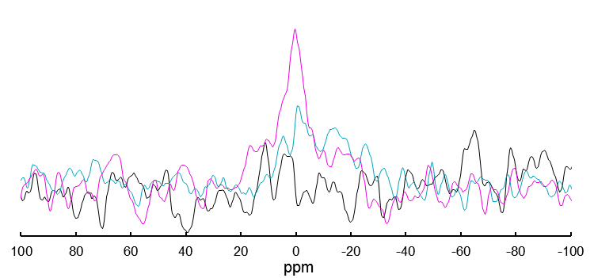
Figure 6:⁶Li-¹H CP-NMR static spectra for pristine washed and sized Li50Na50-Mg-EM (Black) and Li50Na50-Mg-EM leached for 112 d at 40 °C (Cyan) and at 90 °C (Magenta).

The leached glass
SEM images of both Li-ISG compositions leached for 112 d at 40 °C and 90 °C displayed no visible alteration products (Fig. 7a to d) in contrast to the macroporous layer wholly covering the surface of the Li-Mg-EM compositions at both 40 and 90 °C (Fig. 7e to h). EDX showed this layer was partially depleted in Na but was rich in Mg (Supp. Fig. 9).
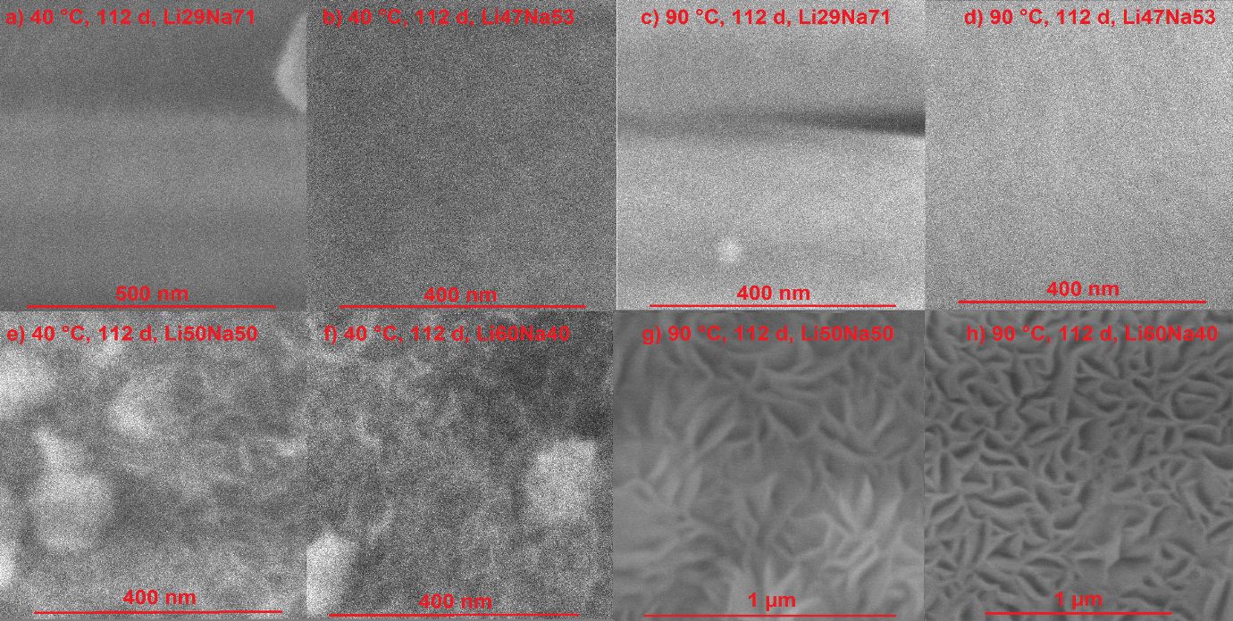
Figure 7: Secondary electron SEM images of the Li-ISG (a to d) and Li-Mg-EM (e to h) compositions leached for 112 d at 40 °C (a, b, e and f) and 90 °C (c, d, g and h).

Discussion

The pristine glasses
The similar ^{III}B/^{IV}B ratios of pristine Li29Na71 and Li47Na53-ISG demonstrated that changing the Li:Na ratio had no measurable impact on the number of species charge compensating the B network and consequently the number of ^{IV}B species (Fig. 2a and Supp. Table II). The difference in ^{III}B/^{IV}B ratios between pristine ISG and the Li-ISG batches may be attributed to differences in thermal history and minor variations in the sample B to total alkali metal ratios [44,45]. These results were therefore consistent with those observed for the pristine Li-Mg-EM compositions, which reported no change in the ^{III}B/^{IV}B ratio with a changing Li:Na ratio [34]. This may be attributed to Na preferentially charge compensating ^{IV}B units whilst Li preferentially modifies the Si-network, based upon observations reported for single and binary alkali borosilicates in the literature [5,41,42,46], such that Li-Si rich domains of depolymerised glass form in a Na-rich borosilicate matrix [34]. When Li is substituted for Na in such a system, the majority of the ^{IV}B units remain charge compensated by Na. This is consistent with the near-identical ²³Na MAS-NMR spectra for all pristine Li-Mg-EM and Li-ISG compositions suggesting no change in the role of Na with a changing Li:Na ratio (Fig. 4). Whilst there is a higher concentration of Na than ^{IV}B in Mg-EM, ISG and Li29Na71-ISG, this is not the case for Li47Na53-ISG and the Li-Mg-EM compositions. Consequently, in the latter compositions, another cation must also be charge compensating the B network in lieu of Na. The similarity of the ¹¹B spectra and the ²³Na spectra of the Li-ISG glasses (Fig. 2a and Fig. 4a) suggests that Li charge compensates the B network in place of Na once the concentration of Na is less than that of the ^{IV}B units. Further, the near-identical ²³Na MAS-NMR spectra of all Li-ISG and Li-Mg-EM compositions (Supp. Fig. 6) supports the view that Na consistently preferentially charge compensates the B-network in all compositions investigated.

Differences in dissolution of the B network and the effects of Li
The substitution of Li for Na in Li-ISG had effects on dissolution behaviour which significantly differed from those observed for the Li-Mg-EM compositions. It should be noted that for the ‘excess Li’ samples in Li-Mg-EM there was a deviation away from an equimolar Li:Na ratio (1.0 to 1.5) but for Li-ISG there was a deviation towards an equimolar ratio (0.4 to 0.9). The preferential leaching of ^{III}B units from the Li-Mg-EM compositions at 90 °C was attributed to Li preferentially modifying the Si network and leaching more readily than charge compensating Na, enhancing glass hydration to effect faster dissolution of ^{III}B units whilst largely not affecting the Na-compensated ^{IV}B units [34]. It was hypothesised preferential dissolution of ^{III}B units also took place at 40 °C but the magnitude of glass alteration was insufficient for this effect to be measurable [34]. Similarly, dissolution of the B network of both Li-ISG compositions was apparently congruent at 40 and 90 °C (Fig. 3 and Supp. Fig. 7) but the magnitude of dissolution appeared insufficient to ascertain whether there was preferential dissolution of ^{III}B units.
The substitution of Li for Na in ISG results in a more depolymerised Si network which presented less of a barrier to the inward diffusion of water species. Additionally, the weaker bond of Li to the glass network in its modifying role than Na in its charge compensating role may result in Li leaching out of the glass before Na to leave a hydrated glass structure faster than in a Li-free composition [5]. As the energy required to hydrolyse the bonds of the B network is low [8], Li promotes the release of B such that the normalised B releases of both Li-ISG compositions [34] were approximately twice those of ISG [7] (Fig. 1a). The larger number of Na than ^{IV}B units for Li29Na71-ISG demonstrated that the faster glass hydration effected by Li modifying the Si network still has a marked impact on the largely Na-compensated B network. The normalised Si releases appeared to reach saturation at similar values for the Li-ISG and Li-Mg-EM compositions and were consistent in displaying no significant change with the Li:Na ratio; as was suggested by the normalised Si releases of the Li-ISG compositions being similar to those of ISG.
Whilst Li50Na50-Mg-EM observed no change in the normalised releases of Na compared with Mg-EM [34,35], the residual Na release rate of ISG was significantly higher than both Li-ISG compositions (Fig. 1c). For Li50Na50-Mg-EM, this similarity with Mg-EM was reconciled as Na-compensating ^{IV}B units remaining largely unaffected by Li modifying the Si network [34], but for Li-ISG it appears that Li is simultaneously promoting dissolution of the B network through increasing the rate of hydration of the glass whilst suppressing the long-term release of Na. As the role of Na does not change with the substitution of Li (Fig. 4a), the fraction of Li charge compensating ^{IV}B units in Li29Na71-ISG is expected to be small. Despite this, the drop in the residual Na release rate of Li29Na71-ISG compared with ISG suggests there is a mixed alkali effect wherein the substitution of Li for Na in ISG results in a reduction in the mobility of Na and subsequently the long-term rate of Na diffusion out of the glass [47]. The higher normalised B releases but similar normalised Na releases of Li50Na50-Mg-EM compared with Mg-EM suggested that for the Li-Mg-EM compositions the enhanced glass hydration effected by Li was an important mechanism but the mixed alkali effect was not [34].
Increasing the Li:Na ratio from 0.4 to 0.9 in Li-ISG had a significantly different effect on the B and Na releases to increasing the Li:Na ratio from 1.0 to 1.5 in Li-Mg-EM. For Li-Mg-EM, initially increased normalised B and Na releases were observed for Li60Na40 relative to Li50Na50-Mg-EM which converged as dissolution progressed [34]. For Li-ISG, the normalised B and Na releases for Li47Na53 were lower than for Li29Na71-ISG and the residual rates of B and Na release for Li47Na53-ISG appeared subtly lower (Fig. 1). Li47Na53-ISG displayed similar behaviour in the normalised Li releases to the Li-Mg-EM compositions, with initial releases which were negligibly higher than and converged to those of Li29Na71-ISG (Fig. 1b) [34].
The initial increases in the B, Li and Na releases of Li60Na40-Mg-EM compared with Li50Na50-Mg-EM were attributed to Li intensifying the previously discussed hydration effects, which were concluded to become irrelevant once a passivating altered layer component had formed [34]. Contrastingly, a subtle decrease in the B and Na normalised releases and lack of significant change in the Li and Si normalised releases for Li47Na53-ISG compared with Li29Na71-ISG shows that increasing the Li:Na ratio intensifies the Li-Na mixed alkali effect to outweigh the previously discussed hydration effects and reduce the normalised releases of B and Na throughout dissolution. For Li, the mixed alkali effect appears to be equally offset by the hydration effects and as such no change in the normalised Li releases was observed. The persistence of these effects throughout the residual rate regime for the Li-ISG compositions suggests the alteration layers for the Li-ISG compositions after 112 d at 90 °C were insufficiently passivating to present a significant barrier to dissolution and to completely outweigh the hydration and mixed alkali effects.

Precipitates and aqueous durability
In addition to profound differences in pristine glass structure and normalised elemental releases, MAS-NMR spectra of the leached Li-Mg-EM and Li-ISG glasses highlighted further significant differences in dissolution behaviour between the two composition types; suggesting a clear relationship between the two analogue types cannot be defined simply through comparing leachate compositions and pristine glass structures. Consistent with Na precipitating as a crystalline sodium silicate hydrate phase on a Na borosilicate after 13.6 years of dissolution at 90 °C in deionised water [7], a well-defined second peak in the ²³Na MAS-NMR spectra of all 90 °C leached Li-Mg-EM samples (Fig. 5a and b) demonstrated a significant amount of a Na-bearing phase was precipitating from solution; with the chemical shift of this peak (centred at approximately -7.3 ppm) being similar to those reported for sodium silicate hydrates [48]. The high degree of symmetry associated with the observed peak in comparison to the quadrupolar line shape reported in the literature may be attributed to the observed precipitate being amorphous. However, no such phase was detected for the Li-ISG glasses at 90 °C (Fig. 5c and d) or any investigated composition at 40 °C (Supp. Fig. 7). It was expected that a Na-bearing phase also precipitates on the Li-Mg-EM glasses at lower temperatures and on the Li-ISG glasses but the rate of precipitation is so slight that these phases are only observable once a significant fraction of the glass has been altered; as supported by the negligible estimated masses of Na in precipitated phases for these compositions at these temperatures (Table V and Supp. Table III) and the measurable masses of sodium silicate hydrate precipitating at 90 °C in the Li-Mg-EM compositions (Table V) before Si-saturation in solution is achieved [34]. The effect of sodium silicate hydrate precipitation on aqueous durability is questionable as Li50Na50-Mg-EM reported higher masses of precipitated Na but initially lower normalised Li, B and Na releases than Li60Na40-Mg-EM [34].
The leached Li-Mg-EM glasses displayed evidence of a magnesium silicate layer forming after just 7 d (Supp. Fig. 9 and 10) which appeared to mature in terms of thickness and pore size with time (Fig. 7e and f) and higher temperatures (Fig. 7g and h) accelerating this process. This macroporous Mg-rich layer is therefore absent from the leached Li-ISG samples. From results reported in the literature, this magnesium silicate layer is expected to be the amorphous precursor to a smectite clay mineral such as a hectorite or saponite [27,49]. Consistent with literature observations of poorer aqueous durability when Mg is present in the glass or leachant composition [27,50], this layer consumes significant amounts of Si from solution to fuel further hydrolysis of the glass throughout dissolution [15,49,51]; effecting poorer aqueous durability for the Li-Mg-EM compositions compared with the Li-ISG compostions. Similarly, a Li-bearing phase formed at 40 and 90 °C after 112 d in Li50Na50-Mg-EM (Fig. 6), as is consistent with Li being incorporated into alteration products during the dissolution of Mg-rich basaltic glasses [51]. This Li-bearing phase was not detected in Li29Na71-ISG leached for 112 d at either temperature. This suggests that the precipitation of a magnesium silicate layer for the Li-Mg-EM glasses results in either small quantities of Li substituting for Mg in the macroporous layer due to their similar ionic radii or the precursor clay itself containing a significant fraction of Li such as in a Hectorite [27]. As there appeared to be small masses of Li precipitated, the precipitation of Li was not expected to significantly impact the kinetics of dissolution.

Conclusions
It was shown here that changing the Li:Na ratio in Li-ISG had no effect on ratio of ^{III}B to ^{IV}B units and as such the number of species charge compensating the B network; implying Li charge compensated the B network when the number of charge-compensating Na dropped below the number of ^{IV}B units as the Li:Na ratio was increased. Similarly, no change in the role of Na was observed with a changing Li:Na ratio in both the Li-Mg-EM and Li-ISG compositions, suggesting Na continues to preferentially compensate the B network as the Li:Na ratio is increased; fulfilling the same role in all Li-Mg-EM and Li-ISG compositions.
Whilst ^{III}B units had been shown to leach more readily than ^{IV}B units in both Li-Mg-EM compositions at long duration at 90 °C [34], the B network was shown to leach congruently for Li-ISG at both 40 and 90 °C. As is consistent with Mg-EM and Li-Mg-EM [34], the substitution of Li into ISG was shown to reduce aqueous durability as measured through the normalised B releases but the residual release rate of Na from ISG was significantly higher than from both Li-ISG compositions. Further, the substitution of Li for Na to an excessively high Li:Na in Li-ISG was shown to result in an increase in aqueous durability as measured through the B and Na releases; an opposite effect to that observed for Li-Mg-EM [34]. Comparisons of pristine glass structures and leachates compositions alone cannot explain the dissolution behaviours and effects of excess Li on Li-Mg-EM and Li-ISG. This also requires a consideration of the relationship between significantly different glass compositions giving rise to dissolution kinetics that are significantly affected by secondary phase precipitation.
Significant amounts of Na were shown to precipitate from solution as an amorphous sodium silicate hydrate for the Li-Mg-EM compositions leached at 90 °C but not at 40 °C or for the Li-ISG compositions. Such a phase was expected to form on all compositions at both temperatures probed but the magnitude of alteration was considered insufficient to observe it. A magnesium silicate layer was also shown to precipitate on the Li-Mg-EM compositions at both 40 and 90 °C, contributing to the significantly poorer aqueous durability of Li-Mg-EM relative to Li-ISG through consuming Si from solution and fuelling glass network hydrolysis. Similarly, Li was shown to precipitate from solution for the Li-Mg-EM compositions at long duration at both 40 and 90 °C but was not expected to significantly affect dissolution kinetics.
Acknowledgements
The authors would like to thank: Frances Williams (Savannah River National Laboratory, USA) for supplying the ISG ingot, Jason Day (Earth Sciences, University of Cambridge) for running the ICP-MS analysis, Iris Buisman (Earth Sciences, University of Cambridge) for training and assistance throughout the EPMA and SEM analyses, Giulio Lampronti (Earth Sciences, University of Cambridge) for training and assistance throughout the XRD and SEM analyses, Rui Guo (Earth Sciences, University of Cambridge) for assistance in interpreting the NMR spectra, and Neil Bramall (Chemistry, University of Sheffield) for digesting the pristine glasses and running the ICP-OES analysis.
Funding
This work was supported by EPSRC under an Industrial CASE award with the Nuclear Decommissioning Authority (NDA) and Radioactive Waste Management (RWM Grant Ref: EP/M507350/1).
References
[1] M.T. Harrison, Vitrification of High Level Waste in the UK, Procedia Mater. Sci. 7 (2014) 10–15. doi:10.1016/j.mspro.2014.10.003.
[2] A. Riley, S. Walker, N.R. Gribble, Composition Changes and Future Challenges for the Sellafield Waste Vitrification Plant, Mater. Res. Soc. 1193 (2009) 1–6. doi:https://doi.org/10.1557/PROC-1193-267.
[3] R. Short, Phase Separation and Crystallisation in UK HLW Vitrified Products, Procedia Mater. Sci. 7 (2014) 93–100. doi:10.1016/j.mspro.2014.10.013.
[4] J.P. Busby, J.R. Lee, S. Kender, J.P. Williamson, S. Norris, Modelling the potential for permafrost development on a radioactive waste geological disposal facility in Great Britain, Proc. Geol. Assoc. 126 (2015) 664–674. doi:10.1016/j.pgeola.2015.06.001.
[5] S. Gin, J. V. Ryan, D.K. Schreiber, J. Neeway, M. Cabié, Contribution of atom-probe tomography to a better understanding of glass alteration mechanisms: Application to a nuclear glass specimen altered 25 years in a granitic environment, Chem. Geol. 349–350 (2013) 99–109. doi:10.1016/j.chemgeo.2013.04.001.
[6] S. Gin, C. Guittonneau, N. Godon, D. Neff, D. Rebiscoul, M. Cabí, S. Mostefaoui, Nuclear glass durability: New insight into alteration layer properties, J. Phys. Chem. C. (2011). doi:10.1021/jp205477q.
[7] S. Gin, X. Beaudoux, F. Angeli, C. Jegou, N. Godon, Effect of composition on the short-term and long-term dissolution rates of ten borosilicate glasses of increasing complexity from 3 to 30 oxides, J. Non. Cryst. Solids. 358 (2012) 2559–2570. doi:10.1016/j.jnoncrysol.2012.05.024.
[8] S. Gin, L. Neill, M. Fournier, P. Frugier, T. Ducasse, M. Tribet, A. Abdelouas, B. Parruzot, J. Neeway, N. Wall, The controversial role of inter-diffusion in glass alteration, Chem. Geol. 440 (2016) 115–123. doi:10.1016/j.chemgeo.2016.07.014.
[9] P. Jollivet, Y. Minet, M. Nicolas, E. Vernaz, Simulated alteration tests on non-radioactive SON 68 nuclear glass in the presence of corrosion products and environmental materials, J. Nucl. Mater. 281 (2000) 231–241. doi:DOI: 10.1016/S0022-3115(00)00187-2.
[10] K. Ferrand, A. Abdelouas, B. Grambow, Water diffusion in the simulated French nuclear waste glass SON 68 contacting silica rich solutions: Experimental and modeling, J. Nucl. Mater. 355 (2006) 54–67. doi:10.1016/j.jnucmat.2006.04.005.
[11] S. Gin, I. Ribet, M. Couillard, Role and properties of the gel formed during nuclear glass alteration: Importance of gel formation conditions, J. Nucl. Mater. 298 (2001) 1–10. doi:10.1016/S0022-3115(01)00573-6.
[12] C. Jégou, S. Gin, F. Larché, Alteration kinetics of a simplified nuclear glass in an aqueous medium: Effects of solution chemistry and of protective gel properties on diminishing the alteration rate, J. Nucl. Mater. 280 (2000) 216–229. doi:10.1016/S0022-3115(00)00039-8.
[13] P. Frugier, C. Martin, I. Ribet, T. Advocat, S. Gin, The effect of composition on the leaching of three nuclear waste glasses: R7T7, AVM and VRZ, J. Nucl. Mater. 346 (2005) 194–207. doi:10.1016/j.jnucmat.2005.06.023.
[14] F. Pacaud, N. Jacquet-Francillon, A. Terki, C. Fillet, R7T7 light water reference glass sensitivity to variations in chemical composition and operating parameters, Mater. Res. Soc. Symp. Proc. 127 (1989) 105–112.
[15] B. Fleury, N. Godon, A. Ayral, S. Gin, SON68 glass dissolution driven by magnesium silicate precipitation, J. Nucl. Mater. 442 (2013) 17–28. doi:10.1016/j.jnucmat.2013.08.029.
[16] N. Valle, A. Verney-Carron, J. Sterpenich, G. Libourel, E. Deloule, P. Jollivet, Elemental and isotopic (29Si and 18O) tracing of glass alteration mechanisms, Geochim. Cosmochim. Acta. 74 (2010) 3412–3431. doi:10.1016/j.gca.2010.03.028.
[17] D. Rébiscoul, F. Rieutord, F. Né, P. Frugier, R. Cubitt, S. Gin, Water penetration mechanisms in nuclear glasses by X-ray and neutron reflectometry, J. Non. Cryst. Solids. 353 (2007) 2221–2230. doi:10.1016/j.jnoncrysol.2007.03.002.
[18] J.J. Neeway, S. Kerisit, S. Gin, Z. Wang, Z. Zhu, J. V. Ryan, Low-temperature lithium diffusion in simulated high-level boroaluminosilicate nuclear waste glasses, J. Non. Cryst. Solids. 405 (2014) 83–90. doi:10.1016/j.jnoncrysol.2014.08.053.
[19] S. Gin, P. Jollivet, G. Barba Rossa, M. Tribet, S. Mougnaud, M. Collin, M. Fournier, E. Cadel, M. Cabie, L. Dupuy, Atom-Probe Tomography, TEM and ToF-SIMS study of borosilicate glass alteration rim: A multiscale approach to investigating rate-limiting mechanisms, Geochim. Cosmochim. Acta. 202 (2017) 57–76. doi:10.1016/j.gca.2016.12.029.
[20] Y. Inagaki, T. Kikunaga, K. Idemitsu, T. Arima, Initial dissolution rate of the international simple glass as a function of ph and temperature measured using microchannel flow-through test method, Int. J. Appl. Glas. Sci. 4 (2013) 317–327. doi:10.1111/ijag.12043.
[21] S. Gin, P. Jollivet, M. Fournier, C. Berthon, Z. Wang, A. Mitroshkov, Z. Zhu, J. V. Ryan, The fate of silicon during glass corrosion under alkaline conditions: A mechanistic and kinetic study with the International Simple Glass, Geochim. Cosmochim. Acta. 151 (2015) 68–85. doi:10.1016/j.gca.2014.12.009.
[22] S. Gin, P. Jollivet, M. Fournier, F. Angeli, P. Frugier, T. Charpentier, Origin and consequences of silicate glass passivation by surface layers, Nat. Commun. 6 (2015) 6360. doi:10.1038/ncomms7360.
[23] S. Gin, M. Collin, P. Jollivet, M. Fournier, Y. Minet, L. Dupuy, T. Mahadevan, S. Kerisit, J. Du, Dynamics of self-reorganization explains passivation of silicate glasses, Nat. Commun. 9 (2018) 2169. doi:10.1038/s41467-018-04511-2.
[24] M. Collin, M. Fournier, P. Frugier, T. Charpentier, M. Moskura, L. Deng, M. Ren, J. Du, S. Gin, Structure of International Simple Glass and properties of passivating layer formed in circumneutral pH conditions, Npj Mater. Degrad. 2 (2018) 1–12. doi:10.1038/s41529-017-0025-y.
[25] J. Hopf, E.M. Pierce, Topography and Mechanical Property Mapping of International Simple Glass Surfaces with Atomic Force Microscopy, Procedia Mater. Sci. 7 (2014) 216–222. doi:10.1016/j.mspro.2014.10.028.
[26] S. Gin, A. Abdelouas, L.J. Criscenti, W.L. Ebert, K. Ferrand, T. Geisler, M.T. Harrison, Y. Inagaki, S. Mitsui, K.T. Mueller, J.C. Marra, C.G. Pantano, E.M. Pierce, J. V. Ryan, J.M. Schofield, C.I. Steefel, J.D. Vienna, An international initiative on long-term behavior of high-level nuclear waste glass, Mater. Today. 16 (2013) 243–248. doi:10.1016/j.mattod.2013.06.008.
[27] E. Curti, J.L. Crovisier, G. Morvan, A.M. Karpoff, Long-term corrosion of two nuclear waste reference glasses (MW and SON68): A kinetic and mineral alteration study, Appl. Geochemistry. 21 (2006) 1152–1168. doi:10.1016/j.apgeochem.2006.03.010.
[28] P.K. Abraitis, F.R. Livens, J.E. Monteith, J.S. Small, D.P. Trivedi, D.J. Vaughan, R.A. Wogelius, The kinetics and mechanisms of simulated British Magnox waste glass dissolution as a function of pH, silicic acid activity and time in low temperature aqueous systems, Appl. Geochemistry. 15 (2000) 1399–1416. doi:10.1016/S0883-2927(99)00118-3.
[29] P.K. Abraitis, B.P. Mcgrail, D.P. Trivedi, The effects of silicic acid, aluminate ion activity and hydrosilicate gel development on the dissolution rate of a simulated British Magnox waste glass, Mater. Res. Soc. Symp. Proc. 556 (1999) 401–408. doi:10.1557/PROC-556-401.
[30] P.K. Abraitis, D.J. Vaughan, F.R. Livens, J. Monteith, D.P. Trivedi, J.S. Small, Dissolution of a complex borosilicate glass at 60 °C: The influence of pH and proton adsorption on the congruence of short-term leaching, in: Mater. Res. Soc. Symp. - Proc., 506 (1998): pp. 47–54. doi:10.1557/PROC-506-47.
[31] M.T. Harrison, The Effect of Composition on Short- and Long-term Durability of UK HLW Glass, Procedia Mater. Sci. 7 (2014) 186–192. doi:10.1016/j.mspro.2014.10.025.
[32] N.J. Cassingham, C.L. Corkhill, M.C. Stennett, R.J. Hand, N.C. Hyatt, Alteration layer formation of Ca- and Zn-oxide bearing alkali borosilicate glasses for immobilisation of UK high level waste: A vapour hydration study, J. Nucl. Mater. 479 (2016) 639–646. doi:10.1016/j.jnucmat.2016.06.009.
[33] C.R. Scales, Characterisation of Simulated Vitrified Magnox product manufactured on the VTR, National Nuclear Laboratory Report NNL (10) 10929 (2011).
[34] T.L. Goût, M.T. Harrison, I. Farnan, Impacts of lithium on Magnox waste glass dissolution, J. Non. Cryst. Solids. 517 (2019) 96–105. doi:10.1016/j.jnoncrysol.2019.04.040.
[35] R. Guo, C.T. Brigden, S. Gin, S.W. Swanton, I. Farnan, The effect of magnesium on the local structure and initial dissolution rate of simplified UK Magnox waste glasses, J. Non. Cryst. Solids. 497 (2018) 82–92. doi:10.1016/j.jnoncrysol.2018.03.002.
[36] ASTM, Standard Test Methods for Determining Chemical Durability of Nuclear , Hazardous , and Mixed Waste Glasses and Multiphase Glass Ceramics : The Product Consistency Test ( PCT ) Designation: C1285-14, (2002). doi:10.1520/C1285-14.2.
[37] K.A. Murphy, N.M. Washton, J. V. Ryan, C.G. Pantano, K.T. Mueller, Solid-state NMR examination of alteration layers on nuclear waste glasses, J. Non. Cryst. Solids. 369 (2013) 44–54. doi:10.1016/j.jnoncrysol.2013.03.021.
[38] R.C. Weast,Astle M.J. and Beyer W.H, CRC handbook of chemistry and physics. Vol. 69. Boca Raton, FL: CRC press, (1988).
[39] B.E. Scheetz, M.P. Freeborn, D.K. Smith, C. Anderson, M. Zolensky, W.B. White, The role of boron in monitoring the leaching of borosilicate waste forms, Mater. Res. Soc. Symp. - Proc. 44 (1984) 129–134.
[40] D. Massiot, F. Fayon, M. Capron, I. King, S. Le Calvé, B. Alonso, J.O. Durand, B. Bujoli, Z. Gan, G. Hoatson, Modelling one- and two-dimensional solid-state NMR spectra, Magn. Reson. Chem. 40 (2002) 70–76. doi:10.1002/mrc.984.
[41] F. Angeli, T. Charpentier, D. De Ligny, C. Cailleteau, Boron speciation in soda-lime borosilicate glasses containing zirconium, J. Am. Ceram. Soc. 93 (2010) 2693–2704. doi:10.1111/j.1551-2916.2010.03771.x.
[42] L.-S.S. Du, J.F. Stebbins, Site preference and Si/B mixing in mixed-alkali borosilicate glasses: A high-resolution 11B and 17O NMR study, Chem. Mater. 15 (2003) 3913–3921. doi:10.1021/cm034427r.
[43] P.P. Man, Quadrupole Couplings in Nuclear Magnetic Resonance, General, in: Encycl. Anal. Chem. Appl. Theory Instrum., (2006). doi:https://doi.org/10.1002/9780470027318.a6111.
[44] S. Sen, Z. Xu, J.F. Stebbins, Temperature dependent structural changes in borate, borosilicate and boroaluminate liquids: High-resolution11B,29Si and27Al NMR studies, J. Non. Cryst. Solids. 226 (1998) 29–40. doi:10.1016/S0022-3093(97)00491-2.
[45] A.J. Connelly, K.P. Travis, R.J. Hand, N.C. Hyatt, E. Maddrell, Composition-structure relationships in simplified nuclear waste glasses: 1. Mixed alkali borosilicate glasses, J. Am. Ceram. Soc. 94 (2011) 151–159. doi:10.1111/j.1551-2916.2010.04066.x.
[46] L.S. Du, J.F. Stebbins, Solid-state NMR study of metastable immiscibility in alkali borosilicate glasses, J. Non. Cryst. Solids. 315 (2003) 239–255. doi:10.1016/S0022-3093(02)01604-6.
[47] M.F. Dilmore, D.E. Clark, L.L. Hench, Chemical durability of Na2O-K2O-CaO-SiO2 glasses, J. Am. Ceram. Soc. 61 (1978) 439–443.
[48] H. Koller, G. Engelhardt, A.P.M. Kentgens, J. Sauer, 23Na NMR spectroscopy of solids: Interpretation of quadrupole interaction parameters and chemical shifts, J. Physial Chem. 98 (1994) 1544–1551. doi:10.1021/j100057a004.
[49] B.M.J.J. Thien, N. Godon, A. Ballestero, S. Gin, A. Ayral, The dual effect of Mg on the long-term alteration rate of AVM nuclear waste glasses, J. Nucl. Mater. 427 (2012) 297–310. doi:10.1016/j.jnucmat.2012.05.025.
[50] M. Debure, L. De Windt, P. Frugier, S. Gin, HLW glass dissolution in the presence of magnesium carbonate: Diffusion cell experiment and coupled modeling of diffusion and geochemical interactions, J. Nucl. Mater. 443 (2013) 507–521. doi:10.1016/j.jnucmat.2013.07.068.
[51] B. Parruzot, P. Jollivet, D. Rebiscoul, S. Gin, Long-term alteration of basaltic glass: Mechanisms and rates, Geochim. Cosmochim. Acta. 154 (2015) 28–48. doi:10.1016/j.gca.2014.12.011.

