Nurses’ and Nursing Assistants’ Perceptions of Spiritual Healthcare:
Spiritual Healthcare Services in Acute Cardiovascular Wards
Victor Sulaiman
Guys and St Thomas NHS Foundation Trust, London
Victor.Sulaiman@gstt.nhs.uk
S. H. Cedar
London South Bank University, London
cedars@lsbu.ac.uk
Abstract: Healthcare chaplains in hospital have a number of roles, many of which may not be known. Whether staff are aware of healthcare provisions and the roles of the spiritual healthcare services will influence the use of these services for patients and, of course, for staff themselves. If staff are not aware of chaplains’ roles this may affect the ability of chaplains to carry out their full range of roles and provide the care needed for patients and staff.
We investigated nursing and nursing assistants’ awareness of spiritual healthcare services in a cardio-vascular department, consisting of six wards and an outpatient clinic, in a central London tertiary NHS Trust hospital. Of the 184 members of staff that are nurses or nursing assistants, 78 filled in our questionnaires (42%). These questionnaires provided descriptive quantitative data to gauge awareness of spiritual healthcare services and provide information for which services needed development. By using the questionnaire, we also hoped to raise awareness of the services provided.
Keywords: Assessment, spiritual care services
Introduction
Health is partly a biological process (Cedar 2017) as well as involving mental, emotional and social aspects; part of a holistic process. Illness, on the other hand, can be caused by just one part of the whole, but affects the whole. The World Health Organization (WHO 1947) defined health as a “state of complete physical, mental and social wellbeing, and not being merely the absence of disease or infirmity”.
The National Health Service (NHS) aims to offer patient centred care, including caring for physical, mental and social wellbeing. Included in this is also spiritual wellbeing (Swift 2015; Turner 2017).
At the same time, the provision of spiritual care is often not seen as a priority in the NHS and it is a contested provision, where other healthcare professionals think it is part of their remit (Austin et al. 2016).
In various patient surveys, spiritual care, especially as part of palliative care, is appreciated (Ross & Austin 2015; Paal et al. 2015; Pujal et al. 2016; Cedar et al. 2018). However, nurses are not the trained healthcare professionals for spiritual care (Ross & Austin 2015). Austin et al. (2017) conducted a cross-sectional survey to determine levels in understanding patients’ spiritual needs and spiritual care among clinical and non-clinical staff working with people with chronic and terminal conditions. Most participants agreed that spiritual care is fundamental to health care and that care-giving organizations should provide support for dealing with patients’ spiritual needs.
In patient centred health care, three themes emerge (Kitson et al. 2013): patient participation and involvement; the relationship between the patient and the healthcare professional; and the context where care is delivered. Chaplains are trained to allow the patient to be the centre of the care (Timmins et al. 2017) and provide a context for care (Puchalski et al. 2014) and, while acting in a professional role, provide a context to where care is delivered.
Following on from previous work looking at patients’ desire for spiritual healthcare services (Cedar et al. 2018) we investigated staff views of spiritual healthcare provision in a tertiary cardiac suite of six acute wards.
Methods
A mixed method approach, using quantitative and qualitative methods, provides broad and deep results. We administered a questionnaire, with questions designed to provide some quantitative responses, and a free question to gather responses that could be analysed qualitatively. While a qualitative question on a questionnaire does not collect as much information as an interview, anonymity was an important consideration, allowing staff to fill in the form without any other member of staff being party to their feedback.
The questionnaire comprised five quantitative questions, with Lickert-style scale answers allowing for agreement or disagreement with the proposition, or a list of possible answers (Question 2) as prompts, with room to write “other reasons”. The final part was more open-ended to find potential themes for what was required by the nursing staff from the spiritual healthcare service.
The site of administration was in the cardiovascular wards of a tertiary acute London NHS hospital. There are six wards in the suite, including a 10-bed high dependency ward. The other wards have beds for 16, 25, 30, 33 and 43 patients respectively– 147 beds in total. Usually there are about 141 male and female patients distributed across the cardiovascular wards as appropriate. Looking after the patients are 158 nurses and 26 nursing assistants (184 staff in total).
All nursing and nursing assistant staff on these cardiovascular wards were included in the survey. The survey was distributed by the ward manager by placing forms for staff to take and fill in. The forms were returned to an envelope at the staff station and then passed by the ward manager to the researcher. The completed surveys were then collected for analysis. The surveys were distributed and collected over a time-period of one month.
Results
Of the 184 staff eligible to take part, 78 staff answered the survey, with some answering all questions and some answering most. This represents a 42% response rate of the staff on the wards.

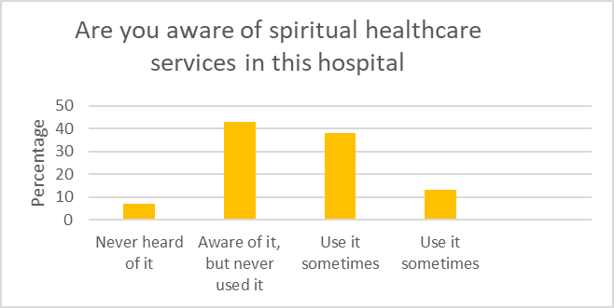
Figure 1. Staff awareness of spiritual healthcare
Of the 78 staff that answered, 43% were aware of spiritual healthcare services in the hospital but had never used them, 38% had heard of it and used it sometimes. Thirteen per cent said they used the service on a regular basis. Seven percent had never heard of the service.
Most staff heard of the service through a colleague (24%) or through other members of staff (26%) while 18% had heard through the hospital intranet and another 18% through spiritual care department leaflets.
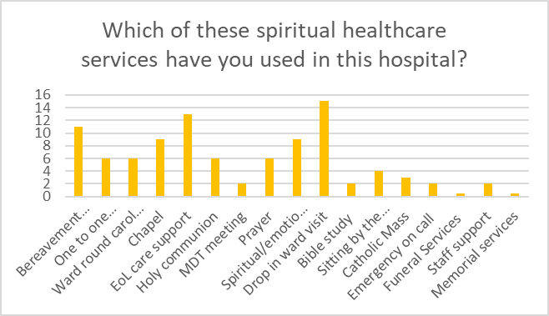
Figure 2. Range of spiritual care used
Of the services used, 15% used the ward drop in service to visit patients, 13% used the services for end of life care and 11% for bereavement support.
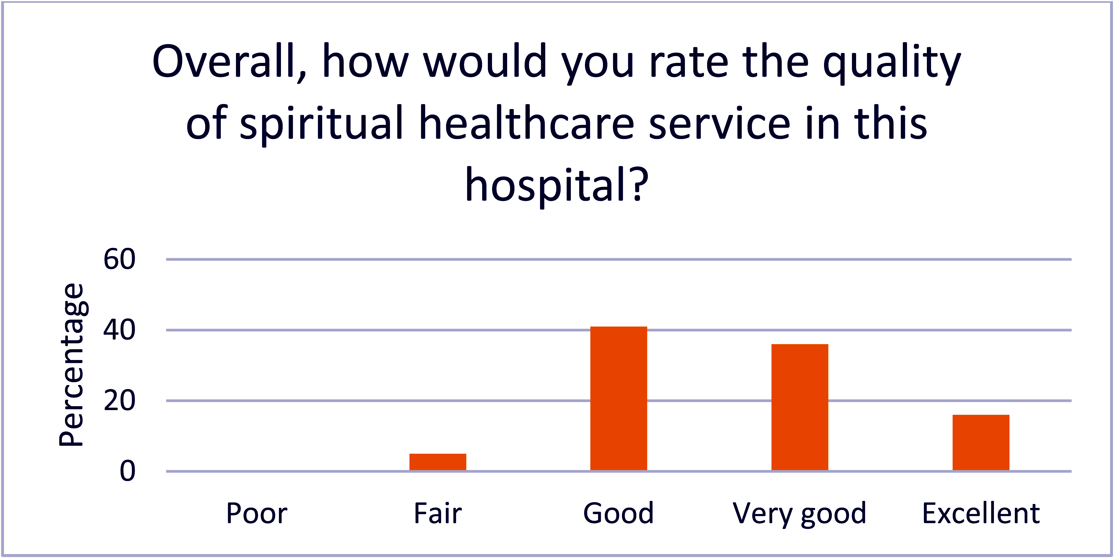
Figure 3. Assessment of care provision
Asked to rate the quality of spiritual healthcare, 41% rated the services as good with 36% rating the service very good and 16% excellent.
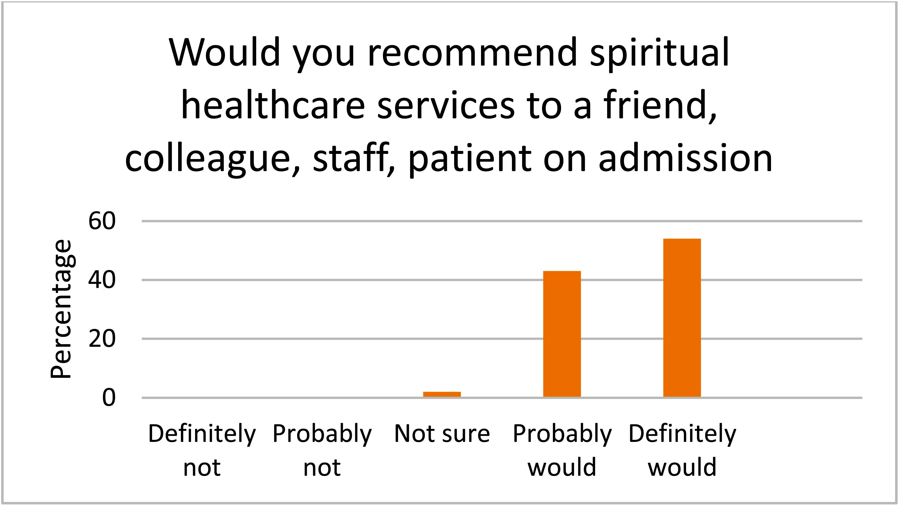
Figure 4. Recommendation to others
Asked if they would recommend the service, 54% said they would, 43% said they would probably recommend the service and 2% were not sure.
On the frequency of recommending spiritual care services 25% had recommended within 1-6 months, 23% had never recommended the service, 15% had recommended in the last month and 15%, 6-12 months previously.

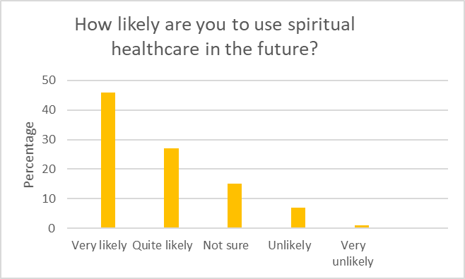
Figure 5. Future use
Of those that answered, 46% were very likely to recommend the services in the future, 27% were somewhat likely to recommend in the future, 15% were not sure, 7% somewhat unlikely and 1% were very unlikely.
Asked in the open-ended questions, what they thought they would most expect to see as part of the spiritual healthcare services, the main themes that emerged were:
Theme 1: Chaplains provide emotional and spiritual support of patients, families, relatives, friends and staff.
Theme 2: Chaplains provide a positive impact of spiritual healthcare services on patients.
Theme 3: Chaplains provide a relevant faith representative when needed.
Discussion
We chose the cardiovascular area of this hospital trust as it is about to be expanded into a centre of excellence, alongside oncology and renal care. As it expands, we wished to gauge the staff awareness of spiritual healthcare services already provided so as to inform the spiritual healthcare department of future needs. We also wished to investigate staff awareness of spiritual healthcare and what roles the staff thought spiritual healthcare undertook. There seemed to be a large number of services provided by the spiritual healthcare team (Figure 2) but little on our roles for staff as well as for patient support.
Only 6% of staff had not heard of the spiritual healthcare services at the hospital. This could be due to a number of factors, among which is the renaming of the service from spiritual healthcare to spiritual care. Chaplaincy is an older term, but one which in a multi-cultural and diverse population may not be so appropriate any more (Swift 2016). Even though some had not heard of it, 93% rated the service good, very good or excellent, with only 7% rating it fair and none rating it poor.
Only 2% of staff were not sure if they would recommend spiritual care services with 98% saying they would. Given that 6% had not heard of it, this questionnaire may have provided a platform for engaging with them and, once they had understood the range of activities that spiritual healthcare offers, were more likely to recommend the services. The questionnaire and its administration may itself create a bias and raise awareness (Bowling 2005).
This may also reflect that most staff had heard of the services through a colleague or other members of staff, with 18% hearing through the staff intranet or through spiritual healthcare leaflets. These may have been the leaflets to patients, with staff hearing about services due to requests from patients for visits. This may indicate a change in culture from hospitals that had firm religious foundations (Swift 2014) to a more secular NHS.
Interestingly, only 73% envisaged using the service in the future for patients, with very few using it for themselves (Figure 2), even though 98% had said they would recommend the service to others. This may highlight a gap between the use of the service for others and the service being seen to have a use for staff as well as for patients and families.
Fifty-five per cent had used the service in the last year for patients, with bereavement services, end of life care and ward visits to patients being the main reasons. The use of the chapel and spiritual support were also reasons cited for use of the service. These functions, end of life care and bereavement care, are often thought of as the remit of palliative care professionals and chaplains (de Vries 2008).
The themes that arose as the main role of spiritual healthcare reflected that role well, despite some thinking that what chaplains offer is not understood (Timmins 2017).
Limitations
This questionnaire was only administered in one clinical area, cardiovascular, in one hospital. While all nursing and healthcare assistants were surveyed, with a response rate of 42%, no other healthcare professionals were surveyed, so their awareness is unknown. We chose nursing and nursing assistants, feeling that they were in the wards and around the patients consistently, as well as being most likely to be aware of any ancillary services on the wards.
Asking about a service, especially the awareness of that service, instantly focuses on the service making it more visible than before the questionnaire, so the questionnaire itself may raise awareness.
Future Questions
The primary point of the survey was to find ways to make the spiritual care service more visible and show the range of activities undertaken and available for patients, families and staff. From the results we have obtained in this survey, there are areas that need work to promote the services:

- If, as in the data, colleagues and staff are the most effective way of promoting the awareness of spiritual healthcare services, what can the spiritual healthcare department do to encourage them to do more?
- As bereavement services featured in the data, is there any spiritual healthcare service that can bring together the staff, patients, family and spiritual healthcare team in remembrance of those who have died on the cardiovascular unit?
- How can the spiritual healthcare team measure the impact of spiritual healthcare services on the staff, patients and family?
Conclusion
The results show that staff perceive that the spiritual care services at the hospital are predominantly for patients and are a valued service by staff for patients. Many staff saw the advantage of having such a service for their patients. Additionally however, many staff found the service of use to them. Asking them about the service may have increased their awareness of the services offered. Given the high turnover and health problems found in healthcare professionals, especially mental health and stress (Cedar & Walker 2018), the spiritual healthcare team may be one of the more useful resources for staff care, although there is work to be done in raising the awareness of the service as a staff provision as well as a patient provision, and of the wide range of services that can be accessed.
References
Austin, P. D., R. Macleod, P. J. Siddall, W. McSherry and R. Egan (2016) “The Ability of Hospital Staff to Recognise and Meet Patients’ Spiritual Needs: A Pilot Study”. Journal for the Study of Spirituality 6(1): 20–37.
Austin, P. D., R. Macleod, P. J. Siddall, W. McSherry and R. Egan (2017) “Spiritual Care Training Is Needed for Clinical and Non-clinical Staff to Manage Patients’ Spiritual Needs”. Journal for the Study of Spirituality 7(1): 50–63.
Bowling, A. (2005) “Mode of Questionnaire Administration Can Have Serious Effects on Data Quality”. Journal of Public Health 27(3): 281–91.
Cedar, S. H. (2017) “Homoeostasis and Vital Signs: Their Role in Health and Its Restoration”. Nursing Times 113: 8, 32–35.
Cedar, S. H., J. Mitchell, J. Watts and M. Hilborn (2018) “Do Oncology Outpatients Need Chaplaincy Services?” Health and Social Care Chaplaincy 6(1).
Cedar, S. H., and G. Walker (2019) “Resilience and Self-care for Healthcare Staff” (in prep)
Kim, K., A. Bauck, A. Monroe, M. Mallory and R. Aslakson (2017) “Critical Care Nurses’ Perceptions of and Experiences with Chaplains: Implications for Nurses’ Role in Providing Spiritual Care”. Journal of Hospice & Palliative Nursing 19(1): 41–48.
Kitson, A., A. Marshall, K. Bassett and K. Zeitz (2013) “What Are the Core Elements of Patient-centred Care? A Narrative Review and Synthesis of the Literature from Health Policy, Medicine and Nursing”. Journal of Advanced Nursing 69(1): 4–15.
Paal, P., Y. Helo and E. Frick (2015) “Spiritual Care Training Provided to Healthcare Professionals: A Systematic Review” Journal of Pastoral Care and Counseling 69(1): 19–30.
Puchalski, C. M., B. Blatt, M. Kogan and A. Butler (2014) “Spirituality and Health: The Development of a Field”. Academic Medicine 89(1): 10-16
Pujol, N., G. Jobin and S. Beloucif (2016) “‘Spiritual Care is Not the Hospital’s Business’: A Qualitative Study on the Perspectives of Patients about the Integration of Spirituality in Healthcare Settings”. Journal of Medical Ethics 42: 733–37.
Ross, L., and J. Austin (2015) “Spiritual Needs and Spiritual Support Preferences of People with End-stage Heart Failure and Their Carers: Implications for Nurse Managers”. Journal of Nursing Management 23(1): 87–95.
Swift, C., the Chaplaincy Leaders Forum and the National Equality and Health Inequalities Team, NHS England (2015) “NHS England NHS Chaplaincy Guidelines 2015: Promoting Excellence in Pastoral, Spiritual & Religious Care” London: NHS England.
—(2016) Hospital Spiritual Healthcare in the Twenty-first Century: The Crisis of Spiritual Care on the NHS. Abingdon . Taylor and Francis/Routledge.
Swift, C., M. Cobb and A. Todd (2014) A Handbook of Spiritual Healthcare Studies: Understanding Spiritual Care in Public Places. London: Ashgate.
Timmins, F., S. Caldeira, M. Murphy, N. Pujol, G. Sheaf, E. Weathers, J. Whelan and B. Flanagan (2018) “The Role of the Healthcare Chaplain: A Literature Review”. Journal of Health Care Chaplaincy 24(3): 1–20
Turner, P., A (2017) “A Theoretical Framework of Holism in Healthcare” Insights in Biomedicine 2(1): 3.
De Vries R., N. Berlinger and W. Cadge (2008) “Lost in Translation: The Chaplain's Role in Health Care”. Hastings Center Report 38(6): 23–27.

. Victor Sulaiman is a Generic Chaplain on the Cardiovascular Unit, Guys and St Thomas’ NHS Foundation Trust, London, UK.
. S. H. Cedar is Associate Professor & Reader and Head of the End of Life Care Research Group, School of Health & Social Care, London South Bank University, London, UK.

