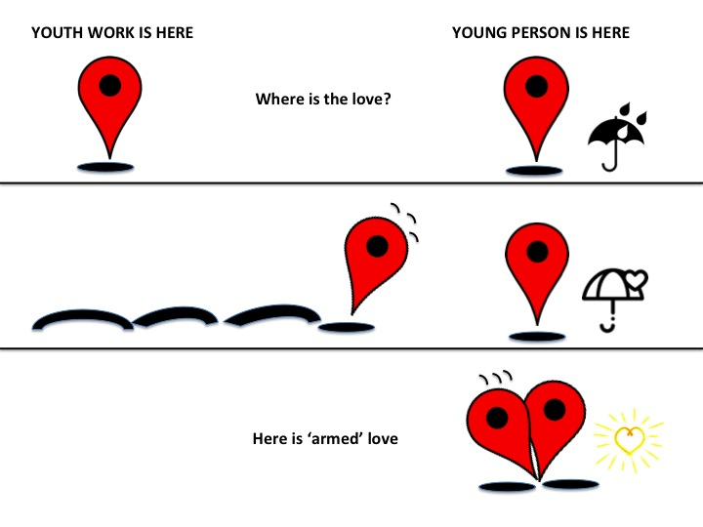
Where is the love? Seeking a convergence towards a ‘welfarist turn’ in work with young people.

Within 21st Century youth work, the growth of results based accountability (RBA) and a seemingly unquenchable thirst amongst politicians and policy makers for ‘evidence of impact’, has led to an obsession with measurement of risk, monitoring of outcomes, setting of targets and instrumental frameworks around work with young people. This has inevitably meant practice ‘shifts’ to an emphasis on ‘what works’ (instruments, tool-kits and methods) rather than a focus on ‘who’ works (practitioners). For those involved in open-access youth work and social pedagogy which each place a significant emphasis on the power of relationships with young people rather than any instrumental intervention, it is in the ‘who works?’ question that solutions may be found rather than in the ‘what works?’

There is perhaps no better demonstration of the above sentiment than the declaration of social pedagogy expert and developmental psychologist Urie Bronfenbrenner (1991, p2) where he states, “Every child needs at least one adult who is irrationally crazy about him or her”. The more complex message behind Bronfenbrenner’s simple statement is that in order to work effectively to meet a young person’s needs, then the primary caregiver should also have the support of another adult from either a familial relationship or close acquaintance. The significance of such a relationship has been recognised by Williamson (2007) where in his collection of short reflective pieces about youth work, he talks repeatedly about the importance of ‘critical people at critical moments’.

Embracing such a closely personalised model in the current ‘risk-averse’ culture of social care and young people carries obvious dangers around safeguarding and welfare issues. However a potential solution can perhaps be found in the marrying of the youth work and social pedagogy professions into a ‘hybrid’ model which features five elements: Participation, Education, Transitioning, Advocacy and Love (PETAL).

The PETAL model (Conroy & Williamson, 2019)
P = Participation is key – Young people as co-constructers of society
E = Education is everything – Educative in broadest sense of the word
T = Transitioning is crucial – Critical people at critical moments
A = Advocacy is necessary – When all are silent – one voice is powerful
L = Love – A notion of ‘armed’ love which is intentional and unrequited

Whilst these are not specifically exclusive to each profession, each of the elements listed draws from the purposes and principles of the two professions (youth work on the one hand, social pedagogy on the other) and combined they might constitute a new hybrid approach on which the model is to be positioned. The PETAL model of socio-educational intervention combines some of the intentionality, values, and more outcomes focussed elements of Youth Work with some of the theories, principles and ‘life space’ requirement to show love (irrational craziness) for young people within Social Pedagogy. It is important to state at this point that the ‘love’ being written about here is not linked to that of any liberal or romanticised notions of love but to what Paulo Freire referred to as ‘armed love’, based on being present with the young person and not derived from any expectations of reciprocity from the young person. Rather, it is aligned with the ‘Advocacy’ element of the PETAL model and is, as Freire declared, the “fighting love of those convinced of their right and duty to fight and denounce and announce” (Freire, 1998, p42). For some leading youth work protagonists, the shift towards more targeted work where young people are worked ‘on’ rather than ‘with’ has arguably taken away any such notion of ‘armed love’ or advocacy of the young person’s voice, or in just simply ‘being present’ with the young person in their life space. The political desire for pre-fixed outcomes and meeting of organisational targets can easily outweigh any focus on what the more holistic and emotional needs of the young person might be.

Youth work has at times been charged as being virtually devoid of attachment to any educational or learning theories, and according to Williamson (2015, p.3), “it has rested its case on assertion that is plausible to the converted but subject to profound doubt amongst those who are more skeptical as to its intentions, actions and impact”. Social pedagogy, on the other hand, does attach itself to the learning theories and educational learning theories which Williamson claims are often absent within the youth work approach. Social pedagogues demonstrate intentional use of learning theory such as the classic learning model of the Zone of Proximal Development (Vygotsky, 1978) or the more recent Diamond Model (Eichsteller & Holtoff, 2012) and these methods can perhaps offer youth work a more scientific and theoretical framework (Heart, Hands, and Mind) around which to position itself and become more widely understood. Social pedagogy primarily concerns itself with the spaces beyond schooling, within informal places and on occasions where learning takes place with young people. Cameron and Moss (2011) describe this practice as being ‘where care and education meet’. A good example of this would be use of what is known as ‘The Common Third’, which involves utilising a shared interest, or activity with the young person that lies outside of any structured programme, and often allows the young person to become the ‘educator’ and the worker the ‘educated’. However, in the case of social pedagogues, use of the common third is not necessarily because the young person is deemed to be in a ‘deficit’ situation, but as a normal part of their socialisation and almost upbringing (Lorenz, 2006).

In recent times, working with young people in such a ‘deficit’ or ‘denizen’ situation is increasingly becoming the domain that youth workers across Europe are finding themselves (especially so in the UK). It might therefore be apposite to propose that youth work should adopt a more social pedagogical approach. This would involve a return to youth work being more holistic in its outlook, starting with where the young person is and considering their wider societal needs not just the needs with highest social risk. The ongoing In Defence of Youth Work campaign nicely articulates this notion with youth work being defined as ‘association and conversations without guarantees’ (IDYW, 2019). Additionally, from a ‘Participation’ (PETAL) perspective and seeing young people as co-creators of society, then any outcomes for this work cannot therefore be pre-fixed. Indeed they have to be determined by whatever transpires in the period originating from the starting point (conversations) in the young person’s life space (association).
In short, an outcome then becomes a reversal of the same word and is what will ‘come-out’ and by the very nature of (truly) participative youth work we cannot know in advance what that will be. Indeed, recent reflection and discussion about youth work throughout Europe has agreed that it is about engaging with young people “on their terms and on their ‘turf’” (2nd European Youth Work Convention 2015, p.58) and that we must be concerned with both supporting and defending space for young people and contributing to the bridges that enable young people to move (Transit) to the next steps and stages in their lives.

Whichever way youth work moves along the ‘open access – targeted’ spectrum in the future, in order for such a young person-friendly PETAL model to be effective, it first requires the formation of trusting, loving relationships between young people and practitioners. It is through these positive associations that we can facilitate children and young people’s meaningful participation and engagement with decision-making processes. Essential to these relationships is the importance attached to each of the PETAL model elements and if attention to any one of these elements is missing then it cannot work.

Finally, the fusion of social pedagogy into youth work must also be framed in a fundamental discussion on the place of children and young people in our society and recognition of the social and politically constructed inequalities which have led to what Powell & Scanlon (2015) describe as young people feeling to be ‘denizens’ (sense of being alien) rather than ‘citizens’ (sense of belonging). A key part of that discussion for policy makers and the like must be around exploration of the potential role that such a youth work model as described above might play in the reversal of such alienation by positively influencing the ‘life-space’ of each individual young person within the community in which they live.

Full version of the above summary paper is available from mick.conroy@southwales.ac.uk
Conroy, M. & Williamson, H. (2019) Youth work and social pedagogy: towards consideration of a hybrid model. Unpublished. (Due for publication Oxford Press December 2019)

Reference list:
2nd European Youth Work Convention (2015), Similarities in a World of Difference, Brussels: Flemish Government

Bronfenbrenner, U. (1991), ‘What do families do?’ Institute for American Values, Winter / Spring

Cameron, C & Moss, P. (2011) Social Pedagogy and Working with Children and Young people ‘Where Care and Education Meet’, London, Kingsley.

Eichsteller, G. & Holthoff, S. (2012), ‘The Art of Being a Social Pedagogue: Developing Cultural Change in Children’s Homes in Essex’, International Journal of Social Pedagogy, 1(1), 30-46

Freire, P. (1998) Teachers as cultural workers; Letters to those that dare to teach, Boulder, CO: Westview

In Defence of Youth Work (2019) https://indefenceofyouthwork.com/2009/03/11/the-open-letter-in-defence-of-youth-work/ accessed: 13th June, 2019

Lorenz. W (2006), ‘Education for the Social Professions’, in K. Lyons and S. Lawrence, Social Work in Europe: Educating for Change, Birmingham: Venture Press

Powell, F. and Scanlon M. (2015), ‘The Youth Precariat; ‘Generationism’ in the austerity city’, Perspectives on youth, Healthy Europe; confidence and uncertainty for young people in contemporary Europe, Vol 3 pp15-26

Vygotsky. L. (1978), Mind in Society, Cambridge, MA, Harvard University Press

Williamson, H. (2007), The Thoughts of Chairman How!, Leicester, National Youth Agency.

Williamson, H. (2015), Finding Common Ground, Mapping and scanning the horizons for youth work in 21st Century, Brussels: European Youth Work Convention

