Measuring interactions and involvement in a cultural context
C. Biscaro¹, M. Calcagno²
¹ Advanced School of Economics, Ca’ Foscari University of Venice, corresponding author: claudio.biscaro@unive.it
² Department of Business Economics and Management, Ca’ Foscari University of Venice

Abstract. This paper stems from a prior longitudinal case study in which the authors analyzed the experience of Palazzo Strozzi, an Italian Cultural Institution experimenting an open approach to the process of sense-making that takes place during the visit. Through a significant re-design of the language, Palazzo Strozzi provides visitors with a two-way pattern of communication instead of a more traditional one-way flow of information .Both in cultural and in non-cultural contexts, innovation has taken place upstream and the role of the user can be mainly considered as a receiver. In terms of sense-making process, users hold a personal set of codes, which is used to give sense to the objects. We describe an experiment in which three different types of verbal content are used to describe different exhibits and the time of frontal interaction between people and exhibits is measured, thus highlighting the effect of the supporting content.
Keywords: innovation, interaction, involvement

In post-modernity, people have a deep relationship with objects from the cradle to the grave both to satisfy their physical needs and the social ones (Cova and Cova 2002). Products are also relevant for their symbolic meanings that are the result of a process of interpretation that consumers activate (Blumer 2008). Products are then central in life and become the focus of our attention in several situations: business hours, spare time, shopping time, and so forth. Enhancing products’ value for the final user is crucial for firms who try, on one side, to involve customers in the phases of product design (Von Hippel 2006; Badlwin and Von Hippel 2009; Chesbrough 2008) and, on the other side, with strategy of extensive partnership (Pisano and Verganti 2008) to work tightly connected with suppliers.
Also in cultural environments, e.g., museums and art galleries, due to competition and to lack of financial resources (Cannon-Brooks 1996), there has been the need to provide a better service to attract more viewers. Two major forces drove innovation in the contexts of museums and exhibitions. On one hand, they pursue an enhancement of the existing services (Grattan and Langeven 2007), and, on the other hand and mainly in the science museums, they introduction of hands-on applications to enhance a more participative interaction with the viewers (vom Lehn et al. 2001; Meisner et al. 2007). In both the cases, innovation was aimed to increase the audience’s satisfaction. What is remarkable is that the design of a cultural experience (Hoolbrook and Hirschman 1982; Hirschman 1983) is always shaped by the interpretation of curators and designers who define the content of the exhibition guiding the audience through the exhibiting space. If we observe the experience of visiting an exhibition, we could identify the process under a double perspective: the perspective of the curator/designer and that of the visitor.
The curator is the writer of the narrative, and chooses the modality to tell this story consistently with his/her aims and purposes in terms of understanding, interaction, and satisfaction. The visitor is the reader and adopts the message proposed by the curator with a lower or higher degree of freedom and adaption as a consequence of her previous preparation and personal experience.
If we consider the writer, we identify a continuum of situations where the curatorial language combines with the audience. On one side, curatorial approaches characterized by a reduced explanation where the single artworks talk by themselves. On the opposite, curatorial approaches rich of information, supports and tools used to help the audience in the visit experience. In both the situations, the user’s interaction is guided by the curatorial strategy of communication through what we could indentify as a proposal of interpretation, which is characterized nevertheless by different degrees of involvement and satisfaction of the reader. We refer mainly to unspecialized audience.
In fact, according to Piaget’s theory of cognitive psychology (Piaget 1954), the reader’s behavior depends on previous preparation and access to already existing and familiar cognitive structures. When the visitor will enter an exhibit that is totally unfamiliar with and in absence of an adequate informative support , we presume that discomfort and overwhelming will prevail affecting the process of learning negatively. (Csikszentmihalyi 1997). On the other hand we presume that a complete and straightforward explanation will improve the process of learning even though the degree of freedom will be controlled by the curatorial viewpoint.
In the case of specialized audience, the curatorial language will not affect the experience so strongly because of the degree of independence and preparation of the user.
In our previous research (Calcagno and Faccipieri, 2009; Calcagno and Biscaro forthcoming), a peculiar case of cultural experience was studied. Palazzo Strozzi, an Italian art gallery, moves along a different paradigm, which does not constrain the visitor’s interpretation to a top-down and one-way view set by the curator, but uses a language that triggers an open interpretation (Bradburne 2000) and a deeper involvement of the viewer.
This paper is aimed to unveil the relationship between type of communications used to support an object and the receiver’s involvement.

Literature review

Innovation of meanings and design
Innovation of products is fundamentally divided into the dichotomous paradigm of market pull and technology push (Dosi 1982), according to which the former type of innovation is driven by the market needs, while the latter gives the firm the strategic role of creating radically new products through the fundamental contribution of technology as an agent of change of products functions . Market pull innovations are then incremental changes of existing products and, and have easily access to the market. On the opposite side, technology push innovations are major technological breakthroughs characterized by a high potential to change the market creating a new demand (Abernathy and Clark 1985; Tuschman and Anderson 1986). There is still a debate upon which strategy is more effective (see e.g., Goldenberg et al. 2001; Shane 2001a; 2001b ). The classification between technology breakthroughs and market reinforcements has been put under discussion thanks to the identification of a third driving force: the design. the so-called design driven innovation (Verganti 2006; 2009) emphasizes the role of design as a third dimension of innovation. Consistently with the postmodernist paradigm, the semiotic traits of the product, i.e. icons, symbols and signs (Eco 1975 ; Douglas and Isherwood 1984; Csikszentmihalyi and Rochberg-Halton 1986; Margolin and Buchanan 1996; Monö 1997) play a role which, in the process of consumption, becomes more crucial than that traditionally assigned to its functions. Technology, whose role is to induce the functional innovation of a products, is then complemented by design where the concept of design is more related with signs than with an aesthetic enrichment of the product, This approach identifies the design as the center of the innopvative process, and a key dimension to compete through a radical change of meanings.
This premise is relevant because it introduces the ideas that a product is made of functions and meaning, that innovations can take place in both these dimensions, and that meaning innovations play an increasingly strategic role for the firm’s competitive success.
Nevertheless, the design driven approach does not give the due attention to the involvement of the customer into the sense making process. Only the firm has the capability to propose a meaning which is the result of a deliberate strategy of design while consumers are conceived as passive receivers of the message.

Innovation in museums and exhibitions
In the realm of cultural products where the word experience substitutes the word consumption giving a central role to the relationship with the audience, the innovation has been increasingly focused on enhancing the experience. This enhancement moves along two dimensions: quantity and quality.
Under the first dimension, an increased number of services have been offered to the audience: new audio guides with games and customized services, Personal Digital Assistants (PDAs) aims to enrich and customize the experience, the explosion of contents accessible on the websites with podcasts, articles, blogs and other services. These tools add new services and contribute to extend the visit experience even to anticipate the feeling of its flavors by seeing parts or the whole content online, by listening to the audio explanations, and by reading the curatorial interpretation from home. The process of miniaturization of digital artifacts allowed also the expansion of the quantity of data available to the visitor through an audio guide or a PDA and the use of RFID sensors (Hsi and Fait 2005) introduced the possibility to active the comments of the curators by the proximity with the opera thus breaking the rigid sequence of the visit flow. Nevertheless, all these innovations did not affect the role of the audience who is still considered as a passive receiver of information provided with the possibility to choose among different options of listening and receiving.
Under the second dimensions, a lower number of museums and art galleries have attempted to change the quality of the experience introducing a set of technological advancements aimed to involve the audience in a more intense and dialoguing relationship with the piece of art. Digital technologies combined with a new attention to designing the interactions with the user and among users resulted in an enhancement of social interaction. Meaningful examples are those of Sotto Voce (Aoki et al. 2002), in which a visitor, through a PDA, may eavesdrop on what a close visitor is listening through her device. In the case study described by Graziola et al. (2005), the PDAs are used to share notes about the artworks among visitors. Technologies are, then, used to improve interactions among users and with the exhibits. The constant need and dependency of portable digital aids for information retrieval carries the undesirable possibility that they might distract visitors’ attention from the exhibits, thus becoming the real center of attraction (Vom Lehn & Heath, 2005).

A story of interaction: the first part of the reserach
A different experiment is that of Palazzo Strozzi, an art gallery in Florence (Calcagno and Biscaro, forthcoming) where non digital visual and hands-on technologies have been used to retrieve content and improve visitors’ experience offering a more complete multi-sensory visit that goes beyond the visual and auditory involvement. Palazzo Strozzi is part of our research and to the study of its innovative approach to user-interaction we dedicated the first part of our research adopting a qualitative method of analysis.
To summarize the story of Palazzo Strozzi and the differentiating attributes of its approach we should go back to the 2008, when the exhibition “Painting Light” took place. The exhibition was addressed to the Impressionism and introduced an experiment to let the visitors get physically in touch with the artworks, thus enriching the simple visual experience. Some sample of canvas where the painting technique was represented were offered to the people visiting the exhibition, so that they could touch them to reach a better understanding of the au plain air style of the paintings (Calcagno and Biscaro, 2009; forthcoming). This was only the starting point of a new strategy called “Visible listening”, and aimed to change radically the way Palazzo Strozzi interacted with its audience. The innovations introduced were all addressed to support the process of fruition and to sustain the symbolic content of the artwork, through an easier, more complete and more customizable system of information retrieval. The exhibitions taking place at Palazzo Strozzi, though maintaining their differences, are all containing a set of supports that activate the audience inviting to enter the process of interpretation. Questions, games, experiments and other tools are introduced along the layout of the exhibition combining visual with tactile experience. More importantly, the audience is invited to give an active contribution to the process of curatorial interpretation and this is obtained through a set of open games where the individual is let free to interpret the artworks. Differently from other museums and art galleries, here the main focus does not lay on the functionalities, i.e., on the performances, of the tool and the the curatorial interpretation is offered as a proposal to enrich with further interpretations (Calcagno Biscaro, forthcoming).

Involvement
The concept of involvement was first studied in Social Psychology (Sherrif and Cantril, 1947) and was conceptualized as the relation between the object and the individual. Since there was no meter to measure this relation, Krugman (1965; 1966) measured the involvement through the intensity, i.e., the number of mental connections activated by an individual. In the following decade, a series of authors (e.g., Hupfer and Gardner, 1971; Lastovicka and Gardner 1979; Robertson 1976) tested the hypothesis that involvement enhances to the extent that the object has distinguishing attributes that are salient for the individual. Other scholars such as Cohen (1982) and Beatty and Smith (1987) defined involvement as the individual’s activation level that can be observed and measured at a point in time. A clear-cutting definition of involvement is missing, but there is a consensus on the aspect that the stimulus given by the task or by the product is pivotal (Greenwald and Leavitt 1984, Mittal 1995). If a person in not involved, she will not perceive an object as important, hence she will be either not caring, indifferent – the object has a value but it is not salient – or both.
Iwasaki and Havitz (2004) try to give a clear definition of leisure involvement and connect it to loyalty, reconciling an emerging stream of literature according to which having involved, and then loyal, customers allows the organization to generate revenue, enhance its positive reputation. It has positive effects on networking and community development (Backman and Compton 1991; Gahwiler and Havitz 1998; Howard, Edginton and Selin 1988), thus creating a competitive advantage through the development of loyalty.
The importance of the beliefs about the action, the interest in it, and its symbolic value is central for the development of involvement (Havitz and Dimanche 1997). This construct can thus be defined as “an unobservable state of motivation, arousal, or interest toward a recreational activity or associated product. It is evoked by a particular stimulus or situation and has drive properties” (Havitz and Dimanche, 1997).
Personal and social factors influence the level of involvement (Iwasaki and Havitz 1998; 2004). Skills – competences – (Csikszentmihalyi 1990) and motivations are personal antecedents of involvement. For example, in the sport of tennis skill positively covaried with ego-involvement (Siegenthaler and Lam 1992), the same in the sport of golf (Backman and Crompton 1991). Involvement is also associated with the research of social support, for instance involvement in sports is positively correlated with of support-seeking coping strategy in the after-injury phase of rehabilitation (Johnson and Carroll 2000). Still the measurement of the involvement has relied on qualitative data or a combination of qualitative and quantitative. To find a valid measure for the involvement, the meter must have two characteristics: first, it has to be related to the features of the construct and, second, it must be free of contamination by other elements of other constructs (Peter, 1981).

Involvement and Knowledge production
At the individual level of analysis, involvement is tightly connected with learning (Csikszentmihalyi 1990). At a higher level of analysis, involvement is, then, positively correlated to the creation of knowledge. The greater is the involvement, the higher is the knowledge produced.
Recently, Rullani provides a simple formalization of the knowledge produced in a given context as a function of the quality of the individual experience and the numerosity, i.e., the attendance for a show. Although he does not try to measure the first dimension, he highlights the importance of going beyond the attendance, which is usually taken as a benchmark of success of the events. The concept of knowledge is referred to three dimensions:
a) the capability to multiply the knowledge through its dissemination;
b) the effectiveness of the knowledge experience, which has to be evaluated subjectively by each individual;
c) the sustainability of the division of the knowledge trough the value chain.
The question is what is the amount of knowledge produced or activated by a process of consumption. Consistently with this model, the amount of knowledge is dependent on the number of cognitive processes that are activated by a process of consumption and by the subjective value of each of these act of consumptions. Rullani, then, formalizes this idea in the following formula:

Where:
- V is the value of the knowledge created in a process
- n is the number of re-uses o the knowledge or, in other terms, the dimension o the market reached by the knowledge (number of people got in touch with the process)
- v is the effectiveness of each act of knowledge lived by any individual. This is then dependent on the subjective satisfaction consequent to an act of consumption and is determined by the evaluation given by him or her.

The formula then tells us that the value of the amount of knowledge produced by an experience of consumption depends on both the number of replications of the act of consumption (number of people living the experience) and the qualitative dimension of the same act (subjective evaluation of the experience).
If we apply this formula to the context of museums and exhibitions, we can use it to reflect upon the value of the knowledge produced in a process of visiting an exhibition. This value depends, on one side, on the number of visitors reached by the exhibition, an indicator normally used to measure the success of this cultural product, but, on the other side, it depends on the value of each single act of “consumption”. This last value descends from both the quality of the services offered during the visit and, more importantly, from the quality of the intimate experience of learning which takes place during the visit. This experience is subjective and is strongly related to the active participation that the visitor is able to reach. As an example, the success of a blockbuster exhibition is measured essentially by the value of n while a lower importance is given to the value of v. We believe that in the experience of Palazzo Strozzi, as emerged in the first part of our research, this second indicator is given a greater importance. Nevertheless, the question unsolved remains how to measure these indicators in order to get a feedback on the success of the strategy followed by the museum.

Experimental Design
The aim of the experiment is to test whether the type of content of the label that supports an exhibit affects the viewer’s involvement. Three different types of verbal content are adopted: the simplest - hereon simple - provides basic information such as the title of the exhibit, the year of production and the author; a curatorial explanation - hereon one-way top-down – provided together with the information in the simple type; and an interactive content - hereon two-ways – that, on one hand, gives some basic clue on the exhibit and, on the other, asks the viewer one or more questions to elicit an own process of sense-making.
The involvement is approximated by the time spent in front of the exhibit. We assume that the longer is the frontal interaction with the exhibit, the higher is the level of involvement reached.
In our work the involvement is a monotonically increasing function of the variable time that is addressed to each object and it cannot be negative. The function is concave and has a kink after a given amount of time. The assumption is that a viewer cannot be involved if she just take a peek at the object. A minimal - positive - level is reached after a minimum duration of the interaction, then it increases less than proportionally with the time.
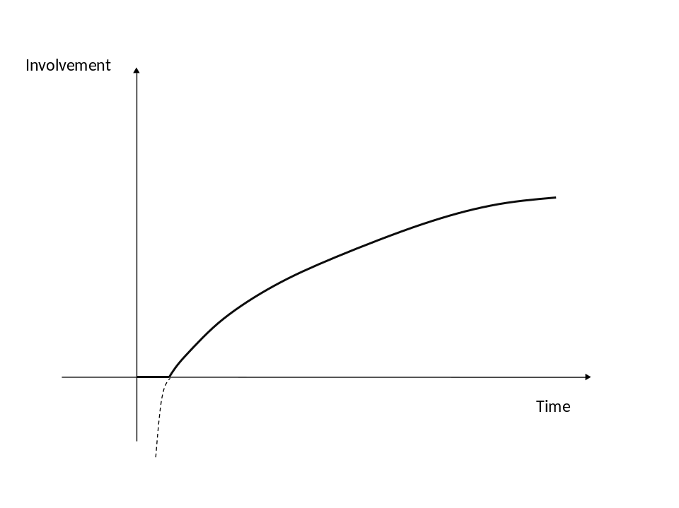
This concave function represents the diminishing sensitivity that occurs in several circumstances of the individual behavior (Starmer 2004). We assume that the difference in involvement elicited by an interaction of 10 and one of 20 seconds is bigger than the difference occurring if the interactions with the object last 60 and 70 seconds.
To model the involvement elicited by the exhibit on the individual as a function of time , we adopt the following form,

where represents discrete units of time measured by a technology that is able to capture the length of the interaction with a customizable interval of time, and is lower than 1 to give concavity to the function.
Each individual spends units of time in front of the exhibits, where is the total amount of time spent in front of the exhibits mapped. Every person must address a quota of her time to the exhibits, which cannot exceed that is ’s upper bound, while 0 is the lower bound and it means that there is no interaction, or it is too short to be mapped, between the individual and the exhibit .
is the weighted amount of time addressed to the artwork by the individual . This new index is needed have a control on the duration of the visit.

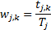

A drawback of this meter of involvement is that it takes into account neither the education of the individual, her skills, nor her motivations, hence it will not finely gauge at the individual basis the involvement, but this limitation does not represent an big issue at the current state of the analysis, because the aim is to check whether the types of label significantly affect the length of the interaction on a large population of visitors that will be sampled into homogeneous groups for education and other demographic aspects. And also the sample of objects will be large, thus to control for both the difference in preferences and the intrinsic quality of the objects.

A first round of this experiment was conducted parallel to another research aimed to discover patterns of social interaction within an Italian IT company. It lasted 3 days in which 3 types of objects were exhibited each day. The first day three representations of different tapestries were shown. The second day three objects of an Italian firm of design, the third day three advertisements by the same company. All the exhibits were hung on a perimeter wall of one of the facilities, close to a gathering place. Simple, one-way top-down, and two-ways labels were used to describe one exhibit a day. To control for an eventual position effect – that might favor a longer interaction in a given place – labels were displaying every day in a different place, as shown in Table 1.

Table 1 - labels and objects
 | PLACE 1 | PLACE 2 | PLACE 3
Tapestries | Two-ways | One-way top-down | Simple
Design Objects | O | S | T
Advertisements | S | T | O

The participants-viewers were the 164 employees of the IT company and its visitors. Both the exhibit displayed and the people were tagged with the technology presented in the following section. The technology to gather the data was scaled for the main experiment, which was one addressed to find the social patterns. This represents one of the limitations of the study, because the time unit was scaled to capture social interaction phenomena, which require longer time to occur. The single unit of time to measure the interaction was set equal to 20 seconds. For example, seconds. Our study needed a shorter time unit.
Another limitation is represented by the proper objective function of the employees and of the visitors who were mainly interested in their working activity and, laterally, in their social one, thus leaving little time and attention to the small exhibition of objects displayed along the wall of one of the facilities.

Interaction retrieval technology
The possibility of translating spatiotemporal face-to-face interaction into a digital information is given by a unobtrusive and portable RFID device distributed to each employee in the Italian IT company. These tags were inserted in badges, such as the ones used in conferences, people carried on the chest. Devices exchange low-power packets, to probe their spatial neighborhood and assess proximity with other tags. Their signal is, then, monitored and uploaded to a remote infrastructure by antennas located in different areas in order to cover all the spaces of the various facilities of the company (Cattuto et al. 2010).

Figure 1 - Perimeter wall, antenna and RFID tag
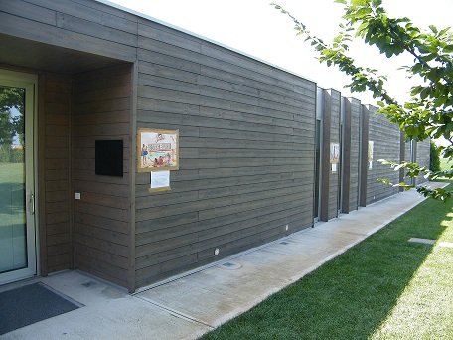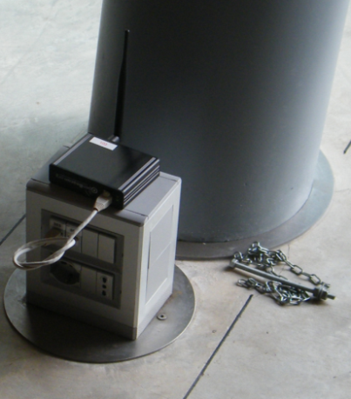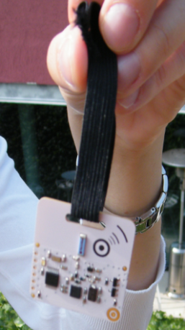

Tags were placed behind the representations of the objects and they measured interactions with other tags in a 3 meter range. Both the wall and the body of the people, who had the badge on their chest, screened the radio packets from interacting with other packets coming from tags behind, thus monitoring only frontal interaction between tags. Hence every individual not turned towards the object, even within a 3 meter range from it, or stopping for a period shorter than the time unit did not appear as involved in the experiment.

Developing hyphothesis
In the experimental setting, the population is composed for the big majority by people who has a strong background on communication and marketing issues and they tend to pay much of attention on colors and images. The set of IT companies installed in the facilities are working in the advertisement and communication fields. A relevant part of the 164 employees are graphics designers, others are software engineers, some economists and people with background in business, few accountants, also a philosopher and some other individuals with different background are part of the tagged population. The population is neither heterogeneous in background, nor in age: few people of the universe are already 40. Preferences, values, attitudes, motivations, needs and skills as well as interpersonal constraints, i.e., the set of personal antecedents Iwasaki and Havitz (1998; 2004) identify as influent for the level of involvement were not directly controlled through questionnaires or tests not to overwhelm employees with additional external activities. This experiment was intended to be a mock up of a large-scale longitudinal test with controls over personal and social antecedents, over solicited thoughts, and over social interaction elicited by the content of the labels.
Despite the various limitation of this experimental setting, we expect to test the following hypothesis:

Hypothesis 1: the two-ways label enhances the level of involvement, i.e., elicits a longer interaction with the exhibit.

In a large-scale experiment, in a totally different setting, i.e., an art gallery, we aim to test the content of the label with different types of public. If the public is divided into two basic groups, highbrow and lowbrow, on the basis of the personal antecedents, we might expect that, according to the knowledge developed in the developmental psychology (e.g. Piaget 1953), it is known that personal experience and knowledge affect the understanding of new situations, i.e., the assimilation process. Hence perceptions depend both on cognitive schemata and on human sensors, and through perception individuals update their preexisting beliefs. Adapting known pieces of knowledge is, then, a simpler process rather than creating a new solid schema for the understanding of an unfamiliar piece of information.
On this basis, we believe that a not prepared person might feel uncomfortable in front of an exhibit whose content is unfamiliar, and she might feel lost and incapable to interpret it in a sensible way. A simple label does not provide enough information to help her in the phase of sense-making.
On the other hand, the content of a one-way top-down label brings the curatorial interpretation directly to the viewer, thus offering one way to access the meaning of the exhibit. Cognitively this might be represented as an adaptation of the curatorial interpretation to the cognitive schemata of the visitor. We suppose that the closer is the new schema to the cognitive background, the better will be the interpretation of the visitor and the higher her involvement.
The type of content in the two-ways label is designed to stimulate attention on particular parts of the exhibit, making questions whose answer is not necessarily precise, and, in the case of an eventual second question, this is designed to reinforce any sensible reply to the prior question. This represents a feedback on the sense made through the first answer. According to the theory of the flow (Csikszentmihalyi 1990; 1997), the feedback tends to encourage concentration and prevents distractions.

H2. The higher the familiarity with the artwork, i.e., highbrow visitors, the lower the impact of the label, whatever type it is.

H3. The lower the familiarity with the artwork, the higher the involvement obtained with the use of one-way top-down and two-ways labels. We expect that the highest positive effect on involvement will be provided by the interactive two-ways label.

Conclusive remarks
Despite the data are not yet available, the purpose of this ongoing research is multifold. First, it intends to provide a meter for understanding involvement whenever it might be measured with a face-to-face interaction. Then, it tries to understand and measure the relation between the type of description and the level of engagement – involvement – elicited. Moreover, an important aspect upon which we will focus is to understand if and how different groups of visitors respond to different stimuli. Using this technology, setting some basic model for the analysis, trying to identify this measure and increasing the understanding over the effect of types of verbal communications will surely pave the way for further study. For example the identification of the reasons of the gaps between intended goals and actual behavior, e.g., in an art gallery setting, the goals of the curators in terms of viewers’ behavior within a museum, in another context, the idea of an architect about people’s interaction when he designs a given space. We believe that this understanding might be significant across different respects and this new pieces of knowledge might be relevant across several disciplines, e.g., marketing, education, social sciences, management studies, architecture and design.

References:
Abernathy, W.J., and K.B., Clark (1985). Innovation: Mapping the Winds of Creative Destruction, Research Policy, 14, 3-22.
Aoki, P.M., Grinter, R.E., Hurst, A., Sztmanski, M.H., Thrornton, J.D., and A. Woodruff, A., 2002, Sotto Voce: Exploring the Interplay of Conversation and Mobile Audio Spaces, Proceedings of the ACM Conference on Human Factors in Computing Systems (CHI 2002), ACM Press, 431-438.
Backman, S.J., and J.L., Crompton (1991). Differentiating between high, spurious, latent, and low loyalty participants in two leisure services, Journal of Park and Recreation Administration, 9(2), 1-17.
Beatty, S.E. and Smith, S., (1987). “External search effort: an investigation across several product categories”, Journal of Consumer Research, Vol. 14, 83-95.
Blumer, H., 2008, Interazionismo simbolico, Il Mulino, Bologna. Edizione originale, Symbolic Interactionism. Perspective and Method, Prentice Hall, 1969.
Baldwin, C. Y., and E., Von Hippel (2009). Modelling a Paradigm Shift: From Producer Innovation to User and Open Collaborative Innovation, Working Paper, Cambridge, Massachusetts: MIT Sloan School of Management.
Bradburne, J.M. (2000), Interaction in the Museum: Observing, Supporting, Learning, Libri Books on Demand.
Cannon-Brookes, P. (1996), “Cultural-Economic Analyses of Art Museums: a British Curator’s Viewpoint”, in V. A. Ginsburgh and P. M. Menger (eds), Economics of the Arts: Selected Essays, 255-274.
Calcagno M., and C. Biscaro (2010). Designing the interactions in a museum: learning from Palazzo Strozzi, ISMO, forthcoming.
Calcagno, M., S., Faccipieri (2009), Nuovi linguaggi per la produzione di conoscenza. Evidenze dal mondo delle produzioni culturali, Convegno XXXII Convegno AIDEA - “Le risorse immateriali nell’economia delle aziende” -, Ancona, September 24-25, In , Proceedings Aidea 2009.
Cattuto, C., Van den Broeck, W., Barrat, A., Colizza, V., Pinton, J.F., and A. Vespignani (2010). Dynamics of Person-to-Person Interactions from Distributed RFID Sensor Networks, PLoS ONE, 5(7), e11569.
Chesbrough, H. (2008). Open. Modelli di business per l’innovazione, Egea.
Cohen, J.B., (1982). “Involvement separating the state from its causes and effects”, paper presented at the Involvement Colloquium, New York University, New York, NY, 3-4 June 1982.
Cova, B. & Cova, V. (2002). Tribal Marketing: The tribalisation of society and its impact on the conduct of marketing, European Journal of Marketing, Vol. 36, No.5/6. pp. 595-620.
Csikszentmihalyi, M., and E., Rochberg-Halton (1986). Il significato delle cose, Roma, Edizoni Kappa.
Csikszentmihalyi, M. (1990). Flow: The psychology of optimal experience. New York: Harper-Perennial.
Csikszentmihalyi, M. (1997), Finding flow: The psychology of engagement with everyday life. The masterminds series. New York: Basic Books.
Dosi, G. (1982). Technological Paradigms and Technological Trajectories: A Suggested Interpretation of the Determinants and Directions of Technical Change, Research Policy, II, 147-162.
Douglas, M., and B., Isherwood (1984). Il mondo delle cose. Oggetti, valori, consumo, Il Mulino, Bologna.
Eco, U. (1975). Trattato di Semiotica Generale, Bompiani, Milan.
Gahwiler, P., and M.F., Havitz (1998). Toward a relational understanding of leisure social worlds, involvement, psychological commitment, and behavioral loyalty. Leisure Science, 20, 1-23.
Goldenberg, J., D. R. Lehmann and D. Mazursky (2001). The Idea Itself and the Circumstances of Its Emergence as Predictors of New Product Success, Management Science, 47, 69-84.
Grattan, N., and N., Langeven (2007). “Communicating the Museum: reaching our audiences”, The voice of Canada’s Museum community MUSE, 11-12 vol.XXVI/6.
Graziola, I., Pianesi, F., Zancanaro, M., and D., Goren-Bar (2005). Dimensions of adaptivity in mobile systems: personality and people’s attitudes, Proceedings of on Intelligent user interfaces (IUI’05).
Greenwald, A.G., and Leavitt, C. (1984). Audience Involvement in Advertising: Four levels, The Journal of Consumer Research, 11 (1), 581-592.
Hirschman, E.C. (1983). Aesthetics, Ideologies and the Limits of the Marketing Concept, Journal of Marketing, Vol. 47, Summer.

Holbrook, M. B. and E. C. Hirschman (1982), “Hedonic Consumption: Emerging Concepts, Methods and Propositions”, Journal of Marketing, 45, 92-101
Howard, D.R., Edginton, C.R., and S.W., Selin (1988). Determinants of program loyalty. Journal of Park and Recreation Administration, 6, 41-51.
Hsi, S., and H., Fait (2005). Rfid enhances visitors’ museum experience at the Exploratorium, Communications of the ACM, 48 (9), 60-65.
Hupfer, N.T., and D.M., Gardner (1971), Differential involvement with products and issues: an exploratory study, in Proceedings, Association for Consumer Research, ed. David M. Gardener, College Park, MD: Association for Consumer Research.
Johnston, L.H., and Carroll, D., (2000). Coping, social support, and injury: Changes over time and the effects of level of sports involvement. Journal of Sport Rehabilitation, 9, 290-303.
Krugman, H.E., (1965). “The impact of television advertising: learning without involvement”, Public Opinion Quarterly, 29, 349-56.
Krugman, H.E., (1966). “The measurement of advertising involvement”, Public Opinion Quarterly, 29, 583-96.
Iwasaki, Y., and M.F., Havitz (1998). A path analytic model of the relationships between involvement, psychological commitment, and loyalty, Journal of Leisure Research, 30, 256-280.
Iwasaki, Y., and M.F., Havitz (2004). Examining relationships between leisure involvement, psychological commitment and loyalty to a recreation agency, Journal of Leisure Research, 36, 45-72.
Lastovicka, J.L., and D.M., Gardner (1979). Components of Involvement, in Attitude Research Plays for High Stakes, ed. B. Silveraman, Chicago: American Marketing Association.
Margolin, V., and R., Buchanan (edited by) (1996). The Idea of Design, Cambridge, MA, The MIT Press
Meisner, R., vom Lehn, D., Heath, C., Burch, A., Gammon, B., and M., Reisman (2007). Exhibiting Performance: Co-participation in science centres and museums, International Journal of Science Education, 29 (12), 1531-1555.
Mittal, B. (1995). A comparative analysis of four scales of consumer involvement, Psychology and Marketing, 12 (7), 663-682.
Monö, R. (1997), Design for Product Understanding: The Aesthetics of Design from a Semiotic Approach, Liber, Stockholm.
Peter, P.J. (1981). Construct validity: A review of basic issues and marketing practices, Journal of Marketing Research, 18, 133-145.
Piaget, J. (1953). The origin of intelligence in the child. London: Routledge.
Pisano, G.P. and R. Verganti (2008), Collaboration is Right 4 You?, Harvard Business Review, December, 79-86.
Robertson, T.S. (1976). Low-commitment consumer behavior, Journal of Advertising Research, 16, 19-27.
Shane (2001a): Technological Opportunities and New Firm Creation, Management Science, 47 (2), 205-20.
Shane (2001b): Technology Regimes and New Firm Creation, Management Science, 47 (9), 1173-90.
Sherrif, M. and H., Cantril (1947). The Psychology of Ego-Involvement, Wiley, New York, NY.
Siegenthaler, K.L., and T.C.M., Lam (1992). Commitment and ego-involvement in recreational tennis, Leisure Science, 14, 303-315.
Starmer C. (2004). Developments in non-expected utility theory: the hunt for a descriptive theory of choice under risk, in C. Camerer, G. F. Loewenstein and M. Rabin (eds.), Advances in Behavioral Economics, Princeton University Press, 2004.
Tuschman, M. L., and P., Anderson (1986). Technological Discontinuities and Organizational Environments, Administrative Science Quarterly, 31 (3), 439-465.
Verganti, R. (2006). Innovating Through Design, Harvard Business Review, 84 (12), 114-122.
Verganti, R., (2009), Design Driven Innovation. Changing Rules of Competition by Radically Innovating What Things Mean, Harvard Business Press.
vom Lehn, D., Heath, C., and J., Hindmarsh (2001). Exhibiting Interaction: Conduct and Collaboration in Museums and Galleries, Symbolic Interaction, 24 (2),189-216.
vom Lehn, D., and C. Heath (2005). Accounting for New Technology in Museum Exhibitions. International Journal of Arts Management, 7 (3), 11-21.
Von Hippel E., 2005, Democratizing innovation. The MIT Press, Cambridge: MA.

“Rischio e valore della conoscenza. La nuova impresa della produzione immateriale.” (Risk and value of knowledge. The new firm of the immaterial production), paper presented to the Annual AIDEA Congress in 2009.

