Bilateral redundancy gain and callosal integrity in a man with callosal lipoma: a diffusion-tensor imaging study.

Journal Name: Neurocase

Matthew E. Roser^{a*}, Michael C. Corballis^{b}, Ashok Jansari^{c}, Jon Fulford^{d}, Abdelmalek Benattayallah^{e}, and William M. Adams^{f}.

- School of Psychology, University of Plymouth, Plymouth PL4 8AA, Devon, United Kingdom.
Telephone: +44 1752 584852
Fax: +44 1752 584808
Email: matt.roser@plymouth.ac.uk
- Department of Psychology, University of Auckland, Private Bag 92019, Auckland 1142, New Zealand.
Email: m.corballis@auckland.ac.nz
- School of Psychology, The University of East London, Water Lane, London E15 4LZ, United Kingdom.
Email: a.jansari@uel.ac.uk
- Peninsula Medical School, Peninsula MR Research Centre, University of Exeter, Exeter EX1 2LU, United Kingdom.
Email: J.Fulford@exeter.ac.uk
- School of Physics, Peninsula MR Research Centre, University of Exeter, Exeter EX1 2LU, United Kingdom.
Email: A.Benattayallah@exeter.ac.uk
- Imaging Directorate, Derriford Hospital, Plymouth PL6 8DH, United Kingdom.
Email: William.Adams@phnt.swest.nhs.uk

* Corresponding author

Abstract
We investigated whether abnormalities in the structural organisation of the corpus callosum in the presence of curvilinear lipoma are associated with increased facilitation of response time to bilateral stimuli, an effect known as the redundancy gain. A patient (A.J.) with a curvilinear lipoma of the corpus callosum, his genetically-identical twin, and age-matched control participants made speeded responses to luminant stimuli. Structural organisation of callosal regions was assessed with diffusion-tensor imaging. A.J. was found to have reduced structural integrity in the splenium of the corpus callosum and produced a large redundancy gain suggestive of neural summation.

Keywords: corpus callosum; redundancy gain; diffusion-tensor imaging

Running head: Bilateral redundancy gain in callosal lipoma.
INTRODUCTION
People with section of the corpus callosum or with agenesis of the corpus callosum show a paradoxical redundancy gain (RG) in simple reaction time (RT) to bilateral stimuli. That is, they respond more quickly to pairs of stimuli, one in each visual field, than to single stimuli in one or other visual field. This effect exceeds that predicted in terms of probability summation (Corballis, 1998; Corballis, Corballis, Hamm, & Barnett, 2002; Iacoboni, Ptito, Weekes, & Zaidel, 2000; Marzi et al., 1996; Reuter-Lorenz, Nozawa, Gazzaniga, & Hughes, 1995; Roser & Corballis, 2002, 2003) implying neural summation, or a convergence of processes, between the cerebral hemispheres (Miller, 1982), despite the absence of callosal fibres. In normal participants, by contrast, redundancy gain is sometimes observed to be within the bounds predicted by probability summation (Corballis, 1998; Corballis et al., 2002; Reuter-Lorenz et al., 1995; Roser & Corballis, 2002, 2003) although redundancy gains exceeding probabilistic predictions are well documented (Cavina-Pratesi, Bricolo, Prior, & Marzi, 2001; Corballis, 2002; Iacoboni & Zaidel, 2003).

Interhemispheric interaction via the corpus callosum is, therefore, clearly implicated in neural summation between the cerebral hemispheres. The paradoxical increased evidence for neural summation in the presence of callosal disconnection can be accounted for by the Hemispheric Coactivation hypothesis (Miller, 2004) in which it is proposed that disruption of interhemispheric communication leads to a reduction in the normal pattern of bihemispheric processing of unilateral stimulus input (Miller, 2004; Roser & Corballis, 2003), thus leading to a greater-than-normal difference between the brain processes evoked in response to unilateral or bilateral stimuli, and a corresponding enhanced redundancy gain.

The nature of the neural activity that underlies the redundancy gain has been investigated in partial-callosotomy patients, in whom either the anterior or posterior callosum is severed. The topographical arrangement of fibres through the corpus callosum (Witelson, 1989) means that the transfer of visual-sensory and motor activity occurs through different regions, or callosal channels (Iacoboni & Zaidel, 1995). Findings on the effect of anterior section are equivocal. Ouimet and colleagues (2009) tested patients in whom the anterior two thirds of the callosum were severed on tasks involving responding to single or redundant targets presented across the visual meridian. Although it was not tested whether the RG exceeded probabilistic models, it was found that partial-callosotomy patients showed a bigger RG than did neurologically-normal controls. Other researchers have found that evidence for neural summation, from response-time (RT) facilitation exceeding that predicted by probability models, was absent in anteriorally-sectioned patients (Corballis et al., 2002; Iacoboni et al., 2000). These patients also showed crossed-uncrossed differences (CUD) in RT, which provide a measure of interhemispheric transfer time, that were within the normal range.

In one case in which the splenium and rostrum were sectioned, leaving more anterior regions intact, there was both redundancy gain and a prolonged CUD (Corballis et al., 2002). These data suggest that the splenium may be responsible for both reducing the redundancy gain evident in the split brain, and for permitting rapid interhemispheric transfer of visually-presented information. There is, nevertheless, a relative paucity of data on the effects of posterior callosal disconnection.
In the present study we investigate redundancy gain and CUD in a man, henceforth referred to as A.J., with a curvilinear lipoma bordering the superior margin of the corpus callosum in the midline. These structures have been associated with callosal dysgenesis, the regional extent of which is related to the developmental timecourse of the abnormality (Jabot et al., 2009; Taglialatela, Galasso, Conforti, Volpe, & Galasso, 2009; Truwit & Barkovich, 1990). A.J. was compared to his neurologically-normal identical twin and a group of control participants. Diffusion-tensor imaging (DTI) was used to define microstructural organisation in regions of the corpus callosum for comparison with a control group and to perform probabilistic fibre tracking between callosal and cerebral regions. These measures allowed disruption to the normal pattern of structural connectivity through the corpus callosum to be assessed and related to behavioural performance. We predicted that, consistent with the hemispheric coactivation hypothesis, we would observe reduced callosal connectivity and enhanced redundancy gain in the case with a curvilinear lipoma. We predicted, further, that abnormality in structural connectivity would be greatest in the posterior corpus callosum, which lies near the region of the lipoma and which has been implicated in enhanced redundancy gain in patients with posterior callosotomy.

EXPERIMENT 1. BRAIN STRUCTURE IN CALLOSAL LIPOMA.
In the first experiment magnetic resonance imaging (MRI) was used to characterise brain structure in case A.J., his identical twin, henceforth referred to as At.J., and a group of neurologically normal control participants. A.J. reported that a MRI scan carried out several years previously had revealed an abnormality that had not been thoroughly characterised. In the present study high-resolution MRI was used to determine the presence of callosal lipoma and the gross morphology of white matter. Curvilinear lipoma are congenital malformations that occur as a result of the persistence and maldifferentiation of the primitive meninges (meninx primitiva) during embryonic development. Lipoma have been most frequently observed at peri-callosal locations and have been associated with callosal malformation, ranging from hypogenesis to agenesis in around 30% of cases (Jabot et al., 2009; Taglialatela et al., 2009; Tart & Quisling, 1991; Truwit & Barkovich, 1990).

METHOD
Participants
Case A.J. and case At.J.
Initial identification of a brain abnormality in A.J. resulted from a routine brain scan undertaken as part of his work. A.J. reported no neurological symptoms. A.J. and At.J. were aged 40 at the time of testing. Both were assessed as right handed using the Edinburgh Handedness Inventory (Oldfield, 1971). This widely-used scale has been previously used in redundancy-gain investigations (Pollmann & Zaidel, 1999). The scale, which generates a laterality quotient, was employed to classify participants’ handedness with greater confidence and accuracy than that which would result from self-reported handedness, to allow matching of A.J. and controls for handedness. Tests of relative manual dexterity were not necessary as the focus of the study was on very simple (button-press) manual responses.

Controls
A group of seventeen male and eight female neurologically-normal adults (mean age 28 years) were scanned as control participants. All but four were right handed.

High-Resolution brain imaging
All participants underwent magnetic-resonance imaging (MRI) on a 1.5 Tesla Philips Intera scanner yielding T1-weighted high-resolution images (Gradient Echo sequence; 160 slices; TR 25 ms; TE 4.1 ms; slice thickness 0.8 mm; Field of View 230 mm; matrix size 256x256; voxel size 0.9x0.9x0.8 mm; flip angle 30 degrees). No abnormalities were noted for At.J or for control participants. A large peri-callosal area of hypertintensive signal was identified in A.J. and was assessed by a Consultant Neuroradiologist (author W.M.A.) as representing a curvilinear lipoma bordering the superior margin of the corpus callosum in the midline. This was associated with a cavum septum pellucidum, which was slightly asymmetric, and lateral ventricles which were slightly dysmorphic, particularly anteriorly. The corpus callosum appeared structurally intact and the remainder of white-matter structures appeared normal, with preservation of the cortico-medullary differentiation both centrally and peripherally. Midsagittal views of the brains of A.J. and At.J. are presented in Figure 1 clearly showing the area of hyperintensity.

--- Figure 1 about here ---

Diffusion-tensor brain imaging
To further characterise abnormality in the corpus callosum in A.J. we used diffusion-tensor imaging (DTI) to investigate microstructural integrity in regions of white matter. Mean fractional anisotropy (FA), which is widely regarded as an index of axonal organisation and mylelination (Basser, 1995; Beaulieu, 2002) was extracted from regions of interest (ROIs) encompassing subregions of the corpus callosum for A.J. and the group of 25 neurologically-normal adults.

Diffusion tensor images (DTI) were acquired from A.J. and control participants using a diffusion weighted single-shot spin-echo EPI sequence. Diffusion weighting was performed along 32 independent directions, with a b-value of 1000 sec/mm2. A reference image (b=0 sec/mm2) was also acquired, as was a T1-weighted high-resolution image using the parameters described for A.J. and At.J. in the previous section. DTI images were processed using the FMRIB Diffusion Toolbox (FDT) implemented within the FMRIB Software Library (FSL) package (Smith et al., 2004). Images were corrected for spatial distortion and diffusion tensors were calculated. Fractional Anisotropy (FA) images were calculated from the eigenvalues of the tensor. The T1 image from each individual was aligned to a standard template (MNI152) using FSL FLIRT (Jenkinson, Bannister, Brady, & Smith, 2002) as was each participant’s FA image. These T1 and FA images in standard space were then further aligned to each other, separately for each individual, to ensure the best possible overlap between them. The image of the principle eigenvector (V1) of the tensor at each voxel was coregistered with the T1 and FA images by applying the linear transformations derived from the FLIRT registrations using the ‘vecreg’ function in FSL. The top panel of Figure 2 shows the region of the corpus callosum in the midsagittal plane for case A.J. The middle image shows V1 colour coded so that left-to-right and right-to-left is red and with image intensity modulated by FA. From this image it is easy to see that the corpus callosum is the region of highest FA (i.e. is brightest) and that fibres running left-right and right-left predominate.

Following from studies of partial-callosotomy patients, in whom the anterior or posterior third of the callosum is typically severed, we divided the corpus callosum into thirds along its length in the midsagittal plane, working from the high-resolution image. ROIs were then placed using the well defined edges of the CC on the T1 image for guidance. These ROIs were restricted to the 5 sagittal slices in the midline and were limited to contiguous regions that differed in intensity by only a small amount from the origin in the centre of the tract. The ROIs were then eroded to remove the outer layer of voxels in all planes and restrict the region to the central 3 slices only. The edges of the ROIs were, therefore, well within the edge of the corpus callosum. These measures were taken to guard against the partial-volume effect in which non white matter is accidentally included in the ROI. Placement was also guided by restricting ROIs to voxels in which the principle eigenvector ran predominantly left-right. The bottom panel in Figure 2 shows three coloured ROIs and the principle direction of diffusion at each voxel represented as a red line. FA within each ROI was recorded for each participant.

--- Figure 2 about here ---

RESULTS
Neurologically-normal participants showed regional FA values that were similar to previous investigations of normal callosal FA (Herweh et al., 2009; Sullivan & Pfefferbaum, 2006; Westerhausen et al., 2004), ranging from 0.5 to 0.8, with the highest FA values observed in the splenium. Figure 3 shows mean regional FA for the control group (N=25) with error bars showing two standard deviations. Data from A.J. are represented as dashed lines. In the genu A.J. has the same mean FA as controls. In the splenium his mean FA is less than the control mean minus two standard deviations. A.J. has significantly greater FA in the midbody of the corpus callosum.

--- Figure 3 about here ---

To verify our findings using an alternative method we divided the corpus callosum into 6 equal divisions along its length (Witelson, 1989). We then selected the voxels on the midsagittal image that were in the centre of these 6 regions along the anterior-posterior vector and in the centre of the tract, maximally distant from the edges of the corpus callosum. Centred on these voxels we placed spherical ROIs encompassing 33 voxels and extracted mean FA from within. Figure 4 shows the placement of 6 ROIs on a representative participant and mean FA values with error bars showing two standard deviations. This analysis produced essentially the same pattern of FA values as the analysis of three larger ROIs.

--- Figure 4 about here ---

To rule out the possibility that age, sex, and handedness differences between the control group and A.J. account for the results, mean FA was calculated for a subgroup of eight right-handed, male, control participants with a mean age of 38 years. Values for the genu, midbody, and splenium from this subgroup (0.71, 0.57, 0.75, respectively) were almost identical to those for the entire cohort (0.71, 0.56, 0.74).

To further investigate the combination of reduced splenial connectivity and greater midbody connectivity in A.J. we performed probabilistic tractography between the callosal ROIs and cortical regions defined from standard brain atlases. Probabilistic fibre tracking allows one to quantify belief in the existence of particular white-matter tracts by tracking a path from a seed region to target region using the angle and degree of diffusion at each voxel (Behrens et al., 2003). Multiple tracks are ‘seeded’ from one location and the proportion reaching another target region can be determined.
We created two cortical targets, based on a standardised atlas (Harvard-Oxford) of cortical regions (Figure 5) included in FSL. The posterior target mask included intracalcarine and cuneal cortex, superior and inferior lateral occipital cortex, and the occipital pole. The middle cortical target mask included the precentral and postcentral gyri. Five thousand tracks were seeded from every voxel in each of the splenial and middle-callosal ROIs. The number of tracks reaching each of the cortical targets was computed for each seed voxel (Table 1). For the splenium to posterior target tracks, A.J. showed significantly fewer completions than the mean of the control group. This was expected because tracking depends on FA, which depends on axonal organisation, and A.J.’s FA through the splenium is reduced. For the splenium to central/middle targets A.J. was within the normal range. This was despite the overall lower FA, which should hinder tracking, in the splenium and strengthens our argument that, in A.J., connectivity between posterior regions through the splenium is reduced, but connectivity between more-anterior regions is normal. Tracking from the midbody to cortical targets did not differ for A.J. and controls.

--- Figure 5 about here --- --- Table 1 about here ---

EXPERIMENT 2. Redundancy gain.
In the second experiment case A.J. was compared to At.J., and to a group of age-matched control participants, on a task requiring speeded manual responses to lateralised visual stimuli.
METHOD
Participants
Case A.J. and case At.J. participated in Experiment 2.

Controls
To provide a direct comparison on the behavioural task with the normal population a group of 14 participants, matched for age and handedness with A.J. and assumed to be neurologically normal, were tested using the exact parameters used to test A.J. and At.J. All 14 control participants were assessed as being right handed using the Edinburgh Handedness Inventory (Oldfield, 1971) and were aged within five years of A.J.

Stimuli and Procedure
The stimuli were white squares, presented on a grey background, which subtended 1 degree of visual angle. Stimuli were displayed at maximum luminance with digital 8-bit RGB values of 255, 255, 255. The grey background was displayed with digital 8-bit RGB values of 100,100,100. Stimuli were, therefore, highly visible against the darker background. Stimuli were aligned with the horizontal meridian with the inner edge presented at 5 degrees from a central fixation point. This degree of eccentricity is commonly employed in studies using simple lateralised stimuli (e.g. Roser & Corballis, 2003) and ensures that initial projection is exclusively to the hemisphere contralateral to the visual field avoiding any visual field overlap (Fendrich & Gazzaniga, 1989). Participants viewed the stimuli on a LCD screen using a chin rest to maintain a constant distance of 57 cm. The experiment was run using NBS Presentation software (Version 11, www.neurobs.com) for A.J. and At.J. and E-Prime software (Psychology Software Tools) for Controls. All stimulus parameters and procedures used for the control group were identical to those used with A.J. and At.J.

Stimuli were presented in six blocks of 99 trials. Within each block, there were 30 trials in which the stimulus was presented in the left visual field (LVF), 30 in which it was in the right visual field (RVF), 30 in which stimuli were presented simultaneously in both fields (bilateral), and nine “catch” trials in which no stimulus was presented. At the beginning of each trial a unilateral LVF or RVF stimulus, or a bilateral stimulus pair, was presented for three screen refreshes (50 ms) and was then removed from the screen. Responses were collected up to 1000 ms following the onset of the stimulus or the beginning of a catch trial. Trials, which began with the onset of the stimulus, were separated by a delay period which varied randomly between 2900 ms and 3100 ms. The central fixation point remained visible throughout each block. Participants were instructed to respond to the onset of the stimuli as quickly as possible by pressing the space bar on the computer keyboard. Participants alternated the hand used to respond on each test block, with the starting hand counterbalanced between participants.

RESULTS
A.J. and At.J.
Raw RT data were filtered so that RTs under 100 ms or longer than 600 ms were removed. No RTs were excluded for A.J. RTs for only two trials were excluded for At.J, one with stimulus presentation in the LVF and one with a stimulus in the RVF. A.J. missed 2 stimuli out of 540, both in the LVF and made one catch-trial error with the right hand. At.J missed two stimuli, both in the RVF and made no catch-trial errors. Mean RTs for A.J. and At.J. are shown in Table 2 separately for each hand under each stimulus condition. The crossed-uncrossed difference (CUD) was calculated separately for each response hand by subtracting the mean RT for responses to stimuli presented in the visual hemifield ipsilateral to the response hand from RTs to stimuli presented contralaterally to the response hand. The redundancy gain (RG) was calculated separately for each hand. To calculate the redundancy gain independent of any effect of a processing-time difference between visual hemifields, the redundancy gain was defined as the difference between the mean RT for Unilateral stimuli presented in the visual field responded to most quickly (always RVF for A.J., LVF for At.J.) minus the RT to the Bilateral stimulus. This calculation, therefore, assesses the degree to which performance was facilitated by bilateral redundancy above the level seen for the hand/field arrangement producing the fastest responses to unilateral stimuli.

--- Table 2 about here ---

One-way analyses of variance showed that A.J. responded significantly more quickly with his left hand than with his right hand [F(1, 890) = 8.92, p = .003] and showed a significant main effect of visual field [F(2, 889) = 18.15, p < .001]. Orthogonal contrasts, not assuming equal variances, showed that left-hand RTs to bilateral stimuli were significantly faster than left-hand RTs to unilateral stimuli presented in the LVF [t(294) = 5.63, p < .001], and to those presented in the RVF [t(297) = 3.03, p = .003]. The contrast comparing right-hand responses to stimuli in the RVF with right-hand responses to bilateral stimuli was not significant. Participant At.J. was significantly faster with his left hand [F(1, 896) = 48.02, p < .001] than with his right. The main effect of visual field approached significance [F(1, 895) = 2.55, p = .079]. The contrast comparing right-hand responses to stimuli in the RVF with right-hand RTs to bilateral stimuli was significant [t(289) = 2.84, p = .005]. The contrast comparing right-hand responses to stimuli in the LVF with right-hand RTs to bilateral stimuli was not significant.

To further investigate redundancy gain, RTs were compared with expectations under the so-called race model (Miller, 1982), in which it is assumed that each stimulus in the bilateral condition undergoes a race for control of the response. According to this model, at any given time t following stimulus presentation, the following “race inequality” should hold
p_{B} < p_{L} + p_{R}
where p_{B} is the probability of a response having been made to the bilateral stimuli, and p_{L} and p_{R} are the probabilities of responses having been made to single stimuli in the LVF and RVF, respectively. Consequently, we can check for violations of the race inequality by cumulating the expression
p_{B} - ( p_{L} + p_{R} ) (1)
over t. The outcome of the expression should always be below 0. Response-time data were assigned to twenty seven response bins, according to value. This binning procedure has been used extensively in previous investigations of redundancy gain (Corballis, 1998; Corballis et al., 2002; Roser & Corballis, 2002, 2003; Schulte, et al., 2005, 2006) and allows the race inequality to be tested for each section of the RT distribution, from the fastest to the slowest of responses. Figure 6 shows the cumulative probabilities of responses to the stimulus condition, and the accumulated values of expression (1), where the RTs are cumulated in bins of ten responses. Bin 1, therefore, represents the probabilities of responses to the stimulus conditions for the fastest ten responses. It is clear that the race inequality is violated for the first 9 bins when A.J. responded with his left hand (Figure 6a), and not when he responded with his right hand (Figure 6b). The sum of the violations for A.J.’s left hand was 0.31. The race inequality was not violated for At.J.

--- Figure 6 about here ---

Control group
Data from four of the control participants were excluded from analysis on the basis of excessive missed responses (at least 7 missed stimuli from the 270 to be responded to with either hand). The remaining 10 participants missed, on average, 0.95 stimuli, made 0.85 anticipatory (<100 msec) responses, 0.45 slow (>600 msec) responses, and made only one catch trial error between them. Mean RTs, CUDs, and RGs were calculated separately for each participant, averaged, and are shown in Table 3. Thus, although stimuli in the RVF were responded to, on average, equally fast with either hand, the average CUD was not zero. When calculated for either hand the CUD was, in fact, negative, although close to zero. Anatomically-implausible negative CUDs have been observed in many previous studies (Corballis, 2002; Clifford D. Saron & Davidson, 1989) and previous research (Iacoboni & Zaidel, 2000) has suggested that large numbers of trials are required for a stable estimate. Control participants showed small redundancy gains with each hand. A repeated-measures analysis of variance, including the factors of response hand and visual field, found a main effect of visual field [F(2, 9) = 30.72, p < .001]. Separate t-tests revealed that RTs to bilateral stimuli were significantly faster to RTs to LVF stimuli [t(9) = 7.542, p < .001] and to RTs to RVF stimuli [t(9) = 7.361, p < .001].

--- Table 3 about here ---

Control-participant RTs were subjected to analysis using the race-model inequality. Figure 7 shows the accumulated mean values of expression (1), where the RTs are cumulated in bins of 10. There was minimal evidence for neural summation in the responses from control participants with violation of the race model reaching only 0.018 in the first RT bin with the left hand (Figure 7a) and 0.02 with the right hand (Figure 7b). The sum of the mean violations for the left hand was 0.04. For the right hand the sum was 0.03.

--- Figure 7 about here ---

DISCUSSION
This observation of violation of the race inequality in A.J. can be taken as evidence for interhemispheric neural summation. This is in marked contrast to the functions obtained from normal participants under the same conditions, in which there was minimal evidence for neural summation, and to those from previous studies in which the mean values of expression (1) were always less than 0, obeying the race inequality (Corballis, 2002). This implies interhemispheric neural summation in the case of A.J., but not in normal participants or in At.J, a genetically-identical participant matched to A.J. for developmental and demographic factors in whom no gross abnormality was present.

EXPERIMENT 3. Retest of A.J.
To verify the observation of implied neural summation, A.J. was retested in a different laboratory under similar conditions to those employed in Experiment 2.

Stimuli and Procedure
For the retest of A.J. the stimuli were filled circular disks, 0.86 deg in visual angle, centred 5 deg either to the left or right of a central fixation cross. The stimuli were presented on a fast-fade videographics adapter screen for 100 ms, and were white against a dark grey background. The stimuli were presented using E-Prime software (Psychology Software Tools) in four blocks of 99 trials. Within each block, there were 30 trials in which the disks were presented in the left visual field (LVF), 30 in which they were in the right visual field (RVF), 30 in which stimuli were presented simultaneously in both fields (bilateral), and nine “catch” trials in which no stimulus was presented. At the beginning of the first trial a small fixation cross appeared in the middle of the screen and remained there for the duration of the block. At the beginning of each trial a unilateral LVF or RVF stimulus, or a bilateral stimulus pair, was presented for three screen refreshes (50 ms) and was then removed from the screen. Responses were collected up to 1000 ms following the onset of the stimulus or the beginning of a catch trial. Trials were separated by a delay period which varied randomly between 2900 ms and 3100 ms. A.J. was instructed to respond to the onset of the stimuli as quickly as possible by pressing the space bar on the computer keyboard. A.J. alternated the hand used to respond on each test block.

RESULTS
A.J. missed 6 stimuli out of 360, and did not respond to any of the 36 catch trials.
A.J.’s mean RTs with each hand under each stimulus condition are shown in Table 4. Analysis of variance showed that he responded significantly more quickly with his left hand than with his right hand [F(1, 348) = 10.35, p = .001] and showed a significant main effect of visual field [F(2, 348) = 19.22, p < .001]. Orthogonal contrasts showed that RTs to bilateral stimuli were significantly faster than those to unilateral stimuli [t(348) = 15.61, p < .001], indicating redundancy gain, and significantly faster to single stimuli in the RVF than in the LVF [t(348) = 8.92, p = .002]. The interaction between hand and field, excluding the bilateral condition, was not significant [F(1, 348) = 2.11, p = .147]. His overall CUD, however, was 6 ms, which is just within the normal range of 2-6 ms (Braun, 1992).

--- Table 4 about here ---

A.J.’s RTs were subjected to analysis using the race-model inequality. Figure 8 shows the cumulative probabilities of responses to the stimulus condition and the accumulated values of expression (1). It is clear that the race inequality is strongly violated when A.J. responded with his left hand, and weakly when he responded with his right hand. The sum of the violations was 0.71 for A.J.’s left hand and 0.07 for the right hand.

--- Figures 8a and 8b about here ---

DISCUSSION
The results suggest that curvilinear lipoma of the corpus callosum results in a subtle disruption to the normal pattern of connectivity through this commissure, which is reflected in behavioural indices sensitive to cerebral disconnection. Reduced fractional anisotropy, and lower rates of fibre-track completion, in A.J. were accompanied by bilateral redundancy gains that violated statistical models of independent processes. These violations implied summation between initially-separate processes elicited by bilateral stimuli and underway in each hemisphere. The observation of redundancy gain sufficiently large to imply neural convergence and summation in A.J., coupled with reduced callosal connectivity, is paradoxical. This paradox can be explained by the Hemispheric Coactivation hypothesis (Miller, 2004; Roser & Corballis, 2003) in which it is proposed that disruption of interhemispheric communication leads to a reduction in the normal pattern of bihemispheric processing of unilateral stimulus input. For instance, the corpus callosum allows visual input from each visual field to activate the ipsilateral hemisphere, as neurologically-normal participants show delayed ipsilateral event-related potentials (ERP) (Lines, Rugg, & Milner, 1984), while acallosal participants show very little evidence of ipsilateral ERPs (Brown, Jeeves, Dietrich, & Burnison, 1999) and split-brained participants show none (Mangun, 1995). This reduction results in a greater-than-normal difference between the brain processes evoked in response to unilateral or bilateral stimuli, and a corresponding effect on reaction time. In the neurologically-normal brain, callosal transmission ensures that both visual cortices receive stimulus information, even if the presentation is lateralised. In the surgically split brain, only when stimuli are presented bilaterally do both cortices receive stimulation. Thus, under the Hemispheric Coactivation hypothesis, cortical disconnection is associated with redundancy gains which are too large to be explained by probability summation. The current result, in which subtle abnormalities of white matter were accompanied by evidence for neural summation, is congruent with this hypothesis.The current result is also in line with a recent study linking callosal disruption, assessed using DTI, and redundancy gain. Schulte and colleagues (2005) found that reduced FA throughout the callosum of alcoholics was accompanied by increased redundancy gain, although a positive association between FA and redundancy gain was found within the group of alcoholics.

The current result is also of relevance to the ongoing debate over the effects of regional disruption to the corpus callosum. Large redundancy gains have now been shown in surgical cases in whom only anterior (Ouimet et al., 2009), or splenial (Corballis et al., 2002) regions have been cut. Together, these results suggest that disruption to the normal pattern of callosal connectivity by regional section can produce RT effects regardless of the region affected, and are congruent with the observation that the corpus callosum subserves multiple aspects of hemispheric interaction, involving frontal and posterior regions, in even the simplest of visuomotor tasks (C.D. Saron, Foxe, Simpson, & Vaughn, 2003). The current study extends these observations to show that subtle deficits in posterior commissural connectivity, accompanied by preserved anterior connectivity, are accompanied by redundancy gains which violate probabilistic models.

Recent DTI investigations (Chao et al., 2009; Park et al., 2006; Putnam, Steven, Doron, Riggall, & Gazzaniga, 2009) of normal white-matter connectivity have found that the splenium carries interhemispheric connections between homotopic and heterotopic locations throughout the occipital and parietal cortices. These extensive posterior connections provide a route whereby visual processes that are initially lateralised, following lateralised stimulus presentation, may become bi-hemispheric and ultimately result in bilateral activation of premotor cortex (C.D. Saron et al., 2003).

The current study informs on the effects of curvilinear lipoma of the corpus callosum. These malformations, which are usually found in the pericallosal zone, are typically asymptomatic although they are associated with the presence of more severe brain abnormalities (Jabot et al., 2009; Taglialatela et al., 2009). Their association with subtle abnormalities of white matter that appears grossly normal has not been previously investigated. The current study shows that even in patients in whom white matter appears normal in high-resolution MRI scans, the corpus callosum may exhibit subtle microstructural abnormalities. This was demonstrated using indices of regional axonal organisation and inter-regional structural connectivity. The use of diffusion-tensor imaging to characterise brain abnormality promises to greatly expand the study of congenital brain malformations.

An asymmetry in redundancy gain, and violation of the race model, was apparent in the responses from A.J. A.J. showed greater redundancy gain with the left hand than with the right hand. One possible explanation for this pattern is that differences in processing of visual information in each hemifield, manifesting as a visual-field RT difference, could mask evidence from mean RTs for redundancy gain for one hand and boost it for the other. For instance, A.J. showed faster responding in the RVF. This can account for the asymmetry in the CUD calculated for the two hands (bigger for the right hand) as crossed stimuli would fall into the LVF for right-hand responses, prolonging RTs. Differences between the two VFs could also affect the RG when it is calculated for each hand as Uncrossed RT minus Redundant RT, and could affect neural summation tested for each hand. Slowed visual processing of stimuli in the LVF could result in a redundant stimulus presented in the LVF having little impact upon mean RT for the right hand. In other words, a slowed process initiated by LVF stimulation may not greatly speed a relatively fast process in which the right hand responds to a RVF stimulus. Despite these effects A.J. demonstrated, over the two experiments, violations of the race inequality with each hand and in three of the four calculated races.

The results provide an interesting contrast with those of a patient, M. C., with surgical section of the splenium and body of the corpus callosum (Corballis et al., 2002). Like A.J., M.C. showed redundancy gain exceeding the race model that was more pronounced with the left than with the right hand. Whereas M.C. showed a prolonged CUD of 142.5 ms, A.J.’s CUD was within the normal range at 5 ms over the two experiments. A.J.’s results runs counter to the prediction by Iacoboni et al. (2000) that redundancy gain should exceed the race model when the CUD exceeds 15 ms, but not otherwise, and suggests that different mechanisms underlie the prolongation of the CUD and the enhancement of redundancy gain in the split brain.

References

Basser, P. J. (1995). Inferring microstructural features and the physiological state of tissues from diffusion-weighted images. NMR in Biomedicine, 8(7-8), 333-344.
Beaulieu, C. (2002). The basis of anisotropic water diffusion in the nervous system - a technical review. NMR in Biomedicine, 15(7-8), 435-455.
Behrens, T. E. J., Woolrich, M. W., Jenkinson, M., Johansen-Berg, H., Nunes, R. G., Clare, S., et al. (2003). Characterization and propagation of uncertainty in diffusion-weighted MR imaging. Magnetic Resonance in Medicine, 50(5), 1077-1088.
Braun, C. M. (1992). Estimation of interhemispheric dynamics from simple unimanual reaction time to extrafoveal stimuli. Neuropsychology Review, 3(4), 321-365.
Brown, W. S., Jeeves, M. A., Dietrich, R., & Burnison, D. S. (1999). Bilateral field advantage and evoked potential interhemispheric transmission in commissurotomy and callosal agenesis. Neuropsychologia, 37(10), 1165-1180.
Cavina-Pratesi, C., Bricolo, E., Prior, M., & Marzi, C. A. (2001). Redundancy gain in the stop-signal paradigm: Implications for the locus of coactivation in simple reaction time. Journal of Experimental Psychology: Human Perception & Performance, 27, 932-941.
Chao, Y. P., Cho, K. H., Yeh, C. H., Chou, K. H., Chen, J. H., & Lin, C. P. (2009). Probabilistic topography of human corpus callosum using cytoarchitectural parcellation and high angular resolution diffusion imaging tractography. Human brain mapping, 30(10), 3172-3187.
Corballis, M. C. (1998). Interhemispheric neural summation in the absence of the corpus callosum. Brain, 121(9), 1795-1807.
Corballis, M. C. (2002). Hemispheric interactions in simple reaction time. Neuropsychologia, 40(4), 423-434.
Corballis, M. C., Corballis, P. M., Hamm, J., & Barnett, K. J. (2002). Paradoxical interhemispheric summation in the split brain. Journal of Cognitive Neuroscience, 14, 1151-1157.
Fendrich, R., & Gazzaniga, M. S. (1989). Evidence of foveal splitting in a commissurotomy patient. Neuropsychologia, 27(3), 273-281.
Herweh, C., Akbar, M., Wengenroth, M., Blatow, M., Mair-Walther, J., Rehbein, N., et al. (2009). DTI of commissural fibers in patients with Chiari II-malformation. NeuroImage, 44(2), 306-311.
Iacoboni, M., Ptito, A., Weekes, N. Y., & Zaidel, E. (2000). Parallel visuomotor processing in the split brain: cortico-subcortical interactions. Brain, 123, 759-769.
Iacoboni, M., & Zaidel, E. (1995). Channels of the corpus callosum: Evidence from simple reaction times to lateralized flashes in the normal and the split brain. Brain, 118(3), 779-788.
Iacoboni, M., & Zaidel, E. (2000). Cross-uncrossed difference in simple reaction times to lateralized flashes: Between- and within-subjects variability. Neuropsychologia, 38(5), 535-541.
Iacoboni, M., & Zaidel, E. (2003). Interhemispheric visuo-motor integration in humans: the effect of redundant targets. European Journal of Neuroscience, 17(9), 1981-1986.
Jabot, G., Stoquart-Elsankari, S., Saliou, G., Toussaint, P., Deramond, H., & Lehmann, P. (2009). Intracranial lipomas: clinical appearances on neuroimaging and clinical significance. Journal of neurology, 256(6), 851-855.
Jenkinson, M., Bannister, P., Brady, M., & Smith, S. (2002). Improved Optimization for the Robust and Accurate Linear Registration and Motion Correction of Brain Images. NeuroImage, 17(2), 825-841.
Lines, C. R., Rugg, M. D., & Milner, A. D. (1984). The effect of stimulus intensity on visual evoked potential estimates of interhemispheric transmission time. Experimental Brain Research, 57, 89-98.
Mangun, G. R. (1995). Neural mechanisms of visual selective attention in humans. Psychophysiology, 32, 4-18.
Marzi, C. A., Smania, N., Martini, M. C., Gambina, G., Tomelleri, G., Palamara, A., et al. (1996). Implicit redundant-targets effect in visual extinction. Neuropsychologia, 34(1), 9-22.
Miller, J. (1982). Divided attention: Evidence for coactivation with redundant signals. Cognitive Psychology, 14(2), 247-279.
Miller, J. (2004). Exaggerated redundancy gain in the split brain: A hemispheric coactivation account. Cognitive Psychology, 49(2), 118-154.
Oldfield, R. C. (1971). The assessment and analysis of handedness: the Edinburgh inventory. Neuropsychologia, 9(1), 97-113.
Ouimet, C., Jolicoeur, P., Miller, J., Ptito, A., Paggi, A., Foschi, N., et al. (2009). Sensory and motor involvement in the enhanced redundant target effect: A study comparing anterior-and totally split-brain individuals. Neuropsychologia, 47(3), 684-692.
Park, H. J., Kim, J. J., Lee, S. K., Seok, J. H., Chun, J., Kim, D. I., et al. (2006). Corpus callosal connection mapping using cortical gray matter parcellation and DT-MRI. Human brain mapping, 29(5), 503-516.
Pollmann, S., & Zaidel, E. (1999). Redundancy gains for visual search after complete commissurotomy. Neuropsychology, 13(2), 246-258.
Putnam, M. C., Steven, M. S., Doron, K. W., Riggall, A. C., & Gazzaniga, M. S. (2009). Cortical projection topography of the human splenium: hemispheric asymmetry and individual differences. Journal of Cognitive Neuroscience(Early Access), 1-8.
Reuter-Lorenz, P. A., Nozawa, G., Gazzaniga, M. S., & Hughes, H. C. (1995). Fate of neglected targets: A chronometric analysis of redundant target effects in the bisected brain. Journal of Experimental Psychology: Human Perception & Performance, 21(2), 211-230.
Roser, M., & Corballis, M. C. (2002). Interhemispheric neural summation in the split brain with symmetrical and asymmetrical displays. Neuropsychologia, 40(8), 1300-1312.
Roser, M., & Corballis, M. C. (2003). Interhemispheric neural summation in the split brain: effects of stimulus colour and task. Neuropsychologia, 41(7), 830-846.
Saron, C. D., & Davidson, R. J. (1989). Visual evoked potential measures of interhemispheric transfer time in humans. Behavioral Neuroscience, 103(5), 1115-1138.
Saron, C. D., Foxe, J. J., Simpson, G. V., & Vaughn, H. G. (2003). Interhemispheric Visuomotor Activation: Spatiotemporal Electrophysiology Related to Reaction Time. In E. Zaidel & M. Iacoboni (Eds.), The parallel brain: The cognitive neuroscience of the corpus callosum (pp. 171). Cambridge: MIT Press.
Schulte, T., Chen, S., Müller-Oehring, E., Adalsteinsson, E., Pfefferbaum, A., & Sullivan, E. (2006). fMRI evidence for individual differences in premotor modulation of extrastriatal visual-perceptual processing of redundant targets. NeuroImage, 30(3), 973-982.
Schulte, T., Sullivan, E. V., Muller-Oehring, E. M., Adalsteinsson, E., & Pfefferbaum, A. (2005). Corpus callosal microstructural integrity influences interhemispheric processing: A diffusion tensor imaging study. Cerebral Cortex, 15(9), 1384-1392.
Smith, S. M., Jenkinson, M., Woolrich, M. W., Beckmann, C. F., Behrens, T. E. J., Johansen-Berg, H., et al. (2004). Advances in functional and structural MR image analysis and implementation as FSL. NeuroImage, 23(Supplement 1), S208-S219.
Sullivan, E. V., & Pfefferbaum, A. (2006). Diffusion tensor imaging and aging. [Review]. Neuroscience and Biobehavioral Reviews, 30(6), 749-761.
Taglialatela, G., Galasso, R., Conforti, R., Volpe, A., & Galasso, L. (2009). Lipomas of corpus callosum. Neuroanatomy, 8, 39-42.
Tart, R. P., & Quisling, R. G. (1991). Curvilinear and tubulonodular varieties of lipoma of the corpus callosum: an MR and CT study. Journal of computer assisted tomography, 15(5), 805.
Truwit, C. L., & Barkovich, A. J. (1990). Pathogenesis of intracranial lipoma: an MR study in 42 patients. American Journal of Roentgenology, 155(4), 855.
Westerhausen, R., Kreuder, F., Sequeira, S. D. S., Walter, C., Woerner, W., Wittling, R. A., et al. (2004). Effects of handedness and gender on macro-and microstructure of the corpus callosum and its subregions: a combined high-resolution and diffusion-tensor MRI study. Cognitive Brain Research, 21(3), 418-426.
Witelson, S. F. (1989). Hand and sex-differences in the isthmus and genu of the human corpus-callosum - a postmortem morphological-study. Brain, 112(3), 799-835.

Acknowledgements

The authors wish to thank Associate Professor Paul S. Morgan for assistance with DTI analysis.
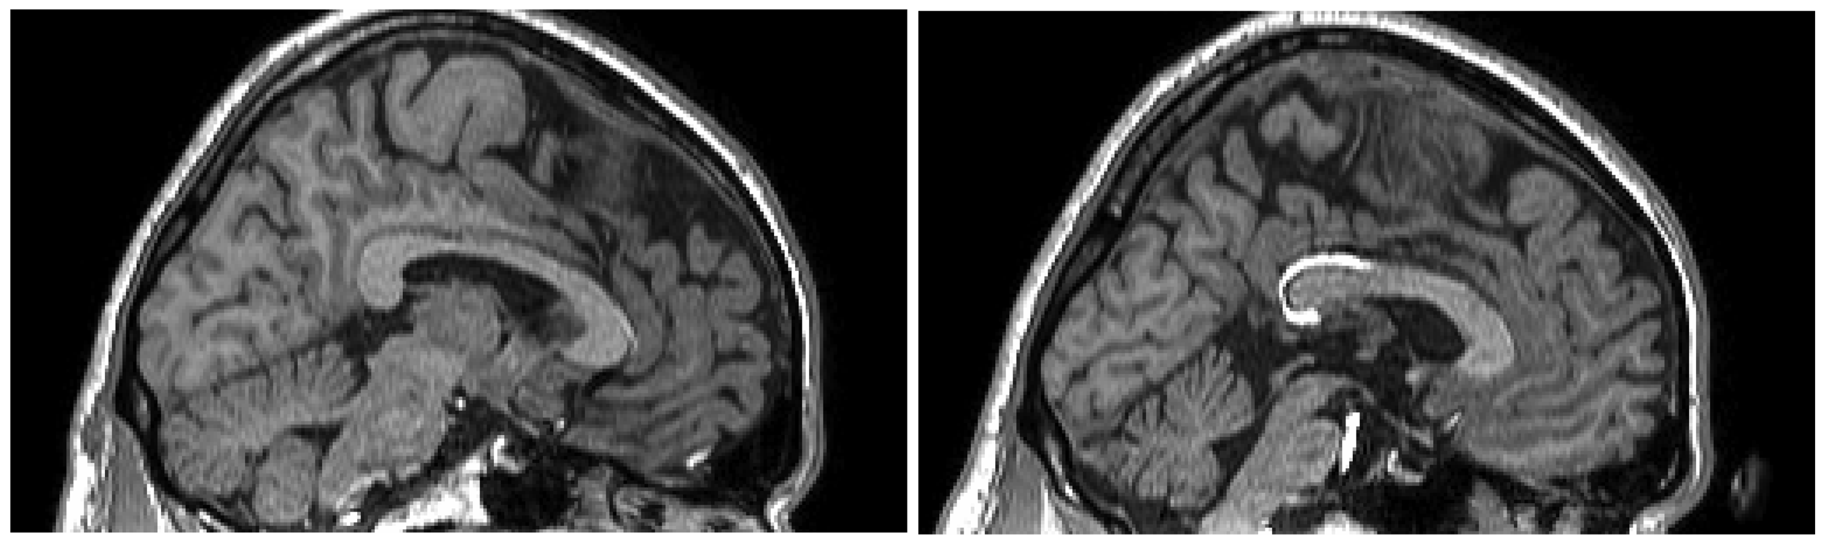
Figure 1. Midsagittal views of the brains of A.J. (left) and At.J. (right). The area of hyperintensity on the T1-weighted scan is the bright region surrounding the splenium (posterior corpus callosum).

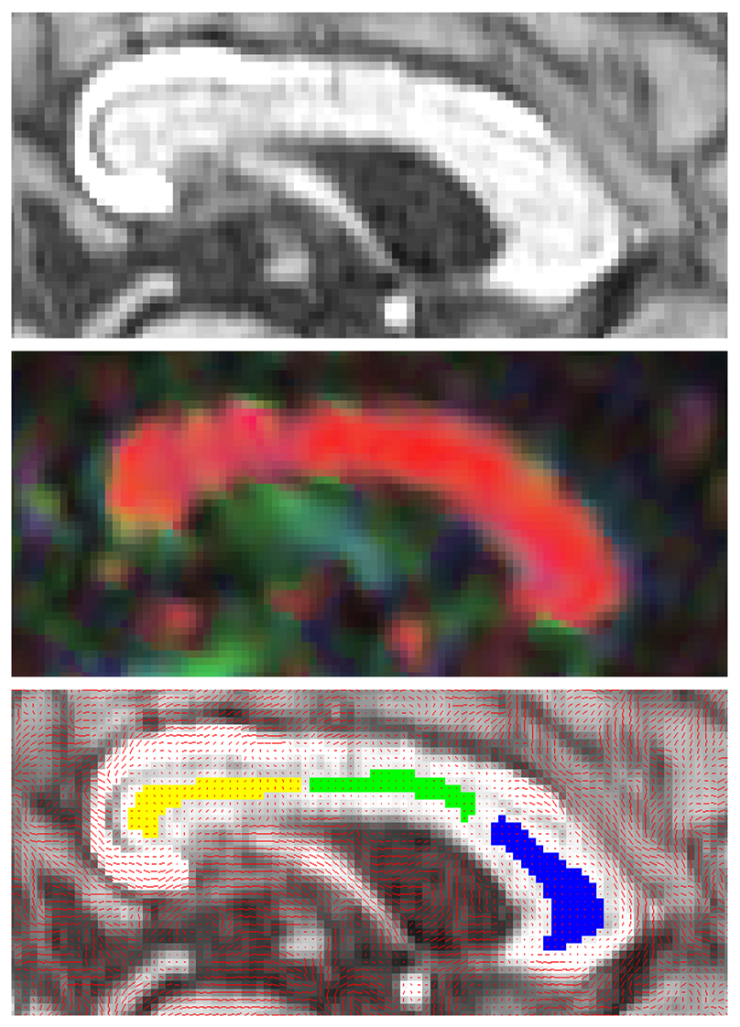
Figure 2. Three images demonstrating ROI placement. Top panel: a T1-weighted image of A.J.’s corpus callosum. Middle panel: principle axis of diffusion for each voxel (red= left/right; blue= superior/inferior; green= anterior/posterior) with brightness scaled by fractional anisotropy (1=brightest, 0=black). Bottom panel: three coloured ROIs overlaid on A.J.’s structural image. Red lines represent the principle axis of diffusion at each voxel.

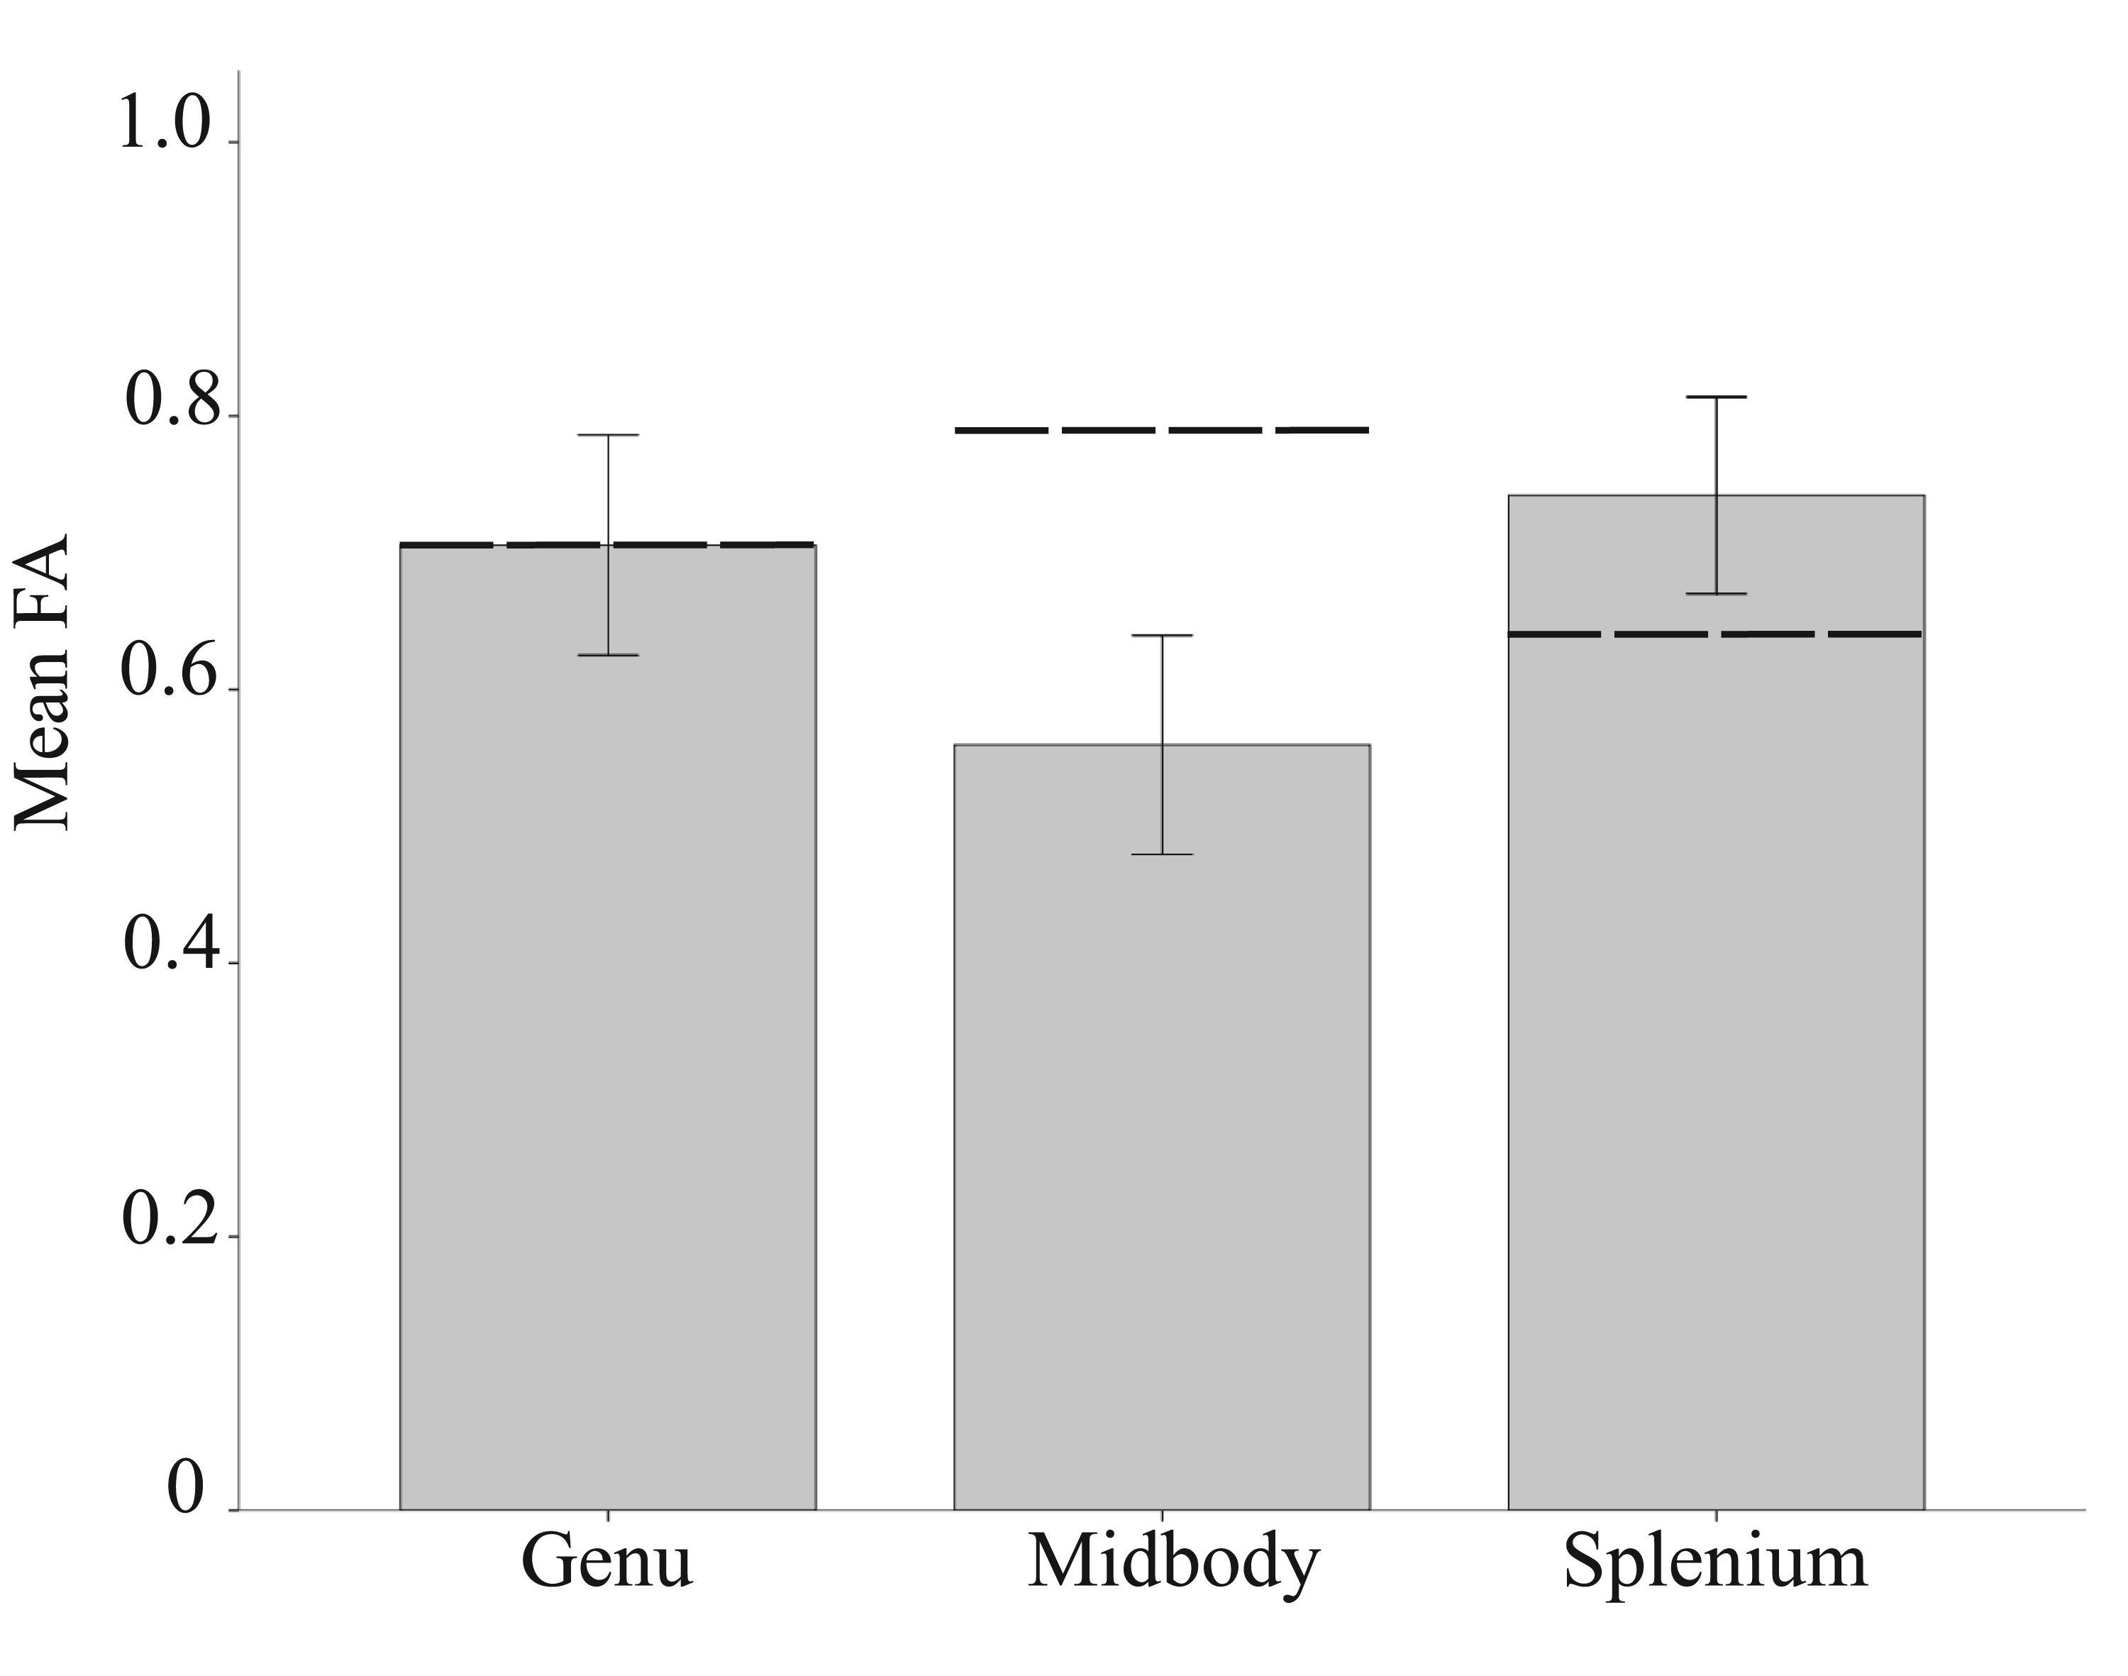
Figure 3. Mean FA within three ROIs for the control group, with error bars showing two standard deviations. A.J.’s FA values are shown as black bars.
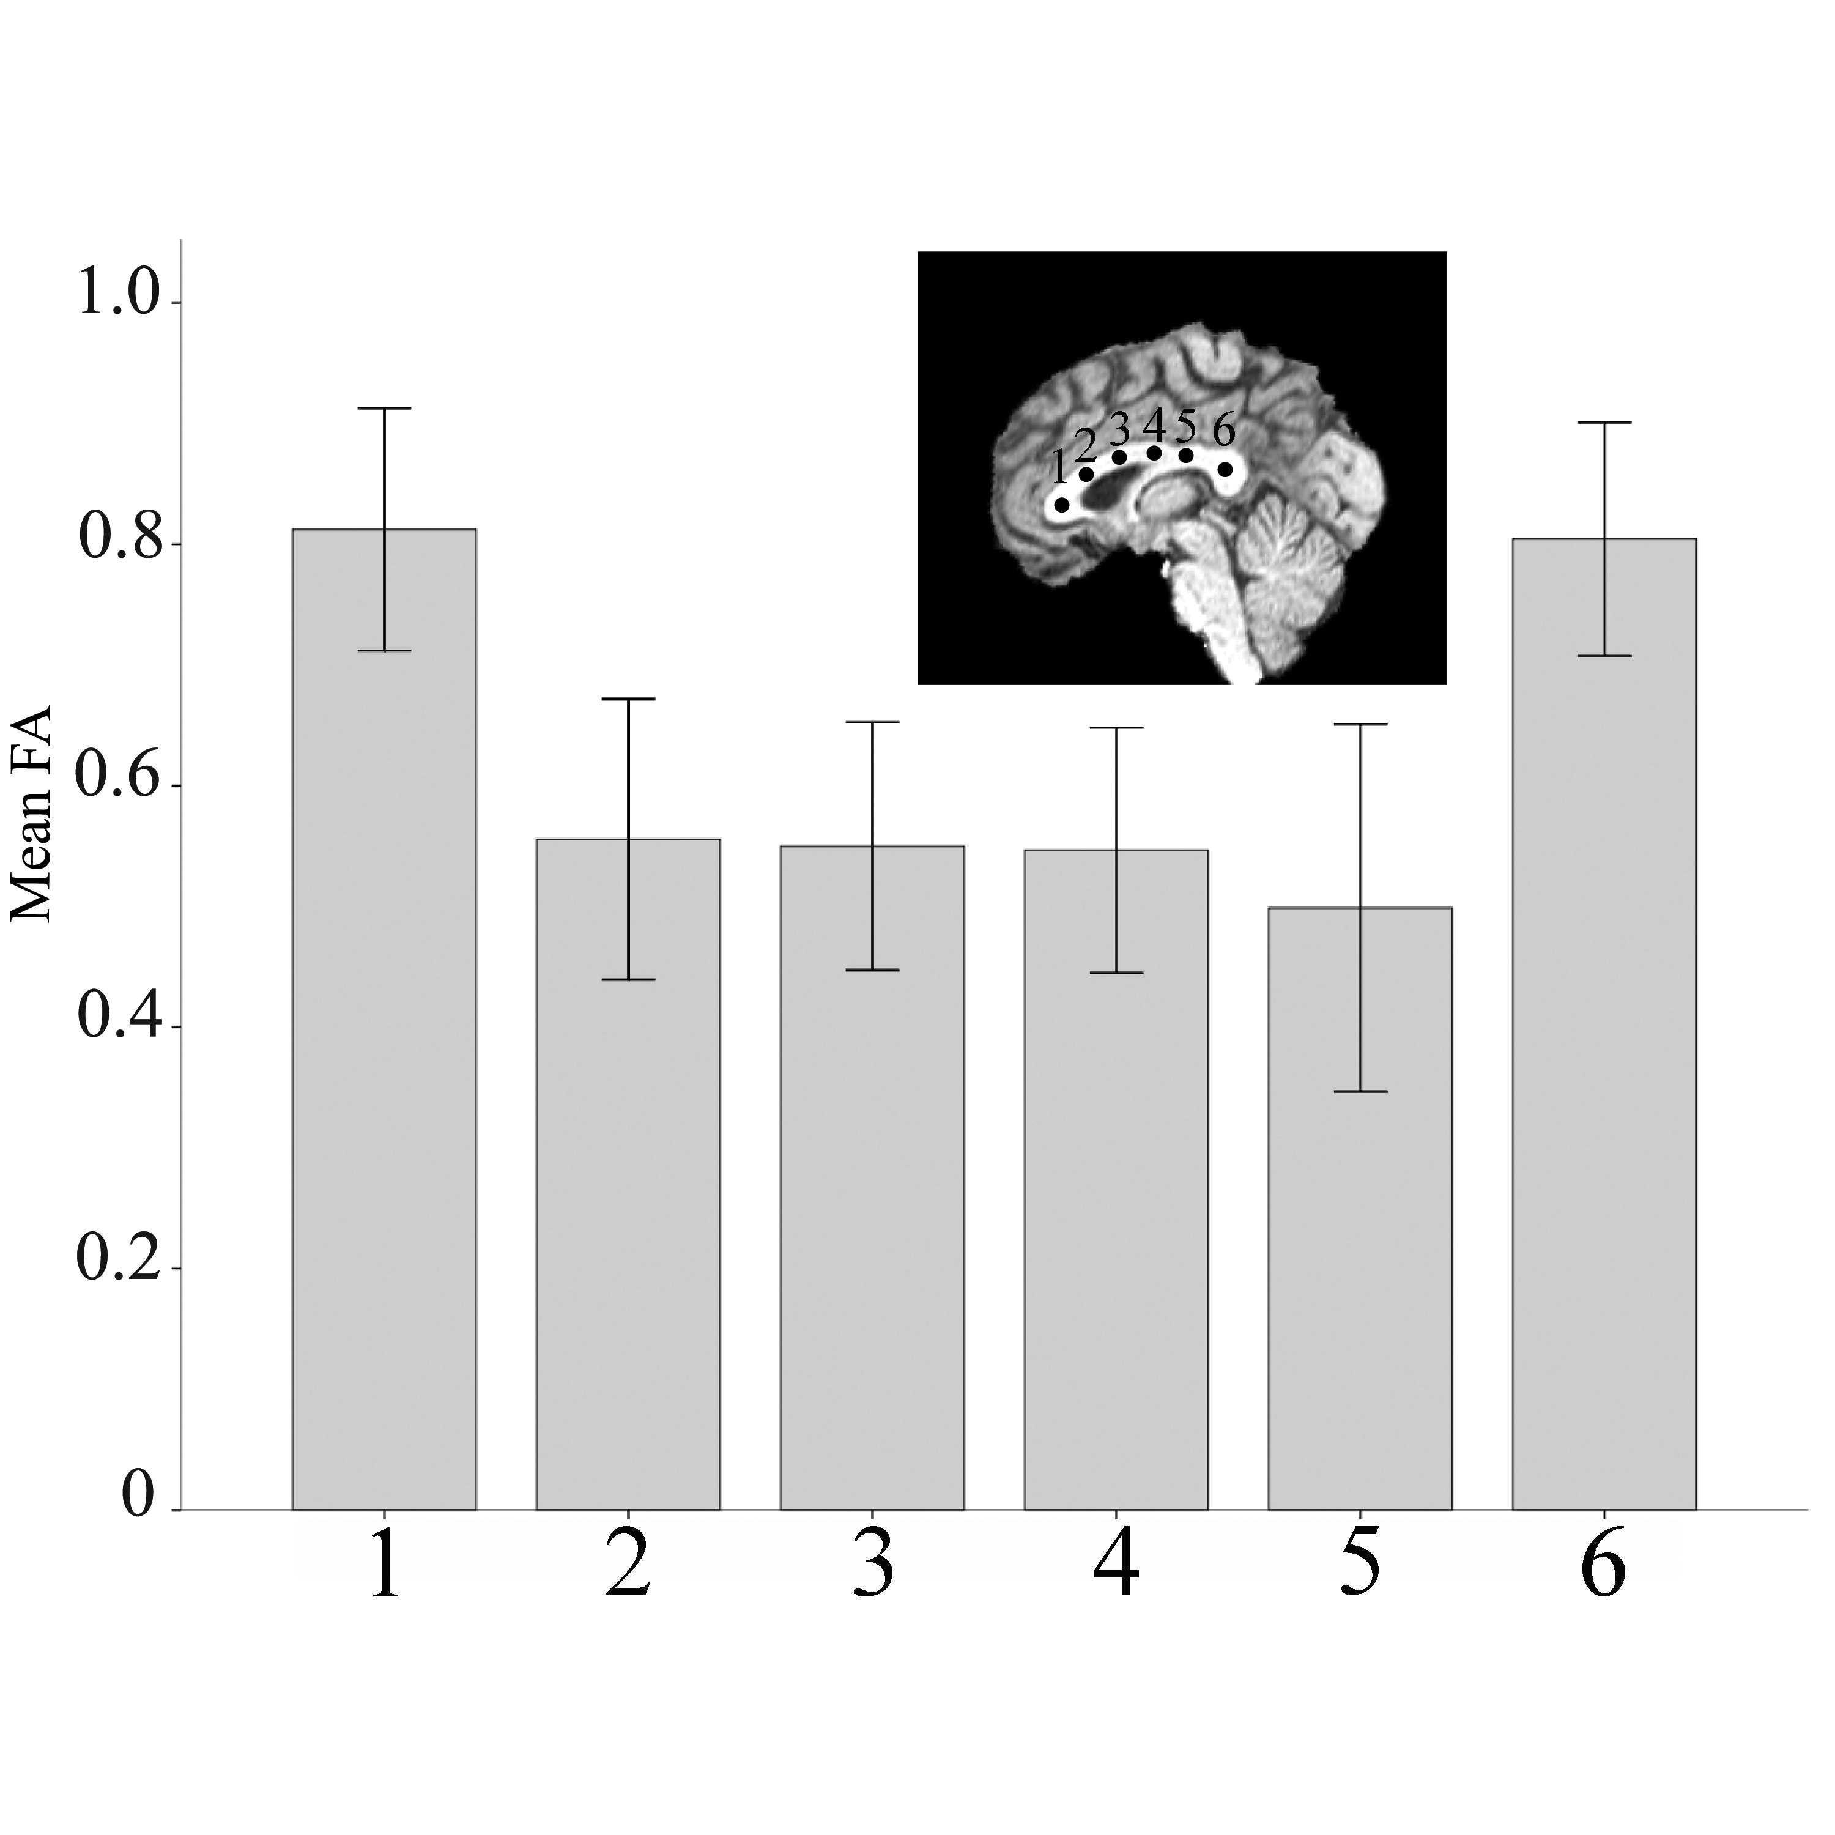
Figure 4. Mean FA within six spherical ROIs for the control group.

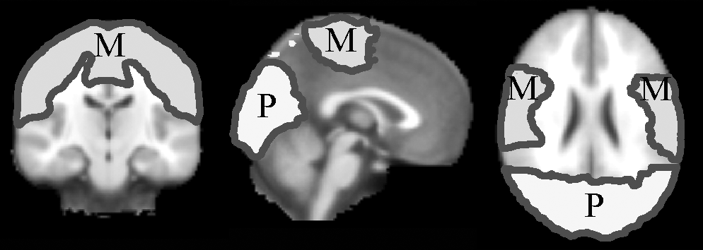
Figure 5. Cortical target regions for probabilistic fibre tracking shown on a template brain image. The Posterior target mask is shown in yellow and red. The Middle cortical target mask is shown in cyan and blue.

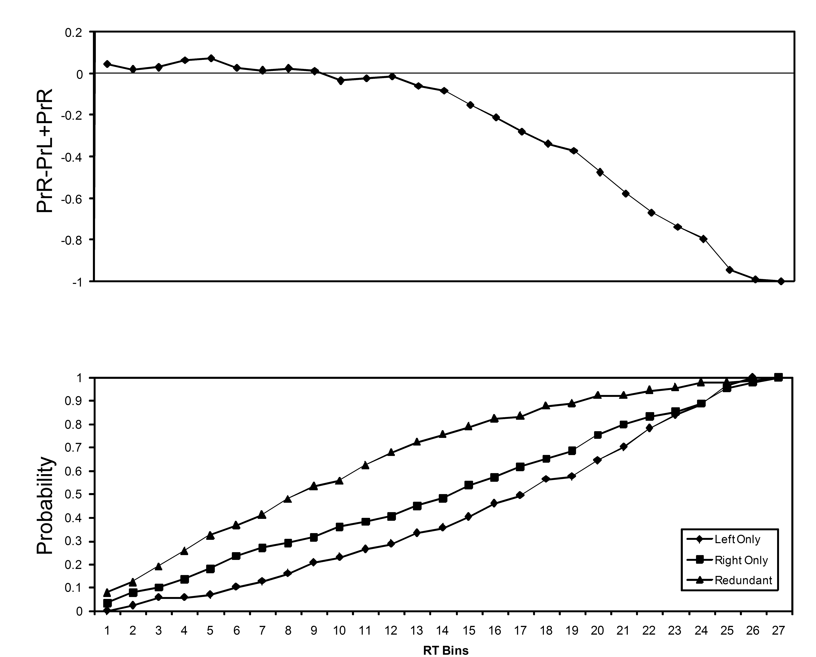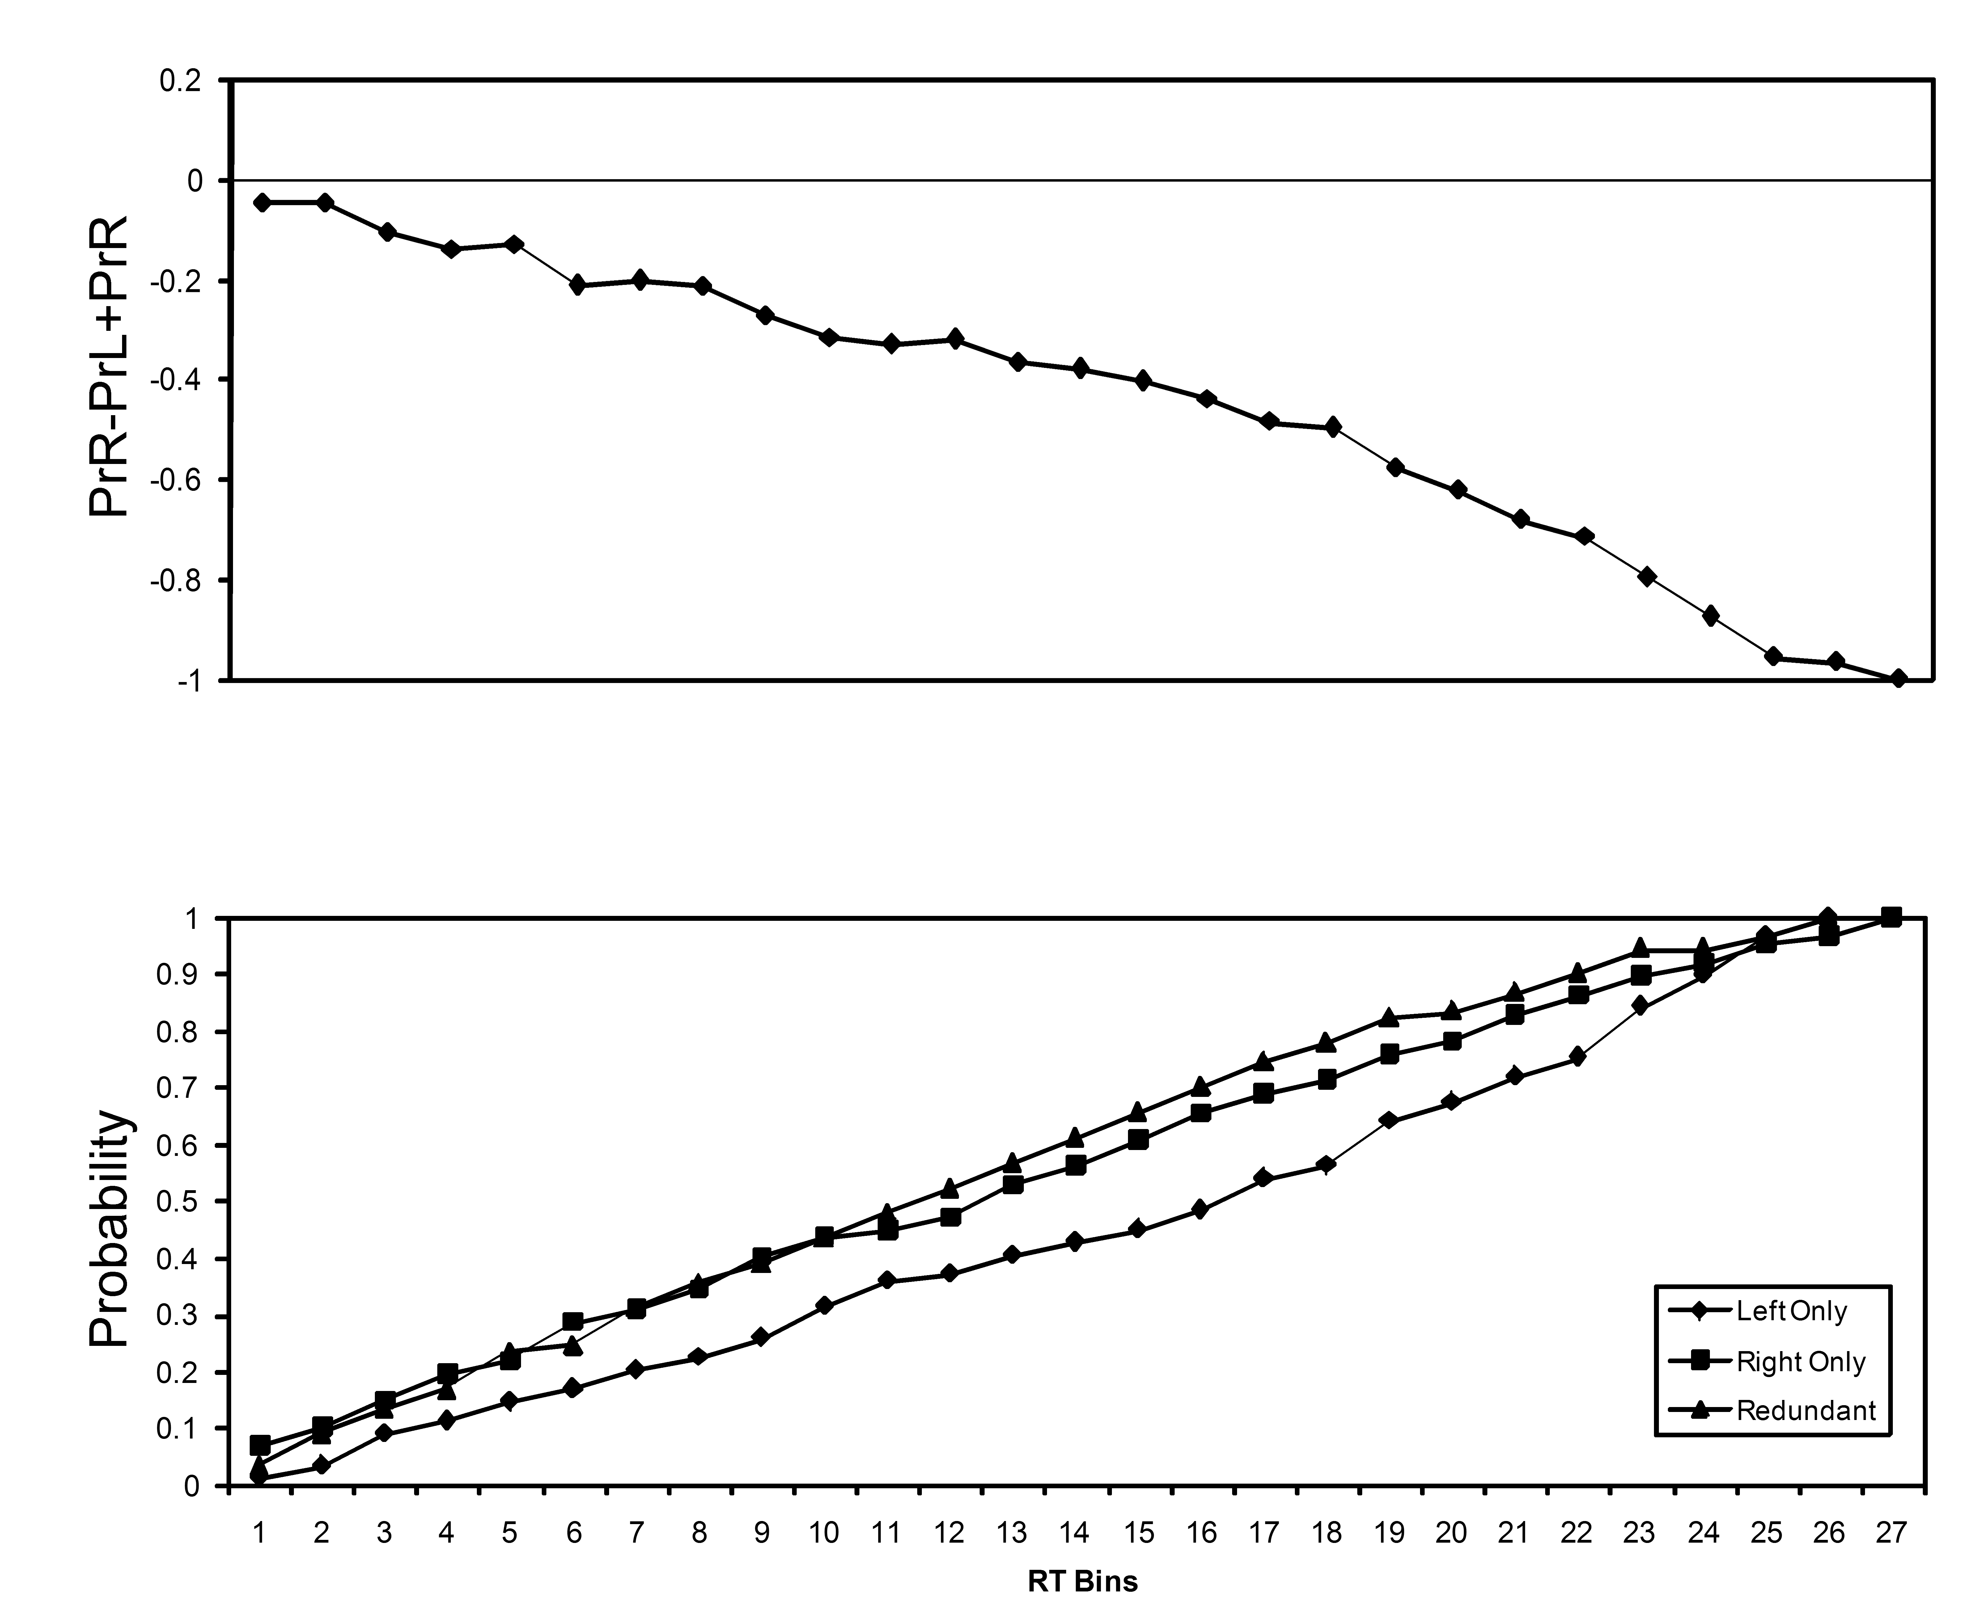
Figure 6. Panel A. Cumulative probabilities for left-hand responses by A.J. to three stimulus conditions are shown in the bottom panel. The outcome of equation 1for A.J.’s left-hand responses. Points above 0 indicate violation of the race inequality.
Panel B. Cumulative probabilities and the outcome of equation 1for A.J.’s right-hand responses.

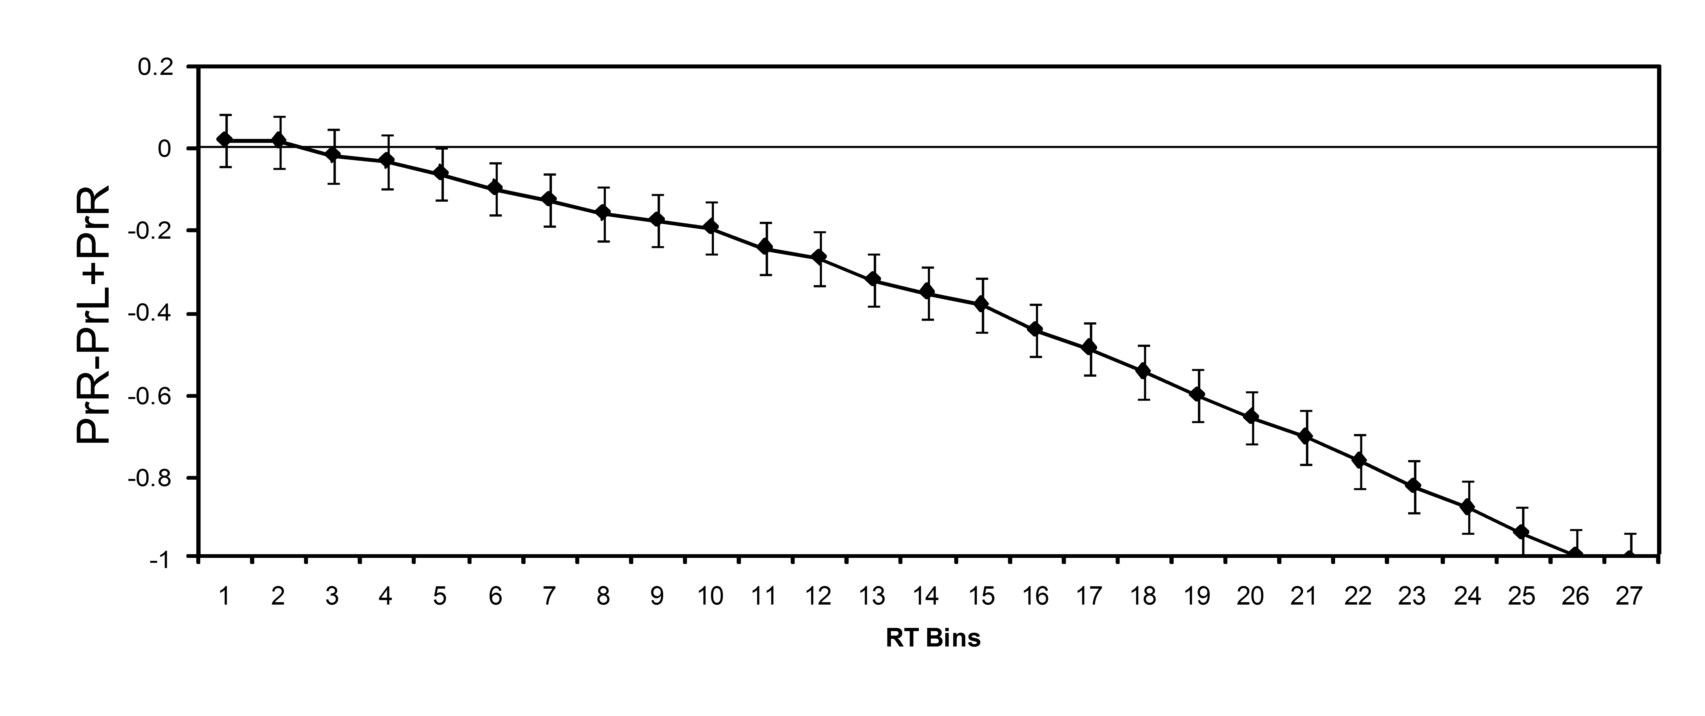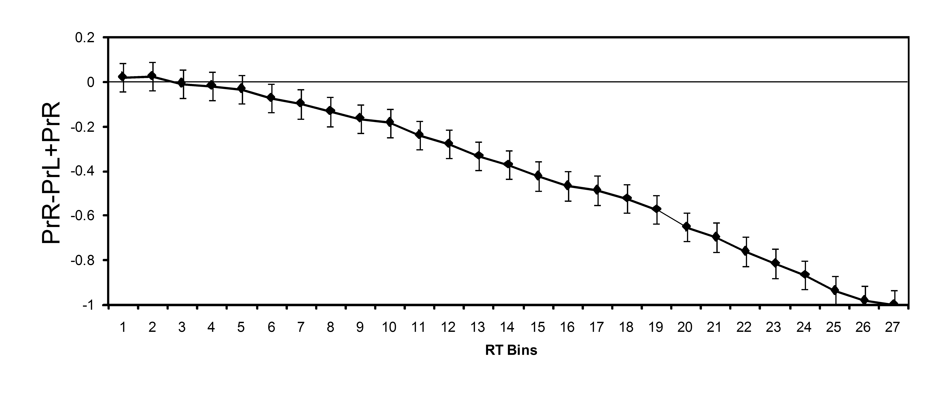
Figure 7. Panel A. The outcome of equation 1for control subjects’ left-hand responses. Panel B. The outcome of equation 1for control subjects’ right-hand responses.

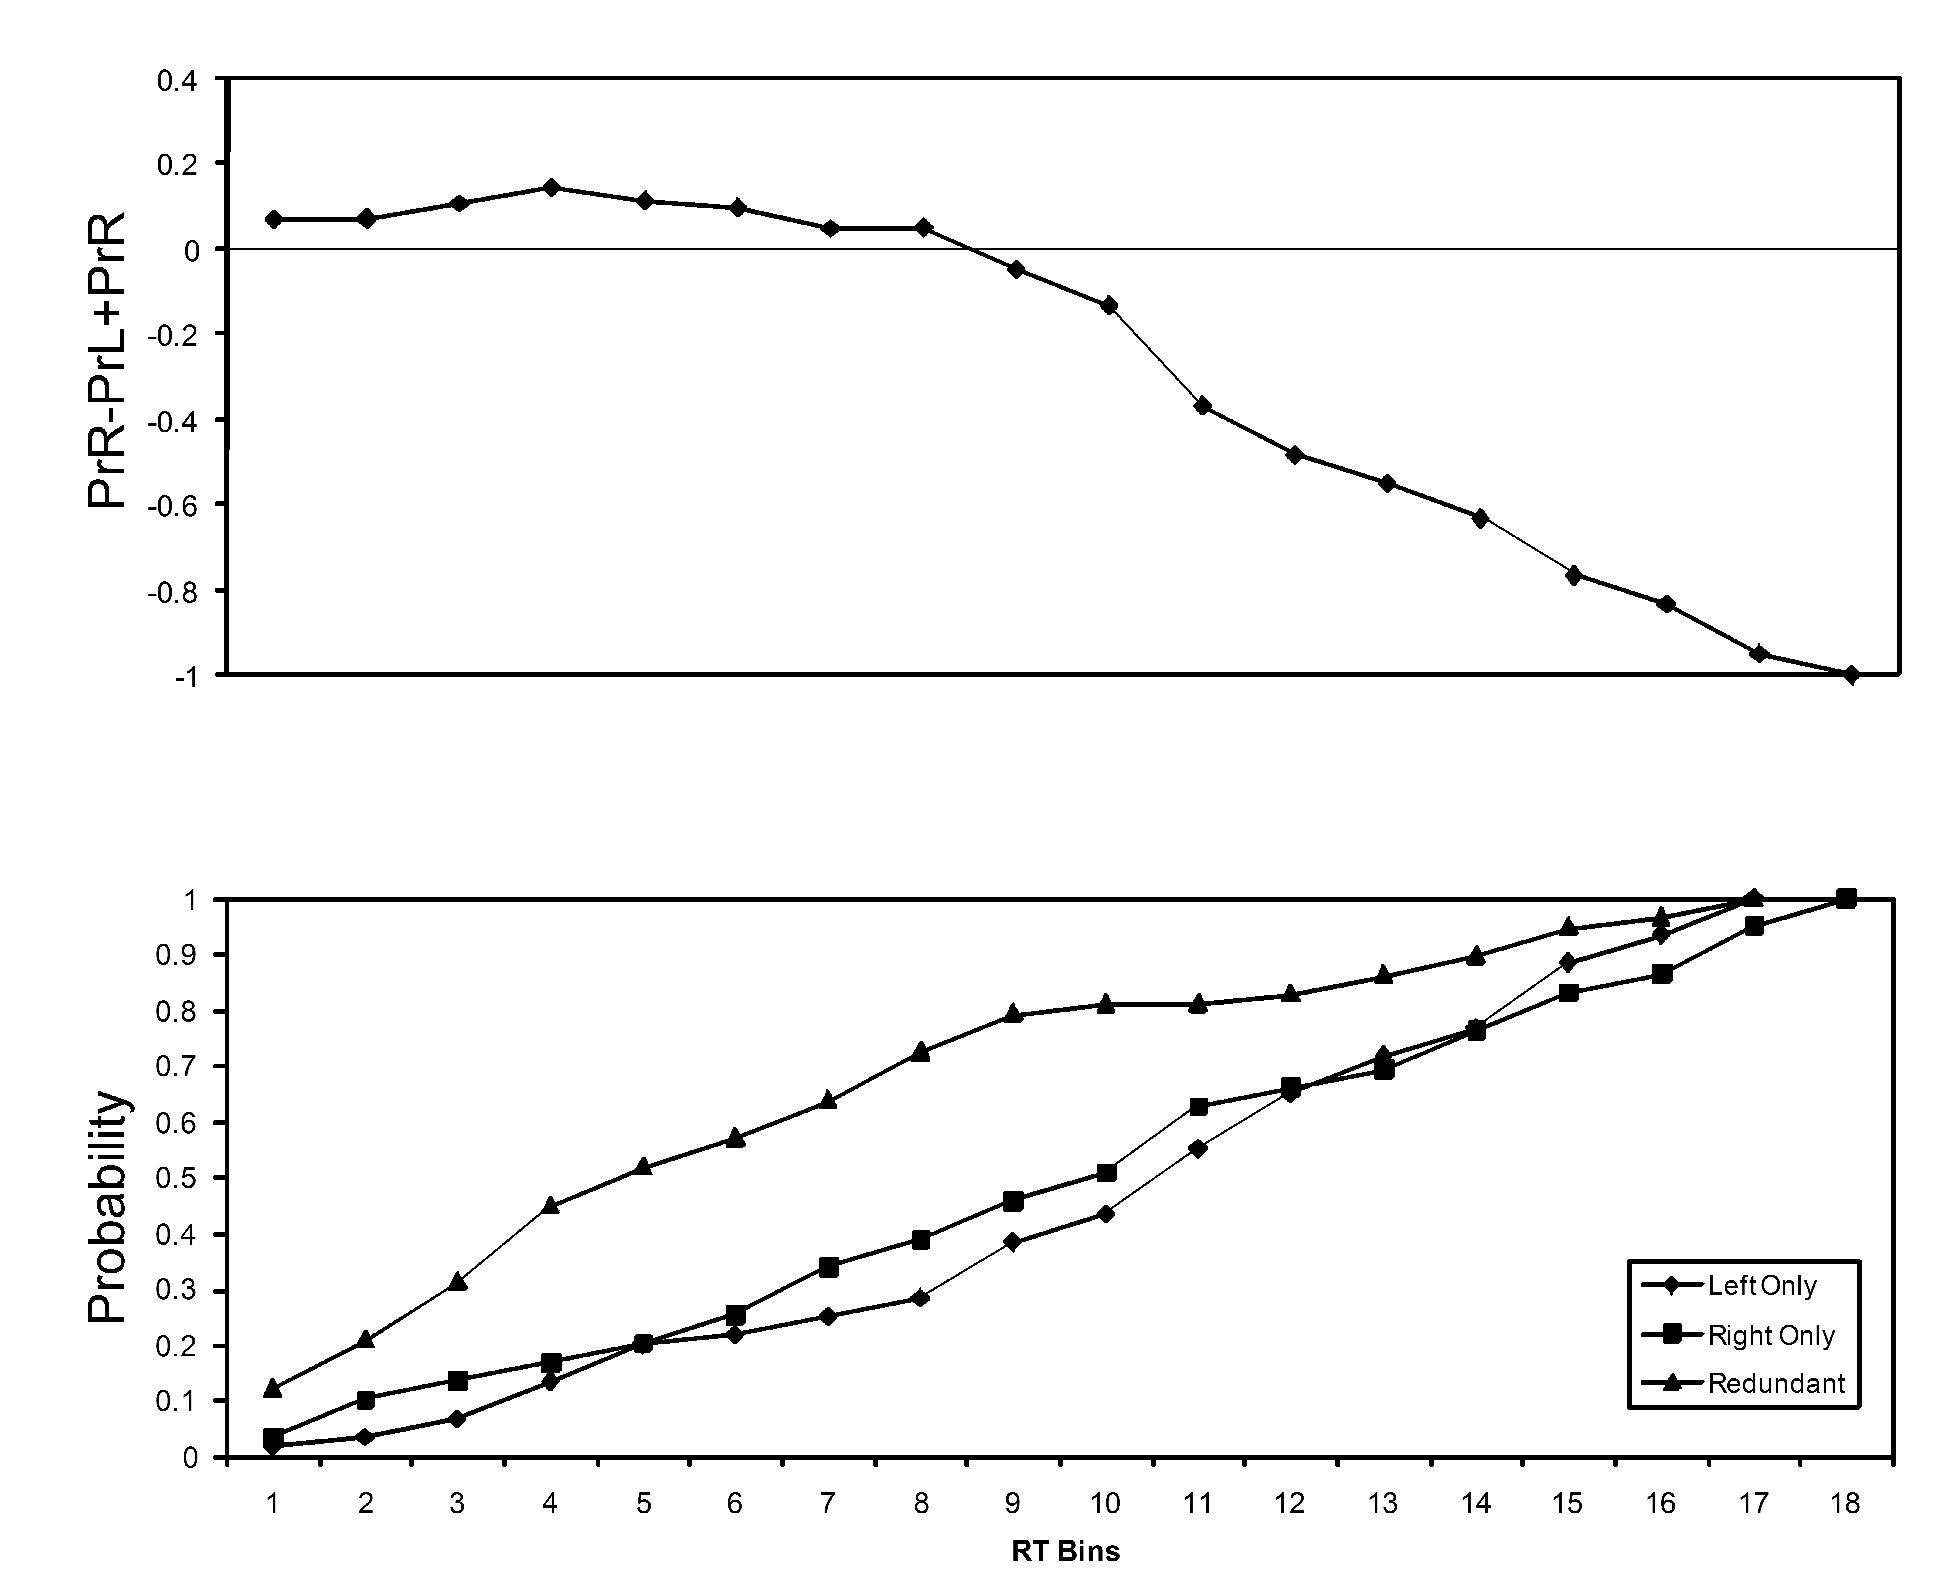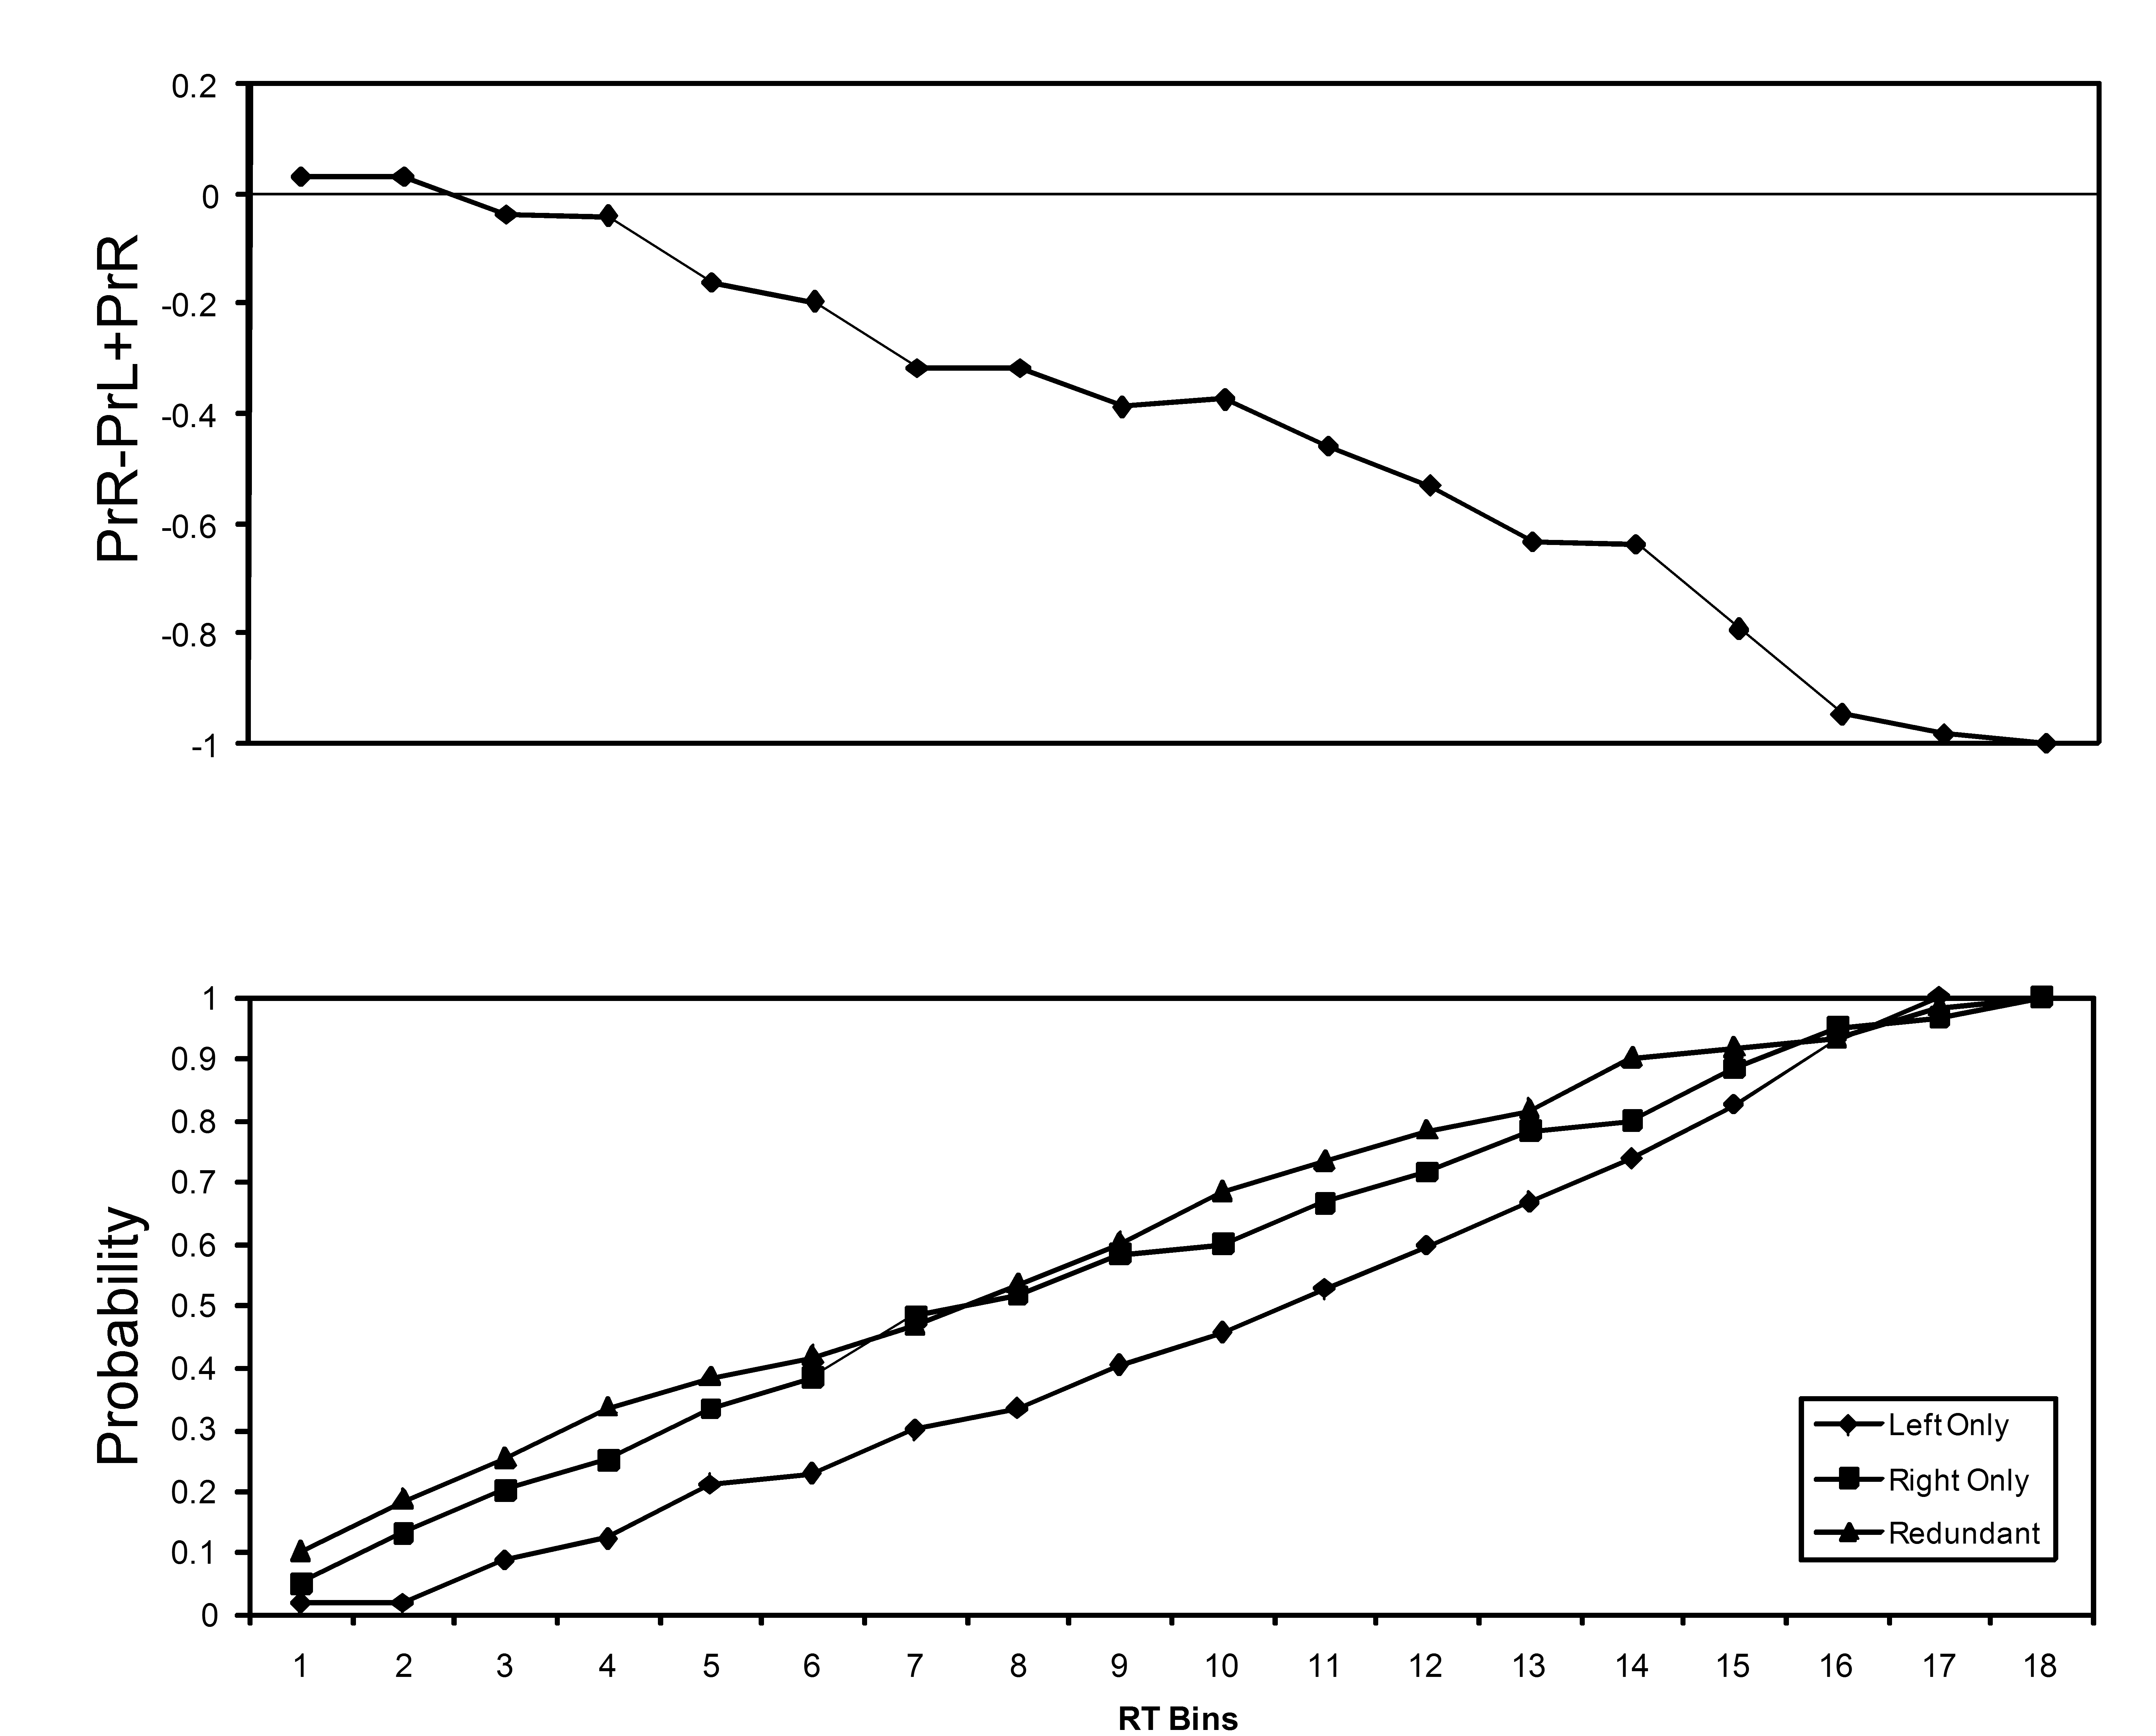
Figure 8. Panel A. Cumulative probabilities (bottom panel) and the outcome of equation 1 (top panel) for left-hand responses by A.J. in Experiment 2.
Panel B. Cumulative probabilities and the outcome of equation 1for A.J.’s right-hand responses.

