Supplementary Information
Figure S1 Comparison of displacement data (record section A, black traces) and synthetics (red traces) at epicentral distances of 14-17 degrees.

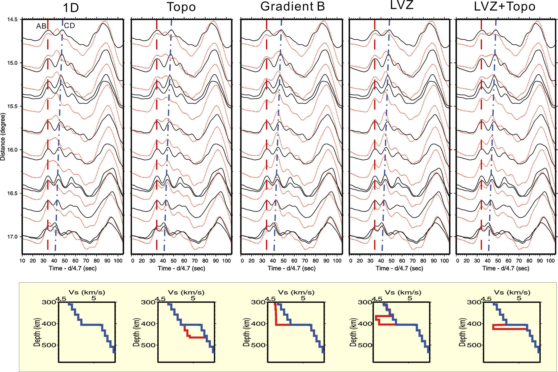

Figure S2 Comparison of tangential displacement data (record section B, black traces) and synthetics (red traces) at epicentral distances of 14-17 degrees.

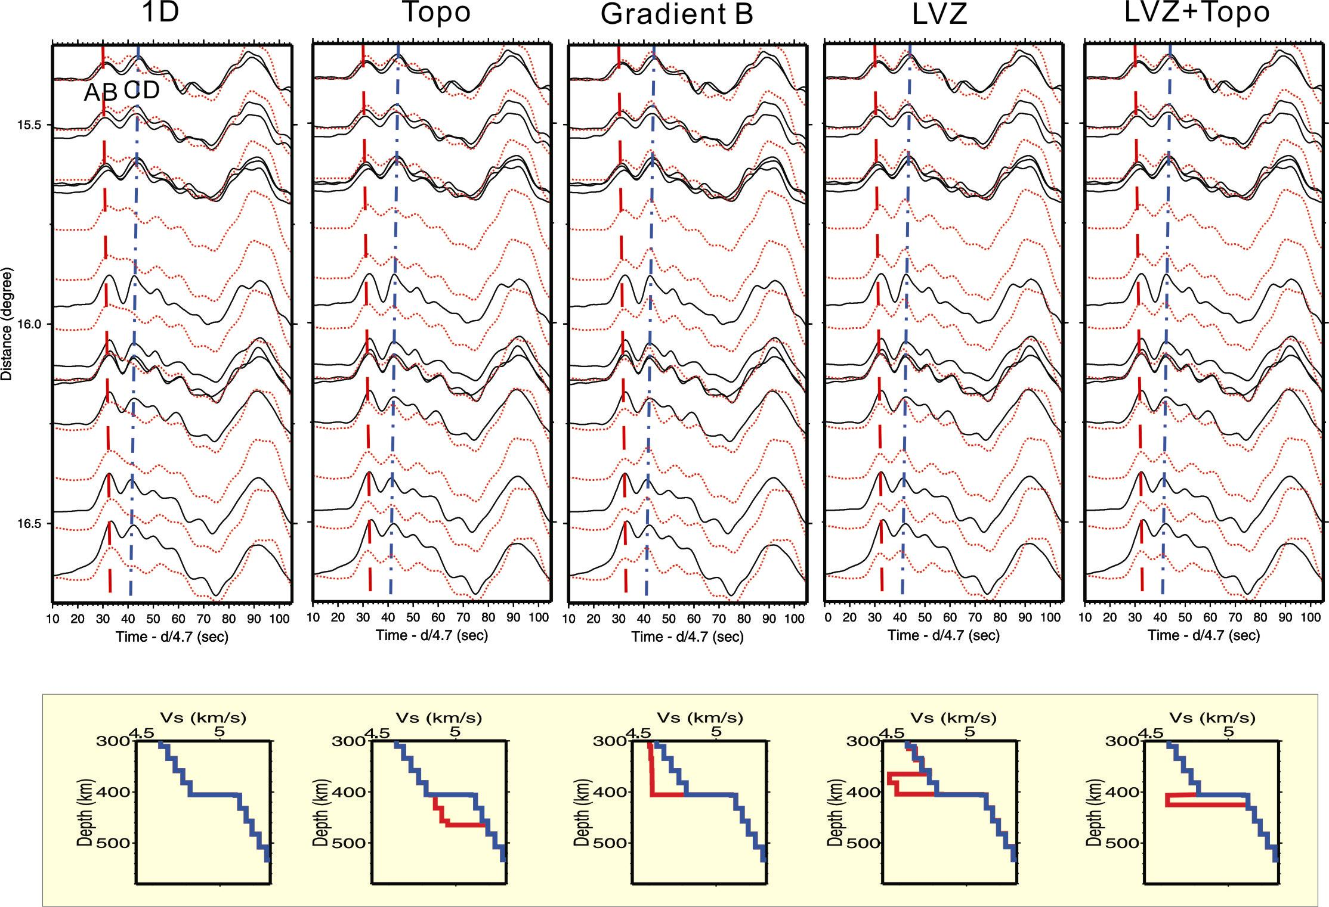

Figure S3 Comparison of synthetics at epicentral distances of 21-23 degrees.
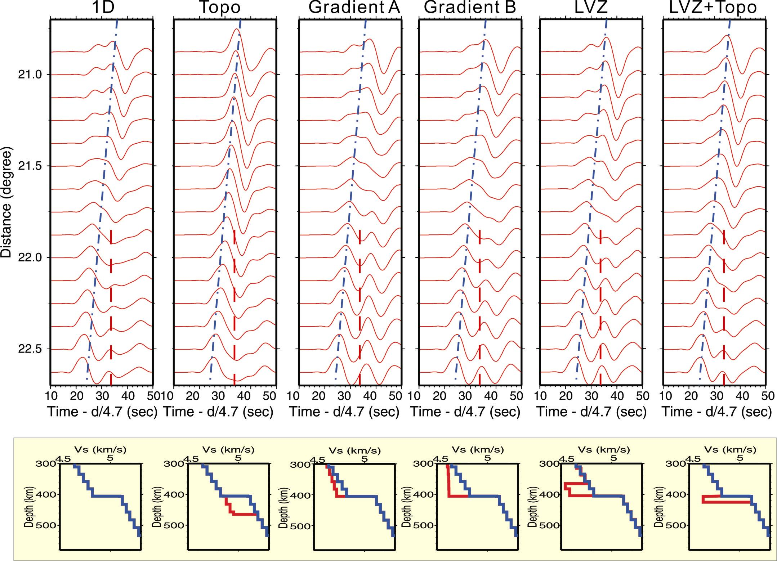

Supplementary Figure Legends
Supplementary Figure 1 Comparison of tangential displacement data (record section A, black traces) and synthetics (red dotted traces) at epicentral distances of 14-17 degrees. Velocity models used in calculating synthetics are shown directly below the record sections. Each inset below the record section shows the perturbed model (red line) and the reference model (blue line). Dashed and dashed-dotted lines indicate triplication branches AB (red) and CD (blue), respectively.

Supplementary Figure 2 Comparison of tangential displacement data (record section B, black traces) and synthetics (red dotted traces) at epicentral distances of 14-17 degrees. Velocity models used in calculating synthetics are shown directly below the record sections. Each inset below the record sections shows the perturbed model (red line) and the reference model (blue line). Dashed and dashed-dotted lines indicate triplication branches AB (red) and CD (blue), respectively.

Supplementary Figure 3 Comparison of synthetics (red traces) at epicentral distances of 21-23 degrees. Synthetics computed from various velocity models, which are shown directly below the synthetics. Each inset below the record sections shows the perturbed model (red line) and the reference model (blue line). Dashed and dashed-dotted lines indicate observed triplication branches AB (red) and CD (blue), respectively. Note models with strong low velocity zone produce the secondary pulse after epicentral distance of about 22 degree.
Supplementary Methods
Waveform modeling
The 1-D reference S model is modified from TNA model¹⁰. We adopt an average upper mantle velocity from 3-D mantle velocity model constructed for the western United States1¹². The reference depth of the 410 is at 405 km with 5 % jump in shear velocity. In addition, the thickness of the crust is fixed at 30 km while we vary the thickness of lithosphere (20-40 km) to match the entire waveforms from the AB branch to the Love wave. Synthetics are computed by the FK reflectivity method⁹ with earthquake parameters from Harvard Centroid Moment Tensor solutions.

Receiver function modeling
The synthetic receiver function is computed with reflectivity method via a given 1-D velocity model. We simulate stacked receiver function by randomly stacking synthetic receiver functions. Those synthetic receiver functions are computed from velocity models with variations in the thickness (20-90 km) of a LVZ atop the 410 and discontinuity topography (20-60 km). A Gaussian filter of 0.5 Hz is applied to each synthetic receiver function.

