Some Critical Thoughts on Computational Materials Science

Dierk Raabe

Max–Planck–Institut für Eisenforschung
Max–Planck–Str. 1, 40237 Düsseldorf, Germany

A Model is a Model is a Model is a Model
The title of this report is of course meant to provoke. Why? Because there always exists a menace of confusing models with reality. Does anyone now refer to “first principles simulations”? This point is well taken. However, practically all of the current predictions in this domain are based on simulating electron dynamics using local density functional theory. These simulations, though providing a deep insight into materials ground states, are not exact but approximate solutions of the Schrödinger equation, which - not to forget - is a model itself [1]. Does someone now refer to “finite element simulations”? This point is also well taken. However, also in this case one has to admit that approximate solutions to large sets of non-linear differential equations formulated for a (non-existing) continuum under idealized boundary conditions is what it is: a model of nature but not reality.

But us let calm down and render the discussion a bit more serious: current methods of ground state calculations are definitely among the cutting-edge disciplines in computational materials science and the community has learnt much from it during the last years. Similar aspects apply for some continuum-based finite element simulations. After all this report is meant to attract readers into this exciting field and not to repulse them. And for this reason I feel obliged to first make a point in underscoring that any interpretation of a research result obtained by computer simulation should be accompanied by scrutinizing the model ingredients and boundary conditions of that calculation in the same critical way as an experimentalist would check his experimental set-up.

In the following I will address some important aspects of computational materials science. The selection is of course biased (more structural than functional; more metals than non-metals; more mesoscale than atomic scale). I will try to reach a balance between fundamental and applied topics. The report focuses particularly on topics and publications of 2001 and 2002.

Introduction into the Semantics of Modeling and Simulation
Before going into medias res let us revisit some basic thoughts on the semantics of modeling and simulation. The words modeling and simulation are often distinguished by somewhat arbitrary arguments or they are simply used synonymously. This lack of clarity reflects that concepts in computational materials science develop faster than semantics. For elaborating a common language in this field, a less ambiguous definition of both concepts might be helpful. In current understanding the word modeling (model (Latin, Italian): copy, replica, exemplar) often covers two quite different meanings, namely, model formulation and numerical modeling. The latter term is frequently used as a synonym for numerical simulation (simulare (Latin): fake, duplicate, mimic, imitate). I think that the general synonymous use of the terms modeling and simulation is not an ideal choice. Rosenblueth and Wiener [2] offered an elegant comment on this point which underlines that the creation of models encompasses a much more general concept than simulation. According to their work the general intention of a scientific inquiry is to obtain an understanding and a control of some parts of the universe. However, most parts of the real world are neither sufficiently obvious nor simple that they could be grasped and controlled without abstraction. Scientific abstraction consists in replacing the part of the real world under investigation by a model. This process of designing models can be regarded as the genuine scientific method of formulating a simplified imitation of a real situation with preservation of its essential features. In other words, a model describes a part of a real system by using a similar but simpler structure. Abstract models can thus be regarded as the basic starting point of theory. However, it must be underlined that there exists no such thing as a unified exact method of deriving models. This applies particularly for the materials sciences, where one deals with a large variety of scales, mechanisms, and parameters. The notion simulation, in contrast, is often used in the context of running computer codes which have been designed according to a certain model. A more detailed discussion of these admittedly philosophical aspects is given in [3,4].

Microstructure Research or the Hunt for Mechanisms
While the evolutionary direction of microstructure is prescribed by thermodynamics, its actual evolution path is selected by kinetics. It is this strong influence of thermodynamic non-equilibrium mechanisms that entails the large variety and complexity of microstructures typically encountered in materials. It is an essential observation that it is not those microstructures that are close to equilibrium, but often those that are in a highly non-equilibrium state that provide advantageous material properties. Following Haasen [5] microstructure can be understood as the sum of all thermodynamic non-equilibrium lattice defects on a space scale that ranges from Angstrøms (point defects) to meters (sample surface). Its temporal evolution ranges from picoseconds (dynamics of atoms) to years (fatigue, creep, corrosion, diffusion). Haasens`s definition clearly underlines that microstructure does not mean micrometer, but non-equilibrium.

Some of the previously suggested size- and time-scale hierarchy classifications group microstructure research into macroscale, mesoscale, and microscale (recently, nanoscale has become very popular, too) (Fig. 1). They take a somewhat different perspective at this topic in that they refer to the real length scale of microstructures (often ignoring the intrinsic time scales). This might oversimplify the situation and suggest that we can linearly isolate the different space scales from each other. In other words the classification of microstructures into a scale sequence merely reflects a spatial rather than a crisp physical classification (Table 1). For instance, small defects, such as dopants, can have a larger influence on strength or conductivity than large defects such as precipitates. Or think of the highly complex phenomenon of shear banding. These can be initiated not only by interactions among dislocations or between dislocations and point defects but as well by a stress concentration introduced by the local sample shape, surface topology, or processing method.

Scale | Quantum-  mechanics | Molecular-  dynamics | Mesoscopic | Macroscopic
Time scales (s) | 10⁻¹⁶ – 10⁻¹² | 10⁻¹³ – 10⁻¹⁰ | 10⁻¹⁰ – 10⁻⁶ | > 10⁻⁶
Length scales (m) | 10⁻¹¹ – 10⁻⁸ | 10⁻⁹ – 10⁻⁶ | 10⁻⁶ – 10⁻³ | > 10⁻³

However, if we accept that everything is connected with everything and that linear scale separation could blur the view on important scale-crossing mechanisms what is the consequence of this insight? One clear answer to that is: we do what materials scientists always did - we look for mechanisms. Let us be more precise. While former generations of materials researchers often focused on mechanisms or effects that pertain to single lattice defects and less complex mechanisms not amenable to basic analytical theory or experiments available in those times, present materials researchers have three basic advantages for identifying new mechanisms: First, ground state and molecular dynamics simulations have matured to a level at which we can exploit them to discover possible mechanisms at high resolution and reliability. This means that materials theory is standing - in terms of the addressed time and space scale - for the first time on robust quantitative grounds allowing us insights we could not get before. It is hardly necessary to mention the obvious benefits arising from increased computer power in this context. Second, experimental techniques have been improved to such a level that - although sometimes only with enormous efforts – new theoretical findings can be critically scrutinized by experiment (e.g. microscopy, nanomechanics, diffraction). Third, due to advances in both, theory and experiment more complex, self-organizing, critical, and collective non-linear mechanisms can be elucidated which cannot be understood by studying only one single defect or one single length scale.

All these comments can be condensed to the statement, that microstructure simulation - as far as a fundamental understanding is concerned - consists in the hunt for key mechanisms. Only after identifying those we can (and should) make scale classifications and decide how to integrate them into macroscopic constitutive concepts or subject them to further detailed investigation. In other words the mechanisms that govern microstructure kinetics do not know about scales. It was often found in materials science, that - once a basic new mechanism or effect was discovered - a subsequent avalanche of basic and also phenomenological work followed opening the path to new materials, new processes, new products, and sometimes even new industries. Well known examples are the dislocation concept, transistors, aluminium reduction, austenitic stainless steels, superconductivity, or precipitation hardening. The identification of key mechanisms, therefore, has a bottleneck function in microstructure research and computational materials science plays a key-role in it. This applies particularly when closed analytical expressions cannot be formulated and when the investigated problem is not easily accessible to experiments.

Fig. 1
Example of a multi-scale simulation for the automotive industry.

Standard Models for Microstructure Simulation

Who needs electrons and atoms?
In the introduction we mentioned the predictive power of ground state and molecular dynamics calculations. But how about possible collective mechanisms above this scale? Understanding microstructure mechanisms at these scales requires the use of adequate simulation methods. This domain which is sometimes referred to as computational microstructure science is rapidly growing in terms of both, improved computational methods and scientific harvest. Among these especially the various Ginzburg-Landau based phase field kinetic models, discrete dislocation dynamics, cellular automata, Potts-type q-state models, vertex models, crystal plasticity finite element models, and texture component crystal plasticity finite element models deserve particular attention.

The predictive power of these approaches depends to a large extent on their approach to deal with the transition from the quantum and atomic scale to the continuum scale. In other words there exist currently only three basic theoretical standard approaches to map matter in a model, namely the quantum scale (dynamics of electrons, relaxation of nuclei), the atomic scale (atom and molecular dynamics), and the continuum scale. An essential challenge in any computational materials approach, therefore, lies in bringing these three concepts into agreement and avoid contradictions. This means that simulation approaches which are formulated at different scales should provide very similar results when tackling the same problem. For instance, some dislocation mechanisms have recently been simulated using phase field theory [6], line tension modeling [7], and even Monte Carlo simulation [8]. In the following I will enter the field of continuum simulations far above the quantum and atomic scale and review recent progress achieved by some of the important methods in this domain.

Ginzburg-Landau-type phase field kinetic models
The capability of predicting equilibrium and non-equilibrium phase transformation phenomena at a microstructural scale is among the most challenging topics in materials science. This is due to the fact that a detailed knowledge of the structural, topological, morphological, and chemical characteristics of microstructures that arise from transformations forms the basis of most microstructure-property models. It becomes more and more apparent that classical thermodamic models are increasingly limited when it comes to the prediction of new materials solely on the basis of free-energy equilibrium data. This is due to the strong dominance of the kinetic boundary conditions of many new materials which have microstructures far away from equilibrium. While the thermodynamics of phase transformation phenomena only prescribes the general direction of microstructure evolution, with the final tendency to eliminate all non-equilibrium lattice defects, the kinetics of the lattice defects determines the actual microstructural path. The dominance of kinetics in structure evolution of technical alloys has the effect that the path towards equilibrium often leads the system through a series of competing non-equilibrium states. For this reason simulation methods in this field which are exclusively build on thermodynamics will be increasingly replaced by approaches which use both, the thermodynamic potentials, considering also elastic and electromagnetic contributions, and the kinetic coefficients of the diffusing atoms and of the lattice defects involved. Among the most versatile approaches in this domain are the Cahn-Hilliard and Allen-Cahn kinetic phase field models, which can be regarded as metallurgical derivatives of the theories of Onsager and Ginzburg-Landau. These models represent a class of very general and flexible phenomenological continuum field approaches which are capable of describing continuous and quasi-discontinuous phase separation phenomena in coherent and non-coherent systems. The term quasi-discontinuous means that the structural and/or chemical field variables in these models are generally defined as continuous spatial functions which change smoothly rather than sharply across internal interfaces. The models can work with conserved field variables (e.g. chemical concentration) and with nonconserved variables (e.g. crystal orientation, long-range order, crystal structure). While the original Ginzburg-Landau approach was directed at calculating second-order phase transition phenomena, metallurgical variants are capable of addressing a variety of transformations in matter such as spinodal decomposition, ripening, non-isostructural precipitation, grain growth, solidification, and dendrite formation in terms of corresponding chemical and structural phase field variables [9-11].

Important contributions to this field in the last months were published by Wen et al. [12] who investigated the influence of an externally imposed homogeneous strain field on a coherent phase transformation in the Ti–Al–Nb system. A related simulation study by Dreyer and Müller [13] addressed phase separation and coarsening in eutectic solders. Another recent contribution was by Wang et al. [6] who formulated a phase field approach for tackling the evolution of sets of dislocations in an elastically anisotropic continuum under an applied external stress. Jin et al. [14] recently performed simulations of martensitic transformation in polycrystals. Mullis and Cochrane [15] investigated the origin of spontaneous grain refinement in undercooled metallic melts using the phase-field method. Wen et al. [16] tackled the coarsening kinetics of self-accommodating coherent domain structures using a continuum phase-field simulation.

Discrete dislocation dynamics
Discrete continuum simulations of crystal plasticity which use time and the position of each portion of dislocation as variables are of great value for investigating mechanical properties in cases where the spatial arrangement of the dislocations is of relevance [3]. In these approaches the crystal is usually treated as a canonical ensemble which allows one to consider anharmonic effects such as the temperature and pressure dependence of the elastic constants and at the same time treat the crystal in the continuum approach using a linear relation between stress and the displacements gradients. Outside their cores dislocations can then be approximated as linear defects embedded in a unbounded homogeneous linear elastic medium. The dislocations are the elementary carriers of displacement fields from the gradients of which the strain rate and plastic spin can be derived. Despite the considerable success of current 3D simulations some extensions of the underlying models are conceivable to render them more physically plausible and in better accord with experiment particular when considering thermal activation. One conceivable extension is the replacement of isotropic elasticity by anisotropic elasticity. Another aspect is the replacement of the phenomenological viscous law of motion by the assumption of dynamic equilibrium and the solution of Newton's equation of motion for each dislocation segment. Further challenges lie in the introduction of climb and related diffusional effects into dislocation dynamics simulations on a physical basis. Most if not all of the suggested model refinements decrease the computational efficiency of dislocation dynamics simulations. However, in some cases their consideration might be of relevance for further predictions. Important recent publications in this field were published in [7,17-20]. Apart from these classical segment and line models, a Monte Carlo model [8] and a phase field approach [6] have been recently successfully introduced to this field.

Cellular automata in microstructure simulation
Cellular automata are algorithms that describe the spatial and temporal evolution of complex systems by applying deterministic or probabilistic transformation rules to the cells of a lattice. The space variable in cellular automata usually stands for real space, but orientation space, momentum space, or wave vector space occur as well. Space is defined on a regular array of lattice points. The state of each lattice point is given by a set of state variables. These can be particle densities, lattice defect quantities, crystal orientation, particle velocity, or any other internal variable the model requires. Each state variable defined at a lattice point assumes one out of a finite set of possible discrete states. The opening state of an automaton is defined by mapping the initial distribution of the values of the chosen state variables onto the lattice. The dynamical evolution of the automaton takes place through the application of deterministic or probabilistic transformation rules (switching rules) that act on the state of each point. The temporal evolution of a state variable at a lattice point given at time (t₀+Δt) is determined by its present state at t₀ (or its last few states t₀, t₀-Δt, etc.) and the state of its neighbors. Due to the discretization of space, the type of neighboring affects the local transformation rates and the evolving morphologies. Cellular automata work in discrete time steps. After each time interval the values of the state variables are updated for all lattice points in synchrony. Owing to their features, cellular automata provide a discrete method of simulating the evolution of complex dynamical systems which contain large numbers of similar components on the basis of their interactions. During the last years cellular automata increasingly gained momentum for the simulation of microstructure evolution in the materials sciences [3,21,22]. The particular versatility of the cellular automaton approach for microstructure simulations particularly in the fields of recrystallization, grain growth, and phase transformation phenomena is due to its flexibility in using a large variety of state variables and transformation rules.

Important fields where microstructure based cellular automata have been recently successfully used in the materials sciences are primary static recrystallization and recovery, formation of dendritic grain structures in solidification processes, as well as related nucleation and coarsening phenomena [23]. For instance, Ding and Guo [24] have recently addressed the complicated field of dynamic recrystallization by using cellular automaton simulations. Gandin [25] used a 3D cellular automaton-finite element model for the prediction of macrostructures formed in casting. Raabe [23,26,27] conducted cellular automaton simulations of textures and microstructures formed during recrystallization. The method was applied to starting data obtained by a preceding crystal plasticity finite element simulation. Various nucleation scenarios were discussed also with respect to macroscopic effects such as friction (Fig. 2), shear localization, and yield surface evolution during recrystallization. Further studies addressed the simulation of mesoscale microstructures and damage evolution [28, 29].

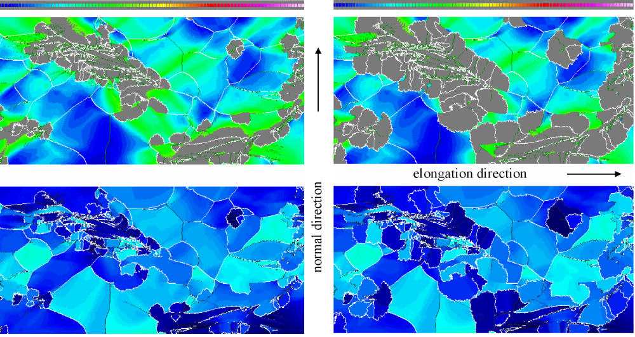
Fig. 2
Two subsequent stages of a 2D isothermal simulation of primary static recrystallization in a deformed aluminum polycrystal on the basis of crystal plasticity finite element data. The upper figures shows the change in dislocation density. The lower figures show the change in microtexture. The gray areas in the upper figures indicate a stored dislocation density of zero, i.e. these areas are recrystallized. Details of the simulation are in [26].

Potts-type multi-spin models for microstructure simulation
The application of the Metropolis Monte Carlo method in microstructure simulation has gained momentum particularly through the extension of the Ising lattice model for modeling magnetic spin systems to the kinetic multistate Potts lattice model. The original Ising model is in the form of an ½ spin lattice model where the internal energy of a magnetic system is calculated as the sum of pair-interaction energies between the continuum units which are attached to the nodes of a regular lattice. The Potts model deviates from the Ising model by generalizing the spin and by using a different Hamiltonian. It replaces the Boolean spin variable where only two states are admissible (spin up, spin down) by a generalized variable which can assume one out of q discrete possible ground states, and accounts only for the interaction between dissimilar neighbors. The introduction of such a spectrum of different possible spins enables one to represent domains discretely by regions of identical state. For instance, in microstructure simulation such domains can be interpreted as areas of similarly oriented crystal material. Each of these spin orientation variables can then be equipped with a set of characteristic state variable values quantifying the lattice energy, the surface energy, the dislocation density, the Taylor factor, or any other orientation-dependent constitutive quantity of interest. Lattice regions which consist of domains with identical spin or state can be interpreted as crystal grains. The values of the state variable enter the Hamiltonian of the Potts model. The most characteristic property of the energy operator used in microstructure research is that it defines the interaction energy between nodes with like spins to be zero, and between nodes with unlike spins to be one. This rule makes it possible to identify interfaces and to quantify their energy as a function of the abutting domains.

The Potts model is very versatile for describing coarsening phenomena. In this field it takes a quasi-microscopic metallurgical view of grain growth or ripening, where the crystal interior is composed of lattice points (e.g. atom clusters) with identical energy (e.g. orientation) and the grain boundaries are the interfaces between different types of such domains. As in a real ripening scenario, interface curvature leads to increased wall energy on the convex side and thus to wall migration. The discrete simulation steps in the Potts model, by which the progress of the system towards thermodynamic equilibrium takes place, are typically calculated by randomly switching lattice sites and weighting the resulting interfacial energy changes in terms of Metropolis Monte Carlo sampling. Recent microstructure simulations using the Potts model have been devoted to recrystallization, grain growth, and scaling aspects [30-34].

Grain boundary vertex models
Topological network and vertex models idealize solid materials or soap-like structures as homogeneous continua which contain networks consisting of large sets of interconnected boundary segments that meet at vertices. The system dynamics lies in the motion of the junctions and boundary segments. The dynamics of these interface portions and of the vertices determine the evolution of the network. The motion of the boundaries and vertices is usually described in terms of a linearized first-order rate equation. Depending on the physical model behind such a simulation, the boundary segments and vertices can be described in terms of characteristic activation enthalpies of their mobility coefficients.

The calculation of the local driving forces in most vertex models is based on equilibrating the line energies of grain boundaries abutting at a junctions according to Herring's equation. The assumption of local mechanical equilibrium at these nodes is for obvious topological reasons in most cases only possible by allowing the neighboring interfaces to curve. These curvatures in turn act through their capillary force, which is directed towards the center of curvature, on the junctions. In sum this algorithm entails a displacement of both, the nodes and the grain boundaries. Most vertex models use switching rules which describe the topological recombination of approaching vertices, for instance in the case of domain shrinkage. This is an analogy to the use of phenomenological annihilation and lock-formation rules used in dislocation dynamics. As in all continuum models, such recombination laws replace the exact atomistic treatment. It is worth noting in this context that the recombination rules, particularly the various critical recombination spacings, can substantially affect the topological results of a simulation. Depending on the underlying constitutive continuum description, vertex simulations can consider crystal orientation and therefore misorientations across the boundaries, interface mobility, and the difference in elastic energy between adjacent grains. Due to the stereological complexity of grain boundary arrays and the large number of degrees of freedom involved, most network simulations are currently confined to 2D. Depending on which defect is assumed to govern the dynamical evolution of the system, one sometimes speaks of pure vertex models, where only the motion of the junctions is considered, or of pure network models, where only the motion of the boundary segments is considered. Recent important contributions to this field are in [35-38].

Crystal Plasticity Finite Element Models
Engineering materials are often in polycrystalline form where each grain has a different crystallographic orientation, shape, and volume fraction. The volume distribution of the different grains in orientation space is referred to as crystallographic texture. The discrete nature of crystallographic slip entails an anisotropic plastic response of polycrystals under load. While the elastic-plastic deformation of single crystals and bicrystals can nowadays be well predicted, plasticity of polycrystalline matter is not well understood. This is essentially due to the intricate interaction of the grains during co-deformation, leading to strong heterogeneity in terms of strain, stress, and crystal orientation. One major aim of plasticity research consequently lies in mapping and predicting this crystallographic anisotropy during large strain plastic deformation of polycrystalline matter. In this context it is essential to note that the crystals rotate during deformation owing to the antisymmetry of the displacement gradients created by crystal slip [39] (Figs. 4, 5).

Crystal plasticity finite element models provide a direct means for updating the anisotropic material state via integration of the evolution equations for the crystal lattice orientation and the critical resolved shear stress. The deformation behavior of the grains can at each integration point determined by a crystal plasticity model which accounts for plastic deformation by crystallographic slip and for the rotation of the crystal lattice during deformation. In most crystal plasticity finite element simulations one assumes the stress response at each continuum material point to be potentially given by one crystal or by a volume-averaged response of a set of grains comprising the respective material point. The accommodation of the plastic portion of the total local deformation gradient is reduced to the degrees of freedom given by the respective crystallographic slip dyads, rotated into the local coordinate crystal system, prescribed by the orientation(s) mapped at each integration point. The flow stress is typically described in terms of a viscoplastic law using an appropriate hardening matrix which relates strain hardening on one slip system to shear on another [40-45]. Other important finite element studies about the micromechanics of microstructures were recently published by Borbély and Biermann [46] who conducted a finite element investigation of the effect of particle distribution on the uniaxial stress-strain behavior of particulate-reinforced metal-matrix composites, by Kraft et al [47] who presented finite element simulations of die pressing and sintering, and of Soppa et al. [48] who conducted a study of in-plane deformation of two-phase materials. Important recent studies about the incorporation of statistical texture models into finite element formulations were presented by Aretz et al. [49,50], and Peeters et al. [51, 52].

Texture Component Crystal Plasticity Finite Element Models
The recently introduced texture component crystal plasticity finite element method (TCCP-FEM) is based on directly mapping a small set of discrete and mathematically compact orientation components onto the integration points of a non-linear crystal plasticity finite element model. The spherical orientation components can be extracted from experimental data, such as pole figures stemming from x-ray or electron diffraction. The main progress of this approach when compared to the conventional crystal plasticity finite element method lies in identifying an efficient way of mapping a statistical and representative crystallographic orientation distribution rather than one single grain orientation on an integration point.

Four different techniques are commonly used to reproduce the orientation distribution function. The first group is referred to as direct inversion methods. These approximate textures by directly integrating the fundamental equation using a large set of pole figure points. The second group comprises Fourier series expansions which use spherical harmonic library functions. The third method is the approximation of either of the two aforementioned functions by a set of discrete and identically shaped single orientation points. The fourth group, referred to as texture component method, comprises schemes which mathematically fit given orientation functions or pole figures using spherical Gauss-type standard functions.

Crystal plasticity finite element approaches which update the texture require a discrete representation of the continuous orientation distribution function at each integration point. This circumstance suggests the use of small groups of non-identical discrete texture components which is based on the use of symmetrical spherical orientation functions. This approach provides a small set of compact texture components which are characterized by simple parameters of physical significance (three Euler angles, full width at half maximum, volume fraction). Using this method, only a few texture components are required for mapping the complete texture in a precise mathematical fashion. This is conducted in two steps. First, the discrete main (center) orientation of each texture component is assigned in terms of its Euler triple (ϕ₁, φ, ϕ₂) onto each integration point. It is important in this context, that the use of the Taylor assumption locally allows one to map more than one orientation on an integration point. Second, all main orientations of each component initially assigned to the integration points are rotated in a fashion that their resulting orientation distribution reproduces the texture function derived before. The reproduction of a texture (e.g. aluminium, steel, copper, magnesium) usually requires 1-4 texture components plus a background random portion. The method was recently described in [53-55].

Drowned by Data – Handling and Analyzing Simulation Data
A very good multi-particle simulation nowadays faces the same problem as a good experiment, namely, the handling, analysis, and interpretation of the resulting data. Let us take for a moment the position of a quantum-Laplace-daemon and assume we can solve the Schrödinger equation for 10²³ particles over a period of time which covers significant processes in microstructure. What had we learned at the end? The answer to that is: not much more than from an equivalent experiment with high lateral and temporal resolution. The major common task of both operations would be to filter, analyze, and understand what we simulated / measured. We must not forget that the basic aim of most scientific initiatives consists in obtaining a general understanding of principles which govern processes and states we observe in nature. This means that the mere mapping and reproduction of 10²³ sets of single data packages (e.g. 10²³ times the positions and momentum of all particles as a function of time) can only build a quantitative bridge to a basic understanding but it cannot replace it.

However, the advantages of this quantitative bridge built by the Laplacian super-simulation introduced above are at hand: First, it would give us a complete and well documented history record of all particles over the simulated period, i.e. more details than from any experiment. Second, once a simulation procedure is working properly it is often a small effort to apply it to other cases. Third, simulations have the capability to predict rather than only to describe. Fourth, in simulations the boundary conditions are usually exactly known (because they are mathematically imposed) as opposed to experimentation where they are typically not so well known. Therefore my initial statement about the concern of being drowned by simulation data aims at encouraging the computational materials science community to better cultivate an expertise of discovering basic mechanisms and microstructural principles behind simulations rather than getting lost in the details.

Virtual Laboratories for the Industry – Tools for Inverse Engineering
Computational materials scientists in industry and public laboratories as well as some research foundations are often not consequent enough when it comes to the introduction of new and promising simulation approaches into industry. Researchers sometimes have the tendency that once they have accomplished a simulation task they move on to the next problem. This attitude has a healthy and a not so healthy side: Of course a good researcher should always move on to the next serious scientific challenge and try to solve it. Sticking too much to solved problems means to neglect a huge set of unsolved problems. On the other hand, researches in the computational materials science community should tend more to finish a certain initiative by making their results understandable and – above all – further exploitable to possible subsequent less-well trained users.

New simulation methods can be essential tools in the industry both, with respect to the immediate prediction of a process or a product and in the form of virtual laboratories. While the former aspect is obvious and often used by industry, the latter aspect has not yet been sufficiently utilized. Virtual laboratories can be referred to as computer simulation methods which have been thoroughly tested and proven reliable and which can be used to explore changes in product quality under different virtual boundary conditions of production. This corresponds to the philosophy of inverse engineering where one starts from a desired material condition and systematically investigates which steps must be taken for obtaining this state by use of computer simulation. Often such studies show that the possible solutions to an optimization problem are not unique but they allow the engineer to choose among different microstructures and processes. Virtual laboratories can also be used to better interpret property changes of products in terms of internal rather in terms of external variables. This physically based method of formulating and exploiting constitutive laws in simulations generally provides deeper insight when compared to empirical laws.

Computational Bio–Materials Science
The life sciences are currently one of the most dynamical fields of research. Computational methods play an ever larger role in this area. This section reviews some of the recent challenges, analogies, and applications of materials simulation methods to biomaterials and biological problems. It is likely, due to the dynamics in this field, that interdisciplinary research between computational materials science and the life sciences will play an increasing role in the next decade.

Typical areas where an overlap exists are the histological and mechanical fundamentals of biological and artificial soft tissues, the micromechanics of arterial walls and cells, cardiac mechanical properties, vascular mechanics, ventricular mechanics, cardiac electromechanical properties, bypass mechanics, arterial regeneration processes, flow properties of blood, rheology of blood in microvessels, viscoelasticity of collagen, DNA-based molecular design, molecular self-assembly mechanisms, biomolecular motors, design and properties of bio-sensors, antibody-antigen binding, organ micromechanics, understanding and development of synthetic materials for the human body including its cellular and genetic composition, mechanical properties of muscles, patient-specific expert and simulation systems for diagnosis and treatment, dynamic micromechanical simulations of artificial diarthrodial joints, the mechanics of articular cartilage layers, bone mechanics including anisotropy and failure mechanisms, as well as macromechanics of the musculoskeleton.

Many of these challenges can be tackled by using simulation methods which have long been used in the computational materials sciences, for instance electron dynamics and molecular dynamics approaches, switching models such as the q-state Potts model or cellular automata, phase field models, and finite element models with incorporation of appropriate micromechanical constitutive descriptions. Since this section cannot provide an overview of all the computational methods used in this field I will only shade some light on the atomic regime.

Electron and molecular dynamics methods are nowadays routinely used to simulate solvated proteins, protein-DNA complex formation, ligand binding, or the mechanics of small proteins. The potentials used in this field depend on the problem addressed. For instance mixed quantum mechanical - classical molecular dynamics simulations are used to study enzymatic reactions in the context of the full protein. More empirical potential functions (often termed force field approximations) which include interactions via molecular bonds and those independent of molecular bonds are employed to study molecular nanomechanics addressing aspects such as bond-stretch, bending angles, and torsion angles. Like in the materials sciences the more empirical potentials are used as a compromise between accuracy and efficiency. The potential parameters can be fitted in a way to match experimental results and/or ground state simulations. In experimental terms the potentials typically are designed to reproduce structural data obtained from X-ray crystallography, dynamic data obtained from spectroscopy and inelastic neutron scattering, as well as thermodynamic data.

An essential limitation of empirical force field potentials is that they do not allow substantial changes in electronic structure, i.e. they cannot model events like bond formation or bond failure. Recently improved potential force field functions have been developed in the form of hybrid quantum mechanical-molecular mechanical force fields. This enables the user to conduct macromolecular simulations of complete potential functions that include force fields for all biomolecular interactions. The atomic scale simulations in this field can provide insight into the fluctuations and conformational changes of proteins, nucleic acids, protein-nucleic acid, and protein-lipid combinations. These calculations are still essentially limited to the nanosecond regime which prohibits to study important processes, such as large conformational transitions in proteins. Many techniques, such as coarse-graining and combination with finite element methods, might soon extend the length and time scale of these simulations. An overview of some important aspects of the current state in this field are given in [56-62].

Scaling, Coarse Graining, and Renormalization in Computational Materials Science
When realizing that quantum mechanics is not capable of directly treating 10²³ particles the question arises how macroscopic material properties of microstructured samples can nonetheless be recovered from first principles. Numerous methods have been suggested to tackle such scale problems. They can be classified into too basic groups, namely, multi-scale methods and scale-bridging methods. The first set of approaches (multi-scale) consists in repeatedly including in a simulation parameters or rules that were obtained from simulations at a respective smaller scale. For instance the interatomic potentials of a material can be approximated using local density functional theory. This result can enter molecular dynamics simulations by using it for the design of embedded atom or tight-binding potentials. The molecular dynamics code could now be used say for the simulation of a dislocation reaction. Reaction rules and resulting force fields of reaction products obtained from such predictions could be part of a subsequent elastic discrete dislocation dynamics simulations. The results obtained from this simulation could be used to derive the elements of a phenomenological hardening matrix formulation and so on. Scale bridging methods take a somewhat different approach at scaling. They try to identify in phenomenological macroscopic constitutive laws those few key parameters which mainly map the atomic scale physical nature of the investigated material and try to skip some of the regimes between the atomic and the macroscopic scale.

Both approaches suffer from the disadvantage that they do not follow some basic and general transformation or scaling rules but require instead complete heuristical and empirical guidance. This means that both, multi-scale and scale-bridging methods must be directed by well trained intuition and experience. An underlying and commonly agreed methodology of extracting meaningful information from different scales and implementing them into another does simply not exist.

A similar but less arbitrary approach to this scale problem might lie in introducing suitable averaging methods, which are capable of reformulating forces among lattice defects accurately in terms of a new model with renormalized interactions obtained form an appropriate coarse graining algorithm. Such a method could render some of the multi-scale and scale-bridging efforts more systematic, general, and reproducible. The basic idea of coarse graining and renormalization group theory consists in identifying a set of transformations (group) that translate characteristic properties of a system from one resolution to another. This procedure is as a rule not symmetric (semi-group). The transformations are conducted in such a way that they preserve the fundamental energetics of the system such as for instance the value of the partition function.

For understanding the principle of renormalization let us consider an Ising lattice model which is defined by some spatial distribution of the (Boolean) spins and its corresponding partition function. The Ising model can be reformulated by applying Kadanoff´s original real-space coarse graining or block spin approach. This algorithm works by summarizing a small subset of neighboring lattice spins and replacing them by one single new lattice point containing one new single lattice spin. The value of the new spin can be derived according to a decimation or majority rule. The technique can be applied to the system in a repeated fashion until the system remains invariant under further transformation. The art of rendering these repeated transformations a meaningful operation lies in the way how the value of the partition function or some other property of significance is preserved throughout the repeated renormalizations.

The effect of successive scale transformations is to generate a flow diagram in the corresponding parameter space. The state flow occurs in our present example as a gradual change of the renormalized coupling constant. Reaching finally scale invariance is equivalent to transforming the system into a fixed point. These are points in parameter space that correspond to a state where the system is self-similar, i.e. it remains unchanged upon further coarse graining and transformation. The system properties at fixed points are, therefore, truly fractal. Each fixed point has a surrounding region in parameter space where all initial states finally end at the fixed point upon renormalization, i.e. they are attracted by this point. The surface where such competing areas abut is referred to as a critical surface. It separates the regions of the phase diagram that scale toward different single-component limits.

The approach outlined in this section is called direct or real space renormalization. For states on the critical surface, all scales of length coexist. The characteristic length for the system goes to infinity, becoming arbitrarily large with respect to atomic-scale lengths. For magnetic phase transitions, the measure of the diverging length scale is the correlation length. For percolation, the diverging length scale is set by the connectivity length of magnetic clusters. The presence of a diverging length scale is what makes it possible to apply to percolation the technique of real-space renormalization.

Although the idea of applying the principles of renormalization group theory to microstructures might seem appealing at first sight it is essential to underline that there exists no general unified method of coarse graining microstructure problems. Approaches in this context must therefore also first take a heuristic view at scaling and carefully check which material property might be useful to assume the position of a preserved function when translating the system to the respective coarser scale. Another challenge consists in identifying appropriate methods to describe the in-grain and grain-to-grain behavior of the system clusters obtained by coarse graining. On the other hand, coarse graining and renormalization group theory might offer an elegant opportunity to eliminate empiricism encountered in some of the scaling approaches used in microstructure simulations. Another advantage of applying renormalization group theory to microstructure ensembles might be to elucidate universal scaling laws which are common also to other materials problems [63-65].

Some important contributions to computational materials science along these lines were recently published by Thomson, Levine, and Shim about percolation and self-organized critical behavior in deforming metals [66-68], by Rose et al. about some universal features of bonding in metals [69], and by Nguyen and Ortiz about coarse scaling and renormalization of atomic-scale binding-energy relations with particular respect to fracture mechanics [70].

Artificial Neural Networks in Materials Science – the Tale of the Surgeon and the Veterinarian
Doing materials science in the world of real materials production (and not in a model or laboratory world) means that we have to deal with fuzzy boundary conditions, unclear production parameters, insufficient reproducibility, and all kinds of similar ill-defined conditions. For making things even worse we can add to this list of constraints the influence of markets, labor, or ecology. Everyone who has ever been confronted with the task of mapping materials science that takes place for instance in a hot rolling mill producing a quarter of a million tons of steels per month (≈10³⁴ atoms) into computational materials science will understand the problem (Fig. 3). In this context, where physically based methods (the surgeon) often fail to quantitatively predict correlations between processes, microstructures, and products, advanced empirical non-linear learning systems (the veterinarian) in the form of artificial neural networks have brought substantial progress.

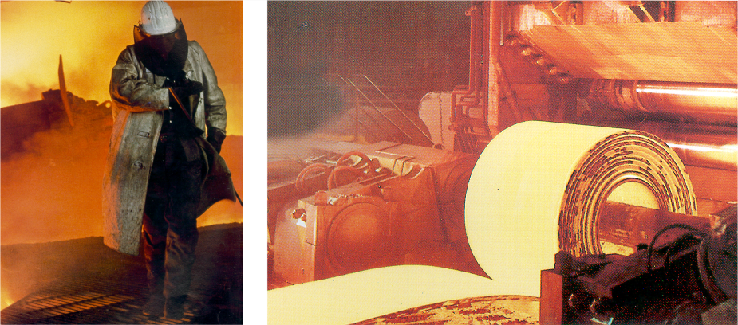
Fig. 3
Simulations of materials processing, microstructures, and resulting properties close to production reality require the consideration of fuzzy boundary conditions, unclear production parameters, and insufficient reproducibility.

Artificial neural networks which are sometimes also referred to as adaptive methods are a branch of the broad field of artificial intelligence. They mimic biological neural networks although the latter are much more complicated than adaptive mathematical models. An artificial neural network is an information processing method that is inspired by the way biological nervous systems, such as the brain, process information. The key element of this paradigm is the novel structure of the information processing system. It is composed of a large number of highly interconnected simple processing elements (neurons) operating in parallel to solve specific problems. A processing unit is essentially an equation which typically has the task of a transfer function, i.e. it receives weighted signals from other neurons, possibly combines them, transforms them and outputs a numerical result. The behavior and performance of neural systems, i.e. how precisely and effectively they map input data to output data, is determined by their connection structure, the weights of the interconnections between neurons, the transfer functions of the neurons (connection strengths), and the processing performed at computing elements or nodes. Most artificial adaptive networks have their neurons structured in layers that have similar characteristics and execute their transfer functions in synchrony. Also, neural networks have neurons that accept data (input layer) and neurons that map the results (output layer). Artificial neural networks must be generally trained by using existing data. This means that they use previous examples to establish (learn) the usually nonlinear relationships between the input variables and the predicted variables by repeatedly setting and adjusting the weights until the predicted variables are very similar to the training variables. Once these relationships are established (the neural network is trained), it can be confronted with new input variables and it will generate predictions within the limits set by the training data. According to these features artificial neural networks resemble the brain in two respects: First, they acquire knowledge through a learning process. Second, they use the interneuron connection strengths known as synaptic weights to map and store the knowledge (Figs. 4, 5).

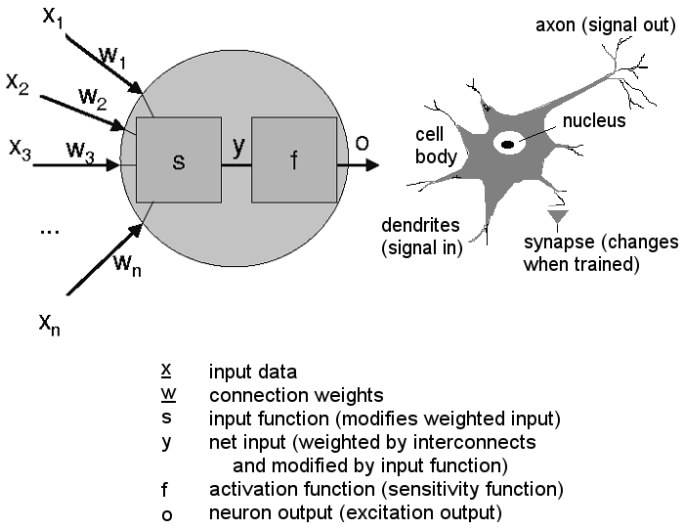
Fig. 4
Basic set-up and functions of a mathematical and of a real neuron.

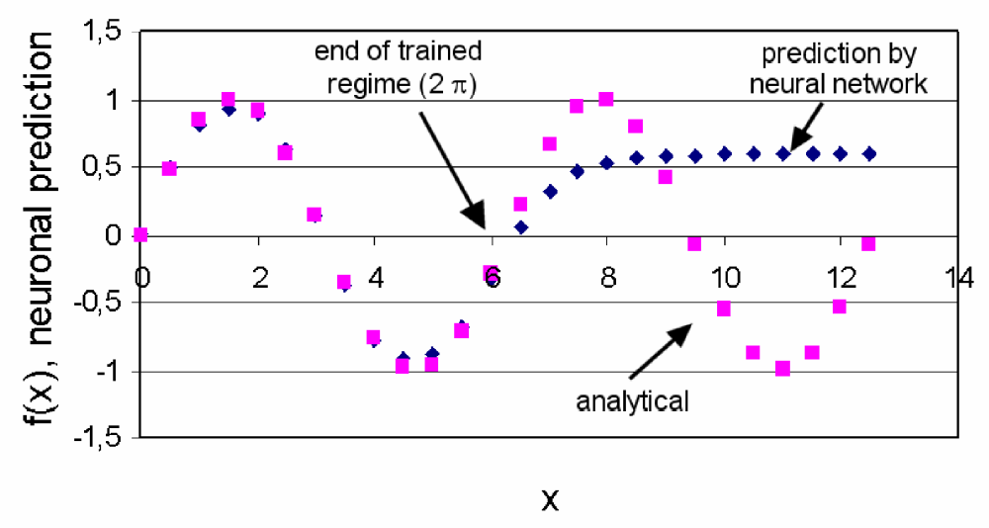
Fig. 5
A neural network which is used outside of its trained regime is of little predictive use. The present backpropagation network was used to predict the function sin(x) outside of the trained area of 2 π.

Artificial neural networks are applied to problems of considerable complexity. Their most important advantage is in solving problems that are too complex for conventional computational technologies or trained human experts. This applies in particular for situations where the complexity of the investigated physical phenomena are too large or where the task consists in deriving meaning from large complicated or imprecise data sets. In general, because of their abstraction from the biological brain, neural networks are well suited to problems that people are good at solving, but for which computers are not. These problems include pattern recognition, empirical forecasting, and non-linear multi-parameter optimization. A well trained neural network can be thought of as a highly trained though empirically working expert in the category of information it has been given to analyze (Figs. 4,5). Although the programming and mathematics behind neural networks are complex, using neural network software can be quite simple and the results are often robust provided the system was properly trained and the forecast remains strictly within the trained area.

The classic form of neural methods used in the materials sciences is the backpropagation network. This system is typically designed in a multi-layer form of the hidden layer with appropriate and versatile bias terms and momentum. It is used to discover and empirically forecast structures in time-series, to provide information on the values of phenomenological internal variables under complex production situations, to identify possible relationships between chemical composition and materials properties in complex multi-component systems, or to control and balance complex machines or assembly lines. The Hopfield adaptive network can be used as an autoassociative system to memorize digital images. The pictures are typically stored by calculating a corresponding weight matrix. Thereafter, starting from an arbitrary configuration, the memory will settle on exactly that stored image, which is nearest to the starting configuration. Thus given an incomplete or corrupted version of a stored image, the network is able to recall the corresponding original image. The system can be used in any area of materials science where the fast interpretation of complex image information is vital, e.g. in the fields of quality control and failure detection in a production environment [3].

Conclusions and Outlook
In this report I have made an approach to highlight some important current topics in the field of computational materials science. Some of the chapters concisely reviewed the fundamentals of mature microstructure methods with particular reference to lattice defect ensemble simulations above the atomic scale. Other chapters took a more general perspective focussing on questions such as data handling or the necessity to identify key mechanisms. What I feel is of particular importance for the further scientific success and reputation of this exciting field is that we avoid to create pure simulation schools which work exclusively with computer models and neglect experimental feedback. Of course, specialization is an essential issue nowadays but joint proposals and mixed reserach programs should always make it possible to find a balance between the realm of simulations and experimental validation. Another tremendous challenge lies in developing smarter and more general methods to bridge the scales in multi-scale simulation initiatives in an unambiguous and reproduceable fashion. I am convinced that in this field much can be improved by adopting methods developed in the framework of renormalization group theory.

References

- K. Ohno, K. Esfarjani, Y. Kawazoe, Computational Materials Science. From Ab Initio to Monte Carlo Methods, Springer Series in Solid-State Sciences Vol. 129, Springer-Verlag, Berlin Heidelberg, 2000.
- W. Rosenblueth, N. Wiener, Philos. Sci. 1945, 12, 316.
- D. Raabe, Computational Materials Science, Wiley-VCH, Weinheim, 1998.
- R. W. Cahn, The Coming of Materials Science, Pergamon Press, Amsterdam, New York, 2001.
- P. Haasen, Physikalische Metallkunde, Springer-Verlag, Berlin, Heidelberg, 1984.
- Y. U. Wang , Y. M. Jin, A. M. Cuitiño, A. G. Khachaturyan, Acta mater. 2001, 49, 1847.
- K. W. Schwarz, X. H. Liu , D. Chidambarrao, Mater. Sc. Engin. A, 2001, 309–310, 229.
- S. Swaminarayan, R LeSar, Comput. Mater. Sc. 2001, 21, 339.
- L. Onsager, Phys. Rev. 1931, 37, 405 and 38, 2265
- L. D. Landau, Collected Papers of L. D. Landau, Volume editor D. Ter Haar, Gordon and Breach, New York, 1965.
- A. G. Khachaturyan, Theory of Structural Transformations in Solids, John Wiley, New York, 1983.
- Y. Wen, Y. Wang, L. Q. Chen, Acta mater. 2001, 49, 13.
- W. Dreyer, W. H. Müller, Intern. J. Sol. Struct. 2001, 38, 1433.
- Y. M. Jin, A. Artemev, A. G. Khachaturyan, Acta mater. 2001, 49, 2309.
- A. M. Mullis, R. F. Cochrane, Acta mater. 2001, 49, 2205.
- Y. H. Wen, Y. Wang, L. Q. Chen, Acta Mater. 2002, 50, 13.
- L. P. Kubin, J. L. Bassani, K. Cho, H. Gao, R. L. B. Selinger (editors) Multiscale Modeling of Materials Materials Research Society Symposium Proceedings 653, Warrendale, Pennsylvania, 2001.
- V. S. Deshpande, A. Needleman, E. Van Der Giessen, Acta mater. 2001, 49, 3189.
- B. D. Wirth, M. J. Caturla, T. Diaz de la Rubia, T. Khraishi, H. Zbib, Nucl. Instrum. Methods Physics Res. B, 2001, 180, 23.
- V. S. Deshpande, A. Needleman, E. Van Der Giessen, Scripta mater. 2001, 45, 1047.
- J. von Neumann, Collected works of John von Neumann Volume editor A. W. Burks. Vol. 5, Pergamon Press, New York, 1963.
- S. Wolfram, Theory and Applications of Cellular Automata Advanced Series on Complex Systems, selected papers 1983-1986, Volume 1, World Scientific Publishing Co. Pte. Ltd, Singapore, 1986.
- D. Raabe, Annual Review of Materials Research, 2002, in press.
- R. Ding, Z. X. Guo, Acta mater. 2001, 49, 3163.
- Ch.-A. Gandin, Adv. Engin. Mater. 2001, 3, 303.
- D. Raabe, Adv. Engin. Mater. 2001, 3, 745.
- D. Raabe, Comput. Mater. Sc. 2000, 19, 13.
- P. Matic, A. B. Geltmacher, Comput. Mater. Sc., 2001, 20, 120.
- S. G. Psakhie, Y. Horie, G. P. Ostermeyer, S. Yu. Korostelev, A. Yu. Smolin, E. V. Shilko, A. I. Dmitriev, S. Blatnik, M. Spegel, S. Zavsek, Theoretical and Applied Fracture Mechanics, 2001, 37, 311.
- D. Raabe, Acta mater. 2000, 48, 1617.
- E. A. Holm, C. C. Battaile, JOM, 2001, 9, 20.
- A. D. Rollett, D. Raabe, Comput. Mater. Sc., 2001, 21, 69.
- P. R. Rios, Scripta Mater., 1999, 41, 1283
- V. Tikare, E. A. Holm, D. Fan and L. -Q. Chen, Acta Mater., 1998, 47, 363.
- D. Weygand, Y. Brechet, J. Lepinoux, Adv. Engin. Mater. 2001, 3, 67.
- F. Montheillet, J. Lépinoux, D. Weygand, E. Rauch, Adv. Engin. Mater. 2001, 3, 687.
- S. Shibata, T. Watanabe, Metall. Mater. Transact., 1999, 30A, 621.
- D. Weygand, Y. Bréchet, J. Lépinoux, Acta Mater., 1999, 47, 961.
- P. Dawson, Intern. J. Solids Structures 2000, 37, 115.
- D. Raabe, M. Sachtleber, Z. Zhao, F. Roters, S. Zaefferer, Acta mater. 2001, 49, 3433.
- D. Raabe, Z. Zhao, S.–J. Park, F. Roters, Acta mater. 2002, 50, 421.
- A. Bhattacharyya, E. El-Danaf, S. R. Kalidindi, R. D. Doherty, Intern. J. Plasticity, 2001, 17, 861.
- B. Peeters, E. Hoferlin, P. Van Houtte, E. Aernoudt, Intern. J. Plasticity, 2001, 17, 819.
- R. J. Morrissey, D. L. McDowell, T. Nicholas, Intern. J. Fatigue, 2001, 23, 55.
- S. Bugat, J. Besson, A. -F. Gourgues, F. N'Guyen, A. Pineau, Mater. Sc. Engin. A, 2001, 317, 32.
- A. Borbély, H. Biermann, Adv. Engin. Mater. 2000, 2, 366
- T. Kraft, H. Riedel, P. Stingl, F. Wittig, Adv. Engin. Mater. 1999, 2, 207
- E. Soppa, P. Doumalin, P. Binkele, T. Wiesendanger, M. Bornert, S. Schmauder, Adv. Engin. Mater. 2001, 3, 261.
- H. Aretz, R. Luce, M. Wolske, R. Kopp, M. Gördeler, G. Pomana, G. Gottstein; J. Phys. IV 2001, 11, 115.
- H. Aretz, R. Luce, M. Wolske, R. Kopp, M. Goerdeler, V. Marx, G. Pomana, G. Gottstein, Model. Simul. Mater. Sc. Engin., 2000, 8, 881.
- B. Peeters, M. Seefeldt, S. R. Kalidindi, P. Van Houtte, E. Aernoudt, Mater. Sc. Engin. A, 2001, 319-321, 188.
- B. Peeters, E. Hoferlin, P. Van Houtte, E. Aernoudt, Intern. J. Plasticity 2001, 17, 819.
- Z. Zhao, F. Roters, W. Mao, D. Raabe, Adv. Eng. Mater. 2001, 3, 984.
- D. Raabe, Z. Zhao, F. Roters, Steel Research 2001, 72, 421.
- D. Raabe, P. Klose, B. Engl, K.-P. Imlau, F. Friedel, F. Roters, Adv. Eng. Mater. 2002, this volume
- Y. C. Fung, Biomechanics Springer Verlag, New York, 1993.
- S. J. Zhou, D. L. Preston, P. S. Lomdahl, D. M. Beazley, Science, 1998, 279, 1525.
- B. L. Holian, P. S. Lomdahl, Science, 1998, 280, 2085.
- T. C. Bruice, K. Kahn, Curr. Opin. Chem. Bio., 2000, 4, 540.
- H. J. C. Berendsen, S. Hayward, Curr. Opin. Struct. Bio., 2000, 10, 165.
- F. G. Gianocotti, Curr. Opin. Struct. Bio., 1997, 9, 691.
- A. Goldbeter Biochemical Oscillations And Cellular Rhythms : The Molecular Bases Of Periodic And Chaotic Behavior. Cambridge University Press, Cambridge; New York, 1996.
- K. G. Wilson, Rev. Mod. Phys. 1983, 55, 583.
- K. Binder (editor) in: Monte Carlo Methods in Statistical Physics, Springer Topics in Current Physics, 1979.
- R. Balian, J. ZinnJustin (editor), Methods in Field Theory, North Holland Publ. Comp., 1976.
- R. Thomson, L. E. Levine, Y. Shim, Mater. Sc. Engin. A 2001, 309–310, 320.
- Y. Shim, L.E. Levine, R. Thomson, , Mater. Sc. Engin. A 2001, 309–310, 340.
- R. Thomson, L. E. Levine, Y. Shim, Physica A 2000, 283, 307.
- J. H. Rose, J. R. Smith, and J. Ferrante, phys. Rev. B, 1983, 28, 1835.
- O. Nguyen, M. Ortiz, J. Mech. Phys. Solids, in press

