Submitted to Advances in Materials and Processing Technologies on 4 May 2017

AN OIL-BASED GEL SYSTEM FOR RESERVOIR ROCK PERMEABILITY MODIFICATION
G. P. Karmakar^{1*}, C. A. Grattoni² and R. W. Zimmerman³
¹Department of Mining Engineering
Indian Institute of Technology
Kharagpur – 721302, INDIA

²School of Earth and Environment
University of Leeds
Leeds LS2 9JT, UK

³Department of Earth Science and Engineering
Imperial College
London SW7 2AZ, UK

ABSTRACT
Water production during gas and oil recovery is a major problem for the oil industry, as the average worldwide production is more than five barrels of water per barrel of oil. Among the many attempted remedies, water-based polymers and cross-linked gels are often injected into the reservoir to control excessive water production. Recently, oil-based gelant systems have been proposed which are oil-soluble. These systems react with the reservoir water to form a rigid water-based gel during the shut-in period, thereby drastically reducing the permeability of the reservoir to water.
The aim of this paper is to improve the understanding of how the flow of oil and water are affected by one of the oil-based gelant systems, TMOS. The gelation behaviour and gel characteristics were studied under static and dynamic conditions. Two-dimensional transparent glass models were used to study the effect of gelant flow, and evaluate the effectiveness of the gel in modifying the oil and water permeability. The ability of the gel to modify the water flow at different flow velocities yields a velocity-dependent permeability. New insights are presented that may help reservoir and production engineers to select and design better gel treatments for a given reservoir.

Keywords: oil-based gelant, gel formation, permeability reduction, two-phase flow
*Corresponding author: e-mail: gpkarmakar@mining.iitkgp.ernet.in

1. INTRODUCTION
Oil and gas production commonly is associated with unwanted water production from the reservoir. Excess water production increases the cost of oil and gas production. Furthermore, the cost of the disposal of this water increases the unit cost of oil production. As a result, the recovery efficiency of the wells in a reservoir goes down. Excessive production of water from reservoir formations can be due to many factors, such as fractures, water coning due to high production rates, the existence of micro-cracks in the cemented annulus around casings, etc. To overcome this problem, many techniques have been used to control excessive water production, with varying degrees of success. It has been shown that a suitable well treatment method may be an effective and profitable solution to the above problem.
One of the most successful methods is to use polymer-gels (Al-Sharji et al., 1999; Zaitoun et al., 1999; Willhite et al., 2000; Stavland, 2001; Vazquez and Eoff, 2013; Lamas et al., 2017). In such cases, polymers and cross-linkers are mixed at the surface, and the mixture is injected into the well. The polymer solution and the cross-linker react to form an annulus of viscoelastic gel around the production well. Once formed, the gel is retained within the reservoir rock, modifying the flow of both the oil and water phases. Thus, these polymers/gels are known as relative permeability modifiers (RPM), and the phenomenon is sometimes called disproportionate permeability reduction (DPR) (Sydansk and Seright, 2007). Other methods, such as the application of chain-like polymers (Pusch et al., 1995), alcohol-containing polymer solutions (Lakatos et al., 2002-a), injection of silicone microemulsions (Pusch et al., 2001; Lakatos et al., 2002-b), hydrophobisation of formation rock (Dewenter et al., 2000) and oil-based gelants (Thomson and Fogler, 1997; Bartosek et al., 2000), have also been studied or applied to prevent the excess water production from oil or gas wells. In all cases, the common objective is to find a suitable solution to reduce high water production by reducing the effective water permeability, with minimal reduction in the oil permeability.
Recently, organically modified silicate gels have been found to produce an effective gel that can modify the relative permeability of the reservoir rock (Bartosek et al., 2000; Grattoni et al., 2001; Karmakar et al., 2002; Karmakar et al., 2003; Karmakar and Chakraborty, 2006; El-karsani et al., 2014; Askarinezhad and Hatzignatiou, 2016). Tetramethyl-orthosilicate (TMOS), or tetramethoxysilane, is one of the oil soluble gelants used to produce these gels. It reacts with water to form a semi-solid gel that is capable of modifying the permeability of the rock. Also, TMOS may be injected into the wellbore dissolved in oil, as it does not precipitate in the absence of water. The gel formation time may vary from a few hours to a few weeks, depending on the concentration of TMOS in oil, the relative amount of water, the pH of the system, the dynamic character of the contact process, and the temperature.
The objective of this paper is to study the gelation behaviour and gel characteristics under static and dynamic conditions for the TMOS organically modified silicate gel. Rheological studies were carried out to study the gelation process. The ability of the gel to modify the water flow was tested in transparent glass models in order to improve the understanding of the flow behaviour.

2. MATERIALS AND METHODS

2.1. Materials
Water Phase: Distilled water prepared in our laboratory was used as water phase fluid, having a density of 1000 kg/m³ and viscosity of 1.00×10⁻³ Pa s at 25ºC. The same water was used for preparing the aqueous solutions.
Oil Phase: Paraffin oil with a boiling point range 178-210ºC, having density of 780 kg/m³ and viscosity of 1.70×10⁻³ Pa s at 25ºC.
Gelant: Tetramethoxysilane, Si (OCH₃)₄, with a concentration of 98%, from Fluka, was used as a gelant. The density of TMOS at 20ºC is 1027 kg/m³, and the boiling point range is 118-122ºC. The same oil was used to prepare the gelant solutions of TMOS at various concentrations.

2.2. Experimental Methods
The methods used to study the gelation process and the gel strength will be presented first, followed by the static and dynamic methods used for studying the effects of gelant concentration, gelant water volume ratios and time of contact. The third subsection describes the method used for studying the flow of oil and water through micromodels containing gel, and in the last section the flow of water through gel-filled capillary tubes is discussed.

2.2.1. Rheological properties
The gelation process was studied more quantitatively with a Paar Physica UDS 200 rheometer, using coaxial cylinders (Z3 DIN). The system was first heated to a temperature of 35±0.1ºC, and was maintained at this temperature throughout the test. Selection of shear stress and frequency were made after initial tests to ensure that the gel structure would not be destroyed during the tests. The TMOS-water mixture was introduced into the cylinder-bob attachment. The gelant system was then subjected to an oscillatory shear stress of 0.04 Pa, at a frequency of 0.1 Hz, for up to fifteen hours.

2.2.2. Static and dynamic gelation
First, a static scoping study was performed to find the lower range of conditions needed to form a gel. The experiments were performed by changing the TMOS concentration in the oil while keeping the oil/water ratio constant, then varying the oil/water ratio while keeping the TMOS concentration in oil constant. The TMOS concentration in oil was varied within a range of 1-7% by volume, and the oil-to-water ratio was varied from 1:1 to 20:1. These experiments were carried out in test tubes in which the total volume of fluids in each case was 10 cm³. The formation of gel in the water phase was verified by inverting the test tubes at different times after mixing; the formation of gel was confirmed when the oil phase flowed to the cap while the gel (rigid type) remained attached to the bottom of the tube. The gel formation time was recorded in each experiment. After preliminary studies, the gel formation time was restricted to 48 hours for each set of experiments.
The dynamic behaviour of the gelation was studied by flowing gelant through a test tube containing a fixed oil-water ratio. The variables studied were the total amount of TMOS, and the injection time, for a fixed concentration of TMOS in oil. During these experiments, a 1% TMOS solution in oil was allowed to flow through the water, while maintaining a fixed oil/water ratio at 2:1, and the initial volume of water at 0.8cm³. The volume of gelant injected was varied between 10-50 cm³ in a period of 1.5 to 6 hours. The gel formation was tested 48 hours after flowing the gelant.

2.2.3. Oil-water flow and permeabilities
Transparent two-dimensional porous and permeable micromodels made of glass were fabricated in the petrophysics laboratory at Imperial College. These micromodels were produced by etching a pattern designed on a photo mask into silica glass, with flow networks of pores and throats (Grattoni et al., 2001). These micromodels have similar surface properties to that of clean sandstone, and hence are strongly water-wet. The pore sizes of the network vary from 50-200 m, and the total pore volume is approximately 100 l. The movements of the fluids inside these visual models were observed through a microscope, and recorded using a video camera. After determining the approximate oil/water ratio and the TMOS concentration required for gel formation in test tubes, a range of TMOS concentrations and volumes of gelant were selected in order to allow gel formation within the porous media to take place within 48 hours. Absolute and effective permeability of the micromodels, before and after gelation were determined using the Falling Head Method. The permeability values were calculated from the measured values of flow rates and pressures.

2.2.4. Water flow through the gel
Steady-state flow experiments in capillary tubes were conducted in order to determine the effectiveness of the silicate gels to control the water flow. The change in water permeability as a function of the TMOS concentration and velocity of the water through the gel was studied. These experiments were performed in gel-impregnated square cross section glass capillary tubes (1.0×1.0 mm and 70.0 mm long). The capillary tubes were initially filled with a TMOS-water mixture. After sealing the inlet-outlet ports, the model was placed in an oven at a constant temperature of 35±0.5ºC for 48 hours, to allow the gel to form. After gelation, a syringe pump was used to inject water at constant flowrate, while the pressure drop was monitored and recorded with a pressure transducer. The water permeability was calculated using Darcy’s law, from the flow rate and pressure drop recorded for each flow rate.

3. RESULTS AND DISCUSSIONS
TMOS is an oil-soluble organically modified silicate compound. TMOS reacts with water over a wide range of concentrations to produce silica gel. During this process, TMOS partitions in the water, becoming hydrolysed and polymerised to form a porous silica network filled with water and some methanol (Karmakar et al., 2002).

3.1. Rheological properties
The viscoelastic properties of the gel, formed during the reaction between TMOS and water, were studied. The gel’s rheological properties may be explained as follows: the storage modulus G′ is due to the elastic response of the porous network the gel, and the loss modulus G′′ is due to the viscous response of the gel, attributable to the solvent contained within the gel structure. After the start of gelation, both of these moduli increased sharply, as shown in Fig. 1.
The time at which the loss and storage moduli are equal can be used as an indication of the starting point of gel network development. In most cases, the initiation of the gel formation took place within 1-2 hours. From the evolution of the loss modulus, it can be inferred that the gel network structure is in general heterogeneous, mainly due to the polymerisation process forming the so-called dual domain structure (Tanaka et al., 1973). In all cases other than 6% TMOS concentration, there were some oscillations in G′ during the transition period (nearly three hours after the test was started). This behaviour may be explained as a rearrangement of the molecules within the gel structure within the initial gel network. After the transition period, no significant increase in G′ was observed, indicating that the gel structure was fully developed, and the gel had achieved its maximum strength. Hence, it seems reasonable to use the value of G′ at ten hours as an indicator of the gel strength. A direct proportionality has been found between the rheological parameters G′ and G′′ for gels produced using different TMOS concentrations (Karmakar et al., 2003).
The loss and storage moduli of the fully developed gels are reported in Table 1. It is worth noting that the rigidity of the gels is dependent upon the TMOS concentration. The gel formed from 6% of TMOS in water showed the highest G′ value, and the gels obtained from 12%, 10%, and 8% of TMOS follow in a descending order (see Table 1). The unusual rheological behaviour as a function of concentration may be explained from the condensation reactions that occur between TMOS and water. After the hydrolysis, the condensation may follow any of the two processes: (a) in the first case, condensation occurs between hydrolysed TMOS molecules only; (b) in the second case, hydrolysed TMOS reacts with a fresh TMOS molecule and produces one molecule of methanol. Consequently, it may be inferred that when the TMOS concentration is low, the first reaction has more probability of taking place. On the other hand, when the TMOS concentration is high, the second reaction is more likely to occur. Thus, as the TMOS concentration is further increased in the system, more methanol is produced. This causes the gel to develop a different structure, and the value of G′ increases accordingly. In our experiments, the production of methanol has been noticed at a higher concentration of TMOS in the gel formation process, which is consistent with the above explanation.

3.2. Static and dynamic gelation
During the static study in test tubes, it was observed that as the TMOS concentration in the oil phase increased, the oil/water ratio required to form a gel decreases. A phase boundary separating the gel phase and liquid phase was obtained for this gelant system, as shown in Fig. 2. The phase boundary can be approximate represented by
$Y=1\text{.}0+5\text{.}0\text{exp}[−(0\text{.}\text{166}X+0\text{.}\text{015}X^{2})]$, (1)
where X is the oil/water ratio, and Y is the minimum TMOS concentration required to form a gel.
The formation of gel under dynamic conditions was studied under the conditions previously stated. For a flow rate of 0.19 cm³/min, a minimum volumetric TMOS/water ratio of 0.87 was required to form a gel. It was also observed that, for a constant total volume injected, the gelation time decreases with the injection time, indicating that the amount of TMOS transferred to the water phase decreases as the flow rate increases. This implies that mass transfer of the TMOS from the oil phase to the water phase plays a major role in the gelation time. The role of mass transfer was confirmed by the fact that an increase in the volume of gelant reduced the time required for gelation. The volume of TMOS used to produce the gel during the micromodel studies was selected on the basis of the above results.

3.3. Oil-water flow and permeability reduction
After finding the conditions needed for gel formation under flow, a series of experiments in micromodels were performed to evaluate the conditions required to reduce the water permeability with a minimum reduction of the oil permeability. The permeability reduction is here defined as the change of the endpoint relative permeability with respect to the initial relative permeability value.
During gel formation, TMOS reacts with the water contained within the pores, converting the water into a rigid gel and increasing the volume occupied by the gel. After gelation, the gel coats the grain surfaces and fills the smaller pores, while the oil path remains open. Thus, the flow of oil into the model takes place through the interconnected paths. There is some reduction in oil permeability, which is due to the decrease in size of the oil paths, as a result of the TMOS mass transfer into the water/gel. A reduction in the amount of TMOS injected minimises this effect, while maintaining the reduction in water permeability. For lower TMOS concentrations, the reduction in oil permeability was lower than for higher concentrations of TMOS. When water was flowed through the model after gelation, the permeability of water was reduced, as the gel blocked the water path. As the gel concentration, volume of gelant injected, and time of injection increase, so does the gel volume and the water permeability reduction. While studying the water permeability after gelation, it was observed that, although water flows through the gel, its flow is very slow. Therefore, TMOS is an effective material for plugging the pores occupied by water, and hence an effective relative permeability modifier.
Figure 3 shows the permeability reduction achieved, for both the oil and water phases, as a function of the volume of gelant injected, for a fixed concentration of 1% TMOS. An injection of 2.5 cm³ of gelant solution was sufficient to form a gel that could reduce the water relative permeability by 66%, while the oil relative permeability reduction was only 22%. When the volume injected is held constant, the increase of TMOS concentration further reduces both the water and oil relative permeabilities. This demonstrates that this gelant system preferentially restricts the water flow, even when used at very low concentrations. The optimum concentration of TMOS depends on the water saturation of the porous medium during gelant injection, the volume of TMOS injected, and the flowrate.

3.4. Water flow through the gel
Flow experiments in capillary tubes were used to study the effect of TMOS concentration on the water flow through the gel and water permeability. Visual observations showed that the water flows through the gel as if flowing through a porous medium, confirming the preliminary micromodel observations. The normalised water permeability though the gels for different TMOS concentrations are presented in Fig. 4. It can be observed that the permeability of the gel increases with the water flow rate according to a power law relationship, which is analogous to other gel systems (Bartosek et al., 2000), and is described by:
$k/{k_{o}}=(v/{v_{o}})^{n}$, (2)
where k/k_{o} and v/v_{o} are the normalised gel permeability and normalised superficial velocity, and v = Q/A, where Q is the water volumetric flow rate [m³/s], and A is the cross sectional area of flow [m²], respectively, and n is the flow velocity exponent. An arbitrary reference velocity, v_{o}, here taken as 1×10⁻³ cm/s, is used to normalise the data, and k_{o} is the gel permeability at v_{o.} For a rigid porous medium, the value of n would be unity, whereas for an elastic porous medium the value of n is less than unity. The flow velocity exponents are summarised in Table 1.
Although the measurement of the permeability of gel-filled capillary tubes may, in general, reflect the flow resistance of both the gel and the capillary walls, it can be shown (Yang et al., 2002) that wall effects are negligible in the present experiments. Thus, the velocity power-law behaviour can only be attributable to the gel properties. At higher rates, the imposed flow is large enough to deform the gel and to modify its flow properties. It may be proposed that the permeability behaviour of this gel is controlled by the internal structure, namely, the dense and the dilute domains within the gel. The variations of gel structure during gel formation are also reflected in the rheological measurements.
In the authors’s previous work (Karmakar et al., 2003) it was shown that a direct proportionality between the rheological parameters and the inverse of the flow velocity exponent (n) exist for gels produced from various TMOS concentrations. This demonstrates that the velocity-dependent behaviour of the water flow through the gel is due to the gel’s viscoelastic characteristics.

4. CONCLUSIONS
When TMOS is used as an oil-soluble gelant, it forms a silicate gel that can partially or totally block the pores occupied by water, modifying the water relative permeability. Therefore, it can act as an effective water control material.
Static and dynamic flow studies have been performed, and have shown that:
- A very low concentration of TMOS, about 1%, is sufficient to form a gel, and hence such a concentration has the potential to reduce the effective water permeability.
- Under flowing conditions, the amount of TMOS solution injected, at a given oil/water ratio, must exceed some critical value, in order for a gel to be formed.
- The time required for gel formation is inversely proportional to the amount of gelant injected, and the injection time.
- The water permeability through the gel increases with the water flow velocity. For a given TMOS concentration, the gel exhibits a velocity-dependent water permeability, which follows a power-law relationship.
- The velocity-dependent behaviour of the water permeability of the gel is due to the viscoelastic characteristics of the gel. It may be inferred that the distribution of the dilute and the dense domains within the gel structure control the gel’s permeability, and its velocity-dependent behaviour.
- The relative permeability reduction is proportional to the amount of gelant injected. The reduction in water relative permeability is greater than the reduction in oil relative permeability for all the conditions investigated, demonstrating that the TMOS produces disproportionate permeability reduction even at low concentrations.
There are several factors that control the gel formation and the permeability reduction. The relationships between TMOS concentration, injection time, rheological properties (storage and loss modulus) and flow velocity exponent obtained for the TMOS-water system may have the potential to be used in predicting the permeability behaviour of this gel system. These observations can be used to improve the design of gelant treatments for reservoirs or for laboratory core tests. The effect of volume injected and time of contact should be included in simulation studies, if they are to capture the physics of the disproportionate permeability reduction process, and be able to predict the effect of gel treatment in the reservoir. The results of this study can help reservoir engineers to select the most appropriate gelant formulation for given wellbore conditions.

References
Al-Sharji, H.H., Grattoni, C.A., Dawe, R.A., and Zimmerman, R.W. 2001. Flow of oil and water through elastic polymer gels, Oil Gas Sci. Tech. IFP Rev., 56(2), 145-152.
Askarinezhad, R., and Hatzignatiou, D.G. 2016. Water-Soluble Silicate Gelants for Disproportionate Permeability Reduction: Importance of Formation Wetting and Treatment Conditions. Paper presented at the International Symposium of the Society of Core Analysts held in Snowmass, Colorado, USA, 21-26 August 2016.
Bartosek, M., Grattoni, C.A., Stavland, A., and Zimmerman, R.W. 2000. Relative Permeability Modification, in Well Treatment and Water Shut-off by Polymer Gels, P. L J. Zitha, ed., Delft University Press, Delft.
Dewenter, W., Sewe, K.U., Burger, W., Geck, M., Esterbauer, L. 2000. Method for drying out rock containing immobile formation water within the encroachment area of natural gas deposits and gas reservoirs. US Patent 6,165,948.
El-karsani, K.S.M., Al-Muntasheri, G., and Hussein, I.A. 2014. Polymer systems for water shutoff and profile modification: A Review over the last decade. SPE Journal, 19(01), 135–149.
Grattoni, C.A., Jing, X.D., and Zimmerman, R.W., 2001. Disproportionate permeability reduction when a silicate gel is formed in-situ to control water production. SPE VII Latin Amer. Petrol. Eng. Conf., Buenos Aires, paper SPE 69534.
Karmakar, G.P., Grattoni, C.A. and Zimmerman, R.W., 2002. Relative permeability modification using an oil-soluble gelant to control water production. SPE Ann. Tech. Conf. Exhib., San Antonio, paper SPE 77414.
Karmakar, G.P., Laik, S., Grattoni, C.A., and Zimmerman, R.W., 2003. Gel rheological properties and water flow behaviour of the tetramethoxysilane-water system. 5th Int. Petrol. Conf. Exhib. (PETROTECH), New Delhi.
Karmakar, G.P., and Chakraborty, C. 2006. Improved oil recovery using polymeric gelants: A review. Indian Journal of Chemical Technology, 13, 162-167.
Lakatos, I., Lakatos-Szabó, J., Kosztin, B., Palásthy, Gy., 2002a. Disproportional permeability modification by alcohol-containing polymer solutions: Laboratory studies and field experiences. 13th SPE/DOE Improved Oil Recovery Symp., Tulsa, paper SPE 75185.
Lakatos, I., Tóth, J., Lakatos-Szabó, J., Kosztin, B., Palásthy, Gy., Wöltje, H., 2002b. Application of silicone microemulsion for restriction of water production in gas wells. SPE 13th Eur. Petrol. Conf., Aberdeen, Scotland, paper SPE 78307.
Lamas, L.L., Botechia, V., Correia, M.G., Schiozer, D.J., Delshad, M. 2017. Influence of polymer properties on selection of production strategy for a heavy oil field. J. Pet. Sci. Eng., 163,110-118.
Pusch, G., Kohler, N., Kretzschmar, H.J. 1995. Practical experience with water control in gas wells by polymer treatment. 8th Eur. IOR Symp., Vienna, Vol. 2., pp. 48-56.
Pusch, G., Meyn, R., Burger, W., Geck, M. 2001. Method for stabilizing the gas flow in water-bearing natural gas deposits or reservoirs. US Patent 6,206,102 B1.
Stavland, A. 2001. Segregated flow is the governing mechanism of disproportionate permeability reduction in water and gas shutoff. SPE Ann. Tech. Conf. Exhib., New Orleans, paper SPE 71510.
Sydansk, R.D., and Seright, R.S. 2007. When and where relative permeability modification water-shutoff treatments can be successfully applied. SPE Production & Operations, 22, 236-247.
Tanaka, T., Hoker, L.O., and Benedek, G.B. 1973. Spectrum of light scattered from a viscoelastic gel. J. Chem. Phys., 59: 5151-5159.
Thompson, K.E., and Fogler, H.S. 1997. Pore-Level mechanisms for altering multiphase permeability with gels. SPE J., 2: 350-362.
Vasquez, J. and Eoff, L. 2013. A relative permeability modifier for water control: Candidate selection, case histories, and lessons learned after more than 3,000 well interventions. SPE European Formation Damage Conference & Exhibition, Noordwijk, The Netherlands, paper SPE 16591.
Willhite, G.P., Zhu, H., Natarajan, D., McCool, C.S., and Green, D.W., 2000. Mechanisms causing disproportionate permeability in porous media treated with Chromium Acetate/HPAAM gels. 12th SPE/DOE Imp. Oil Recov. Symp., Tulsa, paper SPE 59345.
Yang, C., Grattoni, C.A., Muggeridge, A.H., and Zimmerman, R.W. 2002. Flow of water through channels filled with deformable polymer gels. J. Coll. Interf. Sci., 250: 466-470.
Zaitoun, A., Kohler, N., Bossie-Codreanu, D., and Denys, K., 1999. Water shutoff by relative permeability modifiers: lessons from several field applications. SPE Ann. Tech. Conf. Exhib., Houston, paper SPE 56740.
Table Headings
Table 1. Summary of TMOS organically modified silicate gel properties for different TMOS concentrations; T is the starting time of gel formation, G′ is the storage modulus, G′′ is the loss modulus, and n is the flow velocity exponent.

Figure Captions
Figure 1. Evolution of the storage modulus (G′) and loss modulus (G′′) during gelation, at 35ºC, for a concentration of 6% TMOS.
Figure 2. Gel formation as a function of oil/water ratio and TMOS concentration in oil. The “phase boundary” is approximately described by Eq. (1).
Figure 3. Influence of the volume of gelant injected on oil and water relative permeability, water-wet media for a gelant with 1% of TMOS.
Figure 4. Normalised permeability (k/k_{o}) as a function of the dimensionless water velocity (v/v_{o}), at different TMOS concentrations.

Table 1. Summary of TMOS organically modified silicate gel properties for different TMOS concentrations; T is the starting time of gel formation, G′ is the storage modulus, G′′ is the loss modulus, and n is the flow velocity exponent.

TMOS (%) | T (min) | G′ (Pa) | G′′ (Pa) | n
6 | 170 | 97.54 | 2.94 | 0.741
8 | 150 | 14.52 | 0.26 | 0.787
10 | 143 | 20.90 | 0.16 | 0.799
12 | 135 | 39.33 | 0.23 | 0.815

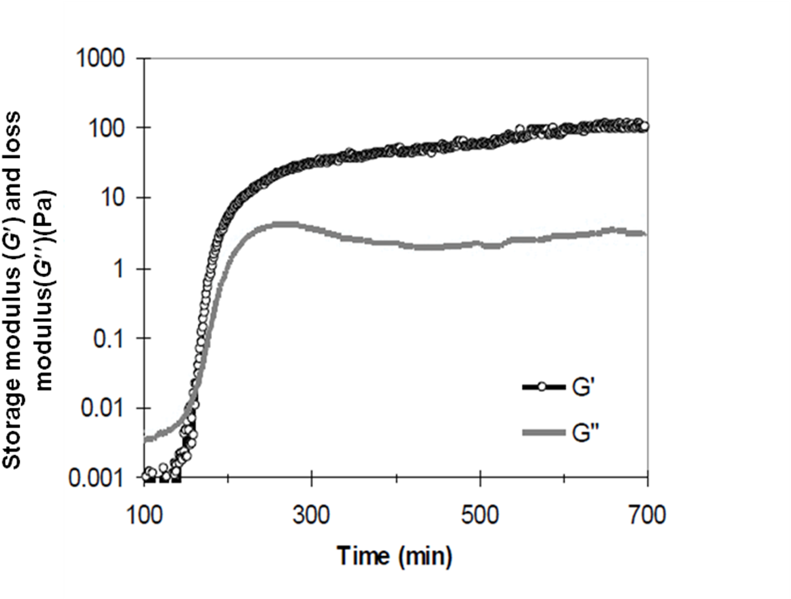

Figure 1. Evolution of the storage modulus (G′) and loss modulus (G′′) during gelation, at 35ºC, for a concentration of 6% TMOS.

Figure 2. Gel formation as a function of oil/water ratio and TMOS concentration in oil. The “phase boundary” is approximately described by Eq. (1).

Figure 3. Influence of the volume of gelant injected on oil and water relative permeability, water-wet media for a gelant with 1% of TMOS.

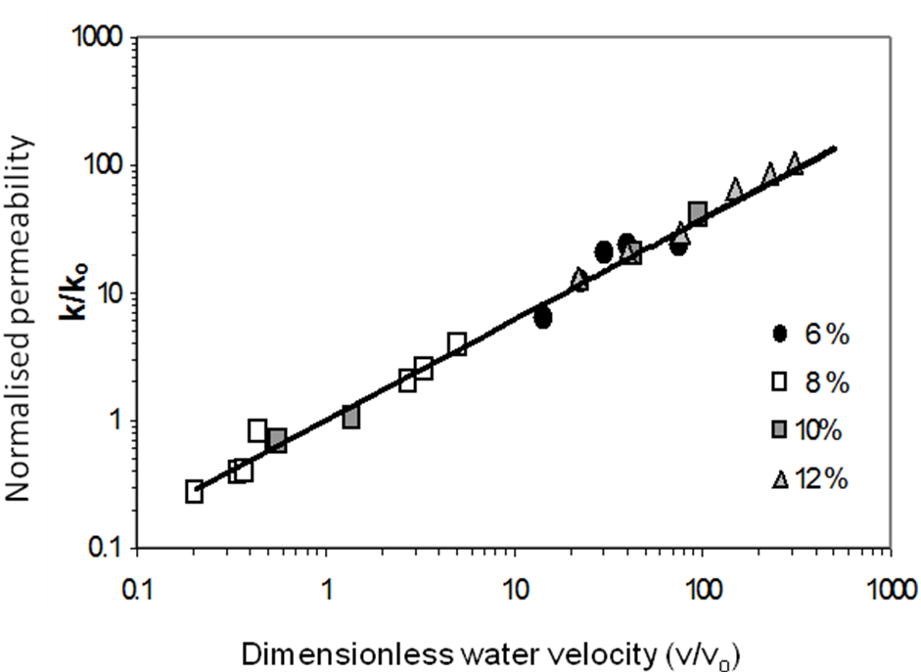

Figure 4. Normalised permeability (k/k_{o}) as a function of the dimensionless water velocity (v/v_{o}), at different TMOS concentrations.

