CRUISE SUMMARY REPORT |  |  |  |  |  |  |  |  |  |  |  |  |  |  |  |  |  |  | FOR COLLATIMG CENTRE USE  Centre: DOD Ref. No.:  Is data exchange  restricted Yes In part No
enter the unique number, name or acronym assigned to the cruise (or cruise leg, if appropriate).
SHIP enter the full name and international radio call sign of the ship from which the data were collected, and indicate the type of ship, for
example, research ship; ship of opportunity, naval survey vessel; etc.

Name: ALKOR Call Sign: DBND

Type of ship: Research Vessel
CRUISE NO. / NAME Al520-2

CRUISE PERIOD start 20/03/2019 to 04/04/2019 end
(set sail) day/ month/ year day/ month/ year (return to port)

PORT OF DEPARTURE (enter name and country) Cuxhaven

PORT OF RETURN (enter name and country) Cuxhaven
RESPONSIBLE LABORATORY enter name and address of the laboratory responsible for coodinating the scientific planning of
the cruise

Name: Senckenberg am Meer, Abteilung für Meeresforschung
Address: Südstrand 40, 26382 Wilhelmshaven
Country: Germany
CHIEF SCIENTIST(S) enter name and laboratory of the person(s) in charge of the scientific work (chief of mission) during the cruise.

Dr. Peter Holler
OBJECTIVES AND BRIEF NARRATIVE OF CRUISE enter sufficient information about the purpose and nature of the cruise so
as to provide the context in which the report data were collected.

Alkor cruise 520-2 was part of the project ASKAWZ (Acoustic Seafloor Classification of the German EEZ) funded by the Federal Maritime and Hydrographic Agency (BSH) and the Feral Agency for Nature Conservation (BfN). The main goal of the cruise was the full area acoustic mapping of the westernmost part of the German EEZ (so called “duck bill”) by sidescan sonar and the detection of natural and man-made structures (trawl marks) on the seafloor. The full area mapping was achieved by 61 sidescan sonar profiles, covering an area of ca. 640 km². A single-beam echosounder with automatic seafloor classification (QTC 5.5) was run simultaneously to the sidescan sonar. The acoustic backscatter data was “ground truthed” using Shipek grab and Box-corer (Reineck-Type) samples. In addition an underwater video camera was used to gather further seabed information.
Aditionally sidescan data was recorded in the Helgoland-Reef pockmark area. Here 13 lines were surveyed (ca. 10 km²) by sidescan sonar in order to document the development of the pockmark field.

PROJECT (IF APPLICABLE) if the cruise is designated as part of a larger scale cooperative project (or expedition), then enter the name of the project, and of organisation responsible for co-ordinating the project.

Project name: ASKAWZ

Coordinating body: BSH

PRINCIPAL INVESTIGATORS: Enter the name and address of the Principal Investigators responsible for the data collected on the cruise and who may be contacted for further information about the data. (The letter assigned below against each Principal Investigator is used on pages 2 and 3, under the column heading ‘PI‘, to identify the data sets for which he/she is responsible)

- Dr. Peter Holler , Senckenberg am Meer, Abteilung für Meeresforschung, Südstrand 40, 26382 Wilhelmshaven
- Dr. Andreas Neumann, Helmholtz Zentrum Geesthacht, Max-Planck-Strasse 1, 21502 Geesthacht

MOORINGS, BOTTOM MOUNTED GEAR AND DRIFTING SYSTEMS

This section should be used for reporting moorings, bottom mounted gear and drifting systems (both surface and deep) deployed and/or recovered during the cruise. Separate entries should be made for each location (only deployment positions need be given for drifting systems). This section
may also be used to report data collected at fixed locations which are returned to routinely in order to construct ‘long time series‘.

PI  See top of page. |  | APPROXIMATE POSITION |  |  |  |  |  |  |  |  |  |  |  |  |  | DATA TYPE  enter code(s) from list on cover page. |  | DESCRIPTION
 |  | LATITUDE |  |  |  |  |  |  | LONGITUDE |  |  |  |  |  |  |  |  | Identify, as appropriate, the nature of the instrumentation the parameters (to be) measured, the number of instruments and their depths, whether deployed and/or recovered, dates of deployments and/or recovery, and any identifiers given to the site.
 |  | deg |  | min |  | N/S |  |  | deg |  | min |  |  | E/W
 |  |  |  |  |  |  |  |  |  |  |  |  |  |  |  |  |  | Please continue on separate sheet if necessary

SUMMARY OF MEASUREMENTS AND SAMPLES TAKEN

Except for the data already described on page 2 under ‘Moorings, Bottom Mounted Gear and Drifting Systems‘, this section should include a summary of all data collected on the cruise, whether they be measurements (e.g. temperature, salinity values) or samples (e.g. cores, net hauls).

Separate entries should be made for each distinct and coherent set of measurements or samples. Different modes of data collection (e.g. vertical profiles as opposed to underway measurements) should be clearly distinguished, as should measurements/sampling techniques that imply distinctly different accuracy’s or spatial/temporal resolutions. Thus, for example, separate entries would be created for i) BT drops, ii) water bottle stations, iii) CTD casts, iv) towed CTD, v) towed undulating CTD profiler, vi) surface water intake measurements, etc.

Each data set entry should start on a new line – it’s description may extend over several lines if necessary.

NO, UNITS : for each data set, enter the estimated amount of data collected expressed in terms of the number of ‘stations‘; miles‘ of track; ’days‘ of
recording; ‘cores‘ taken; net ‘hauls‘; balloon ‘ascents‘; or whatever unit is most appropriate to the data. The amount should be entered
under ‘NO‘ and the counting unit should be identified in plain text under ‘UNITS‘.

PI  see page  2 |  | NO  see  above |  | UNITS  see  above |  |  |  | DATA TYPE  Enter code(s) from list on cover page |  |  |  | DESCRIPTION
 |  |  |  |  |  |  |  |  |  |  |  | Identify, as appropriate, the nature of the data and of the instrumentation/sampling gear and list the parameters measured. Include any supplementary information that may be appropriate, e. g. vertical or horizontal profiles, depth horizons, continuous recording or discrete samples, etc. For samples taken for later analysis on shore, an indication should be given of the type of analysis planned, i.e. the purpose for which the samples were taken.
A |  | 17 |  | stations |  |  |  | G02 |  |  |  | sediment samples by Shipek grab for grain size distribution
B |  | 5 |  | stations |  |  |  | G02 |  |  |  | sediment samples by Box grab for biogeochemical analyses
A |  | 10 |  | stations |  |  |  | G02 |  |  |  | sediment samples by Box grab for geotecnical analyses
A |  | 11 |  | tracks |  |  |  | G21 |  |  |  | underwater video for ground truthing
A |  | 74 |  | profiles |  |  |  | G24 |  |  |  | sidescan sonar lines
A |  | 74 |  | profiles |  |  |  | G73 |  |  |  | single beam echosounder with QTC 5.5 AGD
B |  | 6 |  | stations |  |  |  | H10 |  |  |  | CTD casts
 |  |  |  |  |  |  |  |  |  |  |  | Please continue on separate sheet if necessary

TRACK CHART: You are strongly encouraged to submit, with the completed  report, an annotated track chart illustrating the route followed and  the points where measurements were taken. | Insert a tick() in  this box if a track  chart is supplied
GENERAL OCEAN AREA(S): Enter the names of the oceans and/or seas in which data were collected during the cruise – please use commonly recognised names (see, for example, International Hydrographic Bureau Special Publication No. 23, ‘Limits of Oceans and Seas‘).

North Sea
SPECIFIC AREAS: If the cruise activities were concentrated in a specific area(s) of an ocean or sea, then enter a description of the area(s). Such descriptions may include references to local geographic areas, to sea floor features, or to geographic coordinates.

Please insert here the number of each square in which data were collected from the below given chart

216

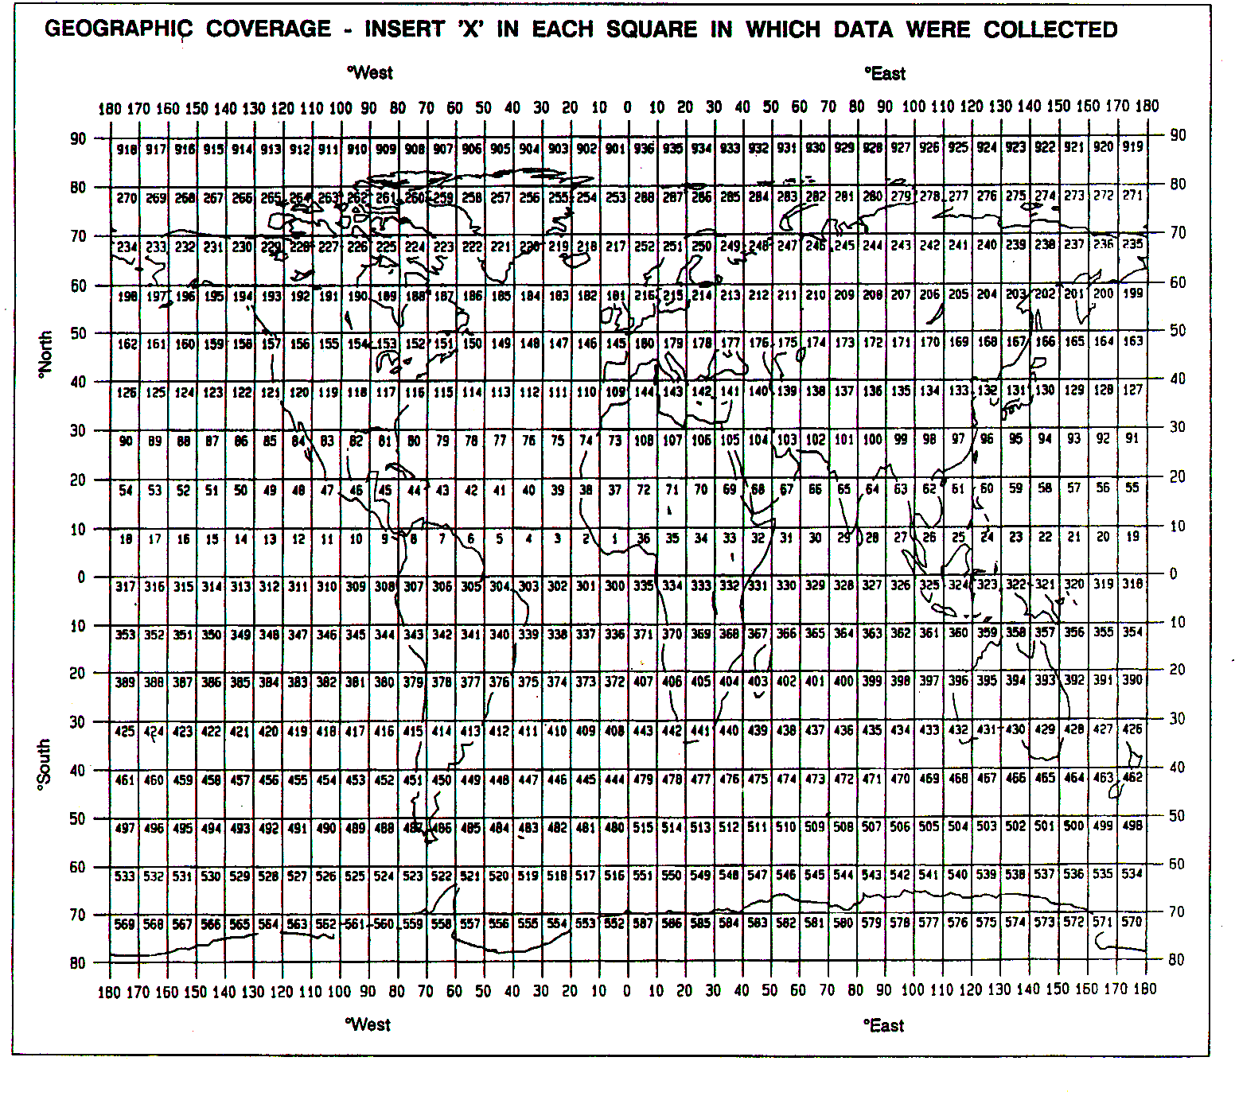
see above

THANK YOU FOR YOUR COOPERATION

Please send your completed report without delay to the collating centre indicated on the cover page

