Determining the sources of nutrient flux to water in headwater catchments: Examining the speciation balance to inform the targeting of mitigation measures
Authors
^{1*}Lloyd, C. E. M., ^{2,3}Johnes, P. J., ^{2,3}Freer, J. E., ⁴Carswell, A., ⁵Jones, J. I., ⁶Stirling, M. W., ⁷Hodgkinson, R. A., ⁷Richmond, C., ⁴Collins, A.L.

¹School of Chemistry, University of Bristol, Cantock’s Close, Bristol BS8 1TS, UK
² School of Geographical Sciences, University of Bristol, University Road, Bristol BS8 1SS, UK
³ Cabot Institute, University of Bristol, BS8 1UJ, Bristol, UK
⁴Sustainable Agriculture Sciences Department, Rothamsted Research, North Wyke, Okehampton, EX20 2SB, UK
⁵School of Biological and Chemical Sciences, Queen Mary University of London, Mile End Road, London E1 4NS, UK
⁶School of Archaeology, Geography and Environmental Sciences, University of Reading, Reading RG6 6AB, UK
⁷Soils, Agriculture and Water, RSK ADAS Ltd, Spring Lodge, 172 Chester Road, Helsby, WA6 0AR, UK

*Corresponding author

Keywords: Nitrogen; phosphorus; headwater catchments; catchment characteristics; mitigation measures.

Abstract
Diffuse water pollution from agriculture (DWPA) is a major environmental concern, with significant adverse impacts on both human and ecosystem health. However, without an appropriate understanding of the multiple factors impacting on water, mitigation measures cannot be targeted. Therefore, this paper addresses this gap in understanding, reporting the hydrochemical monitoring evidence collected from the UK Government’s Demonstration Test Catchments (DTC) programme including contrasting chalk and clay/mudstone catchments. We use data collected at daily and sub-daily frequency over multiple sites to address: (1) How does the behaviour of the full range of nitrogen (N) species and phosphorus (P) fractions vary? (2) How do N species and P fractions vary inter- and intra-annually? (3) What do these data indicate about the primary pollution sources? And (4) which diffuse pollution mitigation measures are appropriate in our study landscapes?
Key differences in the rates of flux of nutrients were identified, dependent on catchment characteristics. Full N speciation and P fractionation, together with dissolved organic carbon (DOC) enabled identification of the most likely contributing sources in each catchment. Nitrate (NO₃-N) was the dominant N fraction in the chalk whereas organic and particulate N comprised the majority of the load in the clay/mudstone catchments. Despite current legislation, orthophosphate (PO₄-P) was not found to be the dominant form of P in any of the catchments monitored. The chalk sub-catchments had the largest proportion of inorganic/dissolved organic P (DOP), accompanied by episodic delivery of particulate P (PP). Contrastingly, the clay/mudstone sub-catchments loads were dominated by PP and DOP. Thus, our results show that by monitoring both the inorganic and organic fractions a more complete picture of catchment nutrient fluxes can be determined, and sources of pollution pin-pointed. Ultimately, policy and management to bring nutrient impacts under control will only be successful if a multi-stressor approach is adopted.
1. Introduction
Diffuse water pollution from agriculture (DWPA) is a major environmental concern with significant adverse impacts on both human and ecosystem health (Foresight, 2011). It presents a significant and rising challenge globally as developed economies continue to rely on Haber-Bosch nitrogen (Sutton, 2011) and the depletion of rock phosphate reserves (Koppelaar and Weikard, 2013) to sustain food production, while developing economies adopt modern farming practices in order to meet their food security and economic development goals (Ambler-Edwards et al., 2009; Vitousek et al., 2009). Point source discharges from sewage treatment and wastewater treatment plants also alter the chemical character of inland and coastal waters, with widespread and adverse consequences. These include the loss of biodiversity and ecosystem services in freshwaters and the coastal zone worldwide, and widespread degradation of ecosystem health, particularly where there is a developed economy (Dinda, 2004). Such impacts are set to increase as a result of global population and economic growth, which drive increases in both gross and per capita resource consumption, and concomitant pollution of the natural environment (Rockstrum et al., 2013). In the EU, the impact of nutrient pollution, organic pollution and toxic substances on waterbodies has led to a range of legislation aimed at halting further degradation of waters and restoring ecosystem health including, most significantly, the EU Water Framework Directive (WFD; 2000/60/EC). Established as a legislative framework for Community action in the field of water policy in 2000, the WFD absorbed a range of prior Directives aimed at controlling specific sources of point and diffuse pollution of waters across the EU.
The implementation of the WFD marked a step change in policy interventions in the environment (Moss, 2008; Jones et al., 2010), requiring member states to monitor waters to determine, for the first time, the extent to which chemical, morphological and ecological status of waters deviated from a reference condition (not subject to any apparent environmental stress) based on a range of standard measures, via a Common Implementation Strategy. It also required member states to develop and implement mitigation strategies via targeted river basin management plans to bring ecologically damaging pollution and other stressors under control to restore ecosystem health to at least Good Ecological Status (GES). In 2012, the European Commission concluded that over 90% of the designated river basins in 17 EU member states ascribed significant pressures to agriculture, with 38% of European waterbodies experiencing significant pressure from diffuse pollution, and 30% of waters experiencing significant eutrophication problems due to nutrient pollution (European Commission, 2012). However, research is showing that the true scale of the problem is much greater than reported in official documents (see for example, Johnes, 2007a; Moss, 2008; Grizzetti et al., 2011; Sutton, 2011).

To address this nutrient enrichment problem, it is necessary to understand both the nature and origins of multiple pollutant fluxes within the landscape, and the challenges that these multiple factors present to biota and other endpoints. However, as monitoring in support of the WFD has been partial, focusing on a limited range of parameters monitored at low temporal resolution; it has thereby failed to generate the necessary underpinning robust evidence needed for targeted policy intervention (Hering et al., 2010) and to detect change in response to policy-driven actions. The European Commission (2012) noted that for 40% of waterbodies, there was insufficient evidence from which to assess their status

Without an appropriate understanding of the multiple factors impacting on a stream, or what their combined effect is, mitigation measures cannot be properly targeted. Nowhere is this more the case than for the mitigation of DWPA which, having no single point of origin in the landscape, poses a significant policy and management challenge across farmed areas of Europe. This is particularly so in the UK, where DWPA is the single largest agricultural contribution to the failure of waterbodies to achieve GES under the EU WFD (Collins et al., 2016). An effective operational monitoring programme is needed to determine the chemical character and ecological role of contaminants flushed from land to water and capture a complete picture of the rate and timing of pollutant flux, as experienced by the biota instream. Only then can the most appropriate Diffuse Pollution Mitigation Measures (DPMMs) be proposed, discussed and implemented. To generate a composite and holistic assessment, multiple pollutant forms commonly generated from the specific land management practices in each catchment need to be included within the hydrochemical monitoring programme. Routine operational monthly monitoring (as carried out in the UK for the purpose of reporting water quality status) to determine instream nitrate-N (NO₃-N) concentrations in a livestock farming landscape where organic-rich nutrient effluent is released to the stream from slurry lagoons, farmyard manure applications and directly by livestock watering instream, would be unlikely to capture the full range of impacts of this farming system on water quality and stream ecology. The development of robust monitoring programmes designed to capture, at a sufficiently high temporal frequency, the pulsed delivery of multiple nutrient forms from land to water is a fundamental requirement for robust decision making. This is especially so, given that the economic costs and damage to catchment manager and stakeholder relations associated with repeated, mis-targeted implementation of DPMMs far outweigh the costs associated with getting it right in the first place (National Audit Office, 2010; European Commission, 2012).

Much research has been conducted to develop our knowledge of the processes affecting the transfer of diffuse pollution and the efficacy of DPMMs, but usually at the mesocosm, plot or field scale (e.g. Mendez et al., 1999; Dosskey et al., 2007; Darch et al., 2015). Far less is known about the efficacy of DPMMs at the catchment scale (Cherry et al., 2008; McGonigle et al., 2014), which is a non-trivial, spatially complex problem to unravel (Lloyd et al., 2014). A major constraint on the design of effective DMPPs arises from the fact that studies have tended to focus on one or two pollutant forms (Hefting and de Klein, 1998; Leeds-Harrison et al., 1999; Kelly et al., 2007; Liu et al., 2008), rather than on multiple parameters that are the norm for aquatic ecosystems (Peukert et al., 2014). Without consideration of multiple chemical forms or ‘species’ which may generate an ecological response, the potential for pollution swapping between forms when DPMMs are applied, and continued adverse impacts on the receiving ecosystem can be overlooked (Stevens and Quinton, 2009). In terms of nutrient flux monitoring, when only inorganic nutrient forms are measured, the opportunities for quantification of the entire N and P load to the receiving water are missed, thus excluding the detection of potential adverse impacts of both dissolved organic (DON and DOP) and particulate N and P (PON and PP), which are directly bioavailable to both autotrophs and heterotrophs in the waterbody (Worsfold et al., 2008; Durand et al., 2011). These less frequently examined nutrient fractions are known to contribute substantially to the total P (TP) and total N (TN) loading to a variety of waterbodies and at a variety of scales of observation worldwide (van Kessel et al., 2009; Durand et al., 2011; Islam et al., 2013). Therefore, they are critical to informing targeted interventions and improving our understanding of the impact of agricultural management decisions on water quality and the likely ecological ‘benefits’ associated with the implementation of DPMMs in different environmental settings (Taylor et al., 2013).

This paper, reports the hydrochemical monitoring evidence collected over the period 2011-2014 from the UK Government’s Demonstration Test Catchments (DTC) programme in the Hampshire Avon and Tamar catchments, in England (McGonigle et al., 2014; Collins et al., 2016), in order to determine sources of diffuse pollution and thereby appropriate DPMMs to implement To establish the parameters that must be measured in order to capture the key pollutant forms potentially impacting on stream ecology in agricultural catchments, under different environmental settings, we collected data at daily and sub-daily frequency over multiple sites to address four questions:
(1) How does the behaviour of the full range of nitrogen (N) species and phosphorus (P) fractions vary between rivers with contrasting catchment hydrogeology and farming systems?
(2) How do N species and P fractions vary within and between water years?
(3) What do these data indicate about the primary pollution sources that could impact on ecological health ?
(4) Using the detailed hydrochemical data as fingerprints of pollution sources, which DPMMs are technically appropriate?

2. Materials and methods
2.1. Catchment characteristics and study sites
In order to provide the range of geologic conditions and farming systems needed to address the four questions of our study, two major monitoring platforms were established in intensively farmed regions in the south/SW of England (Figure 1), as part of the UK-wide DTC programme (McGonigle et al., 2014). These were the catchments of the Hampshire Avon (~1750 km²) and the River Tamar (~1800 km²). Work within these study catchments was unique within the national DTC platform, as the water samples collected were subject to additional chemical analyses compared with the other catchments: specifically, these additional analyses were undertaken to determine concentrations of the full range of N species and P fractions in the rivers sampled (see section 2.3 for details).

The Hampshire Avon rises in Wiltshire as two separate rivers: the West Avon and the East Avon, both of which drain the Vale of Pewsey in the north of the catchment (Figure 1). The two tributaries converge at Upavon, then flow south across Salisbury Plain to the city of Salisbury where radial drainage from a range of tributaries (Wylye, Ebble and Sem/Nadder) amplifies the flow volume as the river flows south to Christchurch Harbour in Dorset. The Hampshire Avon is a groundwater-dominated river catchment, with around 85% of main river flow supplied by the Cretaceous Chalk and Upper Greensand aquifers. The upper reaches of parts of the River Avon flow through chalk, where headwaters are drained by ephemeral ‘winterbourne’ streams, with seasonally dry periods when the groundwater table is depressed. The western tributaries flow across clays and chalk, while Tertiary sands and gravels dominate the lower catchment. Base flow indices (BFIs) are typically >0.7 and as high as >0.95 in some parts of the catchment (Marsh and Hannaford, 2008), reflecting the high groundwater inputs. Topographical features such as open chalk downland with steep scarp slopes and sheltered valleys are typical. Land use mainly comprises arable land, improved pasture and woodland except for the River Bourne tributary which is dominated by urban areas, fisheries management, historic milling and restored water meadows. Approximately 85% of the Hampshire Avon DTC is designated as a Nitrate Vulnerable Zone (NVZ; 81/676/EEC), and the Hampshire Avon together with its tributaries has been designated as a Special Area of Conservation (SAC) under the EU Habitats Directive (92/43/EEC) since 1992. Increased N, P and sediment delivery to the Hampshire Avon from agricultural land has contributed to nutrient enrichment (Jarvie et al., 2005), siltation issues (Walling et al., 2008) and the occurrence of so-called ‘chalk stream malaise’ (UK Biodiversity Action Plan STeering Group for Chalk Rivers, 2004). More recently, detailed analysis of temporal and spatial trends in N speciation and P fractionation in the Wylye, a chalk sub-catchment of the Hampshire Avon, identified delivery of N and P from diffuse sources in the autumn to winter period and during high flow events, and lack of dilution of point source discharges to the Wylye from septic tanks, small package Sewage Treatment Works and larger Waste Water Treatment Works during the summer low flow period, as key sources contributing to nutrient enrichment problems in the river (Yates and Johnes, 2013).

The River Tamar flows via a dendritic drainage network along the Cornish-Devon border to discharge into Plymouth Sound in Devon. The catchment (Figure 1) is largely underlain by Old Red Sandstone and mudstones overlain with alluvial silts and clays. Although the Tamar catchment includes the upland areas of West Dartmoor and East Bodmin Moor, it is largely characterised by rolling farmland, valleys and heaths and has a BFI of approximately 0.4. The River Tamar was adopted as a DTC sentinel catchment in autumn 2011, providing an opportunity to assess the hydrochemical and ecological responses to an intensive programme of implementing DPMMs in its catchment, funded by South West Water (SWW) via the Payment for Ecosystem Services (PES) scheme under the Upstream Thinking initiative.

Within the two catchments, priority sub-catchments were selected (approximately 10 to 40 km²) to monitor hydrochemistry in order to determine sources of DWPA. Prerequisites for selecting DTC sub-catchments included accessibility; representative farm types; land use, geology and soils of the wider catchment; and access either to mains power at the sub-catchment outlet monitoring point for higher-specification monitoring kiosks or compatibility with solar panels for lower-specification monitoring installations. It was also important to select sub-catchments in which significant point sources were absent.

The Hampshire Avon study sites selected included the rivers Wylye (at Kingston (KD) and Brixton Deverill (BD)), Sem (at Priors Farm (PF) and Cool’s Cottage (CC)), and Ebble (upstream (EBUS) and downstream (EBDS) of a valley bottom constructed wetland at Ebbesbourne Wake). The Tamar DTC platform comprised Caudworthy Water, monitored at Winnacott (WC) in the Tamar catchment itself, and the neighbouring Neet satellite catchment, monitored at Burracott (BC)., This was located to the north of the Tamar catchment but shared the same hydrogeological and land use characteristics as the Caudworthy sub-catchment (see Figure 1). The characteristics of each of the study sub-catchments differed, representing the range of conditions encountered in the two catchments (Table 1).
The three sub-catchments chosen for the Hampshire Avon monitoring programme cover all the principle geological outcrops of the catchment:
- The Sem is representative of a typical clay sub-catchment with intensive dairy and lowland grazing livestock production. The sub-catchment suffers from typical problems associated with livestock enterprises, including stocking densities, lack of integrated manure and slurry management, cattle poaching of river margins and poor farm track management. This combined with clay catchment hydrology (Allen et al., 2014), provide efficient routing of both artificial fertiliser, and organic manures and slurries to the river. CC and PF were selected as the sub-catchment monitoring points.
- The Ebble is a predominantly lowland grazing livestock and arable farming catchment, with steep-sided chalk valley slopes, and valley bottom gravels underlain by chalk. The dominant flow pathways delivering diffuse pollution from the landscape are leaching via throughflow and groundwater flow pathways, with overland flow along roads, and via compacted farm tracks and tractor wheelings in arable fields. The principal issues in this sub-catchment include elevated diffuse nutrient and sediment inputs associated with livestock and arable farming practices, plus localised direct inputs of manure and urine from sheep and some cattle grazing on valley bottom grassland areas with direct access to the watercourse. Monitoring sites were established immediately upstream and downstream of a valley bottom wetland which had been created to alleviate flooding in the village of Ebbesbourne Wake downstream. The wetland had been established for five years prior to the commencement of this monitoring programme and had been colonised by native wetland flora and fauna from an adjacent area of riparian wetland. DTC monitoring infrastructure here had samplers upstream and a downstream of the artificial wetland. This site was included in the study owing to the pre-existence of an established DPMM feature, even though it was located on an ephemeral reach of the river.
- The Wylye flows through areas underlain by both greensand and chalk but is predominantly a chalk catchment (Allen et al., 2014).. The valley floor has a series of gravel layers with alluvium, providing an effective flow pathway and hyporheic exchange layer with the underlying chalk aquifer. Dominant flow pathways are similar to those in the Ebble catchment. Farming in this sub-catchment is dominated in the lower half by arable production, with few areas of woodland and few hedgerows to impede overland flow on the chalk downland. As a result, surface runoff occurs commonly, with effective mobilisation of sediment and sediment-associated nutrient loads from land to stream, often via in-field wheelings, adjacent farm tracks and roads. NO₃-N leaching is a dominant process delivering nitrate from diffuse agricultural sources to the Wylye via both throughflow and groundwater flow pathways. Septic tanks in the upper catchment are commonplace in the villages and settlements, contributing to both N and P enrichment of the Wylye. Monitoring points were established for this programme at the perennial head of the Wylye at KD and at an Environment Agency gauging station downstream at BD.
The headwater sub-catchments selected from the Tamar DTC are representative of much of the Tamar catchment and share similar geology, hydrology and farming systems. The Neet sub-catchment , with a monitoring station established at BC, shares the same combination of slowly permeable clay and non-alluvial, slightly acid loamy soils as Caudworthy Water at WC . Both sub-catchments are drained by flashy streams and are dominated by lowland intensive mixed livestock farming with problems arising from manure management from beef cattle production and high sediment loadings, and pressures associated with livestock poaching including direct access to watercourses, and the production of risky crops such as cereals and fodder maize (Table 1).

Over the period of study, mean annual rainfall in the sub-catchments varied from 863 mm in the Sem to 1137 mm in the Caudworthy. Baseflow indices were highest in the chalk sub-catchments, with a maximum of 0.97 for the Ebble, and lower BFIs in the clay and mudstone catchments, with a minimum of 0.23 for the Sem at PF (Table 1). Farming types varied across the seven sub-catchments. Intensive dairying dominated both Sem sub-catchments. Intensive arable farming on shallow, limey loams dominated the Ebble and Wylye sub-catchments, with secondary, sheep grazing on steep scarp slopes and adjacent water meadows. By contrast, the Neet and Caudworthy sub-catchments both supported intensive beef cattle farming, with associated cultivation of maize and fodder crops. The sites selected were thus broadly representative of the range of geoclimatic conditions and intensive farming types typically found in the south and SW of England.

2.2. Sample collection, handling and storage
Discharge and water chemistry data were collected from all the sub-catchments between January 2012 and March 2014, leading to the generation of eight discharge and water chemistry data sets. Characterisation of sub-catchment hydrology was determined using 15 min discharge data. Discharge was calculated using stage height and velocity data collected via a Mace FloPro XCI system at the PF, CC, KD, and WC sites. At the EBUS, EBDS and BC sites, discharge was calculated from stage and velocity measurements collected using a Nivus OCM F system. As EBUS was located only 250m upstream from EBDS, with no significant tributaries between the two sites, flow was only monitored at the EBDS station. Flow measurement systems on the Ebble and Neet used Doppler ultrasonic sensors to measure flow velocity with integrated pressure transducers to take stage readings; discharge was then calculated using the velocity-area method. At PF, the sensors were located within a concrete culvert and as a consequence, an additional weir equation was used to calculate the discharge at times when the culvert was overtopped (Full details can be found in Lloyd et al. (2016b)).

To provide representative samples of sub-catchment water chemistry under a variety of hydrological flow conditions, samples were collected daily at each monitoring station using automated water samplers (ISCO 3700 series), and the samples were collected from the field at weekly intervals. These were placed in 4ºC cool boxes for transportation to the laboratory. All filtering and subsequent analyses to determine inorganic N and P and dissolved organic carbon (DOC; as non-purgeable organic carbon) concentrations were performed within 24 h of samples being returned to the laboratory. Storage-associated transformations are a potential risk, in conjunction with a range of physical and biochemical processes including hydrolysis, sorption, precipitation, microbial uptake or release and complexation (Jarvie et al., 2002; Harmel et al., 2006). Therefore, analysis was carried out on the daily data to check that there was no relationship between the concentrations of the potentially unstable nutrient fractions (particularly NH₄-N and PO₄-P) and the day of the week on which the sample was collected. There was no evidence that any degradation of samples had occurred during storage in field and, therefore, all nutrient fractions are reported and used in analysis at daily resolution.

2.3. Laboratory analyses
2.3.1 Filtration and analysis to determine nutrient fraction concentrations
Concentrations of N species, P fractions and DOC, were determined for each sample (Figure 2). On arrival in the laboratory, 100 ml of each sample was passed through a 0.7 μm Whatman GFF filter, acidified to pH 2 and stored in the dark at 4ºC (max. 7 days) prior to analysis of DOC (measured as non-purgeable organic C) via combustion catalytic oxidation, using a Shimadzu TOC analyser. A further 100 ml comprised the unfiltered sample (see below), with the remaining 300 ml of the sample filtered through a pre-washed 0.45 µm cellulose-nitrate membrane filter. Concentrations of major inorganic nutrient fractions comprising total oxidised nitrogen (TON = nitrate-N (NO₃-N) + nitrite-N (NO₂-N)), NO₂-N, total ammonium (NH₄-N), and soluble reactive phosphorus (measured as PO₄-P), were determined using a Skalar San++ automated wet chemistry multi-channel analyser, following the methods of Henriksen and Selmer-Olsen (1970), Crooke and Simpson (1971) and Murphy and Riley (1962), respectively. NO₃-N was calculated by subtraction of NO₂-N from TON.

Total dissolved N (TDN) and total dissolved P (TDP), and total N (TN) and total P (TP) were determined on the filtered and unfiltered subsamples respectively, following the persulphate oxidation method of (Johnes and Heathwaite, 1992), within 7 days of sample return to the laboratory. Sample digests were analysed to determine TDN and TN colourimetrically as the sum of TON plus any residual NH₄-N, while TDP and TP were determined colourimetrically as PO₄-P, following methods outlined above. Dissolved organic N (DON) and dissolved organic P (DOP, often referred to elsewhere as soluble unreactive P (SUP)), together with the particulate nutrient fractions (particulate organic N (PON), and particulate P (PP)) were subsequently calculated by subtraction, where: DON = TDN - TON – NH₄-N; PON = TN – TDN; DOP = TDP – PO₄-P; and PP = TP - TDP.

2.3.2 Quality assurance of laboratory analyses
A series of procedures was applied to monitor the effectiveness of the sampling methodology, to demonstrate sampling errors were controlled adequately, and to give an indication of the uncertainty encountered as a result of variability in sampling. This was achieved through routine collection of replicate samples as a check on the precision of sampling, the use of field blank samples to monitor sources of sample contamination, and the use of spiked samples as quality controls to assess sample stability during transport and storage. All samples returned to the laboratory, taken through a preparatory step, and/or placed into cold storage prior to analysis, were brought back to room temperature and agitated for 1 minute prior to analysis. All data were subjected to rigorous QA procedures, where all nutrient fractions were checked for imbalances (e.g. false negative values for calculated fractions): where problems were identified, samples were re-analysed for the full suite of nutrient fractions, as a false negative could arise from any one of several steps in the protocol (Figure 2). For QA, each method was tested with a series of blank measurements to determine the limit of detection due to noise and the standard deviation multiplied by three to give the three-sigma limit of detection. Multiple analyses of a bulk sample of river water were undertaken to ascertain the ratio of standard deviation (RSD) to mean concentration for each determinand. For inorganic nutrient analyses and for DOC, we required an RSD of <2%. However, for the organic and particulate fractions, where methods involved highly corrosive digests running through analytical instruments, we accepted an RSD of <10%. Reference materials were used to calibrate every run of each instrument and to provide a record of analytical performance, calculated as:

(Measured value - Known value)/ Known value* 100

Within any single run the acceptable tolerance was 5%, with the run repeated if this limit was breached. QA controls then used reference recoveries to pass the instrument ready for analysis. Only results from samples passing these QA criteria are quoted here. The analytical uncertainty associated with each of the data streams was then calculated using these QA data streams, as outlined below.

2.4. Data analyses
2.4.1. Representativeness of daily sampling
As a first step, the water chemistry data derived at a daily sampling resolution was checked against the high-resolution (15 min) discharge data to determine if the daily sampling frequency had adequately captured the whole range of discharge values observed at a higher frequency. This was achieved by mapping points, where daily resolution chemistry data were available, on flow duration curves for each site, for each year of data collection.

2.4.2. Data uncertainty
Lloyd et al. (2016b) described the inherent uncertainty associated with the calculation of nutrient loading based on in-situ measurements of flow velocity and stage height to determine discharge, and laboratory measurements to determine the concentration of each nutrient fraction. Consequently, the discharge and nutrient data presented here have undergone the same uncertainty analyses. This analysis resulted in 100 replicate datasets for each determinand which encompassed the range of values that could represent the ‘true’ value, given the statistical characteristics of the analytical errors present in the original data (including homoscedasticity and autocorrelation where relevant).

2.4.3 Load calculation
Nutrient loads for each site were calculated for the two full calendar years of data available (2012 and 2013). The loads were determined by pairing the closest discharge measurement (within 10 minutes) with each of the daily chemistry nutrient concentrations determined in the laboratory, following the findings of earlier investigations of the uncertainties associated with nutrient load estimation (see Lloyd et al. (2016b)). This procedure was carried out for each of the 100 replicate discharge and nutrient data sets generated through the uncertainty analysis in combination, to produce 10,000 values of what the ‘true’ load could be. After QA procedures were completed, and due to instrumental malfunction in either the field or the laboratory, where analyses could not be completed within our fixed acceptable window of time, there were missing data points at all sites. As a result, seasonal loads were calculated based on the number of days of data available in each season and extrapolated to the total number of potential sampling days where there was river discharge in that season. The loads for each of the four seasons were then summed to provide an annual load for each determinand and site. The loads were also determined on an annual basis split into low-, mid- and high-flow categories, where low-flow represented the bottom 0-10%, mid-flow 10-90% and high-flow 90-100% of the flow duration curve, respectively. All calculated loads were normalised by sub-catchment area and are presented as kg C ha⁻¹, kg N ha⁻¹ and kg P ha⁻¹.

3. Results
3.1 Sampling
The flow duration curves (Figure 3) showed that at all sites, daily sampling represented the majority of the flow duration curve, capturing a representative range of samples with which to characterise nutrient flux behaviours. The only area of the flow duration curves not represented was the extreme high flows, representing a maximum of 0.35% of the exceedance curve at the Wylye sites (KD, BD), the Sem sites (PF, CC) and the Tamar sites (WC, BC). The only exception to this was during 2013 at Ebbesbourne Wake (EBUS and EBDS), when the top 1% of flows were not captured by the daily resolution sampling. There was no evidence of any systematic bias between the two sampling years, in terms of the range of flow events captured at daily sampling frequency, suggesting that this frequency is likely to capture a representative evidence base, even where there is marked inter-annual variation in hydrological behaviour, as was the case in this study.

3.2 Discharge and DOC response
The relationship between discharge and DOC was influenced by the flow regimes operating across the eight field sites (Figure 4). The discharge at BD (Figure 4a), a chalk site, was characterised by dampened responses to storm events. Although some spikes in discharge were observed in response to rainfall, the rate of flow decline on the falling limb tended to be slow, as the input of water from groundwater occurred over a longer time after peak rainfall than in those sub-catchments with a low BFI. There were also several small step changes visible in the flow at BD during periods of low flow (e.g. during August and September 2013), caused by the groundwater pumping stream augmentation regime operated by the local water utility, Wessex Water, as a method of supporting stream flow during dry periods. The flow regime observed at KD, was similar to that at BD, although as it is located upstream of both BD and the groundwater augmentation site, the river did not flow continually throughout the monitoring period. The sites on the Ebble were strongly controlled by their chalk geology also, with delayed and damped responses to storm events. The section of the Ebble studied is ephemeral, and there were periods when the water table was sufficiently low for the stream to dry up completely, during the first part of 2012 and again in the middle to latter part of 2013. In general, 2012 was an unusual year hydrologically across all the DTC sites, but particularly in the chalk; a winter drought caused exceptionally low water levels until heavy rainfall commenced at the end of April and continued throughout the rest of the year. These atypical conditions also influenced the hydrochemical behaviour.

In marked contrast, the catchments underlain by clays and mudstones (Sem, Caudworthy and Neet), which lack a significant groundwater component, showed much quicker responses to storm events, with characteristic flashy peaks and a short time lag between peak rainfall and peak runoff in each event (Figure 4b). The response of DOC across all the monitored sub-catchments was similar, with peaks in DOC coinciding with storm peaks. However, at the chalk sites, in addition there were numerous increases in DOC concentration which did not correspond with changes in flow, suggesting that these were not weather-related responses. In general, average DOC concentrations were significantly higher in the flashy sub-catchments (5.7-7.8 mg C L⁻¹) compared with the chalk catchments (2.8-3.9 mg C L⁻¹) (Mann Whitney, p = <0.001). Nevertheless, the largest DOC spikes were observed at KD, where concentrations spiked >60 mg L⁻¹ on multiple occasions not associated with increases in flow, and likely to be due to flow-independent discharges of organic-rich effluent from septic tanks proximal to the stream.

3.3 Nitrogen species
Variation in the concentration of N species was influenced by the flow regime at each site (Figures 5a and 6a). N flux at BD was dominated by NO₃-N, mainly delivered to the stream via groundwater inputs (Figure 5a). This was illustrated by the dilution of NO₃-N concentration during peaks in the discharge hydrograph, when inputs of lower NO₃-N concentration water were added to the stream from overland flow or directly by rainfall. However, storm events coincided with peaks in DON concentrations, suggesting that a local surficial source of organic N material was transported into the stream, potentially derived from flushing of bankside septic tanks or their drainage fields in riparian villages in this catchment, given that there is not a comparable increase in PON concentrations in these events. Similar features were evident in the data collected from EBUS and point to common patterns in the chemical form of N delivered to streams draining chalk landscapes.

In contrast with the chalk catchments, the N speciation evident in the clay catchments of the Sem (Figure 6a) showed consistent peaks in both NO₃-N and DON with each storm event, suggesting a flushing of material when surficial landscape sources were connected to the stream via overland or rapid drain flow pathways. It is likely that these peaks in NO₃-N and DON delivery during storm events were a result of flushing of excess fertiliser, manure and slurry applications to the stream along highly connected surface flow and near surface quickflow pathways. While NO₃-N and DON tended to be the dominant fractions during storm events in this sub-catchment, during baseflow conditions DON was the dominant source of N in the streams, where concentrations were relatively stable at ~5 mg N L⁻¹ throughout 2013. Annual average NH₄-N concentrations were similar (0.06 - 0.09 mg N L⁻¹) across all monitored sub-catchments (Table 2) (Mann Whitney, p = 0.09 when PF omitted), with the exception of the livestock dominated PF sub-catchment where concentrations were more than double (0.18 - 0.27 mg N L⁻¹), reflecting the frequent of NH₄-N rich livestock manures and slurries in this sub-catchment. DON concentrations followed a similar trend, with markedly higher concentrations observed at PF, reflecting the abundant DON sources in the animal manures voided directly to the land and applied as slurry to grassland in this intensively farmed dairy sub-catchment. However, unlike NH₄-N, the DON concentrations were significantly different between the clay and chalk sites, even when the particularly high concentrations at PF were omitted from the analysis (Mann Whitney, p = <0.001). By contrast, TN concentrations in the chalk sub-catchments were dominated by NO₃-N (Figures 4a and 5a), with concentrations 3 - 4 times higher than at the sites on different geologies. The chalk sites generally had the lowest concentrations of PON, with the exception of the Ebble, where concentrations were elevated at the site downstream of the wetland suggesting that the wetland was acting as a source of nutrients to the stream. When the relationship was tested statistically, concentrations of PON were significantly higher in the clay sites (Mann Whitney, p = <0.001), unless EBDS was included in the analysis when concentrations in the chalk sites where then significantly higher than in the clay (Mann Whitney, p = <0.001). The clay dominated sites in the Sem had the next highest concentrations, which were, in turn, higher than those observed in the Tamar sites (Table 2).

3.4 Phosphorus fractions
In the chalk sub-catchments, total P transport was dominated by PO₄-P (Figure 5b), likely to be a consequence of flushing of bankside septic tanks and field drains into the Wylye as the groundwater table rose during high flow events. The time series showed noticeable peaks in TP associated with high flow events; during 2012 these were driven predominantly by increased PO₄-P concentrations. However, in 2013, there was a shift such that spikes were dominated by the PP fraction instead.

In contrast with the chalk catchments, data collected for the flashy clay sub-catchment at PF (Figure 6b) showed that flow related spikes in TP were overwhelmingly driven by PP. When the P concentrations were compared across all the monitored sub-catchments (see Table 2), the Sem sub-catchments had the highest average concentrations of TP, with PF having double those observed at its paired catchment, CC. All the other sub-catchments had similar average TP concentrations (between 0.15 and 0.23 mg P L⁻¹) (Mann Whitney, p = 0.153). The main contrast was that in the chalk sub-catchments, the signal was dominated by PO₄-P (Mann Whitney, chalk vs clay, p = <0.001) whereas in the Tamar catchments (Mann Whitney, chalk vs clay, p = <0.001), where intensive beef farming is prevalent, it was dominated by DOP. In the absence of a comparable trend in PP, this suggests that P delivery in the Tamar was dominated by throughflow rather than overland flow pathways. As with the N species, EBDS showed uncharacteristically high TP compared with the other chalk sites in both 2012 and 2013, and specifically was three times as high as at the EBUS station only 250m further upstream, supporting the argument that the wetland releasing nutrients, particularly during the wet period during 2012.

3.5 Nutrient loads to streams
3.5.1 Annual and seasonal totals

Total discharge was calculated for each site and season over each of the two monitoring years to illustrate the impact of the changing weather between the two years on stream flow in the catchments and to provide context for the resultant nutrient loads (Figure 7a). The sub-catchments where flow was continuous for the whole monitoring period (Sem, Tamar and Wylye at BD) showed higher flow volumes during 2012 than in 2013 when autumn and winter were particularly dry, compared with only an unusually dry spring in 2012. Although the Ebble showed similar total discharge for both monitored years, just over 4 million m³ per year, it experienced a shift in the seasonal distribution of flow (Figure 7a): the water table receded below the surface for 4 months in 2012 and 5.5 months in 2013. The total discharge at KD was markedly different from that at BD downstream. As KD was upstream of the groundwater pumping station used to support stream levels during dry periods, it experienced periods of no flow, and total discharge was approximately a quarter of that observed at BD (Figure 7a).

Annual DOC loads varied between 3.4±0.2 and 91.9±3.3 kg C ha⁻¹ across the monitored catchments (where, and hereafter, the ± represents the standard deviation calculated from the 10,000 load estimates derived from the uncertainty analysis: Figure 7b). In all sub-catchments, the annual DOC load was lower during 2013 compared with 2012, suggesting that DOC loading was strongly related to total discharge. Statistical analysis showed that while DOC and discharge were significantly correlated (p = < 0.001), the coefficients were <0.3 showing that flow is only one of many variables driving the DOC in the catchments. The lowest annual loads were observed in the chalk sub-catchments, where the maximum load was 9.4±0.2 kg C ha⁻¹. In contrast, the catchments underlain by clays and mudstones, supporting intensive livestock farming, had annual loads that were up to an order of magnitude larger: the highest loads were observed at the Tamar sites, which had the highest percentage area of improved pasture for lowland grazing livestock. Statistical analysis showed that the DOC loads in the clay and mudstone sites were significantly larger than in the chalk catchments (Mann Whitney, p = <0.001).

In terms of seasonal patterns, in the livestock farming sub-catchments with clay soils, most of the DOC load was delivered during the autumn and winter period, derived from manures and urine either voided directly to the land surface or from slurry stores depending on whether the cattle are outside or housed, and mobilised along throughflow pathways, with only a small percentage of the load delivered during the summer months. By contrast, DOC delivery to the chalk streams was distributed throughout the year and not so closely related to seasonal variation in discharge, perhaps reflecting a continuous source of organic-rich effluent to the chalk streams from the riparian zones.

The chalk sub-catchments had TN loads ranging from 7.9±0.04 to 20.5±0.06 kg N ha⁻¹, of which under 1% comprised NH₄-N (Figure 8). The greatest proportion of the TN load in the chalk sub-catchments comprised NO₃-N (65 - 80%). In the Wylye, the NO₃-N load was evenly distributed across all four seasons during 2012 (Figure 8b). However, in 2013 there was a shift, with most of the NO₃-N load delivered during the spring and winter months. A similar trend was observed on the Ebble at the EBUS station, although there was little NO₃-N load during spring 2012 as the stream did not begin to flow until April. Between 16.5 and 20% of the TN load in the chalk was derived from organic sources (Figure 8c & d), with the timing of fluxes similar to those observed for DOC. These constituted an important secondary source of N loading in the chalk sub-catchments, particularly during the autumn and winter months when the greatest rates of DON loading occurred. The remaining c. 2% of the TN load was particulate in origin, with the exception of 2013 upstream of the wetland on the Ebble and both monitored years at the downstream site, where PON made up between 4.9 and 9.6 % of the TN load. On the Wylye at KD, those periods with the highest flows were the most important for the transport of PON. However, further downstream at BD, the delivery of PON was more evenly distributed throughout the year and might point to generation of PON through plant uptake of soluble N forms and the subsequent flushing downstream of N-rich biological material. In the Ebble, over half of the PON load was monitored during the winter months, with autumn also playing a role during 2012 at the downstream site, reflecting periods of wet weather.

Despite the Sem and the Tamar clay sub-catchments having TN concentrations almost 50% lower than those observed in the chalk catchments, TN loads were comparable or larger (5.6±0.08 - 22.7±0.3 kg N ha⁻¹ and 11±0.4 – 50±0.7 kg N ha⁻¹ for the Sem and Tamar, respectively) resulting in no statistical difference between the populations (T-test, p = 0.207). This illustrates the importance of the dominant transport pathway for the delivery of nutrients to the streams and the contrasting hydrological behaviour of groundwater-dominated versus clay sub-catchments (Figure 8e). The NO₃-N and NH₄-N components contributed between 43 and 53% of the TN load, with a higher proportion of the TN load comprising NH₄-N compared with the chalk sites. The vast majority of NH₄-N was delivered during spring and winter months. Although NH₄-N represented a small proportion of the total load in the Tamar, this was double that observed in the chalk sub-catchments, and most likely to be derived from proximal sources of animal manure from livestock which graze outside, using extended grazing periods in this landscape. The NO₃-N load was more evenly distributed throughout the year in the Sem, with total loads of 3±0.05 and 8±0.2 kg N ha⁻¹, some of the lowest NO₃-N loads across all the monitored sub-catchments (Figure 8b). The DON fraction across the clay sub-catchments comprised between 30 and 53% of the TN load, 5 to 12 times higher, and therefore significantly larger than loads observed in the chalk sub-catchments (Mann Whitney, p = 0.021). Again, the highest loads were observed in the PF, BC and WC sub-catchments where livestock farming dominated the landscape. The delivery of the DON fraction occurred throughout the year suggesting that there was an inexhaustible source close to the stream, rapidly mobilised whenever there was flow. The particulate fraction provided a further 0.9±0.02 – 3.5±0.1 kg N ha⁻¹ towards the TN load (around 7 - 16% of TN load), with the highest absolute PON loads observed during 2012 at PF and at WC (Figure 8d).

The sub-catchments underlain by chalk, in general, had the lowest annual flux of TP (Figure 9), with the exception of EBDS. TP loads were 0.2±0.002 -1.9±0.01 kg P ha⁻¹ across the chalk sites, with 0.06±0.001 - 0.27±0.002 kg P ha⁻¹ supplied in the form of PO₄-P (Figure 9), representing 28 - 59% of the total, with the exception of EBDS where PO₄-P constituted 15 - 20%. The winter months were especially important for the transport of PO₄-P in these sub-catchments, along with summer 2012 when the weather was unusually wet. Likewise, annual DOP loads were similar across the chalk sites (0.03±0.001 - 0.1±0.002 kg P ha⁻¹, representing 23-40% of TP: Figure 9b), with spring and winter being the dominant periods of transport. The greatest contrast between the chalk sites was apparent in the PP fraction, due to the large fluxes observed at EBDS. PP loads were 0.08±0.001 – 0.15±0.002 kg P ha⁻¹ on the Wylye, compared with 0.04±0.001 – 1.5±0.01 kg P ha⁻¹ on the Ebble (Figure 9c), such that the PP fraction comprised up to 77% of the TP load. Almost all the PP flux on the Ebble occurred during winter, with autumn fluxes playing a role at the downstream site during the wet year of 2012.

The clay sub-catchments in the Sem showed marked differences between the two monitored sites also, with higher fluxes of all P fractions at PF (1±0.03 – 3±0.1 kg P ha⁻¹) compared with CC (0.3±0.005 - 0.5±0.006 kg P ha⁻¹). The Tamar sub-catchments had the lowest concentrations of TP yet had loads comparable with those seen in the clay, ranging between 0.7 - 2.3 kg P ha⁻¹ (Figure 9d) and therefore there was no statistical difference between the populations (T-test, p = 0.731). The dissolved inorganic fraction represented 22 - 37%, 10% and 12% of the TP load at PF and CC and the Tamar sub-catchments, respectively, highlighting the importance of land use and land management and its potential impact on nutrient fluxes from land to water in hydrogeologically similar sub-catchments. The two Sem sub-catchments were more similar in terms of their relative DOP and PP loadings (15 - 20% and 42 - 67% of TP load, respectively), with these fractions dominating TP flux from land to stream across all seasons. As seen in the N species data (Figure 8), no one season was dominant in terms of P transport, and patterns related to flow volume could be seen, including an increase in the concentration of both DOP and PP instream as flow increased, suggesting a readily available source close to the stream. In the Tamar sub-catchments, the majority of the TP load was organic or particulate in origin. During 2012 at both sites, DOP and PP loads were similar. However, during 2013 DOP loads were larger than PP loads, most likely due to a lack of mobilisation and transfer of PP to the stream during the dry summer months: winter and autumn were the most active months for P transport during 2013. The data indicate, as in the Sem, that delivery of DOP and PP from animal manures and P-rich eroded sediment were the key sources of P in the Caudworthy Water and Neet sub-catchments.

3.5.2 Impact of discharge on nutrient loading
Examination of the timing of nutrient fluxes with reference to stream discharge can provide insights into the potential contributing source areas in the catchment and the proximity or connectivity of those sources to the stream. This is key if effective land management strategies are to be implemented. As a result, the nutrient loads for each C, N and P fraction were also examined, split by periods of low, mid and high flow, according to the flow duration curves for each site. The number of days over which the load was delivered to the stream was calculated also to assess the relative importance of low-frequency, high intensity versus higher-frequency, less intense rainfall events. The results showed that, in general, the dissolved inorganic (Figures 10 & 11) and organic fractions (Figure 12) displayed similar behaviour across all sites, in terms of the timing of delivery relative to flow, while the particulate fractions showed contrasting behaviour between sites (Figure 13). The temporal distribution of the delivery of the fractions to the stream was interrogated by calculating Gini coefficients (a measure of temporal equality: GC) for each site (see Supplementary Table 1). A high value of the GC represents a high degree of temporal inequality, i.e. behaviour which is episodic in nature.

There were clear differences in the transport of NO₃-N between the groundwater-driven chalk sites and the flashier overland flow-dominated clay sites (Figure 10). In the chalk, the majority of the NO₃-N was delivered to the stream during mid-flow conditions, indicating a steady input of nitrate from groundwater sources. This is supported by the GC; an average of 0.56 is calculated across sites and years on the Wylye. When these streams were flowing, the source (groundwater) was always connected to the overlying stream regardless of flow conditions. In contrast, the clay and mudstone sites showed that a large proportion of the NO₃-N transfer occurred during high-flow conditions and over a small number of days, particularly during 2013 (GC between 0.5 and 0.85). This implies that storm events provided connectivity in the landscape and drove the transport of NO₃-N along overland or near-surface quickflow or drain pathways. The only exception to this was at CC in 2013, where 75% of the NO₃-N load was delivered during mid-flow conditions.

When the trends in NO₃-N (Figure 10) are compared with PO₄-P (Figure 11), the chalk sites showed more varied behaviour. The Wylye sub-catchments indicated a higher importance of high-flow events for PO₄-P transport compared with NO₃-N, particularly at KD, where high-flow (~20 days) accounted for around 60% of the annual PO₄-P load (GC = 0.65 and 0.75 in 2012 and 2013, respectively). In contrast, the sites on the Ebble exhibited behaviours similar to those for NO₃-N with mid-flow conditions being responsible for between 53-80% of the total load. The behaviour of PO₄-P in the clay and mudstone sub-catchments was more like that shown for NO₃-N where, in the majority of cases, the greatest proportion of the load occurred at high discharge, particularly at PF during 2012 (GC = 0.78) and on the Tamar sites during 2013 (GC = 0.74 and 0.9 for BC and WC, respectively). CC during 2013 was the only site where over 50% of the PO₄-P was delivered to the stream during mid-flow conditions (GC = 0.6), although high-flow conditions over 32 days still accounted for 45% of the PO₄-P load, suggesting that landscape connectivity during storms is still an important source of dissolved P.

In terms of PON delivery, with the exception of KD on the Wylye, the chalk sites showed that there was a steady release throughout the varying flow conditions (Figure 12). This was particularly the case for the sites on the Ebble, where there was a constant source of PON flux that was not flow-related. The most extreme case was at EBUS, where 99% of the PON was delivered to the stream over a period of 72 days, of mid-flow conditions (Figure 12c). The other extreme occurred at PF during 2013 where 84% of the annual PON loading was delivered to the stream over 37 days of high-flow conditions (Figure 12e).

4. Discussion
The analysis of samples to determine the full N speciation, P fractionation and DOC concentrations, at a temporal resolution sufficient to capture the nature of flows along pathways linking source to stream, enabled identification of the most likely contributing source areas in each catchment. In particular, the approach allowed discrimination between nutrient fluxes along the source-pathway-receptor continuum (Lemunyon and Gilbert, 1993; Haygarth et al., 2005) as this varies according to landscape character, farming type, by season, and in relation to flow conditions. Specifically, the high temporal resolution of sampling allowed distinction of flow-dependent inputs (such as rapidly mobilised proximal sources in the stream corridor, versus hydrologically-connected sources more distal from the stream), from less well-connected sources, flow-independent point sources (such as septic tanks located alongside the water course), and gathering yards, manure stores and slurry stores/tanks with some connectivity to streams (via drainage fields or ditches and pipes). This monitoring programme, applied across diverse landscape and farming types, has also allowed quantitative examination of both the concentration and total load of each fraction reaching the watercourse from each contributing source area, allowing identification of the key sources contributing to the total nutrient load entering the stream at each site.

The evidence presented here supports the hypothesis that catchment character controls both the nature and timing of the nutrient flux to waters, and that this varies with climate, dominant farming type and geologic character. Whilst the range of conditions represented by the study sites is far from that which would be needed to deliver generic advice for all landscape and farming types in the UK, the findings would be broadly applicable in analogous systems dominated by permeable (chalk) geology and arable cropping, through to catchments underlain by heavier mudstones and clays where livestock farming is the dominant land use.

4.1 Nutrient fluxes in groundwater-driven chalk catchments
Two chalk rivers were investigated here, the Wylye and the Ebble. Both sub-catchments are characterised by high baseflow indices (between 0.89 and 0.97) highlighting the importance of nutrient delivery to surface waters from groundwater sources. The land use in these catchments is dominated by arable farming due to the suitability of the free-draining soils for growing crops, although both the Wylye and Ebble sub-catchments include areas of improved pasture and rough grazing. The long residence times of water within the sub-catchments (Allen et al., 2014), and the dominance of long travel-time delivery pathways linking source to stream (Mathias et al., 2007) is likely to result in the delivery of material which has been chemically and biologically processed and, therefore, is compositionally different from its original source, making it potentially more challenging to pin-point specific sources for mitigation design.
The flow in the Wylye is strongly controlled by the hydrogeology of the sub-catchment, therefore, exhibiting dampened responses to storm events with long recession limbs and slow changes in baseflow conditions (Lloyd et al., 2016a). There is an added influence of groundwater being pumped into the stream through a stream support initiative to maintain river flow during dry conditions, thus allowing continued abstraction of drinking water further downstream (Yates and Johnes, 2013). N delivery to the stream is dominated by inorganic N species; in particular, by NO₃-N. There was overwhelming evidence that NO₃-N delivery to these streams was mainly from groundwater, with fertiliser applications to crops and grass on the chalk likely to be a key contributing source. The NO₃-N time series showed both time-lagged delivery and dilution during storm events, typically observed in groundwater-dominated catchments (Johnes and Burt, 1993; Di and Cameron, 2002; Mathias et al., 2007; Jackson et al., 2008; Huebsch et al., 2014). In addition, the average NO₃-N concentration during 2012 in a groundwater borehole (data not shown) near Kingston Deverill was 6.9 mg L⁻¹, very similar to concentrations observed in the stream between storm events. The timing of the fluxes also showed that there was a near-constant supply of NO₃-N to the stream, evident from the seasonal flux data (Figure 7) and from the fluxes analysed according to flow duration (Figure 9). The steady temporal distribution of the flux was supported by a low GC. These data are in direct contrast with data collected in the same area of the Wylye during 2010 and 2011 where peaks in NO₃-N were observed during storm events, suggesting that local land management may have altered during the last few years and have influenced the main source of NO₃-N delivery to the stream (Yates and Johnes, 2013). Inter-annual variability in the hydrological routing and delivery of nutrient fractions to streams confirms the findings of earlier research, which suggested that long-term monitoring is likely to be needed in order to characterise the nature of nutrient exports or to detect changes in relation to DPMM implementation in catchments (see for example the findings of Campbell et al. (2015) on phosphorus transfers in catchments).
The NO₃-N flux behaviour in the Wylye catchment was markedly different to that observed for PON, where the average GC was 0.82, indicating that the delivery of the particulate fraction was more episodic in nature and suggesting a different source and transport pathway, most likely driven by overland flow. It is also known that particulate nutrient fractions are often accumulated in the abundant plant beds characteristic of chalk streams (Prior and Johnes, 2002; Evans and Johnes, 2004) due to low water velocities and settling (Warren et al., 2009). Hence, there is an accessible source of nutrient-rich, fine particulate matter available for remobilisation and dispersal downstream during storm events, especially during autumn and winter when stream vegetation dies back (Jones et al., 2012).
P transport was markedly different to N transport in these chalk streams. Variation in TP concentrations was dominated by episodic delivery of the soluble fraction rather than PP transport, suggesting that PO₄-P was flushed from the P-saturated soils in the riparian zone via shallow throughflow pathways, or from flushing of bankside septic tanks as the groundwater table rose. There was also some evidence of P enrichment in the groundwater which may also contribute to this flux, as the average concentrations of PO₄-P during 2012 in groundwater samples extracted from boreholes in the catchments was 0.13 mg P L⁻¹ (data not shown), comparable with in-stream concentrations. It has been suggested that groundwater contributions of P have been under-estimated and that the leaching from P-saturated soils in human-impacted catchments can be an important nutrient source (Behrendt and Boekhold, 1993; Johnes and Hodgkinson, 1998; Holman et al., 2008; Holman et al., 2010; McDowell et al., 2016).
In general, the trends in nutrient transport observed in the Ebble were similar to those observed in the Wylye, although the ephemeral nature of the Ebble did influence transport processes. As in the Wylye catchment, inorganic solutes dominated TN flux to the stream, with NO₃-N dilution coinciding with storm flow peaks, suggesting a dominance of groundwater inputs. This coincidence of the observational data across all four sites studied in the Wylye (KD, BD) and Ebble (EBUS, EBDS) confirms the importance of NO₃-N leaching from groundwater and via throughflow processes as the dominant mechanism for the routing of N from land to water in these lowland permeable landscapes. However, the TP flux data for the Ebble showed reduced importance of PO₄-P as a component of TP flux compared with the Wylye, with a corresponding increase in the importance of organic and particulate fractions. The reduction in the quantitative importance of PO₄-P in this system is likely to reflect the relatively low abundance of septic tank sources in this catchment. Therefore, septic tanks are unlikely to be a quantitatively significant source of instream P loading in chalk catchments unless there is a high human population density in the stream corridor.

The greater importance of organic and particulate N and P delivery to the Ebble, compared with the Wylye, and particularly at EBDS, point to a local source that could be rapidly mobilised during high flow events. In contrast with the Wylye, there was an increase in the contribution of the PON fraction during storm events at EBDS. There were also a number peaks in DON, PON, DOC, DOP and PP in the stream which were not always co-incident with flow variations, again especially at the downstream sampling site. This suggests that the wetland was acting as a source of nutrients to the stream, with senescing plant material during autumn and winter providing a large pool of dissolved organics and particulates for transport into the stream. This result highlights the issue that wetlands can, in contrast to being a DPMM, reach storage capacity and become a source of nutrients to streams. In any strategy to target DPMMs in catchments, clearly the specific management proposed for maintenance of the DPMM needs to be fully evaluated prior to implementation.

4.2 Nutrient fluxes in surface-water driven clay/mudstone catchments
The hydrological behaviour of the surface-water driven catchments of the Sem and Tamar, which lacked a significant groundwater or delayed throughflow component, contrasted markedly with that of the groundwater-driven catchments of the Wylye and Ebble. They displayed flashy responses to storm events and rapid recovery to baseflow conditions within a few hours of rainfall. These surface-water driven catchments were characterised by low baseflow indices (0.23-0.49), and heavy drained clay or low permeability clayey loam soils. As a result, the land use was dominated by improved permanent pasture used to support livestock production. The shorter residence time of water within these catchments is likely to result in the rapid transport of material which is relatively unchanged chemically from its original source prior to delivery to the watercourse, and by rapid instream hydrochemical responses to rainfall events.

The quickflow response to storm events means that the delivery of nutrients to the streams in both the Sem and the Tamar was more episodic compared with the chalk catchments, with lower concentrations for most nutrient fractions during baseflow conditions, and substantially higher concentrations during storm events. While almost 50% of the TN flux was derived from NO₃-N, its delivery was in pulses in response to flow events (mean GC = 0.67), with short time lags between peak rainfall and peak concentrations instream. These response patterns suggest the activation of near-stream NO₃-N sources during storm periods, possibly associated with surface dressing of soils with fertilisers. However, concentrations of NO₃-N were substantially lower than those observed in the chalk catchments, and peaks in NO₃-N flux during storm events were accompanied by pulses in other dissolved N solutes, such NH₄-N and DON, reflecting the influence of livestock inputs from rapidly mobilised manures and slurries, which are then transported largely without time for transformation before they are delivered to the stream. This pattern has been observed in similar studies in other catchments. Edwards et al. (2012), for example, showed that NH₄-N, PO₄-P and faecal indicator organisms derived from washings from local farmyards could be seen in-stream throughout the year when livestock were present. Washings from farmyards were also highlighted as in important source of organic material to watercourses by Old et al. (2012) using fluorescence data, and by Yates et al. (2013), using a combination of direct measurement of the full suite of nutrient fractions, and fluorescence and UV-visible spectrometric evidence. Earlier works, based solely on monitoring to determine the N species and P fractions transported in high rainfall events, have also reported similar findings (see, for example, Heathwaite and Johnes, 1996; Heathwaite et al., 1998; Correll et al., 1999; Martin and Harrison, 2011).

Concentrations of PON during storm events were also elevated compared with the chalk catchments, due to the increased erosion potential in surface-water dominated systems. The response of total P to storm events in the surface-water driven catchments showed that PP was the dominant P fraction, supporting the fact that surface runoff or drain flow, and resultant entrainment and mobilisation of surface deposits of manure, as well as the erosion of P-enriched soil particles, is a key mobilisation and transport mechanism in these environments. In the Sem, dissolved P showed that both inorganic and organic fractions formed an important component of the TP loading, with both likely to be derived from animal manures and slurries voided in the catchment or flushed from stores on farm, and from P-saturated soils within the fields. In the Tamar, organic sources were dominant, with PO₄-P representing only a minor component of the TP load exported from land to stream, whereas PO₄-P delivery in the Sem occurred across all seasons, suggesting that there is a readily available source of PO₄-P which could be mobilised whenever the transport mechanisms were switched. The presence of septic tanks in both the CC and PF sub-catchments, and frequent slurry applications on the farms at the head of the PF sub-catchment may account for this source. The results show overall that the presence of livestock within these catchments has a large influence on the nutrient loadings. This finding reflects those of Kato et al. (2009), who showed that mean concentrations of TP, TN, NO₃-N and NH₄-N were 2-6 times higher in areas with high livestock density. The results of the investigation into the livestock-dominated catchments of the Sem and Tamar highlight the importance of livestock wastes, as well as discharges from septic tanks in rural communities, as key sources of nutrient enrichment instream.

4.3 Implications for pollutant mitigation decisions
The data presented here show key differences in both the nature and rates of nutrient flux from land to stream, dependent on catchment character and the resulting farming system supported in that environment. NO₃-N was the dominant nitrogen fraction in only the chalk catchments, while PO₄-P was never the dominant phosphorus fraction in any of these sites, though evidence from this programme suggests PO₄-P enrichment from septic tank systems may be locally important in chalk catchments. By contrast, PP (i.e. P delivered attached to fine-grained sediment particles eroded from P-enriched agricultural soils and entrained from manures and slurries) was the dominant P fraction in all the chalk catchments. Meanwhile, organic N (both DON and PON) and DOP, together with DOC were the dominant fractions in livestock farming systems, pointing to the need to mitigate the amount, the management and the impacts of organic nutrient enrichment in these regions through targeted DPMMs if ecosystem health is to improve in these systems. By monitoring both the inorganic and organic fractions a more complete picture of catchment nutrient export can be determined, and the most likely sources of pollution can be pin-pointed. As current legislation only considers the inorganic nutrient forms (specifically the PO₄-P fraction), a large proportion of the nutrient flux in the clay catchments, is undocumented and absent from the evidence base available to catchment managers and policy makers. This is particularly important given the growing body of evidence that the organic fraction is bioavailable and can directly utilised by biota (Worsfold et al.; Durand et al.). Clearly, the results of this study show that the selection of DPMMs in any catchment should be underpinned by knowledge of the dominant sources and pathways of all forms of nutrient flux in each catchment. These local conditions are a function of catchment characteristics, which influence the nature and rate of nutrient flux, as well as the connectivity of catchment sources to the stream. Selection of appropriate DPMMs can only be achieved by developing the appropriate, holistic evidence base needed to identify all the nutrient species or fractions influencing the stream ecosystem.

In terms of specific advice on the appropriate DPMMs for the catchments studied here (see Table 3), the evidence from the chalk sub-catchments indicate that inorganic N forms are important, and these are delivered to the stream system via groundwater flow pathways. The dominance of the inorganic N species in the chalk poses a challenge for mitigation: whilst some N will come from inorganic fertiliser applied to fields, which is slowly leached via throughflow, some may be derived from organic materials from livestock, which will have longer to be processed and converted into inorganic forms before delivery to the streams because of the increased residence times of the water. DPMMs therefore need to address a mixture of fertiliser and to a lesser extent, manure sources in these permeable catchments, all of which may be contributing to NO₃-N leaching into the groundwater aquifer. DPMMs targeting the rates, timing and methods of both fertiliser and manure application to land would be appropriate in these landscapes (Table 3). In addition to the long-term delivery of N from groundwater, the delivery of P to the chalk streams was also predominantly in dissolved forms, both inorganic (PO₄-P) and organic (DOP), but was more episodic in nature: the evidence points to flow-independent delivery from septic tank systems and the mobilisation of manures and slurries voided on riparian grazing land as sources of P enrichment. Therefore, mitigation should include DPMMs that focus on reducing the availability of excess P in soils which can be readily mobilised by throughflow, in combination with targeted management (e.g. regular emptying of tanks, infrastructure checks and repairs where necessary) to reduce the rate of P discharge from septic tank systems in riparian villages.

In contrast, the dominant nutrient delivery mechanisms in the flashy surface-water driven catchments were via surface runoff pathways and, consequently, the erosion of particulate matter and, thus, sediment-associated nutrient fractions from the landscape, and the entrainment and mobilisation of organic N and P forms from livestock manures. DPMMs in these intensive livestock farming catchments would need to target livestock numbers and their management, both on grazing land and in-store, as well as the management of manures or slurry stores and artificial fertilisers on these farms, aiming to reduce the efficiency of hydrological pathways linking these sources to adjacent waters (Table 3). Whilst the hydrochemical moniotoring provides a compelling evidence base for helping select technically relevant DPMMS, implementation of interventions requires co-design with farmers and land managers (Collins et al., 2016).

5. Conclusions
The delivery of N, P, C and sediment to streams is often episodic and can only be fully captured through high frequency monitoring (minimum daily). As a result, it is important that both the frequency of data collection is considered as well as the type of data being collected. The data presented here show that inter-annual variability in nutrient loading is marked and, therefore, it is important to assess catchments over longer time periods if the range of catchment nutrient flux behaviours is to be adequately assessed and optimal mitigation strategies are to be designed and implemented (Lord et al., 2002; Bechmann et al., 2005; Lloyd et al., 2014).

The results presented here have also shown that a high-resolution monitoring programme, which encompasses the full range of nutrient species and fractions, can highlight different priorities for mitigation in different landscape types and farming systems. These reflect both the inherent differences in the hydrological function and, therefore, pathways linking sources to streams, and the different chemical character and physical location of the nutrient sources available for mobilisation and transport to streams. Here, we demonstrate that for livestock farming, a variety of DPMMs will need to be implemented if the impact of intensive livestock production practices is to be minimised. We demonstrate that this is also the case in arable farming systems, where fertiliser applications to crops and grass remain the major source of nutrient enrichment in streams draining these landscapes, except where livestock or human waste is introduced to the system. We also demonstrate conclusively that, despite the focus of current WFD reporting on inorganic nutrient fluxes, PO₄-P delivery is a minor component of P load in rural catchments. In addition, our data show that the other P fractions do not necessarily mimic PO₄-P and therefore DPMMs targeting solely PO₄-P delivery to streams are unlikely to generate the benefits to ecosystem health that are widely anticipated under the EU WFD. Meanwhile, N delivery is generally not dominated by NO₃-N, except in groundwater-dominated catchments, and thus DPMMs must continue to target livestock-related sources of nutrient flux rather than just fertilizer management and water quality monitoring must cover more than just NO₃-N.. Ultimately, policy and management to bring these impacts under control and, thus, meet WFD hydrochemical targets, will only be successful if both organic and particulate fractions are taken into consideration. Such an approach will require targeted management to mitigate both the relatively obvious fresh additions of fertilisers and the fluxes of fresh organic and particulate matter, as well as the continued flux from nutrient pools accumulated in agricultural soils, aquifers, wetlands, stream sediments and the biota.

Acknowledgements
The authors gratefully acknowledge the funding provided by Defra project WQ0211 (the Hampshire Avon Demonstration Test Catchment programme) and NERC Grant NE/1002200/1 (The Environmental Virtual Observatory Pilot), and the access to the Brixton Deverill gauging site and flow data provided by Geoff Hardwicke at the Environment Agency. Rothamsted Research receives strategic funding from the UK Biotechnology and Biological Sciences Research Council (BBSRC) and work on this paper by ALC was supported by grant BBS/E/C/000I0330.

References

Table 1: Sub-catchment characteristics.
Catchment | Hampshire Avon |  |  |  |  |  |  | Tamar
River | Sem |  | Ebble |  | Wylye |  |  | Neet | Caudworthy Water
Monitored location | Cool’s  Cottage  (CC)  ST 901 297 | Priors  Farm  (PF)  ST 891 284 | Ebbesbourne  Wake  (EBUS/EBDS)  ST 990 243 |  | Kingston  Deverill  (KD)  ST 841 371 |  | Brixton  Deverill  (BD)  ST 868 401 | Burracott  (BC)  SS 228 005 | Winnacott  (WC)  SX 247 926
Area (km²)ª | 2.6 | 4.6 | 16.4/16.7 |  | 25.2 |  | 50.2 | 10.9 | 16.6
Average rainfall (mm)ª | 897 | 863 | 912 |  | 980 |  | 967 | 1067 | 1137
Base Flow Index (BFI; ratio)ª | 0.49 | 0.23 | 0.97 |  | 0.89 |  | 0.93 | 0.44 | 0.35
Monitored elevation  (m A.S.L)ª | 163 | 126 | 165 |  | 190 |  | 189 | 108 | 139
Average slope (%)ª | 10.1 | 2.7 | 12.9 |  | 6.72 |  | 7.7 | 11.2 | 5.4
Dominant geology | Jurassic Mudstone with Clay |  | Cretaceous Chalk with Upper Greensand |  |  |  |  | Carboniferous Mudstone, Siltstone, Sandstone
Soil types | Slightly acid loams and clays |  | Shallow limey loams with slightly acid loams and clays |  |  |  |  | Slightly acid loams and clays
Dominant land use | Livestock | Livestock | Mixed | Mixed |  | Mixed |  | Mixed |  | Mixed
Arable (%)^{b} | 14 | 0 | 20 | 40 |  | 49 |  | 11 |  | 13
Improved pasture (%)^{b} | 37 | 77 | 52 | 36 |  | 30 |  | 77 |  | 73
Rough grazing (%)^{b} | 9 | 14 | 11 | 12 |  | 11 |  | 0 |  | 0
Woodland (%)^{b} | 38 | 6 | 5 | 4 |  | 3 |  | 10 |  | 10
Urban (%)^{b} | 2 | 3 | 12 | 8 |  | 7 |  | 2 |  | 4
Notable features | Intensive dairy farming | Intensive dairy farming | Constructed Wetland | Mixed arable farming |  | Mixed arable farming |  | Intensive beef cattle farming |  | Intensive beef cattle farming
WFD (2012) Classification | Moderate | Moderate | Poor | Poor |  | Moderate |  | Moderate |  | Moderate
ª based on the Flood Estimation Handbook, averages from 61-90. (Robson and Reed, 1999).
^{b} based on the ADAS land use database and for reference year 2010 (see Comber et al. (2008) for background to its development).

Table 2: Annual average (2012 and 2013) concentrations (mg L⁻¹) of measured nutrient fractions across all monitored sites.
 | Hampshire Avon |  |  |  |  |  |  |  |  |  |  |  | Tamar
 | Sem |  |  |  | Ebble |  |  |  | Wylye |  |  |  | Caudworthy Water |  | Neet
 | Priors Farm |  | Cool’s Cottage |  | Upstream |  | Downstream |  | Kingston Deverill |  | Brixton Deverill |  | Winnacott |  | Burracott
 | 2012 | 2013 | 2012 | 2013 | 2012 | 2013 | 2012 | 2013 | 2012 | 2013 | 2012 | 2013 | 2012 | 2013 | 2012 | 2013
DOC | 7.65  ±0.2 | 7.96  ±0.1 | 6.57  ±0.1 | 5.17  ±0.1 | 3.84  ±0.09 | 2.56  ±0.07 | 3.66  ±0.06 | 3.15  ±0.05 | 4.45  ±0.14 | 2.73  ±0.08 | 3.30  ±0.06 | 2.29  ±0.03 | 6.12  ±0.12 | 5.38  ±0.08 | 6.65  ±0.12 | 5.60  ±0.1
NH₄-N | 0.27  ±0.005 | 0.18  ±0.003 | 0.06  ±0.004 | 0.06  ±0.003 | 0.09  ±0.005 | 0.07  ±0.005 | 0.08  ±0.004 | 0.10  ±0.003 | 0.07  ±0.004 | 0.08  ±0.005 | 0.08  ±0.003 | 0.06  ±0.003 | 0.09  ±0.004 | 0.08  ±0.003 | 0.07  ±0.003 | 0.06  ±0.003
NO₃-N | 2.23  ±0.005 | 1.93  ±0.005 | 2.03  ±0.006 | 2.68  ±0.007 | 6.82  ±0.01 | 7.75  ±0.02 | 6.26  ±0.01 | 6.49  ±0.01 | 6.74  ±0.01 | 6.96  ±0.02 | 7.18  ±0.009 | 7.20  ±0.009 | 2.38  ±0.006 | 1.87  ±0.004 | 1.58  ±0.005 | 1.06  ±0.003
DON | 2.53  ±0.008 | 2.37  ±0.006 | 1.40  ±0.007 | 1.56  ±0.008 | 1.72  ±0.02 | 1.63  ±0.02 | 1.80  ±0.01 | 1.75  ±0.01 | 1.65  ±0.01 | 1.82  ±0.02 | 1.54  ±0.01 | 1.52  ±0.01 | 1.48  ±0.007 | 1.75  ±0.005 | 1.53  ±0.007 | 1.55  ±0.005
PON | 0.84  ±0.004 | 0.34  ±0.004 | 0.62  ±0.004 | 0.82  ±0.004 | 0.22  ±0.006 | 0.48  ±0.007 | 1.61  ±0.005 | 0.89  ±0.005 | 0.22  ±0.006 | 0.22  ±0.008 | 0.24  ±0.005 | 0.18  ±0.005 | 0.34  ±0.004 | 0.22  ±0.003 | 0.30  ±0.003 | 0.24  ±0.003
TN | 5.83  ±0.003 | 4.80  ±0.002 | 4.11  ±0.003 | 5.14  ±0.003 | 8.73  ±0004 | 9.76  ±0.005 | 9.59  ±0.004 | 9.26  ±0.004 | 8.53  ±0.004 | 9.10  ±0.006 | 8.92  ±0.003 | 8.97  ±0.003 | 4.22  ±0.002 | 3.94  ±0.002 | 3.46  ±0.002 | 2.90  ±0.002
PO₄-P | 0.15  ±5x10⁻⁴ | 0.17  ±5x10⁻⁴ | 0.03  ±2x10⁻⁴ | 0.04  ±2x10⁻⁴ | 0.08  ±4x10⁻⁴ | 0.05  ±3x10⁻⁴ | 0.09  ±3x10⁻⁴ | 0.08  ±3x10⁻⁴ | 0.14  ±5x10⁻⁴ | 0.09  ±5x10⁻⁴ | 0.09  ±3x10⁻⁴ | 0.10  ±2x10⁻⁴ | 0.02  ±2x10⁻⁴ | 0.02  ±2x10⁻⁴ | 0.02  ±2x10⁻⁴ | 0.02  ±2x10⁻⁴
DOP | 0.10  ±6x10⁻⁴ | 0.08  ±6x10⁻⁴ | 0.07  ±3x10⁻⁴ | 0.07  ±3x10⁻⁴ | 0.05  ±7x10⁻⁴ | 0.07  ±9x10⁻⁴ | 0.05  ±4x10⁻⁴ | 0.05  ±4x10⁻⁴ | 0.05  ±7x10⁻⁴ | 0.06  ±6x10⁻⁴ | 0.05  ±4x10⁻⁴ | 0.05  ±3x10⁻⁴ | 0.07  ±3x10⁻⁴ | 0.08  ±2x10⁻⁴ | 0.07  ±2x10⁻⁴ | 0.08  ±3x10⁻⁴
PP | 0.43  ±0.001 | 0.19  ±7x10⁻⁴ | 0.19  ±6x10⁻⁴ | 0.22  ±5x10⁻⁴ | 0.03  ±9x10⁻⁴ | 0.07  ±0.002 | 0.47  ±0.002 | 0.27  ±9x10⁻⁴ | 0.04  ±6x10⁻⁴ | 0.09  ±8x10⁻⁴ | 0.04  ±4x10⁻⁴ | 0.04  ±3x10⁻⁴ | 0.06  ±4x10⁻⁴ | 0.05  ±3x10⁻⁴ | 0.06  ±4x10⁻⁴ | 0.05  ±3x10⁻⁴
TP | 0.68  ±0.001 | 0.47  ±6x10⁻⁴ | 0.29  ±6x10⁻⁴ | 0.33  ±6x10⁻⁴ | 0.16  ±4x10⁻⁴ | 0.17  ±6x10⁻⁴ | 0.61  ±0.001 | 0.41  ±9x10⁻⁴ | 0.23  ±5x10⁻⁴ | 0.24  ±6x10⁻⁴ | 0.18  ±3x10⁻⁴ | 0.18  ±3x10⁻⁴ | 0.15  ±3x10⁻⁴ | 0.15  ±2x10⁻⁴ | 0.15  ±4x10⁻⁴ | 0.15  ±2x10⁻⁴

Table 3: Details of potential DPMMs relevant to the farm types present in the contrasting catchments monitored and points on the source-mobilisation-delivery continuum (Haygarth et al., 2005) which they target.
Catchment  Sub-catchment  and geology | Farm Types | Potential Measures | Continuum  Point
Avon / Tamar  Sem / Caudworthy Water  Clay / Mudstone | Grazing livestock (lowland), dairy, mixed. | Increase the capacity of farm manure or slurry stores to improve timing of applications. Site solid manure heaps away from watercourses or drains. Cover solid manure stores. Fertiliser / manure spreader calibration. Use a fertiliser recommendation system. Integrate fertiliser and manure nutrient supply. Do not apply manufactured fertiliser to high risk areas or at high risk times Do not apply P fertilisers to high P index soils. Do not apply manure to high risk areas or at high risk times. Reduce field stocking rates when soils are wet. Move feeders at regular intervals.  Loosen compacted soil layers in grassland fields. Use slurry injection application techniques.  Re-site gateways away from high risk areas. Fence off rivers and streams from livestock. Construct bridges for livestock crossings. Farm track management and resurfacing.  Establish and maintain settling ponds. Implementation / extension of riparian buffer strips. | Source  Mobilisation  Delivery
Avon  Ebble / Wylye  Chalk | Cereals, mixed, grazing livestock (lowland), dairy, specialist pig. | Fertiliser spreader calibration. Use a fertiliser recommendation system. Integrate fertiliser and manure nutrient supply. Do not apply manufactured fertiliser to high risk areas or at high risk times Do not apply P fertilisers to high P index soils. Do not apply manure to high risk areas or at high risk times.  Establish cover crops in the autumn. Early harvesting and establishment of crops in the autumn. Use slurry injection application techniques.  Manage over-winter tramlines. Cultivated and drill across the slope. Fence off rivers and streams from livestock. Insert constructed wetlands. | Source  Mobilisation  Delivery

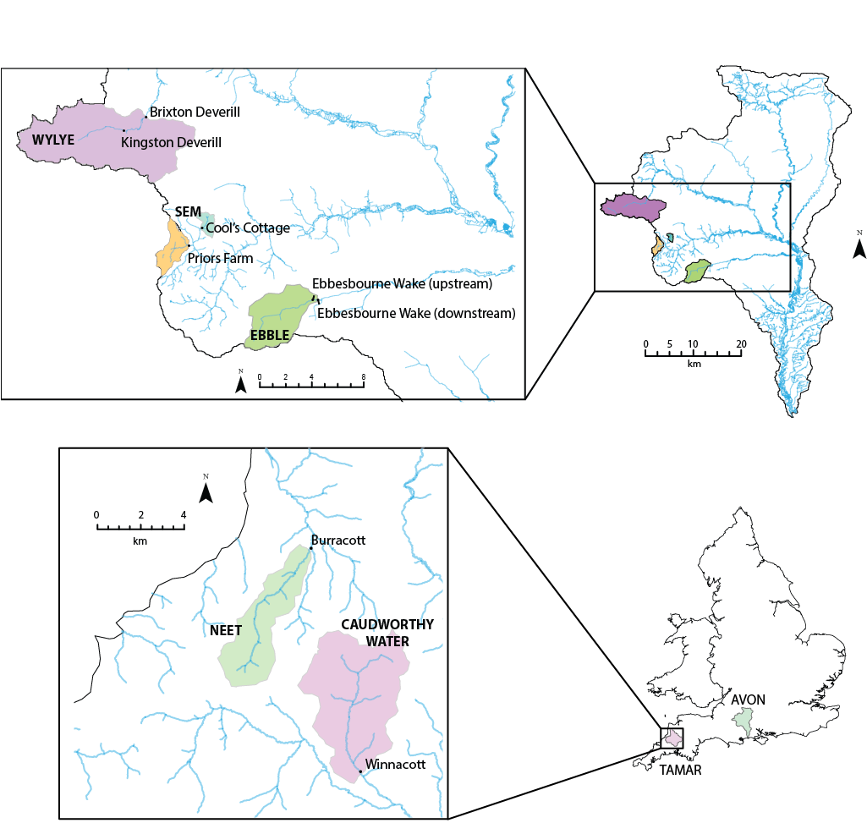

Figure 1: Map of England and Wales showing the Hampshire Avon, Tamar and Neet catchments, with the study site locations.
Water sample
Digestion
by persulphate oxidation
Digestion
by persulphate oxidation
Segmented Flow Analysis
1. Total Dissolved N
(as TON + residual NH₄-N)
2. Total Dissolved P
(as PO₄-P)
Segmented Flow Analysis
1. Total N
(as TON + residual NH₄-N)
2. Total P
(as PO₄-P)
Calculate by difference
1. Dissolved Organic N
(= TDN - Inorganic N species)
2. Dissolved Organic P
(= TDP - PO₄-P)
Calculate by difference
1. Particulate Organic N
(= TN - TDN)
2. Particulate P
(= TP - TDP)
Filtration
0.7 μm Whatman GFF filter
0.45 μm cellulose membrane filter
Segmented Flow Analysis
1. Inorganic N species
(TON, NO₂-N, NH₄-N)
2. Soluble Reactive P
(PO₄-P)
Combustion Catalytic oxidation
Determination of DOC as NPOC
Calculate by difference
1. Nitrate N (NO₃-N)
(= TON – NO₂-N)

Figure 2: Sample analysis protocol (after Johnes and Heathwaite, 1992).
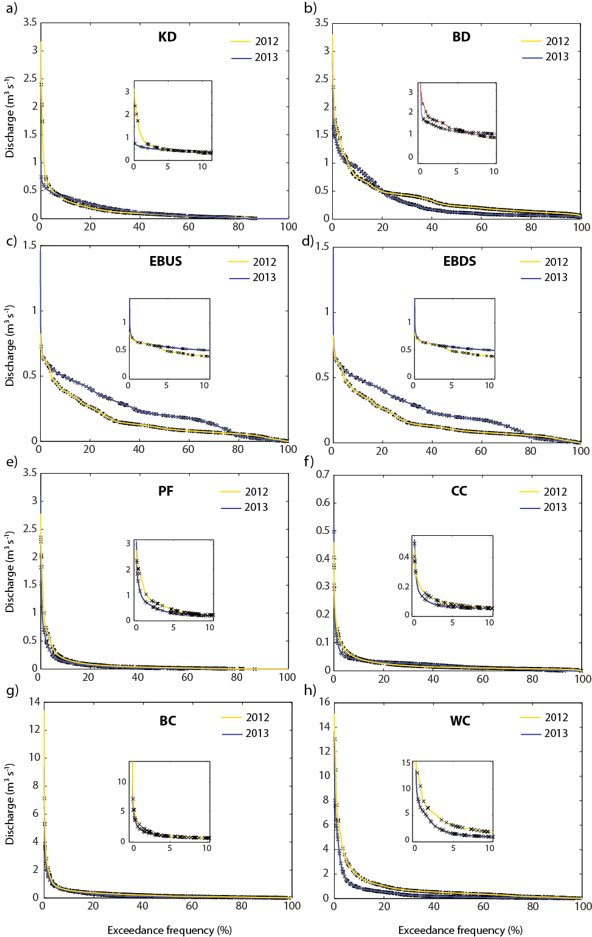
Figure 3: Flow duration curves generated from high-resolution (15-min) discharge; black crosses represent the presence of a daily water chemistry sample. Inset shows expanded area of the graph. KD – Kingston Deverill, BD – Brixton Deverill, EBUS – Ebbesbourne Wake Upstream, EBDS – Ebbesbourne Wake Downstream, PF – Priors Farm, CC – Cool’s Cottage, BC – Burracott, WC – Winnacott.

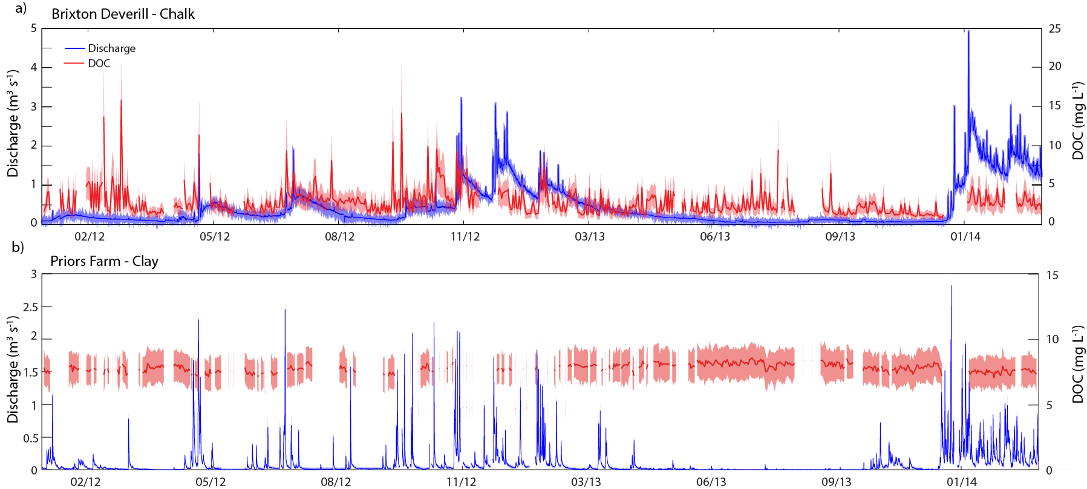
Figure 4: Time series showing discharge and DOC concentrations for a) Brixton Deverill (Wylye) and b) Priors Farm (Sem) sites.

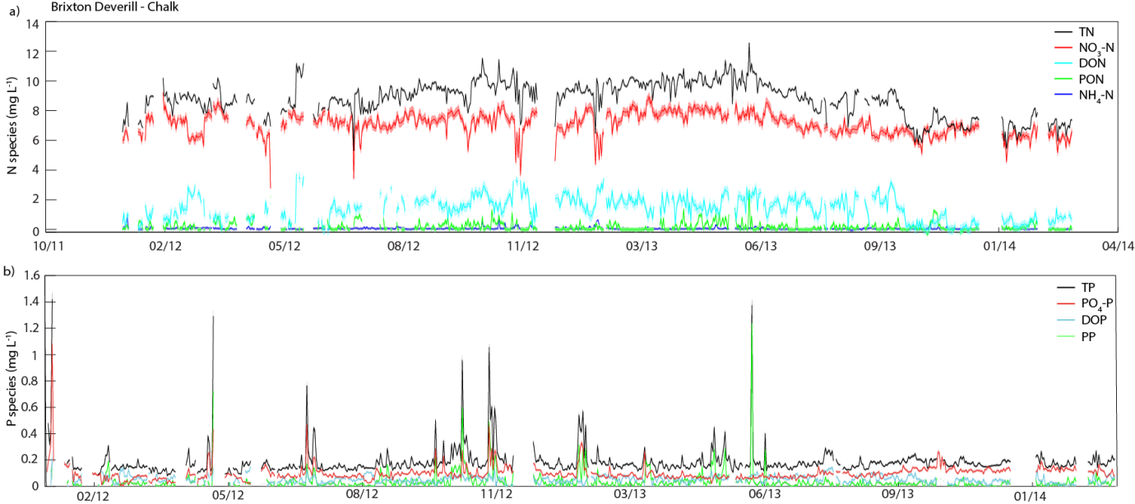
Figure 5: Temporal patterns in a) N species and b) P fractions at Brixton Deverill (Wylye).

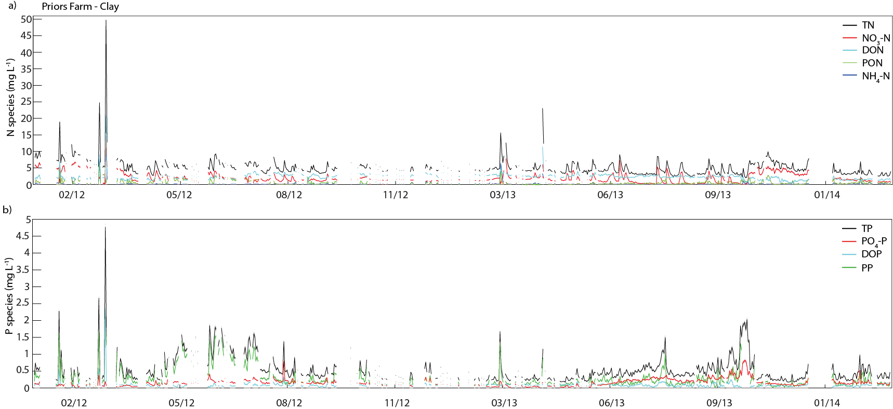
Figure 6: Temporal patterns in a) N fractions and b) P fractions observed at Priors Farm (Sem).

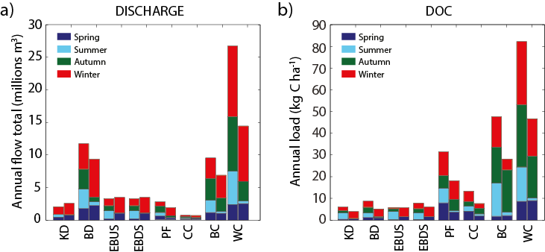
Figure 7: Seasonal a) discharge totals and b) DOC loads across all monitored sub-catchments during 2012 (left bar) and 2013 (right bar). The bars represent the mean annual loads based on the 100 totals and 10,000 load estimates derived from the uncertainty analysis for discharge and DOC, respectively, split by season. KD – Kingston Deverill, BD – Brixton Deverill, EBUS – Ebbesbourne Wake Upstream, EBDS – Ebbesbourne Wake Downstream, PF – Priors Farm, CC – Cool’s Cottage, BC – Burracott, WC – Winnacott. (The annual totals with error bars 10th-90th percentile range of values obtained from the uncertainty analysis can be seen in the Supplementary information).

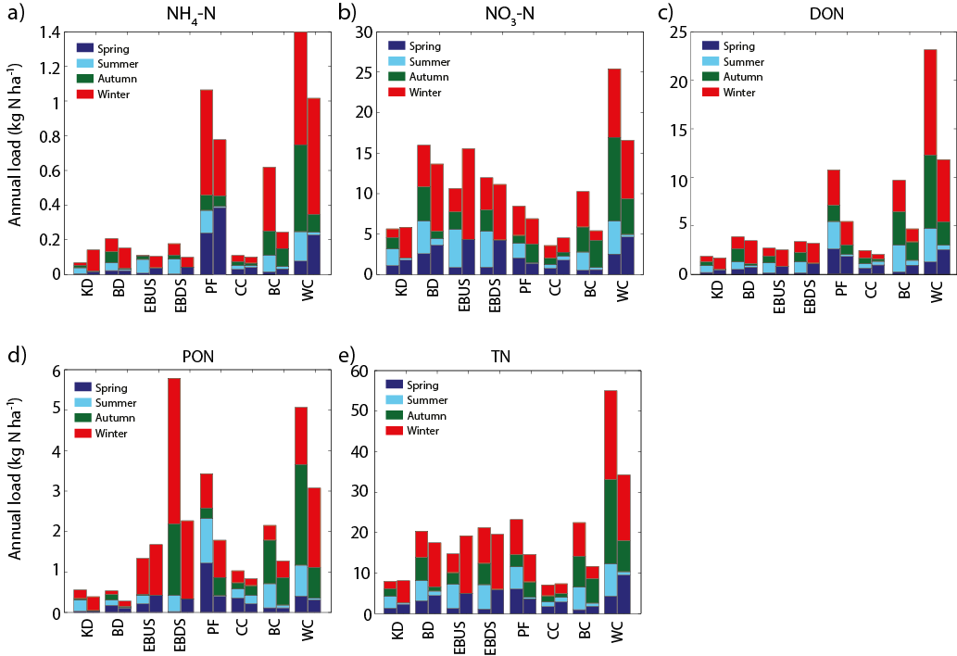
Figure 8: Seasonal loads of a) NH₄-N, b) NO₃-N, c) DON, d) PON and e) TN across all monitored sub-catchments during 2012 (left bar) and 2013 (right bar). The bars represent the mean annual loads based on the 10,000 load estimates derived by the uncertainty analysis, split by season. KD – Kingston Deverill, BD – Brixton Deverill, EBUS – Ebbesbourne Wake Upstream, EBDS – Ebbesbourne Wake Downstream, PF – Priors Farm, CC – Cool’s Cottage, BC – Burracott, WC – Winnacott. (The annual totals with error bars showing 10th-90th percentile range of values obtained from the uncertainty analysis can be seen in the Supplementary information).

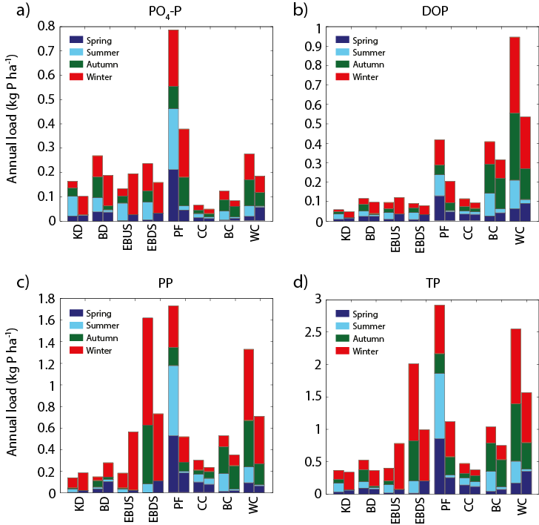
Figure 9: Seasonal loads of a) PO₄-P, b) DOP, c) PP and d) TP across all monitored sub-catchments during 2012 (left bar) and 2013 (right bar). The bars represent the mean annual loads based on the 10,000 load estimates derived by the uncertainty analysis, split by season. KD – Kingston Deverill, BD – Brixton Deverill, EBUS – Ebbesbourne Wake Upstream, EBDS – Ebbesbourne Wake Downstream, PF – Priors Farm, CC – Cool’s Cottage, BC – Burracott, WC – Winnacott. (The annual totals with error bars showing the 10th-90th percentile range of values obtained from the uncertainty analysis can be seen in the Supplementary information).

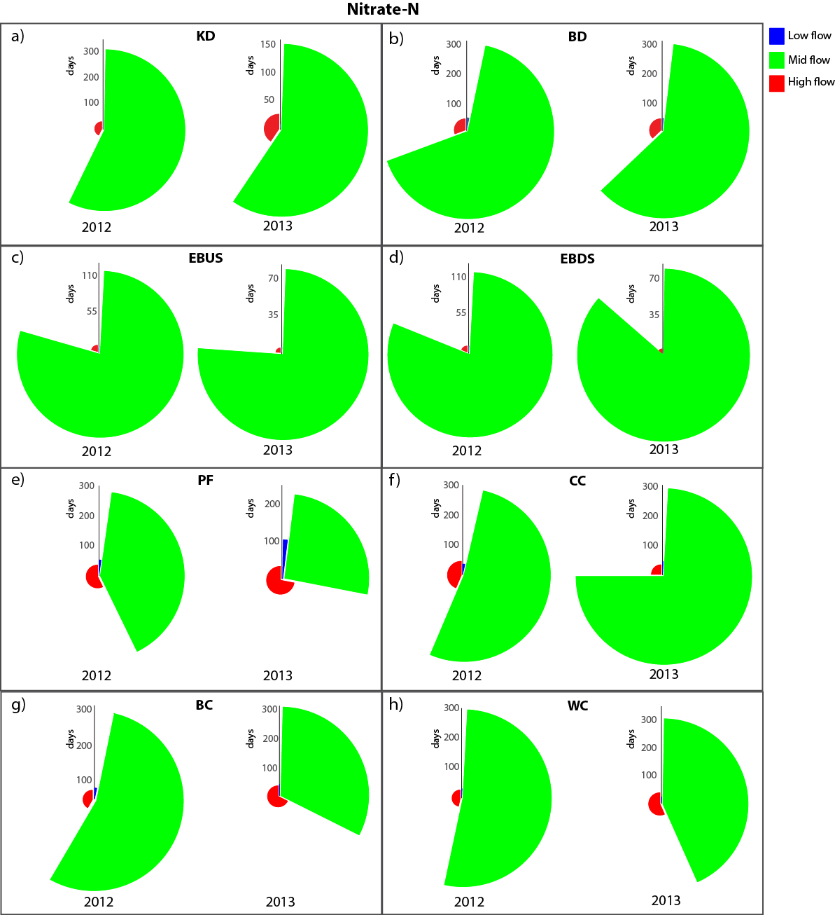
Figure 10: The proportion of the annual NO₃-N load transported during high, mid and low flow periods. The radius of the pie slices represents the number of days over which the flux was observed.

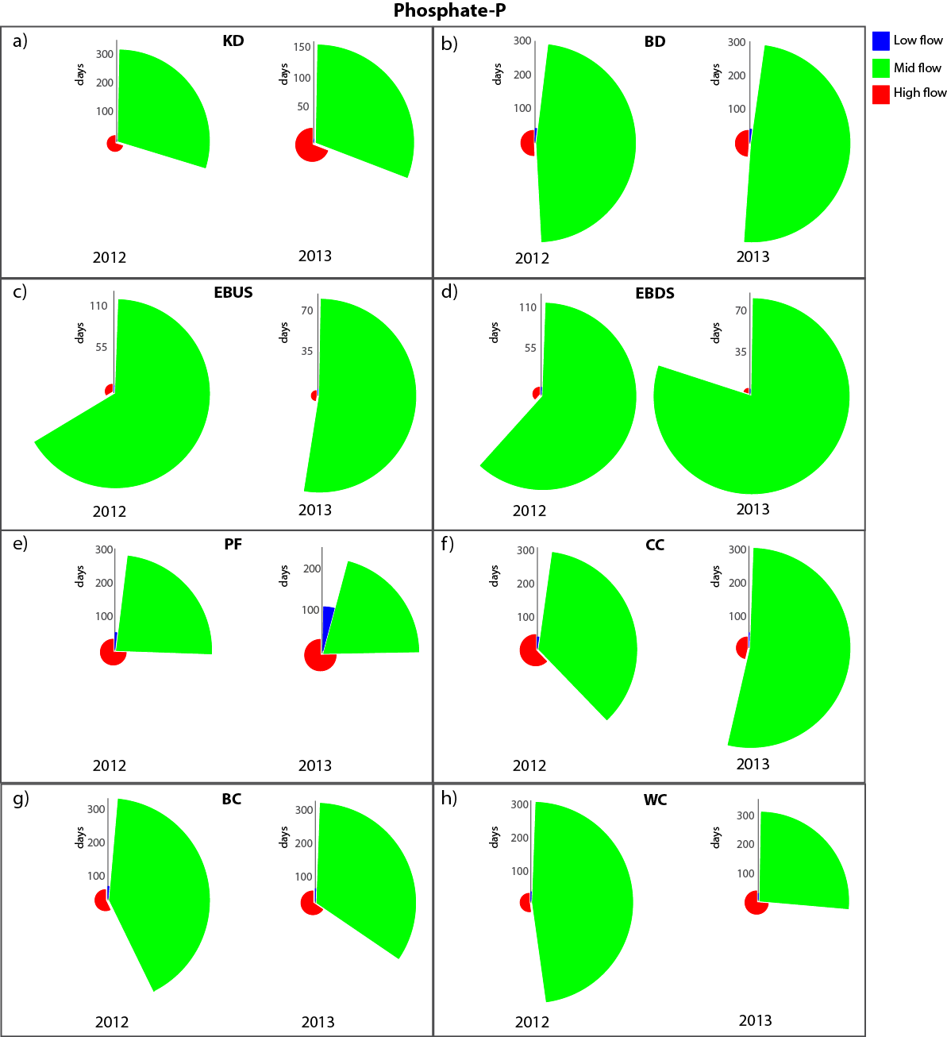
Figure 11: The proportion of the annual PO₄-P load transported during high, mid and low flow periods. The radius of the pie slices represents the number of days over which the flux was observed.

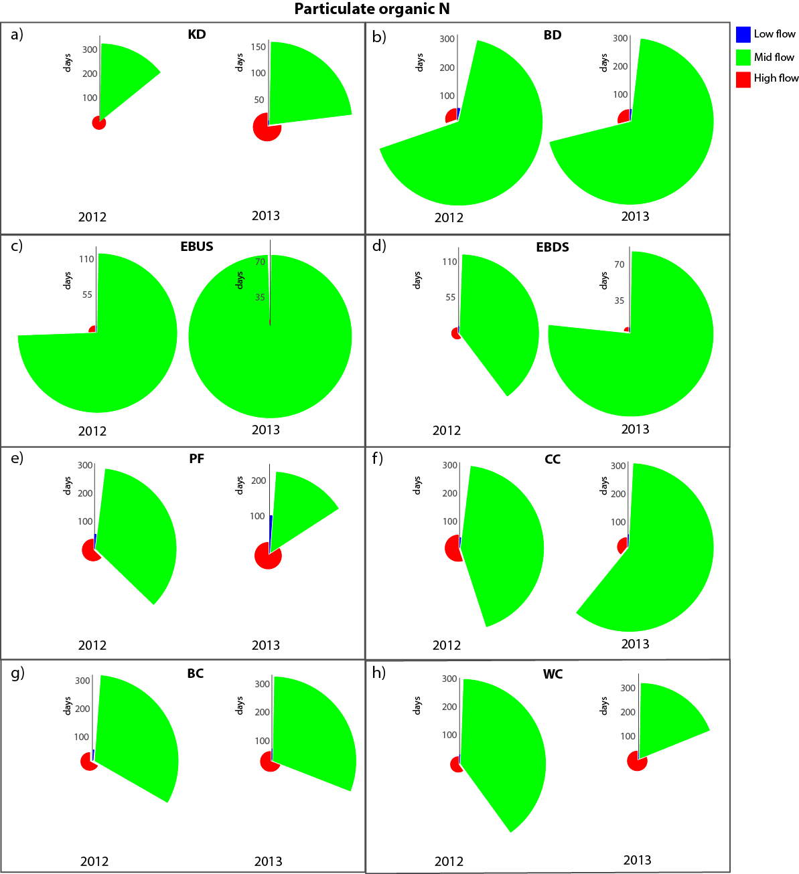
Figure 12: The proportion of the annual PON load transported during high, mid and low flow periods. The radius of the pie slices represents the number of days over which the flux was observed.

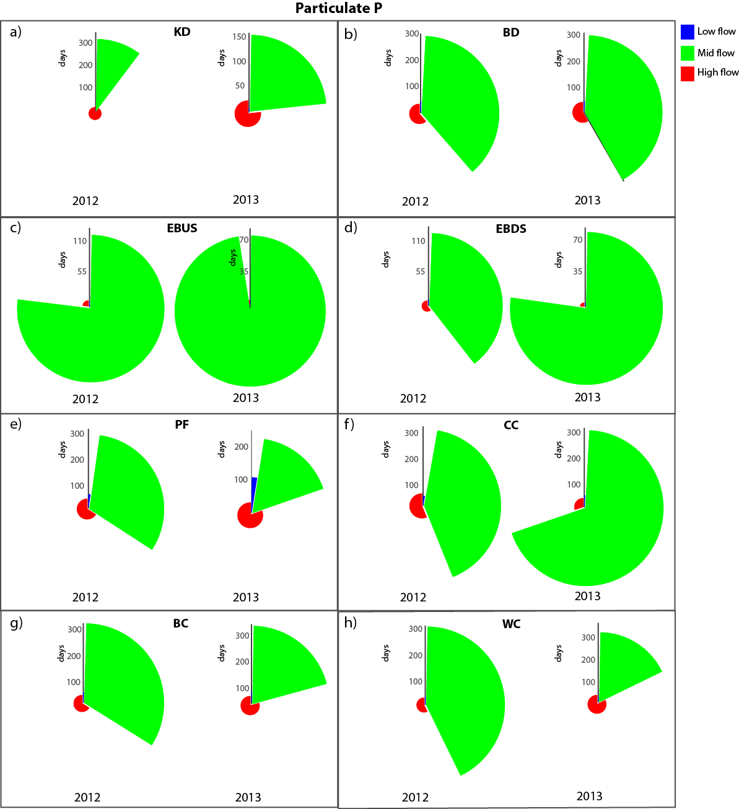
Figure 13: Pie charts showing the proportion of the annual PP load transported during high, mid and low flow periods. The radius of the pie slices represents the number of days over which the flux was observed.

