INFLUENCE OF GENETIC SELECTION AND PHYSICAL ACTIVITY ON TIBIAL BONE MATERIAL PROPERTIES IN LAYING HENS.
A. Rodriguez-Navarro^{1*}, H.M. McCormack², R.H. Fleming², P. Alvarez-Lloret³, Julia Romero-Pastor¹, N. Dominguez-Gasca¹, Tanya Prozorov⁴, I. C. Dunn².
¹Departamento de Mineralogía y Petrologia, Universidad de Granada, 18002 Granada, Spain. ²The Roslin Institute, University of Edinburgh, EH25 9PS, Scotland, UK.
³Departamento de Geología, Universidad de Oviedo, 33005 Oviedo, Spain.
⁴Ames Laboratory. Iowa State University, Ames, IA 50100, USA.
*Corresponding author: anava@ugr.es

HIGHLIGHTS:

Abstract
Laying hens develop a type of osteoporosis that arises from a loss of structural bone, resulting in poor bone quality and increased fracture risk. In this study, a comparison of lines of hens created by divergent selection to have high and low bone quality and housed in either a cage, with limited mobility or in an aviary environment with opportunity for increased mobility was made for bone material properties using FTIR, XRD, BSE-SEM, TEM. The material for this study had previously been used to demonstrate that the improvement of bone biomechanics in the high line hens and in aviary housing was mainly due to increased bone mass, i.e. thicker cortical bone and more medullary bone,. This study shows that besides large morphological differences between lines, bone material properties such as cortical and medullary bone mineral composition and crystallinity as well as collagen maturity did not differ between lines. However, bone material properties of birds from the different type of housing were markedly different. The cortical bone in aviary birds had a lower degree of mineralization and bone mineral was less mature and less organized than in caged birds. These differences can be explained by increased bone turnover rates due to the higher physical activity of aviary birds that stimulates bone formation and bone remodeling resulting in the bone tissue having characteristic of newly deposited bone. Multivariable statistical analyses shows that both cortical and medullary bone contribute to breaking strength of bone. However, cortical bone has a greater contribution than medullary bone to bone strength. The cortical thickness was the single most important contributor to bone mechanical properties while its degree of mineralization and porosity had a smaller contribution. Bone properties had poorer correlations with mechanical properties in cage birds than in aviary birds presumably due to the greater number of structural defects of cortical bone in cage birds compared to aviary birds. This knowledge will help in designing selection strategies to reduce the incidence of osteoporosis and the risk of bone fracture in laying hens.
Keywords: Welfare, Housing, Chicken,

Introduction
Laying hens offer an interesting model for studying bone pathologies such as osteoporosis (Whitehead and Fleming, 2000; Dunn et al., 2007). They have developed specific physiological adaptations to facilitate adequate calcium supply for the rapid calcification of the eggshell having the most efficient calcium metabolism in nature (Dacke et al., 1993; Jonchere et al., 2010). They need to mobilize about 2 g of calcium daily for eggshell formation, equivalent to 10 % of the total body calcium (Miller, 1992). In general, calcium comes in part from the diet and in part from the skeleton, the contribution varying depending on the available calcium in the diet (Taylor and Moore, 1954). As hens reach sexual maturity and come into lay, osteoblast function switches from producing cortical and trabecular bone to produce medullary bone in the marrow cavities of the long bones. Medullary bone serves as a calcium reservoir for eggshell calcification which to some extent buffers the supply and demand over the day (Dacke et al., 1993; Van de Velde, 1985; Whitehead, 2004). However, during lay, osteoclasts not only mobilize Ca from medullary bone when required for shell formation but they also continue cortical bone resorption resulting in a progressive loss of structural bone (Fleming et al., 2006). The loss of structural bone is not compensated by the formation of medullary bone which is mechanically weaker (Ascenzi et al., 1963; Bonucci and Gherardi, 1975; Fleming et al.,2006) and as a result bone became more prone to fracture (Whitehead, 2004; Mazzuco and Hester, 2005). This skeletal weakening is considered to be a type of osteoporosis. Its prevalence in commercial flocks of laying hens, particularly towards the end of lay, and associated bone fractures, is an important welfare challenge (Whitehead, 2004; Webster, 2004; Mazzuco and Hester, 2005; Fleming et al., 2006).
Avian osteoporosis is known to have a large genetic component (Bishop et al., 2000; Fleming et al., 2006; Dunn et al., 2007) making it possible to ameliorate the problem by selecting birds with bone traits that lower the risk of bone fracture. On the other hand, increased physical activity of birds in non-caged housing systems stimulate bone formation making bone stronger (Isaksson et al., 2009; Wang et al., 2013; Warden et al., 2014; Aido et al., 2015). We had previously studied two White Leghorn lines (High and Low), which had been divergently selected for seven generations based on a high or low bone index (BI) which included tibial and humeral breaking strength and keel bone radiographic density (Bishop et al., 2000; Dunn et al., 2007). The effect of physical activity on bone biomechanical properties had been studied in bird housed in conventional cages, with restricted mobility, and in aviary systems, with relatively unrestricted physical activity (Fleming et al., 2006). The results showed that genetic and environmental factors (e.g., housing) affect bone properties, (i.e. bone strength, cortical area, % cortical bone and radiographic density) and their effects were positive independent and additive. Also, the amount of medullary bone was also favorable affected by the selection process and the increased physical activity in aviary systems (Fleming et al., 2006).

Bone is a complex composite material constituted by carbonated apatite nanocrystals mineralizing an organic matrix of cross-linked collagen fibres (Glimcher, 1998; Weiner and Wagner, 1998; Fratlz et al., 2004). The mechanical properties of bone are not only determined by the total bone mass but also by its geometrical distribution, porosity, its structural organization at different scales and the quality of the bone materials (Gupta et al., 2006; Zimmermann et al., 2011). Important bone quality parameters that are currently used to evaluate the fracture risk are mineral density and organization in different bone structures (i.e, osteons, collagen fibres) as well as mineral crystallinity and collagen maturity (cross-linking; Martin and Ishida, 1989; Nakano et al.; 2002; Fratlz et al., 2004; Boskey and Mendelsohn, 2005; Gourion-Arsiquaud et al., 2009; Zimmermann et al., 2011).
To define the main bone characteristics contributing to the observed improvement of the bone mechanical properties during line selection and different physical activity regimens, we have characterized in detail cortical and medullary bone material properties including the degree of mineralization, mineral crystallinity, collagen cross-linking and mineral organization. For this end, we have used complementary analytical techniques such as electron microscopy, infrared spectroscopy and X-ray diffraction. These techniques provide detailed information about the chemical composition and structural organization of main bone components and can help to better understand how the two different bone types contribute to the global mechanical properties of this complex material. The knowledge acquired in this study could increase our understanding of the underlying events resulting on specific bone pathologies (i.e., avian osteoporosis) and may lead to strategies aimed to improve bone quality and reduce the incidence of bone fractures in commercial poultry farms.

METHODOLOGY
Bone samples
Tibia samples from two lines of White Leghorn hens (56 weeks old) with either high or low bone BI were from a previously described study (Fleming et al., 2006). Briefly, hens were reared together in a 60 m² pen until 15 weeks old. After 15 weeks, hens were transferred to individual cages or aviary-type housing systems. For this study, a total of 94 hens (55 and 39 from the low and high lines, respectively) were considered for this study. Of these, 25 hens were housed in individual cages (15 and 10 hens from the low and high lines, respectively) and 69 in aviary systems (40 and 29 hens from the low and high lines, respectively). Bones were stored in a freezer at -20 ºC until analyzed.
Bone properties
The main morphological properties of bones used were measured in a previous study according to the protocols described (Fleming et al., 2006). Briefly, bone dimensions (i.e., tibiae length) and bone mass (whole tibiae radiographic densities) were determined by X-ray radiography of whole tibiae. Histomorphological preparations of mid-diaphysis cross-sections were used to measure the tibiae outer and inner diameter, the cortical thickness and porosity of cortical bone. Biomechanical properties (i.e., tibiae breaking strength and stiffness) were determined by a three points bending test using a material testing machine (JJ Lloyd LRX50). Additionally, in the present study, we measured bone material specific properties (e.g., bone microstructure, chemical composition of the cortical and medullary bone, mineral crystallinity and orientation, and collagen maturity) using electron microscopy, infrared spectroscopy and X-ray diffraction techniques as described below.
Electron Microscopy
Scanning electron microscopy (SEM) observation was carried out on polished cross-sections of the tibiae mid-diaphyses. To prepare the sections, bone samples were embedded in resin, cut, polished, coated with carbon (Hitachi UHS evaporator) and observed with an environmental SEM (FEI Quanta 400) using a backscattering electron (BSE) detector and an accelerating voltage of 15 KeV. A selection of bone samples (2 from each line and housing system; 8 in total) were analyzed by transmission electron microscopy (TEM). Bone samples were fixed with 2.5 % glutaraldehyde and cacodylate buffer (0.1M pH=7.4) for 4 h at 4 ° C. Later on samples were dehydrated using an ethanol gradient (50, 70, 90, and 100%), embedded in resin. Then, they were ultra-thin sectioned (50-70 nm thick) with a LEICA Ultracut R (Germany), carbon coated and analyzed using a Carl Zeiss LIBRA 120 PLUS (Germany) TEM microscope. Calcium distribution in TEM images of the thin sections were determined by EELS. From the Ca maps, the percentage of mineralized tissue was obtained.
Infrared spectrometry
The chemical composition of bone tissues (cortical and medullary bone) were analyzed by infrared spectroscopy. The cortical and medullary bone collected from the tibiae mid-diaphyses were manually separated using a scalpel and homogenized by grinding in an agate ball mill. Bone tissue in powder form was pressed against the ATR diamond crystal window (MIRacle Single Reflection ATR, PIKE Technologies) and the infrared spectra recorded at a 2 cm⁻¹ resolution over 100 scans with a FTIR spectrometer (mod 6200, JASCO). The relative amounts of water, proteins (collagen), lipids, phosphate and carbonate in the bone samples were determined from the peak area of the absorption bands associated with the characteristic molecular groups of each component (e.g., O-H: water; C-H: lipids; amide I: collagen; v₂, v₃ CO₃: carbonates; v₁, v₃ PO₄: phosphates; Boskey and Mendelsohn, 2005; Rodriguez-Navarro et al., 2006). Overlapping peaks were resolved and their integrated areas measured using specifically designed curve fitting software. From the peak areas, the following compositional parameters were determined to define bone material properties: 1) the relative amount of mineral to organic matrix (PO4/Amide I) determined as the ratio of the main phosphate (v₁, v₃ PO₄; 900 - 1200 cm⁻¹) to Amide I (1590-1710 cm⁻¹) band area ratio. 2) The amount of carbonate substituted in the mineral (MinCO3_870) as the ratio of v₂ CO₃ (850-890 cm⁻¹) to the main phosphate (900 - 1200 cm⁻¹) band area, that mainly represents carbonate ions substituting for phosphate ions in the apatite crystalline structure. This ratio increases as the bone mineral matures (Type B carbonate; Rey et al., 1989; Donnelly et al., 2010). 3) Total carbonate relative to mineral content (MinCO3_1415) determined as the ratio of the main carbonate band (v₃ CO₃; 1390-1440 cm⁻¹) to the main phosphate (900 - 1200 cm⁻¹) band area ratio which decreases as bone mineral matures (Ou-Yang et al., 2001; Rodriguez-Navarro et al., 2006); Additionally, we evaluate the total amount of carbonate relative to organic matrix (CO3_a1415/AmideI) as the peak area ratio of the main carbonate band to the amide I band. 4) The mineral crystallinity index (CI) determined as the area ratio between phosphate sub-bands 1030 and 1020 cm⁻¹ which increases as the mineral crystal size and perfection increases (Donnelly et al., 2010). 5) The amount of collagen cross-links as the area ratio between amide I sub-bands at 1660 and 1690 cm⁻¹ which increases with collagen maturity (Paschalis et al., 2001; Donnelly et al., 2010). Additionally, the absolute water, organic matter, carbonate and phosphate content was determined by thermogravimetry (TGA) in selected bone samples. For these analyses, about 25 mg of the powdered bone was introduced into a crucible and analyzed using a TGA system from METTLER-TOLEDO (mod. TGA/DSC1). A heating rate of 20 ° C/min was used for registering the TGA curves.
X-ray diffraction
Tibiae cortical bone (about 1x1 cm) cut from the midshaft of the diaphysis were analyzed in transmission mode with a single crystal diffractometer equipped with an area detector (D8 SMART APEX from Bruker) and Mo radiation (50 KV and 30 mA; 0.5 mm collimator). A quantitative estimation of the degree of alignment of the c-axis of apatite crystals in the cortical bone was determined from the angular breadth of bands displayed in the intensity profile along the Debye-Scherrer ring associated with the 002 reflection of apatite mineral (Wenk and Heidelbach, 1999). The wider the band, the greater the scattering in the orientation of the c-axis of apatite crystals, becoming more randomly distributed. This also represent a measurement of the alignment of mineralized collagen fibers as the apatite crystals nucleate within the collagen fibre gap zone with their c-axis aligned with the collagen fibrils (Fratzl et al., 2004; Nudelman et al., 2013). Additionally, crystallinity of bone mineral was determined by measuring the full width at half maximum (FWHM) of the main apatite peaks (e.g., 002, 211, 310) displayed in 2theta scans. The sharper the peaks and smaller the FWHM, the greater is the crystallinity. XRD2DScan software was used to analyze the collected 2D-XRD diffraction patterns (Rodriguez-Navarro, 2006). Alternatively, XRD crystallinity of bone mineral was determined from powdered samples analyzed with a X-ray powder diffractometer (Panalytical Expert Pro, The Netherlands) with Cu radiation (40 KV and 35 mA) (1D-XRD).
Statistical analyses
Basic descriptive statistics were used to characterize bone properties. Analysis of variance (two-way ANOVA) was used to compare bone properties between birds from different lines and housing types considered. Pearson’s correlation analysis and multivariate linear regression models were used to study the relationships between the different properties of bone and bone mechanical properties. Because cage and aviary birds had very different bone material properties, the later analyses were done separately for each type of housing system. All statistical analyses were performed using Origin Pro (Microcal) or SPSS 22.0 (SPSS Inc.) software package.

RESULTS
Bone morphology
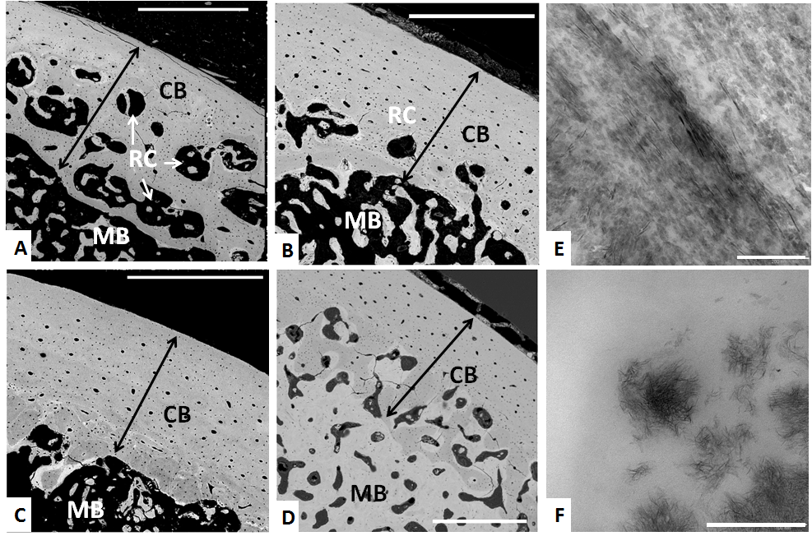
Figure 1. Backscattering electron (BSE-SEM) images of tibiae cross-section at the mid-shaft from birds from Low and High lines kept either in individual cages or aviary housing systems: Bone cross-section from: A) a low line bird housed in an individual cage; B) a high line bird housed in an individual cage; C) a low line bird housed in an aviary; D) a high line bird housed in an aviary. CB: cortical bone; MB: medullary bone; RC: resorption center. Scale bars: 500 µm. E-F) TEM imaging of bone from the mid-shaft tibiae. E) Longitudinally-sectioned cortical bone. F) Section of medullary bone. Scale bars: 200 nm.
Figure 1A-D displays representative BSE-SEM images of tibiae cross-section at mid-diaphyses of birds from different lines and housing systems. The outer bone shell or cortex is composed of dense cortical bone with evenly distributed osteons characterized by the concentric deposition of bone tissue around blood vessels (e.g., Harvesian channels). The marrow cavity was partially mineralized with trabecula of medullary bone which generally are isolated. BSE-SEM images show cortical and medullary bone mineral bright (i.e., high electron density) and pores and resorption cavities dark (low electron density). Tibiae cross-sections from birds of different lines and/or housing systems show evident differences in the cortical bone thickness, porosity and amount of medullary bone present in the marrow cavity. In general, the cortical bone of Low line birds was thinner than that of High line birds. On the other hand, bone from birds housed in cage systems show large resorption cavities in which the cortical bone was partially replaced by medullary bone (Figure 1 A and B). In contrast, the cortical bone of birds housed in aviary systems was thicker and generally does not show resorption centers (Figure 1 C and D). The porosity of cortical bone was higher in birds from the Low line (or from cage systems) compared to birds from the High line (or from aviary systems) though these differences did not attain significance (p = 0.120) (Fig 2). Some birds from the High line from aviary systems have the marrow cavity highly mineralized with medullary bone with connected trabecula bound to the cortical bone inner surface. These birds showed the highest bone mechanical properties (e.g. Breaking strength of 790 N compared to an average of about 500 N for High Line birds).
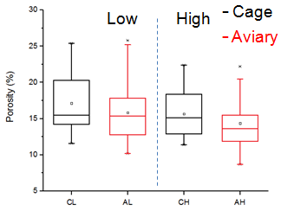
Figure 2. Cortical bone porosity at mid-diaphysis.
Figure 1E-F displays representative TEM images of the cortical and medullary bone from the tibiae mid-diaphysis. Cortical bone is constituted by mineralized collagen fibrils aligned parallel to the bone long axis. The collagen fibrils show their characteristic periodic banding which matches with more densely mineralized areas. The collagen fibrils are mineralized with needle-like apatite crystals oriented with their c-axis parallel to the fibrils and which have a size of 66 ± 18 nm in length and 6.7 ± 0.7 nm wide. Medullary bone was composed of randomly arranged collagen fibrils and ribbon-shaped apatite crystals distributed in separated bundles. The size of apatite crystals in medullary bone was much smaller than in cortical bone. These crystals have an average length of 15.0 ± 1.4 nm and a width of 1.7 ± 0.2 nm.
TEM imaging of cortical and medullary bone did not reveal obvious differences between birds from different lines and/or housing systems regarding the size or shape of apatite crystals and/or its relationship with collagen fibril distribution. However, image analyses of cortical bone sections revealed that this tissue had generally a higher degree of mineralization in caged birds (48.3 ± 4.6 %) than in aviary birds 40.1 ± 10.7 %; p< 0.001).

Bone material properties
Infrared spectroscopy
FTIR spectra of cortical and medullary bone (Figure 3) show the same infrared absorption bands (i.e., amide bands from bone collagen, phosphate and carbonate bands from bone mineral). However, FTIR spectra of cortical bone show more intense v₁ , v₃ PO₄ and v₂ , v₃ CO₃ bands than medullary bone which indicate that cortical bone had a greater relative amount of mineral (phosphate and carbonate) than medullary bone. It should be noted that medullary bone is mixed with organic marrow material so that the degree of mineralization determined by FTIR (PO4/Amide I ratio) was a measure of the amount of medullary bone mineral in the marrow. Cortical bone mineral has a higher degree of carbonate substitution in the mineral (MinCO3_870) than medullary bone. In contrast, cortical bone had a relatively lower total amount of carbonate (MinCO3_1415) than that of medullary bone mineral. Note that the later parameters are calculated exclusively from mineral components (phosphate and carbonate) of the medullary bone and therefore are not affected by the presence of marrow organic matter. All in all, these characteristics indicate that mineral maturity was greater in cortical bone than in medullary bone.
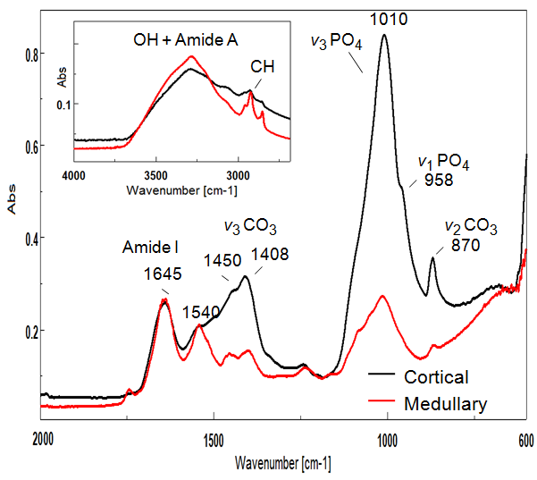
Figure 3. Representative FTIR spectra of cortical (black) and medullary (red) bone displaying characteristic bands corresponding to the absorption of main molecular components of bone tissue (e.g., water (OH), lipids (CH), collagen (amide I), carbonates (v₂ , v₃ CO₃ ), phosphates (v₁ , v₃ PO₄)).
The determined FTIR compositional parameters for cortical and medullary bone also reveal important differences among birds from different lines and/or housing systems, the results are summarized in figure 4 (cortical bone) and figure 5 (medullary bone). In the case of cortical bone, compositional parameters did not show any significant differences between Low and High line birds. However, there are marked differences in cortical bone material properties between birds housed in cage and aviary systems. Cortical bone in birds housed in aviary systems have a lower amount of mineral (about 25 % less) than caged birds (figure 4A) (PO4/Amide I = 3.89 ± 0.56 (aviary) and 4.82 ± 0.59 (caged); p < 0.001) ; equivalent to 34 % and 42 % of mineral by weight as determined by TGA analyses) and also a lower carbonate content (figure 4D) than in caged birds (CO3_1415/ Amide I = 0.80 ± 0.09 (aviary) and 0.87 ± 0.06 (cage), p = 0.002; equivalent to 1.26 % and 1.38 % carbonate by weight). In addition, the cortical bone mineral, in aviary birds, had a significantly lower degree of carbonate substitution (MinCO3_870; p < 0.001) and lower crystallinity (CI; p = 0.002) than in cage birds (figure 4B). In contrast, the total carbonate in bone mineral (MinCO3_1415; p < 0.001) was higher in aviary birds compared to caged birds (figure 4C). On the other hand, the degree of collagen cross-linking in cortical bone estimated as the a1660/a1690 ratio (figure 4F) was higher in birds from aviary systems than in birds from cage systems (p = 0.02).
Pearson correlation analyses show well defined relationships between cortical bone compositional parameters (Table 1). Specifically, the amount of phosphate (a900_1200) and total carbonate (a1415) in this tissue are positively and highly correlated, confirming that carbonate was bound to phosphate as part of the bone mineral. On the other hand, there was significant positive correlation between the degree of mineralization (PO4/Amide I) and the amount of carbonate substituted in the mineral (MinCO3_870). There was also a positive correlation between the degree of mineralization and the crystallinity index (CI) as well as between the degree of mineralization and carbonate substitution (MinCO3_870) and the crystallinity index (CI). In contrast, there was a significant negative correlation between the degree of mineralization and the total amount of carbonate in the mineral (MinCO3_1415). All these relationships are coherent and can be explained by the bone mineral maturation process. Bone mineral increases in crystallinity and incorporates more carbonate into its crystalline structure (type B carbonate). At the same time, the mineral loses labile carbonate, accounting for the reduction of the total amount of carbonate (CO3_1415/Amide I). Additionally, the positive correlation between the degree of cross-linking (a1660/a1690) and the crystallinity index (CI) indicates that as bone tissue matures, the density of collagen cross-linking also increases.

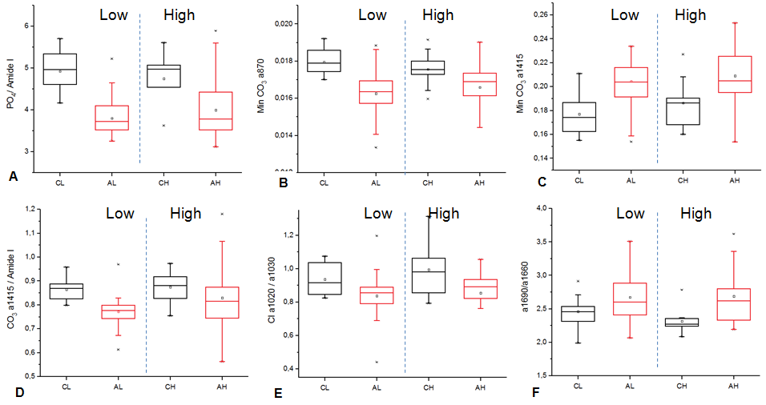
Figure 4. FTIR compositional parameters of cortical bone for caged (black) and aviary (red) birds: A) degree of mineralization (PO4/Amide I); B) degree of carbonate substitution in bone mineral; C) total amount of carbonate in bone mineral (MinCO3_1415); D) total amount of carbonate in bone (CO3_1415/Amide I); E) crystallinity index (CI); F) collagen cross-linking (a1660/a1690).

Table 1. Pearson correlation analysis of cortical bone parameters determined by FTIR.
 |  | PO4/AmideI | CO3_1415/AmideI | MinCO3_900 | MinCO3_1415 | CI | a1660/a1690
PO4/AmideI | R | 1
 | p | --
 | N | 98
CO3_1415/AmideI | R | 0.735 | 1
 | p | < 0.001 | --
 | N | 98 | 98
MinCO3_900 | R | 0.372 | 0.539 | 1
 | p | < 0.001 | < 0.001 | --
 | N | 98 | 98 | 98
MinCO3_1415 | R | -0.716 | -0.065 | 0.027 | 1
 | p | < 0.001 | 0.556 | 0.805 | --
 | N | 98 | 98 | 98 | 98
CI | R | 0.321 | 0.543 | 0.733 | 0.093 | 1
 | p | 0.003 | < 0.001 | < 0.001 | 0.400 | --
 | N | 98 | 98 | 98 | 98 | 98
a1660/a1690 | R | -0.118 | -0.218 | -0.447 | -0.099 | -0.579 | 1
 | p | 0.289 | 0.047 | < 0.001 | 0.374 | < 0.001 | --
 | N | 98 | 98 | 98 | 98 | 98 | 98

In the case of medullary bone, FTIR showed that birds from the High line, or housed in aviary systems, had a greater amount of medullary bone than birds from the Low line, or those housed in cage systems. Particularly, birds from the High line housed in aviary systems had the greatest amount of medullary bone mineral (Figure 5A) (p < 0.001). On the other hand, there was not significant differences in the other bone material properties investigated (Figure 5B-F)) between birds from the two lines. However, the type of housing did influence the composition of medullary bone mineral. Specifically, the carbonate substitution in the mineral (Figure 5B) was significantly lower for aviary birds (p = 0.010), indicating the medullary bone mineral was less mature in aviary birds. Also, collagen cross-linking (Figure 5F) was lower in medullary bone of aviary birds (p = 0.018).
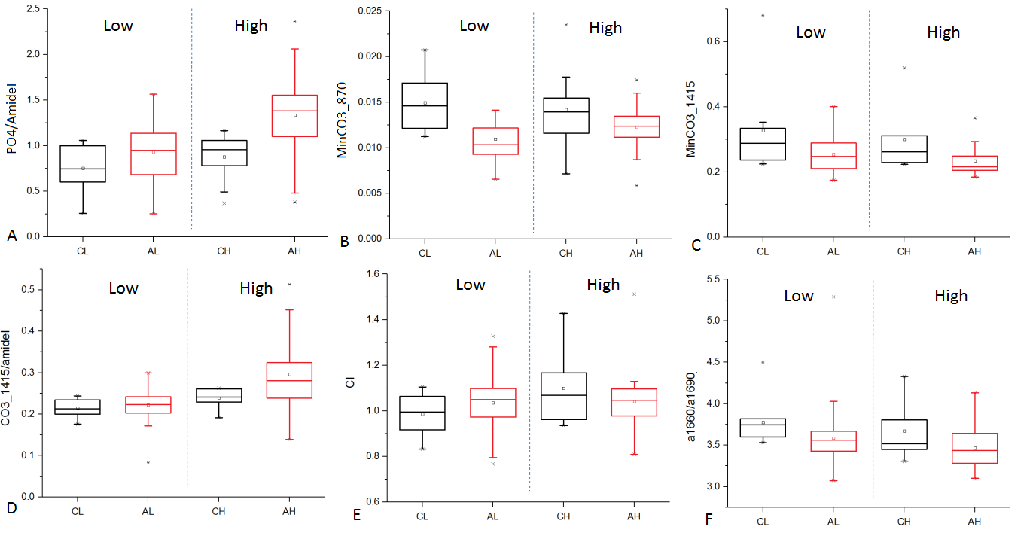
Figure 5. FTIR compositional parameters for medullary bone: A) degree of mineralization (PO4/Amide I); B) degree of carbonate substitution in bone mineral (MinCO3_870); C) total amount of carbonate in bone mineral (MinCO3_1415); D) total amount of carbonate in bone (CO3_1415/Amide I); E) crystallinity index (CI); F) collagen cross-linking (a1660/a1690).
X-ray diffraction
X-ray diffraction shows notable differences between the cortical and medullary bone related to mineral organization and its crystallinity (Figure 6). In both tissues, the main mineral phase detected was nanocrystalline apatite. Cortical bone mineral has a greater crystallinity than medullary bone mineral, as indicated by better defined and sharper Bragg reflection peaks (lower FWHM; Figure 7). On the other hand, 2D-XRD patterns of cortical bone shows that the intensity of Debye-Scherrer rings is concentrated in arcs (i.e., 002 reflection) due to the preferentially orientation of apatite crystals that have their c-axis aligned parallel to the elongation of long bones (Figure 6A and D). In contrast, 2D-XRD patterns of medullary bone shows complete Debye-Scherrer rings of homogenous intensity, characteristic of materials with a random crystal orientation (Figure 6B and D).
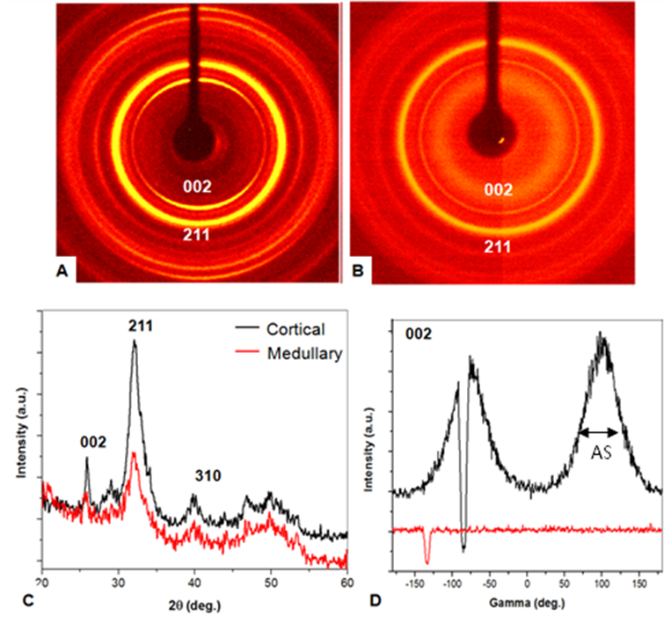
Figure 6. 2D and 1D X-ray diffraction patterns from cortical and medullary bone. A) 2D-XRD of cortical bone. B) 2D-XRD pattern of medullary bone. C) 2theta scan of cortical (black) and medullary (red) bone. D) Gamma scan displaying the intensity variation along the 002 Debye ring for cortical (black) and medullary (red) bone. AS corresponds to angular spread of crystal orientation.
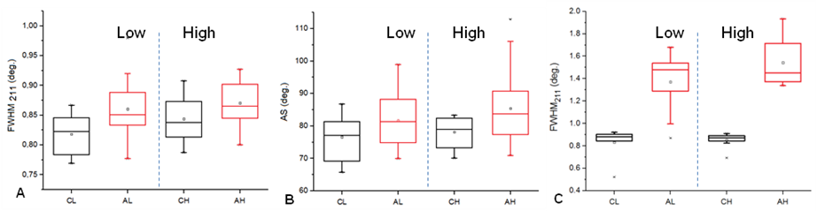
Figure 7. XRD determined parameters for cortical and medullary bone mineral for caged (black) and aviary (red) birds: A) FWHM of 211 reflection of apatite in cortical bone. B) Angular spread (AS) of 002 reflection in cortical bone. C) FWHM of 211 reflection of apatite in medullary bone.
In figure 7 parameters determined by X-ray diffraction for cortical and medullary bone are summarized. Cortical bone mineral of birds from the Low line, and from cage systems, have lower FWHM values of 211 reflection than birds from the High line, and from aviary systems, indicating that bone mineral has a higher crystallinity in the former groups (Figure 7A). However, the effect on bone mineral crystallinity of the type of housing (p = 0.001) was larger than that of lines (p = 0.077). On the other hand, the angular spread (AS) of apatite crystals of cortical bone in aviary birds was larger than in cage birds (Figure 7B) (p = 0.016). No significant differences were observed between lines for AS parameter (p = 0.309). Thus, the cortical bone mineral in aviary birds has a lower crystallinity and is more disorganized (lesser degree of alignment of crystals and collagen fibres) than that of cage birds. Also, the medullary bone from aviary birds have much higher values of FWHM 211 reflection than cage birds, indicating that medullary bone mineral in aviary birds has a very low crystallinity (Figure 6 C; p < 0.001).
Influence of bone material properties on mechanical properties
Pearson correlation analyses show that mechanical properties (bone breaking strength) are positively and significantly correlated with cortical thickness and even more strongly with whole tibiae radiographic density (Table 2). This was indicative that bone mass was a major determinant of bone mechanical properties. There was also a negative correlation between mechanical properties (bone breaking strength) and cortical bone porosity which was only significant in the case of cage birds. There was a positive correlation between mechanical properties and degree of mineralization of both cortical and medullar bone. However, these relationships were only statistically significant in the case of aviary birds. The orientation of apatite crystals (angular spread) was not correlated to mechanical properties.
A multivariate linear regression model was built to better understand the contribution of cortical and medullary bone to the global bone mechanical properties (Table 2). Cortical bone properties considered were: cortical thickness, degree of mineralization, porosity, angular spread (AS). For medullary bone, the degree of mineralization was the only parameter used. Since bone properties of cage and aviary birds were markedly different, data from each group were treated separately. In the case of cage birds, the contribution of cortical bone and medullary bone on bone mechanical properties was moderate. Each type of bone tissue could explain only up to 33 % of the variance in bone breaking strength (cortical bone: CT; R²= 0.302; p =0.004; medullary bone: MDM; R²= 0.161; p =0.096). Adding the cortical and medullary bone properties in the model did not improve the fitting (R²= 0.270; p =0.115). In contrast, in the case of aviary birds, the separated contributions of cortical and medullary bone were high. Cortical bone and medullary bone properties alone could explain up to 49 and 40 % of variance of bone mechanical properties, respectively. Adding both types of bone in the model did significantly improve the fitting (R²= 0.691; p < 0.001). Thus, in the case of aviary birds, both types of tissues significantly contribute to bone mechanical properties though the contribution of cortical bone was notably more important.
Table 2. Pearson correlation analysis and multivariate linear regression model of bone mechanical properties and bone material properties. WTRD: whole tibiae radiographic density; CT: cortical thickness; CP: cortical porosity; CDM: cortical degree of mineralization; AS: angular spreading; MDM: Medullar degree of mineralization.
Max. Load | Cage |  |  | Aviary
 | R2 | p | N | R2 | p | N
WTRD | 0.842 | < 0.001 | 24 | 0.889 | < 0.001 | 69
CT | 0.302 | 0.004 | 23 | 0.399 | < 0.001 | 68
CP | 0.172 | 0.043 | 24 | 0.024 | 0.197 | 69
CDM | 0.009 | 0.692 | 19 | 0.114 | 0.006 | 65
AS | 0.114 | 0.156 | 19 | 0.001 | 0.840 | 64
MDM | 0.161 | 0.096 | 18 | 0.396 | < 0.001 | 63
CT+ CP | 0.287 | 0.013 | 23 | 0.420 | < 0.001 | 68
CT+ CP + CDM | 0.214 | 0.098 | 18 | 0.514 | < 0.001 | 64
CT+CP+CDM+AS | 0.280 | 0.081 | 18 | 0.490 | < 0.001 | 57
CT+CP+CDM+AS+MDM | 0.270 | 0.115 | 18 | 0.691 | < 0.001 | 55

Discussion
The present study extends previously published work aimed to analyze the influence of genetic and environmental factors on the incidence and severity of osteoporosis in laying hens (Bishop et al., 2000; Fleming et al., 2006; Dunn et al., 2007). Specifically, it utilizes the same material used by Fleming et al. 2006, where it was studied the effect of genetic selection plus environment factors (housing, diet) on bone histomorphological (cortical area, radiographic density, osteoclast number) and mechanical properties (bone breaking strength). Here a detailed study of relevant bone material properties (i.e., bone chemical composition, mineral crystallinity and structural organization) was performed for each type of avian bone tissue (cortical and medullary). The information obtained allowed us to determine the influence of genetic and environmental factors on bone material properties and the contribution of different type of bone tissue on global bone mechanical properties.
As previously described for these samples (Fleming et al. 2006), hens from the High line had stronger bones than those from the Low line which was correlated with greater bone mass indicated by a higher radiographic density and thicker cortical bone. High line hens also had more medullary bone than the low line hens which may have assisted in maintaining the stronger bones of the high line hens (Fleming et al. 2006). Hens housed in the aviary system also had stronger bones compared to birds housed in cage systems, again due to an increased bone cortical thickness, a lower bone cortical porosity, a larger amount of medullary bone and overall a greater total bone mass. An increased bone resorption due to a higher osteoclast number in low line birds was responsible for their reduced cortical thickness.
Despite the large differences observed between the High and Low lines for mechanical and morphological measurements (Fleming et al. 2006), the cortical and medullary bone material properties analyzed in the current study; degree of mineralization, carbonate substitution in the mineral, mineral crystallinity, collagen cross-linking, degree of alignment of apatite crystals were indistinguishable between birds lines. The selection process, therefore, did not appear to change the properties of bone constituting materials (e.g., mineral, collagen) but rather the amount of bone and its geometrical distribution. It has however been reported that the level of cross-linking in the high line hens (measured using a chemical method) was elevated (Sparke et al., 2002).
The type of housing (cage vs aviary systems), however, did have a large influence on bone material properties. Caged birds have more and larger resorption cavities in their cortical bone than aviary birds. In addition, cortical bone in aviary birds has a lower degree of mineralization, lesser carbonate mineral substitution and a lower crystallinity than cortical bone in caged birds. Overall, these characteristics are typical of younger, less mature bone mineralization (Boskey, 2005; Donnelly et al., 2010). This suggests that cortical bone in aviary hens is more metabolically active and has a faster turnover rate, so that bone tissue is continuously being renewed and do not have time to become fully mineralized and the mineral to mature and became more organized (Wang et al., 2013) as we have observed. Also, the medullary bone mineral in aviary hens was less mature than in caged hens, suggesting that aviary birds had an overall higher rate of medullary bone formation and turnover than caged hens.
The increased metabolic activity of bone and higher turnover rates in aviary birds should allow for a more efficient bone adaptation to mechanical loads. Also, the replacement of old bone tissue with new bone during the remodeling process avoids the accumulation of microfractures. All these changes can have a positive contribution to the improved mechanical properties of bone in aviary birds (Isaksson et al., 2009; Wang et al., 2013; Warden et al., 2014; Aido et al., 2015). In fact, bone remodelling rates is one of the main factor that determine bone properties and different bone pathologies result from an altered or unbalanced bone remodeling rate (Fratzl et al., 2004; Boskey et al, 2005; Isaksson et al., 2010; Paschalis et al., 2011).
The improved bone mechanical properties of aviary birds should be directly related to greater physical activity of these birds in this type of housing (Fleming et al., 2006) which have been confirmed during lay (Leyendecker et al., 2001; Regmi et al., 2016) and during rear (Regmi et al., 2015). Prolonged immobility in cage hens increases bone resorption whereas increased physical activity (in aviary birds) stimulate bone formation and remodelling (Bassey 1995; Mosekilde et al., 1994; Bell et al., 1988; Shipov et al., 2010; Aguado et al., 2015). Besides the amount of bone, changes in bone material properties could have also influenced bone breaking strength. For example, the amount of cross-linking estimated by FTIR was increased in cortical bone from aviary hens which may contribute to the improvement in the observed material and mechanical properties (Saito and Marumo, 2010). On the other hand, mineral organization defined as the degree of crystal alignment determined by XRD was not correlated to the global mechanical properties of bone. However, aviary hens which showed the highest bone strength had a lower degree of crystal orientation. Thus, we cannot preclude that mineral organization is an important contributor to bone strength. In fact, mineral and collagen organization in bone are responsible of the large anisotropy of bone mechanical properties at the microscale (Weiner and Wagner, 1998; Ishimoto et al., 2013).
Multivariable statistical analyses shows that both cortical and medullary bone contribute to breaking strength of bone. Cortical bone had as expected the greatest contribution to bone strength. The cortical thickness was the most important parameter while the degree of mineralization of cortical bone had a smaller contribution. In the case of medullary bone, its degree of mineralization was correlated with bone breaking strength even though, its contribution was less important than cortical bone properties. The weaker relationship between bone material properties and breaking strength in caged hens could be due to the greater number of structural defects (high porosity, large resportion cavities) of cortical bone in these hens. The large resorption cavities found in cortical bone are significant flaws that may act as crack initiation sites, greatly reducing the fracture toughness of bone despite relatively small effects on the material properties. However, the best single predictor of global bone mechanical properties (breaking strength) was the total bone mass determined as the whole radiographic density. This property was measured in the whole tibiae bone whereas the material properties were measured locally (at the mid-shaft of the tibiae). The differences in scale of sampling and measurements might account for different predictive power of the determined bone properties.
In summary, the global bone mechanical properties are determined by many factors; type of bone tissue, geometry, porosity, degree of mineralization. Cortical bone had the greatest contribution to global bone mechanical properties. Medullary bone may also contribute significantly to bone strength particularly when present at greater amounts as a highly mineralized dense material. Greater amounts of mineralized medullary bone may also serve to protect cortical bone from resorption. The study suggests that selection of hens based on an index featuring mainly bone strength did not produce significant changes in the constituent materials properties of bone. In contrast, the type of housing produced changes in bone material properties. The changes in the bone material properties between cage and aviary hens appeared to be mainly due to differences in bone metabolism resulting from increased physical activity in aviary hens stimulating bone formation and/or turnover rates. High line hens appear to have a greater capacity to form bone and to respond to the mechanical stimuli of increasing physical activity in aviary systems. Fleming et al. (2006) and Whitehead (2004) attributed the increased bone mass in the High line hens to better bone formation during rearing and less resorption during the laying period due to a reduced density of osteoclasts observed in the high line which was reduced further in the aviary. The study confirms the beneficial effects of aviary systems on bone quality and suggests that if the problems of collisions in aviaries can be solved, combined with improved genetics, then the risk of fracture in laying hens can be ameliorated. Knowledge acquired in this study could help in designing better selection strategies and/or housing systems aimed to reduce the incidence of osteoporosis in laying hens.

Acknowledgements
We are grateful for financial support through grants CGL2011-25906 and CGL2015-64683-P (Ministerio de Ciencia e Innovación, Spain) (ARN), RNM-179 group (Junta de Andalucía, Spain) (ARN). The Roslin Institute is supported by a BBSRC institute strategic programme grant BB/J004316/ and we are in receipt of an ERANET ANIHWA grant ‘BetterBones’. The original samples were collected using funding from DEFRA and the BBSRC with collaboration from Lohmann Tierzucht. We thank Bendicion Funes, Maria Jose Martinez, Jose Romero, Isabel Sanchez and Juan de Dios Buenos (U. Granada), and Tracey M. Pepper (Iowa State University) for their help during sample preparation and analyses.
References
Aguado E, Pascaretti-Grizon F, Goyenvalle E, Audran M, Chappard D. Bone Mass and Bone Quality Are Altered by Hypoactivity in the Chicken. PLoS ONE (2015) 10(1): e0116763.
Aido, M., Kerschnitzki, M., Hoerth, R., Checa, S., Spevak, L., Boskey, A.L., Fratzl, P., Duda, G.N., Wagermaier, W., Willie, B.M., 2015. Effect of in vivo loading on bone composition varies with animal age. Exp. Gerontol. 63, 48-58.
Ascenzi, A., Francois, C., Bocciarelli, D. S. (1963). On the bone induced by oestrogens in birds. J. Ultrastruct. Res. 8, 491–505.
Bassey. E.J. Exercise in primary prevention of osteoporosis in women. Ann. Rheum. Dis. 54(11) (1995) 861-862.
Bell N.H, Godsen R.N., Henry D.P., Shary J., Epstein S. The effects of muscle-building exercise on vitamin-D and mineral metabolism. J. Bone Miner. Res. 3(4) (1988) 369-373.
Bishop, S.C., Fleming, R.H., McCormack, H.A., Flock, D.K., Whitehead, C.C. Inheritance of bone characteristics affecting osteoporosis in laying hens. British Poultry Science, 2000 41 (1), 33-40.
Bonucci, E., Gherardi, G. (1975). Histochemical and electron microscope investigations on medullary bone. Cell Tissue Res. 163 (1), 81–97.
Bonucci, E. The mineralization of bone and its analogies with other hard tissues. In Advanced Topics in Crystal Growth; Ferreira, S.O., Ed.; InTech: Rijeka, Croatia, 2013; pp. 145–184.
Boskey, A.; Mendelsohn, R. Infrared analysis of bone in health and disease. J. Biomed. Opt. 2005, 10, 031102-1-031102-9.
Dacke C.G., Arkle S., Cook D.J., Wormstone I.M., Jones S., Zaidi M., Bascal Z.A. Medullary Bone and Avian Calcium Regulation, J. Exp. Biol. 184 (1993) 63-88.
Donnelly E, Boskey AL, Baker SP, van der Meulen MC. Effects of tissue age on bone tissue material composition and nanomechanical properties in the rat cortex. J Biomed Mater Res A. 2010, 92(3):1048-56.
Dunn IC, Fleming R.H., McCormack H.A., Morrice D, Burt DW, Preisinger R, Whitehead CC.. A QTL for osteoporosis detected in an F2 population derived from White Leghorn chicken lines divergently selected for bone index. Anim Gen 38 45 (2007).
Fleming, R. H., H. A. McCormack, L. McTeir, and C. C. Whitehead. 1998a. Medullary bone and humeral breaking strength in laying hens. Res. Vet. Sci. 64:63–67.
Fleming, R. H., H. A. McCormack and C. C. Whitehead. 1998b. Bone structure and strength at different ages in laying hens and effects of dietary particulate limestone, vitamin K and ascorbic acid. Br. Poult. Sci. 39:434–440
Fleming, R. H., Whitehead C.C., Alvey D., Gregory NG, Wilkins LJ. 1994. Bone structure and breaking strength in laying hens housed in different husbandry systems. Br. Poult. Sci. 35:651–662.
Fleming, R.H., McCormack, H.A., McTeir, L., Whitehead, C.C.. Relationships between genetic, environmental and nutritional factors influencing osteoporosis in laying hens. 2006. British Poultry Science, 47, (6), 742-755.
Fratzl P., Gupta H.S, Paschalis E.P., Roschger P. Structure and mechanical quality of the collagen-mineral nano-composite in bone. J. Mater. Chem.14:2115–23 (2004).
Glimcher, M. J. The nature of the mineral phase in bone: Biological and clinical implications. In Metabolic Bone Disease and Clinically Related Disorders; Alvioli, L. V., Krane, S. M., Eds.; Academic Press: San Diego, CA, 1998; pp 23-50.
Gourion-Arsiquaud S, Faibish D, Myers E, Spevak L, Compston J, Hodsman A, Shane E, Recker RR, Boskey ER, Boskey AL. Use of FTIR spectroscopic imaging to identify parameters associated with fragility fracture. J Bone Miner Res. 2009;24:1565–71.
R. Gupta, M. Grasruck, C. Suess, S. Bartling, B. Schmidt, K. Stierstorfer, S. Popescu, T. Brady, T. Flohr. Ultra-high resolution flat-panel volume CT: fundamental principles, design architecture, and system characterization. European Radiology, 16 (2006), 1191–1205
Isaksson H, Grongroft I, Wilson W, van Donkelaar CC, van Rietbergen B, Tami A, Huiskes R, Ito K. Remodeling of fracture callus in mice is consistent with mechanical loading and bone remodeling theory. J Orthop Res. 2009;27(5):664–72.
Ishimoto, Nakano, et al., 2013 Degree of Biological Apatite c-Axis Orientation Rather Than Bone Mineral Density Controls Mechanical Function in Bone Regenerated Using Recombinant Bone Morphogenetic Protein-2. JBMR 28 (5) 2013, 1170–1179.
Jonchère V1, Brionne A, Gautron J, Nys Y. Identification of uterine ion transporters for mineralisation precursors of the avian eggshell. BMC Physiol. 2010 Sep 4;12:10. doi: 10.1186/1472-6793-12-10.
Leyendecker M., Hamann H., Hartung J. , Kamphues J., Ring C., Glunder G., Ahlers C., Sander I., Neumann U, Distl O. Analysis of genotype-environment interactions between layer lines and hen housing systems for performance traits, egg quality and bone breaking strength - 3rd communication: Bone breaking strength, Zuchtungskunde 73(5) (2001) 387-398.

Martin, RB., Ishida, J., 1989. The relative effect of collagen fiber orientation, porosity, density and mineralization on bone strength. Journal of Biomechanics 22, 416-426.
Mazzuco, H. and Hester P.Y. The Effect of an Induced Molt Using a Nonfasting Program on Bone Mineralization of White Leghorns. 2005 Poultry Science 84:1483–1490.
Miller, S.C., 1992. Calcium homeostasis and mineral turnover in the laying hen. In C.C. Whitehead (Ed.) Bone Biology and Skeletal Disorders in Poultry. Vol. 23. Carfax, Abingdon, pp. 103-113.
L. Mosekilde, C.C. Danielsen, C.H. Sogaard, E. Thorling, The effect of long-term exercise on vertebral and femoral bone mass, dimensions, and strength - assessed in a rat model, Bone 15(3) (1994) 293-301.
Nakano T, Kaibara K, Tabata Y, Nagata N, Enomoto S, Marukawa E, Umakoshi Y. Unique alignment and texture of biological apatite crystallites in typical calcified tissues analyzed by microbeam X-ray diffractometer system. Bone. 2002;31:479–87.
Nudelman, F., Lausch A. J., Sommerdijk N. A. J. M., Sone E. D., 2013. In Vitro models of collagen biomineralization. J Struct Biol 183: 258-269.
Ou-Yang H, Paschalis EP, Mayo WE, Boskey AL, Mendelsohn R. Infrared microscopic imaging of bone: spatial distribution of CO3(2-)J Bone Miner Res. 2001 May;16(5):893-900.
Paschalis EP, Verdelis K, Doty SB, Boskey AL, Mendelsohn R, Yamauchi M. Spectroscopic characterization of collagen cross-links in bone. J Bone Miner Res. 2001 Oct;16(10):1821-8.
Paschalis, E. P., Mendelsohn, R., Boskey, A. L. 2011. Infrared Assessment of Bone Quality: A Review. Clinical Orthopaedics and Related Research 469: 2170-2178.
Prince RL, Price RI, Ho S. Forearm bone loss in hemiplegia: a model for the study of immobilization osteoporosis. J. Bone Miner. Res. 1988, 3: 305-310.
P. Regmi, N. Smith, N. Nelson, R.C. Haut, M.W. Orth, D.M. Karcher, Housing conditions alter properties of the tibia and humerus during the laying phase in Lohmann white Leghorn hens, Poult. Sci. 95(1) (2016) 198-206.
P. Regmi, T.S. Deland, J.P. Steibel, C.I. Robison, R.C. Haut, M.W. Orth, D.M. Karcher, Effect of rearing environment on bone growth of pullets, Poult. Sci. 94(3) (2015) 502-511.
Rey C, Collins B, Goehl T, Dickson IR, Glimcher MJ.The carbonate environment in bone mineral: a resolution-enhanced Fourier Transform Infrared Spectroscopy Study. Calcif Tissue Int. 1989 Sep;45(3):157-64.
Rodriguez Navarro, A. B. XRD2DScan a new software for polycrystalline materials characterization using two-dimensional X-ray diffraction. Journal of Applied Crystallography 39, 905- 909 (2006).
Rodriguez-Navarro, A. B.; P. Alvarez-Lloret, C.S. Romanek, K. Gaines. Effect of in ovo exposure to PCBs and Hg on bone chemistry of Clapper Rail from a contaminated salt marsh in coastal Georgia. Environmental Science and Technology, 40, 4936-4942 (2006).
Shipov A, Sharir A, Zelzer E, MilgramJ,Monsonego-Ornan E, Shahar R. The influence of severe prolonged exercise restriction on themechanical and structural properties of bone in an Avian Model. Vet J 2010; 183(2):153–60.
Taylor TG, Moore JH. Skeletal depletion in hens laying on a low-calcium diet. Br J Nutr. 1954;8(2):112-24.
Saito M., Marumo K. Collagen cross-links as a determinant of bone quality: a possible explanation for bone fragility in aging, osteoporosis, and diabetes mellitus, Osteoporosis Int. 21(2) (2010) 195-214.
Sparke, A.J., Sims, T.J., Avery, N.C., Bailey, A.J., Fleming, R.H., Whitehead, C.C. Differences in composition of avian bone collagen following genetic selection for resistance to osteoporosis. British Poultry Science, (2002) 43: 127–134.
Van de Velde, J.P., Vermeiden, J.P.W., Bloot A.M. Medullary bone matrix formation mineralization and remodeling related to dialy egg-laying cycle of Japanese quail. A histological and radiological study. Bone 6, 321-328 (1985).
Wang, J., Ishimoto, T., Nakano, T. Preferential Orientation of Collagen/Biological Apatite in Growing Rat Ulna under an Artificial Loading Condition. Materials Transactions, 54, 1257 -1261 (2013)
Warden, S.J., Davis, I.S., Fredericson M., Management and Prevention of Bone Stress Injuries in Long-Distance Runners. Journal of Orthopaedic & Sports Physical Therapy, 2014:44, 10, 749–765.
Webster, A. B. 2004.Welfare implications of avian osteoporosis. Poult. Sci. 83, 184-192.
Weiner, S. and Wagner, H. D. The material bone: Structure-Mechanical Function Relations. Annu. Rev. Mater. Sci. 28:271–98 (1998).
Wenk HR, Heidelbach F. Crystal alignment of carbonated apatite in bone and calcified tendon: results from quantitative texture analysis. Bone. 1999 Apr;24(4):361-9.

Whitehead, C.C. 2004. Overview of Bone Biology in the Egg-Laying Hen. Poultry Science.
Whitehead C.C, Fleming R.H. Osteoporosis in cage layers, Poult. Sci. 79(7) (2000) 1033-1041.
Zimmermann EA, Schaible E, Bale H, Barth HD, Tang SY, Reichert P, Busse B, Alliston T, Ager JW 3rd, Ritchie RO. Age-related changes in the plasticity and toughness of human cortical bone at multiple length scales. Proc Natl Acad Sci U S A. 2011 Aug 30;108(35):14416-21.

