
Community Café: Sharing teaching ideas
Name: | Yiqing (Jennie) Li
Language(s) taught: | Chinese
Age(s) of learners: | 9-15
Level(s) of learners: | Beginners |  | Intermediate  * |  | Advanced  * |  | Mixed ability
Teaching idea  (continue over the page if necessary): | Introduce some culture-oriented contents to the students via below methods:  - Supplementary reading materials in Chinese extracted from internet  - to encourage them to absorb what they have learned from the articles  - to express themselves in Chinese more confidently  - Traditional Chinese music and some famous Chinese folk songs  - Background introduction  - Allow students to appreciate the beauty of Chinese culture.  - Traditional Festivals in China (Spring Festival, Mid-Autumn festival, Lantern’s festival, Dragon Boat Festival, etc)  - History Introduction  - Introduce the differences between Northern China and Southern China  The most important four topics in China pertain to Costume, Food, Places to live and Places of interests;  - Costume (Below is QiPao, image extracted from google image)  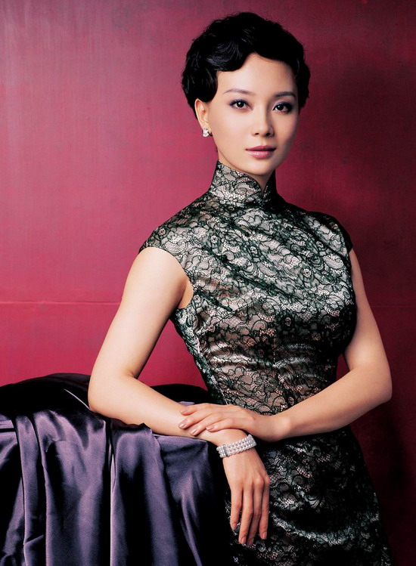  - Costumes of different dynasties in Ancient China are different.  - People’s costumes are different depending on their geographical locations, etc. (below is the costume in XinJiang for girls, picture extracted from google image)  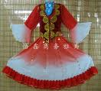  - Food  - Different styles of food may contribute to the weather and where people live, etc.  - Places to Live  - Ancient China, King and Queen live in Palace (eg, Forbidden City), picture as below extracted from google image  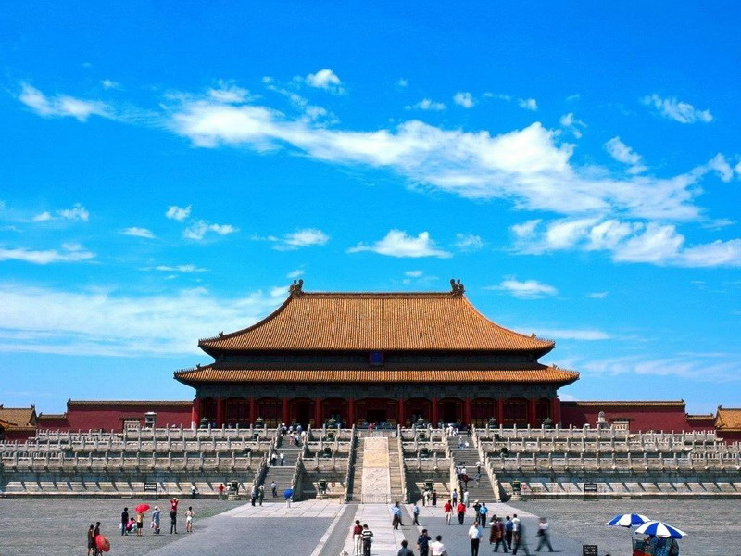  normal people live in bungalows  - Nowadays, people live either in tall buildings or houses.  - Places of Interests
Resources (these might include materials you want to create): | Colourful Pictures, Music, CD, etc.
Language skill: | Reading  * | Writing  * |  | Speaking  * | Listening  * | Grammar  * |  | Vocabulary  *
Keywords:

