Ordering and magnetoelestic properties of Fe-Ga alloy

K. Perduta¹, J. Olszewski², S. Busbridge¹, M. Nabiałek²

School of Environment and Technology, University of Brighton
UK BN2 4GJ Brighton, Lewes Road, United Kingdom; kama@wip.pcz.pl
Institute of Physics, Częstochowa University of Technology
PL 42-200, 19 Armii Krajowej Ave., Poland

PACS: 76.80.+y, 75.50.Bb, 75.80.+q, 81.40.Ef, 83.80.Ab
Abstract
In this paper the investigations of the ordering, microstructure and magnetomechanical properties of the Fe₈₀Ga₂₀ alloy and its composites are presented. The composites consisted of the Fe-Ga particles with a size distribution in the range between 20 to 50 μm. These particles were produced by blade milling of arc-melted alloy. After milling the powders were annealed at 723K for 2.5, 7.5 and 12.5 hours. The epoxy-bonded composites in rectangular shape were made from the as-cast as well as from the annealed powders. Mössbauer spectroscopy studies revealed that the as-cast alloy is completely disordered. After annealing at 723 K the long range atomic order appeared. It was stated that the best magnetoelastic properties were exhibited by composites made from ferromagnetic particles obtained from the as-cast alloy. The measured saturation magnetostriction was λ_{s}= 70 x 10⁻⁶ for the bulk alloy and λ_{s}=100 x 10⁻⁶ for composite.

1. Introduction
It has been recognized that substituting approximately 20 atomic % of non-magnetic Ga for Fe in bcc solid solution resulted in a ten-fold increase in magnetostriction, λ_{s}, over that of Fe and two-fold increase of λ_{s} in comparison with that for Fe-Al alloys [1, 2]. It is commonly believed that Ga-Ga pairing is responsible for this effect in the case of Fe-Ga alloys near 19 atomic % of Ga. The further increase of Ga amount in Fe-Ga alloy (~25 atomic %) resulted in creation of an ordered D0₃ phase and deterioration of magnetoelastic properties [3].
The single crystals of Fe-Ga (up to ~ 19 atomic % of Ga) have been shown to exhibit magnetostrictive strains up to 400 x 10⁻⁶ along the <100> crystallographic direction with relatively low saturating fields [2, 4]. The Fe-Ga alloys have most of the required characteristics of good magnetostrictive transducer materials due to their large saturation magnetostriction at low saturation fields, high mechanical strength, and good ductility. They may be useful in magnetostrictive actuators and sensors, for example linear motors, damping devices, torque sensors, speakers and microphones. These alloys also exhibit good corrosion resistance [5, 6].
A significant problem with metallic magnetic actuators is eddy current loss when actuated at high frequencies, which significantly limit their useable bandwidth to typically less than 1 kHz. A solution to this problem is to embed the magnetic particles in a non-conducting binder (i.e. create so-called 0-3 composite). Magnetic composites represent a large group of materials consisting of ferromagnetic or superparamagnetic particles dispersed in non-ferromagnetic matrix. The mechanical and magnetic characteristics of these materials depend on the properties of both the particles and the matrix. The smaller particle size substantially reduces eddy currents without a significant lowering of the magnetostriction [7, 8]. Composites of epoxy-bonded Fe-Ga alloys possess additional benefits of easy manufacturability and low material costs.
In this paper we present studies of the microstructure and magnetic properties of bulk and epoxy-bonded Fe-Ga particle composites.

2. Experimental procedures
Ingots of the initial Fe₈₀Ga₂₀ alloy were obtained by arc melting of high purity components. In order to achieve the homogeneity the ingots were remelted several times. Subsequent blade-milling in an argon atmosphere and sieving of powders provided particles in the size range of 20-50 μm. After blade-milling, the powders were annealed at 723K for 2.5, 7.5 and 12.5 hours. The various composites were made from powders directly after blade-milling and after each stage of annealing. The powders were mixed with an epoxy binder and compressed under a pressure of 120 MPa to obtain rectangular samples with dimensions of 10 mm x 40 mm and thickness of 7-10 mm. Compaction was carried out without an applied magnetic field. The volume fraction of the Fe-Ga powder used was nominally 0.80.
The microstructure of the powdered alloy was studied using Mössbauer spectroscopy. This technique was chosen because X-ray diffraction is relatively insensitive to ordering in Fe-Ga alloys ( i.e. the atomic scattering factors in this system result in extremely weak superlattice peaks). Mössbauer studies were carried out for the powders obtained from the as-cast alloy and after annealing at 723 K for 2.5, 7.5 and 12.5 hours. The saturation magnetostriction (λ_{s}) of the bulk alloy and its composites was measured using a standard strain gauge technique. All investigations were performed at room temperature.

3. Results and discussion
It is well known that the Fe_{x}Ga_{1-x} alloys exhibit a strong correlation between the structure and their magnetoelastic properties. In order to examine the existence of the ordered phase in this alloy, Mössbauer spectra for Fe₈₀Ga₂₀ powders were obtained.
All Mössbauer spectra of FeGa powders have Zeeman sextet shape with broadened lines (Fig. 1). They were decomposed into five independent elementary subspectra corresponding to iron atoms having n = 0, 1, 2, 3 or 4 gallium atoms in their nearest neighbourhood (NN).
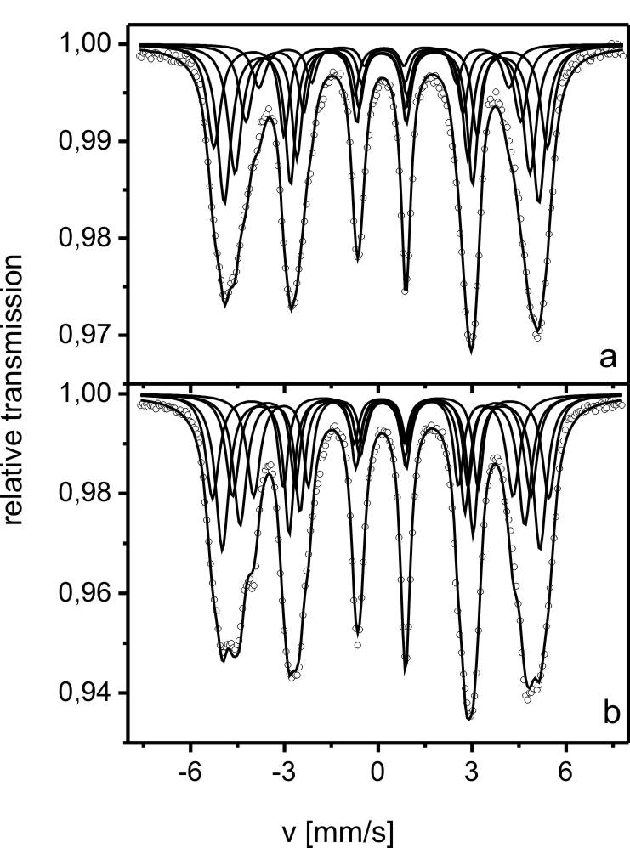
Fig. 1. Transmission Mössbauer spectra and their components of the as-cast (a) and annealed at 723 K for 7.5 h (b) powdered Fe₈₀Ga₂₀ alloy

The hyperfine interaction parameters obtained from Mössbauer spectra analysis are shown in Table I. It may be added that the values obtained for Fe₈₀Ga₂₀ powders annealed for 12.5 h were almost the same as for the samples annealed for 7.5 h (they are not presented in Table I).

Table I. Hyperfine interaction parameters for elementary Zeeman sextets for the as-cast and annealed Fe₈₀Ga₂₀ powder; B – hyperfine magnetic field induction, IS – isomer shift (relative to α-Fe) and Int – relative intensity of elementary sextet
Number of Ga atoms | Mössbauer parameters |  | Heat treatment
Number of Ga atoms |  |  | As-cast | 723 K/2.5 h | 723 K/7.5 h
n=0 | I sextet | B [T] | 33.04 | 33.22 | 33.29
n=0 | I sextet | IS [mm/s] | 0.077 | 0.081 | 0.080
n=0 | I sextet | Int (%) | 19.0 | 20.1 | 17.6
n=1 | II sextet | B (T) | 31.16 | 31.37 | 31.40
n=1 | II sextet | IS [mm/s] | 0.106 | 0.098 | 0.099
n=1 | II sextet | Int (%) | 32.1 | 24.9 | 25.2
n=2 | III sextet | B (T) | 29.24 | 29.46 | 29.43
n=2 | III sextet | IS [mm/s] | 0.134 | 0.121 | 0.120
n=2 | III sextet | Int (%) | 27.2 | 17.0 | 16.0
n=3 | IV sextet | B (T) | 27.24 | 28.19 | 28.15
n=3 | IV sextet | IS [mm/s] | 0.162 | 0.141 | 0.139
n=3 | IV sextet | Int (%) | 15.0 | 19.9 | 21.9
n=4 | V sextet | B (T) | 25.01 | 25.67 | 25.61
n=4 | V sextet | IS [mm/s] | 0.186 | 0.159 | 0.157
n=4 | V sextet | Int (%) | 6.7 | 18.1 | 19.3
Quadruple splitting for all sextets is equal to zero.

Taking into account the values of the hyperfine magnetic field induction and the isomer shift of the elementary sextets (Table I) and using the additive model [9, 10] they may be approximated by:
(1)
and
, (2)
where is the hyperfine magnetic field induction of pure iron, n is the number of Ga atoms in the first coordinating zone of an Fe atom, is the change of the hyperfine magnetic field induction of caused by the presence of one Ga atom, is a constant and is the change of the isomer shift caused by the presence of one Ga atom in the NN of an Fe atom.
It has been found that for the as-cast powders and . However, for the annealed powders and .
In the case of the isomer shift for the as-cast powders , and for the annealed powders and .
Comparing theoretical predictions of the relative intensities Int(n) of elementary zeeman sextets with these experimentally achieved, the type of superstructure and its order parameter can be determined. In the case of the DO₃ superstructure Int(n) depends on the probability (γ) of finding a Ga atom in the NN zone of an Fe atom in this type of superstructure [11] as follows:
(3)
where c is concentration of Ga atoms in the alloy.
The Bragg – Williams long range order parameter (S) [12] can be calculated as:
, (4)
While for short range ordered structure
, (5)
where α₁ is the Cowley-Warren short range order parameter for first coordination zone [10,13].
In the case when mixture of ordering occurs the relative intensities Int(n) of the elementary Zeeman sextets can be described as:
where V is the volume fraction of the sample occupied by the DO₃ – type ordered phase.
From the analysis of the relative intensities of the elementary sextets (Table I) it can be seen that in the as-cast powdered samples the atomic ordering does not occur. However, for the annealed powders the DO₃-type superstructure (V = 0.5) with the Bragg – Williams long range order parameter S = 0.8 and antiphase boundaries are observed. It is worth adding that in these boundaries short range atomic order is present. The results from this analysis show that in the first coordinating zone of an Fe atom a larger number of Ga atoms are present than is expected from consideration of the Ga concentration in the sample. The Cowley-Warren short range order parameter of this type of antiphase boundaries is . After annealing the powders for 7.5 and 12.5 h only an increase in the short range order parameter is observed ().

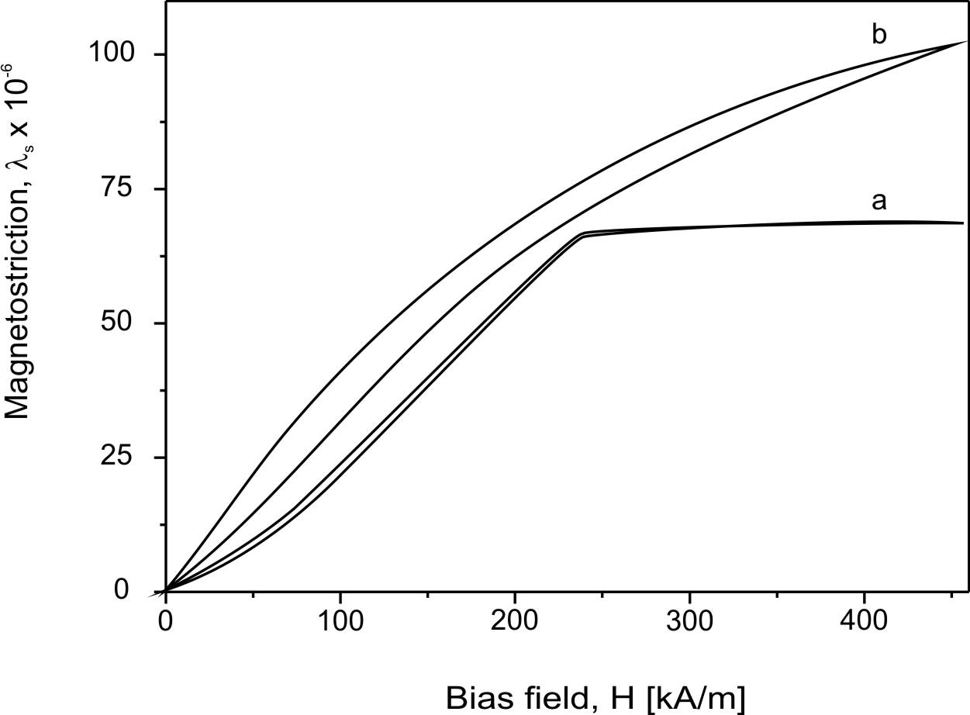

Fig. 2. Magnetostriction curves for the bulk sample of Fe₈₀Ga₂₀ (a) and its composite made from the as-cast powder with particle size range of 20-50 μm (b)

The investigations indicate that the best magnetoelastic properties are obtained for the composite made from the as-cast powder. The saturation magnetostriction observed for this composite is equal to λs=100 × 10⁻⁶ (Fig. 2), while λs=70 × 10⁻⁶ for the bulk alloy. When the magnetic field decreases the magnetostriction of composites samples exhibit magnetostriction hysteresis. The hysteresis may be associated with a mechanical interaction between the epoxy matrix and the metallic Fe-Ga particles.
The processes of creep and relaxation of the epoxy matrix may influence the observed magnetostriction hysteresis. A change of the sample size is accompanied by the elongation of the walls of the epoxy-matrix existing between the particles in composite. As the matrix walls become thinner the stress to which they are subjected increases. An additional elongation of the sample occurs when it is placed in a magnetic field. It may be supposed that during decreasing of the magnetic field the elongated matrix walls exhibit a tendency to relax stress, which is observed as creep effect. This effect will be more pronounced at larger volume fractions.

4. Conclusion
From Mössbauer spectroscopy studies we have concluded that Fe₈₀Ga₂₀ alloy obtained by blade-milling of arc melted ingots does not exhibit atomic order. However after annealing of the powders a mixture of DO₃-type superstructure and a short range ordered phase occur. Moreover, we have found that best magnetoelastic properties are exhibited by composites made from ferromagnetic powders obtained from the as-cast alloy. The measured saturation magnetostriction was λ_{s}= 70 × 10⁻⁶ for the bulk alloy and λ_{s}=100 × 10⁻⁶ for composites fabricated from these powders.

This work acknowledges support from the European Union (Interreg IIIa grant number 349)

- J. R. Cullen, A. E. Clark, M. Wun-Fogle, J. B. Restorff, T. A. Lograsso, J. Magn. Magn. Mater. 226-230, 948 (2001)
- A. E. Clark, M. Wun-Fogle, J. Restorff, T. A. Lograsso, A. R. Ross, D. L. Schlagel, IEEE Trans. Magn 36, 3238 (2000)
- T. A. Lograsso, A. R. Ross, D. L. Schlagel, A. E. Clark, W. Wun-Fogle, J Alloys Compounds 350, 95 (2003)
- R. Kellogg, A. B. Flatau, A. E. Clark, M. Wun-Fogle, T. A. Lograsso, J. Appl. Phys. 91, 7821 (2002)
- N. Srisukhumbowornchai, S. Guruswamy, J. Appl. Phys. 90, 5680 (2001)
- T. V. Jayaraman, N. Srisukhumbowornchai, S. Guruswamy, M. L. Free, Corrosion Science 49, 4015 (2007)
- S. Bednarek, Appl. Phys. A., 68, 63 (1999)
- A. Clark, U.S. Patent No. 4,378,258, March 29 (1983)
- G.K. Wertheim, V. Jaccarino, J.H. Wernick, D.N.E. Buchanan, Phys. Rev. Lett. 12 24 (1964)
- S.M. Dubiel and W. Zinn, J. Magn. Magn. Mater. 45, 298 (1984)
- В.С. Литвинов, С.Д. Каракишев, В.В. Овчинников „Ядерная гамма – резонансная спектроскопия сплавов” Металлургия, Москва, 58-73 (1982)
- А.А. Смирнов „Обобщенная теория упорядочения сплавов” Наукова Думка, Киев, 71-77 (1986)
- М.А. Кривоглаз, А.А. Смирнов „Теория упорядочивающихся сплавов” Физматизд. Москва, 68-72 (1958)

