Casein phosphopeptides: from milk to nutraceutical
Silvia Perego (silvia.perego@unimi.it)
Dept. Medical Chemistry, Biochemistry and Biotechnology, University of Milan, Milan, Italy
Tutor: Dr. Anita Ferraretto

Milk and dairy products are known sources of bioavailable calcium for its association with casein, whose proteolysis produces caseinphosphopeptides (CPPs). CPPs are phosphorylated peptides able to bind and solubilise calcium. In human intestinal tumor cells differentiated in vitro toward an enterocityc phenotype, they also induce a calcium uptake. Moreover, in human in vitro osteoblasts, CPPs favour the mineralization of the extracellular matrix. CPPs can differently affect proliferation and apoptosis in differentiated and /or tumor intestinal cells. Due to all these properties, CPPs may be considered as potential nutraceutical/functional food.

I caseinofosfopeptidi: dal latte alla nutraceutica
Latte e derivati rappresentano la miglior fonte alimentare di calcio, presente in forma biodisponibile associato alla caseina, dalla cui proteolisi derivano i caseinofosfopeptidi (CPP), peptidi fosforilati in grado di legare e mantenere in forma solubile il calcio. I CPP sono anche in grado di favorire l’ ingresso del minerale in cellule tumorali umane differenziate in vitro in senso enterocitico. Inoltre, in osteoblasti umani in coltura si sono dimostrati in grado di attivare la mineralizzazione. I CPP influenzano diversamente l’attività proliferativa e apoptotica delle cellule intestinali differenziate e/o tumorali. Tali proprietà candidano i CPP al ruolo di possibili nutraceutici/functional food.

Key words: Casein phosphopeptides; intestinal cells; calcium; calcium channels.

1. Introduction
Milk and dairy products represent the main source of calcium in Western population, since the content and the bioavailability of the mineral is higher than in other food, but the absorption of the mineral at the intestinal level is a crucial point in the calcium homeostasis. The major protein groups of dairy products are mucins, caseins and whey proteins. Casein does not display any bioactivity, being a reservoir of amino acids for our health, but peptides coming from the in vitro and/or in vivo casein digestion can display particular bioactivities. Among these peptides, casein phosphopeptides (CPPs) represent a family characterized by a particular chemical-physical structure correlated to precise functioning in the body. The primary structure of CPPs is characterized by the presence of phosphorylation sites linked to serine amino acid, Ser(P), moreover in determined region of the amino acids sequence, a motif constituted of five amino acids, Ser(P)Ser(P)Ser(P)GluGlu, named “acidic motif”, is present. This motif was found to be conserved among centuries and species, thus the studies initially addressed to understand its reason and utility. CPPs and their properties were discovered in the Fifties (Mellander and Olsson, 1956), and since then a potentiality in enhancing calcium intestinal absorption was speculated for them. This hypothesis was based on the fact that the presence of phosphorylated serines can be correlated to the possibility to bind and maintain calcium in a soluble state, a prerequisite for its absorption by the intestine (Kitts and Yuan, 1992) and was supported by the notion that, after a meal containing casein, a higher concentration of soluble calcium was found in the small intestinal tract than with the other proteins (Lee et al., 1980).
Several casein-derived phosphopeptides (CPPs), corresponding to different phosphorylated regions of αs₁-, αs₂- and β-caseins, are produced in vivo and/or in vitro and now are well characterized (Meisel and Frister, 1988, Juillerat et al., 1989). The high negative charge of these phosphopeptides renders them partially resistant to further proteolysis, and confer them the ability to bind cations as Ca, Fe, Mn, Cu and Se, therefore they possibly act as carriers for a variety of minerals (Sato et al., 1986, Berrocal et al., 1989).
The CPP ability in binding calcium and activate the mineral entry into the intestinal cells has been observed in several in vitro studies (Ferraretto et al., 2001, Ferraretto et al., 2003, Gravaghi et al., 2007). Moreover, in the last years new potentialities for CPPs such as the modulation of cell viability, i.e. proliferation and apoptosis, have been demonstrated in different human cell cultures (Meisel and Gunther, 1998, Hartmann et al., 2000).
The aim of the present PhD research project was therefore to investigate at molecular and cellular level the mechanism with which CPPs can act as inducers of calcium entry in intestinal cells and their possible use as nutraceuticals.

2. Materials and Methods
The used CPPs preparation is a casein derived hydrolysate, kindly provided by DMV International (CE 90 CPP III, DMV International, Veghel, The Netherlands) whose composition is reported in Table 1. CPPs were administered to the cells at concentration of 1280 µM, being the concentration at which they exert the maximal activity in inducing the intracellular calcium rises (Gravaghi et al., 2007, Cosentino et al., 2010).
Undifferentiated and differentiated human intestinal cell lines HT-29 was used as in vitro cellular model of tumor or physiologic intestinal epithelium. Cell culture were performed as previously described (Gravaghi et al., 2007). Cell proliferation rate was estimated by incorporation of bromodeoxyuridine (BrdU). Cell apoptosis was measured by caspase 3/7 activation and nuclei DAPI staining.
Cytoplasmic calcium, [Ca²⁺]_{i}, was measured on cells seeded on a glass coverslips and loaded with 2.5 μM Fura-2/AM and 2.5 μM Pluronic F-127 in a Krebs-Ringer HEPES solution (KRH), according to the procedure already described (Ferraretto et al., 2001, Cosentino et al., 2010). The experiments were carried out by means of a thermostatted (TC-202 A, Medical System Corporation, Holliston, MA, USA) perfusion chamber (PDMI-2, same commercial source) and a microscope (TE 200, Nikon, Tokyo, Japan) connected to a CCD intensified camera (Extended Isis, Photonic Science, Millham, UK). The fluorescence image acquisition and data analysis system (Applied Imaging, High Speed Dynamic Video Imaging Systems, Quanticell 700, Sunderland, UK) allowed to determine the [Ca²⁺]_{i} on single cells. The amount of intracellular free calcium, [Ca²⁺]_{i}, within the cells was calculated from the 340/380 nm images by means of a calibration performed with external standards of calcium and Fura-2, according to the equation of Grynkiewicz et al. (Grynkiewicz et al., 1985).
Gene expression of VDR and TRPV6 was evaluated on undifferentiated and differentiated Caco2 and HT-29 cells, following Vit.D₃ and CPP treatments. Total RNA was extracted, reverse transcribed and cDNA was used as template for real time PCR (iCycler thermal cycler Bio-Rad Laboratories), performed with Sybr Green (iQ SYBR Green Supermix; Bio-Rad Laboratories). The fold change in expression of the different genes compared with control cells was normalized to the expression of GAPDH gene.
In vitro mineralization experiments were carried out on human osteosarcoma SaOS-2 cells treated for 4 weeks either with CPP DMV or with a different commercial CPP mixture (CPP MD) by MD Foods Ingredients Amba (Videbaek, Denmark) enriched in calcium (6.6% w/w) whose composition is reported in Table 1. After 4 weeks of treatment, cells were washed with PBS, fixed for 5 minutes in 4% neutral formalin solution and washed with deionized water for von Kossa staining (Jørgensen et al., 2004)
Table 1 Chemical composition of the CPP mixture used. All data reported were given as data sheets by the manufacturer.
 | CPP DMV  (CE 90 CPP III) | CPP MD  (Peptigen 110)
CPP content | 90.5% | 95%
Ca²⁺ content | 0 | 6.6%
P content | 3.7% | 3.2%
NP ⁻¹ (molar ratio) | 3.7 | 7.8
Ser P⁻¹ (molar ratio) | 0.85 | 0.97

3. Results and discussion
3.1 CPP effects in in vitro osteoblast mineralization
The effect of CPP in formation of mineralized extracellular matrix was investigated by means of human SaOS-2 cell line that represents a generally acknowledged model of human osteoblasts.
The results obtained showed that CPPs, particularly CPP MD, enhance the production of calcification nodules (Fig.1). The effect was specific and was also comparable to the ones observed both in cells treated with Dexamethasone, a known inducer of osteoblast differentiation, and in cells treated with Vit.D₃, or the Dexamethasone/ Vit.D₃ combination.
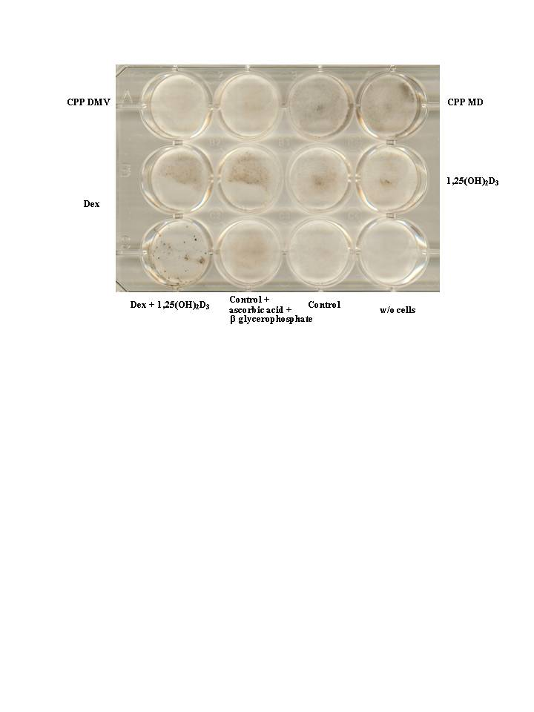
Figure 1. Effect of CPP DMV and CPP MD on in vitro mineralization. Human SaOS-2 cells were cultured for 4 weeks in the presence of 50 µg/ml ascorbic acid and 10mM β-glycerophosphate, plus different agents as follows. Rank one: duplicate incubation with 1280 µM CPP DMV and 1280µM CPP MD; rank two: duplicate incubation with 100 nM Dexamethasone (Dex) and 1 nM Vit.D₃; rank three: single incubation with Dexamethasone and Vit.D₃; single incubation with standard culture medium plus ascorbic acid and β-glycerophosphate; single incubation with standard culture medium

3.2 CPP effects on proliferation rate and apoptosis in undifferentiated /differentiated HT-29 cells
In undifferentiated HT-29 cells, that mimics the behavior of tumor intestinal cells in their early stages, CPPs increase apoptosis, both at physiological calcium concentration and in calcium overload, a situation which mimics the increase of calcium in the intestinal lumen after a meal. This result is shared by the calcium chelator EGTA, thus is presumably due to the ability in binding the extracellular calcium ions.
In differentiated HT-29 cells, CPPs i) increase proliferation, especially in calcium overload; ii) do not affect apoptosis; iii) protect from calcium overload toxicity. On the contrary, EGTA behaves as a cytotoxic agent, decreasing proliferation and increasing apoptosis (Fig.2).
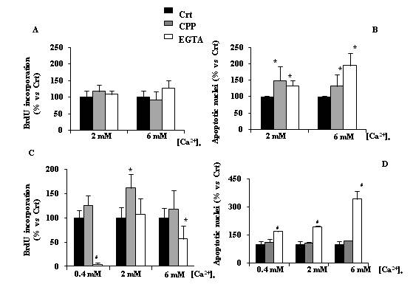
Figure 2. Effect of CPPs on the proliferation rate and apoptotic acitvity in undifferentiated HT-29 cells (Panel A and B) and in differentiated HT-29 cells (Panel c and D)

The different effects observed in undifferentiated tumour HT-29 cells vs differentiated HT-29 cells when CPPs or EGTA were administered could be possibly explained considering that CPPs are able to induce [Ca²⁺]_{i} rise only in differentiated intestinal cells (Cosentino et al., 2010), thus the hypothesis that the CPP-induced increment in the proliferation rate of differentiated HT-29 cells could be associated to the influx of calcium ions activated by the same CPPs. To investigate this issue, experiments were performed in differentiated HT-29 cells with the use of agonist and/or antagonists of L-types calcium channels, known to activate calcium entry into the cells under depolarization and to exert a mitogenic effect. The administration of the agonist, Bay-K8644, in CPP responsive cells produced a higher response to the subsequent CPP administration which accounts for a 100% increase in the [Ca²⁺]_{i} and a 50% increase in the percentage of responsive cells, demonstrating the existence of an interaction between CPPs and these calcium entry channels. The effect of antagonists Nifedipine and Nimodipine on CPP bioactivity was thereafter evaluated (Fig.3). Both antagonists were able to totally or partially reduce the CPP-induced calcium rise in differentiated HT-29 cells. The percentage of cells which did not responded to CPP administration after Nimodipine or Nifedipine treatment was almost the same and accounts for about 36-38%. A direct evidence of the CPP action on L-type Ca²⁺ channels came from experiments in which the membrane potential of differentiated HT-29 cells was measured by the use of DiBAC₄(3), a probe whose fluorescence increases in depolarized conditions and decreases during hyperpolarization. CPPs increased the fluorescence activity (plus 16%) at the same entity of Gramicidin (plus 13%), a known depolarizing agent while the hyperpolarizing KRH solution decreased fluorescence (minus 34%).
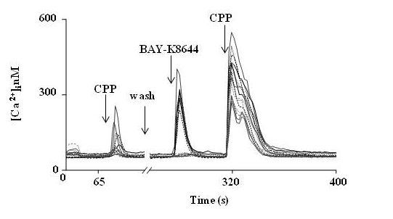
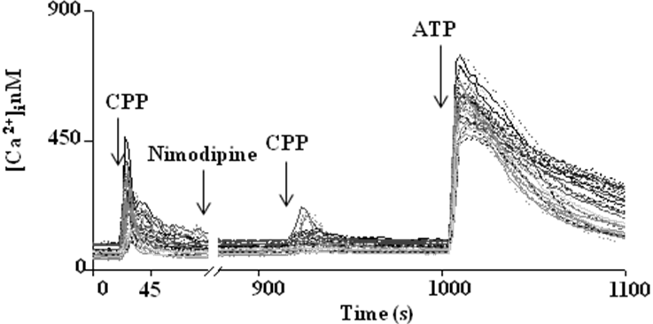

Figure 3. Effect of Bay-K8644and Nimodipine on CPP induced calcium rise in differentiated HT-29 RPMI cells. In the graphs the intracellular calcium changes of some representative cells belonging to the chosen cellular field are reported. Each line in the graph refer to a single cell behavior. This graph is representative of 5 analogous experiments.

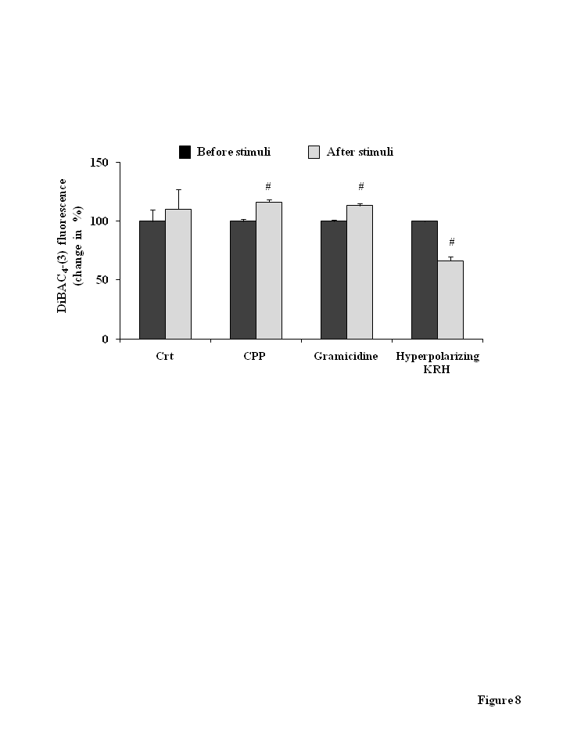
Figure 4. Effect of CPP administration on membrane potential in differentiated HT-29 cells.

3.3 Effects of Vit.D₃ and CPPs on VDR and TRPV6 mRNA expression
The possibility for CPPs to modulate the transcellular calcium transport was considered by evaluating the expression of the nuclear Vit.D₃ receptor, the VDR, since the vitamer controls all the process, and of the TRPV6 calcium channel, which is recognized as the major intestinal channel responsible for the intestinal calcium entry (Fig.5).
In undifferentiated/differentiated Caco2 cells results obtained showed the same expression profile as it concerns the VDR receptor expression, while the level of TRPV6 expression is initially lower in differentiated cells compared to undifferentiated cells and becomes higher after Vit.D₃ treatment.
The level of TRPV6 expression is equal in undifferentiated and differentiated HT-29 cells; the treatment with Vit.D₃, under which undifferentiated cells do differentiate (Cosentino et al., 2010), increased the expression in both differentiated and undifferentiated cells, but the effect is higher in undifferentiated cells.
CPPs by themselves are not active in modulating TRPV6 expression, but a slight increase in the channel expression, though not statistically significant, was found in undifferentiated HT-29 cells, and in Caco2 cells, both undifferentiated and differentiated, if pre treated with Vit.D₃.
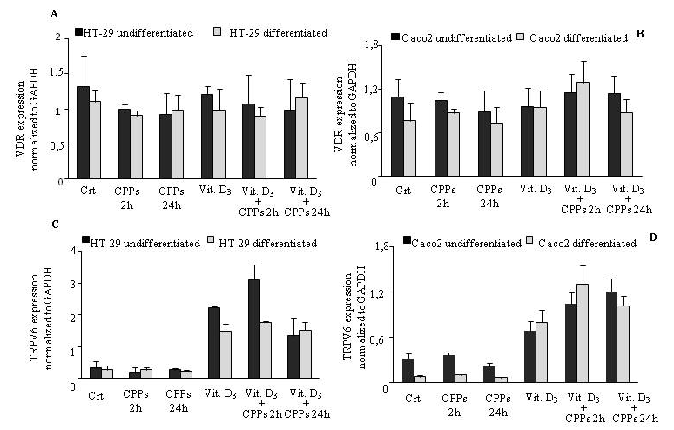

Figure 5. Effect of CPPs and Vit.D₃ on VDR mRNA expression (Panel A and B) and on TRPV6 mRNA expression (Panel C and D).
4. Discussion
The human need for calcium depends on its important function, as mineral in bone formation and maintenance, as second messenger for many cellular functions. The absorption mechanism, due to the low efficiency, represents the key process to obtain available calcium for cells and tissues. Dietary co-nutrients or bioactive products of digestion can enhance calcium absorption, mainly the passive transport. In particular, milk components such as lactose, proteins and phosphopeptides are demonstrated to help the intestinal absorption of calcium, maintaining the mineral in a soluble form until it reaches the distal intestine. In the present work, CPPs demonstrated an ability to induce the mineralization of the extracellular matrix in a human osteoblast cell line in in vitro culture. At the intestinal level, CPPs can affect the apoptosis in undifferentiated tumor cells, while they increase proliferation rate in differentiated cells, thus contributing to the death of tumor cells and the increase in the number of healthy cells. Moreover, CPP modulate the activity of L-type calcium channels and produce a depolarization, similar to other digestion products, i.e. glucose, amino acids, and oligopeptides.
L-type calcium channels, above all the Cav1.3 subunit, sensitive to the depolarizing action by nutrients, seem to be involved in the passive calcium absorption process (Morgan et al., 2003).
Taken together all these results underline the importance of consider CPPs as bio-molecules for the intestinal health.
5. References
Berrocal R, Chanton S, Juillerat M A, Pavillard B, Scherz J C, Jost R (1989) Tryptic phosphopeptides from whole casein. II. Physicochemical properties related to the solubilization of calcium. J Dairy Res, 56: 335-41.
Cosentino S, Gravaghi C, Donetti E, Donida B M, Lombardi G, Bedoni M, Fiorilli A, Tettamanti G, Ferraretto A (2010) Caseinphosphopeptide-induced calcium uptake in human intestinal cell lines HT-29 and Caco2 is correlated to cellular differentiation. J Nutr Biochem, 21: 247-54.
Ferraretto A, Gravaghi C, Fiorilli A, Tettamanti G (2003) Casein-derived bioactive phosphopeptides: role of phosphorylation and primary structure in promoting calcium uptake by HT-29 tumor cells. FEBS Lett, 551: 92-8.
Ferraretto A, Signorile A., Gravaghi C, Fiorilli A, Tettamanti G (2001) Casein phosphopeptides influence calcium uptake by cultured human intestinal HT-29 tumor cells. J Nutr, 131: 1655-61.
Gravaghi C, Del Favero E, Cantu L, Donetti E, Bedoni M, Fiorilli A, Tettamanti G, Ferraretto A (2007) Casein phosphopeptide promotion of calcium uptake in HT-29 cells - relationship between biological activity and supramolecular structure. FEBS J, 274: 4999-5011.
Grynkiewicz G, Poenie M, Tsien R Y (1985) A new generation of Ca2+ indicators with greatly improved fluorescence properties. J Biol Chem, 260: 3440-50.
Hartmann R, Günther S, Martin D, Meisel H, Pentzien A K, Schlimme E, Scholz N (2000) Cytochemical model systems for the detection and characterization of potentially bioactive milk components. Kieler Milchwirtschaftliche Forschungsberichte, 52: 61-85.
Juillerat M A, Baechler R, Berrocal R, Chanton JC, Jost R (1989) Tryptic phosphopeptides from whole casein. I. Preparation and analysis by fast protein liquid chromatography. Journal of Dairy Research, 56: 603-611.
Jørgensen Nr, Henriksen Z, Sørensen Oh, Civitelli R (2004) Dexamethasone, BMP-2, and 1,25-dihydroxyvitamin D enhance a more differentiated osteoblast phenotype: validation of an in vitro model for human bone marrow-derived primary osteoblasts. Steroids 69: 219-26
Kitts D D, Yuan Y V (1992) Caseinophosphopeptides and calcium biovailability. Trends in Food Science & Technology, 3: 31-35.
Lee Y S, Noguchi T, Naito H (1980) Phosphopeptides and soluble calcium in the small intestine of rats given a casein diet. Br J Nutr, 43: 457-67.
Meisel H, Frister H (1988) Chemical characterization of a caseinophosphopeptide isolated from in vivo digests of a casein diet. Biol Chem Hoppe Seyler, 369: 1275-9.
Meisel H, Gunther S (1998) Food proteins as precursors of peptides modulating human cell activity (short communication). Nahrung, 42: 175-6.
Mellander O, Olsson N (1956) The influence of peptide bound calcium and phosphorus on bone calcification in rickets. Bol Med Hosp Infant Mex, 13: 243-6.
Morgan E L, Mace O J, Helliwell P A, Affleck J, Kellett G L (2003) A role for Ca(v)1.3 in rat intestinal calcium absorption. Biochem Biophys Res Commun, 312: 487-93.
Sato R, Noguchi,T, Naito H (1986) Casein phosphopeptide (CPP) enhances calcium absorption from the ligated segment of rat small intestine. J Nutr Sci Vitaminol (Tokyo), 32: 67-76.

