Conformation and self-association of peptide amphiphiles based on the KTTKS collagen sequence
Pasquale Palladino, Valeria Castelletto, Ashkan Dehsorkhi, Dmitry Stetsenko, Ian W. Hamley*
School of Chemistry, Food and Pharmacy, University of Reading, Reading RG6 6AD, U.K.
*i.w.hamley@reading.ac.uk; Fax: +44 1183788450; Tel: +44 1183786341

ABSTRACT: Studying peptide amphiphiles (PAs), we investigate the influence of alkyl chain length on the aggregation behavior of the collagen-derived peptide KTTKS with applications ranging from anti-wrinkle cosmetic creams to potential uses in regenerative medicine. We have studied synthetic peptides amphiphiles C₁₄-KTTKS (myristoyl-Lys-Thr-Thr-Lys-Ser) and C₁₈-KTTKS (stearoyl-Lys-Thr-Thr-Lys-Ser) to investigate in detail their physico-chemical properties. It is presumed that the hydrophobic chain in these self-assembling peptide amphiphiles enhances peptide permeation across the skin compared to KTTKS alone. Subsequently C_{n}-KTTKS should act as a prodrug and release the peptide by enzymatic cleavage. Our results should be useful in the further development molecules with collagen-stimulating activity.
Introduction
Peptide amphiphiles (PAs), i.e. peptides conjugated to one or more hydrophobic moieties, self-assemble into ordered or amorphous aggregates depending on molecular structure and the balance of hydrophilic/hydrophobic interactions.^{1,2} According to these tunable properties, PAs have generated a dynamic research area with applications of bioengineering and nanomedicine.³⁻¹⁰ In this regard, we have recently examined the self-assembly properties of a collagen-stimulating peptide amphiphile; C₁₆-KTTKS (palmitoyl-Lys-Thr-Thr-Lys-Ser); based on the peptide KTTKS identified by Katayama et al. as the minimum sequence retaining extracellular matrix (ECM) regulatory activity.¹¹ C₁₆-KTTKS is available also in a solution for skin topical application commercialized as Matrixyl,^{®12,13} with applications ranging from anti-wrinkle cosmetic creams to potential uses in regenerative medicine. The reported clinical beneficial effects of C₁₆-KTTKS as a skin anti-ageing agent are not fully understood because of the lack of in vitro skin penetration data. However, it is presumed that the palmitoyl moiety enhances peptide permeation across the skin compared to KTTKS alone,¹³ subsequently C₁₆-KTTKS should release the peptide via enzymatic cleavage of peptide amide bonds.¹³
In our recent investigations on C₁₆-KTTKS, we have characterized for the first time its conformational and self-assembly properties, observing tape-like nanostructure formation¹⁴ and a morphology transition from sol to gel induced by addition of charged surfactant.¹⁵ We show here the influence of alkyl chain length on aggregation behavior of the collagen-derived peptide KTTKS. Some examples are reported in the literature on the alkyl chain effect on tuning of PA conformation, critical aggregation concentration, and supramolecular self-assembly,¹⁶⁻¹⁸ therefore affecting the thermal stability of the PA aggregates¹⁹⁻²¹ and their ability to selectively bind, penetrate cell membrane, and exert a biological activity²²⁻²⁴. Here, we have studied synthetic peptide amphiphiles C₁₄-KTTKS (myristoyl-Lys-Thr-Thr-Lys-Ser) and C₁₈-KTTKS (stearoyl-Lys-Thr-Thr-Lys-Ser) to investigate in detail their properties through fluorescence spectroscopy, circular dichroism (CD), Fourier transform infrared (FTIR), small-angle X-ray scattering (SAXS), fibre X-ray diffraction (XRD) and transmission electron microscopy (TEM). PA C₁₈-KTTKS self-assembles into β-sheet fibrils above a critical aggregation concentration. In contrast, C₁₄-KTTKS adopts an unordered conformation in solution, although β-sheet features are observed for dried films. In previous work by our group,¹⁴ the self-assembly of C₁₆-KTTKS into β-sheet fibrillar (nanotapes) structures was observed. These results indicate a minimal hydrophobic chain length to observe β-sheet formation.

EXPERIMENTAL SECTION
Materials. Chemicals were purchased from Sigma-Aldrich or Fisher (UK) unless stated otherwise.
Synthesis and characterization. Peptides amphiphiles C₁₄-KTTKS, myristoyl-Lys-Thr-Thr-Lys-Ser and C₁₈-KTTKS, stearoyl-Lys-Thr-Thr-Lys-Ser were prepared by Fmoc solid-phase peptide synthesis²⁵ on TentaGel S Trt resin (Rapp Polymere) preloaded with Fmoc-Ser(tBu)-OH (0.24 mmol g⁻¹) at a 1.75 mmol scale (7 g of resin) using a stepwise elongation protocol and fivefold excess of each of 9-fluorenylmethoxycarbonyl (Fmoc) protected amino acid derivatives Fmoc-Thr(tBu)-OH and Fmoc-Lys(Boc)-OH (Novabiochem). Fmoc removal was achieved by 20% (v/v) piperidine in dimethylformamide (DMF) for 10 min before each coupling. 2-(7-Aza-1H-benzotriazol-1-yl)-1,1,3,3-tetramethyluronium hexafluorophosphate (HATU) (4.75 equiv) with N,N-diisopropylethylamine (DIEA) (10 equiv) in N-methylpyrrolidone-2 (NMP) were employed for activation of the Fmoc amino acids for 5 min at ambient temperature prior to addition to the Fmoc-deprotected resin. The resin was agitated by a gentle stream of nitrogen for 1 hour, then washed with NMP (25 cm³) and DMF (50 cm³), and the deprotection-coupling cycle was repeated until the last amino acid (Lys) was incorporated. After that the resin was washed with methanol (50 cm³), dichloromethane (50 cm³) and diethyl ether (25 cm³), dried in vacuo, and split into 1 g portions. The portion was Fmoc-deprotected, then the respective fatty acid (myristic or stearic acid) was coupled to the N-terminus of the resin-bound peptide under the same conditions as above (5 equiv acid, 4.75 equiv HATU, 10 equiv DIEA in NMP with 5 min pre-activation and 1 h coupling time). After cleavage from the solid support and deprotection the peptides were purified by RP-HPLC on a Perkin-Elmer System 200 HPLC chromatograph at ambient temperature using a C18 Supelco column (250×22 mm), a linear gradient of 0.01N aq HCl in acetonitrile (Buffer B) in 0.01N aq HCl in water (Buffer A)²⁶ and a flow rate of 4 cm³ min⁻¹. The appropriate fractions were pooled and freeze-dried to afford solid peptides. Peptide integrity was confirmed by ESI HRMS (Thermo Scientific LTQ Orbitrap XL): [M+H]⁺ C₁₄-KTTKS calc. 774.0 Da, obs. 774.5 Da; C₁₈-KTTKS calc. 830.1 Da, obs. 830.6 Da.
Secondary structure prediction. Secondary structure prediction of the peptide corresponding to the C-terminus of the alpha-1(I) collagen propeptide, previously reported by Katayama et al.⁴ as residues 197-223 was performed using PSIPRED V3.0 software available at http://bioinf.cs.ucl.ac.uk/psipred.²⁷
Partition coefficient and skin permeability. Octanol/water partition coefficients (logP_{o/w}). were calculated using the ACD/ChemSketch V12.0 freeware software available at http://www.acdlabs.com/resources/freeware/chemsketch.²⁸ Skin permeability (K_{p}) was calculated according an equation introduced by Potts and Guy²⁹: logK_{p} = 0.71logP_{o/w} − 0.0061M_{w} − 2.74, where M_{w} is the molecular weight.
Circular Dichroism (CD). Spectra were measured using a Chirascan™ CD spectrometer equipped with Peltier thermostatted sample holders and CS/JS recirculating chiller. Spectra were acquired with samples in quartz cells (pathlength: 0.01 mm, 0.1 mm, 0.2 mm, 0.5 mm, 1 mm, 10 mm). The wavelength was from 280 to 180 nm. Final spectra were obtained after subtracting contribution from solvent and converting the signal to units of deg cm² dmol⁻¹.
Fourier transform infrared (FTIR). Spectra were recorded using a Nexus-FTIR spectrometer equipped with a DTGS detector. Solutions were sandwiched between two CaF₂ plate windows with a 0.012 mm spacer. All spectra were scanned 128 times over the range of 4000-950 cm⁻¹.
Fluorescence spectroscopy. The fluorescence of pyrene was excited at 335 nm at room temperature, and emission spectra were recorded from 360 to 460 nm, using a 10.0 mm × 5.00 mm quartz cell in a Varian Model Cary Eclipse spectrofluorimeter. Excitation and emission bandwidths of 2.5 nm were used throughout the experiments. The concentration of pyrene in water was 6.48 × 10⁻⁷ M. The same pyrene solution was used to dilute each peptide sample to avoid any dilution effect on pyrene fluorescence due to the addition of subsequent peptide amphiphile aliquots.
Fibre X-ray diffraction (XRD). X-ray diffraction was performed on stalks prepared from 1 wt% solution in water. The stalks were mounted vertically onto the four axis goniometer of a R-AXIS IV++ X-ray diffractometer (Rigaku) equipped with a rotating anode generator. XRD data were collected using a Saturn 992 CCD camera. One-dimensional profiles in the equatorial and meridional reflections and peak positions were obtained using the software CLEARER.³⁰
Transmission electron Microscopy (TEM). TEM experiments were performed using a Philips CM20 transmission electron microscope operated at 200kV. Droplets of the solutions were placed on Cu grids coated with a carbon film (Agar Scientific, UK), stained with uranyl acetate (1 wt%) and dried.
Small-angle X-ray scattering (SAXS). The measurements were performed on a Bruker Nanostar diffractometer using CuK_{α} radiation from a Incoatec microfocus source. The beam was collimated by a three slit system. The peptide amphiphile solution was mounted in a glass capillary (1mm diameter). The sample-detector distance was 67 cm, and a Vantec-2000 photon counting detector was used to collect the SAXS patterns.

Results
Secondary structure prediction. Type-I collagen is the most abundant collagen of the human body and it is highly conserved between species. Several years ago, Katayama et al. identified a region with stimulating activity¹¹ (1415-1441: CTSHTGAWGKTVIEYKTTKSSRLPIID) within the C-terminus α-1(I) collagen propeptide (1219-1464). A secondary structure prediction algorithm²⁷ applied to this peptide indicates high β-strand propensity for the core region (1425-1430: TVIEYK) and unordered propensity for outer sequences (Figure 1). However, the conformational ambiguity of threonine-rich sequences³¹ enables the coil to β-sheet conformation transition observed in solution (vide infra) for C₁₈-KTTKS.
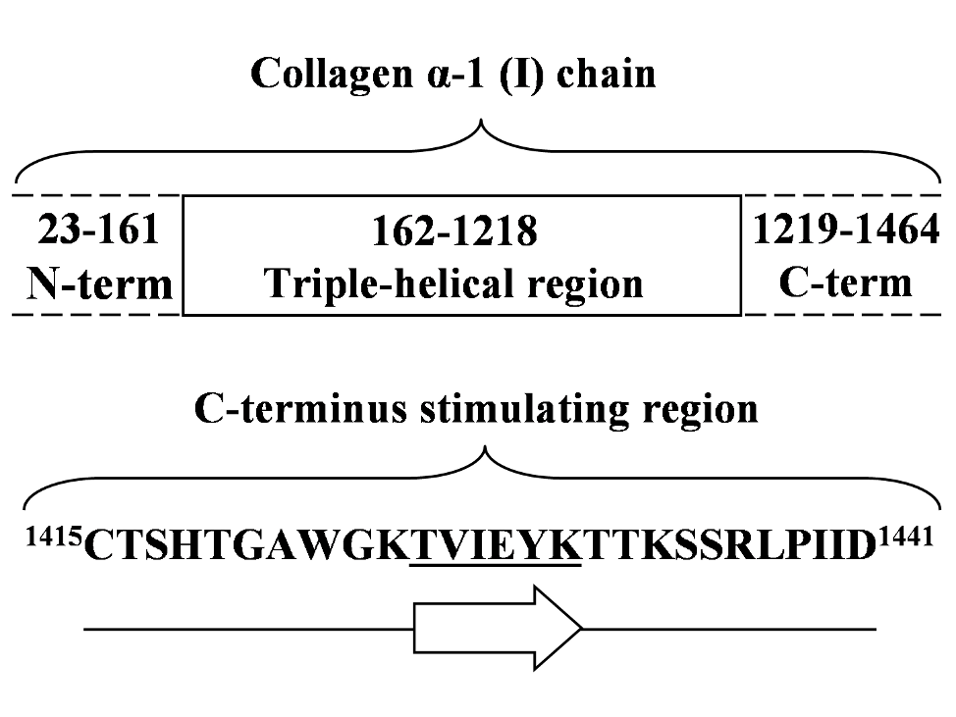
Figure 1. (Top) Collagen alpha-1(I) cartoon description. (Bottom) Secondary structure preferences of C-terminus stimulating region (1415-1441)¹¹ by prediction algorithm²⁷ psipred v3.0. Coil (1415-1424: CTSHTGAWGK; 1431-1441: TTKSSRLPIID) and strand (1425-1430: TVIEYK) predicted regions are reported as coil and arrow, respectively.
Partition coefficients and skin permeability. The palmitoyl moiety, nowadays present in PAs in Matrixyl® formulations, was chosen on the basis of unrelated results on cutaneous absorption of palmitoyl-interferon α2b (p-IFNα) which was greater than IFNα alone^{32,33}. According to the empirical Potts and Guy equation for human skin permeability²⁹ (logK_{p} = 0.71logP_{o/w} − 0.0061M_{w} − 2.74) a molecular weight (M_{w}) increase, due to fatty acid conjugation, affects negatively the skin permeability, but the higher octanol/water partition coefficient²⁸ (logP_{o/w}) of C_{n}-KTTKS has a predominant effect on the calculated permeability (K_{p}). The properties of peptide amphiphiles studied here are listed in Table 1 along with C₁₆-KTTKS studied previously^{14,15}. Values of K_{p} for C_{n}-KTTKS shown here are merely indicative because these have been calculated by just one of the early models³⁴ developed for molecular weights lower than 700 Da. However, the huge improvement of permeation properties of PAs vs. KTTKS is evident and it was largely underestimated in a recent paper.¹³ K_{p} values of KT derived amphiphiles, also employed in anti-wrinkle creams³⁵, are calculated and shown in Table 1 for comparison of alkyl tail effect on PAs with a lower molecular weight. The calculated value of K_{p} for sequence KT (2.09 × 10⁻⁶ cm h⁻¹) is three orders of magnitude higher than KTTKS (2.03 × 10⁻⁹ cm h⁻¹) due to the lower M_{W} (247.29 vs. 563.64) and higher partition coefficient logP_{o/w} (-2.00 vs. -3.54). This relationship between values of K_{p} for C_{n}-KTTKS and C_{n}-KT series is preserved for fixed hydrophobic tail length. Nevertheless, it is worth noting that K_{p} increases roughly four times from C₁₄ to C₁₆ and from C₁₆ to C₁₈ for both amino acid sequences because the ∆M_{w} and ∆logP_{o/w} are exclusively related to carbon atom number increase (i.e. for ∆n =2, ∆M_{w} = 28.05, ∆logP_{o/w} = 1.06, K_{p,n+2}/K_{p,n} = 3.82 ).

Table 1. Skin permeability of peptides
Structure | M_{w} | logP_{o/w} | K_{p} / cm h⁻¹
KTTKS | 563.64 | -3.54 | 2.03 × 10⁻⁹
C₁₄-KTTKS | 774.00 | 2.66 | 2.67 × 10⁻⁶
C₁₆-KTTKS | 802.05 | 3.72 | 1.02 × 10⁻⁵
C₁₈-KTTKS | 830.11 | 4.78 | 3.89 × 10⁻⁵
KT | 247.29 | -2.00 | 2.15 × 10⁻⁶
C₁₄-KT | 457.65 | 4.63 | 5.70 × 10⁻³
C₁₆-KT | 485.70 | 5.69 | 2.17 × 10⁻²
C₁₈-KT | 512.75 | 6.75 | 8.29 × 10⁻²

Circular Dichroism (CD). Circular dichroism spectroscopy was used to study the conformation of peptide amphiphiles of our study. Far UV CD spectra of C₁₄-KTTKS in D₂O at 20 ºC are reported in Figure 2A. The spectra show the typical features associated with unordered conformation^{36,37} with a strong negative band close to 200 nm and a negative shoulder between 220 and 240 nm. This lack of regular peptide secondary structure is preserved for all concentrations explored from 50 µM to 50 mM (0.004 - 4 wt%). Nevertheless, the spectrum for a dried film of C₁₄-KTTKS, obtained by water evaporation by flushing nitrogen gas onto a 50 mM solution in a 0.01 mm quartz cell, shows β-sheet features³⁶ with a positive band under 200 nm and a negative band between 215 and 220 nm (Figure 2B). This structuring phenomenon is likely due to the crossing of the critical aggregation concentration (cac) by removal of solvent from the C₁₄-KTTKS solution. These results suggest that PA micellization (at the cac) could favor secondary structure formation and vice versa. However, the cac for C₁₄-KTTKS was not determined because PA concentration higher than 50 mM causes peptide amphiphile precipitation in solution. The same spectroscopic analysis was conducted on C₁₈-KTTKS. CD spectra at 20 ºC for this stearoyl-peptide, between 0.12 mM and 0.60 mM (0.01 - 0.05 wt%), are reported in Figure 2C. The concentration-dependent β-sheet structure is observed, typical of self-association, and the presence of an isodichroic point at 212 nm is indicative of a two-state (coil-strand) conformational equilibrium.³⁸ Figure 2D shows an abrupt decrease of the minimum around 220 nm on increasing concentration which indicates an increase in β-sheet content of C₁₈-KTTKS starting from a concentration below PA 0.12 mM; 0.01 wt%, the lowest concentration sample examined.
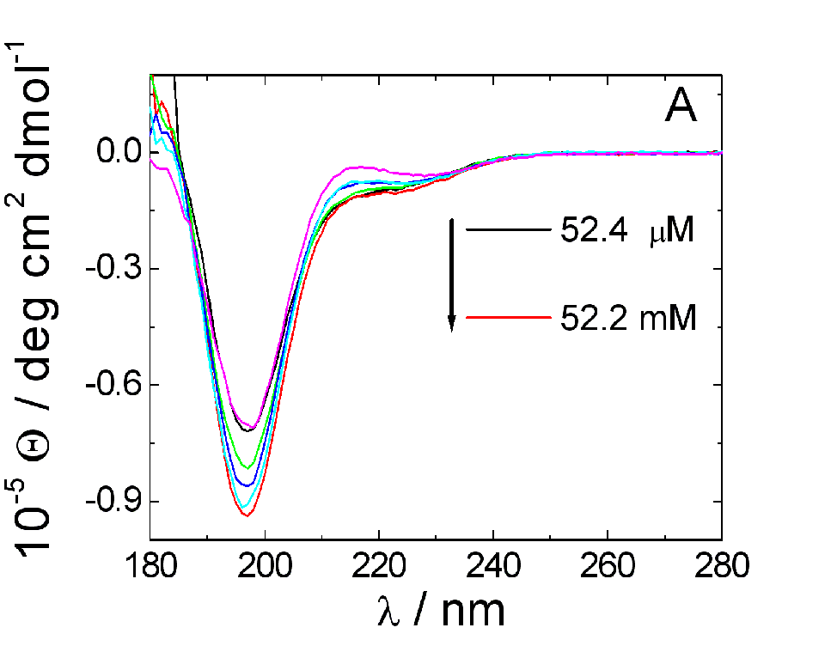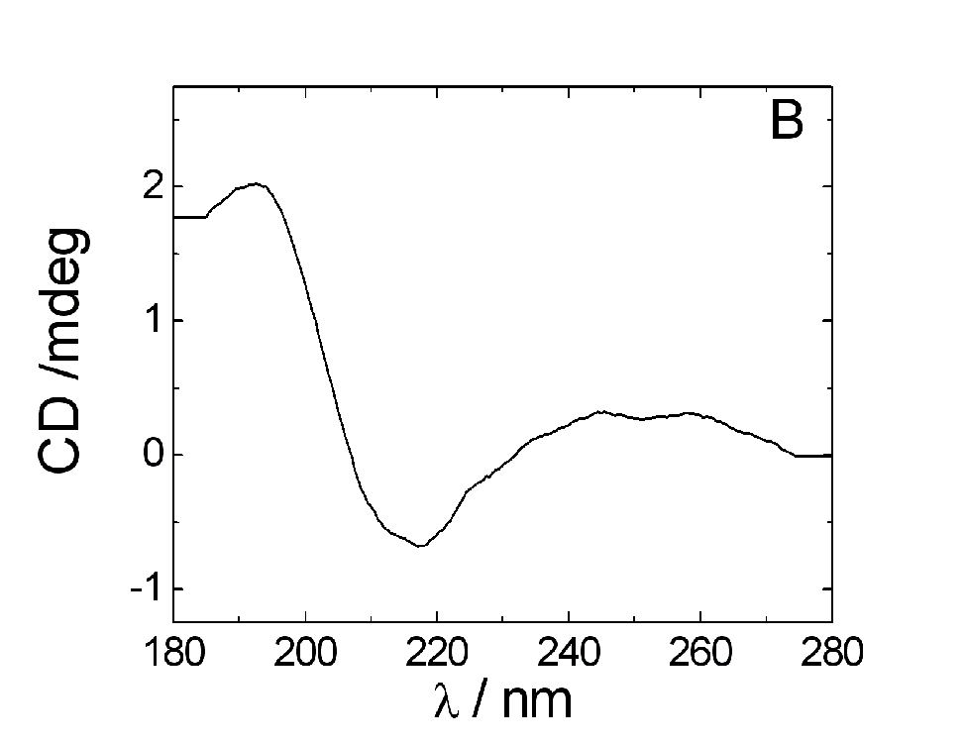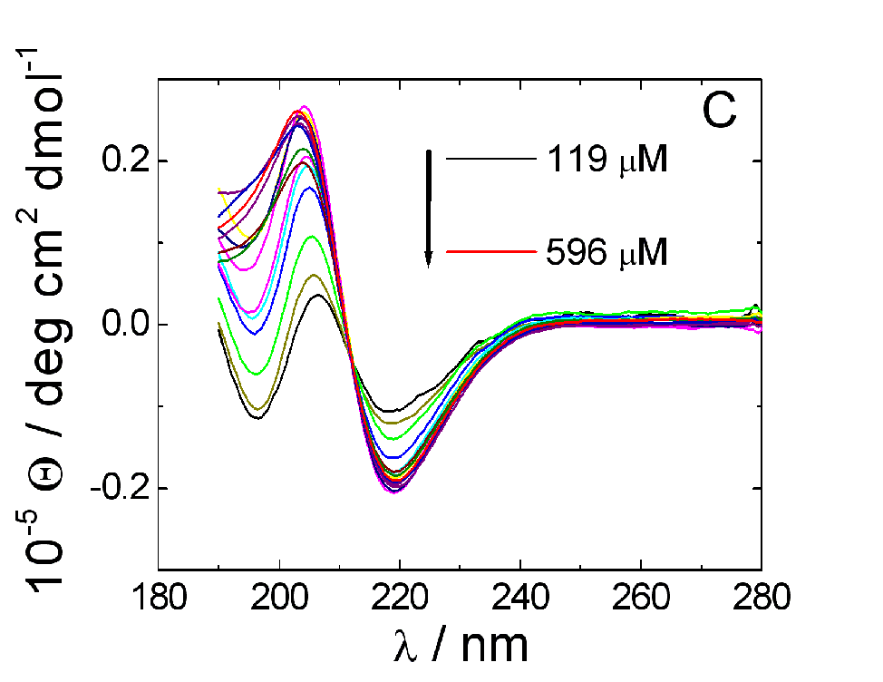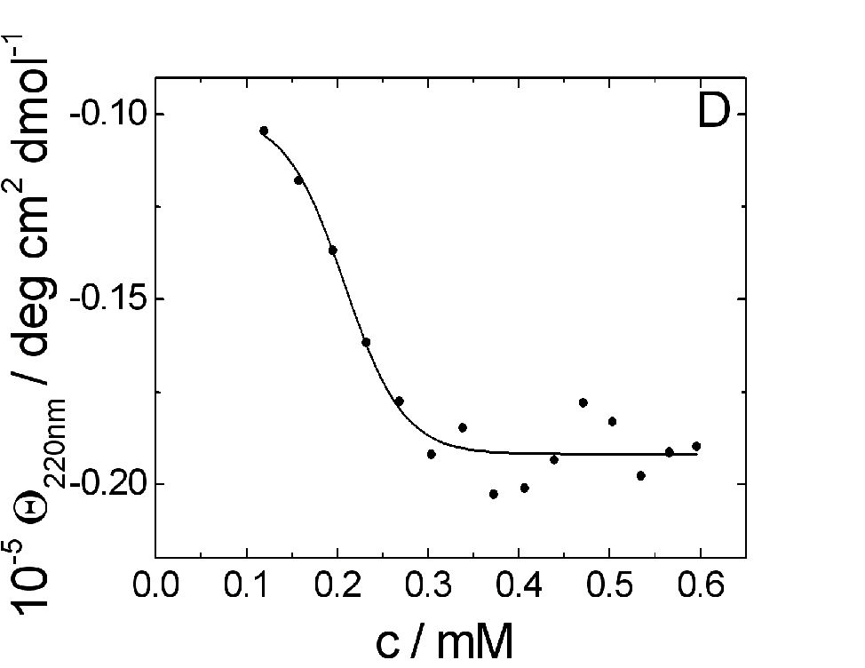
Figure 2. Far UV CD spectra of peptide amphiphiles. (A) Spectra for C₁₄-KTTKS in D₂O are superimposed as a function of sample concentration from bottom to top, 52.4 µM – 52.2 mM (0.004 - 4 wt%) showing an unordered profile.^{36,37} (B) CD spectrum of C₁₄-KTTKS with a β-conformation as dried film. (C) C₁₈-KTTKS spectra in D₂O are superimposed as a function of sample concentration from 0.119 mM to 0.596 mM (0.01 - 0.05 wt%). (D) Depth of β-sheet minimum at 220 nm vs. concentration (the line is inserted to guide the eye).
The effect of temperature on PA conformation was investigated by CD analysis on C₁₈-KTTKS in D₂O between 5 °C and 55 °C (Figure 3A). In this picture, a β-sheet structure is predominant at low temperature, whereas heating the sample generates a spectrum associated to coil conformation. In particular, C₁₈-KTTKS β-sheet unfolding was characterized by following the change in ellipticity at 220 nm versus temperature. The apparent midpoint of unfolding transition was at 34 °C, as determined by fitting the data to a sigmoidal function (Figure 3B).
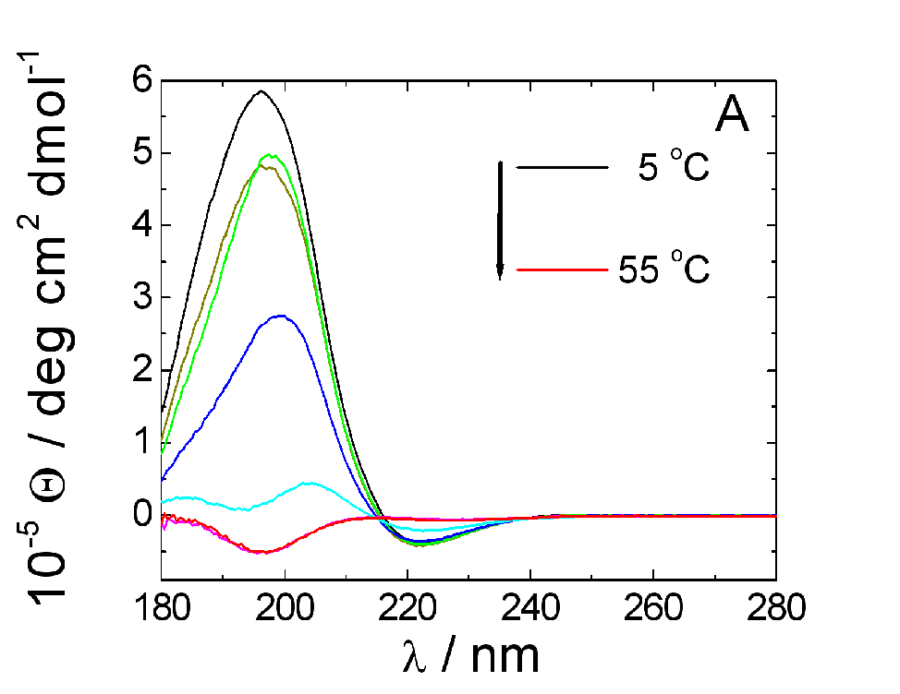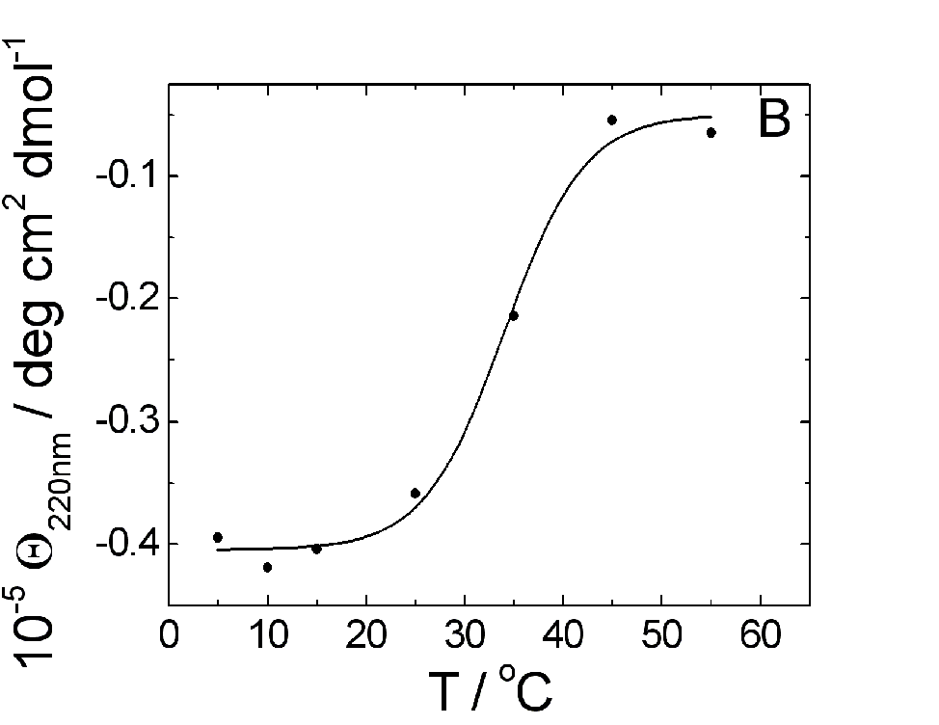
Figure 3. Far UV CD spectra of C₁₈-KTTKS at different temperatures. (A) Spectra for 5 wt% in D₂O are superimposed as a function of temperature from 5 °C (top black line) to 55 ºC (bottom red line). (B) Peptide amphiphile unfolding transition followed by ellipticity at 220 nm versus temperature. The apparent midpoint was at 34 °C, as determined by fitting the data to a sigmoidal function (solid line).
Cooling the solution of PA to 5 ^{º}C does not restore the β-sheet structure which requires several hours to re-establish an ordered arrangement (Figure 4A). Two-state behavior for this time-dependent coil-strand conversion is again confirmed by the presence of isodichroic point around 212 nm as observed in Figure 2C. Using the ellipticity observed at 220 nm and 5 ^{º}C (Θ_{obs}) it is possible to estimate the amount of peptide amphiphile monomer in coil conformation (Θ_{coil}) converted to β-sheet (Θ_{β}) over time (t), i.e. the fraction of PA folded α = (Θ_{obs} − Θ_{coil})/(Θ_{β} − Θ_{coil}).
Kinetic folding data for C₁₈-KTTKS could be fitted using a two-step model, successfully applied to several self-association processes including amyloid and prion protein aggregation.³⁹⁻⁴²
We have used the equation α = 1- (k₁ + k₂′)/[k₂′ + k₁exp(k₁ + k₂′)t], where k₁ and k₂′ (i.e. k₂[PA₀], with [PA₀] = 60 mM, 5 wt%) are apparent average rate constants of nucleation and the autocatalytic growth, respectively. Data fitting in Figure 4B gives k₁ = 0.36 h⁻¹, k₂′ = 1.75 h⁻¹ (corresponding to k₂ = 3.48 × 10⁻⁵ µM⁻¹ h⁻¹) with an optimal coefficient of determination (R² = 0.999). This minimalistic kinetic model indicates a fast nucleation process and a slow growth phase.
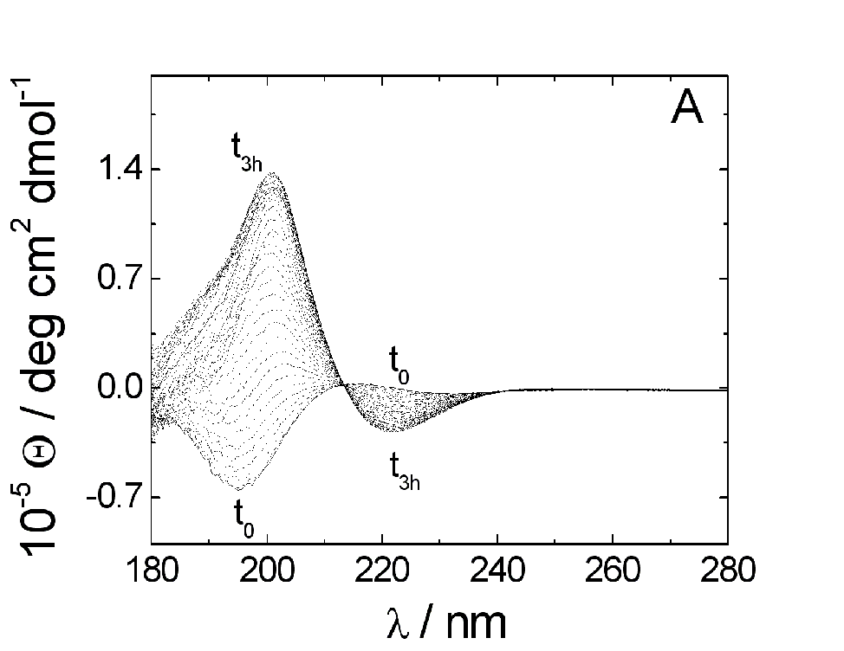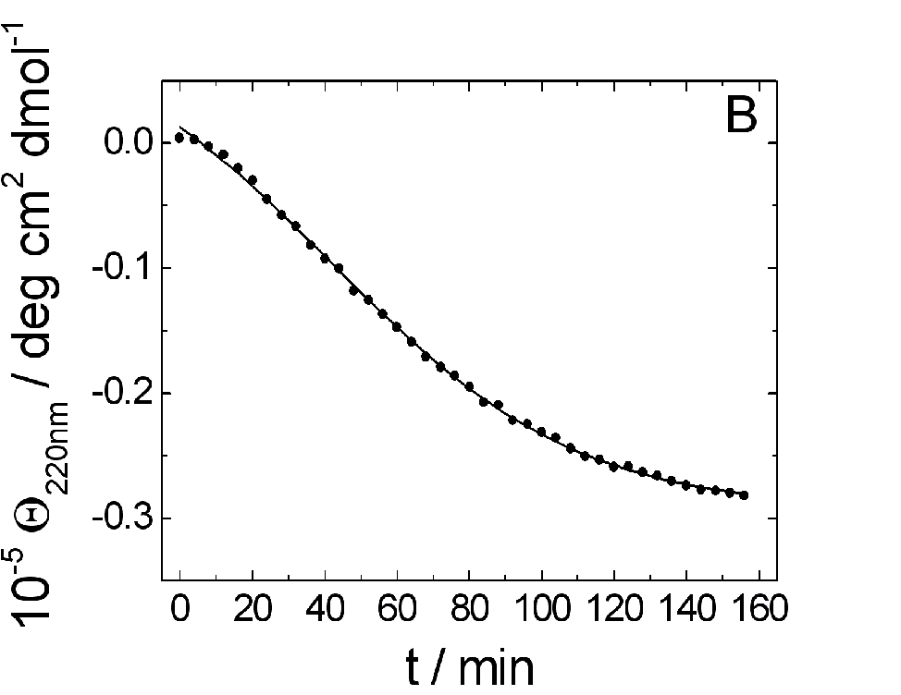
Figure 4. Far UV CD spectra of C₁₈-KTTKS. (A) Spectra for a 5 wt% sample in D₂O at 5 ºC are superimposed as a function of time (0 - 3 h). Isodichroic point around 212 nm confirms a two-state behavior for this time-dependent coil-strand conversion. (B) Folding kinetic data fitted by two-step model.³⁹⁻⁴²
Fourier transform infrared (FTIR). CD results concerning the conformation of the PAs were confirmed by Fourier transform infrared analysis in the amide I′ region. In fact, the FTIR spectrum of C₁₄-KTTKS (5 wt% in D₂O) shows a peak at 1645 cm⁻¹ assigned to disordered structure⁴³ (Figure 5A), whereas C₁₈-KTTKS (5 wt% in D₂O) shows the 1616 cm⁻¹ peak assigned to β-sheet structure⁴³ and a shoulder at 1645 cm⁻¹ likely due to C₁₈-KTTKS monomer in equilibrium with PA aggregates (Figure 5B). FTIR confirms that C₁₈-KTTKS conformational equilibrium is strictly dependent on temperature. In fact, C₁₈-KTTKS heating leads to unordered structure with a peak centered at 1645 cm⁻¹ by FTIR (Figure 5B). The weaker peak around 1720 cm⁻¹ is assigned to the C=O stretch in the carboxylic group at the C-terminus of the PA molecule.⁴⁴
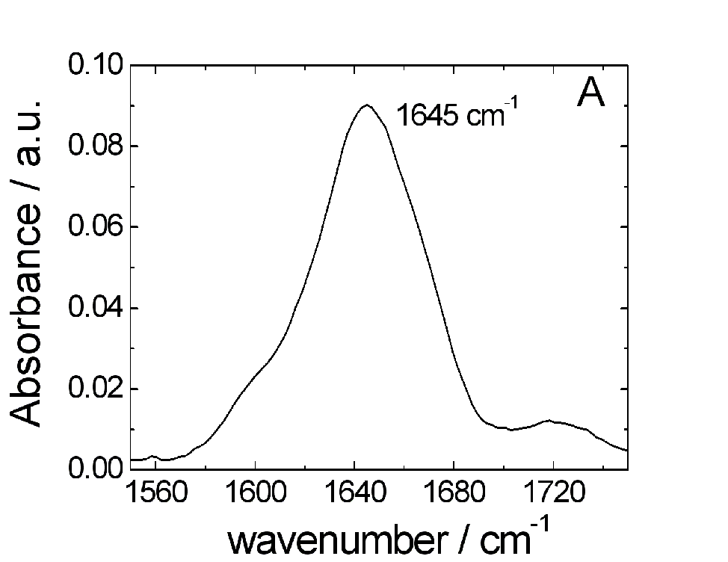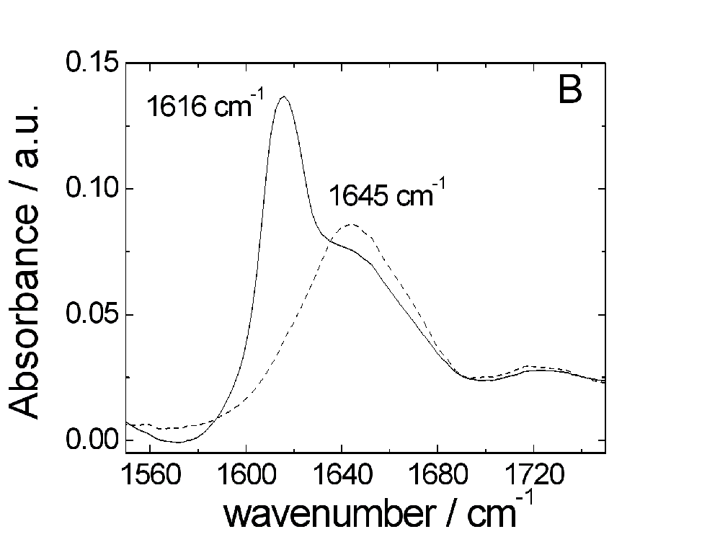
Figure 5. Amide I′ FTIR spectra of peptide amphiphiles (5 wt% in D₂O). (A) C₁₄-KTTKS shows a peak at 1645 cm⁻¹ consistent with unordered peptide.⁴³ (B) C₁₈-KTTKS shows a peak at 1616 cm⁻¹ peak at room temperature and assigned to β-sheet structure (solid line). A peak at 1645 cm⁻¹ (dashed line) was observed heating the sample over 50 °C. It is consistent with unordered peptide.
Fluorescence spectroscopy. The dependence of the fluorescence vibrational structure of pyrene on environmental hydrophobicity was used to estimate the critical aggregation concentration (cac) of C₁₈-KTTKS in H₂O by using the so-called I₁/I₃ ratio; i.e. the ratio between the fluorescence intensity measured at the wavelengths corresponding to the first (I₁ ~ 373 nm) and third (I₃ ~384 nm) vibronic bands of pyrene, this method having already been successfully applied to ionic and non ionic surfactants.^{45,46} Figure 6A shows representative fluorescence spectra of pyrene upon titration with C₁₈-KTTKS in water. The cac of C₁₈-KTTKS was evaluated by fitting the pyrene I₁/I₃ fluorescence ratio (F_{1:3}) versus peptide amphiphile concentration (Figure 6B). The cac was estimated to occur at the centre of a fitted decreasing sigmoid function, i.e. c₀, as reported elsewhere⁴⁵, given by F_{1:3} = (F₁-F₂)/[1+exp(c-c₀)/s] + F₂, where F₁ and F₂ are the upper and lower fluorescence limits of the sigmoid, respectively, with slope s. This analysis allows to estimate a value of 0.046 mM (0.0038 wt%) for C₁₈-KTTKS aggregation in water, lower than concentration range explored by CD (0.01 - 0.05 wt%, Figure 2D), and one order of magnitude lower than cac value of C₁₆-KTTKS which is 0.025 wt% under the same conditions.⁴⁷ This value is expected to be orders of magnitude lower than the cac of C₁₄-KTTKS due to the longer alkyl chain²³. As a matter of fact, C₁₄-KTTKS did not show any β-sheet structure up to 50 mM (4 %wt) (Figure 2A), but such a behavior does not exclude some kind of aggregation of the lipid chains without peptide moiety association. However, C₁₄-KTTKS was not analyzed further because precipitation of the PA prevents spectroscopic study in solution.
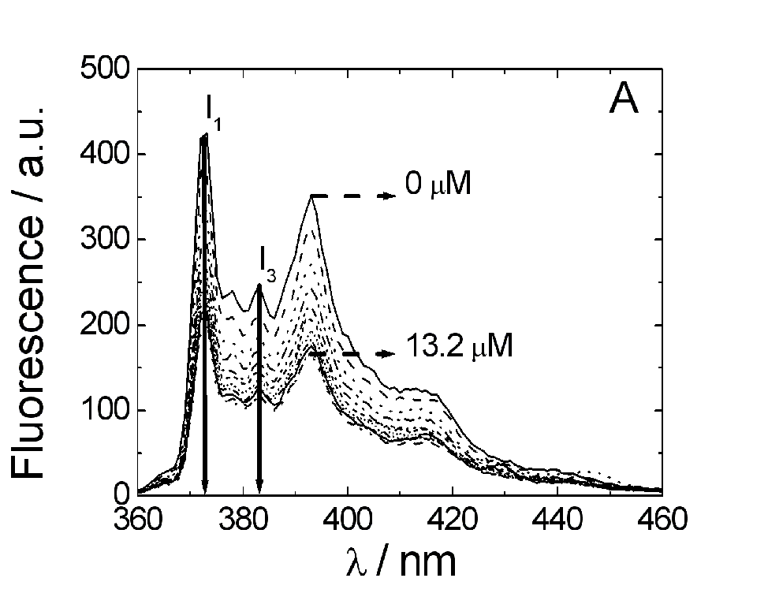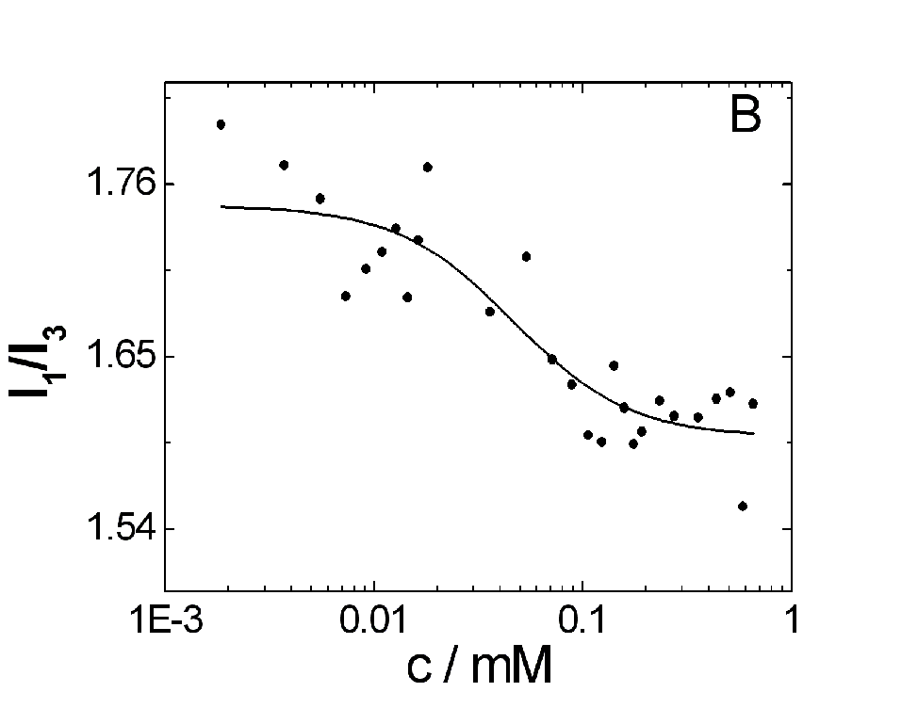
Figure 6. (A) Representative fluorescence spectra of pyrene upon titration with C₁₈-KTTKS in water. Arrows indicate the quenching of first (I₁ ~ 373 nm) and third (I₃ ~384 nm) vibronic band of pyrene upon C₁₈-KTTKS concentration increase (0 – 13.2 µM). (B) Pyrene I₁/I₃ ratio (F_{1:3}) decrease upon C₁₈-KTTKS concentration increase (0 – 0.656 mM).
X-ray diffraction. The X-ray diffraction pattern from peptide amphiphile dried stalks (XRD) is shown in Figure 7. The XRD image for C₁₄-KTTKS reported in Figure 7A indicates a pseudo-polycrystalline order, with multiple reflections including a 4.74 Å peak assigned to β-strand spacing already reported for C₁₆-KTTKS.¹⁴ These XRD results are in agreement with the above reported CD data indicating a β-sheet conformation of C₁₄-KTTKS in a dried film. X-ray diffraction analysis on C₁₈-KTTKS shows a nicely aligned cross-beta fibre diffraction pattern with 12.5 Å and 4.8 Å spacing, and also a sharp 2.9 Å C_{α}-C_{α} spacing (Figure 7B). In order to further investigate the C₁₈-KTTKS self-assembled nanostructure, transmission electron microscopy (TEM) was also employed. Figure 7C shows images obtained by negative stain TEM. TEM shows the nanostructure formation consisting of long fibre networks formed by 0.5 wt% C₁₈-KTTKS in D₂O. The average fibril thickness is 13.4 ± 3.2 nm. Furthermore, one dimensional small-angle X-ray scattering (SAXS) profile in Figure 7D shows the Bragg peak position for a 1 wt% solution of C₁₈-KTTKS in D₂O (q ≈ 0.14 Å⁻¹, d = 44.9 Å).

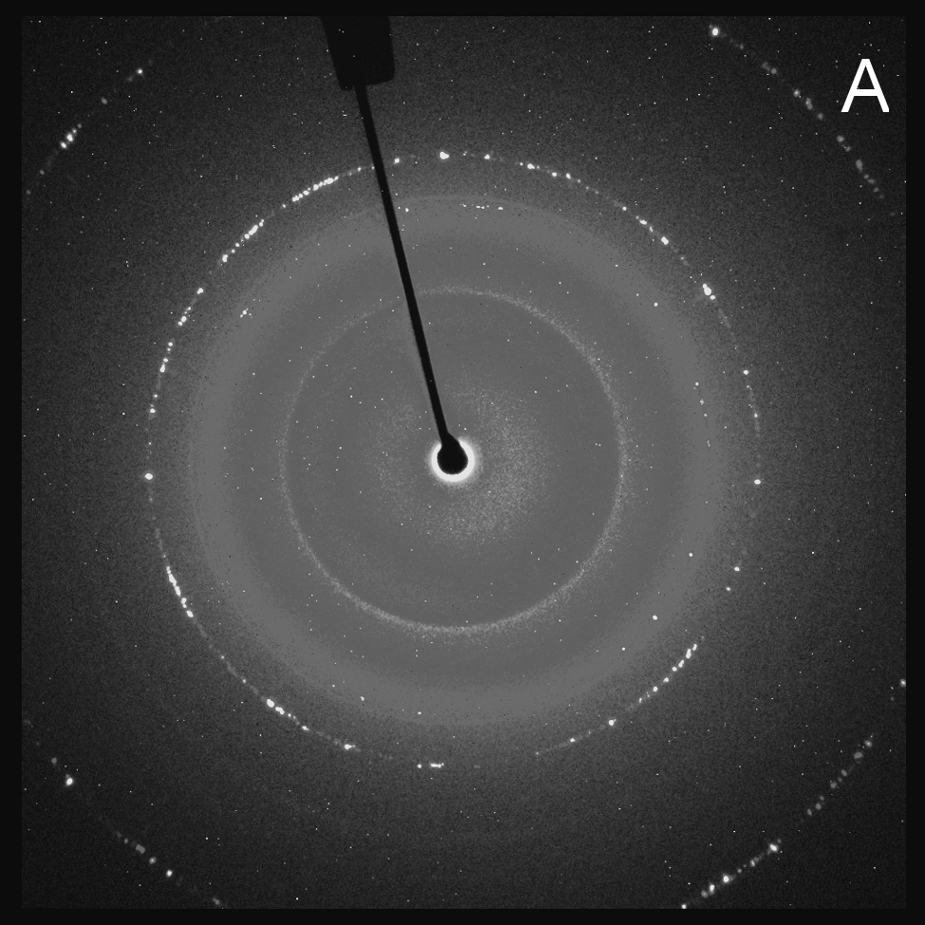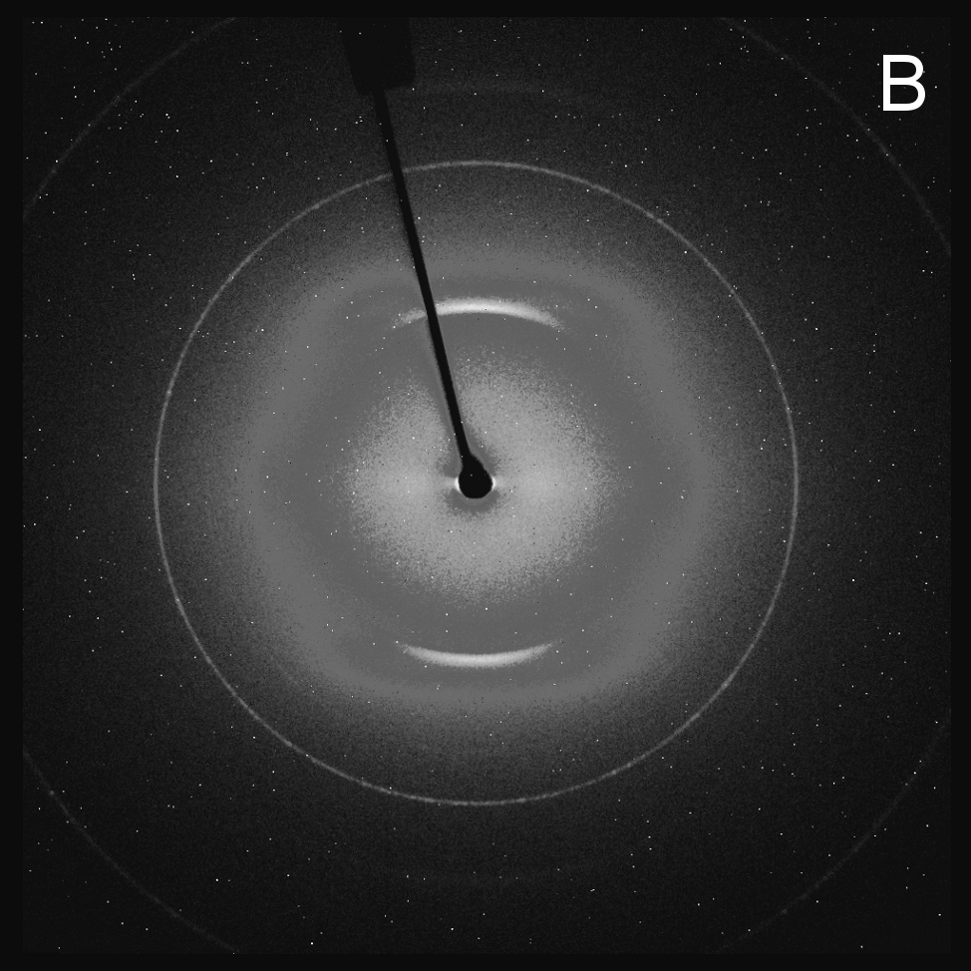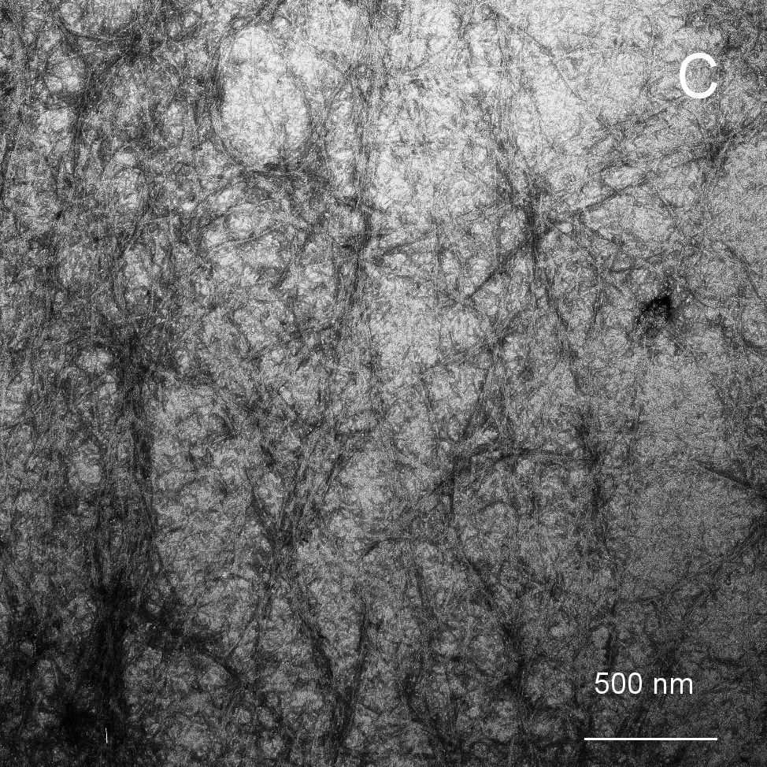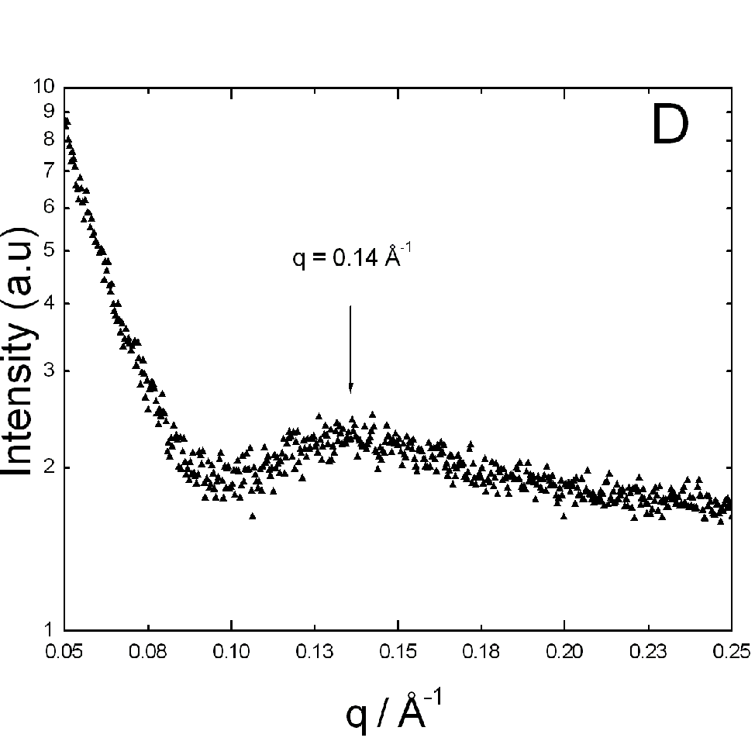
Figure 7. X-ray diffraction and TEM data. (A) XRD pattern from a dried stalk of C₁₄-KTTKS shows a pseudo-polycrystalline order, with multiple reflections including 4.74 Å peak assigned to the β-strand spacing. (B) C₁₈-KTTKS dried stalk XRD pattern shows a very clear cross-β pattern consistent with β-sheet ordering.¹⁴ (C) TEM image for an 0.5 wt% sample of C₁₈-KTTKS in D₂O. Average thickness of fibers is 13.4 ± 3.2 nm. (D) One dimensional SAXS profile showing Bragg peak position for 1 wt% C₁₈-KTTKS in D₂O.
DISCUSSION AND CONCLUSIONS
The physico-chemical properties of peptide amphiphiles C_{n}-KTTKS derived from the C-terminal type I collagen propeptide can be modulated by changing the length of the fatty acid moiety.
Although self-assembly of PAs depends on several factors including alkyl chain hydrophobic interactions, peptide back-bone hydrogen bond formation and electrostatic interactions generated by peptide charged side chains and C-terminus,¹ in this study it was possible to isolate the hydrophobic effect on PA aggregation by preservation of the peptidic moiety. C₁₄-KTTKS and C₁₈-KTTKS studied here showed self-association, giving both a β-sheet structure in the dried state, and for the sample latter a coil-strand conformational equilibrium in solution. PA micellization and secondary structure formation are probably interrelated cooperative processes as discussed elsewhere.⁵ However, this aspect was not deeply investigated in this paper. Previously C₁₆-KTTKS has been shown to self-assemble into β-sheet rich nanotapes in aqueous solution.^{14,15} Originally, because of the potential applications of KTTKS in topical use, a fatty acid derivative was synthesized to overcome the difficulties associated with delivery of this highly hydrophilic molecule across the skin barrier. We calculated here the theoretical improvement of permeation properties of PAs vs. KTTKS alone (three orders of magnitude) derived from the enhancement of hydrophobicity which overcomes the negative size-increase effect. Furthermore, the skin permeability of PA containing C₁₄ tail is estimated to be 3.8 times lower than C₁₆ which in turn appears to be 3.8 times lower than C₁₈.
Clinical studies on C₁₆-KTTKS, as well as for KTTKS, reported benefits around 3 ppm (0.0003 wt%).^{6,33} Since the cac for C₁₆-KTTKS is roughly 0.025 wt% in water and 0.010 wt% in FBS-free Dulbecco’s Modified Eagle Medium (DMEM),⁴⁷ C₁₆-KTTKS is likely to act as monomer at 3 ppm prior to drying, which may favor aggregation. Our CD and fluorescence results indicate a cac of 0.0038 wt% for C₁₈-KTTKS at room temperature, and for C₁₄-KTTKS it has to be even higher than C₁₆-KTTKS (it must aggregate when dried, i.e. at 100 wt%). In terms of the relationship between the self-assembly and the cosmetic application, these results mean that using the recommended concentration for these new PAs, it is possible to retain the monomer state in the topically applied cream but the biological efficacy should change depending on the skin permeability of each PA. The longer alkyl chain PA may show an enhanced collagen-stimulating effect on the basis of its higher permeability value. Consequently, it should be also possible to change the concentration of active ingredient of anti-wrinkle cosmetic creams and reduce the formulation cost. This will be the subject of future research.

ACKNOWLEDGMENTS
This work was supported by EPSRC grants EP/F048114/1, EP/G026203/1 and EP/G067538/1 to IWH. X-ray diffraction experiments were performed in the BioCentre at the University of Reading.

REFERENCES
(1) Velichko, Y. S.; Stupp, S. I.; Overa de la Cruz, M. Molecular Simulation study of peptide Amphiphile Self-Assembly. J. Phys. Chem. B 2008, 112, 2326-2334.
(2) Shimada, T.; Lee, S.; Bates, F. S.; Hotta, A.; Tirrell, M. Wormlike Micelle Formation in Peptide-Lipid Conjugates Driven by Secondary Structure Transformation of the Headgroups. J. Phys. Chem. B 2009, 113, 13711–13714.
(3) Versluis, F.; Robson Marsden, H.; Kros, A. Power struggles in peptide-amphiphile nanostructures. Chem. Soc. Rev. 2010, 39, 3434-3444.
(4) Galler, K. M.; D'Souza, R. N.; Hartgerink, J. D. Biomaterials and their potential applications for dental tissue engineering. J. Mater. Chem. 2010, 20, 8730-8746.
(5) Trent, A.; Marullo, R.; Lin, B.; Black, M.; Tirrell, M. Structural properties of soluble peptide amphiphile micelles. Soft Matter 2011, 7, 9572-9582.
(6) Hamley, I. W. Self-assembly of amphiphilic peptides. Soft Matter 2011, 7, 4122-4138.
(7) Matson, J. B.; Stupp, S.I. Self-assembling peptide scaffolds for regenerative medicine. Chem. Commun. 2012, 48, 26-33.
(8) Yuwono, V. M.; Hartgerink, J. D. Peptide Amphiphile Nanofibers Template and Catalyze Silica Nanotube Formation. Langmuir 2007, 23, 5033–5038.
(9) Rexeisen, E. L.; Fan, W.; Pangburn, T. O.; Taribagil, R. R.; Bates, F. S.; Lodge, T. P.; Tsapatsis, M.; Kokkoli, E. Self-Assembly of Fibronectin Mimetic Peptide-Amphiphile Nanofibers. Langmuir 2010, 26, 1953–1959.
(10) Shroff, K.; Timothy R. Pearce, T. R.; Kokkoli, E. Enhanced Integrin Mediated Signaling and Cell Cycle Progression on Fibronectin Mimetic Peptide Amphiphile Monolayers. Langmuir 2012, 28, 1858–1865.
(11) Katayama, K.; Armendarizborunda, J.; Raghow, R.; Kang, A. H.; Seyer, J. M. A Pentapeptide from Type I Procollagen Promotes Extracellular Matrix Production. J. Biol. Chem. 1993, 268, 9941-9944.
(12) Röper, B.; Kaisig, D.; Auer, F.; Mergen E.; Molls, M. Thêta-Cream® versus Bepanthol® lotion in breast cancer patients under radiotherapy. A new prophylactic agent in skin care? Strahlenther. Onkol. 2004, 5, 315-322.
(13) Samah, N. H.; Heard, C. M. Topically applied KTTKS: a review. Int. J. Cosmetic Sci. 2011, 1-8.
(14) Castelletto, V.; Hamley, I. W.; Perez, J.; Abezgauz, L.; Danino, D. Fibrillar superstructure from extended nanotapes formed by a collagen-stimulating peptide. Chem. Comm. 2010, 46, 9185-9187.
(15) Castelletto, V.; Hamley, I. W.; Adamcik, J.; Mezzenga, R.; Gummel, J. Modulating self-assembly of a nanotape-forming peptide amphiphile with an oppositely charged surfactant. Soft Matter 2012, 8, 217-226.
(16) Hartgerink, J. D.; Beniash, E.; Stupp, S. I. Peptide-amphiphile nanofibers: A versatile scaffold for the preparation of self-assembling materials. Proc. Natl. Acad. Sci. USA 2002, 99, 5133-5138.
(17) Cui, H.; Murakowa, T.; Cheetham, A. G.; Stupp, S. I. Self-assembly of Giant Peptide Nanobelts. Nano Letters 2009, 9, 945-951.
(18) Yu, C. Y.; Tirrell, M.; Fields, G. B. Minimal Lipidation Stabilizes Protein-Like Molecular Architecture. J. Am. Chem. Soc. 1998, 39, 9979-9987.
(19) Gore, T.; Dori, Y.; Talmon, Y.; Tirrell, M.; Bianco-Peled, H. Self-Assembly of Model Collagen Peptide Amphiphiles. Langmuir, 2001, 17, 5352–5360.
(20) Löwik, D. W. P. M.; Garcia-Hartjes, J.; Meijer, J. T.; van Herst, J. C. M. Tuning Secondary Structure and Self-Assembly of Amphiphilic Peptides. Langmuir 2005, 21, 524-526.
(21) van den Heuvel, M.; Baptist, H.; Venema, P.; van der Linden, E.; Löwik, D. W. P. M.; van Hest, J. C. M. Mechanical and thermal stabilities of peptide amphiphile fibres. Soft Matter 2011, 7, 9737-9743.
(22) Missirlis, D.; Khant, H.; Tirrell, M. Mechanism of Peptide Amphiphile Internalization by SjSA-1 Cells in Vitro. Biochemistry 2009, 48, 3304-3314.
(23) Chu-Kung, A. F.; Nguyen, R.; Bozzelli, K. N.; Tirrell, M. Chain length dependence of antimicrobial peptide-fatty acid conjugate activity. J Colloid Interface Sci. 2010, 345, 160-167.
(24) Lockwood, N. A.; Haseman, J. R.; Tirrell, M. V.; Mayo, K. H. Acylation of SC4 dodecapeptide increases bactericidal potency against Gram-positive bacteria, including drug-resistant strains Biochem. J. 2004, 378, 93-103.
(25) Amblard, M.; Fehrentz, J-A.; Martinez, J.; Subra, G. Methods and protocols of modern solid phase peptide synthesis Mol. Biotechnol. 2006, 3, 239-254.
(26) Gaussier, H.; Morency, H.; Lavoie, M. C.; Subirade, M. Replacement of Trifluoracetic Acid with HCl in the Hydrophobic Purification Steps of Pediocin PA-1: a Structural Effect. Appl. Environ. Microbiol. 2002, 68, 4803-4808.
(27) McGuffin, L. J.; Bryson, K.; Jones, D. T. The PSIPRED protein structure prediction server. Bioinformatics 2000, 4, 404-405.
(28) Osterberg, T.; Norinder, U. Prediction of drug transport processes using simple parameters and PLS statistics. The use of ACD/logP and ACD/ChemSketch descriptors. Eur. J. Pharm. Sci. 2001, 3, 327-337.
(29) Potts, R. O.; Guy, R. H. Predicting skin permeability. Pharmaceut. Res. 1992, 9, 663-669.
(30) Makin, O. S.; Sirkoski, P.; Serpell, L. C. CLEARER: a new tool for the analysis of X-ray fibre diffraction patterns and diffraction simulation from atomic structural models. J. Appl. Cryst. 2007, 40, 966-972.
(31) Tizzano, B; Palladino, P.; De Capua, A.; Marasco, D.; Rossi, F.; Benedetti, E.; Pedone, C.; Ragone, R.; Menotti, R. The human prion protein α2 helix: a thermodynamic study of its conformational preferences. Proteins: Struct. Funct. Bioinform. 2005, 1, 72-79.
(32) Foldvari, M.; Attah-Poku, S.; Hu, J.; Li, Q.; Hughes, H.; Lorne, A. B.; Kruger, S. Palmitoyl derivatives of interferon α: Potential for cutaneous delivery. J. Pharm. Sci. 1998, 87, 1203–1208.
(33) Robinson, L. R.; Fitzgerald, N. C.; Doughty, D. G.; Dawes, N. C.; Verge, C. A. Topical palmitoyl Pentapeptide provides improvement in photoaged human facial skin. Int. J. Cosmetic Sci. 2005, 27,155-160.
(34) Moss, G. P.; Wilkinson, S. C.; Sun, Y. Mathematical modelling of percutaneous absorption. Curr. Opin. Colloid Interface Sci. 2012, 3, 166–172.
(35) Kaczvinsky, J. R.; Griffiths, C. E. M.; Schnicker, M. S.; Li, J. Efficacy of anti-aging products for periorbital wrinkles as measured by 3-D imaging. J. Cosmetic Dermatol. 2009, 3, 228–233.
(36) Yang, J. T.; Wu, C. S. C.; Martinez, H. M. Calculation of protein conformation from circular dichroism. Meth. Enzymol. 1986, 130, 208-269.
(37) Greenfield, N. J. Using circular dichroism spectra to estimate protein secondary structure. Nature protocols 2006, 6, 2876-2890.
(38) Terzi, E.; Hölzemann, G.; Seelig, J. Self-association of β-Amyloid Peptide (1–40) in Solution and Binding to Lipid Membranes. J Mol. Biol. 1995, 5, 633–642.
(39) Morris, A. M.; Watzky, M. A.; Agar, J. N.; Finke, R. G. Fitting neurological protein aggregation kinetic data via a 2-step, minimal/”Ockham’s razor” model: the Finke-Watzky mechanism of nucleation followed by autocatalytic surface growth. Biochemistry 2008, 47, 2413-2427.
(40) Watzky, M. A.; Morris, A. M.; Ross, E. D.; Finke, R. G. Fitting Yeast and Mammalian Prion Aggegation Kinetic Data with the Finke-Watzky Two-Step Model of Nucleation and Autocatalytic Growth. Biochemistry 2008, 47, 10790-10800.
(41) Morris, A. M.; Watzky, M. A.; Finke, R. G. Protein aggregation kinetics, mechanism, and curve fitting: A critical review of the literature. Biochim. Biophys. Acta 2009, 1794, 375-397.
(42) Finney, E. E.; Finke, R. G. Is there a Minimal Chemical Mechanism Underlying Classical Avrami-Erofe’ev Treatments of Phase-Transformation Kinetic Data? Chem. Mater. 2009, 21, 4692-4705.
(43) Kong, J.; Yu, S. Fourier Transform Infrared Spectroscopic Analysis of Protein Secondary Structures. Acta Biochim. Biophys. Sin. 2007, 8, 548-559.
(44) Aureau, D.; Ozanam, F.; Allongue P.; Chazalviel, J.-N. The Titration of Carboxyl-Terminated Monolayers Revisited: In Situ Calibrated Fourier Transform Infrared Study of Well-Defined Monolayers on Silicon. Langmuir, 2008, 24, 9440–9448.
(45) Kalyanasundaram, K.; Thomas, J. K. Environmental Effects on Vibronic Band Intensities in Pyrene Monomer Fluorescence and Their Application in Studies of Micellar Systems. J. Am. Chem. Soc. 1977, 7, 2039-2044.
(46) Aguiar, J.; Carpena, P.; Molina-Bolivar, J. A.; Carnero Ruiz, C. On the determination of the critical micelle concentration by the pyrene 1:3 ratio method. J. Colloid Interface Sci. 2003, 258, 116-122.
(47) Castelletto, V.; Jones, R.; Connon, C. J.; Hamley, I. W. A Collagen-Stimulating Peptide Amphiphile Shows Potential as a Cell Culture Medium (manuscript in preparation).

Table of contents only
