The Role of Endnote in the Process of Reference Writing
ALI JAHANI
PhD candidate in University of Malaya, Malaysia
Jahani_ali25403@yahoo.com

0173824960

20-18-2 Midah Ria Condo. Jalan Midah 8 Taman Midah Cheras
Abstract
The aim of this study was to investigate the role of Endnote in the process of reference writing for a thesis. Endnote is software that everybody wants to write references in his research or thesis can use it. Since, there are many resources available because of advances in technology; it seems that Endnote will be used in the future by many researchers. Therefore, learning how to use this software can be a great help to all the researchers. But, the most important question is that: is there any significant relationship between using of Endnote and having better references in thesis?
Therefore, two groups of Master students were selected as the subjects of the present study as control and experimental groups. They had to do a research before their graduation .First of all, the student as experimental group had instruction in order to get familiar with Endnote software and another group (control group) did not receive any instruction.
It must be mentioned that the site of this study was Iran, Bojnord and the samples were selected the master students who were studying in Azad University. And the instruments used in this study for data collection were questionnaire and interview.
The result showed that there were not any significant differences between control and experimental groups and consequently, the researcher has concluded that the using of Endnote software cannot be effective enough to make any differences between two groups.
Introduction
Guiding students to appropriate knowledge; directing students to appropriate learning activities; helping students practice, encode, and process information; monitoring student performance; and providing feedback as to the appropriateness of the student's learning activities and practice performance are completed by instruction. One of the most important knowledge is learning how to use the technologies and among these technologies computer stands in the first place. It is obvious that students and researchers need to use the computers, but there is some software which can make their job easier. One of this software is Endnote. Endnote is a software package which can help to manage references or bibliographies while writing papers, essays and thesis.
Background of the study
We have witnessed advanced technology has a great effect on everything for the last 50 years. According to Gibbons (2004), recent advances have revealed the need for changes and development in education field. In parallel to these advances, the use of computer software and related technologies has increased obviously since the late 1960s (Divitini, Haugalokke&Yaron, 2000; Ling & Vaage, 2000; Lundby, 2002; Roschelle & Pea, 2002).
For this reason, everybody needs to increase their knowledge about theses technologies. This issue seems more important for university students and researchers. They are looking for new ways via computer software which can help them in doing their assignments especially in writing their thesis. Although, they use other software such word processor, Internet and so on, but using new software such as Endnote has been more important for them. Moreover it has been noticeable for all researchers who have been looking for something which help them during their researches. Thus, it seems that the role of End note software would be considerable according to following reasons.
- It is software which has been accompanied with new word processor such as 2007 word.
- It can be help to researcher for easy writing of references when they are writing their research.
- End note arranges the name of resources alphabetically so it can help to researchers in order to find the name of authors who has been mentioned during the research.
Methodology
Subjects and procedures
The main objective is to introduce new software to aid students to do their thesis as efficiently as possible. First of all, the researcher wanted to be sure the new style works successfully. Therefore, two groups of Master students were selected as the subjects of the present study as control and experimental groups. The subjects were selected by random sampling. They had to do a research before their graduation .First of all, the student as experimental group had instruction in order to get familiar with Endnote software and another group (control group) did not receive any instruction.
It must be mentioned that the site of this study was Iran, Bojnord and the samples were selected the master students who were studying in Azad University. And the instruments used in this study for data collection were questionnaire and interview. They were 48 Iranian Master Students from same L1 background (Farsi). They divided into two groups; one group as experimental group (N=18) and the other one as control group (N=30).
Since the number of the students who accepted using the endnote is eighteen, therefore, the researcher had no way to make equal the number of the students in two groups. It must be mentioned here all subjects participated in this study voluntarily, and they could drop out from the study at any time they wanted. The study was done through a quantitative design, experimental method.
The student as experimental group had instruction in order to get familiar with Endnote software one month, three days a week, every session is two hours, totally they received 12 sessions, but, another group (control group) did not receive any instruction.
After three months, both group received a questionnaire. They were asked their ideas about doing their thesis. The researcher wanted to know if Endnote could help students to do their thesis more easily or not. All the questions (semi-structured) and instructions were in Persian which was made by the researcher and standardized by a pilot study. For calculating the scores of questioner, the Likert scale was used.
After answering the questionnaire, all the subjects were interviewed. The questions are semi-structured. Subjects were interviewed in Persian. Responses to interviews were analyzed on the basis of qualitative approaches.
Generally speaking, interview data was added to that obtained from questionnaire, because the researcher wanted to know the subjects’ (learners) ideas, beliefs, opinions and expectations. Ekrami (2001) believes that whenever a researcher intends to gain a general trend, interview is the best and most appropriate instrument.
The other reason for conducting interviews with Iranian EFL learners relates to the fact that according to our culture, Iranians feels nervousness while writing (Ekrami, 2001). They prefer not to answer some questions, or write something which is not true. So, the researcher used interview in order to get deep understanding; he could indirectly gain some insights during the conversation.
All the interviews were conducted by the same researcher. All interview sessions were recorded and were subsequently be transcribed. Eventually, all above data (qualitative data from interviews and quantitative data from questionnaires), provided a general picture for the main objective of this study which was to examine the status of endnote in doing the thesis.

T-tests – comparison of Means:
In this part T-test is used to test whether there are any significant differences between the control group and experimental group.
Ho: There are no differences in the mean scores (M₁ = M₂).
H1: There are differences in the mean scores (M₁ ≠ M₂).
The t value or t obtained must be calculated to find out whether it is greater than t critical and is in the rejection zone, so null hypothesis will be rejected and the alternative hypothesis of H₁ will be retained. If calculated t value is smaller than t critical, it is in the retain zone and, the null hypothesis will not be rejected.
The table below shows the scores for control and experimental group at department of Education, University of Malaya.
By looking at the table and comparing the means we could see that the degree of satisfaction among Male students is higher than Female students. The t-test is applied to find out if this conclusion is right or not.
The formula for calculating t is:
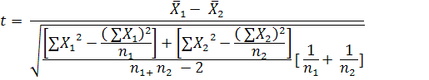

75.6875 71.
1211 2139
96561 161973

t = 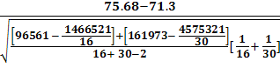
t = 0.78
Next step is to find the critical value of t from the table.
The degree of freedom is df = n1 + n₂ - 2 = 16 + 30 – 2 = 44
For the 2-tailed test, alpha for each tail 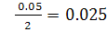
So the critical value for the degree of freedom 44 and α = .05 is: 2.014

Interpretation:
Comparing t obtained of (0.78) with the critical value of (2.014) shows that the critical value is greater than the t obtained so the null hypothesis is not rejected. Therefore there are no differences in the mean of the control and experimental group.
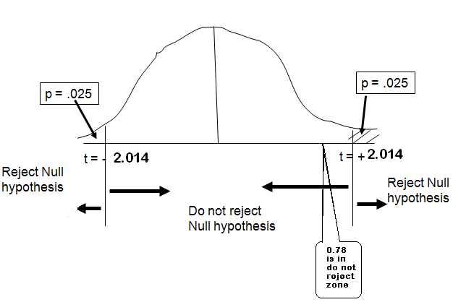SPSS output to test the significance of the differences between means of the control and experimental group:

Table4a

 | Groups | N | Mean | Std. Deviation | Std. Error Mean
Overall Satisfaction | control | 16 | 75.69 | 18.080 | 4.520
Overall Satisfaction | Experimental | 30 | 71.30 | 18.063 | 3.298

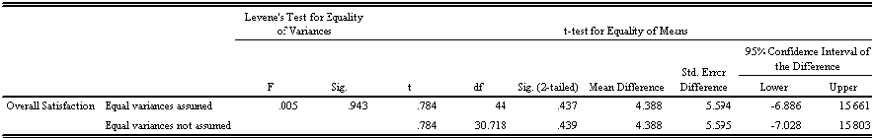

The SPSS T-test results also show that the t value calculated is 0.784 and the corresponding p value is .437 and it is greater than .05 (p > .05) so we do not reject H_{o} and conclude that there are no differences in the mean of control and experimental groups.
Discussion and Conclusion
The result showed that there were not significant differences between control and experimental groups and consequently, the researcher has concluded that the using of Endnote software cannot be effective enough to make any differences between two groups. The findings of this study revealed that if the teachers cannot change the learners’ beliefs, the best and most advanced technology cannot be useful. Although, the researcher’s experiences showed that Endnote is very helpful software. The present paper showed that the learners play the most important role in accepting the new style. It is hoped this study can help teachers and policy makers in education, to use the learners’ preferences. The results of this study showed that the students could develop their abilities in different skills if they believe in something.

Bibliography
Babbie, E. (1984). The practice of social research. California: Wadsworth Publishing Company.
Berg, B. L. (1989). Qualitative research methods for the social sciences. Massachusetts: Allyn and Bacon.
Best, J. W. & Kohn, J.V. (1998). Research in education. (8th ed.). Boston: Allyn &
Bacon.Boling, E. C. (2008). Learning from Teachers' Conceptions of Technology Integration: What do blogs. instant messages, and 3d chat rooms have to do with it? Research in the Teaching of English, 43, 74.
Clark, R. (1985). Evidence for Confounding in Computer-Based Instruction Studies:
Analyzing the Meta-Analyses. Educational communication and technology journal, 33,
249-269.
Creswell, J.W. (2005). Educational research: planning, conducting, and evaluating quantitative and qualitative research. (2nd edition). New Jersey: Pearson/Merrill Prentice Hall.
Denzin, N. (1978). The research act: A theoretical introduction to sociological methods.
New York: McGraw-Hill
Ekrami, M. (2001). The principles of study and research. Zarihe Aftab Publication.
Jonnasen, D. H. (2004). Handbook of Research on Educational Communications an
Technology (Second Edition ed.).
Kvale, S. (1983). The qualitative research interview: A phenomenological and a hermeneutical mode of understanding. Journal of Phenomenological Psychology,14, 171-196.
Miles, M. B., & Huberman, A. M. (1994). Qualitative data analysis. London: Sage Publications.
Mirzaee, KH. & Fatemipour, H. R. (2000). Second language research methods. Arasbaran Publishers.
Patton, M. Q. (1990). Qualitative evaluation and research methods (2nd ed.). Newbury Park, CA: Sage.
Vossughi, H.. (2000). An encyclopedic dictionary of teaching English as a foreign language. Rahnama publication.

