GaAs/AlGaAs potential well barrier diodes: novel diode for detector and mixer applications
Mise Akura^{*, 1}, Geoffrey Dunn¹ James Sexton² and Mohamed Missous²
¹ School of Engineering, Fraser Noble Building, Kings College, University of Aberdeen, AB24 3TS, UK
² School of Electrical and Electronic Engineering, Sackville Street Building, University of Manchester, M13 9PL, UK
Received 09 May 2017, revised 04 June 2017, accepted ZZZ
Published online ZZZ
Keywords ideality factor, zero-bias detection, asymmetry, potential barrier, drift-diffusion model

Heterostructure potential well barrier (PWB) diodes in GaAs/AlGaAs system operating in a similar way to Planar Doped Barrier (PDB) diodes, though exploiting a potential well to trap charge, rather than a fixed doping spike have recently been realized and reported in the literature. This paper analyses the complex operation of these devices and determines the sensitivity of the IV characteristics to various design parameters. The PWB diode displays a significant temperature sensitivity, opposite in nature to PDB temperature dependence, and this

suggests the possibility of temperature stabilized hybrid designs. The active bias dependence nature of charge within the well is found to have a significant effect on the device and impacts the ideality factor which is more bias dependent than other comparable devices such as PDB’s. However, the same mechanism offers the prospect of improvement in the current asymmetry and this effect can be greatly improved upon by changing the design and shape of the potential well.

Copyright line will be provided by the publisher

1 Introduction The potential well barrier (PWB) diode is a novel form of majority carrier rectifying diodes in which charge accumulates in a potential well to form a nearly triangular potential barrier profile. A prototype diode, shown in Fig 1, has recently been reported and demonstrated [1]. As with the PDBs, there is ease of technologically controllable barrier heights to achieve desired heights for zero bias detection but further possesses some significant advantages over the PDB and Schottky barrier diodes. For example, PWB diode offers to provide alternative where Schottky barrier diode is used but for which contacts stability and capability to modify barrier height is of extreme significance [2]. Also in a PDB diode, the barrier height is determined mainly by the position and absolute control of the -doping profile [3] and as such has fixed charge, which limits the extent to which barrier height may be adjusted to attain the desired heights for zero-bias detection. These basically form the limitations to the performance of PDB and Schottky barrier diodes. In contrast, the PWB diode does not have problem of contact stability and is not dependent on the fixed charge or accurate -doping profile.
In this paper, we will examine in detail the active nature of charge in the well of the PWB diode and its effect on the performance of the diode and show how this may offer improvements over other existing structures such as the PDB [4], [5] and Schottky barrier diodes [6]. The paper will elucidate how variations in design parameters affect the IV characteristic. In section 3.1, we will consider the effect of well depth, sections 3.2 and 3.3 will examine the effect of variations in intrinsic region lengths and section 3.4 will investigate the influence of the well size. Sections 3.5, 3.6 and 3.7 will explore the factors influencing total charge in the well, its variation as function of bias and temperature and the impact this has on the ideality factor and the differences between the performance of PWB’s and PDB’s. A theme will be developed in section 3.8 where we will look at possible redesigns in the well shape to improve the IV characteristics. This work will also show that the PWB diode displays a negative temperature coefficient and as such the barrier height of PWB diode decreases with increasing temperature in contrast to the PDB [7]. This suggests the possibility for a hybrid PWB/PDB device which might be designed to exploit the advantage of the opposite and sensitive nature of temperature in the two devices to produce a temperature stabilized device and improved asymmetry.

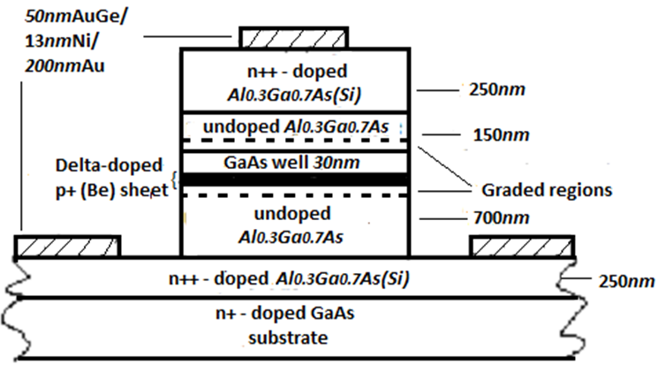
Figure 1. PWB diode epitaxial structure and parameters. Intrinsic (undoped) regions of 7000 and 1500 in the long and short regions respectively are sandwiched between the two -doped regions of with length 2500 and concentration of, and a GaAs well of 300 is inserted within the -regions.

2. Device design and simulation As a starting point, we will consider the PWB diode reported in [1] (PWB_V1689), where the experiment was fully described and the epitaxial structure of diode used for this investigation was a GaAs/AlGaAs heterostructure with labels and dimensions as shown in Fig. 1. The simulation of the diode was done using the drift-diffusion model described in [1] and the assumptions of the model were validated using the same Monte Carlo simulation software. The potential distribution over a mesh of 1500 points were generated by determining a doping profile for diodes using numerical analysis to solve Poisson’s equation. Conduction band offsets around the potential well as a function of Al concentration were taken from [8].
Measurements of diodes were carried out on-wafer using a probe station at room temperature. The IV-characteristics was measured using an Agilent (Keysight) B1500A Semiconductor Device Analyzer. The IV characteristics for the three experimentally realized diodes (of diameters and together with the simulation of the diodes have shown excellent agreement as shown in Fig 2 [1]. The PWB diode shows asymmetry in voltage of 1:6 at a current density of) which verifies diode performance. This degree of asymmetry in a diode of this type, reflects the asymmetry of the short and long intrinsic regions [1]. This paper will use the drift diffusion model used in [1] to investigate variations in device parameters.

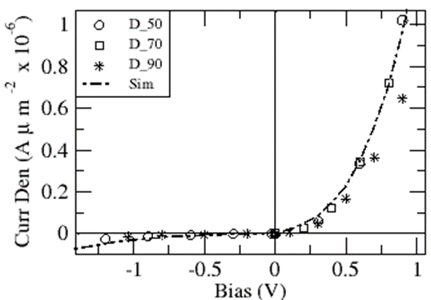
Figure 2. Comparison of the current densities of the experimental results and the simulated result: D50 (circle), D70 (square) and D90 (star)m represents the diameters of diode used for the experiment while sim (broken lines) represents the simulated result [1]. All devices show good fit with the simulation. Note the good scalability of the 3 experimental devices.

3 Analysis and discusion of results
3.1 Effect of well depth variation on device performance PWB_V1689 had a potential well depth of 0.25eV. We consider here three different well depths: and corresponding to changes in the content with concentrations of and respectively [8], while the other parameters were kept constant. The IV-characteristic of these devices are shown in Fig 3(a) & (b).
The rectifying behaviour of the PWB diode increases steadily as the depth of the well deepens. A Figure of Merit which compares the ratio of the reverse bias to the forward at current density of for each diode shows that a diode with depth of has while those with well depths of and have of and respectively. This is because a deeper well attracts more charge, resulting in an increase in the asymmetry of the diode. However, deeper wells do not favour the operation of PWB diode in the forward direction as the diode turn-on voltage increases rapidly (see Fig 3a) and causes a further increase in the ideality factor of the diode and hence reduces the responsivity of the device. For example, at the point where a current of was reached, diodes with respective well depths of and have ideality factors of and In terms of the amount of charge in the well, we obtained equivalent sheet charge densities for each of the well depths as and corresponding to well depths of and at a bias of respectively (see Fig 3b).

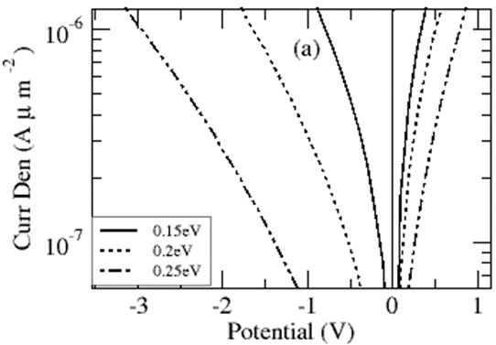

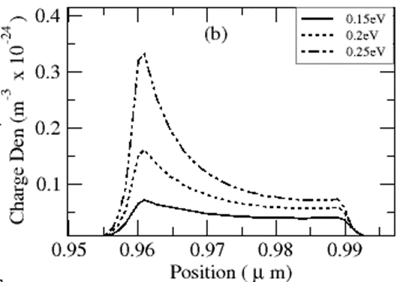
Figure 3. (a) Effect of varying well depth on -characteristics of three PWB diodes operating at barrier heights of and. (b) Charge density in potential well as a function of position (microns)

3.2 Effect of varying the long intrinsic regions The PWB_V1689 originally had a long intrinsic region of Here we will consider devices with long intrinsic regions of, and, all other parameters remaining the same (see Fig 4). The IV- characteristic shows that in forward bias, there is no significant difference especially at current densities below Above this value of current density in the forward direction, the variation in the IV-characteristics increases steadily with the bias. The results however differ significantly in reverse bias. In the reverse bias, increases in long intrinsic region length causes the IV characteristic to drift further away from the origin and a shorter intrinsic thickness result in a decrease in the asymmetry of diode. The IV-characteristic of diode with a region of 7000 has the highest asymmetry, while the diode with length 5000 has the lowest asymmetry. The PWB diode shows asymmetry in voltage of for respectively at currents of. This shows that the long intrinsic region size is approximately proportional to the asymmetry of the diodes. The variation of the long intrinsic regions of the PWB also affects the ideality factor of the diode especially above 0.5V as can be seen from the forward bias gradients in figure 4b.

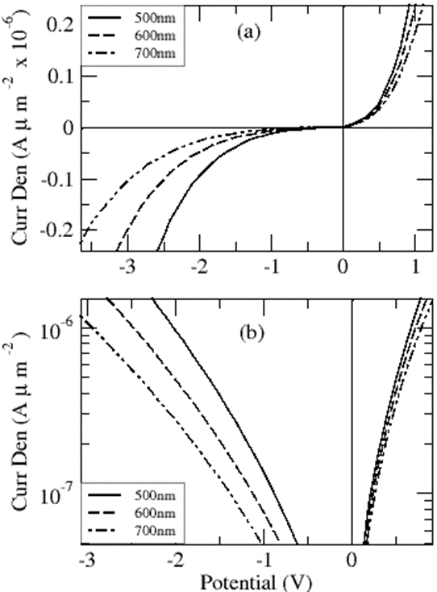
Figure 4. Effect of varying the long intrinsic length on the asymmetry of diode. Lengths of region were simulated at,and.

3.3 Effect of varying the short intrinsic regions Originally, the experimental PWB_V1689 sample had a short intrinsic region length of 1500 Here, we will compare devices with short intrinsic regions of 500, 1000 and 1500. The diode with a region of 50 has a turn-on closer to the origin compared to diodes with regions of and 1500as shown in Fig 5. The IV-characteristic shows that all the devices have a nearly constant asymmetrical structure in reverse bias. In forward bias, however, the devices vary significantly at all currents for different lengths of the short intrinsic region. As the short region increases, the IV-characteristic move further away from the origin, thus reducing the sensitivity of the diode to detect very low voltage signals. This adversely affects the ideality factor of the diode and hence its responsivity.
The ideality factor can be seen to reduce as the short region length reduces. In terms of the variation of the diode’s IV-characteristics to changes in the short region length, we found that increasing/decreasing the short region length by respectively increased/decreased the characteristic of the diode by at the point where a current of is reached. The values of ideality factors of the diodes with short region lengths of 500, 1000 and 1500 respectively were and at a bias of

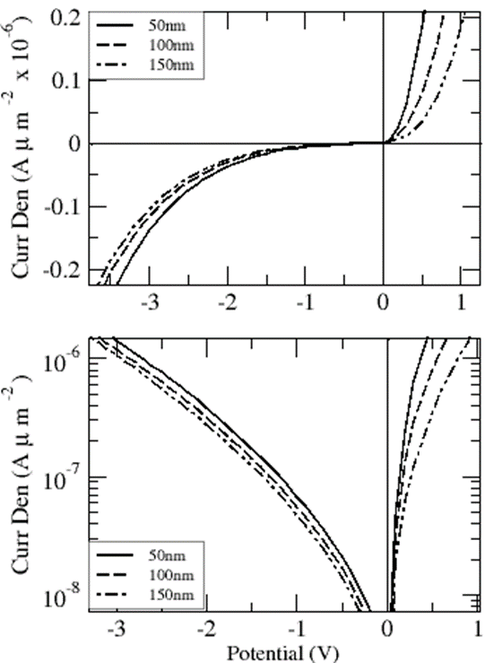
Figure 5. IV characteristic of diodes at varying lengths of the short intrinsic region; the intrinsic region was varied from to to while maintaining other parameters constant.

3.4 Effect of varying well size on asymmetry of PWB diode PWB_V1689 had a well size of . Here, we will consider well sizes of, and with the same well depth of . Figure 6 shows that the size of well does not have so much effect on the diode’s IV-characteristic in the forward direction. The results however do show a small variation in the IV-characteristics for different well size of the diodes in reverse bias. The difference in the curves shows that a wider well attracts more charge which may favour reverse bias operation and hence the asymmetry and this also reaffirms the active nature of charge in the well especially when the diode is operating in reverse bias. The sensitivity of all the three diodes is roughly the same and all diodes have ideality factors of 3.12 at .

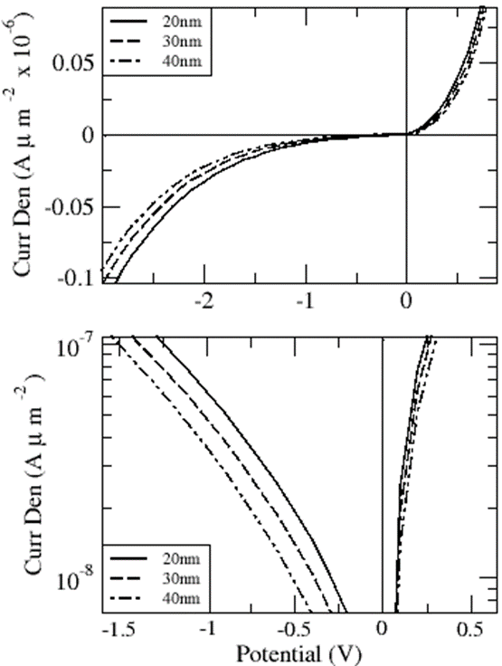

Figure 6. IV characteristics of PWB diode with different sizes of well. The diode was simulated for potential wells of, and. Results show relatively similar IV-characteristics in the forward bias

3.5 Sensitivity of PWB to variations in temperature Simulations were carried out with a diode (of well width and well depth of ) operating at temperatures of and whose IV characteristics are shown in Fig 7. Increases in operating temperatures result in the IV characteristics favoring the forward bias operation but greatly reduces the reverse performance capability as more electrons leave the well resulting in a lower barrier height. The IV characteristics however increases in both forward and reverse bias operation with decreases in temperature as more charge is trapped in the well, presenting larger barriers. The voltage sensitivity of the diodes increases with temperature as this impacts the ideality factor. The ideality factor of the diodes at temperatures of and respectively were calculated to be 6.2, 2.12 and 1.72 at a current density of . This clearly shows that the diode’s ideality factor decreases with an increase in temperature and hence the voltage sensitivity increases.

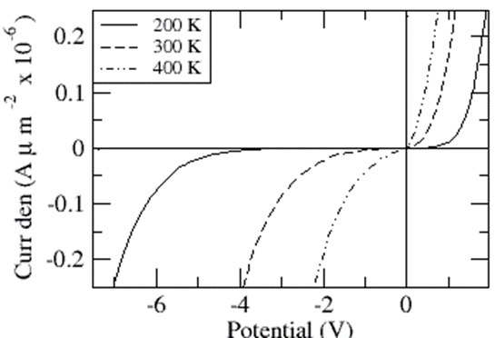
Figure 7. The characteristics of PWB diodes operating at and

Fig 8 compares the amount of charge in the potential well for diodes operating at temperatures of and, with corresponding equivalent sheet charge of, and

respectively.

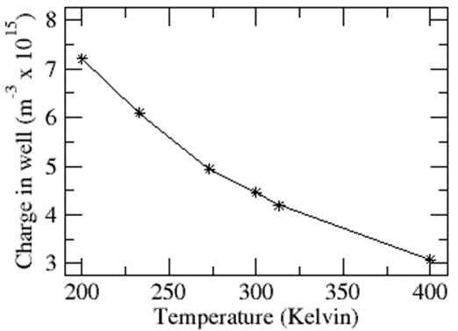
Figure 8. Variation of charge in well with temperature. The charge drops steadily as temperature increases.
The plot of the charge in the potential well against temperature shows an inverse relationship; the implication being that as temperature increases, charge in the well lessens and so does the barrier height.

3.6 Equivalent charge in the potential well at different bias Fig 9 shows the relationship between the charge in the well and potential for the experimental data of the diode PWB_V1689 . The figure shows a good agreement between the simulated and experimental results. The result confirms the assertion made earlier that more charge is attracted into the well with diode operation in the reverse than forward directions [1]. The diode operation was further compared both in the forward and reverse directions at current density of 1; an equivalent charge of was observed corresponding to a reverse bias of while in the forward bias, a charge of was built up at a corresponding forward bias of It shows clearly that at the same currents, a higher charge will accumulate in the well for reverse bias thus, presenting a higher barrier in reverse than forward bias.

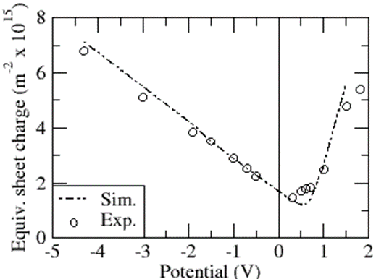
Figure 9. Equivalent charge in the well as a function of the bias. More charge is attracted in the well in reverse than forward bias.

3.7 Comparison of the IV characteristics of a PWB and an equivalent PDB diode An integrated sheet charge of corresponding to a bias of in the reverse direction and 1.26 in forward was extracted and simulated as a PDB diode, with thickness of the region being same as the PWB and results compared (as shown in Fig.10). Both diodes display ideal behaviour up to in forward bias but differ significantly above this voltage as more charge accumulate in the well at higher bias. The PDB diode has a nearly constant ideality factor at all voltages while the PWB diode has an ideality factor that varies significantly with voltage above (as shown in Fig 10b). For example, at, the PDB diode has an ideality factor of 1.36 and is reasonably constant irrespective of the bias while the PWB diode has an ideality of which increases noticeably with bias as shown in figure 10. In the reverse bias operation, the PWB diode shows a more promising rectifying capability than the PDB diode due to the active nature of the charge in the well, attracting in more charge and creating a greater potential barrier.

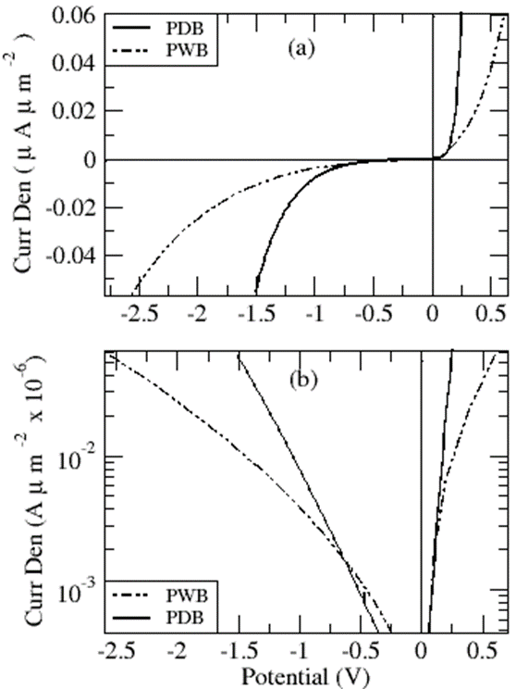
Figure 10. IV-characteristic of the PWB diode and an equivalent PDB. Both the PDB and PWB diodes have similar ideality factors up to a bias of 0.15V. The PWB deviates above this bias as the barrier height increases.

3.8 Suggested improvement on well design of the PWB diode We have found that by grading the shape of the well, significant improvements to the ideality factor of the PWB diode and the can be made. Fig 11(a) and (b) show the IV characteristics of a square and graded wells, (c) shows the shape of the graded and square wells and their respective charge densities at in the forward bias operation while (d) shows the charge density of the two wells in the reverse bias operation at . The graded well was obtained by grading some percentage of the concentration from GaAs to over 0.04 microns (as shown in Fig 11c). The turn-on voltage of the graded well diode has more promising zero bias detection capability than the turn-on voltage of the square well diode at any value of the current density (see Fig 11a and b). For example, at a current density of , the corresponding turn-on voltage of the diode with graded and square well regions respectively are and.
The depth and shape of the wells and charge densities were also compared at a bias of in the forward bias (Fig 11c). For the square well, the highest charge density rests against the side of the well towards the positive potential and provides a steep slope that poses difficulty for charge leaving the well. In the graded well however (in forward bias), the highest charge density rests along the graded region thus, providing a small barrier and eases charge escape from the barrier. Thus, the graded well device shows a smaller charge density of in the well compared to the square well with charge density of. This accounts for barrier height lowering in the graded well and hence improved forward bias turn-on voltage compared to the square well.
Both the graded and square wells in reverse bias shows little variation in charge density and hence have the same IV-characteristics for the two diodes in the reverse direction at a potential of - since both diodes uses a nearly square well in the reverse bias operation. The highest charge density for the two wells rest against equally steep well sides. (Fig 11 d). In terms of the sensitivity of the graded well and square well diodes to small voltage signals, we compare the ideality of the two diodes and hence the maximum curvature of the diodes or the responsivity.
We found that the diode with square well has ideality of while the diode with graded region has ideality of at a bias of The voltage sensitivity [9], [10] calculated at 10GHz for the square-well and graded-well PWB diodes were respectively found to be 6.4 and . The PWB diode with a graded potential well has shown improved voltage sensitivity over the one with a square potential well and this result also compares favorably with PDB [2] and Schottky devices [9]. These diodes design are similar to the PDB diodes and may well be suitable for high frequency and microwave applications such as mixers and detectors, as demonstrated for the PDB diodes in [11][12].

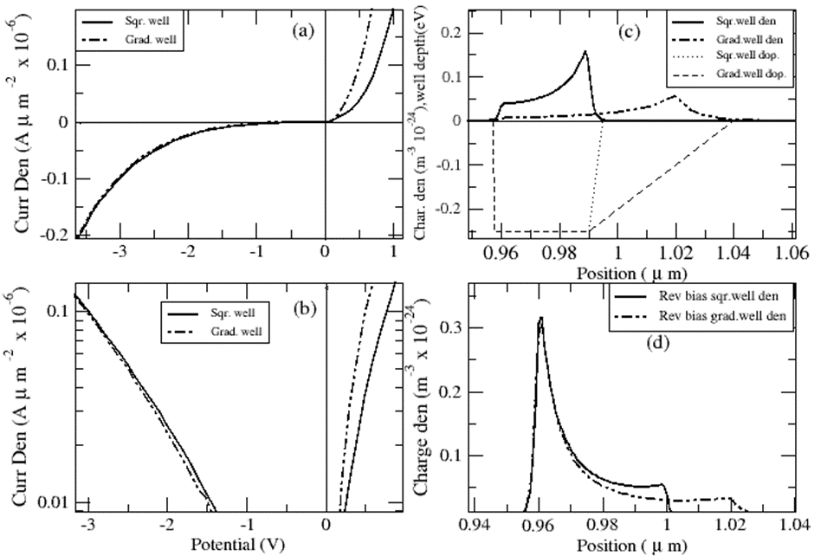
Figure 11. Comparison of diodes performance of the graded well and square well devices in both forward and reverse bias showing (a) the -characteristics of the two devices (b) log plot of the -curves (c) the shape and depth of wells and charge density in the forward bias (d) the charge density as a function of position in the reverse bias.

4 Conclusions The analyses of the complex operation of Potential Well Barrier (PDB) diodes in the GaAs/AlGaAs system has revealed a notable dependence of barrier height on bias, temperature and potential well shape. This variation is reflected in the non-constancy of the ideality factor of the devices with bias. Also of utmost importance is that, the barrier height of the PWB diode at all operating temperatures exhibits a negative temperature coefficient, opposite to that of the PDBs with a positive temperature coefficient and this suggests the idea of a hybrid PWB/PDB design to produce a more temperature stabilized device with improved asymmetrical structures. Graded well structures have shown the potential for significant improvements over the square well diode prototype, with improved ideality factors, voltage sensitivities and current asymmetry.

References

[1] M. Akura, G. Dunn, M. Missous and J. Sexton, IEEE Electron. Device Lett. 38, 438 (2017)
[2] M.J. Kearney, and I. Dale, GEC J. of Res. 6, 1 (1990).

[3] Z. Pei, V. Amit, V. Jai, X. G. Huili, P. Fay, D. Jena, IEEE Electron Device Lett., 35, 615 (2014)
[4] R. J. Malik, R. Aucorn, R. L. Ross, K. Board, C. E. C. Wood and L. F. Eastman, Electron. Device Lett. 16, 836 (1980).
[5] R. J. Malik, M. A. Hollis, L. F. Eastman, D. W. Woodard, C. E. C. Wood and T. R. Aucorn, Proceedings of 8th Bienniel IEEE Cornel conference on High Speed Devices And Circuits, Ithaca, NY, 87 (1981)
[6] W. C. Thomas, J. M. Robert, P. R. Hans, L. B. William, B. P. William, L. Xiaolei, Proceedings of the IEEE, 80, 1827 (1992)
[7] V. T. Vo, H. Zhirun and H. Ali, Proceedings EDMO Vienna, Austria, 143 (2001)
[8] Y. Wang, F. Zahid, Y. Zhu, L. Liu, J. Wang and H. Guo, Appl. Phys. Lett. 102, 132109 (2013) DOI: 10.1063/1.4800845
[9] “The zero bias Schottky detector diode“, Application Notes 969, Agilent Technologies
[10] A. M. Cowley, and H. O. Sorenson Proceedings MMT14, 12, 588 (1966)
[11] M. J. Kearney, A. Condie, and I. Dale, Electron Lett. 27, 721 (1991).
[12] R. J. Malik and S. Dixon, IEEE Electron Device Lett. 3, 205
(1982)

* Corresponding author: e-mail r01mja16@abdn.ac.uk, Phone: +44 776 900 5842

