Material Length Scale of Strain Gradient Plasticity: A Physical Interpretation
Dabiao Liu^{1,2,3*}, D. J. Dunstan¹
¹School of Physics and Astronomy, Queen Mary University of London, London E14NS, UK
²Department of Mechanics, Huazhong University of Science and Technology, Wuhan 430074, China
³Hubei Key Laboratory of Engineering Structural Analysis and Safety Assessment, Wuhan 430074, China
*Corresponding author: Dr. Dabiao Liu
E-mail: dbliu@hust.edu.cn; or dabiao.liu@qmul.ac.uk

Abstract:
The physical basis and the magnitude of the material length scale in theories of strain gradient plasticity are crucial for accounting for size effects in the plastic behavior of metals at small scales. However, the underlying physics of the length scale is ambiguous. The length scales in strain gradient plasticity theories in which the plastic work density can be expressed as a function of the gradient-enhanced plastic strain are here derived from known physical quantities via critical thickness theory. A connection between the length scale and the fundamental physical quantities is elucidated. The combination of the strain and strain-gradient terms within the deformation theory of strain gradient plasticity is addressed. It is shown that, compared with the harmonic sum of the strain and strain-gradient terms in Fleck-Hutchinson theory, the linear combination gives a more reasonable value of length scale, several micrometers, which is close to that in the gradient theory of Aifantis. In contrast, the value of length scale in Nix-Gao theory is much larger, in the millimeter range. The length scales determined by critical thickness theory are in good agreement with those obtained by fitting to experimental data of wire torsion.

Keywords: Strain gradient Plasticity; Critical thickness; Size effects; Geometrically necessary dislocations; Torsion

1. Introduction
A wide range of experiments at the micron/sub-micron scale have revealed strong size-dependent strengthening associated with plastic strain gradients induced by non-uniform deformation, for example, nano indentation (e.g. Ma et al., 2012; Stelmashenko et al., 1993; Swadener et al., 2002; Zhu et al., 2008), thin wires in torsion (e.g. Fleck et al., 1994; Dunstan et al., 2009; Liu et al., 2013a, b; Liu et al., 2012), thin foils in bending (e.g. Ehrler et al., 2008; Haque and Saif, 2003; Hayashi et al., 2011; Moreau et al., 2005; Stölken and Evans, 1998), etc. In general, the observed phenomenon is that smaller is stronger, which is referred to as the size effect. These experimental observations cannot be captured by conventional theories of plasticity since such theories do not involve any characteristic length scales. In parallel, inspired by the concept of geometrically necessary dislocations (GNDs) introduced by Nye (1953), Kröner (1958), Lardner (1969) and Ashby (1970), various continuum theories of small-scale plasticity, e.g. strain gradient plasticity (SGP) theory (e.g. Abu Al-Rub and Voyiadjis, 2006; Aifantis,1987, 1999; Brinckmann et al., 2006; Ban et al, 2016; Fleck and Hutchinson, 1997, 2001; Fleck et al., 1994; Fleck and Willis, 2009a, b; Gao et al., 1999; Gudmundson, 2004; Gurtin and Anand, 2005a, b; Hutchinson, 2012; Kuroda and Tvergaard, 2010; Mühlhaus and Aifantis, 1991; Nix and Gao, 1998; Voyiadjis and Faghihi, 2012; Voyiadjis et al., 2010; Lubarda, 2016; Zreid and Kaliske, 2016) have been proposed for encapsulating the observed size effects in non-uniform deformation. These theories are often based on the gradient-enhanced effective plastic strain variable (Evans and Hutchinson, 2009; Hutchinson, 2012; Lubarda, 2016; Niordson and Hutchinson, 2011). However, most of the aforementioned models neglect the contribution of the plastic spin (i.e. the skew-symmetric part of the plastic distortion), which may be problematic in certain situations (Bardella, 2010; Bardella and Panteghini, 2015; Poh et al., 2011). The gradient plasticity theory proposed by Gurtin (2004) is different from most of the other SGP theories available. It accounts for the dissipation arising from the plastic spin together with the energetic counterpart in the free energy, i.e. the defect energy. The recent literature (e.g. Bardella, 2009, 2010; Bardella and Panteghini, 2015; Poh and Peerlings, 2016; Wulfinghoff, 2017) has demonstrated its relevance in isotropic gradient plasticity theory, even on the basis of the comparison with strain gradient crystal plasticity of Bardella (2006). In particular, by analyzing the size effect by the deformation approximation of Gurtin’s theory, Bardella (2010) found that the size effect due to the defect energy leads to strain hardening with diminishing size, while the gradient-enhanced plastic potential gives rise to strengthening, i.e. the increase in initial yielding. Besides, various theories of strain gradient crystal plasticity (e.g. Bammann, 2001; Ma et al., 2006; Clayton et al., 2006; Gurtin and Needleman, 2005; Gurtin, 2008; Gurtin and Reddy, 2014) and continuum dislocation theory (Berdichevsky, 2006, 2016; Le, 2016; Le and Günther, 2014; Zaiser, 2015) have also been developed for modelling the size-dependent plastic behavior.
To date, strain gradient plasticity has attracted much attention due to its feasibility in applications. Most of SGP theories are phenomenological isotropic theories (e.g. Aifantis,1987, 1999; Fleck and Hutchinson, 1993, 1997, 2001; Gudmundson, 2004; Gurtin, 2004; Gurtin and Anand, 2005a, b; Hutchinson, 2012; Mühlhaus and Aifantis, 1991); Several of them are based on physical dislocation mechanisms, for example, the mechanism-based strain gradient plasticity (MSG) theory (Gao et al., 1999; Nix and Gao, 1998), the physically-based gradient plasticity theory (Abu Al-Rub and Voyiadjis, 2006), and the dislocation-density based strain gradient model (Brinckmann et al., 2006). An early attempt for strain gradient plasticity is to extend the rate-independent J₂ theory by involving a dependence on plastic strain gradients, e.g. Mühlhaus and Aifantis (1991), Fleck and Hutchinson (1993, 2001). However, the authors do not discuss the compatibility of the theories with thermodynamic requirements in detail. Gudmundson (2004) and Gurtin and Anand (2009) pointed out that the Fleck-Hutchinson theory (2001) does not always meet the thermodynamic dissipation restriction. Afterwards, Hutchinson (2012) and Fleck et al. (2014, 2015) modified the theory to meet the thermodynamic requirement through partitioning the higher-order stresses into energetic (recoverable) and dissipative components. Alternatively, another attractive class of phenomenological SGP theories which are thermodynamically consistent have been established by Gudmundson (2004), Gurtin (2004) and Gurtin and Anand (2005 a). These theories express the higher-order stresses in terms of the increments of strain and strain gradient. Recently, Hutchinson (2012), Fleck, et al. (2014, 2015), and Bardella and Panteghini (2015) indicated that this expression can lead to the possibility of elastic gap in the plastic flow, which requires experimental validation (Fleck, et al., 2015).
In this paper, we merely focus on the class of SGP theories in which the plastic work density can be expressed as a function of a gradient-enhanced plastic strain measure, see the discussion of Evans and Hutchinson (2009), Fleck et al. (2014, 2015), Hutchinson (2012), Lubarda (2016), and Niordson and Hutchinson (2011). In these theories, the constitutive relation allows for a contribution from the local value of plastic strain and a contribution from the local plastic strain gradient. For dimensional reason, one or more length scales necessarily enter into the theories. One of reasons why SGP theories are able to successfully fit experimental data at small scales is that the length scales introduced are free fitting parameters. However, the physical basis of the material length scale in SGP is ambiguous (Chakravarthy and Curtin, 2011; Dunstan, 2016; Evans and Hutchinson, 2009; Groma et al. 2007); that is one of the reasons why the SGP theories have not been thoroughly accepted (Evans and Hutchinson, 2009). To date, only a few attempts (e.g. Abu Al-Rub and Voyiadjis, 2006; Dunstan, 2016; Evans and Hutchinson, 2009; Groma et al. 2007; Voyiadjis and Abu Al-Rub, 2005; Zhang and Aifantis, 2015) have been made to study its physical origin. For example, by fitting to the bending data of thin foils, Evans and Hutchinson (2009) found that the length scale in the Nix-Gao (NG) model is about 25mm, and in the Fleck-Hutchinson (FH) model it is about 5μm, but the physical interpretation of these values is not clear. Here we will provide an interpretation of these very divergent values.
As well as the ambiguities about the physical interpretation of the material length scales in SGP, another reason for doubt is the experimental evidence for a size effect at yield. The interpretations of SGP are always in terms of GNDs, yet at initial yield there is not yet any plastic strain gradient and hence no (or only a few) GNDs. Evans and Hutchinson (2009), however, showed that strain gradient plasticity can predict a size effect in the form of an elevated yield stress. By considering the predictions for perfect plasticity, they showed that the FH theory rather surprisingly predicts an elevated yield stress and no size-effect-induced strain hardening, while the NG theory does the opposite as expected. Evans and Hutchinson (2009) were not able to explain the strengthening convincingly in physical terms.
In semiconductor technology, critical thickness theory (CTT) has been well developed in the context of epitaxial strained layers (e.g. Matthews, 1966; Fitzgerald, 1991; Dunstan, 1997) and other films (Nix, 1989), and CTT gives a physical insight into the size effect at initial yield. It has been extended to explain the size effect in many forms of micromechanical testing (e.g. Bushby and Dunstan, 2011; Dunstan, 2012; Dunstan and Bushby, 2004; Dunstan et al., 2009; Motz and Dunstan, 2012). Recently, Dunstan (2016) has shown that it is possible to establish a relation between the material length scale in SGP and the physical quantities by equating the gradient-enhanced yield strength to the yield strength predicted by CTT. The key aim of this paper is to establish a relation between the material length scales in typical deformation theories of SGP with a gradient-enhanced effective plastic strain and known physical quantities by using CTT. One point to be emphasized is that the conditions for CTT and SGP to apply are in fact the same. Both require there to be dislocation-based plasticity, with sufficient mobile dislocations and operating sources, and neither has an upper limit on the dislocation density. Thus, the mechanical properties of dislocation-free whiskers (e.g. Brenner, 1956) are not accounted for by continuum SGP theories; equally, they are not accounted for by CTT. Instead, they are accounted for by, for example, the dislocation starvation model (Greer et al., 2005) or the statistical model (Sudharshan Phani et al., 2013).
The paper is organized as follows. In Section 2, the CTT theory is revisited. In Section 3, three deformation theories of SPG, namely the NG model, the Aifantis model, and the FH model, are introduced. In Section 4, the connection between CTT and SGP theories is established. Discussion and analysis of the material length scales in those SGP theories based on CTT are provided. In Section 5, basic aspects of plasticity relevant to strain gradient effects are presented. The formulations and general trends are elucidated. The validation of SGP theories for the prediction of size effect in wire torsion is also addressed. Finally, conclusions of the work are given in Section 6.

2. Critical Thickness Theory Reviewed
Matthews’ critical thickness theory (Matthews and Blakeslee, 1974) is based on the idea, first proposed by Frank and van der Merwe (1949a) and Bragg (1942), that misfitting epitaxial layers will be elastically strained if the introduction of a dislocation that reduces the elastic misfit strain nevertheless increases the total energy. In fact, this concept, which may be described as the fundamental physics of the size effect, goes back to Bragg (1942) who proposed that the grain-size dependence of the strength of polycrystalline metals (later known as the Hall-Petch effect) is explained by noting that a dislocation will only move a small distance (e.g. across a grain) if driven by an elastic strain greater than (i.e. a stress greater than where is the appropriate modulus) with the magnitude of the relevant component of the Burgers vector. In epitaxial layers, since the energy of a strained layer is proportional to the thickness of the layer, while the energy of a dislocation varies with the logarithm of the thickness, a critical thickness may be defined above which plastic relaxation is expected (Matthews, 1966). Below critical thickness, the unrelaxed fully-strained layer is thermodynamically stable. The dislocations required for plastic relaxation are called misfit dislocations or GNDs, since they are due to the misfit between the layer and the substrate, and the presence of these dislocations corresponds to a plastic strain gradient or discontinuity from geometrical arguments. There is a large literature on the calculation of critical thickness for epitaxial layers, both for the extension of existing dislocations for the first introduction of GNDs and for the operation of sources to create new GNDs at larger plastic strains. According to CTT (see e.g. Beanland, 1992; Dunstan, 1997; Dunstan et al., 1991; Dunstan and Bushby, 2004; Fitzgerald, 1991; Matthews, 1966; Matthews and Blakeslee, 1974), dislocation sources normally operate in the GND-free region and the strain-thickness integral in this region is a constant determined by the need to operate sources (e.g. Frank-Read, spiral, single-armed sources). As indicated by Dunstan and Bushby (2004), the Matthews critical thickness equation gives
where and are factors of the order of unity, the misfit strain, the magnitude of the Burgers vector of the misfit dislocations. is determined by crystallographic parameters, the relative orientations of the slip planes, the growth plane and the direction of the Burgers vector. represents the core energy of the dislocation. This equation gives the critical thickness at which misfit dislocations may elongate to relieve the elastic strain in a simple layer with misfit strain . The logarithmic term in Eq. is usually of little importance in comparison with experiment, and Eq. can be simplified for applications to for the initial extension of existing dislocations (Dunstan, 2012; Dunstan and Bushby, 2004). For significant plastic relaxation, sources must operate, and the simplification becomes (then is often called the relaxation critical thickness, ).
Here, we focus on the plastic relaxation of non-lattice-matched epitaxial strained-layer structures grown above their critical thicknesses and requiring source operation. This is a well-understood example of the size effect in semiconductor technology. Dunstan (2016) has shown that, for the simple constant-composition strained layer, the effective yield stress can be approximated as . Here, is a bulk (intrinsic) yield strength, is the relevant elastic modulus, and is the critical thickness for a simple layer. Without or with strain-hardening, the effective flow stress may be written as
where is the bulk flow stress, is the layer thickness. In all that follows, we assume no strain-hardening, i.e. perfect plasticity, for which . So, Eq. can be seen as the size-dependent yield strength predicted by the critical thickness theory, extended to predict the size effect under various loading conditions and during plastic deformation as well as at yield (see e.g. Dunstan, 2012; Dunstan and Bushby, 2004). The predictions for a simple epitaxial layer with are shown in Fig. 1(a). In Fig. 1(a), the state of a simple (flat) epitaxial layer is when grown to various thicknesses. The dotted line shows the misfit strain which is divided into elastic strain (solid lines drawn for four thicknesses, , , , ) and plastic strain (). The dashed line plots Eq. for elastic strain with . The key point is that for the hatched rectangular areas are the elastic strain-thickness products, which are constant, at .
It may seem from Eq. that CTT has no place for strain gradients. However, in Eq. , there is no requirement that is a constant, as it is for simple “flat” epitaxial strained layers. Quite early in the technological development of semiconductor strained layers, more complicated structures were grown (e.g. Dunstan et al, 1994), such as the linearly-graded layer with , where denotes the misfit strain gradient along the growth direction , as shown in Fig. 1(b). Tersoff (1993) has analysed this problem in the framework of CTT and showed that the outcome is a layer that is fully relaxed near the substrate, with therefore a plastic strain gradient . This part of the layer therefore contains a constant density of GNDs. Near the surface, Tersoff (1993) showed that there is a GND-free region with a constant plastic strain and an elastic strain rising with the gradient . It is straightforward to calculate the critical thickness for this situation. The strain–thickness product has to be evaluated as the integral of over the thickness, and the condition for is
The values and are for the first extension of pre-existing dislocations or for the operation of sources respectively (Dunstan, 2016). Above critical thickness, from the free surface a depth $h_{c}=\sqrt{\text{10}b/g}$ is elastically strained. From there to the substrate, the material is fully (plastically) relaxed, so that the plastic strain gradient is and the density of GNDs is while the surface region of thickness remains free of GNDs. As growth of the graded layer continues, dislocations glide to relieve the added strain, but at the top the elastically-strained thickness of remains unchanged, as shown in Fig. 1(b). As growth continues to the same thicknesses as in Fig. 1(a), the hatched triangular regions are of constant area (strain-thickness integral) of .
It should be noted that Evans and Hutchinson (2009) pointed out the importance of the average plastic strain gradient in SGP. Even for a simple flat epitaxial layer, as in Fig. 1(a), an average plastic strain gradient is readily identified. There is a plastic strain of zero in the substrate, and throughout the layer of thickness . While the gradient of the plastic strain is ideally infinite at the substrate-layer interface and zero elsewhere, its average value from the substrate to the free surface is simply . The main difference between the flat layer and the graded layer is the constant , of the order of unity, introduced by Evans and Hutchinson (2009) to cover the detail differences of different strain distributions. This constant is the ratio of the maximum peak value of to its average value, and so takes values in the range 1 to 2 for different physical situations such as the simple layer () and the thick linearly-graded layer (), see the discussion given by Dunstan (2016) for details. In what follows, we will comment on values of when relevant.
The graded layer is readily seen to be the same problem as a beam in bending, as shown in Fig.1(c). In the beam-bending problem, the neutral plane acts in the same way as the substrate, and from the neutral plane to either free surface the structure acts in the same way as a graded layer. In graded-layer growth, the strain gradient is kept constant and the thickness increases during growth. In beam bending, the thickness is constant and the strain gradient increases as bending proceeds, as shown in Fig. 1(c). The total strain under a degree of bending just sufficient to cause plastic deformation is shown by the red dotted line. The elastic strain is shown by the red solid line, demarcating the hatched triangle with the area (strain–thickness integral) of . After more bending, the total strain is successively the blue and the purple dotted lines and the elastic lines are the parallel solid lines demarcating the triangles, still of the same area as the red horizontally-hatched triangle, but successively steeper and narrower. However, this does not affect the solutions (Eq.) for any given strain gradient and thickness – the history, how given values and are reached, does not affect the state of the specimen. When the critical condition of Eq. is met, misfit dislocations begin to form. It is important to understand that in the case of the graded layer, during growth, plastic deformation occurs in the surface region of thickness only, generating a plastic gradient only below this region. In beam bending, plastic deformation occurs from the surfaces all the way to the neutral plane, yet generates a plastic strain gradient only between .
The predictions of CTT for the two epitaxial-growth examples discussed here have been extensively tested experimentally. Recently, Motz and Dunstan (2012) have shown that the behaviour of a thin beam under bending in discrete dislocation dynamics simulation accords excellently with the CTT predictions. This is also the physical situation for which SGP theories are entirely applicable. So, in what follows, we consider it justifiable to compare the predictions of CTT and SGP theories for these three situations and to use the comparison to establish as far as possible the physical meaning of the material length scales in SGP theories and indeed the physical meaning of the SGP theories themselves.
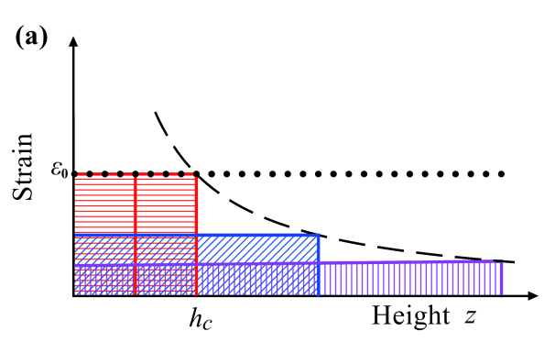 | 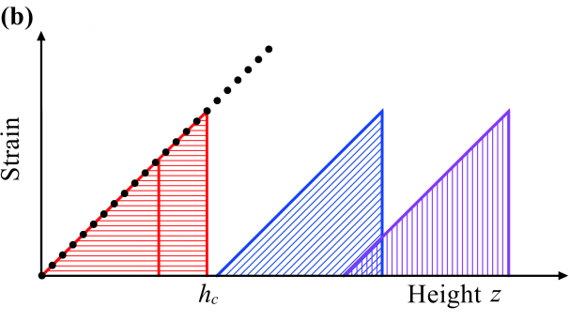
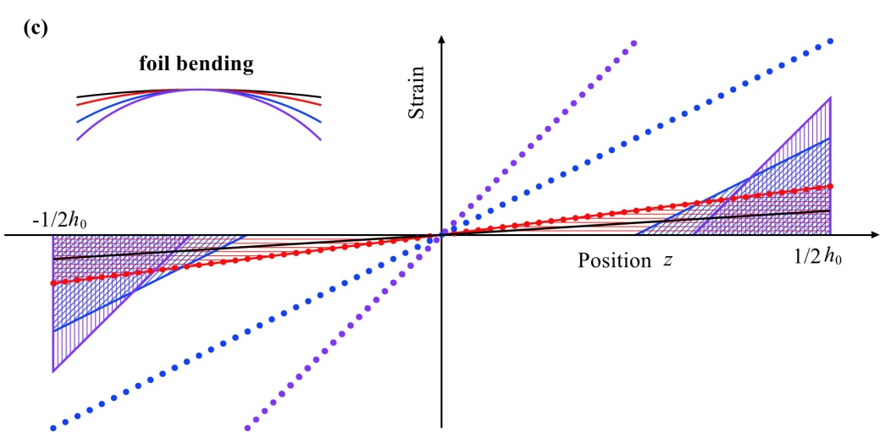
Fig. 1. Schematic diagrams of the critical thickness solutions for (a) a simple flat epitaxial layer, (b) a graded layer and (c) a foil under bending. Here, represents the relaxation critical thickness. For thicknesses , the elastic strain (solid lines) is equal to the misfit strain (dotted lines). For , the thick solid line has the same gradient as the misfit line and the rectangles in (a) or triangles in (b) and (c ) have the constant area of keeping constant.

3. Formulations of strain gradient plasticity
Here, we summarize several deformation theories of SGP, i.e. the generalized J₂ deformation theory, which are simple generations of conventional plasticity. One theory was developed by Nix and Gao (1998) and Gao et al.(1999), and then generalized further by Abu Al-Rub and Voyiadjis (2006). This class of SGP theories is inspired by the Taylor relation and invokes an enhanced flow stress governed by the density of the GNDs. Another is the phenomenological SGP theories of Aifantis, and Fleck and Hutchinson and their generalization. This class of SGP theories introduce a gradient-enhanced measure of effective plastic strain accounting for additive contributions from the SSDs and GNDs. It should be pointed out that the class of SGP theories involving a gradient addition to the free energy, e.g. Gudmundson (2004), Gurtin (2004), Gurtin and Anand (2005a), are not considered here since the hardening due to the energetic length scale cannot be predicted by CTT.

3.1 NG model and the generalization
The Nix-Gao model (Gao et al., 1999; Nix and Gao, 1998) is based on the Taylor relation of the flow stress, , and the dislocation density (Taylor, 1938). The Taylor relation states that
where is the shear modulus, is the magnitude of the Burgers vector, is the total dislocation density, is an empirical constant ranging from 0.1 to 0.5 (Ashby, 1970), and is the Taylor factor acting as an isotropic interpretation of the crystalline anisotropy at the continuum level (Kocks, 1976; Taylor, 1938), and for an isotropic solid, for FCC polycrystalline metals. Here, following Ashby’s idea (Ashby, 1970), the total dislocation density is considered as the sum of the density of statistically stored dislocations (SSDs), , accumulated by dislocation trapping at obstacles in a more or less random way, and that of GNDs , which are required for strain compatibility across the material. In the absence of strain gradients, vanishes and then
Here, represents the stress-plastic strain relation in the absence of the gradient effect. And is the initial yield stress, is a function of plastic strain. The density of GNDs can be calculated as (see e.g. Ashby, 1970; Fleck et al., 1994; Nix and Gao, 1998)
where is the Nye factor reflecting the scalar measure of the density of GNDs due to plastic strain gradients (Arsenlis and Parks, 1999), is the effective plastic strain gradient which can be assumed to be .
Substituting Eqs. and into Eq. , Nix and Gao (1998) obtained a law for SGP
where is the effective plastic strain, and is a material length scale which is expressed as
Their tentative interpretation is that scales with with representing the spacing between dislocation obstacles (see discussion in Appendix A). For an isotropic material, the yield strain can be calculated as
where is the poisson’s ratio. Substituting Eq. into Eq. , we then have
Here, is on the order of unity. For FCC metals, , , , , so we have .
Following Gao et al. (1999) and Nix and Gao (1998), Abu Al-Rub and Voyiadjis (2006) developed a gradient plasticity theory involving a variable length scale . The flow stress has the form
where is the initial yield stress, is the so-called reference stress, and is the effective plastic strain gradient. If we assume , and constant, Eq. is degraded into NG model, Eq. . However, the length scale depends on plastic strain as
where is a parameter accounting for the grain size dependency (Beaudoin and Acharya, 2001), other parameters have the same meanings as in Eq. . We can see that one of the main differences between NG model and Voyiadjis-Abu model is the expression of the length scale. If we neglect the dependence of the length scale on the plastic strain, Eq. becomes
which is very similar to that proposed by Nix and Gao (1998). Following the similar procedure for deriving Eq. , we obtain with . Since the Voyiadjis-Abu model is an extension of the NG model and the length scales in both models are in the same order, we only discuss the length scale in the NG model hereafter.

3.2 Gradient-enhanced effective plastic strain in phenomenological SGP models
In the deformation theory of SGP without considering the contribution of defect energy, the specific plastic work (per unit volume) can be expressed as (e.g. Evans and Hutchinson, 2009; Niordson and Hutchinson, 2011; Hutchinson, 2012; Lubarda, 2016)
where is a gradient-enhanced effective plastic strain. The starting point for many deformation theories of SGP, e.g. Aifantis (1987), Nix and Gao (1998), Fleck and Hutchinson (2001), is the definition of . As indicated by Hutchinson (2012), Niordson and Hutchinson (2011), Eq. implies that the plastic work required to deform the material element to the plastic strain in the presence of plastic strain gradients is larger than that in the absence of plastic strain gradients. Following Lubarda (2016) (Eq. (6) therein), Eq. can be rewritten as

This equation distinguishes the energy required for normal plastic deformation, the energy integral to the upper limit , which is dissipated, from the energy associated with the creation of the network of GNDs (Lubarda, 2016). To date, the specific mechanism for the strengthening related to GNDs is still controversial (Fleck and Willis, 2015). It should be emphasized that the gradient extension given by definition (14) is generally not equivalent to the deformation theory approximation of SGP theories accounting for both dissipative and energetic contributions of plastic strain gradients, e.g. Gudmundson (2004), Gurtin (2004), Gurtin and Anand (2005). For example, Bardella (2010) has analysed the size effects predicted by the deformation theory approximation of Gurtin (2004)’s theory, and demonstrated that the gradient extension of the plastic work density like Eq. (14) leads to strengthening only, while the (quadratic) defect energy increases the strain hardening with diminishing size without any strengthening. A similar conclusion has also been drawn by Chiricotto (2016) for the analysis of a strip undergoing simple shear by using a one-dimensional SGP theory of Anand et al. (2005).
In Matthews’ critical thickness theory (Matthews and Blakeslee, 1974), the lengthening of a threading dislocation to form a misfit dislocation is certainly reversible if the strain or thickness is reduced instead of increased further. Indeed, this is observed – it is called the anomalous Bauschinger effect (Liu, et al., 2013 a; Liu, et al., 2015; Bardella and Panteghini, 2015). However, when dislocation sources are required to operate, this requires about five times the stress required simply to extend dislocations (see Section 2). This extra energy is not recoverable. It has been dissipated by the motion and lengthening of dislocations under excess stress. In fact, in experiments where the anomalous Bauschinger effect is observed, most of the plastic recovery does indeed occur in the last 20% or so of unloading (e.g. Liu et al. 2013 a,c). So in the critical thickness model of small-scale plasticity, the distinction between dissipative energy and recoverable (energetic) energy is not germane.

3.2.1 Aifantis strain measure
Apparently, the earliest attempt at a phenomenological plasticity theory with strain gradient can be attributed to Aifantis (1987), although the pioneering works on finite deformation, geometrically rigorous strain gradient theory established for elastic-plastic crystals date back to Kröner (1958), Teodosiu (1969), Lardner (1969), and others in the 1960s and 1970s. Aifantis and coworkers (Aifantis, 1987; Aifantis, 1992; Aifantis, 1999; Mühlhaus and Aifantis, 1991; Zbib and Aifantis, 1992) introduced a nonlocal approximation of the effective plastic strain, i.e.
where is the effective plastic strain, is the strain-gradient term, and is the Laplace operator. Eq. permits both the first-order plastic strain gradient and the Laplacian terms to strengthen the material.

3.2.2 Fleck-Hutchinson-Willis strain measures
In the theory of Fleck and Hutchinson and its generalization (Evans and Hutchinson, 2009; Fleck and Hutchinson, 1997, 2001; Fleck et al., 2014; Fleck and Willis, 2009a, b; Hutchinson, 2012), the gradient-enhanced effective plastic strain can be expressed as
where emerges due to dimensional consistency, and is an additional parameter defining the manner whereby the plastic strain and plastic strain gradient terms are combined in the SGP theories. Two choices of have been employed in literature, and , which specify as either a linear or harmonic sum of and . Generally, the value of is strongly dependent on the choice of in fitting experimental data (Liu et al., 2013b). The choice is particularly appealing from the mathematical point of view and has been used in most studies (Fleck and Hutchinson, 1997, 2001; Fleck and Willis, 2009a, b; Gudmundson, 2004; Gurtin and Anand, 2005a). Recently, Evans and Hutchinson (2009) argue that the choice is much more attractive. In fact, Eq. with is similar to the Aifantis model, Eq. . As discussed by Fleck and Hutchinson (1997) and Voyiadjis and Abu Al-Rub (2005), the version with is based on the dislocation argument that the flow strength depends upon the total dislocation density . If we assume that is linear in effective strain and is linear in the strain gradient, then an appropriate scalar measure of hardening, i.e. Eq. with is obtained. Actually, the version with can also be proved mathematically in terms of nonlocal concept, see Voyiadjis and Dorgan (2004) in detail. The version with can be rationalized by assuming . Two measures of plastic strain gradient have been adopted, one is
It is referred as the scalar measure in the terminology of Fleck and Willis (2009a). This measure is firstly proposed by Aifantis (1984). Correspondingly, the material length scale required is . The other is
which is referred as the tensor measure (Fleck and Willis, 2009b). And the corresponding material length scale is denoted as . As pointed out by Niordson and Hutchinson (2011), these two measures are the same only for a shear deformation with only one non-zero gradient, e.g. . The relation between and is
where . Note that only holds in the case for a shearing with only one nonzero gradient, e.g. , otherwise . For rigid-plastic torsion of a wire, , see Liu et al. (2013b) in detail.

4. Physically-based material length scale
Evans and Hutchinson (2009) found that the FH model can predict a size effect in the yield strength and no increase in the hardening rate, while NG model does the opposite. They were not able to explain this behavior convincingly in physical terms. It may be understood in the following way. The NG theory considers only the effect of a dislocation density on flow stress. The FH theory, however, focuses on an increase in the energy required for plastic deformation in the presence of a strain gradient, independent of any considerations of dislocation density. At the yield point, the density of GNDs is zero. Setting up a plastic strain gradient therefore requires the creation of GNDs. This is exactly the physics of critical thickness theory.
Creating GNDs requires energy proportional to the length of GNDs created. If this is the mechanism of plastic deformation, rather than the movement of existing GNDs, there is immediately a size effect at the yield point rather than only in the strain hardening. The energy required may be evaluated as Mathews did (see Section 2) as the self-energy of the dislocations themselves. Or, following Beanland (1992), if sources are needed, the stress required to drive them is about four or five times as much, and the extra energy is then dissipated as the generated dislocations lengthen. So, comparing the appropriate formulation of CTT with the FH theory, we can immediately solve for the material length scale (Dunstan, 2016). In what follows, we extend this comparison to other SGP theories.
The key difference between CTT and SGP is that the latter establishes a continuum relationship between stress, plastic strain and plastic strain gradient, suitable for finite-element modeling. CTT, in contrast, is a non-local theory, reflecting the physical reality that the lengthening of a GND is a consequence of the reduction in elastic strain energy over a finite volume – often over the whole volume of the plastic deformation. In this sense, the theories of SGP turn out to be pointwise-valid approximations – valid only to the extent that the approximation is good. However, as discussed by Bardella (2009, 2010) and Chiricotto (2016), the energetic contribution of strain gradients gives rise to strain hardening with diminishing size, while the dissipative contribution part of strain gradients leads to strengthening merely. The approach presented here can only be applied to derive the length scale introduced in the gradient-enhanced strain measure, rather than the length scale involved in the defect energy. This is the main limitation of the approach presented here.
In the following, the pseudomorphic (strained-layer) heteroepitaxial crystal growth, as introduced in Section 2, is used to derive the material length scale for different deformation theories of SGP. This problem can be solved by both SGP theories and CTT, which therefore provides a method to derive the length scale in SGP directly from known physical quantities.

4.1 Derivation of the length scale in NG model by CTT
Rather than using the Taylor relation in Section 3.1, we derive the expression of in the NG model via CTT. Following Evans and Hutchinson (2009), we consider the non-uniform deformations of an object of size with perfect plasticity , which experiences the effective plastic strain and effective plastic strain gradient with . The constant is the ratio of the peak value of to its average value (Dunstan, 2016). From Eq. , the flow stress is
This equation reveals that the strain-gradient term increases the rate of strain hardening rather than the yield strength. For a standard epitaxial structure, the effective stress can be also calculated from Eq. . Setting Eq. equal to Eq. , and assuming the material length scale roughly corresponds to the value at yielding (Gao et al., 1999), i.e. , we obtain
Note that the yield strain used here and thereafter is the initial yield strain at which the onset of plastic flow occurs (Maass and Derlet, 2017). So, it is smaller than the yield strain for engineering use. Generally, we take , . Therefore, compared to the second term in Eq. , the first term can be neglected. Then,
It is remarkable that the expression of derived by CTT is in the same order with the original form, Eq. , given by Nix and Gao (1998). The length scale estimated by Eq. is in agreement with given by Evans and Hutchinson (2009) for Ni metal, if we adopt , , and here. This derivation justifies the use of CTT for deducing a reasonable value of material length scale for strain gradient plasticity.
It is also surprising that this agreement is found despite the CTT theory predicting only an increase in the yield strength while the NG theory predicts only an increase in the strain-hardening. The explanation of this may be that the situations for which the NG theory were developed (indentation with pointed indenters) the full stress-strain curve is not measured, a large plastic strain is present from the beginning of the deformation, and an increase in strength cannot be attributed unambiguously to a raised yield strength or an increased rate of work-hardening.

4.2 Material length scale in Aifantis model
Considering the same example in Section 4.1, we assume that the effective plastic strain only varies in one direction. In this case, we have and , where and are constants of order unity. Define the flow stress which is a function of the yield stress and the plastic strain, , the plastic work per unit volume, Eq. , is written as
Assuming a perfect plasticity i.e. , we then have
And the flow stress is
Following Voyiadjis and Abu Al-Rub ( 2005), we take , and . Setting Eq. equal to Eq. , we obtain
which is approximately equal to the material length scale in FH model, i.e. Eq. (7) derived by Dunstan (2016). Note that here we use the Taylor series expansion since . This result also shows that the Laplacian term in the Aifantis model produces a smaller influence on size effect than the first-order strain gradient, which is in agreement with that observed by Voyiadjis and Abu Al-Rub (2005).

4.3 Material length scale in FH model
Following the similar procedures in Section 4.2 and taking the same assumptions, we obtain the plastic work per unit volume for the FH model by submitting Eq. into Eq. ,
Similarly, we take . Then, the effective flow stress is
This is a generalized version of Eq. (11) in the work of Evans and Hutchinson (2009). One can see that the hardening is independent of . As discussed by Evans and Hutchinson (2009), the strain gradients in FH model increase the yield strength but not the rate of hardening. This point is clearly seen in Section 5. Setting Eq. equal to Eq. , we obtain
Obviously, the material length scale in FH model depends on the exponent of , i.e. the combination manner between the strain and strain gradient terms. Taking typical parameters for copper metal, , , , we plot against the value of in Fig. 2. One can see that the magnitude of strongly depends on the value of , the larger is the value of , the larger is the magnitude of . We will discuss the value of the material length scale for and below. Substituting into Eq. , we obtain
which is exactly the same with that derived by Dunstan (2016) and . Alternatively, Eq. can also be rationalized by assuming the length scale is on the order the average slip distance, see Appendix A for details. Notably, if we neglect the term of in Eq. , the gradient theory of Aifantis is equivalent to the FH theory with . It implies that the FH theory with shares a number of similarities with the Aifantis theory. Furthermore, comparing Eq. and Eq. , we have
.
Here, we avoid any additional factors emphasizing one dislocation density over the other in order not to introduce any fitting parameters. Alternatively, substituting into Eq. , we obtain
.
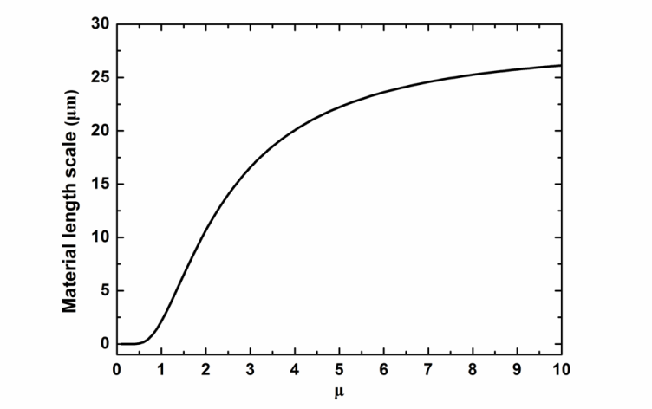
Fig. 2. Increase in material length scale of the FH model with the value of .

5. Discussions

5.1 Trends of normalized flow stress in various models
The size-dependent yield stress (i.e. ) predicted by CTT, Eq. , shows that there is no fitting parameter in this theory. If we assume , , we can see that there is an increase in the initial yielding strength as is decreased, whereas there is no elevation in the rate of strain hardening. For example, if , the corresponding ratio , respectively. This trend corresponds to the physical image that the generation of dislocations is restricted by a geometrically necessary small volume and hence a higher yield strength is required.
The general trends of flow stress in different SGP models are given in Table 1 and Fig. 3 for various values of . For all cases there is an enhancement in normalized flow stress at a plastic strain of unity by a factor 1.4 to 3 when the ratio of increases from zero to unity. We note that the strain-gradient term in NG model increases the rate of strain hardening but not the yield strength (see Fig. 3), while the strain-gradient term in Aifantis and FH models increases the yield strength but not the rate of strain hardening, see Eqs. and . Fig. 3 shows that the predicted size effect in NG model only becomes significant when the plastic strain becomes large. By using the same material length scale, the size effect predicted by the Aifantis model is close to that predicted by the FH model with , as summarized in Table 1. One can also see from Table 1 that the elevation in flow stress for FH model is much greater for than for . Except for the NG model, the basic trends in SGP models are in qualitative agreement with that given by CTT.
There is an assumption in NG model that the size effect is attributed to the existence of a high density of GNDs as required in Eq. . Since there are no GNDs or just a few of GNDs at the initial yielding, in this sense, the NG model based on this assumption is not reasonable. That is the reason why the NG model is unable to predict the size dependence of initial yielding. As indicated by Weertman (2002), Eq. does not provide any explanation how the GNDs can hinder each other’s motion when SSDs are too few in number to pin the dislocations. Our point is that the size effect (especially, at the initial yielding) is attributed to the difficulty in creating and moving dislocations (Weertman, 2002), or to the constraint the size puts on dislocation curvature (Bushby and Dunstan, 2011; Dunstan, 2012; Dunstan and Bushby, 2004). This mechanism has been further confirmed by the continuum dislocation theory (Kaluza and Le 2011; Le and Nguyen, 2013) and the discrete dislocation dynamics simulations (Motz and Dunstan, 2012). Critical thickness theory is based on this idea, so it is able to predict the size effect at the initial yield.
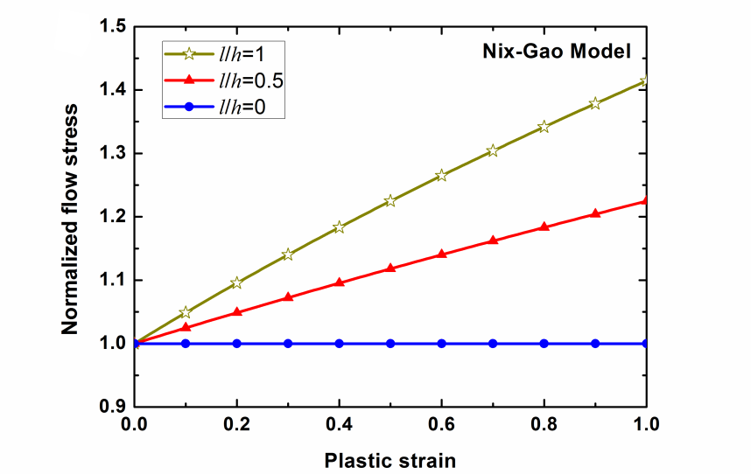
Fig. 3. Trends of gradient-enhanced flow stress in NG model, Eq. with , as a function of effective plastic strain
Table 1 The size-dependent flow stress predicted by Aifantis and FH model.
l/h  σ_{e} /σ_{Y} | 0 | 0.5 | 1
Aifantis model, Eq. * | 1 | 1.75 | 3
FH model, Eq. with μ=1, c=1 | 1 | 1.50 | 2
FH model, Eq. with μ=2, c=1 | 1 | 1.12 | 1.41
* Here, and are assumed.

5.2 Prediction of the material length scale
Assuming , , , we compare the material length scales in various models (i.e. Eqs. , , , and ), as shown in Fig. 4. An attractive feature of the expressions for the material length scales given here is that we do not require any free fitting parameter in addition to the basic physical quantities, i.e. the yield strain, and the magnitude of Burgers vector. The inverse correlation between the material length scale and the yield strain of material is illustrated in Fig. 4. The material length scales predicted by both the Aifantis model (curve (c)) and the FH model with (curve (d)), ranging from several microns to tens of microns, agree well with the length scales obtained by fitting to foil bending and micro-indentation data. The FH model with (curve (e)) predicts a higher value of material length scale than and the Aifantis theory, which is on the order of ten microns. The length scales in the NG model (Eq., curve (a), and Eq. , curve (b)) are in the range of tens of microns to tens of millimeters. Such a magnitude of the material length scale is close to that obtained by Evans and Hutchinson (2009) through fitting to bending data of foils (～25mm). In addition, the value of material length scale of the NG model based on CTT (curve (b)), Eq. , is higher than that given by the expression proposed by Nix and Gao (1998), Eq. , i.e. curve (a). Divergences in the magnitude of the material length scales among different models arise from the manner in which the strain and strain gradient terms are combined.
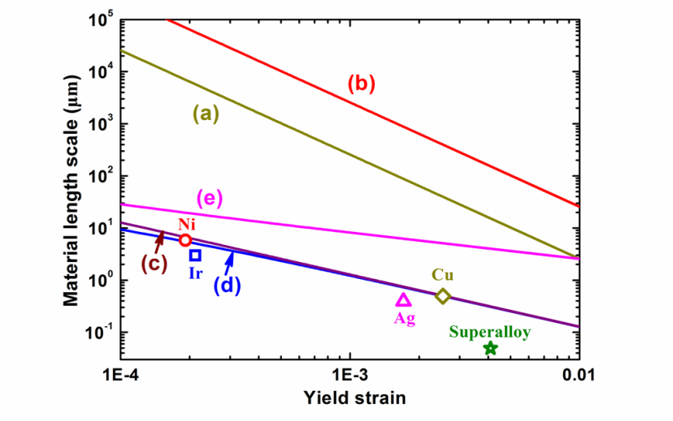
Fig. 4. Logarithmic plot of the relation between the material length scales and the yield strain for various models. (a) The NG model, Eq. with ; (b) The length scale in NG model derived by CTT, Eq. with ; (c) The Aifantis model, Eq. with ; (d) The FH model with , Eq. with ; (e) The FH model with , Eq. with and . The length scales obtained by fitting the FH theory to indentation data for Ir, Ag, Cu and Superalloy, and to bending data for Ni foils (After Evans and Hutchinson (2009)) agree with the predictions given by the Aifantis theory and the FH model with .
Taking typical parameters for copper metal, , , one then obtains . The thickness (e.g. the radius of a wire in torsion) is taken as . By using these parameters, we can calculate the material length scales for different models, as listed in Table 2. In the next Section, taking the strain gradient effect in wire torsion as an example, we will see whether these length scales predicted by CTT are in agreement with those obtained from empirical fitting to experimental data.
Table 2. Predicted material length scales in different models via critical thickness theory
Model |  | (nm) | (μm) |  | (μm)
NG, Eq. | 0.0006 | 0.256 | － | 1 | 7869.6
Aifantis, Eq. | 0.0006 | 0.256 | － | 1 | ～2.1
FH with μ=1, Eq. | 0.0006 | 0.256 | － | 1 | 2.1
FH with μ=2, Eq. | 0.0006 | 0.256 | ～25 | 1 | 10.5

5.3 Application to wire torsion
Recently, we performed torsion experiments on electropolished copper wires with different diameters but the same grain size, see Guo et al. (2017) in detail. An individual contribution of plastic strain gradient to the size effect is demonstrated, as shown in Fig. 5. Typical results are given for each wire diameter . The torsion data here are displayed in the form vs , where is the torque, the wire radius, and the twist per unit length. The shear strain at the wire surface is manifested as . Obviously, there is a strong size effect in both the initial yielding and the plastic flow. For example, at , the magnitude of for is about 1.7 times the value of for . The material length scales for different SGP models can be obtained by fitting to these data (see below sections). Finally, we will compare these length scales with that derived directly from known physical quantities (i.e. values in Table 2), and see whether they coincide with each other.
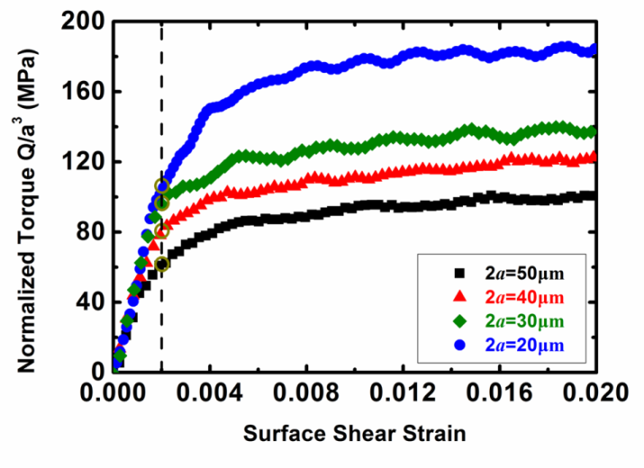
Fig. 5. Normalized torque versus surface shear strain for copper wires with different diameters but the same grain size at low strain.

5.3.1 Analysis based on the Aifantis model
For simplicity, we consider torsion of a metal wire made of rigid-plastic material. This problem is preferable since it allows the derivation of the closed-form analytical expression for the torque-twist relation for the given definition of the gradient-enhanced effective plastic strain. We take a Cartesian co-ordinate system with the axis along the central axis of the wire. The non-vanishing components of the plastic strain tensor are
,
For the gradient theory of Aifantis, we have
where is the radius in polar coordinates . Substituting Eq. into Eq. , we have
Substituting Eq. into Eq. and assuming , we obtain
The torque is the work conjugate to , which is
In the limit of , the strain gradient vanish and the torque is
The ratio representing the elevation in torque due to strain gradient effect is given by
Following Voyiadjis and Abu Al-Rub (2005), we assume , then the strain gradient effect diminishes rapidly with increasing .

5.3.2 Analysis based on the FH model
For the FH model, according to Eqs. and , we have
for scalar version
for tensor version
Submitting Eq. (or Eq. ) into Eq. , we obtain
Here, for the scalar version and for the tensor version. Substituting Eq. into Eq. and assuming , we have
Following the similar procedure for deriving Eq. , we obtain
where denotes the regularized hypergeometric function. Comparing Eq. and Eq. , we obtain the ratio
For the choices of and , we have
Similar to Eq. , the strain gradient effect diminishes rapidly with decreasing .

5.3.3 Analysis based on the NG model
For the NG model, Eq., assuming and ,, we then have
So, the plastic work per unit volume is
Then,
In the limit of , the torque is the same as Eq. . Then, the ratio is given by
Here, is the surface shear strain. Obviously, the value of is strongly dependent on the surface shear strain . Note that the measure of plastic strain gradients taken by Nix and Gao (1998) and Gao et al. (1999) is different from here. In their original definition, is taken for torsion of thin wire.

5.3.4 Comparison with experiment
Following Fleck et al. (1994), we use the following procedure to deduce the value of the material length scale for different models, i.e. Eqs. , and . For each diameter of wire, we can read from Fig. 5 the value of at a surface shear strain . A measure of the degree of size effect associated with each diameter of wire is the ratio . Here, is measured at for a wire of diameter , is measured at for the wire of diameter . We assume the conventional normalized torque , then . From Eqs. , , one can see that only the material length scale enters into the ratio for a given wire diameter for both the Aifantis and the FH models. In contrast, the ratio for the NG model, Eq. , strongly depends on the surface shear strain. Predicted values of the ratio are evaluated from Eqs. , and plotted in Fig. 6(b) and (c), separately, as a function of for the wire diameters . For NG model, taking in Eq. , we plot the ratio against the material length scale in Fig. 6(c). We use these theoretical curves of different models to estimate values of from observed values of . The estimated values for for different models are shown for each wire diameter by the arrows in Fig. 6(a)-(c). For the Aifantis model, as shown in Fig. 6(a), is in the range 3.0-3.7μm, with a mean value of 3.2μm. For FH model Eq. with (see Fig. 6(b), solid line), is in the range 3.8-5.4μm, with a mean value of 4.7μm. For the FH model with (see Fig. 6(b), dashed line), is in the range 9.0-11.4μm, with a mean value of 10.3μm, which is larger than . From Fig. 6(c), one obtain that is in the range 11.4-18.0mm, with a mean value of 15.3 mm. These values are all in good agreement with the values predicted by the CTT model, as shown in Table 2. It is confirmed that the material length scale in NG model is on the order of several millimeters, and the material length scale in Aifantis model and FH model is on the order of several micrometers. This conclusion agrees with that given by Evans and Hutchinson (2009). It is also demonstrated that the values of material length scale in strain gradient plasticity can be derived from known physical quantities.
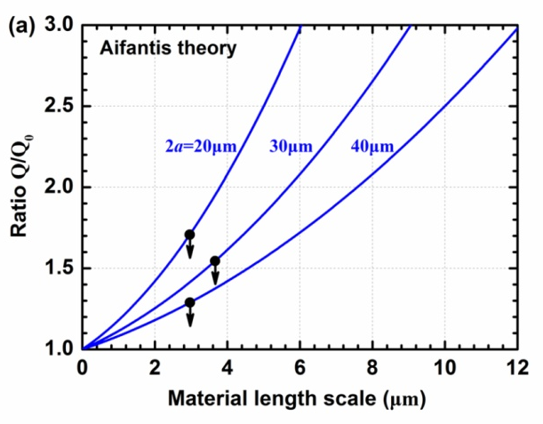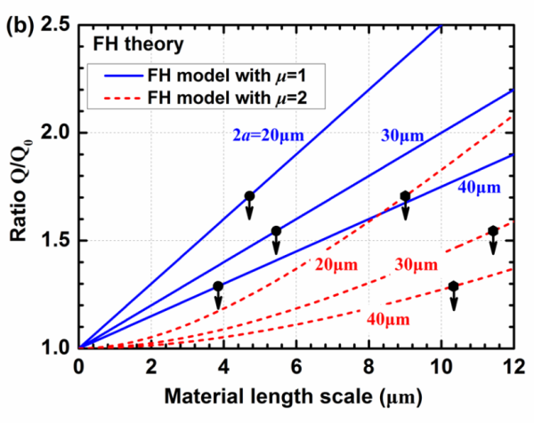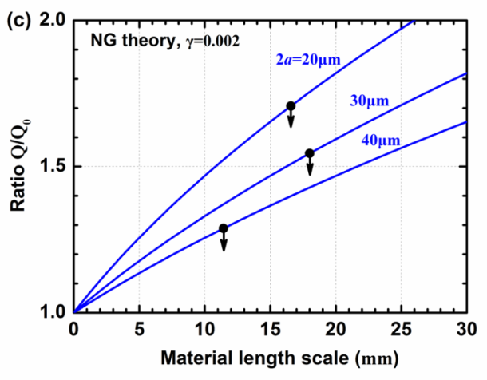
Fig. 6. Non-dimensional torque versus material length scales predicted by (a) the phenomenological plasticity law of the Aifantis model Eq. , (b) the FH model Eq. , and (c) the NG model . The arrows show the experimental data used to predict the value of the material length scale for the different models.

6. Concluding Remarks
A fundamental physical understanding of the material length scales that are inherent in the deformation theory of SGP is provided in the light of critical thickness theory. By setting the size-enhanced yield strength predicted by CTT equal to that by SGP theories, relations between the well-known physical quantities and the material length scales in Aifantis, Fleck-Hutchinson and Nix-Gao SGP theories are presented. One attractive feature of these relations is that no free fitting parameters are used. Another attractive feature is that no appeal need to be made to an unphysical direct effect of plastic strain gradient on yield or flow stress. The application to wire torsion demonstrates that the material length scales predicted by CTT for different SGP models agree well with those determined by fitting the SGP theories to the experimental data. This explains the strain gradient plasticity theories for use in engineering applications such as finite element analysis. Yet, the approach presented here is unable to predict the energetic length scales introduced in the theories accounting for both energetic and dissipative strain gradient dependences (e.g. Gudmundson, 2004; Gurtin, 2004; and Gurtin and Anand, 2005a), and the length scale in the continuum dislocation theory (e.g. Berdichevsky, 2006, 2016; Le, 2016; Le and Günther 2014) which strongly depends on the form of defect energy. It will be interesting to study the relationship between the strain gradient plasticity and the continuum dislocation theory, and to provide the physical interpretation of (energetic) length scales involved therein in future.

Acknowledgements
This work is financially supported by the EU’s Horizon 2020 research and innovation programme under the Marie Sklodowska-Curie grant agreement No. 704292. DL also thanks the financial support from the NSFC (No. 11472114), the Young Elite Scientist Sponsorship Program by CAST (No. 2016QNRC001), and the Opening Project of Applied Mechanics and Structure Safety Key Laboratory of Sichuan Province (SZDKF-1603).

Appendix A. An alternative derivation of Eq.
According to the well-known Orowan bowing equation, Evans and Hutchinson (2009) give
where is the spacing between obstacles, and the second equation follows from the first as above. Again, there are various geometrical factors and corrections for obstacle pinning strength which have not been included. Thus, as indicated by Evans and Hutchinson (2009), Eq. and Eq. give
where is the dislocation density. If and , then and . This would appear to be a physically reasonable value for beam bending experiments (Ehrler et al., 2008; Evans and Hutchinson, 2009).
For the FH model, Evans and Hutchinson (2009) conclude that
where is the average slip distance, which is expected to be of the same order as the distance between obstacles, . The value of 5𝜇𝑚 for quoted above again seems quite physical in this context, and it is noteworthy that the values of and are remarkably similar (2.5 and 5 𝜇𝑚) given the magnitude of the approximations involved. Continuing, from Eqs. and , we have
which is in fact the relation Eq. without a pre-factor. This relation is implied by Evans and Hutchinson ( 2009), although they did not explicitly express this relation. These results have been already implied from the original strain gradient theories of NG and FH, with only a reference to the usual Orowan equations, which are a fundamental feature of conventional plasticity.

References
Abu Al-Rub, R.K., Voyiadjis, G.Z., 2006. A physically based gradient plasticity theory. Int. J. Plasticity 22, 654-684.
Aifantis, E.C., 1984. On the microstructural origin of certain inelastic models. J. Eng. Mater. -T ASME 106, 326-330.
Aifantis, E.C., 1987. The physics of plastic deformation. Int. J. Plasticity 3, 211-247.
Aifantis, E.C., 1992. On the role of gradients in the localization of deformation and fracture. Int. J. Eng. Sci. 30, 1279-1299.
Aifantis, E.C., 1999. Strain gradient interpretation of size effects. Int. J. Fracture 95, 299-314.
Anand, L., Gurtin, M.E., Lele, S.P., Gething, C., 2005. A one-dimensional theory of strain-gradient plasticity: Formulation, analysis, numerical results. J. Mech. Phys. Solids 53, 1789-1826.
Arsenlis, A., Parks, D.M., 1999. Crystallographic aspects of geometrically-necessary and statistically-stored dislocation density. Acta Mater. 47, 1597-1611.
Ashby, M.F., 1970. The deformation of plastically non-homogeneous materials. Phil. Mag. 21, 399-424.
Bammann, D.J., 2001. A model of crystal plasticity containing a natural length scale. Mater. Sci. Eng. A-STRUCT 309, 406-410.
Ban, H., Yao, Y., Chen, S., Fang, D., 2017. The coupling effect of size and damage in micro-scale metallic materials. Int. J. Plasticity. doi: 10.1016/j.ijplas.2017.04.012.
Bardella, L., 2006. A deformation theory of strain gradient crystal plasticity that accounts for geometrically necessary dislocations. J. Mech. Phys. Solids 54, 128-160.
Bardella, L., 2009. A comparison between crystal and isotropic strain gradient plasticity theories with accent on the role of the plastic spin. Eur. J. Mech. A-solid. 28, 638-646.
Bardella, L., 2010. Size effects in phenomenological strain gradient plasticity constitutively involving the plastic spin. Int. J. Eng. Sci. 48, 550-568.
Bardella, L., Panteghini, A., 2015. Modelling the torsion of thin metal wires by distortion gradient plasticity. J. Mech. Phys. Solids 78, 467-492.
Beanland, R., 1992. Multiplication of misfit dislocations in epitaxial layers. J. Appl. Phys. 72, 4031-4035.
Beaudoin, A., Acharya, A., 2001. A model for rate-dependent flow of metal polycrystals based on the slip plane lattice incompatibility. Mat. Sci. Eng. A-Struct. 309, 411-415.
Berdichevsky, V.L., 2006. Continuum theory of dislocations revisited. Continuum. Mech. Therm. 18, 195-222.
Berdichevsky, V., 2016. Energy of dislocation networks. Int. J. Eng. Sci. 103, 35-44.
Bragg, W.L., 1942. A theory of the strength of metals. Nature 149, 511-513.
Brenner, S.S., 1956. Tensile Strength of Whiskers. J. Appl. Phys. 27, 1484-1491.
Brinckmann, S., Siegmund, T., Huang, Y., 2006. A dislocation density based strain gradient model. Int. J. Plasticity 22, 1784-1797.
Bushby, A.J., Dunstan, D.J., 2011. Size effects in yield and plasticity under uniaxial and non-uniform loading: Experiment and theory. Phil. Mag. 91, 1037-1049.
Chakravarthy, S.S., Curtin, W.A., 2011. Stress-gradient plasticity. Proc. Natl. Acad. Sci. USA 108, 15716-15720.
Chiricotto, M., Giacomelli, L., Tomassetti, G., 2016. Dissipative scale effects in strain-gradient plasticity: the case of simple shear. Siam. J. Appl. Math. 76, 688-704.
Clayton, J. D., McDowell, D. L., Bammann, D. J., 2006. Modeling dislocations and disclinations with finite micropolar elastoplasticity. Int. J. Plasticity, 22, 210-256.
Dunstan, D.J., 1996. Mathematical model for strain relaxation in multilayer metamorphic epitaxial structures. Philosophical Magazine A 73, 1323-1332.
Dunstan, D.J., 1997. Strain and strain relaxation in semiconductors. J. Mater. Sci-mater. El 8, 337-375.
Dunstan, D.J., 2012. Critical Thickness Theory Applied to Micromechanical Testing. Adv. Eng. Mater. 14, 942-947.
Dunstan, D.J., 2016. Validation of a phenomenological strain-gradient plasticity theory. Phil. Mag. Lett. 96, 305-312.
Dunstan, D.J., Bushby, A.J., 2004. Theory of deformation in small volumes of material. Proc. Roy. Soc. Lond. A Mat 460, 2781-2796.
Dunstan, D.J., Ehrler, B., Bossis, R., Joly, S., P'NG, K.M.Y., Bushby, A.J., 2009. Elastic limit and strain hardening of thin wires in torsion. Phys. Rev. Lett. 103, 155501.
Dunstan, D.J., Kidd, P., Fewster, P.F., Andrew, N.L., Grey, R., David, J.P.R., González, L., González, Y., Sacedón, A., González‐Sanz, F., 1994. Plastic relaxation of metamorphic single layer and multilayer InGaAs/GaAs structures. Appl. Phys. Lett. 65, 839-841.
Dunstan, D.J., Young, S., Dixon, R.H., 1991. Geometrical theory of critical thickness and relaxation in strained‐layer growth. J. Appl. Phys. 70, 3038-3045.
Ehrler, B., Hou, X., Zhu, T.T., P'Ng, K.M.Y., Walker, C.J., Bushby, A.J., Dunstan, D.J., 2008. Grain size and sample size interact to determine strength in a soft metal. Phil. Mag. 88, 3043-3050.
Evans, A.G., Hutchinson, J.W., 2009. A critical assessment of theories of strain gradient plasticity. Acta Mater. 57, 1675-1688.
Fitzgerald, E.A., 1991. Dislocations in strained-layer epitaxy: theory, experiment, and applications. Mater. Sci. Rep. 7, 87-140.
Fleck, N.A., Hutchinson, J.W., 1993. A phenomenological theory for strain gradient effects in plasticity. J. Mech. Phys. Solids 41, 1825-1857.
Fleck, N.A., Hutchinson, J.W., 1997. Strain gradient plasticity. Adv. Appl. Mech. 33, 295-361.
Fleck, N.A., Hutchinson, J.W., 2001. A reformulation of strain gradient plasticity. J. Mech. Phys. Solids 49, 2245-2271.
Fleck, N.A., Hutchinson, J.W., Willis, J.R., 2014. Strain gradient plasticity under non-proportional loading. Proc. R. Soc. Lond. A 470, 20140267.
Fleck, N. A., Hutchinson, J. W., Willis, J. R., 2015. Guidelines for constructing strain gradient plasticity theories. J. Appl. Mech. 82(7), 071002.
Fleck, N.A., Muller, G.M., Ashby, M.F., Hutchinson, J.W., 1994. Strain gradient plasticity: Theory and experiment. Acta Met. Mater. 42, 475-487.
Fleck, N.A., Willis, J.R., 2009a. A mathematical basis for strain-gradient plasticity theory-Part I: Scalar plastic multiplier. J. Mech. Phys. Solids 57, 161-177.
Fleck, N.A., Willis, J.R., 2009b. A mathematical basis for strain-gradient plasticity theory. Part II: Tensorial plastic multiplier. J. Mech. Phys. Solids 57, 1045-1057.
Frank, F.C., van der Merwe, J.H., 1949a. One-dimensional dislocations. I. Static theory. Proc. Roy. Soc. Lond. A Mat 198, 205-216.
Frank, F.C., Van der Merwe, J.H., 1949b. One-dimensional dislocations. II. Misfitting monolayers and oriented overgrowth. Proc. Roy. Soc. Lond. A Mat 198, 216-225.
Gao, H., Huang, Y., Nix, W.D., Hutchinson, J.W., 1999. Mechanism-based strain gradient plasticity - I. Theory. J. Mech. Phys. Solids 47, 1239-1263.
Greer, J.R., Oliver, W.C., Nix, W.D., 2005. Size dependence of mechanical properties of gold at the micron scale in the absence of strain gradients. Acta Mater. 53, 1821-1830.
Groma, I., Gyorgyi, G., Kocsis, B., 2007. Dynamics of coarse grained dislocation densities from an effective free energy. Phil. Mag. 87, 1185-1199.
Gudmundson, P., 2004. A unified treatment of strain gradient plasticity. J. Mech. Phys. Solids 52, 1379-1406.
Guo, S., He, Y., Lei, J., Li, Z., Liu, D., 2017. Individual strain gradient effect on torsional strength of electropolished microscale copper wires. Scripta Mater. 130, 124-127.
Gurtin, M.E., 2004. A gradient theory of small-deformation isotropic plasticity that accounts for the Burgers vector and for dissipation due to plastic spin. J. Mech. Phys. Solids 52, 2545-2568.
Gurtin, M.E., 2008. A finite-deformation, gradient theory of single-crystal plasticity with free energy dependent on densities of geometrically necessary dislocations. Int. J. Plasticity 24, 702-725.
Gurtin, M.E., Anand, L., 2005a. A theory of strain-gradient plasticity for isotropic, plastically irrotational materials. Part I: Small deformations. J. Mech. Phys. Solids 53, 1624-1649.
Gurtin, M.E., Anand, L., 2005b. A theory of strain-gradient plasticity for isotropic, plastically irrotational materials. Part II: Finite deformations. Int. J. Plasticity 21, 2297-2318.
Gurtin, M.E., Anand, L., 2009. Thermodynamics applied to gradient theories involving the accumulated plastic strain: The theories of Aifantis and Fleck and Hutchinson and their generalization. J. Mech. Phys. Solids 57, 405-421.
Gurtin, M.E., Needleman, A., 2005. Boundary conditions in small-deformation, single-crystal plasticity that account for the Burgers vector. J. Mech. Phys. Solids 53, 1–31.
Gurtin, M.E., Reddy, B.D., 2014. Gradient single-crystal plasticity within a Mises–Hill framework based on a new formulation of self-and latent-hardening. J. Mech. Phys. Solids 68, 134-160.
Haque, M.A., Saif, M.T.A., 2003. Strain gradient effect in nanoscale thin films. Acta Mater. 51, 3053-3061.
Hayashi, I., Sato, M., Kuroda, M., 2011. Strain hardening in bent copper foils. J. Mech. Phys. Solids 59, 1731-1751.
Huang, Y., Gao, H., Nix, W.D., Hutchinson, J.W., 2000. Mechanism-based strain gradient plasticity - II. Analysis. J. Mech. Phys. Solids 48, 99-128.
Hutchinson, J.W., 2012. Generalizing J(2) flow theory: Fundamental issues in strain gradient plasticity. Acta Mech. Sinica 28, 1078-1086.
Kaluza, M., Le, K.C., 2011. On torsion of a single crystal rod. Int. J. Plasticity 27, 460-469.
Kocks, U., 1976. Laws for work-hardening and low-temperature creep. J. Eng. Mater. 98, 76-85.
Kröner, E., 1958. Kontinuumstheorie der Versetzungen und Eigenspannungen. Springer, Berlin.
Kuroda, M., Tvergaard, V., 2010. An alternative treatment of phenomenological higher-order strain-gradient plasticity theory. Int. J. Plasticity 26, 507-515.
Lardner, R.W., 1969. Dislocation dynamics and the theory of the plasticity of single crystals. Zeitschrift für angewandte Mathematik und Physik ZAMP 20, 514-529.
Le, K.C., 2016. Three-dimensional continuum dislocation theory. Int. J. Plasticity 76, 213-230.
Le, K.C., Günther, C., 2014. Nonlinear continuum dislocation theory revisited. Int. J. Plasticity 53, 164-178.
Le, K., Nguyen, B., 2013. On bending of single crystal beam with continuously distributed dislocations. Int. J. Plasticity 48, 152-167.
Liu, D., He, Y., Dunstan, D.J., Zhang, B., Gan, Z., Hu, P., Ding, H., 2013a. Anomalous plasticity in the cyclic torsion of micron scale metallic wires. Phys. Rev. Lett. 110, 244301.
Liu, D., He, Y., Dunstan, D.J., Zhang, B., Gan, Z., Hu, P., Ding, H., 2013b. Toward a further understanding of size effects in the torsion of thin metal wires: An experimental and theoretical assessment. Int. J. Plasticity 41, 30-52.
Liu, D., He, Y., Shen, L., Lei, J., Guo, S., Peng, K., 2015. Accounting for the recoverable plasticity and size effect in the cyclic torsion of thin metallic wires using strain gradient plasticity. Mat. Sci. Eng. A-Struct. 647, 84-90.
Liu, D., He, Y., Tang, X., Ding, H., Hu, P., 2012. Size effects in the torsion of microscale copper wires: Experiment and analysis. Scripta Mater. 66, 406-409.
Lubarda, V.A., 2016. On the recoverable and dissipative parts of higher order stresses in strain gradient plasticity. Int. J. Plasticity 78, 26-43.
Mühlhaus, H.B., Aifantis, E.C., 1991. A variational principle for gradient plasticity. Int. J. Solids. Struct. 28, 845-857.
Ma, A., Roters, F., Raabe, D., 2006. A dislocation density based constitutive model for crystal plasticity FEM including geometrically necessary dislocations. Acta Mater. 54, 2169-2179.
Ma, Z.S., Zhou, Y.C., Long, S.G., Lu, C., 2012. On the intrinsic hardness of a metallic film/substrate system: Indentation size and substrate effects. Int. J. Plasticity 34, 1-11.
Maass, R., Derlet, P., 2017. Micro-plasticity and recent insights from intermittent and small-scale plasticity. arXiv preprint arXiv:1704.07297.
Matthews, J.W., 1966. Accommodation of misfit across the interface between single-crystal films of various face-centred cubic metals. Phil. Mag. 13, 1207-1221.
Matthews, J.W., Blakeslee, A.E., 1974. Defects in epitaxial multilayers: I. Misfit dislocations. J. Cryst. Growth 27, 118-125.
Moreau, P., Raulic, M., P'Ng, K.M.Y., Gannaway, G., Anderson, P., Gillin, W.P., Bushby, A.J., Dunstan, D.J., 2005. Measurement of the size effect in the yield strength of nickel foils. Phil. Mag. Lett. 85, 339-343.
Motz, C., Dunstan, D.J., 2012. Observation of the critical thickness phenomenon in dislocation dynamics simulation of microbeam bending. Acta Mater. 60, 1603-1609.
Niordson, C.F., Hutchinson, J.W., 2011. Basic strain gradient plasticity theories with application to constrained film deformation. J. Mech. Mater. Strct. 6, 395-416.
Nix, W.D., 1989. Mechanical properties of thin films. Metall. Mater. Trans. A 20, 2217-2245.
Nix, W.D., Gao, H., 1998. Indentation size effects in crystalline materials: a law for strain gradient plasticity. J. Mech. Phys. Solids 46, 411-425.
Poh, L., Peerlings, R., Geers, M., Swaddiwudhipong, S., 2011. An implicit tensorial gradient plasticity modeleformulation and comparison with a scalar gradient model. Int. J. Solids Struct. 48 (18), 2595e2604.
Poh, L., Peerlings, R., 2016. The plastic rotation effect in an isotropic gradient plasticity model for applications at the meso scale. Int. J. Solids. Struct. 78, 57-69.
Stölken, J.S., Evans, A.G., 1998. A microbend test method for measuring the plasticity length scale. Acta Mater. 46, 5109-5115.
Stelmashenko, N.A., Walls, M.G., Brown, L.M., Milman, Y.V., 1993. Microindentations on W and Mo oriented single crystals: An STM study. Acta Met. Mater. 41, 2855-2865.
Sudharshan Phani, P., Johanns, K.E., George, E.P., Pharr, G.M., 2013. A simple stochastic model for yielding in specimens with limited number of dislocations. Acta Mater. 61, 2489-2499.
Swadener, J.G., George, E.P., Pharr, G.M., 2002. The correlation of the indentation size effect measured with indenters of various shapes. J. Mech. Phys. Solids 50, 681-694.
Taylor, G.I., 1938. Plastic strain in metals. Journal of the Institute of Metals 62, 307-324.
Teodosiu, C., 1969. A dynamic theory of dislocations and its application to the theory of elastic–plastic continuum. Fundamental Aspects of Dislocation Theory. NBS Special Publication 317. US Government Printing Office, Gaithersburg, pp. 837–876.
Tersoff, J., 1993. Dislocations and strain relief in compositionally graded layers. Appl. Phys. Lett. 62, 693-695.
Voyiadjis, G.Z., Abu Al-Rub, R.K., 2005. Gradient plasticity theory with a variable length scale parameter. Int. J. Solids. Struct. 42, 3998-4029.
Voyiadjis, G.Z., Dorgan, R.J., 2004. Bridging of length scales through gradient theory and diffusion equations of dislocations. Comput. Method. Appl. M 193, 1671-1692.
Voyiadjis, G.Z., Faghihi, D., 2012. Thermo-mechanical strain gradient plasticity with energetic and dissipative length scales. Int. J. Plasticity 30-31, 218-247.
Voyiadjis, G.Z., Pekmezi, G., Deliktas, B., 2010. Nonlocal gradient-dependent modeling of plasticity with anisotropic hardening. Int. J. Plasticity 26, 1335-1356.
Weertman, J., 2002. Anomalous work hardening, non-redundant screw dislocations in a circular bar deformed in torsion, and non-redundant edge dislocations in a bent foil. Acta Mater. 50, 673-689.
Wulfinghoff, S., 2017. A generalized cohesive zone model and a grain boundary yield criterion for gradient plasticity derived from surface-and interface-related arguments. . Int. J. Plasticity 92, 57-78.
Zbib, H.M., Aifantis, E.C., 1992. On the gradient-dependent theory of plasticity and shear banding. Acta Mech. 92, 209-225.
Zhang, X., Aifantis, K., 2015. Interpreting the Internal Length Scale in Strain Gradient Plasticity. Rev. Adv. Mater. Sci 41, 72-83.
Zhu, T.T., Bushby, A.J., Dunstan, D.J., 2008. Size effect in the initiation of plasticity for ceramics in nanoindentation. J. Mech. Phys. Solids 56, 1170-1185.
Zaiser, M., 2015. Local density approximation for the energy functional of three-dimensional dislocation systems. Phys. Rev. B 92, 174120.
Zreid, I., Kaliske, M., 2016. An implicit gradient formulation for microplane Drucker-Prager plasticity. Int. J. Plasticity 83, 252-272.

That is an increase of the flow stress required to attain a given amount of plastic strain.
It was called the “ghost length scale” by Dabiao Liu and Xu Zhang in the Sino-Hellenic workshop organized by Prof. E. C. Aifantis in 2015.

