Morphology alterations of skin and subcutaneous fat at NIR laser irradiation combined with delivery of encapsulated Indocyanine Green

Irina Yu. Yanina^{1,2}
Yulia I. Svenskaya³
Nikita A. Navolokin^{3,4}
Alla B. Bucharskaya⁴
Galina N. Мaslyakova⁴
Dmitry A. Gorin³
Gleb B. Sukhorukov^{3,5}
Valery V. Tuchin^{1,3,6}
¹Saratov National Research State University, Research-Educational Institute of Optics and Biophotonics, 83 Astrakhanskaya str., Saratov 410012, Russia
E-mail: irina-yanina@list.ru, tuchinvv@mail.ru

²Interdisciplinary Laboratory of Biophotonics, National Research Tomsk State University, 36 Lenin’s av., Tomsk 634050, Russia
E-mail: irina-yanina@list.ru, tuchinvv@mail.ru

³Education and Research Institute of Nanostructures and Biosystems, Remote Controlled Theranostic Systems Lab, 83 Astrakhanskaya str., Saratov 410012, Russia
E-mail: svenskaya@info.sgu.ru, gorinda@mail.ru, g.sukhorukov@qmul.ac.uk

⁴Saratov State Medical University, 112 B Kazachaya str., Saratov 410012, Russia
E-mail: nik-navolokin@yandex.ru, gmaslyakova@yandex.ru

⁵ School of Engineering and Materials Sciences, Queen Mary University of London, Mile End Road, London, E1 4NS, United Kingdom
E-mail: g.sukhorukov@qmul.ac.uk

⁶Laboratory of Laser Diagnostics of Technical and Living Systems of Precision Mechanics and Control Institute of the Russian Academy of Sciences, 24 Rabochaya, Saratov 410028, Russia
E-mail: tuchinvv@mail.ru

Correspondence: Dr. Irina Yanina, Saratov National Research State University, Research-Education Institute of Optics and Biophotonics, 83 Astrakhanskaya str., Saratov, Russia, 410012; E-mail: irina-yanina@list.ru
Abstract. The goal of this study is to quantify impact of in vivo photochemical treatment of rats with obesity using indocyanine green (ICG) disolved in saline or dispersed in encapsulated form at NIR laser irradiation what was moniroted by the tissue sampling and histochemistry. The subcutaneous injection of ICG solution or ICG encapsulated into polyelectrolyte microcapsules followed up with diode laser irradiation (808 nm, 8 W/cm², 1 min), resulted in the substantial differences in lipolysis of subcutaneous fat. The most of morphology alterations occurred in response to the laser irradiation if free ICG solution had been injected. In such conditions, the membrane disruption, stretching and even delamination in some cases were observed for a number of cells. The encapsulated ICG aroused similar morphology changes but with weakly expressed adipocyte destruction under the laser irradiation. Cochran Q test rendered the difference between the treatment alternatives as a statistically significant. By this means, laser treatment using the encapsulated form of ICG seems more promising and could be used for safe layer-wise laser treatment of obesity and cellulite.

Keywords: obesity, cellulite, ICG; polyelectrolyte microcapsules; Layer by Layer assembly, NIR laser treatment; photochemical action; adipose tissue; histological analysis; cell lipolysis

1. Introduction

Diabetes, hypertension, heart disease and early death as obesity complications are often connected with extra abdominal fat.¹⁻⁵ The fat cell studies are very important not only to fight against obesity, but also in the treatment of cancer (e.g. breast cancer).⁶⁻⁸ Usually adipose tissue surrounding the tumor and therefore it is important to remove fat tissue accurately to ensure optical access to the tumor.⁹ Treatment of breast cancer involves a multi-modal approach incorporating surgery (lumpectomy, mastectomy and/or removal of axillary lymph nodes), chemotherapy, and/or radiation therapy.¹⁰⁻¹⁶

One of the effective optical methods for treatment of tumors and other lesions is a combined use of such dye as indocyanine green (ICG) and NIR laser irradiation.¹⁷⁻²⁸ ICG is a cyanine dye widely applied in medical diagnostics and surgery for imaging.¹⁷⁻¹⁹ It is used for determining cardiac output, hepatic function, and liver blood flow, and for ophthalmic angiography.^{19,20} It has a peak spectral absorption at 778-790 nm at the monomeric form with a molar absorption coefficient of 10800 M^{–1}cm^{–1}, related to the π→π* transition.^{27,28} Usually ICG is administered intravenously where it binds tightly to plasma proteins, thus is confined to the vascular system. Depending on liver performance it is eliminated from the body exclusively by the liver to bile juice with a half life of approximately 3–4 min.²⁶

At topical application, the monomeric absorption band of ICG is moved on approximately 20 nm to the longer wavelengths due to binding to tissue proteins, to 805-810 nm.^{25,27,29} Therefore diode lasers with the wavelength of 805-810 nm are suitable for heating and controllable photothermal injury of ICG stained tissue sites without impact on the surrounding unstained tissue.^{22-24,30} In addition at light exposure, ICG releases free radicals such as singlet oxygen that also damage target cells.²⁷ That works particularly well for tumors, because they naturally absorb more ICG than healthy tissue. When ICG is injected near tumors, their response to laser light is 2.5 times as much as the surrounding tissue does.³¹ It is also possible to target specific cells by conjugating the ICG to antibodies.³² The method was used to destroy tumors and cancer cells.^{22,24,33-35} In particular, the combination of ICG laser therapy with a triggered immune response provides tumor destruction without future recurrences of cancer.^{33,34}

ICG is problematic dye to work with due to its susceptibility to chemical degradation, nonspecific binding to blood and tissue proteins, and rapid clearance from the body. Thus, it needs to be localized in the target area for minimizing these adverse effects. Therefore, improved delivery systems were introduced to stabilize ICG, such as the use of phospholipid emulsions, poly-lactic co(glycolic)-acid (PLGA) particles, and diblock copolymer micelles.³⁶⁻⁴³ ICG-filled biocompatible polyelectrolyte microcapsules are presumed to stabilize the dye and prevent it from immediate interaction with tissue. Microcapsule shells can be formed by layer-by-layer electrostatic adsorption method using biocompatible polymers.⁴⁴⁻⁴⁷

ICG mediated fat cell laser lipolysis was recently proposed.³⁰ There are other laser based methods for removing of unwanted body fat. Laser liposuction is a new and developing technology for removing fat deposits.^{48,49} However, its application is accompanied by necrosis of adipocytes which are destroyed, but not totally removed from the body in the course of liposuction.⁴⁸ Lipolysis is defined as a partial or total destruction of fat cells to release their contents in the interstitial space.^{50,51} The cell death can occur under the action of various physical, chemical and biological factors. Depending on protocol, cell apoptosis or necrosis may take place as result of lipolysis.⁵²

There are novel least-invasive optical methods providing reduction of regional or site-specific accumulations of abdominal fat (so-called belly fat or stomach fat) under development.⁵³⁻⁵⁹ The concept that photochemical treatment based on photodynamic, phototoxic and photothermal effects induced by NIR diode laser irradiation of fat cells stained by ICG may lead to their lipolysis was recently proposed and proved.^{30,60}

In our previous work, we found that photochemical treatment in rats in vivo at subcutaneous injection of ICG solution (0.5 mg/ml in saline or in alcohol mixture) and follow up 808 nm-diode laser irradiation (16 W/cm² and 1 min-exposure) caused the development of pronounced changes in tissue morphology.⁶¹

The goal of this work is to quantify impact of ICG applied in solution or as encapsulated into polyelectrolyte microcapsules to provide photochemical treatment by NIR laser irradiation through rat skin in vivo using the follow up tissue sampling and histology.

- Materials and Methods
2.1 Laboratory animals
Group of 2-year old female rats of totally 20 animals were kept 14 days, rats besides the standard diet received additionally per 5 g of each nutrients such as sugar, dry milk, sunflower oil, and egg powder in order to induce alimentary obesity. Animals were divided into 2 groups of 10 rats each. Hairs were removed within the region of ribs on the back, where treatment was carried out by cream to depilation Veet (Reckitt Benckiser, France). All procedures with animals were done in accordance with the European Convention for the Protection of animals used for experimental and other scientific purposes.⁶² The experimental study was conducted in Centre of Collective Use of Saratov State Medical University (Russia) and according to the guidelines of the University’s Animal Ethics Committee (Russia) and the relevant national agency regulating experiments with animals.
2.2 Agents
2.2.1 Dye
Saline solution of ICG (SIGMA-ALDRICH Co., Germany) of concentration 0.5 mg/ml was used for fat tissue staining. The solution was kept for 1-2 hours before use.

2.2.2 Capsule preparation and characterization
ICG (SIGMA-ALDRICH Co., Germany) was encapsulated into polyelectrolyte microcapsules fabricated by layer-by-layer assembly technique. The ICG-loaded calcium carbonate (СaCO₃) microparticles were fabricated using early designed technology.⁴⁵ For what 1-ml volumes of 1 M Na₂CO₃ and 1 M CaCl₂ water solutions were quickly added to 5 ml of 1 mg/ml ICG water solution in a glass vessel at room temperature and then mixed by using the magnetic stirrer Mini MR Standard (IKA, Germany) at 500 rpm. The synthesized CaCO₃ particles were washed twice with water and then used as templates for microcapsule shell formation. Polyelectrolyte shells were prepared by self-assembly method using biocompatible polymers (chitosan and dextran sulfate sodium salt) adsorbed layer-by-layer on the templates. The polyelectrolytes were deposited from 1 mg/ml solutions in 0.15M NaCl. After each deposition, the suspension was centrifuged for 1 min at 5000 rpm in order to separate it into fractions and remove supernatant liquid phase and then was triply washed with water. After consequent deposition of the eight polyelectrolyte layers, CaCO₃ templates were dissolved in 2M ethylenediaminetetraacetic acid (EDTA) and the suspension of microcapsules were triply washed with water, centrifuged at 7000 rpm for 5 min and re-suspended in 1 ml of saline. Thus, ICG-filled biocompatible polyelectrolyte microcapsules were formed.

To study the morphology and microstructure, a drop of the microcapsule suspension was put on the silicon wafer, dried, sputtered with gold and imaged with scanning electron microscopes (SEM), a MIRA II LMU (Tescan) at acceleration voltage of 20 kV and a Phillips XL 30 at 5-30 kV. Performed SEM images of ICG-loaded polyelectrolyte microcapsules are presented in Figure 1. The images demonstrate a spherical shape of the capsules and their narrow size distribution 3.5±0.5 μm.
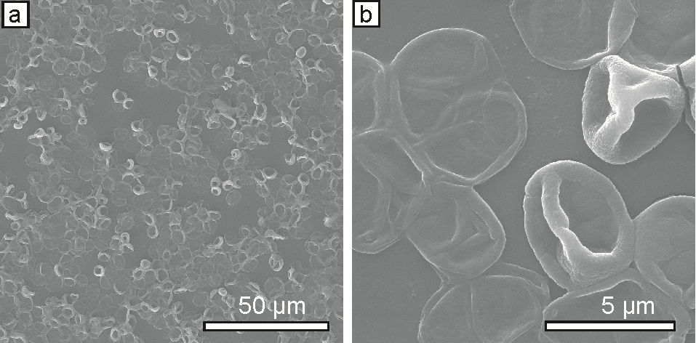
Fig. 1. Scanning electron microscopy images of ICG-loaded polyelectrolyte microcapsules at different magnifications
In order to estimate the ICG concentration in polyelectrolyte containers, the supernatant was collected at each polyelectrolyte deposition and washing steps which absorption spectrum was examined with Lambda 950 spectrophotometer (Perkin Elmer, USA). The total amount of loaded molecules was deduced by subtracting the measured amount of unloaded and washed-off molecules of the supernatant from the initial amount of 0.5 mg/ml of ICG, which had been added to the system. As a measure of the amount of ICG in solution, its optical density spectrum was recorded in the spectral range of 300-1000 nm. A calibration curve was obtained from the measurements of known concentrations of ICG in saline.

The resulting concentration of ICG in the saline suspension of obtained microcapsules was found to be equal to 0.5 mg/ml meaning 1 pg of ICG per one polyelectrolyte microcapsule.

2.3 Protocol of experiment
The skin sites for each rat with obesity were demarcated into 4-zones. Each sampling zone was about 1 cm in diameter. The zone 1 was kept as a control without any staining or radiation. For zone 2, subcutaneous dye injection (free ICG or encapsulated ICG (encapICG), 0.5 mg/ml) was performed: ICG solution was applied for the rats of the first group, meanwhile the encapsulated ICG was injected into the rats of the second group. Zone 3 was exposed to radiation from a diode NIR laser (wavelength 808 nm, power density of 8 W/cm², exposure of 1 min). For zone 4, free ICG or encapICG injection of the same volume and concentration was followed up by light irradiation. Anesthesia of rats was carried out with Zoletil (Vibrac, France). After 1 hour elapsed since 1-min light exposure, rats were decapitated.

2.4 Histology
For histological studies, samples of skin with subcutaneous tissue of thickness 1.5-2.5 mm were taken by surgery from rats within marked 4-zones of the skin site. For histological examination of excised tissue samples, fixation was carried out by 10% solution of formaldehyde. After fixation, the 5-7 µm-tissue slices across all layers of subcutaneous tissue were made, then stained by hematoxylin-eosin using a standard technique and then analyzed.⁶³

2. 5 Statistical data analysis
Statistical data analysis was performed using the “Statistics 6.0.” Cochran's Q-test, a nonparametric test usually applied to the analysis of two-way randomized block designs where the response variable can take only two possible outcomes (coded as 0 and 1) was used.⁶⁴ Test provides a quick recognition of whether k treatments have identical effects simply by counting the number of times each treatment is better than the other.

3. Results and Discussion
3.1 Histological analysis of control samples
The samples were skin slices with a layer of subcutaneous adipose tissue. In the control samples (zone 1) no changes in the epidermis and dermis, and subcutaneous adipose tissue (Fig. 2a) were found. The epidermis is normally thin and cells do not have any degenerative changes. The dermis is represented by collagen fibers distributed in different areas and located close to each other. The contours of the fat cells are distinct. Muscle fibers with distinct cross striation are also seen. Skin appendages are not changed.

3.2 Histological analysis of the samples after the injection of agent
For the first group of rats, free ICG dissolved in saline was injected subcutaneously, while for the second group encapsulated ICG was applied. In the samples corresponding to zone 2, i.e. the subcutaneous injection of free ICG (Fig. 2b) or encapsulated ICG (Fig.2c), no essential morphological changes of epidermis and dermis were observed. No any, even weakly expressed destruction of adipose tissue, was found. For the first group of rats fat tissue was presented by cells with thinning and split boundaries of the external environment - the cell membrane-cytoplasm-fat drop. In the case of encapsulated ICG injection, no damage was noticed as well. However, for some samples delamination of cell membranes was found. This fact could be explained by the mechanical stress on cells caused by swelling.

3.3 Histological analysis of the samples after irradiation
For the samples corresponding to zone 3, after NIR diode laser irradiation (power density of 8 W/cm² and the exposure of 1 min), no significant changes were observed: just a little thinned out areas were found for theepidermis. , meanwhile for the dermis edema was discovered. The irradiation leads to hyperemia in the hypodermis (Fig. 2d) of irradiated sites. Moreover, the signs of damage in adipose tissue were found: the boundary thinned and partly disrupted (indicated by arrows on Fig. 2e) membranes had a stretched shape, and the membrane delamination was observed in some cases (Fig. 2e). Changes of fat cells during 1 hour of observation were characterized as destruction process which could potentially lead to lipolysis or necrosis.^{65,66} NIR laser irradiation may stimulate an increase the permeability of fat cell membranes resulting in release of intracellular fat. The fatty triglycerides may flow out through the disrupted cell membranes into the interstitial space, where they gradually pass through the lymphatic drainage system.⁶⁷

3.4 Histological analysis of the samples after the dye subcutaneous injection and irradiation
In the samples with subcutaneous injection of ICG solution and subsequent laser irradiation, definite signs of damage in adipose tissue were observed (Fig.2f). The epidermis was in normal state, while a local hemorrhage in the dermis and a moderate infiltration of neutrophils and eosinophils in hypodermis took place. Edema with swelling of the certain muscle fibers was observed in the muscle tissue (Fig. 2g). Adipose tissue had the pronounced signs of damage seen as strongly stretched cells. There were also found the disrupted membranes (indicated by red arrows on Fig. 2f). The ICG tissue staining via subcutaneous injection and subsequent laser irradiation at physiological constant temperature leads to generation of oxygen radicals (superoxide and hydroxyl radicals) that causes a modification of fat cell phospholipid membranes and transmembrane cell lipolysis coming out as cell shape transformations .

In the case of encapsulated ICG-injection, we observed the similar changes, but with weakly expressed cell destruction (Fig. 2h). In the course of the photochemical/photothermal reaction in addition to direct cell lipolysis cell apoptosis can be induced when the microdamages of cell membrane reach a critical number or strength.^{68,69} Encapsulated ICG tissue treatment rendered the smaller damaging ability. However, such damages could also lead to cell lipolysis and/or apoptosis.^{70,71}

In our previous work, we investigated photochemical treatment by using of ICG solution with concentration of 1 mg/ml dissolved in alcohol and 808 nm-laser irradiation (power density of 16 W/cm² and the exposure time 1 min) which caused the pronounced changes in ex vivo adipose tissue accompanied by cell apoptosis and/or necrosis depending on the level of tissue damage.⁵² It was established, that the application of free ICG-water solution (1 mg/ml) or encapICG-water solution (2 mg/ml) as a photochemical dye in ex vivo experiment increased the cell membrane permeability leading tolipolysis.⁷² For tissue stained by ICG-water solution, a total lipolysis was seen to 295 min, while for tissue stained by encapsulated ICG it was to 165 min.⁷²

In the current study, the biopsy specimens for histology were taken in 60 min after light exposure when only the first signs of cell damage and lipolysis occurred. Such experiment rendered the encapsulated form of ICG as more effective (see Table) and promising due to ability to control cell lipolysis more smoothly and to avoid unwanted effects of necrosis.
a | b | c
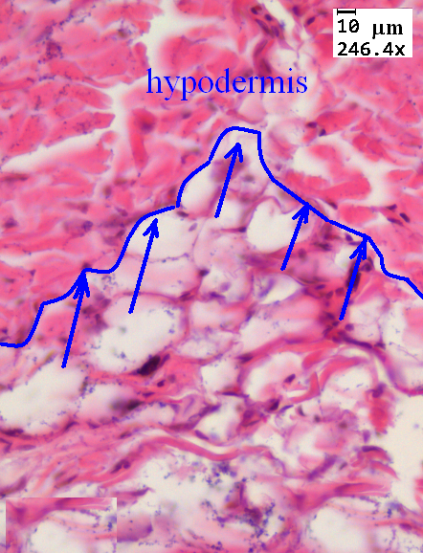 | 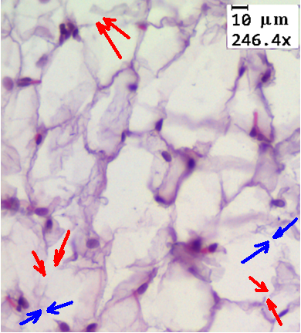 | 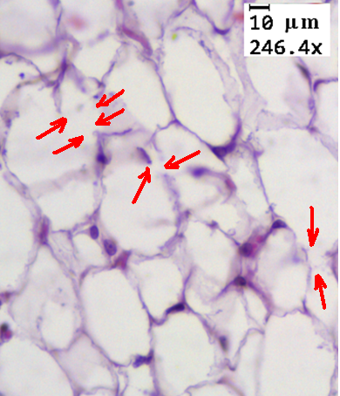
d | e | f
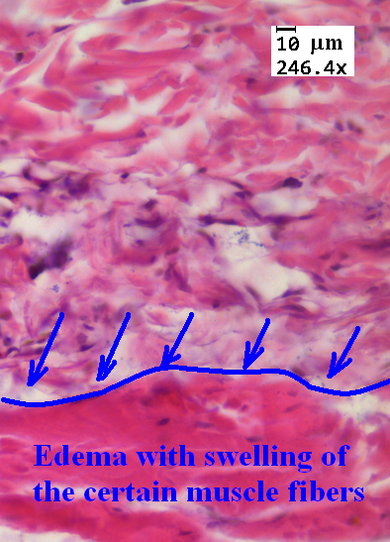 | 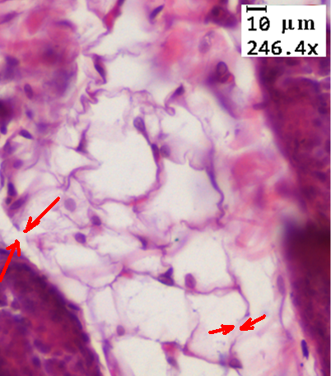
g | h
Figure 2. Histological (H&E staining) images of subcutaneous adipose tissue samples taken from in vivo treated rats (magnification 246.4×): a – no treatment (control); b - after injection of free ICG solution (0.5 mg/ml in saline); c – after injection of encapsulated ICG (0.5 mg/ml in saline); d – hyperemia in the hypodermis in zone 3; e – after 1-min 808 nm-diode laser irradiation (8 W/cm²); f – after free ICG injection (ICG 0.5 mg/ml in saline) and 1-min 808 nm-diode laser irradiation (8 W/cm²); g – edema with swelling of the certain muscle fibers in zone 4; h – after encapsulated ICG injection (encapsulated ICG 0.5 mg/ml in saline) and 1-min 808 nm-diode laser irradiation (8 W/cm²). Blue arrows – changed (thinned) membranes; red arrows - disrupted membranes.

The Cochran Q test can be used to evaluate the relation between two variables which are measured on a nominal scale. One of the variables may consist of only two possible values (dichotomous scale). In our case, six different treatments for 10 laboratory animals were evaluated. The scale of evaluation was dichotomous: the any changes in subcutaneous adipose tissue either were (=1) or not (=0) presented in the histological samples.

Table. Statistics for the modification appearance in subcutaneous adipose tissue determined from histological studies of rat skin sites at different treatments in vivo.

Animal number | Zone 1 (control) | Zone 2 (dye) |  | Zone 3 (laser) | Zone 4 (dye and laser)
Animal number | Zone 1 (control) | Free ICG | Encapsulated ICG | Zone 3 (laser)
 |  |  |  |  | Free ICG | Encapsulated ICG
1 | 0 | 1 | 1 | 1 | 1 | 1
2 | 0 | 1 | 1 | 1 | 1 | 1
3 | 0 | 0 | 0 | 0 | 1 | 1
4 | 0 | 0 | 1 | 1 | 1 | 1
5 | 0 | 0 | 0 | 0 | 0 | 1
6 | 0 | 1 | 1 | 1 | 1 | 1
7 | 0 | 0 | 0 | 1 | 1 | 1
8 | 0 | 1 | 1 | 1 | 1 | 1
9 | 0 | 0 | 0 | 0 | 0 | 0
10 | 0 | 0 | 1 | 1 | 1 | 1
% of cases | 0% | 40% | 60% | 70% | 80% | 90%

The value of Q becomes greater if there is statistical association between the variables. If there is no association and only chance is operating, Q reaches exactly the same values as Chi squared (χ²-distribution). The degree of freedom equals to (k − 1), where k is the number of cases or treatments, thus for our study we have degree of freedom = 5. On the basis of data presented in Table, the Q value of 27.6 was calculated using the “Statistics 6.0” program. It is known that results would be significant when the Q has a higher value than 15.09 for significance level p = 0.01.⁶⁴ Therefore the Cochran Q test shows that the empirically found difference between the treatment alternatives is statistically significant, because in our case Q >15.09.

Thus, the combined treatment with the encapsulated ICG dye and the 808 nm-laser (last column in the Table) is more effective in comparison with the other treatments. The level of significance of such a conclusion is rather high, p = 0.01.

- CONCLUSION
Based on the analysis of the results of histology of tissue samples taken from the in vivo ICG-stained subcutaneous tissue after NIR laser treatment, we came to the following conclusion. The greatest changes without necrosis were observed in the case of combined action of the injection of free ICG and 808 nm-laser irradiation. For some cells, membrane was partly disrupted, the cells had a stretched shape, and cell membrane delaminationwere observed in some cases. For encapsulated ICG application, we observed similar changes with weakly expressed destructive changes of tissue structures and forms of adipocytes without disruption of cell membrane. Cochran Q test showed that the empirically found difference between the treatment alternatives is statistically significant, since Q >Q_{critical} (Q=27.6, Q_{critical} = 15.09). Therefore, laser treatment using the encapICG came out as more effective method in comparison with the free ICG injection protocol. The significance of the conclusion is rather high, p = 0.01.

We hypothesize that light irradiation of ICG-stained cells may lead to increase of fat cell lipolytic activity (the enhancement of lipolysis of cell triglycerides due to expression of lipase activity and cell release of free fat acids (FFAs) due to temporal cell membrane porosity), and cell elimination due to apoptosis caused by the induced fat cell stress and/or limited cell necrosis. The obtained data can be used for safe layer-by-layer laser treatment of obesity and cellulite. /I did not get last sentence do you mean step-wise layer ablation of cellulite with IGD delivered? Do not mixed up with LbL capsule making then/

Acknowledgments
This study was supported in part by the Government of the Russian Federation (grant 14.Z50.31.0004) to support scientific research projects implemented under the supervision of leading scientists, Russian Presidential grant for support of young researchers № MK-6009.2016.2 and Russian Presidential grant NSh-7898.2016.2.

References
- L. F. Van Gaal, I. L. Mertens and C. E. De Block, “Mechanisms linking obesity with cardiovascular disease” Nature 444, 875-880 (2006).
- C. S. Fox et al., “Abdominal Visceral and Subcutaneous Adipose Tissue Compartments Association With Metabolic Risk Factors in the Framingham Heart Study,” Circulation 116, 39-48 (2007).
- B. L. Wajchenberg, “Subcutaneous and Visceral Adipose Tissue: Their Relation to the Metabolic Syndrome,” Endocr. Rev. 21 (6), 697-738 (2011).
- P. K. Myint et al, “Body fat percentage, body mass index and waist-to-hip ratio as predictors of mortality and cardiovascular disease,” Heart. 100, 1613-1619 (2014).
- N. J. Alvey, “Association of fat density with subclinical atherosclerosis,” J Am Heart Assoc. 3, e000788 (2014).
- L. M. Morimoto et al., “Obesity, body size, and risk of postmenopausal breast cancer: the Women’s Health Initiative (United States),” CCC 13, 741-751 (2002).
- M. Protani, M. Coory, J. H. Martin, “Effect of obesity on survival of women with breast cancer: systematic review and meta-analysis,” Breast Cancer Res Treat. 123(3), 627-635 (2010).
- D. P. Rose, D. Komninou and G. D. Stephenson, “Obesity, adipocytokines, and insulin resistance in breast cancer,” Obes. Rev. 5(3), 153–165 (2004).
- Y.-F. Zhou, “High intensity focused ultrasound in clinical tumor ablation,” World J Clin 2 (1), 8–27 (2011).
- K. L. Maughan, M. A. Lutterbie, and P. S Ham, “Treatment of Breast Cancer,” Am Fam Physician 81(11), 1339-1346 (2010).
- N. V. Bareggi Renato, N. Paola, “New Targeted Therapies Against Breast Cancer,” J Carcinogene Mutagene 1, 110 (2010).
- D. M. McClatchy III et al., “Molecular dyes used for surgical specimen margin orientation allow for intraoperative optical assessment during breast conserving surgery,” J. Biomed. Opt. 20 (4), 040504 (2015).
- D. E. Wazer, “Measuring the value of radiotherapy in older women with breast cancer,” JCO 30 (23), 2809-2811 (2012).
- K. B. Clough et al., “Oncoplastic techniques allow extensive resections for breast-conserving therapy of breast carcinomas,” Ann Surg. 237 (1), 26–34 (2003).
- H. Bartelink et al., “Impact of a higher radiation dose on local control and survival in breast-conserving therapy of early breast cancer: 10-year results of the randomized boost versus no boost EORTC 22881-10882 trial,” Collette JCO 25 (22) 3259-3265(2007).
- S. Darby et al., “Effect of radiotherapy after breast-conserving surgery on 10-year recurrence and 15-year breast cancer death: Meta-analysis of individual patient data for 10,801 women in 17 randomized trials,” Lancet 378, 1707–1716 (2011).
- J. T. Alander et al, “A review of indocyanine green fluorescent imaging in surgery,” Int. J. Biomed. Imaging 2012, Article ID 940585, 26 pages. doi:10.1155/2012/940585 (2012).
- J. T. Alander et al, “Review of indocyanine green imaging in surgery,” in: Fluorescence Imaging for Surgeons: Concepts and Applications, F. D. Dip, T. Ishizawa, N. Kokudo, R. Rosenthal, Eds., pp. 35-53, New York, Dordrecht, London, Springer International Publishing Switzerland (2015).
- D. Grosenick, H. Wabnitz, and B. Ebert, “Review: Recent advances in contrast-enhanced near infrared diffuse optical imaging of diseases using indocyanine green,” J. Near Infrared Spectrosc. 20 (1), 203–221 (2012).
- Y. Nishiyama et al, “Endoscopic indocyanine green video angiography in aneurysm surgery: an innovative method for intraoperative assessment of blood flow in vasculature hidden from microscopic view,” J Neurosurg 117 (2), 302-308 (2012).
- N. Topaloglu et al, “Antibacterial photodynamic therapy with 808-nm laser and indocyanine green on abrasion wound models,” J Biomed Opt 20 (2), 028003 (2015).
- G. Shafirstein et al, “Indocyanine green enhanced near-infrared laser treatment of murine mammary carcinoma,” Int. J. Cancer. 130 (5), 1208–1215 (2012).
- W. R. Chen et al, “Chromophore-enhanced laser-tumor tissue photothermal interaction using an 808-nm diode laser,” Cancer Lett. 88, 15-19 (1995).
- W. R. Chen et al, “Photothermal effects on murine mammary tumors using indocyanine green and an 808-nm diode laser: an in vivo efficacy,” Cancer Lett. 98, 169-173 (1996).
- I. Yu. Yanina et al., “Absorption spectra of photosensitized human fat tissue,” Opt Spec 109 (2), 217-224 (2010).
- http://www.cancer.gov/publications/dictionaries/cancer-drug?cdrid=540122.
- S. Fickweiler et al, “Indocyanine green: Intracellular uptake and phototherapeutic effects in vitro,” J. Photochem. Photobiol. B: Biol. 38, 178-183 (1997).
- K. Urbanska et al, “Indocyanine green as a prospective sensitizer for photodynamic therapy of melanomas,” Acta Biochimica Polonica 49(2) 387–391 (2002).
- V.V. Tuchin et al, “A pilot study of ICG laser therapy of acne vulgaris: Photodynamic and photothermolysis treatment,” Lasers Surg. Med. 33(5), 296-310 (2003).
- I. Yu. Yanina et al., “Optical image analysis of fat cells for indocyanine green mediated near-infrared laser treatment,” Laser Phys. Lett. 8 (9), 350-359 (2011).
- X. Li et al, “Tumor localization using fluorescence of indocyanine green (ICG) in rat models,” Proc. SPIE 2389, 789–797 (1995).
- M. Ogawa et al, “In vivo Molecular Imaging of Cancer with a Quenching Near-Infrared Fluorescent Probe Using Conjugates of Monoclonal Antibodies and Indocyanine Green,” Cancer Res. 69 (4), 1268–1272 (2009).
- L. Bromwell, “Innovative laser therapy offers new hope for breast cancer patients,” http://www.lifeextension.com/Magazine/2012/11/Innovative_Laser_Therapy/Page-01 (2012).
- W. R. Chen, “Photoimmunotherapy for cancer treatment,” J Environ Pathol Toxicol Oncol. 25(1-2), 281-291 (2006).
- W. Tseng et al, “Infrared laser activation of indocyanine green inhibits growth in human pancreatic cancer,” Pancreas 27 (3), e42–e45 (2003).
- A. Schönbächler et al., “Indocyanine green loaded biocompatible nanoparticles: Stabilization of indocyanine green (ICG) using biocompatible silica-poly(ε-caprolactone) grafted nanocomposites,” J Photochem Photobiol A: Chemistry 261, 12– 19 (2013).
- V. B. Rodriguez et al, “Encapsulation and stabilization of indocyanine green within poly(styrene-alt-maleic anhydride) block-poly(styrene) micelles for near-infrared imaging,” J Biomed Opt. 13 (1), 1-10 (2008).
- S. Zanganeh et al, “Enhanced fluorescence diffuse optical tomography with indocyanine green-encapsulating liposomes targeted to receptors for vascular endothelial growth factor in tumor vasculature,” J Biomed Opt 18 (12), 126014 (2013).
- T. Toyota, et al., “Near-infrared-fluorescence imaging of lymph nodes by using liposomally formulated indocyanine green derivatives,” Bioorg Med Chem 22(2), 721-727 (2014).
- A. Fernandez-Fernandez et al., “Covalent IR820-PEG-diamine nanoconjugates for theranostic applications in cancer,” Intern J Nanomed 9, 4631–4648 (2014).
- J. Zhong and S. Yang, “Contrast-enhanced photoacoustic imaging using indocyanine green-containing nanoparticles,” JIOHS 7 (1), 1350029- 1-7 (2014).
- J. Zhong et al., “In vivo photoacoustic therapy with cancer-targeted indocyanine green-containing nanoparticles,” Nanomed (Lond) 8(6), 903-919 (2013).
- X. Zheng et al., “Indocyanine green-containing nanostructure as near infrared dual-functional targeting probes for optical imaging and photothermal therapy,” Mol Pharm 8(2), 447-456 (2011).
- E. Donath et al., “Novel hollow polymer shells by colloid-templated assembly of polyelectrolytes,” Angew. Chem. Int. Ed. 16 (37), 2201-2205 (1998).
- G. B. Sukhorukov et al., “Porous calcium carbonate microparticles as templates for encapsulation of bioactive compounds,” J Mater Chem 14, 2073-2081 (2004).
- Yu. I. Svenskaya et al, “Calcium Carbonate Microparticles Containing a Fotosens Photosensitizer: Preparation, Ultrasound Stimulated Dye Release, and In Vivo Application,” Nanotechnol. Russ. 9(7–8), 398–409 (2014)
- E. A. Genina et al, “In vivo optical monitoring of transcutaneous delivery of calcium carbonate microcontainers,” Biomed. Opt. Express 7(6), 2082-2087 (2016)
- A. Goldman, D. E. Schavelzon, G. S. Blugerman, “Laser lipolysis: Liposuction using Nd-YAG laser,” Rev. Soc. Bras. Cir. Plast. 17, 17-26 (2002).
- A. Zulmira et al., “Analysis of laser lipolysis effects on human tissue samples obtained from liposuction,” Aesth. Plast. Surg. 29 (4), 281-286 (2005).
- K. H. Kim, R. G. Geronemus, “Laser lipolysis using a 1064 nm Nd:YAG laser,” Dermatol. Surg. 32, 241–248 (2006).
- M. Lukac et al., “QCW Pulsed Nd:YAG 1064 nm laser lipolysis,” J. Laser Health Acad. 4 (1), 1-12 (2009).
- I. Yu. Yanina et al., “The morphology of apoptosis and necrosis of fat cells after photodynamic treatment at a constant temperature in vitro,” Proc. SPIE 7887, 78870X (2011).
- G. B. Altshuler et al., “Extended theory of selective photothermolysis,” Laser Surg Med. 29, 416–432 (2001).
- R. R. Anderson et al., “Selective Photothermolysis of Lipid а Rich Tissues: A Free Electron Laser Study,” Laser Surg Med. 38, 913 – 919 (2006).
- M. Wanner et al., “Effects of Noninvasive, 1210 nm Laser Exposure on Adipose Tissue: Results of a Human Pilot Study,” Laser Surg Med. 41, 401–407 (2009).
- M. A. Adatto, R. M. Adatto-Neilson, G. Morren, “Reduction in adipose tissue volume using a new high-power radiofrequency technology combined with infrared light and mechanical manipulation for body contouring,” Laser Med. Sci. 29 (5), 1627 (2014).
- R. A. Weiss, “Noninvasive radio frequency for skin tightening and body contouring,” Semin. Cutan. Med. Surg. 32, 9-17 (2013).
- R. S. Mulholland, and M. Kreindel, “Non-surgical body contouring: introduction of a new non-invasive device for long-term localized fat reduction and cellulite improvement using controlled, suction coupled, radio frequency heating and high voltage ultra-short electrical pulses,” J. Clinical & Exp. Derm. Res. 3, 157 (2012).
- G. A. Ferraro et al., “Synergistic effects of cryolipolysis and shock waves for noninvasive body contouring,” Aesth. Plast. Surg. 36 (3), 666 (2012).
- V. V. Tuchin et al., “Fat tissue staining and photodynamic/photothermal effects,” Proc. SPIE 7563, 75630V1-7 (2010).
- I. Yu. Yanina et al., “Fat tissue histological study at ICG- mediated photothermal/photodynamic treatment of the skin in vivo,” J Biomed Opt 17 (5), 058002-1-9 (2012).
- D. W. Straughan, “First European Commission report on statistic of animal use,” ATLA 22, 289-292 (1994).
- J. H. Thompson, W. R. Richter, “Hematoxylin-eosin staining adapted to automatic tissue processing,” Biotech & Histochem 35 (3), 145-148 (1960).
- T. Hill, P. Lewicki, “Statistics: Methods and applications: A comprehensive reference for science, industry, and data mining,” StatSoft, USA, p. 381–393 (2006).
- S. Mordon et al., “Histologic evaluation of laser lipolysis: Pulsed 1,064 nm Nd:YAG laser versus CW 980nm diode laser,” Aesth. Surg. J. 27, 263-268 (2007).
- K. Ichikawa et al., “Histologic and photonic evaluation of a pulsed Nd:YAG laser for ablation of subcutaneous adipose tissue,” Lasers. Surg. Med. 36, 43-46 (2005).
- J. C. McBean, B. E. Katz, “Laser lipolysis: An update,” J Clin Aesthet Dermatol. 4 (7), 25–34 (2011).
- N. L. Oleinick, R. L. Morris, and I. Belichenko, “The role of apoptosis in response to photodynamic therapy: what, where, why, and how,” Photochem. Photobiol. Sci. 1, 1–21 (2002).
- A. Matsubara et al., “Photodynamic therapy induces caspase-dependent apoptosis in rat CNV model,” Invest Ophthalmol Vis Sci. 48 (10), 4741-7 (2007).
- A. Green et al., “Stimulation of lipolysis by tumor necrosis factor-alpha in 3T3-L1 adipocytes is glucose dependent: implications for long-term regulation of lipolysis,” Diabetes. 53 (1), 74-81 (2004).
- L. Eiselein et al., “Lipolysis products from triglyceride-rich lipoproteins increase endothelial permeability, perturb zonula occludens-1 and F-actin, and induce apoptosis,” Am J Physiol Heart Circ Physiol. 292 (6), H2745-53 (2007).
- I. Yu. Yanina et al., “Effect of bacterial lectin on acceleration of fat cell lipolysis at in vitro diode laser treatment using encapsulated ICG,” Proc. SPIE. 8337, 83370F-1-7 (2012).

