ONCOLOGIC AND FUNCTIONAL OUTCOMES OF SEXUAL-FUNCTION PRESERVING CYSTECTOMY COMPARED WITH STANDARD RADICAL CYSTECTOMY IN MEN: A SYSTEMATIC REVIEW

Virginia Hernández ª, Estefania Linares Espinos ^{b}, James Dunn ^{c}, Steven MacLennan ^{d}, Thomas Lam e, Yuhong Yuan ^{f}, Eva Compérat ^{g}, Nigel C. Cowan ^{h}, Georgios Gakis ^{i,} Thierry Lebrét ^{j}, Antoine G. van der Heijden ^{k}, J.Alfred Witjes ^{l}, Maria J. Ribal ^{m}

^{a.} Department of Urology, Hospital Universitario Fundación de Alcorcón, Madrid, Spain
hernandezcv@gmail.com
^{b.} Department of Urology, Hospital Universitario Infanta Sofía, Madrid, Spain
estefanialinares@gmail.com
^{c.} Department of Urology, Derriford Hospital , Plymouth United Kingdom
jamie.j.dunn@gmail.com
^{d.} Academic Urology Unit, University of Aberdeen, Scotland, United Kingdom
steven.maclennan@abdn.ac.uk
^{e.} Academic Urology Unit, University of Aberdeen, Scotland, United Kingdom
thomasbllam@abdn.ac.uk
^{f.} Department of Medicine, Health Science Centre, McMaster University, Hamilton, Ontario, Canada
yyuan@mcmaster.ca
^{g.} Department of Pathology, Groupe Hospitalier Pitié – Salpêtrière, Paris, France
evacomperat@gmail.com
^{h.} Department of Radiology, Queen Alexandra Hospital, Portsmouth, United Kingdom
nccowan@gmail.com
^{i.} Department of Urology, Eberhard-Karls University, Tübingen, Germany
georgios.gakis@gmail.com
^{j.} Department of Urology, Foch Hospital, Suresnes, France
lebret@me.com
^{k.} Department of Urology, Radboud University Medical Center, Nijmegen, The Netherlands
Toine.vanderHeijden@radboudumc.nl
^{l.} Department of Urology, Radboud University Medical Center, Nijmegen, The Netherlands
Fred.Witjes@radboudumc.nl
^{m.} Department of Urology, Hospital Clinic, University of Barcelona, Barcelona, Spain
mjribal@clinic.ub.es

Corresponding author
Virginia Hernández
Hospital Universitario Fundación Alcorcón, Department of Urology
C/Budapest 1. 28922. Alcorcón. Madrid. Spain
Tel. 0034 916219464
Fax. 0034 916219401
E-mail: hernandezcv@gmail.com

ABSTRACT
Introduction: Different sexual-function preserving surgical techniques aimed at improving voiding and sexual function in patients undergoing radical cystectomy for bladder cancer have been described. The objective of this systematic review was to determine the effect of sexual function-preserving cystectomy on functional and oncological outcomes.

Materials and Methods: Relevant databases were searched covering the time frame 2000-2015. All publications presenting data on any type of sexual function-preserving cystectomy reporting oncologic and/or functional outcomes with a minimum follow-up of one year were identified. Comparative studies including a minimum of 30 patients and single-arm case series with a minimum of 50 patients were selected. No language restrictions were applied.

Results: Out of 8,517 identified abstracts, 12 studies were eligible for inclusion. Sexual function-preserving cystectomy described included prostate-, capsule-, seminal vesicle and nerve-sparing techniques. Local recurrence ranged from 1.2-61.1% (vs 16.0-55.0% in the control group) and metastatic disease from 0-33.3% (vs 33.0%). No differences were found in comparative studies reporting oncological outcomes. Post-operative potency was significantly better in the sexual function-preserving cystectomy groups in 6 studies comparing sexual function-preserving cystectomy vs radical cystectomy (p<0.05). No major impact on continence was found. Overall, there was moderate to high risk of bias and confounding.

Conclusions: The evidence base for prostate-, capsule- or nerve-sparing cystectomy suggests that these procedures may yield better sexual outcomes than standard cystectomy, without compromising oncological outcomes. However, the overall quality of the evidence was moderate, and hence if offered, patients must be carefully selected, counselled and closely monitored.

KEY WORDS: Cystectomy; Erectile Dysfunction; Urinary Bladder Neoplasms; Urinary Incontinence
INTRODUCTION
Radical cystectomy remains the standard procedure for patients with muscle-invasive bladder cancer (MIBC) or non-muscle-invasive bladder cancer (NMIBC) with either high risk of progression or following failure of intravesical therapy [1,2]. This technique is associated with significant morbidity and a high prevalence of postoperative erectile dysfunction, which may have a major impact on quality of life, especially in younger patients[3,4]. Several attempts at sexual-preserving surgery have been reported in order to minimize impact on quality of life. A neuro-anatomical approach to radical cystoprostatectomy with preservation of sexual function was first described by Shlegel and Walsh in 1987[5]. They suggested that the main reason for postoperative ED was the injury to the pelvic nerve plexus, and proposed a modification over the standard procedure that consisted of the preservation of the cavernosal nerves. Several modifications to this technique have been described to date, aiming at improving voiding and sexual function in patients undergoing radical cystectomy for bladder cancer (BC) [6,7].

Technical variations range from complete prostate preservation to other procedures where the prostate is partly or completely removed, preserving the vasa deferentia, seminal vesicles and ejaculatory ducts[8]. There is a lack of consensus regarding the best approach from a functional perspective and different expectations regarding the results. Furthermore it is not known if such techniques have a detrimental impact on oncological control.

The objective of this systematic review was to determine the effect of prostate, capsule or nerve-sparing cystectomy on sexual function, oncological outcomes and urinary continence compared with standard radical cystectomy in men with BC.

MATERIALS AND METHODS
EVIDENCE ADQUISITION
1. Search strategy
The study protocol was published in the PROSPERO database[9]. The review was performed in line with the Preferred Reporting Items for Systematic Reviews and Meta-analysis (PRISMA) statement [10] using the methods outlined in the Cochrane Handbook for Systematic Reviews[11]. The databases searched were Medline, Embase and Cochrane Central Register of Controlled Trials, Cochrane Database of Systematic Reviews and Cochrane Health Technology Assessment databases and clinicaltrial.gov. The search strategy is available in Appendix 1. Only studies published from the year 2000 onward were included to reflect current clinical practice. The search was supplemented by hand searching the reference list of European Association of Urology (EAU) Guidelines on Bladder Cancer. The study steering group (EAU Muscle-invasive and Metastatic Bladder Cancer Guideline Panel) provided clinical expertise and advice. Relevant trialists and organizations were contacted to identify any additional relevant articles. No language restrictions were applied. The review was commissioned by the EAU Muscle-invasive and Metastatic Bladder Cancer Guideline Panel as part of its guideline update for 2016.
Following de-duplication, all abstracts and eligible full text articles were independently screened by different reviewers (VH, ELE, JD). Any disagreements were resolved by discussion or by consulting a third independent party (SM or TL) who acted as an arbiter.
2. Types of study design included
All study designs incorporating the relevant interventions were eligible, including Randomised Controlled Trials (RCTs), Quasi-Randomised Controlled Trials, prospective and retrospective non-randomised comparative studies (NRCSs), including studies with historical controls as control group and observational studies, and single-arm case series. Conference meeting abstracts with no subsequent full text report were excluded. For inclusion, studies needed to have a minimum follow-up of 1 year; comparative studies needed to have recruited at least 30 participants; and case series needed at least 50 participants.
3. Types of participants
The participant population was men with BC undergoing cystectomy (for MIBC or high risk NMIBC) with curative intent in the primary setting. Participants with up to clinical stage T4, Nx/N1, M0 were included. Neo- and/or adjuvant treatment (chemotherapy) was allowed.
4. Types of intervention and comparator
The following interventions were included:
- Prostate-sparing radical cystectomy: part or the whole prostate is preserved including seminal vesicles, vas deferens and neurovascular bundles.
- Capsule-sparing radical cystectomy: the capsule or peripheral part of the prostate is preserved, however, a transurethral resection of the prostate (TURP) or adenomectomy is performed. Seminal vesicles, vas deferens and neurovascular bundles are also preserved
- Seminal vesicle-sparing cystectomy: seminal vesicles, vas deferens and neurovascular bundles are preserved.
- Neurovascular bundle-sparing cystectomy: the neurovascular bundles are the only tissue preserved.
A valid comparator was standard radical cystectomy (without any sexual function-preserving technique) or any of the pre-specified interventions.

5. Types of outcome measures
Primary outcomes were:
- Sexual function (as defined by trialists [e.g. ability to engage in sexual activity, erectile function, ejaculatory function, etc.], based on pre-operative and post-operative assessment with validated-questionnaires or self-impression reports) at 6-12 months.
- Oncological outcomes: were defined as positive margins, any local or metastatic disease recurrence, disease-free survival and overall survival at >2 years.
Secondary outcome was:
- Continence (including need for self-catheterisation, pad usage, incontinence questionnaires, night vs day continence, etc.), measured with validated-questionnaires, number of pads or self-impression reports; measured immediately, at 6 and 12 months.
6. Assessment of risks of bias
The risk of bias (RoB) in the included studies was assessed using the Cochrane Risk of Bias Assessment tool for RCTs[11]. A modified version of the RoB assessment tool was used in assessing NRCSs with the addition of further domains to assess risk of confounding[12]. A list of the five most important potential confounders for harm and benefit outcomes was developed a priori with clinical content experts (EAU Muscle-invasive and Metastatic Bladder Cancer Guideline Panel) [9]. The assessment of single-arm case series focussed on reporting biases and external validity[9]. This pragmatic approach is informed by the methodological literature[13,14].
7. Data analysis
A narrative synthesis was planned because of the anticipated clinical and methodological heterogeneity in included studies. Descriptive statistics were used to summarise baseline characteristics data. For continuous variables, data were summarised using mean (+/- standard deviation) and median (+/- interquartile range); for categorical variables, data were summarised using proportions. When time-to-event data were reported by authors using univariate or multivariate models (e.g. Cox regression), data were summarised as hazard ratios and 95% confidence intervals, median survival and point estimates at specific time points as appropriate. Subgroup and sensitivity analyses were also planned, if data were available, to explore the impact of clinical heterogeneity on the results[9].
RESULTS
EVIDENCE SYNTHESIS
1. Quantity of evidence identified
Out of 8,517 abstracts assessed, 26 articles were eligible for full text screening, and 21 articles reporting on 12 studies were included (Figure 1).
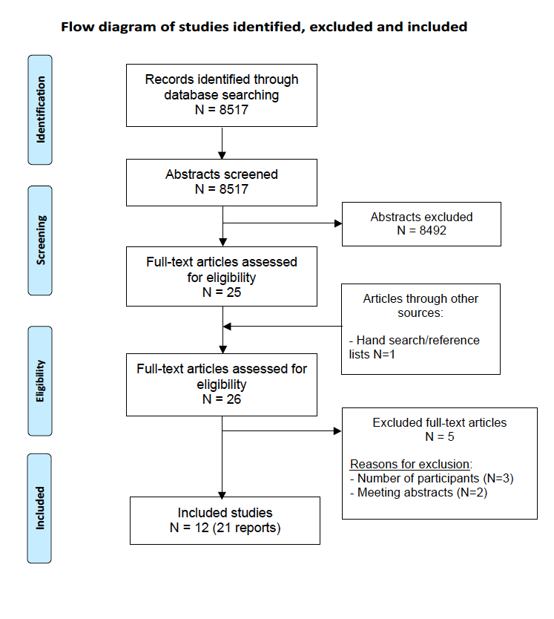
Figure 1. PRISMA flow diagram of studies identified, excluded and included

2. Characteristics of included studies
Twelve studies recruiting a total of 1,098 patients (823 in the intervention group vs 275 in the control group [Table 1]) were identified, including nine comparative studies (one RCT and two restrospective NRCSs with matched pair design) [7,15–24] and three single-arm case series[25–27]. Three types of comparisons were found: prostate-sparing vs radical cystectomy, capsule-sparing vs radical cystectomy and nerve-sparing vs radical cystectomy. None of the published studies comparing seminal vesicle-sparing cystectomy vs radical cystectomy was eligible for inclusion. Two studies [23,24] compared different types of sexual-preserving techniques.

Table 1. Baseline characteristics of all included studies

Study ID  (Author and country) | Type of study |  |  | Type of surgery | Number of patients |  |  | Median Follow-up (months)
Study ID  (Author and country) |  |  | Recruitment period | Type of surgery | Entire study | Intervention | Control | Intervention | Control
Jacobs 2015; USA | RCT | Prospective | 2007-2011 | Capsule sparing  vs Nerve sparing | 40 | CS:20 | NS:20 | 41 | 37
De Vries 2009/ Mertens 2014; Netherlands | Comparative | Retrospective (Matched pair) | 1994-2006 | Prostate sparing  vs RC | 126 | 63 | 63 | 76 | 56
Basiri 2012; Iran | Comparative | Retrospective (Matched pair) | 2003-2008 | Capsule sparing  vs RC | 50 | 23 | 27 | 39 | 35
Wang 2008; China | Comparative | Retrospective | 2000- 2006 | Capsule sparing  vs RC | 36 | 27 | 9 | 3-84
Moon 2005; Korea | Comparative | Retrospective | 1999-2003 | Capsule sparing  vs RC | 35 | 17 | 18 | 16.1  (6-27) | 17.9  (6-44)
Vilaseca 2013; Spain | Comparative | Retrospective | 2006-2009 | Nerve sparing  vs RC | 44 | 11 | 33 | 21
El-Bahnasawy 2006 /Hekal 2009; Egypt | Comparative | Retrospective | 2003-2005 | Nerve sparing  vs RC | 60 | 30 | 30 | 38.8+19.2 | 42.9+26.9
Kessler 2004; Switzerland | Comparative | Retrospective | 1985-2003 | Nerve sparing  vs RC | 331 | 256 | 75 | 31.2 (IQR 12-72)
Colombo 2015; Italy | Comparative | Retrospective | 1997-2012 | Capsule sparing vs Seminal sparing vs Nerve sparing | 90 | CS:36 | SS:19  NS:35 | 58 (16–174) | CS: 141  SS: 36  NS: 113
Gotsadze 2008; Georgia | Single-arm case series | Retrospective | 1991-2005 | Prostate sparing | 87 | 87 |  | 36.8 ± 34.6  (9–161) *
Rozet 2008; France | Single-arm case series | Retrospective | 1992-2004 | Capsule sparing | 108 | 108 |  | 55 ± 3.6  (3-146.2)
Muto 2014; Italy | Single-arm case series | Retrospective | 1990-2009 | Capsule sparing | 91 | 91 |  | 102  (28-236)*
IQR: intercuartilie range; CS: capsule sparing; SS: seminal sparing; NS: nerve sparing
* Data expressed as mean

In the majority of cases, the open surgical approach was used. Only three studies reported that some patients underwent laparoscopic or robotic surgery[17,23,24]. The urinary diversion of choice was an orthotopic neobladder in the majority of studies. Only two studies reported heterotopic urinary diversions in less than 25% of recruited patients[20,22].
Median follow-up ranged from 16.1-141 months, and was longer than 3 years in 9 studies[15,17,18,21,23–27], with 3 of them presenting results at a median follow-up longer than 5 years[15,24,27].
Patient selection was different across all the identified studies and is summarized in Table 2. Median age ranged from 47 to 62 years in the intervention group and from 46 to 61 years in the control group. Prostate cancer was ruled out with DRE, PSA, transrectal biopsy or biopsy of the prostatic urethra by TURP in all of the sexual function-preserving cystectomy (SPC) techniques, except in those performing nerve-sparing cystectomy where no prostatic tissue was left in place.

Table 2. Patient selection in all included studies.

Study ID | Type of surgery | INCLUSION CRITERIA
Study ID | Type of surgery | Tumour-free (bladder neck/ prostatic urethra) | Absence of Prostate Cancer |  |  |  |  |  | Organ confined disease |  | Normal preoperative sexual function | Age
Study ID | Type of surgery | Tumour-free (bladder neck/ prostatic urethra) | DRE | PSA | Biopsy (TRUS) |  | Biopsy (TURp) |  |  |  | Normal preoperative sexual function | Age
Jacobs 2015 | Capsule sparing  Nerve sparing |  |  |  |  |  |  |  |  | 
De Vries 2009/ Mertens 2014 | Prostate sparing  vs RC |  |  |  |  |  |  |  |  |  | 
Basiri 2012 | Capsule sparing  vs RC |  |  |  |  |  |  | 
Wang 2008 | Capsule sparing  vs RC |  |  |  |  |  |  | 
Moon 2005 | Capsule sparing  vs RC |  |  |  |  |  |  |  |  |  | 
Vilaseca 2013 | Nerve sparing  vs RC |  |  |  |  |  |  |  |  |  |  | 
El-Bahnasawy 2006 /Hekal 2009 | Nerve sparing  vs RC |  |  |  |  |  |  |  |  |  |  | 
Kessler 2004 | Nerve sparing  vs RC |  |  |  |  |  |  |  |  | 
Colombo 2015 | Capsule sparing  Seminal sparing  Nerve sparing |  |  |  |  |  |  |  |  |  |  | 
Gotsadze 2008 | Prostate sparing |  |  |  |  |  |  |  |  |  |  | 
Rozet 2008 | Capsule sparing |  |  |  |  |  |  | 
Muto 2014 | Capsule sparing |  |  |  |  |  |  |  |  |  |  | 

3. Risk of bias and confounding assessment
RoB and confounding assessments for RCT, NRCSs and case series are presented in Figures 2-4. The single RCT[23] had an overall low RoB, whilst for NRCSs, the majority of studies had high RoB across more than 50% of domains. For case series, the overall risk of bias was moderate.
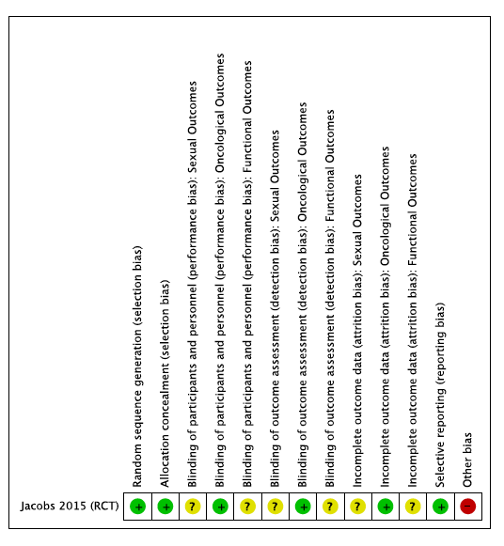
Figure 2. Risk of bias and confounding assessments for RCT

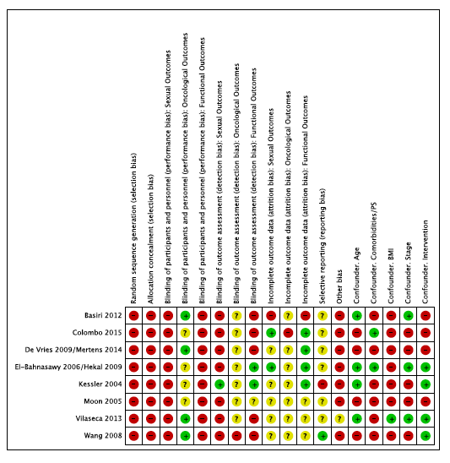
Figure 3. Risk of bias and confounding assessments for NRCSs

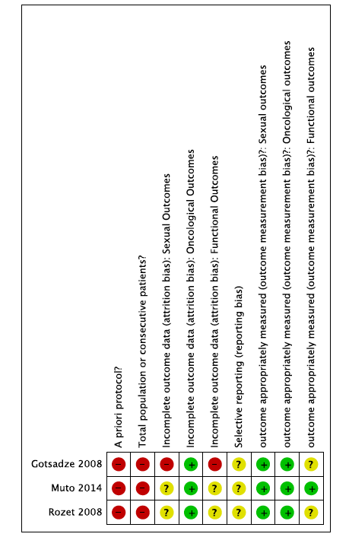
Figure 4. Risk of bias and confounding assessments for case series

4. Comparisons of interventions results
4.1 Data from comparative studies
Oncological results
The clinical and pathological characteristics of the patients are presented in Table 3. Local recurrence after SPC was commonly defined as any urothelial cancer recurrence below the iliac bifurcation within the pelvic soft tissue and ranged from 7.9-61.1% (vs 15.9-55.0% in the control group). Metastatic recurrence was reported in only one comparative study with rates of 28.6 and 33.3% in both groups[15]. The use of neoadjuvant therapy was scarcely reported and only two studies reported some use of adjuvant chemotherapy in this setting [15,17]. No differences were found in any of the three comparative studies reporting oncological outcomes for the prostate-, capsule- or nerve-sparing techniques (Table 4 and Figure 5).
Table 3. Oncological outcomes: Clinical and pathological characteristics of participants in all included studies

Study ID | Clinical Bladder Stage (>T2/N+) |  |  | Pathological Bladder Stage (>T2/N1) |  |  | Incidental Prostate Cancer
Study ID | Intervention | Control | p-value | Intervention | Control | p-value | Intervention | Control | p-value | GS >=8
Jacobs 2015 | T2+T3: 50.0%  N+:0% | T2+T3: 70.0%  N+:0% | 0.23 | >T2: 10.0%  N1: 10.0% | >T2: 20.0%  N1: 25.0% | 0.45  0.19 | 15.0% | 40.0% | 0.15 | 0%
De Vries 2009/ Mertens 2014 | >T2: 15.9%  N+: 11.1% | >T2: 23.8%  N+: 11.1% | NS | >T2: 25.4%  N1: 28.6% | >T2: 34.9%  N1: 19.0% | NS  NS | 3.2% | 14.2% | - | -
Basiri 2012 | >T2: 17.4%  N+: 0% | >T2: 3.7%  N+:0% | 0.31 | >T2: 26.0% | >T2: 33.3% | 0.51 | 4.3% | 7.4% | 0.86 | 0%
Wang 2008 | - | - | - | >T2: 48.1% | >T2: 44.4% | >0.05 | - | - | - | -
Moon 2005 | >T2:0% | >T2:0% | NS | - | - | - | - | - | - | -
Vilaseca 2013 | >T2:0% | >T2:0% | NS | N1: 15.9% | - | - | - | - | - | -
El-Bahnasawy 2006 /Hekal 2009 | >T2:0% | >T2:0% | NS | >T2: 52.3%  N1: 9.5% | >T2: 54.1%  N1: 16.7% | 0.42  0.42 | - | - | - | -
Kessler 2004 | N+:0% | N+:0% |  | >T2: 51.7%  N1: 23.9% | - | - | - | - | - | -
Colombo 2015 | >T2:0% | >T2:0% | NS | >T2: (CS) 8.3%  N1: (CS) 2.8% | >T2: (NS) 8.6%; (SS) 5.3%  N1: (NS) 2.9%; (SS) 0% | 0.5  NR | CS: 0% | NS: 17.1%  SS: 15.8% | - | -
Gotsadze 2008 | - |  |  | >T2: 6.9%  N1: 19.5% |  |  | - |  |  | -
Rozet 2008 | - |  |  | >T2: 40.7%  N1: 13.9% |  |  | 5.5% |  |  | -
Muto 2014 | >T2:0%  N+:0% |  |  | >T2: 1.1%  N1: 0% |  |  | 2.2% |  |  | -
GS: Gleason Score; NS: non significant; CS: capsule sparing; SS: seminal sparing; NS: nerve sparing

Table 4. Oncological outcomes: Local recurrence and metastatic disease

Study ID | Type of surgery | Neoadyuvant chemotherapy  % (n/total) |  |  | LOCAL RECURRENCE  % (n/total) |  |  | METASTATIC DISEASE  % (n/total)
Study ID | Type of surgery | Intervention | Control | p-value | Intervention | Control | p-value | Intervention | Control | p-value
De Vries 2009/ Mertens 2014 | Prostate sparing  vs RC | 17.5%(11/63) | 12.7%(8/63) | - | 7.9% (5/63) | 15.9% (10/63) | 0.1 | 28.6% (18/63) | 33.3% (21/63) | 0.4
Gotsadze 2008 | Prostate sparing | - | - | - | 1.2% (1/87) |  |  | 8.0% (7/87)
Basiri 2012 | Capsule sparing  vs RC | 0 | 0 | ns | 61.1% (11/18) | 55.0% (11/20) | >0.05 | - | - | -
Wang 2008 | Capsule sparing  vs RC | 0 | 0 | ns | - | - | - | - | - | -
Moon 2005 | Capsule sparing  vs RC | - | - | - | - | - | - | - | - | -
Rozet 2008 | Capsule sparing | 0 |  |  | 4.6% (5/108) |  |  | 33.3% (36/108)
Muto 2014 | Capsule sparing | - |  |  | 2.2% (2/91) |  |  | 6.6% (6/91)
Jacobs 2015 (CS group) | Capsule sparing | 40%(8/20) |  |  | - |  |  | -
Colombo 2015 (CS group) | Capsule sparing | - |  |  | 5.5% (2/36) |  |  | 5.5% (2/36)
Vilaseca 2013 | Nerve sparing  vs RC | - | - | - | 18.2% (2/11) | 21.2% (7/33) | 0.14 | - | - | -
El-Bahnasawy 2006 / Hekal 2009 | Nerve sparing  vs RC | 0 | 0 | ns | - | - | - | - | - | -
Kessler 2004 | Nerve sparing  vs RC | - | - | - | - | - | - | - | - | -
Jacobs 2015 (NS group) | Nerve sparing | 50%(10/20) |  |  | - |  |  | -
Colombo (NS group) | Nerve sparing | - |  |  | 5.7% (2/35) |  |  | 0% (0/35)
RC: radical cystectomy; CS: capsule sparing; NS: nerve sparing; ns: non-significant
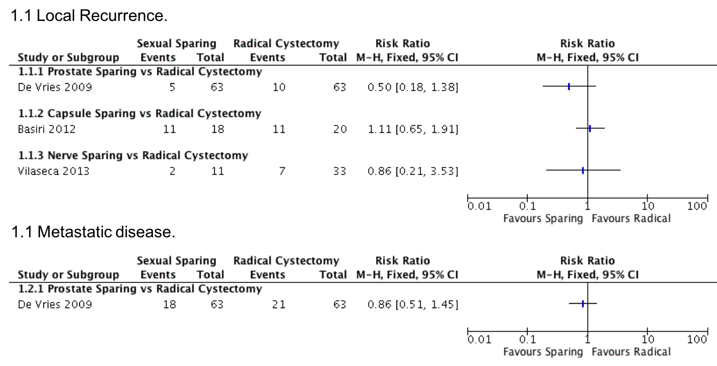

Figure 5. Forest plot for oncological outcomes: Local recurrence and metastatic disease

Two comparative studies presented results of disease-specific survival (DSS) or overall survival (OS), showing no statistically significant differences between groups for the prostate- and capsule-sparing techniques at a median follow-up of 3 to 5 years (Table 5) and one of the studies comparing two different types of intervention did not show any difference in recurrence-free survival (RFS), progression-free survival (PFS), DDS or OS between groups[23].
For those techniques preserving prostatic tissue (prostate or capsule sparing) rates of incidental prostate cancer in the intervention group ranged from 0 to 15%. Preoperatively, mean PSA ranged from 1.0 to 2.2ng/mL and postoperatively from 0.1 to 1.53ng/mL. None of the series reported incidental prostate cancer with Gleason score ≥8 (Table 3).

Table 5. Oncological outcomes: recurrence-free survival, progression-free survival, disease-specific survival and overall survival

Study ID | Type of surgery | RFS |  |  | PFS |  |  | DSS |  |  | OS
 |  | Intervention | Control | p-value | Intervention | Control | p-value | Intervention | Control | p-value | Intervention | Control | p-value
De Vries 2009/  Mertens 2014 | Prostate sparing vs RC | - | - | - | - | - | - | 3 yr: 77%  5 yr: 66% | 3 yr: 68%  5 yr: 64% | p=0.6 | - | - | -
Gotsadze 2008 | Prostate sparing | - |  |  | - |  |  | - |  |  | -
Basiri 2012 | Capsule sparing vs RC | - | - | - | - | - | - | 5yr: 35% | 5yr:13% | - | 5yr: 47% Median OS: 48mo | 5yr: 30%  Median OS: 36 mo | p>0.05
Wang 2008 | Capsule sparing vs RC | - | - | - | - | - | - | - | - | - | - | - | -
Moon 2005 | Capsule sparing vs RC | - | - | - | - | - | - | - | - | - | - | - | -
Rozet 2008 | Capsule sparing | - |  |  | - |  |  | 5yr: 71% |  |  | 5yr: 67%
Muto 2014 | Capsule sparing | - |  |  | 6yr CSS: 90.2%- 93.3% | - | - | 6yr: 88.5%-93.3% | - | - | 6yr: 89.6%-93.3% | - | -
Vilaseca 2013 | Nerve sparing vs RC | - | - | - | - | - | - | - | - | - | - | - | -
El-Bahnasawy 2006 / Hekal 2009 | Nerve sparing vs RC | - | - | - | - | - | - | - | - | - | - | - | -
Kessler 2004 | Nerve sparing vs RC | - | - | - | - | - | - | - | - | - | - | - | -
Jacobs 2015 | Capsule vs Nv sparing | - | - | p>0.05 | - | - | p>0.05 | - | - | - | - | - | p >0.05
Colombo 2015 | Capsule vs Seminal vs Nerve sparing | - | - | - | - | - | - | - | - | - | - | - | -
RFS: recurrence free survival; PFS: progression free survival; DSS: disease specific survival; OS: overall survival; yr: year; mo:months
Kaplan-Meier survival estimates reported by authors.

Sexual and functional results
Sexual outcomes were evaluated in 832 patients (699 in the intervention group and 133 in the control group) using validated-questionnaires (International Index Erectile Function; Erection Hardness Score; Bladder cancer Index;) in eight studies [7,17,20,22–25,27] and self-impression reports in seven. Four studies described some type of ejaculation outcome, such as antegrade or retrograde ejaculation[16,17,25,27]
Postoperative potency was significantly better than standard cystectomy in the SPC groups in 6 studies comparing SPC vs RC (p<0.05), ranging 89.7%, 58.0-93.8% and 77.0-78.8% for prostate, capsule or nerve-sparing techniques, respectively (Table 6 and Figure 6). Antegrade ejaculation was reported in 7-35.5% in two studies and 63.2%-100% reported retrograde ejaculation when addressed.
In the two studies comparing different sexual sparing techniques, only Colombo found differences in favour of capsule-sparing cystectomy or seminal-sparing cystectomy over the nerve-sparing cystectomy.
Table 6. Sexual function results

Study ID | Postoperative sexual function assessment |  |  |  | Sexual outcomes-potency
Study ID | Time frame (months) | Questionnaire | Self-impression | n evaluated  (Intervention vs Control) | Intervention | Control | p | Treatment ED
PROSTATE SPARING
De Vries 2009/ Mertens 2014 | NA | No | Yes | 87 (Int only) | 89.7% | - | - | NA
Gotsadze 2008 | NA | Yes, NR | No | 54 (Int only) | 79.6% | - | - | NA
CAPSULE SPARING
Basiri 2012 | 6 | Yes, IIEF-5 | Yes | 24 (12 vs 12) | 58.0% | 0% | 0.002 | NA
Wang 2008 | 6 | No | Yes | 30 (23 vs 7) | 83.0% | 43.0% | <0.05 | NA
Moon 2005 | 3-12 | No | Yes | 34 (16 vs 18) | 93.8% | 0% | <0.001 | PDE-5
Rozet 2008 | NA | - | - | - | - | - | - | -
Muto 2014 | 6 | Yes, IIEF | No | 91 | 95-100% | - | - | 1.0% PDE-5  3.4% PG (alprostadil)
Jacobs  (CS group) | 12 | Yes,  BCI | Yes | 20 | 50.0% | - | - | -
Colombo  (CS group) | 24 | Yes, IIEF-5 | Yes | 36 | 91.6% | - | - | -
NERVE SPARING
Vilaseca 2013 | NR | Yes, EHS | No | 30 (9-21) | 77.8% | 4.5% | <0.001 | 100% Intervention, 23.0% control (PDE-5)
El-Bahnasawy 2006 / Hekal 2009 | 12 | Yes, IIEF-5 | No | 21 | 78.8% | 0% | <0.05 | 21.0% PDE-5
Kessler 2004 | 3-24 | Yes, NR | Yes | 331 (256-75) | 77.0% | - | <0.001 | 8.0% PDE-5, 16.0% PG
Jacobs  (NS group) | 12 | Yes, BCI | Yes | 20 | 45.0% | - | - | -
Colombo  (NS group) | 24 | Yes, IIEF-5 | Yes | 35 | 28.6% | - | - | -
INTERVENTION vs INTERVENTION
Jacobs 2015  - Capsule sparing  - Nerve sparing | 12 | Yes, BCI | Yes | 40 (20-20) | 50.0%  45.0% | - | 0.06 | 55.0% PDE-5
Colombo 2015  - Capsule sparing  - Nerve sparing  - Seminal Sparing | 24 | Yes, IIEF-5 | Yes | 90  CS:36  NS:35  SS:19 | 91.6%  28.6%  84.2% | - | <0.001 | 19.4% PDE-5  54.2% PDE-5  31.0% PDE-5
CS: capsule sparing; NS: nerve sparing; SS: seminal sparing; NA: non available; NR: non reported; ED: erectile dysfunction; IIEF: International Index Erectile Function; EHS: Erection Hardness Score; BCI: Bladder cancer Index; PDE-5: phosphodiesterase type 5 inhibitor; PG: prostaglandins;

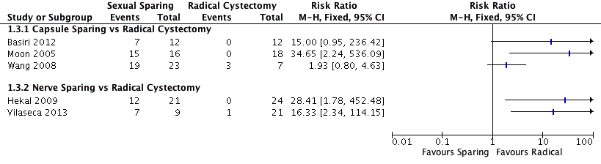
Figure 6. Forest plot for sexual function results

Functional results were evaluated in 917 patients (720 in the intervention group and 197 in the control group). Incontinence was defined as the use of 1 or more pads in the majority of studies. The type of measurement used to evaluate continence varied across all studies. Number of pads was used in 6 studies [16,17,19–21,24] and self-impression was used in 7 studies, only 1 study [20] used pad-test for continence evaluation and 2 studies used voiding diaries [21,27].
Day-time continence ranged from 88.9-100% and night-time continence from 55.0-88.9% in the SPC with no difference observed in the majority of the studies. Only two comparative studies showed differences in favour of the sexual-preserving techniques[7,18]

Table 7. Continence results
Study ID | Postoperative continence function assessment |  |  | Urinary outcomes-Continence
Study ID | Time frame (months) | Measurements | n evaluated (Intervention-Control) | Day-time Intervention | Day-time Control | p | Night-time Intervention | Night-time Control | p
PROSTATE SPARING
De Vries 2009/Mertens 2014 | NA | Nº pads, self-impression, PVR | 105 | 96.0% | - |  | 82.0% | -
Gotsadze 2008 | NA | - | 85 | 100% | - |  | 96.0% | -
CAPSULE SPARING
Basiri 2012 | 6 | Nº pads, self-impression | 29 (16-13) | 94.0% | 92.0% | >0.05 | 81.0% | 62.0% | >0.05
Wang 2008 | 6 | Self-impression | 36 (27-9) | 88.9% | 33.3% | <0.05 | 88.9% | 33.3% | <0.05
Moon 2005 | 1-9 | Nº pads | 34 (16-18) | 100% | 94.0% | 0.52 | 81.0% | 50.0% | 0.06
Rozet 2008 | NA | - | - | - | - | - | - | - | -
Muto 2014 | NA | Self-impression, voiding diary | 91 (61-30) | 95.0-100% | - | 0.2 | 31.0-50.0% | - | 0.07
Jacobs 2015  (CS group) | 12 | Self-impression, BCI questionnaire | 20 | BCI reduction*:  13±30 |  |  | NA
Colombo 2015  (CS group) | 48 | Nº pads | - | 94.4% |  |  | 77.8%
NERVE SPARING
Vilaseca 2013 | NA | Nº pads, pad-test | 33 (11-22) | 91.0% | 91.0% | 0.99 | 55.0% | 50.0% | 0.81
El-Bahnasawy 2006 / Hekal 2009 | 12 | Nº pads, self-impression, voiding diary | 60 (30-30) | 97.0% | 93.0% | NA | 70.0% | 63.0% | >0.05
Kessler 2004 | 12 | Self-impression | 331 (256-75) | 92.0% |  | 0.02 | 67.0% | - | 0.86
Jacobs 2015  (NS group) | 12 | Self-impression, BCI questionnaire | 20 | BCI reduction*:  28±33 | - | - | - | - | -
Colombo 2015  (NS group) | 48 | Nº pads | - | 82.9% | - | - | 62.9% | - | -
INTERVENTION VS INTERVENTION
Jacobs 2015 (RCT)  - Capsule sparing  - Nerve sparing | 12 | Self-impression, BCI questionnaire | 34 | BCI reduction*:  13±30  28±33 | - | 0.1 | NA | -
Colombo 2015  - Capsule sparing  - Nerve sparing  - Seminal sparing | 48 | Nº pads | 79 | 94.4%  82.9%  89.5% |  | 0.3 | 77.8%  62.9%  63.2% | - | 0.05
CS: capsule sparing; NS: nerve sparing; SS: seminal sparing; NA: non available; NR: non reported; PVR: post-void residual measurements; BCI: Bladder Cancer Index;
* Data expressed as: mean±SD

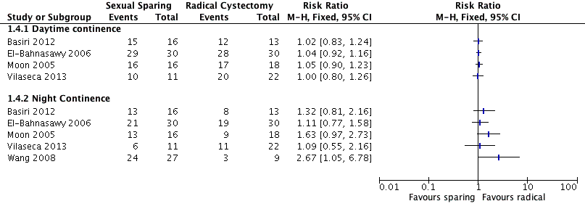
Figure 7. Forest plot for continence results

In the two studies comparing different SPC techniques, no differences were observed for day-time continence, and only Colombo found differences in favour of capsule-sparing cystectomy in night-time continence.
Only one comparative study (Basiri 2012) presented data of patients dependent on clean intermittent catheterization in both groups. In that study, there were differences in favour of the standard cystectomy (31% in the capsule sparing group vs 8% in the control group). The rest of the studies, presented rates of CIC for the intervention group that ranged from 2% to 31%.

4.2 Data from single-arm case series
The three single-arm case series included in this review[25–27] presented oncological results that were slightly better than in comparative studies in terms of local recurrence (1.2-4.6%), with similar rates of metastatic recurrence (6.6-33.3%). DSS and OS at a median time of 5 and 6 years were also better studies for two of the studies[26,27].
Potency rates ranged from 79.6-100% and continence rates were 95.0-100% for day-time continence and 31.0-96.0% for night-time continence

DISCUSSION
Principal findings
The review found that sexual outcomes in terms of postoperative potency were significantly better in the SPC groups compared with standard radical cystectomy in all comparative studies that reported this outcome[7,17–20,22]. In addition, large case series of SPC showed potency rates of 79-100%[25–27]. In terms of studies comparing different sparing techniques, conflicting findings were found. Jacobs et al[23], the only RCT included in this review, compared capsule-sparing vs nerve-sparing cystectomy and found potency rates in both groups were not significantly different (50% vs 40%). Colombo et al[24] analysed three different techniques, finding capsule-sparing cystectomy and seminal-sparing cystectomy to be superior over nerve-sparing cystectomy; however, no real conclusions can be drawn due to the limited number of patients included in the study and its retrospective design.
It has been postulated that sparing therapies could have an impact on continence outcome in series with continent urinary diversion. Large cystectomy case series with long follow-up have reported diurnal incontinence rates of 8-10% and nocturnal incontinence of 20-30%[28,29]. In this review, continence outcomes were similar in patients submitted to standard cystectomy or to any kind of preserving technique. Only two studies showed an improvement in functional outcomes in favour of the sexual preserving techniques, but considering the low number of patients[18] and the retrospective study design[7], as well as the wide confidence intervals, these results should be interpreted with caution. When comparing sparing techniques, Jacobs et al’s RCT[23], with a primary objective of continence-outcome assessment, showed no differences between capsule-sparing vs nerve-sparing cystectomy.
Finally, there has been a concern that oncological outcomes could be compromised by sparing techniques with an increased risk of widespread unusual metastases [30,31]Local recurrence was <20% in all studies except one [17] with a median follow-up period of 21 to 102 months, with no significant differences between the prostate-, capsule- or nerve-sparing techniques. Basiri et al[17] reported higher rates of local recurrence (61% vs 55%), with no significant differences between groups. This higher recurrence rate in both groups in the study compared with the other studies may reflect clinical heterogeneity in terms of differences in patient and disease characteristics between the studies. For metastatic disease, only one comparative study[15] measured the outcome, with no differences found between groups (29 vs 33% for prostate-sparing cystectomy vs radical cystectomy, respectively). The other studies reporting metastatic recurrence were case series showing rates of 0% for nerve-sparing technique[24] and 5-33% for prostate or capsule sparing techniques[24–27]. In seven studies, the oncological outcomes were presented as RFS, PFS, DSS or OS. No differences were found in the two studies comparing prostate- or capsule-sparing cystectomy vs radical cystectomy[15,17], nor in the studies comparing the different SPC techniques[23,24]. In summary, none of the comparative studies found any differences in oncological outcomes between SPC vs radical cystectomy, or between the different sparing techniques, regardless of which measure of oncological effectiveness was reported, or the time point of measurement.
Implications for clinical practice and further research

Although sexual preserving techniques were first described in the 1980s[5], there are major uncertainties and unanswered questions, including the ideal candidates for these procedures, the most effective technique, the magnitude and nature of functional benefits, and if oncological outcomes are compromised[30,31]. There is a lack of clear guidelines on the topic. This systematic review was hampered by heterogeneity in the outcomes reported, and lack of standardization in the definitions of outcomes, the tools used to measure the functional outcomes, and the time point at which these outcomes are measured. The field of nerve sparing bladder cancer surgery would benefit form a core outcome set[32] and well-designed RCTs[33]. Nonetheless, the present study represents the first systematic review addressing the effectiveness of different sexual preserving cystectomy techniques in men.
Considering all the points previously discussed, the overall oncological results appear to be acceptable, but selection of patients is of paramount importance. Although patient selection was different across all the studies, in the majority, the authors stated some oncological inclusion criteria (i.e. tumour-free in the bladder neck and prostatic urethra, or the presence of organ confined disease) and some functional criteria as a normal preoperative sexual function, or the age of the patients. A sexual-preserving cystectomy could be offered to motivated men aiming to preserve their sexual function with organ-confined disease and the absence of tumour in the bladder neck, prostate or prostatic urethra. Magnetic resonance imaging can be considered in the preoperative assessment in order to improve local staging[1]. Prior to surgery, and mainly for those techniques where some prostate tissue is left in place, any tumour at the prostate, prostatic urethra or bladder neck should be ruled out with preoperative PSA, TURP or transrectal biopsy.
Based on the results of this systematic review, none of the SPC techniques (Prostate/Capsule/Nerve Sparing) can be recommended over the others due to the lack of any clear superiority, in the limited number of studies comparing them.
The impact of new techniques and approaches such as robotic surgery on outcomes remains unknown[34–36], and only a small number of patients included in this review were operated on with a robot-assisted device. Finally, all of the described preserving techniques have a considerable learning curve, which could hinder the implementation of the procedures even in specialist centres.
Strengths and limitations
The main strength of the review is the robust, reproducible and transparent methodology based on Cochrane Review principles. The review elements, including research questions, participants, interventions, comparison and outcomes (PICO), search strategy, and study inclusion and exclusion criteria were developed in conjunction with the EAU MIBC Guideline Panel which is a multi-disciplinary panel of expert urologists, oncologists, pathologists, radiologists, methodologists and patient representative. The quality of evidence appraisal was based on meticulous risk of bias and confounding assessment using standardized tools. The findings of this review were incorporated into the panel’s guideline update for 2016. The main limitations include the clinical and methodological heterogeneity present across studies, such that it is difficult to be certain how comparable the results of studies are, and to determine the impact of important confounders on the outcomes. In addition, the majority of studies were small, retrospective non-randomised studies with moderate to high risks of bias and confounding, thereby compromising the overall quality of the evidence base. In order to minimize these limitations, studies with small numbers of participants or short follow-up were excluded.

CONCLUSION
Prostate-, capsule- or nerve-sparing cystectomy appear to yield better sexual outcomes compared with standard cystectomy without compromising oncological outcomes. However, the quality of the evidence was low to moderate, and numerous uncertainties remain. As such, until higher quality evidence emerges, it seems prudent to restrict sexual function-preserving cystectomy to carefully selected men keen to preserve their sexual function, who have organ-confined disease and absence of tumour in the bladder neck, prostate or prostatic urethra. Such patients should be carefully counselled regarding the many prevalent uncertainties surrounding the procedure, and closely followed-up and monitored.
REFERENCES
[1] Alfred Witjes J, Lebret T, Compérat EM, Cowan NC, De Santis M, Bruins HM, et al. Updated 2016 EAU Guidelines on Muscle-invasive and Metastatic Bladder Cancer. Eur Urol 2017;71:462–75. doi:10.1016/j.eururo.2016.06.020.
[2] Babjuk M, Burger M, Zigeuner R, Shariat SF, van Rhijn BWG, Compérat E, et al. EAU guidelines on non-muscle-invasive urothelial carcinoma of the bladder: update 2013. Eur Urol 2013;64:639–53. doi:10.1016/j.eururo.2013.06.003.
[3] Hautmann RE, de Petriconi RC, Volkmer BG. Lessons learned from 1,000 neobladders: the 90-day complication rate. J Urol 2010;184:990–4. doi:10.1016/j.juro.2010.05.037.
[4] Zippe CD, Raina R, Massanyi EZ, Agarwal A, Jones JS, Ulchaker J, et al. Sexual function after male radical cystectomy in a sexually active population. Urology 2004;64:682-685-686. doi:10.1016/j.urology.2004.05.056.
[5] Schlegel PN, Walsh PC. Neuroanatomical approach to radical cystoprostatectomy with preservation of sexual function. J Urol 1987;138:1402–6.
[6] Davila HH, Weber T, Burday D, Thurman S, Carrion R, Salup R, et al. Total or partial prostate sparing cystectomy for invasive bladder cancer: long-term implications on erectile function. BJU Int 2007;100:1026–9. doi:10.1111/j.1464-410X.2007.07169.x.
[7] Kessler TM, Burkhard FC, Perimenis P, Danuser H, Thalmann GN, Hochreiter WW, et al. Attempted nerve sparing surgery and age have a significant effect on urinary continence and erectile function after radical cystoprostatectomy and ileal orthotopic bladder substitution. J Urol 2004;172:1323–7.
[8] Terrone C, Porpiglia F, Cracco C, Tarabuzzi R, Cossu M, Renard J, et al. Supra-ampullar cystectomy and ileal neobladder. Eur Urol 2006;50:1223–33. doi:10.1016/j.eururo.2006.07.049.
[9] Hernandez V, Linares E, Dunn J, Yuan Y, MacLennan S, Lam T, et al. What are the oncological and functional outcomes of sexual-function preserving cystectomy compared with standard radical cystectomy in men with bladder cancer? n.d.
[10] Moher D, Liberati A, Tetzlaff J, Altman DG, PRISMA Group. Preferred reporting items for systematic reviews and meta-analyses: the PRISMA statement. PLoS Med 2009;6:e1000097. doi:10.1371/journal.pmed.1000097.
[11] Higgins JPT, Green S, editors. Cochrane handbook for systematic reviews of interventions v.5.0.2. The Cochrane Collaboration, 2011. http://www.cochrane-handbook.org/. Accessed February 2014. n.d.
[12] Deeks JJ, Dinnes J, D’Amico R, Sowden AJ, Sakarovitch C, Song F, et al. Evaluating non-randomised intervention studies. Health Technol Assess Winch Engl 2003;7:iii–x, 1-173.
[13] Viswanathan M, Ansari MT, Berkman ND, Chang S, Hartling L, McPheeters M, et al. Assessing the Risk of Bias of Individual Studies in Systematic Reviews of Health Care Interventions. Methods Guide Eff. Comp. Eff. Rev., Rockville (MD): Agency for Healthcare Research and Quality (US); 2008.
[14] Dalziel K, Round A, Stein K, Garside R, Castelnuovo E, Payne L. Do the findings of case series studies vary significantly according to methodological characteristics? Health Technol Assess Winch Engl 2005;9:iii–iv, 1-146.
[15] de Vries RR, Nieuwenhuijzen JA, van Tinteren H, Oddens JR, Visser O, van der Poel HG, et al. Prostate-sparing cystectomy: long-term oncological results. BJU Int 2009;104:1239–43. doi:10.1111/j.1464-410X.2009.08615.x.
[16] Mertens LS, Meijer RP, de Vries RR, Nieuwenhuijzen JA, van der Poel HG, Bex A, et al. Prostate sparing cystectomy for bladder cancer: 20-year single center experience. J Urol 2014;191:1250–5. doi:10.1016/j.juro.2013.11.031.
[17] Basiri A, Pakmanesh H, Tabibi A, Radfar MH, Tajalli F, Ahadi B, et al. Overall survival and functional results of prostate-sparing cystectomy: a matched case-control study. Urol J 2012;9:678–84.
[18] Wang X-H, Luo X, Chen S-Q. [Impact of preservation of distal prostatic capsula and seminal vesicle on functions of orthotopic ideal neobladder and erectile function of bladder cancer patients]. Ai Zheng Aizheng Chin J Cancer 2008;27:62–5.
[19] Moon KH, Park S, Ahn H. Nerve and Seminal Sparing Cystectomy for Bladder Cancer. Korean J Urol 2005;46:555–60.
[20] Vilaseca A, García-Cruz E, Ribal MJ, Pérez Márquez M, Alcaraz A. Erectile function after cystectomy with neurovascular preservation. Actas Urol Esp 2013;37:554–9. doi:10.1016/j.acuro.2013.02.012.
[21] el-Bahnasawy MS, Gomha MA, Shaaban AA. Urethral pressure profile following orthotopic neobladder: differences between nerve sparing and standard radical cystectomy techniques. J Urol 2006;175:1759–1763; discussion 1763. doi:10.1016/S0022-5347(05)01019-0.
[22] Hekal IA, El-Bahnasawy MS, Mosbah A, El-Assmy A, Shaaban A. Recoverability of erectile function in post-radical cystectomy patients: subjective and objective evaluations. Eur Urol 2009;55:275–83. doi:10.1016/j.eururo.2008.06.072.
[23] Jacobs BL, Daignault S, Lee CT, Hafez KS, Montgomery JS, Montie JE, et al. Prostate capsule sparing versus nerve sparing radical cystectomy for bladder cancer: results of a randomized, controlled trial. J Urol 2015;193:64–70. doi:10.1016/j.juro.2014.07.090.
[24] Colombo R, Pellucchi F, Moschini M, Gallina A, Bertini R, Salonia A, et al. Fifteen-year single-centre experience with three different surgical procedures of nerve-sparing cystectomy in selected organ-confined bladder cancer patients. World J Urol 2015;33:1389–95. doi:10.1007/s00345-015-1482-y.
[25] Gotsadze DT, Chakvetadze VT, Danelia EV. [Why and how to modify standard cystectomy]. Urol Mosc Russ 1999 2008:22–6.
[26] Rozet F, Lesur G, Cathelineau X, Barret E, Smyth G, Soon S, et al. Oncological evaluation of prostate sparing cystectomy: the Montsouris long-term results. J Urol 2008;179:2170-2174-2175. doi:10.1016/j.juro.2008.01.112.
[27] Muto G, Collura D, Rosso R, Giacobbe A, Muto GL, Castelli E. Seminal-sparing cystectomy: technical evolution and results over a 20-year period. Urology 2014;83:856–61. doi:10.1016/j.urology.2013.08.093.
[28] Hautmann RE, Volkmer BG, Schumacher MC, Gschwend JE, Studer UE. Long-term results of standard procedures in urology: the ileal neobladder. World J Urol 2006;24:305–14. doi:10.1007/s00345-006-0105-z.
[29] Stein JP, Skinner DG. Results with radical cystectomy for treating bladder cancer: a “reference standard” for high-grade, invasive bladder cancer. BJU Int 2003;92:12–7.
[30] Hautmann RE, Stein JP. Neobladder with prostatic capsule and seminal-sparing cystectomy for bladder cancer: a step in the wrong direction. Urol Clin North Am 2005;32:177–85. doi:10.1016/j.ucl.2005.02.001.
[31] Botto H, Sebe P, Molinie V, Herve J-M, Yonneau L, Lebret T. Prostatic capsule- and seminal-sparing cystectomy for bladder carcinoma: initial results for selected patients. BJU Int 2004;94:1021–5. doi:10.1111/j.1464-410X.2004.05097.x.
[32] Williamson P, Altman D, Blazeby J, Clarke M, Gargon E. Driving up the quality and relevance of research through the use of agreed core outcomes. J Health Serv Res Policy 2012;17:1–2. doi:10.1258/jhsrp.2011.011131.
[33] Catto JWF, Blazeby JM, Holmberg L, Hamdy FC, Brown J. In Defense of Randomized Clinical Trials in Surgery: Let Us Not Forget Archie Cochrane’s Legacy. Eur Urol 2017;71:820–1. doi:10.1016/j.eururo.2016.12.029.
[34] Asimakopoulos AD, Campagna A, Gakis G, Corona Montes VE, Piechaud T, Hoepffner J-L, et al. Nerve Sparing, Robot-Assisted Radical Cystectomy with Intracorporeal Bladder Substitution in the Male. J Urol 2016;196:1549–57. doi:10.1016/j.juro.2016.04.114.
[35] Canda AE, Atmaca AF, Altinova S, Akbulut Z, Balbay MD. Robot-assisted nerve-sparing radical cystectomy with bilateral extended pelvic lymph node dissection (PLND) and intracorporeal urinary diversion for bladder cancer: initial experience in 27 cases. BJU Int 2012;110:434–44. doi:10.1111/j.1464-410X.2011.10794.x.
[36] Haberman K, Wittig K, Yuh B, Ruel N, Lau C, Wilson TG, et al. The effect of nerve-sparing robot-assisted radical cystoprostatectomy on erectile function in a preoperatively potent population. J Endourol 2014;28:1352–6. doi:10.1089/end.2014.0315.
Appendix 1: Literature Search Strategy
The following databases will be searched using the provided search strategy: Medline, Embase, Cochrane CCRCT, CDSR and HTA
Search Strategy:
Cochrane Central Register of Controlled Trials, Cochrane Database of Systematic Reviews, –Cochrane Health Technology Assessment, Ovid MEDLINE(R) In-Process & Other Non-Indexed Citations and Ovid MEDLINE(R), , Embase
1 exp bladder tumor/ or exp Urinary Bladder Neoplasms/
2 (bladder adj3 (cancer* or carcin* or malig* or tumor* or tumour* or neoplas*)).ti,ab,kw.
3 exp transitional cell carcinoma/
4 or/1-3
5 exp cystectomy/
6 cystectomy.ti,ab,kw.
7 5 or 6
8 4 and 7
9 limit 8 to yr="2000 -Current"
10 case report/ or Case Reports/ or Comment/ or note/ or letter/ or editorial/ or news/
11 9 not 10
12 exp animals/ not humans/
13 11 not 12
14 (random: or clinical trial:).mp. or exp health care quality/
15 double-blind:.mp. or placebo:.tw. or blind:.tw.
16 (case control or case-control or (case* adj2 control*)).tw.
17 exp case control study/ or exp Case-Control Studies/
18 exp epidemiology/ or exp Epidemiologic Methods/
19 exp cohort analysis/ or exp Cohort Studies/
20 (cohort adj3 (study or studies or analy*)).tw.
21 exp cross-sectional study/ or exp Cross-Sectional Studies/
22 ((epidemiolog* adj2 (study or studies or method*)) or cross sectional).tw.
23 (followed or (follow up adj3 (study or studies))).tw. or exp Follow-Up Studies/
24 exp longitudinal study/ or exp Longitudinal Studies/
25 (longitudinal or prospective$ or retrospective$).tw.
26 ((valid* or comparative or evaluat* or multicenter or observ*) adj3 (studies or study)).tw.
27 (groups or trial* or controlled or compared).tw.
28 (Systematic review or meta-analysis).ti,ab,pt. or meta-analysis /
29 or/14-28
30 13 and 29
31 remove duplicates from 30

