AC losses in horizontally parallel HTS tapes for possible wireless power transfer applications

Boyang Shen*, Jianzhao Geng, Xiuchang Zhang, Lin Fu, Chao Li, Heng Zhang, Qihuan Dong, Jun Ma, James Gawith and T. A. Coombs*

Electrical Engineering Division, Department of Engineering, University of Cambridge, Cambridge CB3 0FA, United Kingdom

*Corresponding authors. Tel.: +44 7869688318 (B. Shen), +44 1223748315 (T. A. Coombs).

E-mail addresses: bs506@cam.ac.uk (B. Shen), jg717@cam.ac.uk (J. Geng), xz326@cam.ac.uk (X. Zhang), lf359@cam.ac.uk (L. Fu), cl644@cam.ac.uk (C. Li), hz301@cam.ac.uk (H. Zhang), qd210@cam.ac.uk (Q. Dong), jm2104@cam.ac.uk (J. Ma), jddg2@cam.ac.uk (J. Gawith), tac1000@cam.ac.uk (T.A. Coombs).

Abstract
This paper presents the concept of using horizontally parallel HTS tapes with AC loss study, and the investigation on possible wireless power transfer (WPT) applications. An example of three parallel HTS tapes was proposed, whose AC loss study was carried out both from experiment using electrical method; and simulation using 2D H-formulation on the FEM platform of COMSOL Multiphysics. The electromagnetic induction around the three parallel tapes was monitored using COMSOL simulation. The electromagnetic induction and AC losses generated by a conventional three turn coil was simulated as well, and then compared to the case of three parallel tapes with the same AC transport current. The analysis demonstrates that HTS parallel tapes could be potentially used into wireless power transfer systems, which could have lower total AC losses than conventional HTS coils.

Keywords: High Temperature Superconductor (HTS), HTS tape, Parallel tape, AC loss, Wireless Power Transfer (WPT).

Introduction
High temperature superconductor (HTS) based coils are able to carry large electrical current density. HTS coils are one of the most popular choices to be used in various superconducting applications such as Magnetic Resonance Imaging (MRI) , superconducting motors , superconducting transformers , and even for superconducting wireless power transmissions . However, alternating current (AC) losses are the crucial problems for HTS applications when they are operating under the action of AC currents and AC magnetic fields . AC losses could generate thermal dissipation and negatively affect overall electric power efficiency . As the result, reducing AC losses has become necessarily important for designing AC systems of superconducting application.
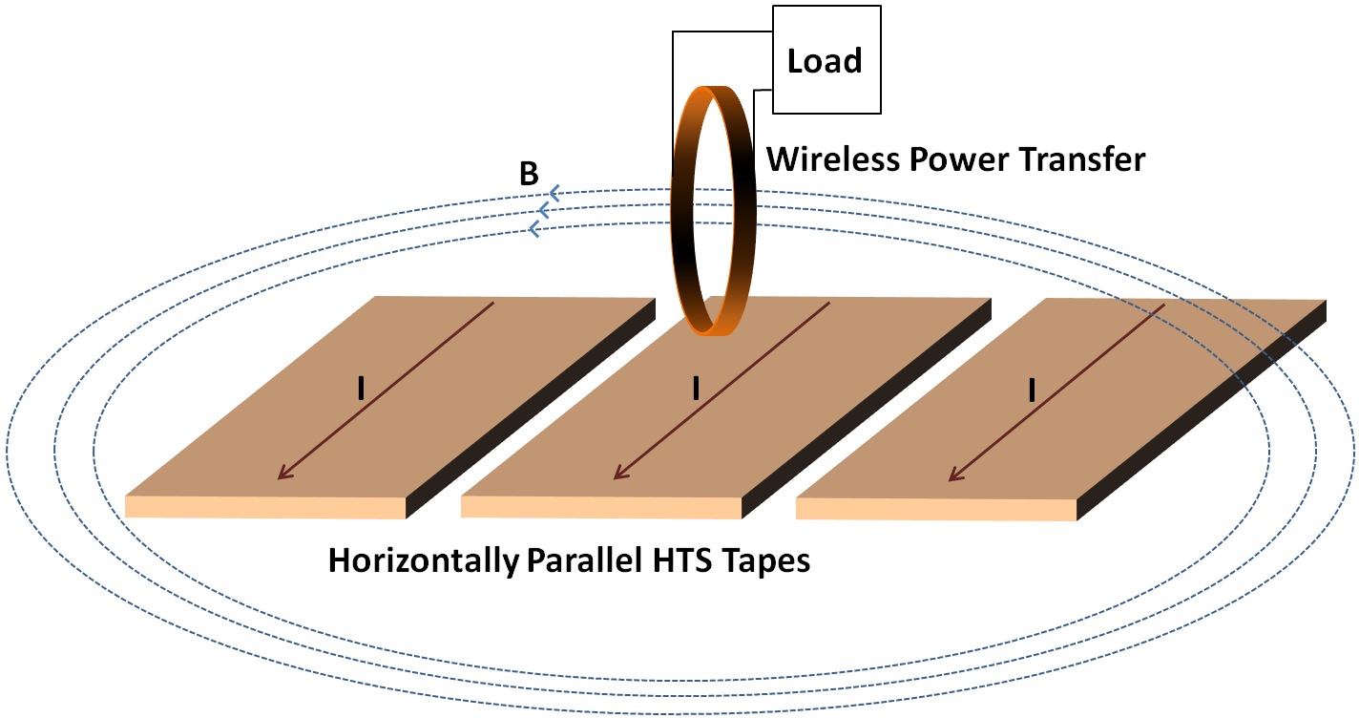
Figure 1. Configuration of multiple horizontally parallel HTS tapes, which could be potentially used in wireless power transfer applications.

HTS coils, generally with round and racetrack shape, are most widely used in various superconducting applications . HTS tapes are carrying the same direction of current and being closely packed in these coil structures. That is the main consequence of the AC loss in each turn of the HTS coil is larger than the AC loss in an equivalent single layer of HTS tape, which is owing to the field dependency of AC loss and anisotropic characteristics of HTS tapes .
It is a proper idea to apply the superconductors into wireless power transfer (WPT) system, because superconducting coils have theoretically zero resistance which significantly reduces the resistive losses from the transmitter and receiving coils . However, the AC losses from the HTS coil still potentially affect the total efficiency of WPT system. Therefore, for WPT system, it is reasonable to design the superconducting part which has less AC losses.
Although there are some literatures regarding the study on AC losses from two interactive parallel tapes , according to best of our knowledge, there is no literature of detailed AC losses study for the configuration of multiple horizontally parallel HTS tapes, and on the idea of using this configuration for wireless power transfer applications. As shown in Figure 1, this paper proposes the concept of utilisation horizontally parallel HTS tapes, whose configuration could be potentially used for wireless power transfer devices. First, we used the three horizontally parallel tapes as the basic configuration, and each parallel tape carried the current with same amplitude and direction. Secondly, we set up the experiment of this three-tape configuration and measured the AC losses from both middle and end tapes with increasing gap distance. These measurements were compared with COMSOL simulations. Thirdly, by using H-formulation electromagnetic simulation from COMSOL, we compared the AC losses from parallel tapes configuration and from the conventional coil configuration which used the same current and could equivalently provide comparable electromagnetic induction (dφ/dt) for wireless power transfer in a certain cross-section.

Experiment Set-up

AC loss measurements by electrical method
As the schematic shown in Figure 2, we used electrical method to measure the AC losses on HTS tapes. The experimental devices includes function generator, power amplifier, lock-in amplifier, transformer and compensation coil. Detailed description of experimental set-up was introduced in our previous work .
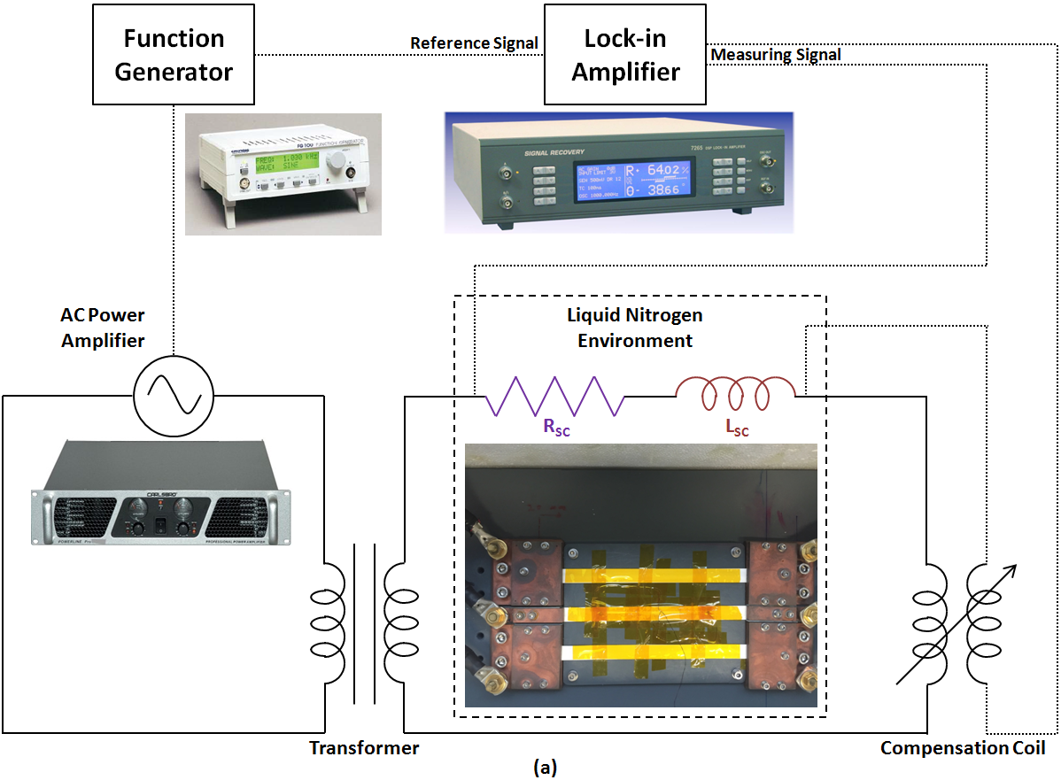
Figure 2. Experimental schematic of AC loss measurements using electrical method.

The transport AC losses can be calculated as :
$Q_{{\text{ac}}_{\text{loss}}}=\frac{I_{\text{rms}}⋅V_{\text{rms}}}{f}$ (1)
where I_{rms} is the AC transport current flowing through HTS tape, V_{rms} is the in-phase voltage with current I_{rms}, and f is the frequency of the AC current.
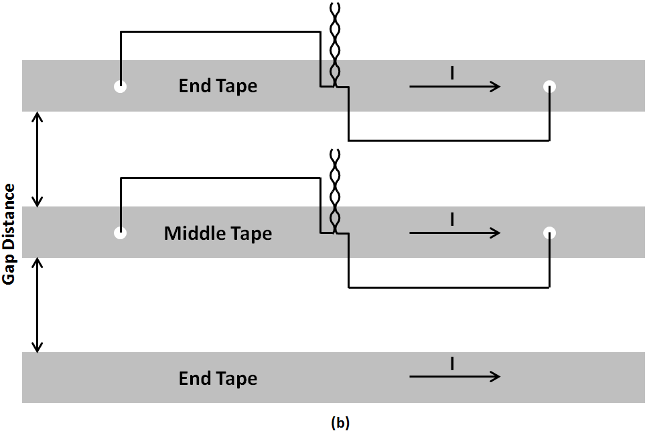
Figure 3. Graphical instruction of AC loss measurements on parallel HTS tapes.
The HTS tapes operated in the experiment are: 12 mm wide SuperPower SF12100. The critical current I_{c} was determined approximately 300 A by measurement in 77 K. As depicted in Figure 3, three side-by-side parallel HTS tapes were connected in series. Moreover, the copper cables for series connecting three HTS tapes were far away from the tapes for reducing their interactive field effect on tapes. Figure 3 presents the AC loss measurements on parallel HTS tapes. We measured the AC losses in both the middle and end tapes, with the distance of each tape’s gap increasing from 2 mm to 20 mm. .

Simulation Method

H-formulation
The H-formulation was used as the FEM method for this work, in order to calculate the losses from HTS tape under the action of AC current and AC magnetic field. H-formulation was able to compute the hysteresis losses, ferromagnetic losses and eddy-current losses for different layers of HTS tape . H-formulation consists of the equations of Faraday’s Law, Ampere’s Law, Ohm’s Law, constitutive Law, and E-J power Law . By combining these equations , the general form of partial differential equation (PDE) for variables H to be computed by COMSOL Multiphysics is:
$\frac{∂\left(μ_{0}μ_{r}H\right)}{∂t}+∇×\left(ρ∇×H\right)=0$ (2)
Where H is the magnetic field intensity, t is the time, ρ is the resistivity, μ₀ is the permeability of free space, μ_{r} is the relative permeability.

AC loss calculation
The real geometry of SuperPower SF12100, with superconducting layer 1 μm, was used for the COMSOL simulation. As the measured critical current in self-field was 300 A at 77K, the equivalent critical current density was calculated to be 2.5 × 10¹⁰ A/m². More detailed parameters are listed in TABLE I. SuperPower SF12100 tapes have the non-magnetic substrate, which means ferromagnetic losses is negligible. Low frequency (20 Hz) AC current was used for both the measurement and simulation, and therefore we could ignore the tiny amount of eddy-current AC losses in substrate and metal layers. In that circumstance, the hysteresis losses in the superconducting layer dominated the total AC losses of superconducting tape, thus only the real geometry superconducting layers of horizontally parallel tapes were simulated to compare with the experimental results. The AC losses of the domain of interest can be calculated using the integration of power density (E·J) :
$Q=\frac{2}{T}\int_{0\text{.}5T}^{T}{\int_{Ω}{E⋅J}}\underset{}{\overset{}{}}dΩ\text{dt}$ (3)
where Ω is the domain of interest and T is the period of cycle.
TABLE I
Parameters for the simulation of SuperPower SF12100 tape
Parameters | Value
Tape width | 12 mm
Superconducting layer thickness | 1 μm
μ₀ | 4π×10⁻⁷ H/m
n (E-J Power Law factor) | 25
J_{c0} | 2.5 ×10¹⁰ A/m²
E₀ | 10⁻⁴ V/m
Gap of tapes | 2, 4, 6, 8, 10, 12, 14, 16, 18, 20 mm

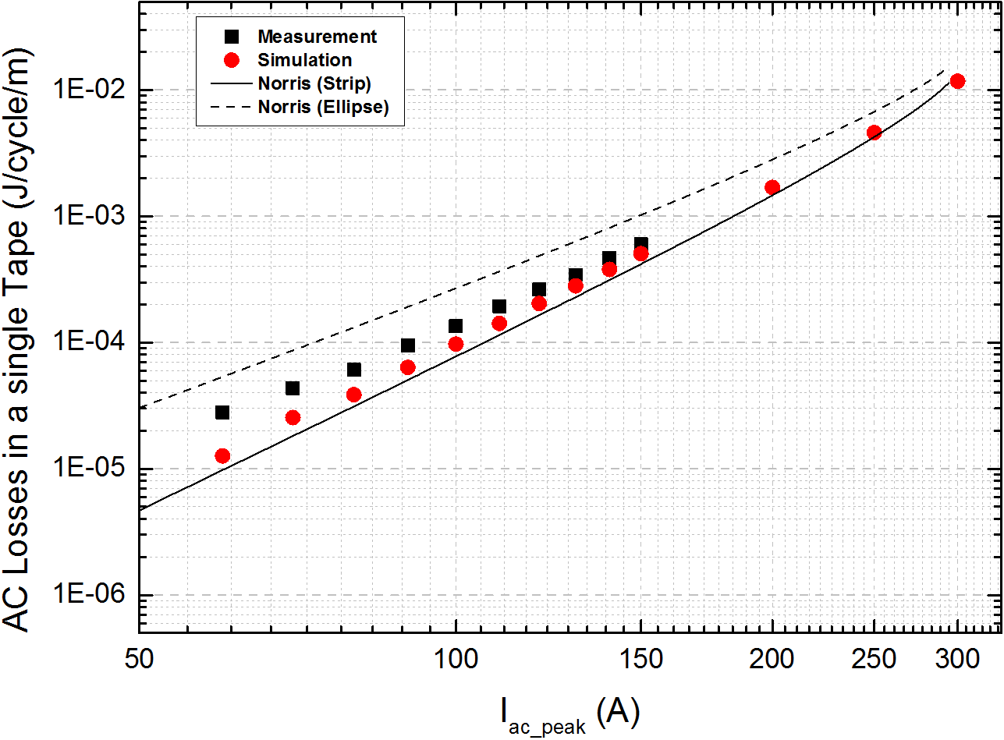
Figure 4. Comparison between measurement and simulation: AC losses in a single (isolated) tape, with the reference of Norris’s analytical solutions (Strip and Ellipse), at frequency of transport current 20 Hz.

AC Loss Measurement and Simulation

AC losses in a single (isolated) tape
First, the AC losses of a single (isolated) tape were measured and simulated, because they could be the reference for following measurement and simulation of middle and end tape in the parallel tapes. Figure 4 presents the measurement and simulation for the AC losses in a single tape, where Norris’s analytical solutions for both the Strip and Ellipse cases are also shown as the references . The AC transport current applied to single tape was increased from 60 A to 150 A of peak value for the measurement, while applied transport current was from 60 to 300 A of peak value for simulation. The frequency of transport current was set to be 20 Hz. It could be discovered that both the AC losses from simulation and measurement were between the range of Norris Strip and Norris Ellipse, and The simulation results agreed with experimental results.

AC losses in three parallel HTS tapes: comparison between measurement and simulation
For the three parallel HTS tapes, we measured and simulated the AC losses in the middle, and then end tapes, with the distance of each tape’s gap increasing from 2 mm to 20 mm. In order to investigate the interactive effect on parallel tapes in a straightforward way, both the experimental and simulation results of single tape have been set as the base values. After that, we converted the simulation and measurement to the normalised ratio of middle tape, end tape and total average AC losses over the isolated single tape AC losses. Figure 5 demonstrates the comparison of simulation and measurement based on normalised ratio of middle tape, end tape and total average over the single tape AC losses. It can be discovered that the simulation results were generally inconsistence with the measured results.
From Figure 5, it can be seen that the normalised ratio of middle and end tape were approaching “1” when the gap increased to higher value, which means that the interactive effect on AC losses became less significant with larger gaps. That is similar to the previous work . As the AC losses in the end tapes dominated the total losses, the tendency of total average AC losses was similar to the tendency of end tape AC losses.
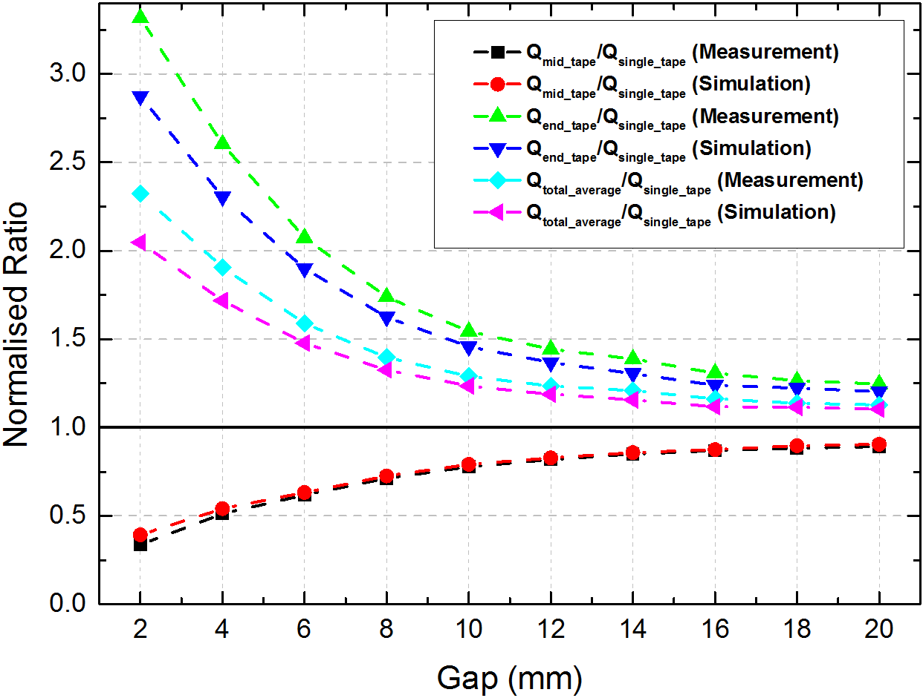
Figure 5. Comparison between simulation and measurement: normalised ratio of mid tape AC losses over the single (isolated) tape AC losses, normalised ratio of end tape AC losses over the single (isolated) tape AC losses, normalised ratio of total average AC losses over the single (isolated) tape AC losses, with transport current 150 A at 20 Hz.

As shown in Figure 5, the largest AC loss of three parallel HTS tapes occurred with the gap 2 mm, whose total average AC loss was approximately 2 time of the individual single tape from simulation, and even slightly higher from the measurement. It could be calculated from the simulation that the total AC loss of three parallel tapes was approximately 0.00311 J/cycle/m, with the gap distance 2 mm, and the transport current 150 A at 20 Hz,

Electromagnetic Induction (EMI) from Horizontally Parallel HTS Tapes

Electromagnetic induction simulation
The Horizontally parallel HTS tapes with proper electrical current are able to produce useful patterns of magnetic field. In this section, the electromagnetic induction (EMI) around three parallel tapes was analysed using the H-formulation with FEM package COMSOL Multiphysics. As shown in Figure 6, the electromagnetic induction above the middle tape has the maximum value in the X-axis direction (the same as the magnetic flux density B_{x} also has the maximum value in the X-axis direction). Therefore, it could be proposed that a rectangle or round receiving coil could be placed in this position to collect the electromagnetic induction (in the X-axis direction) generated by the horizontally parallel tapes. Figure 6 presents a possible cross-section of a circular coil with diameter of 10 mm (a typical receiving coil in small portable devices). The centre of the coil was 7 mm above the middle tape. The AC current 150 A peak at 20 Hz was applied into three parallel tapes. We integrated the (dB/dt) in the line cross-section and calculated the RMS (root mean square) value. Then, the electromagnetic induction (EMI) in X-axis (dφ/dt) per unit-length could be computed:
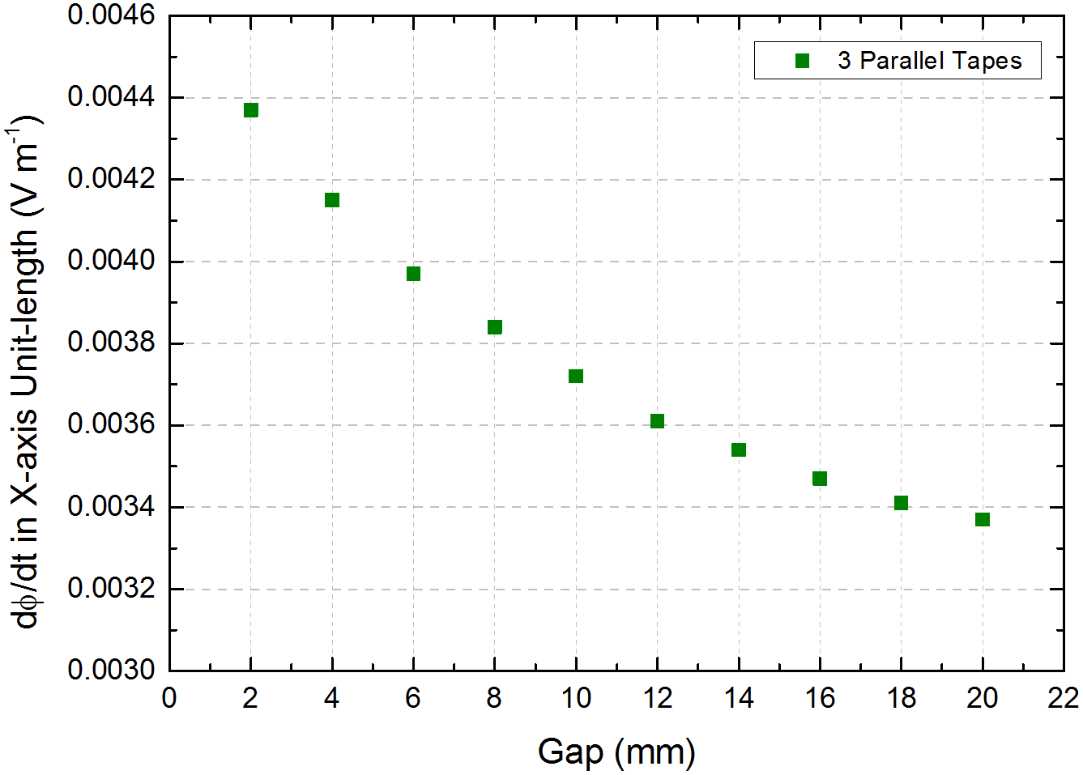
Figure 7. Electromagnetic induction (dφ/dt) with the magnetic flux density in X-axis direction from three parallel HTS tapes, with different gap distances.
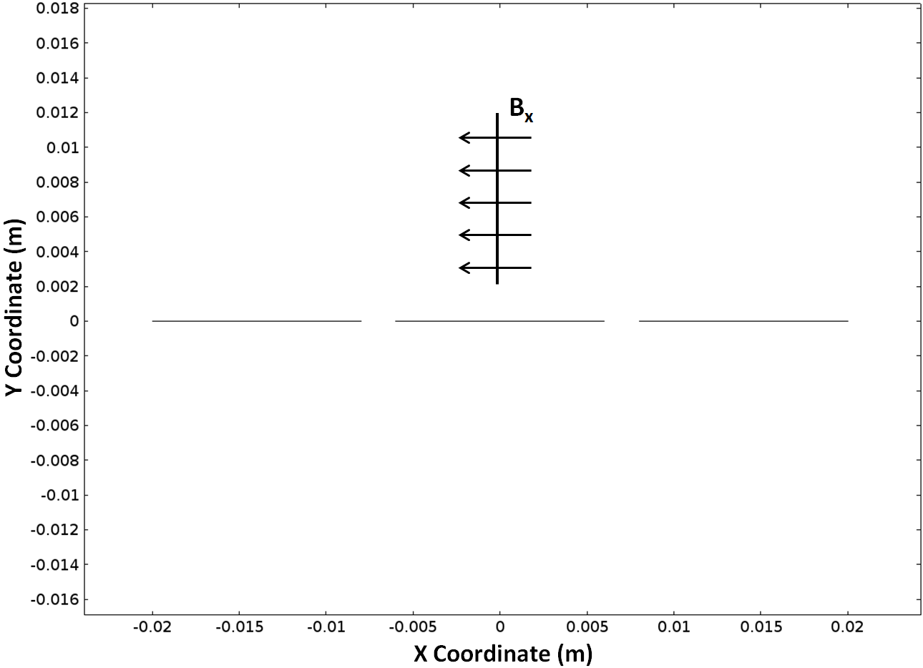
Figure 6. Cross-section of three parallel HTS tapes and electromagnetic induction (dφ/dt) with the magnetic flux density in X-axis direction.
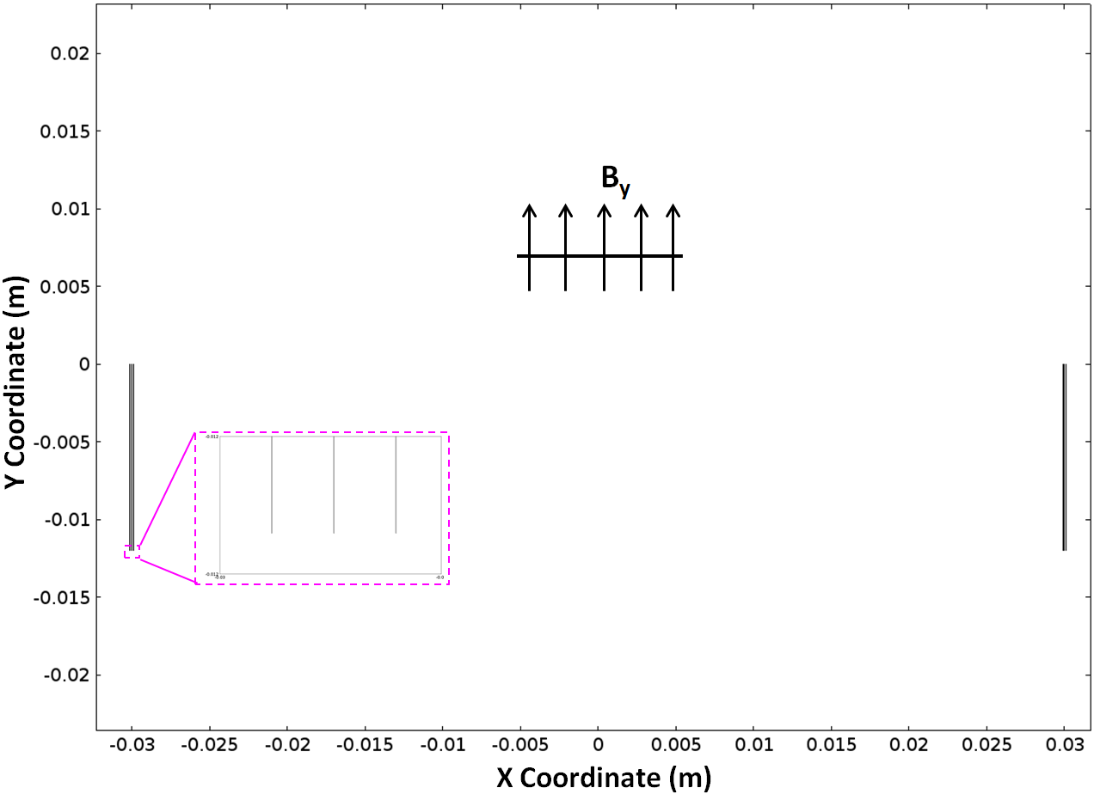
Figure 8. Cross-section of three turns HTS coil and electromagnetic induction (dφ/dt) with the magnetic flux density in Y-axis direction.

$\text{EMI}\left({\text{Vm}}^{−1}\right)=\int_{l}{\frac{{\text{dB}}_{x}}{\text{dt}}}\text{dl}$ (4)
Figure 7 demonstrates the electromagnetic induction in X-axis (dφ/dt) per unit-length generated by three parallel tapes with difference gap distances. Similar to the AC losses tendency with increasing gap distance, it can be seen from Figure 7 that electromagnetic induction per unit-length decreased when gap increased, but the decreasing speed of electromagnetic induction per unit-length became slower when gap distance increased to high value.

Comparison between 3 parallel tapes and 3 turns coil
Coils are one of the most common topologies to build the magnetic field, and create electromagnetic induction which used in the wireless power transfer system. However, if coils are fabricated by superconducting tapes, the AC losses are needed to be taken into consideration because of the anisotropic characteristics of HTS tapes and field dependency.
Figure 8 illustrates the cross-section of the 3 turns HTS coil. We also used the real geometry of tape with the superconducting layer 1 μm, and each tape cross-section had the separation of real tape thickness 0.1 mm. There is a zoom-in part of Figure 8 which shows the cross-section of three turns coil clearly. Typically, for wireless power transfer, transmitting coil and receiving coil are placed in vertically parallel direction, in order to obtain more electromagnetic induction. As shown in Figure 8, the receiving coil was to collect the electromagnetic induction (in Y-axis direction) generated from the 3 turns coil. We still used the same size of the receiving coil cross-section (10 mm diameter) as the three parallel tape case mentioned above, and placed in the same position 7 mm above the transmitting system (HTS coil level). The same AC current 150 A at 20 Hz was applied to HTS coil.
Figure 9 presents a comparison of the electromagnetic induction per unit-length generated from three parallel tapes (2 mm gap) and three turns coil, using the same AC current and the same receiving coil cross-section with diameter of 10 mm. For the three parallel tapes case the electromagnetic induction per unit-length is 0.0435 Vm⁻¹, and for the three turns coils case the electromagnetic induction per unit-length is 0.0460 Vm⁻¹, which indicates their difference (5%) is not significant. Figure 10 demonstrates the comparison of the total AC losses per unit-length from three parallel tapes (2 mm gap) and three turns coil, which are 0.00311 J/cycle/m for three parallel tapes case and 0.0151 J/cycle/m for three turns coil case. From Figure 10 it can be clearly seen that the difference of their total AC losses was approximately 5 times.
To summarise, for a particular case with a receiving coil cross-section 10 mm diameter above transmitting system, the horizontally three parallel tapes could achieve the comparable electromagnetic induction per unit-length, but merely generated 1/5 of the total AC losses from the three turns coil case. However, the three parallel tapes case is suitable for the receiving coil diameter less than a certain value (15 mm), and the receiving coil is just above the transmitting system, whose configuration could be used for small scale portable devices charging on wireless power transfer base. For the larger receiving coils, the parallel tape case is no longer as efficient as the coil structure. That is because the electromagnetic induction decays sharply when the centre of receiving coil is far away from the level of transmitting system. Moreover, the conventional vertically parallel coils could have better wireless power transfer efficiency and quality. Nevertheless, the low total AC losses characteristic of multiple parallel tapes could be beneficial for the further investigation of electromagnetic applications with parallel HTS tapes configuration.
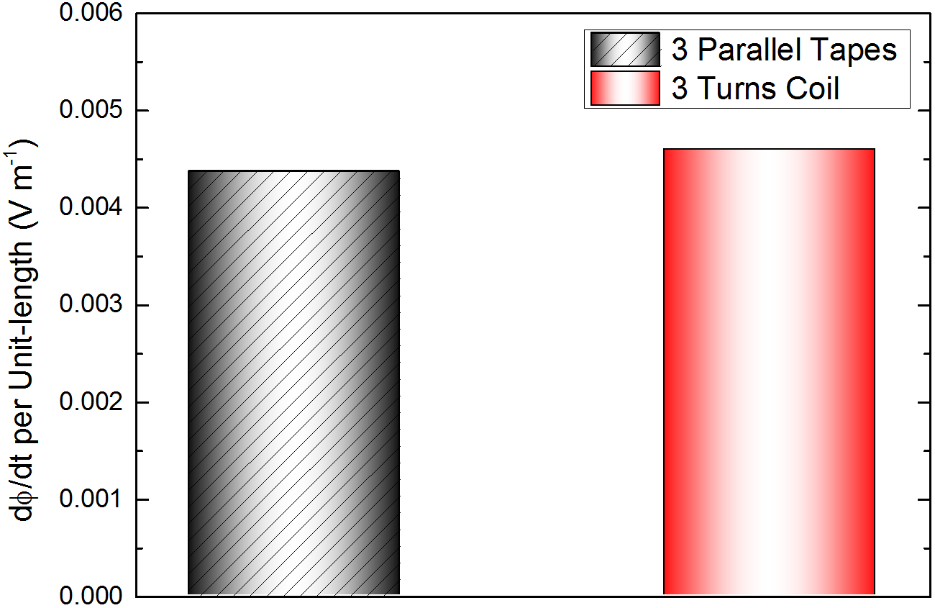
Figure 9. Comparison between three parallel tapes and three turns coil: the effective electromagnetic induction (dφ/dt) for wireless power transfer per unit-length in 2D cross-section.

Conclusion
The concept of utilisation of horizontally parallel HTS tapes has been proposed with AC loss study. First, the AC losses from isolated single tape have been measured using the electrical method as the reference. Second, the parallel-tape AC loss measurement from middle and end tapes with the different gap distances have been carried out and compared with AC losses from isolated single tape. The corresponding simulations of these experiments have been executed by 2D H-formulation on the FEM platform of COMSOL Multiphysics. The simulation results well matched the experimental results on the AC loss characteristics of middle and end tape, as well as the total average loss. We have found the maximum total AC loss was with the smallest gap 2 mm, and the AC loss interactive effect on parallel tapes became less significant and started to approach the isolated tape case, with increasing gap distances.
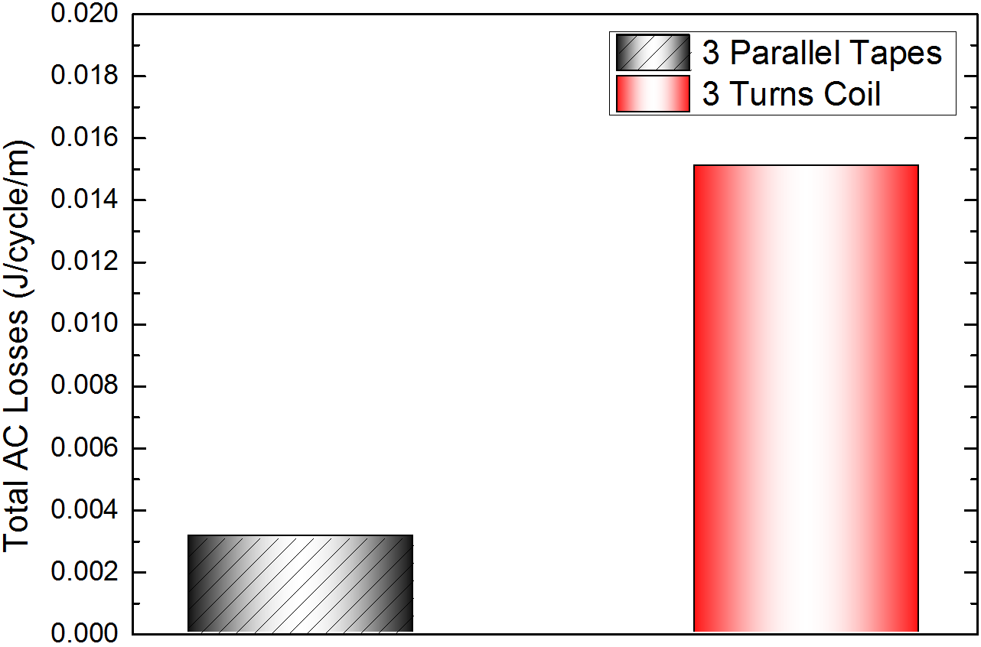
Figure 10. Comparison between three parallel tapes and three turns coil: the total AC losses per unit-length in 2D cross-section.
As the simulation results shown, a receiving coil with 10 mm diameter cross-section was able to collect the comparable electromagnetic induction (per unit-length) generated by three parallel tapes or by three turns HTS coil, with the same AC transport current and the same position of receiving coil 7 mm above transmitting system. The total AC losses from the three parallel tapes case was only 1/5 of the total AC losses from the three turns coil case. But the electromagnetic induction decays greatly if the centre of receiving coil becomes far away from the level of transmitting system, and the conventional vertically parallel coils present better wireless power transfer efficiency in more spacious region. However, the configuration of multiple horizontally parallel tapes system has the obvious advantage of lower total AC losses than multiple tapes closely stacked in a conventional coil. The horizontally parallel tapes could create useful patterns of electromagnetic induction, and could be potentially used into the wireless power transfer system for portable devices.

Acknowledgments
The experimental work was carried out with the assistance from the Electrical Engineering Division, Department of Engineering, University of Cambridge. Authors would like to express gratitude to Mr John Grundy and other members of staff for their important help. Some of the authors are research students, and they are greatly grateful to China Scholarship Council (CSC) for their scholarships and support for overseas study.

References
[1] J. R. Hull, “Applications of high-temperature superconductors in power technology,” Reports on Progress in Physics, vol. 66, no. 11, pp. 1865, 2003.
[2] Z. Huang, H. S. Ruiz, Y. Zhai, J. Geng, B. Shen, and T. Coombs, “Study of the Pulsed Field Magnetization Strategy for the Superconducting Rotor,” IEEE Trans. Appl. Supercond., vol. 26, no. 4, pp. 1-5, 2016.
[3] S. Lee, S. Byun, W. Kim, K. Choi, and H. Lee, “AC loss analysis of a HTS coil with parallel superconducting tapes of unbalanced current distribution,” Phys. C, Supercond., vol. 463, pp. 1271-1275, 2007.
[4] R. J. Sedwick, “Long range inductive power transfer with superconducting oscillators,” Annals of Physics, vol. 325, no. 2, pp. 287-299, 2010.
[5] I. K. Yoo et al, “Design and Analysis of High Q-Factor LC Resonant Coil for Wireless Power Transfer,” Korean Institute of Information Technology, pp. 9-116, 2014.
[6] I.-S. Jeong, H.-S. Choi, and M.-S. Kang, “Application of the Superconductor Coil for the Improvement of Wireless Power Transmission Using Magnetic Resonance,” Journal of Superconductivity and Novel Magnetism, vol. 28, no. 2, pp. 639-644, 2015.
[7] I.-S. Jeong, Y.-K. Lee, and H.-S. Choi, “Characteristics analysis on a superconductor resonance coil WPT system according to cooling vessel materials in different distances,” Phys. C, Supercond., vol. 530, pp. 123-132, 2016.
[8] H. Yu, G. Zhang, L. Jing, Q. Liu, W. Yuan, Z. Liu, and X. Feng, “Wireless power transfer with HTS transmitting and relaying coils,” IEEE Trans. Appl. Supercond., vol. 25, no. 3, pp. 1-5, 2015.
[9] W. Zuo, S. Wang, Y. Liao, and Y. Xu, “Investigation of efficiency and load characteristics of superconducting wireless power transfer system,” IEEE Trans. Appl. Supercond., vol. 25, no. 3, pp. 1-6, 2015.
[10] A. Kurs, A. Karalis, R. Moffatt, J. D. Joannopoulos, P. Fisher, and M. Soljačić, “Wireless power transfer via strongly coupled magnetic resonances,” science, vol. 317, no. 5834, pp. 83-86, 2007.
[11] B. Shen, J. Li, J. Geng, L. Fu, X. Zhang, H. Zhang, C. Li, F. Grilli, and T. A. Coombs, “Investigation of AC losses in horizontally parallel HTS tapes,” Supercond. Sci. Technol., vol. 30, no. 7, 2017.
[12] J. Šouc, E. Pardo, M. Vojenčiak, and F. Gömöry, “Theoretical and experimental study of AC loss in high temperature superconductor single pancake coils,” Supercond. Sci. Technol., vol. 22, no. 1, pp. 015006, 2008.
[13] B. Shen, L. Fu, J. Geng, H. Zhang, X. Zhang, Z. Zhong, Z. Huang, and T. A. Coombs, “Design of a Superconducting Magnet for Lorentz Force Electrical Impedance Tomography,” IEEE Trans. Appl. Supercond., vol. 26, no. 3, 2016.
[14] B. Shen, L. Fu, J. Geng, X. Zhang, H. Zhang, Q. Dong, C. Li, J. Li, and T. A. Coombs, “Design and simulation of superconducting Lorentz Force Electrical Impedance Tomography (LFEIT),” Phys. C, Supercond., vol. 524, pp. 5-12, 2016.
[15] E. Pardo, and F. Grilli, “Numerical simulations of the angular dependence of magnetization AC losses: coated conductors, Roebel cables and double pancake coils,” Supercond. Sci. Technol., vol. 25, no. 1, pp. 014008, 2011.
[16] G. Zhang, H. Yu, L. Jing, J. Li, Q. Liu, and X. Feng, “Wireless power transfer using high temperature superconducting pancake coils,” IEEE Transactions on Applied Superconductivity, vol. 24, no. 3, pp. 1-5, 2014.
[17] K. Ryu, K. Park, and G. Cha, “Effect of the neighboring tape's AC currents on transport current loss of a Bi-2223 tape,” IEEE Trans. Appl. Supercond., vol. 11, no. 1, pp. 2220-2223, 2001.
[18] Z. Wu, Y. Xue, J. Fang, L. Yin, and D. Chen, “The Influence of the YBCO Tape Arrangement and Gap Between the Two Tapes on AC Loss,” IEEE Trans. Appl. Supercond., vol. 26, no. 7, 2016.
[19] B. Shen, J. Li, J. Geng, L. Fu, X. Zhang, C. Li, H. Zhang, Q. Dong, J. Ma, and T. A. Coombs, “Investigation and comparison of AC losses on Stabilizer-free and Copper Stabilizer HTS tapes,” Phys. C, Supercond., vol. 541, 2017.
[20] Y. Zhao, J. Fang, W. Zhang, J. Zhao, and L. Sheng, “Comparison between measured and numerically calculated AC losses in second-generation high temperature superconductor pancake coils,” Phys. C, Supercond., vol. 471, no. 21, pp. 1003-1006, 2011.
[21] F. Grilli, E. Pardo, A. Stenvall, D. N. Nguyen, W. Yuan, and F. Gömöry, “Computation of losses in HTS under the action of varying magnetic fields and currents,” IEEE Trans. Appl. Supercond., vol. 24, no. 1, pp. 78-110, 2014.
[22] Z. Hong, A. M. Campbell, and T. A. Coombs, “Numerical solution of critical state in superconductivity by finite element software,” Supercond. Sci. Technol., vol. 19, no. 12, pp. 1246, 2006.
[23] B. Shen, J. Geng, C. Li, X. Zhang, L. Fu, H. Zhang, J. Ma, and T. Coombs, “Optimization study on the magnetic field of superconducting Halbach Array magnet,” Phys. C, Supercond., vol. 538, pp. 46-51, 2017.
[24] W. Norris, “Calculation of hysteresis losses in hard superconductors carrying ac: isolated conductors and edges of thin sheets,” Journal of Physics D: Applied Physics, vol. 3, no. 4, pp. 489, 1970.
[25] E. Pardo, A. Sanchez, D.-X. Chen, and C. Navau, “Theoretical analysis of the transport critical-state ac loss in arrays of superconducting rectangular strips,” Physical Review B, vol. 71, no. 13, pp. 134517, 2005.

