Abstract—This paper presents a simple third-order inductor- free memristive chaotic circuit, which is derived from a second- order active band pass filter (BPF) by replacing a resistor with an improved memristor and has only three op-amps, two multipliers, three capacitors, and six resistors. The circuit has three unstable saddle-foci and exhibits complex dynamical behaviors including period, chaos, period doubling bifurcation, coexisting bifurcation modes, and constant Lyapunov exponents (CLEs). Especially, the property of CLEs leads to that the amplitudes of the chaotic signals are linearly controlled by a potentiometer without changing system’s essences. Moreover, hardware circuit using less discrete components is fabricated and experimental verifications are performed, from which the existence of chaos is validated. Compared with other memristive chaotic circuits reported before, the proposed memristive BPF chaotic circuit is inductor-free and topologically simplified, which is only third-order, and much simpler and more intuitive in practical realization.
A Simple Third-Order Memristive Band Pass Filter Chaotic Circuit
Bocheng Bao, Ning Wang, Quan Xu, Huagan Wu, and Yihua Hu, Senior Member, IEEE

Index Terms—Memristor, memristive band pass filter (BPF) chaotic circuit, chaos, constant Lyapunov exponent (CLE)

INTRODUCTION
DUE to that commercially available memristors are not expected to appear in the near future, various kinds of physically implementable emulators behaving like memristors have been proposed for studying the application circuits of memristors [1]–[14]. However, most of these memristor emulators mimic the theoretical features with complex discrete components [6]–[11]. Only the circuits built with operational amplifiers and analog multipliers [1]–[5] as well as the circuits consisting of diode bridge cascaded with RC or LC filters [13], [14] have been used for breadboard experiments of memristor based chaotic circuits [1]–[5], [14]–[17]. However, these memristive chaotic circuits are at least fourth-order. Since a simple third-order memristive chaotic circuit using inexpensive commercial discrete components can be regarded as a paradigm in mathematical and experimental demonstrations of chaos

[18], it is a research topic of significant value to minimize the number of dynamic elements to simplify the memristive circuit.
Focusing on searching this kind of third-order memristive chaotic circuit, firstly, an improved memristor emulator is provided in this paper. Compared with the conventional ideal flux-controlled memristors [1]–[3], [15], two improvements are achieved in the emulator herein. A current-inverter is removed for simplifying the circuit realization and a parallel resistor is added to avoid DC voltage integral drift [4], [5], resulting in that the emulator has simple circuit structure but is more suitable for practical fabrication of memristive chaotic circuit.
A second-order active band pass filter (BPF) is made to oscillate sinusoidally. Based on the active BPF, two types of Chua’s chaotic circuits with different nonlinearities of Chua’s diodes have been derived recently [19], [20]. Moreover, by linearly coupling a parallel memristor and capacitor filter to the active BPF, a fourth-order memristive Chua’s chaotic circuit has been extended currently [21]. Distinguishing from the building scheme of this fourth-order BPF based memristive circuit [21], a novel memristive BPF circuit is directly constructed from the active BPF by replacing a resistor with the proposed emulator. Thus, an inductor-free memristive chaotic circuit with complex dynamics is finally obtained, which is only third-order and has simple hardware realization. Notably, it is valuable in engineering applications [22], [23] that the circuit has three CLEs independent of a circuit parameter and thereby the amplitudes of the generated chaotic signals can be controlled by a potentiometer linearly.

Third-Order Memristive BPF Chaotic Circuit
An improved memristor emulator is designed to realize a voltage-controlled memristor, as shown in Fig. 1. The circuit is made up of two op-amps U_{a} and U_{b}, three resistors R_{a}, R_{b}, and R_{c}, one capacitor C₀, and two multipliers M_{a} and M_{b}. Unlike the realization circuit of the flux-controlled memristor reported in [1], [2], the current-inverter at the M_{b} output terminal is removed and a parallel resistor R_{b} is supplemented to the integral capacitor C₀. Remarkably, R_{b} can be used to avoid DC voltage integral drift [4], [5]. Thus, the emulator is much simpler and more suitable for hardware experiments.
The emulator in Fig. 1 is a grounded one-port network, where v and i represent the voltage and the current at the input port, respectively, V₀ stands for the voltage across the integral capacitor C₀, and g denotes the total scale factor of two multipliers M_{a} and M_{b}. The emulator is modeled as
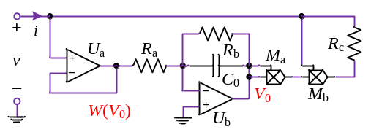
Fig. 1. An improved memristor emulator realized by discrete components

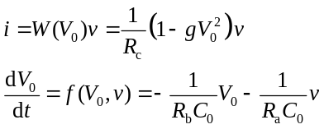 (1)
where f(V₀,v) is a continuous linear function with respect to V₀ and v, and W(V₀) is a continuous nonlinear memductance function related to V₀, which can be given by
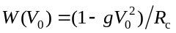 (2)
The mathematical model (1) is used to characterize the voltage- current relationship of the memristor emulator, which accords with the form of generalized voltage-controlled memristor defined by Chua in [24]. Thus, the emulator is a first-order generalized voltage-controlled memristor.
A second-order active band pass filter (BPF) [19], [20] is shown in Fig. 2(a), which contains one single op-amp U, two capacitors C₁ and C₂, and four resistors R, R₁, R₂, and R₃. Compared with the classical Wien bridge oscillator, the active BPF is implemented in different circuit topology but identical discrete components [20].
By replacing the resistor R in Fig. 2(a) with the memristor W in Fig. 1, a memristive BPF chaotic circuit is designed, as shown in Fig. 2(b). Because the integral capacitor C₀ in Fig. 1 represents the internal dynamic element of W, the memristive BPF chaotic circuit in Fig. 2(b) is a third-order nonlinear circuit and has only three op-amps, two multipliers, three capacitors, and six resistors. Specially, the circuit implemented by less discrete components is inductor-free, which can avoid the manually winding inductor and make the circuit hardware gadget [19], [20], suitable for IC design, and better robust due to the benefits of inductor-free and simplified realization.
According to the constitutive relation of the memristor emulator and the node voltage equations of the active BPF circuit [19], the dynamics of the memristive BPF circuit in Fig. 3(b) is featured by three first-order autonomous nonlinear differential equations, which are written as
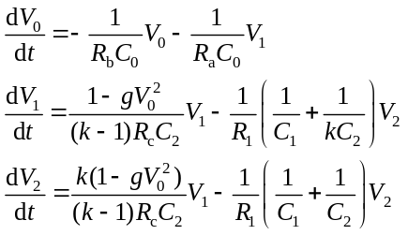 (3)
where k = 1+R₂/R₃, V₀, V₁, and V₂ are three node voltages standing for three state variables.
By introducing three new variables and scaling the circuit
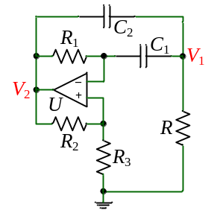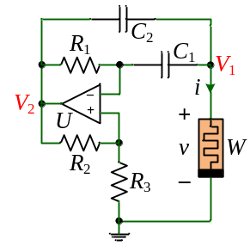
(a) (b)
Fig. 2. Active BPF circuit and its extending memristive chaotic circuit. (a) Single amplifier biquad based BPF. (b) Memristive BPF chaotic circuit.

parameters in a dimensionless form as
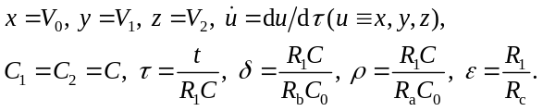 (4)
Equation (3) can be rewritten as
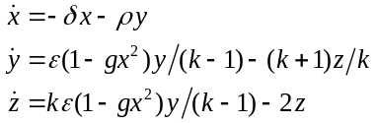 (5)
In this way, the parameter amount of the dimensionless equation (5) will decrease to five.
The circuit parameters in Figs. 1 and 2 are given as R_{a} = 5 kΩ, R_{b} = 50 kΩ, R_{c} = 120 Ω, C₀ = 5 nF, and g = 0.1, as well as R₁ = 20 kΩ, R₂ = 1 kΩ, R₃ = 50 Ω, and C₁ = C₂ = 100 nF. Therefore, the normalized parameters are calculated by (4) as
(6)
In our next work, the normalized parameters of (6) are taken as typical parameters. With these typical parameters, chaos in the third-order memristive BPF circuit is investigated.

Equilibrium And Its Stability
Obviously, system (5) is symmetrical about the origin. The symmetrical property can be verified from the invariance of (5) under the transformation (x, y, z) → (–x, –y, –z), which indicates if (x, y, z) is a solution of (5), then (–x, –y, –z) is also a solution.
To evaluate the dissipativity of system (5), mathematical expression of exponential constrain rate is deduced as
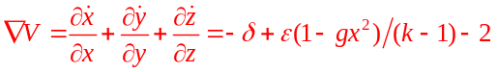 (7)
When 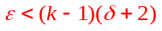, (7) is negative, i.e., , implying that system (5) is dissipative, its all orbits are ultimately confined to a specific subset with zero volume, and the asymptotic motion will settle onto an attractor.
Setting the left-hand side of (5) to zero, system (5) has three equilibrium points including one zero equilibrium and two symmetric nonzero equilibria, which are given by
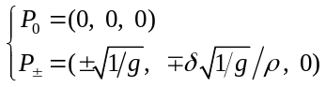 (8)
When the parameters ε = 500/3, g = 0.1, and k =21 are fixed while parameters δ and ρ are varied, the Jacobian matrix at zero equilibrium P₀ can be derived as
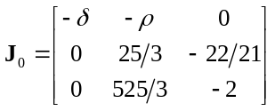 (9)
The characteristic equation is yielded as
(10)
Correspondingly, the eigenvalues at P₀ are calculated as
(11)
which implies that P₀ is an unstable saddle-focus.
Similarly, the Jacobian matrix at two nonzero equilibria P± can be deduced as
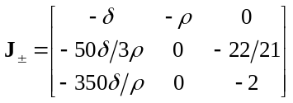 (12)
The characteristic equation is given by
(13)
Calculating the three eigenvalues at P±, it is found that P± are two unstable saddle-foci and the eigenvalues have two complex conjugate roots with positive real parts and a negative real root. For instance, when δ = 8, the eigenvalues at P± are calculated as
(14)
It should be noted that the memristive BPF circuit has three unstable saddle-foci and its characteristic equations of (10) and (13) only relate to the parameter δ and do not associate with the parameter ρ. This implies that the stability of these three equilibria is independent of ρ, i.e., the dynamical characteristic of system (5) has nothing to do with the parameter ρ.

Numerically Simulated Dynamical Behaviors

Parameter Dependent Bifurcation Behaviors
Consider that the parameter δ increases from 6.7 to 11 and the other parameters are given in (6). Bifurcation diagrams and first two Lyapunov exponents are obtained, as shown in Fig. 3. When δ < 6.7, system (5) shows diverging behavior, which indicates the occurrence of boundary crises. Along with increase of δ in the interval, 6.7 ≤ δ < 8.91, system (5) locates in chaos. When δ > 8.15, coexisting bifurcation modes appear and system (5) manifests the emergences of coexisting attractors. At δ = 8.94, 9.1, and 9.92, three reverse period doubling bifurcations occur, and the orbits have transitions from coexisting period-8 to 4 to 2 and to 1 limit cycles successively. Furthermore, two main periodic windows with period-9 and period-7 appear in the regions of [7.06, 7.26] and [7.79, 7.87]. Note that in the region of 6.8 < δ ≤ 6.95, system (5) is in weak chaotic state and its first Lyapunov exponent is very small.
For different values of δ, phase portraits of system (5) in the y
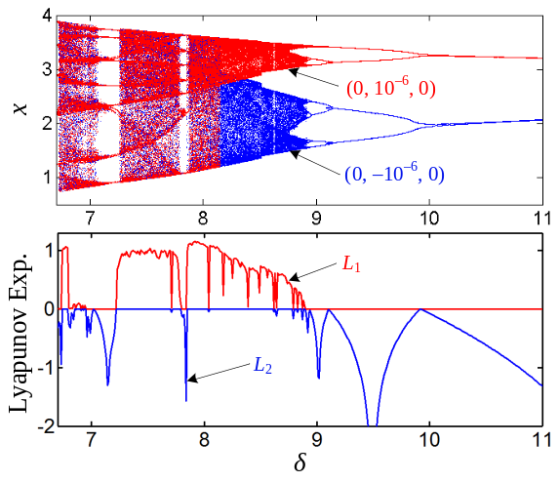
Fig. 3. Bifurcation diagrams of x and first two Lyapunov exponents with respect to δ, where ρ = 80, ε = 500/3, g = 0.1, k =21, and δ = 6.7 ~ 11. Note that in the bifurcation diagrams, the red trajectories start from the initial conditions (0, 10⁻⁶, 0), and the blue trajectories emerge from (0, −10⁻⁶, 0).
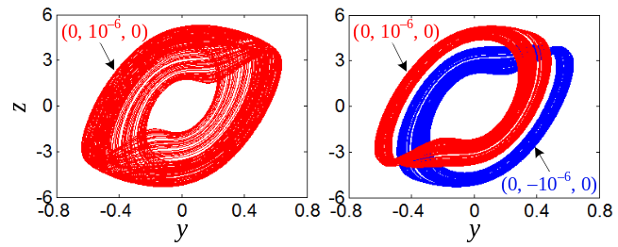
(a) (b)
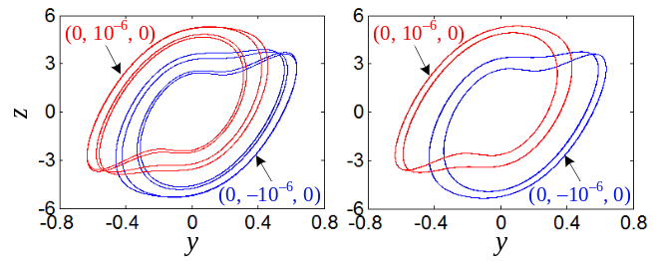
(c) (d)
Fig. 4. Numerically simulated phase portraits with different δ in the y − z plane, where ρ = 80, ε = 500/3, g = 0.1, and k =21. (a) Chaotic attractor at δ = 8. (b) Coexisting chaotic attractors at δ = 8.6. (c) Coexisting period-4 limit cycles at δ = 9. (d) Coexisting period-2 limit cycles at δ = 9.5.
− z plane are numerically simulated, as shown in Figs. 4(a) − 4(d), respectively, where the initial conditions of the red and blue trajectories are the same as those used in Fig. 3. These results just emulate the dynamical behaviors of period, chaos, period doubling bifurcation, and coexisting bifurcation modes emerging from system (5).

Amplitude Control with CLEs
In Section III, it can be found that when the parameter ρ is varying, the eigenvalues at three equilibria remain unchanged, which result in the CLE spectra [22]. To illustrate this interesting nonlinear phenomenon, bifurcation diagrams of the three state variables x, y, and z and three Lyapunov exponents are plotted in Fig. 5, where δ = 8, ε = 166.67, g = 0.1, k =21, and the initial conditions (0, 10⁻⁶, 0) are fixed, and the parameter ρ
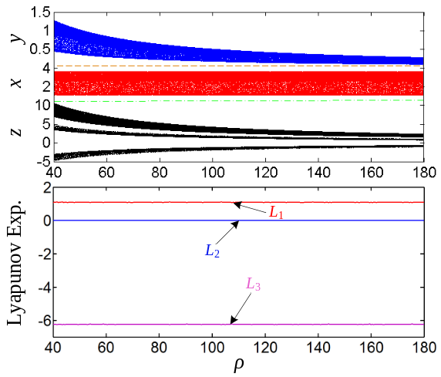
Fig. 5. Bifurcation diagrams of three state variables x (red), y (blue), and z (black), as well as three Lyapunov exponents with respect to ρ, where δ = 8, ε = 500/3, g = 0.1, k =21, ρ = 40 ~ 180, and initial conditions (0, 10⁻⁶, 0).
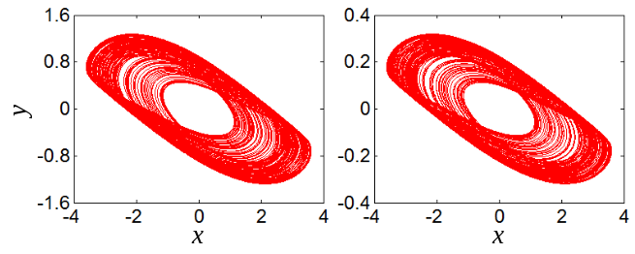
(a1) (b1)
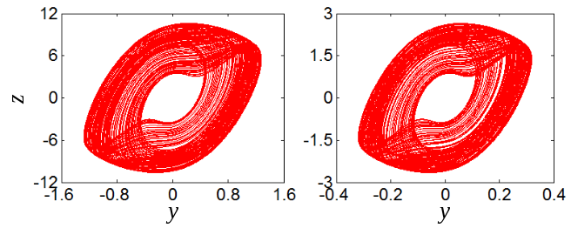
(a2) (b2)
Fig. 6. Numerically simulated phase portraits with different ρ, where δ = 8, ε = 500/3, g = 0.1, and k =21; the phase portraits (a1) and (b1) are in the x − y plane, whereas the phase portraits (a2) and (b2) are in the y − z plane. (a1) and (a2) Chaotic attractor at ρ = 40. (b1) and (b2) Chaotic attractor at ρ = 160.

is adjusted from 40 to 180.
When the parameter ρ is set to 40 and 160, respectively, phase portraits of system (5) in the x − y and y − z planes can be numerically simulated, as shown in Fig. 6. Interestingly, it is clearly seen from Figs. 5 and 6 that the dynamic amplitudes of y and z of the generated chaotic signals are inversely proportional to the values of ρ, i.e., the dynamic amplitudes of y and z will vary according to 1/ρ, whereas the dynamic amplitudes of x of the generated chaotic signals are unchanged despite of the variation of ρ. Meanwhile, it is observed from Fig. 5 that the Lyapunov exponents are three constants with tiny numerical errors. Consequently, the parameter ρ is a scaling factor. However, if the transformation (x, y, z) → (x, y/ρ, z/ρ) is performed, the algebraic system structure will change. Thus, the amplitude control regime appearing in system (5) is completely different from that reported in [22], [23].
According to (4), the resistance R_{a} is proportional to 1/ρ,
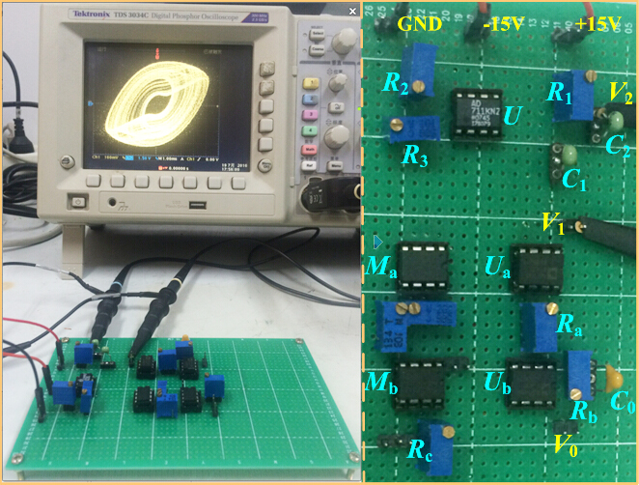
Fig. 7. Photograph of the experimental prototype for the memristive BPF chaotic circuit, the left is a global graph of digital oscilloscope connecting with circuit breadboard and the right is an enlarged view of circuit breadboard.
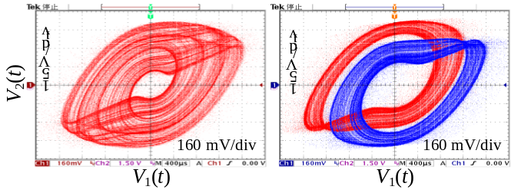 (a) (b)
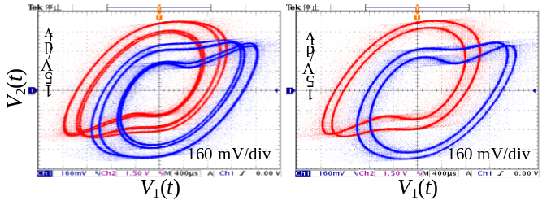(c) (d)
Fig. 8. Experimentally measured phase portraits with different R_{b} in the V₁(t) – V₂(t) plane, where R_{a} = 5 kΩ, R_{c} = 120 Ω, C₀ = 5 nF, g = 0.1, R₁ = 20 kΩ, R₂ = 1 kΩ, R₃ = 50 Ω, and C₁ = C₂ = 100 nF. (a) Chaotic attractor at R_{b} = 50 kΩ. (b) Coexisting chaotic attractors at R_{b} = 46.512 kΩ. (c) Coexisting period-4 limit cycles at R_{b} = 44.44 kΩ. (d) Coexisting period-2 limit cycles at R_{b} = 42.11 kΩ.

implying that as R_{a} increases, the dynamic amplitudes of y and z linearly increase and the dynamic amplitude of x stays the same. It means that the dynamic amplitudes of the generated chaotic signal can be linearly adjusted by a potentiometer, which are convenient and benefit in secure communications and other fields of information engineering [22], [23].

Verifications from Hardware Experiments

A hardware level on a breadboard is fabricated to verify dynamical behaviors of the memristive BPF chaotic circuit. The experimental prototype is photographed, as shown in Fig. 7, where potentiometer and monolithic ceramic capacitor as well as op-amp AD711KN and multiplier AD633JN with ±15 V DC power supplies are chosen. The circuit parameters are selected as R_{a} = 5 kΩ, R_{b} = 50 kΩ, R_{c} = 120 Ω, C₀ = 5 nF, and g = 0.1, as well as R₁ = 20 kΩ, R₂ = 1 kΩ, R₃ = 50 Ω, and C₁ = C₂ = 100 nF.
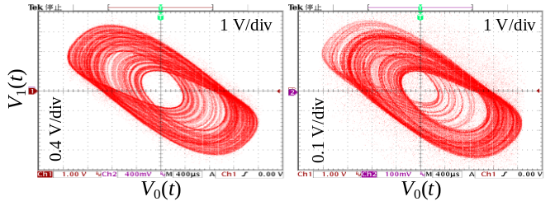(a1) (b1)
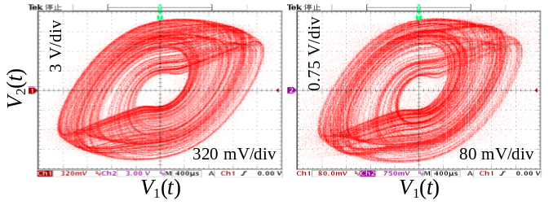(a2) (b2)
Fig. 9. Experimental measured phase portraits with different R_{a}, where R_{b} = 50 kΩ, R_{c} = 120 Ω, C₀ = 5 nF, g = 0.1, R₁ = 20 kΩ, R₂ = 1 kΩ, R₃ = 50 Ω, and C₁ = C₂ = 100 nF. The phase portraits (a1) and (b1) are in the V₀(t) – V₁(t) plane, whereas the phase portraits (a2) and (b2) are in the V₁(t) – V₂(t) plane. (a) Chaotic attractor at R_{a} = 10 kΩ. (b) Chaotic attractor at R_{a} = 2.5 kΩ.

Tektronix TDS 3034C is utilized for attractor visualization.
Two potentiometers R_{a} and R_{b} are taken as two adjusting resistances. When R_{b} is turned as different resistances, phase portraits in the V₁(t) – V₂(t) plane are observed, as shown in Fig. 8. However, when R_{a} is adjusted as different resistances, phase portraits in the V₀(t) – V₁(t) and V₁(t) – V₂(t) planes are measured, as shown in Fig. 9. Note that the different initial states in Figs. 8(b) − 8(d) are linearly related to three capacitor voltages, which are identified from the sensing voltages by switching on and off the hardware circuit power supply.
Ignoring the minor deviations caused by parasitic circuit parameters, the experimental results shown in Figs. 8 and 9 meet the results of numerical simulations in Figs. 4 and 6, which illustrates the existences of rich dynamical behaviors in the memristive BPF chaotic circuit.

Conclusion
This paper presents a simple third-order memristive BPF chaotic circuit, which is constructed by replacing a resistor of second-order active BPF with an improved memristor emulator. Theoretical analyses, numerical simulations, and hardware experiments are performed, which show that the third-order memristive circuit with simple topological structure has three unstable saddle-foci and generates complex dynamical behaviors of period, chaos, period doubling bifurcation, coexisting bifurcation modes, and CLEs. The interesting property of CLEs independent of certain circuit parameter leads to that the amplitudes of the generated chaotic signals can be linearly controlled by a potentiometer without changing system’s essences. Besides, the improved memristor emulator is much simpler and more intuitive in practical realization and the constructing third-order memristive chaotic circuit with less discrete components is inductor-free, which makes the circuit hardware gadget, suitable for IC design.
References
- B. Muthuswamy, “Implementing memristor based chaotic circuits,” Int. J. Bifurcation Chaos, vol. 20, no. 5, pp. 1335–1350, May 2010.
- B. C. Bao, Q. Xu, H. Bao, and M. Chen, “Extreme multistability in a memristive circuit,” Electron. Lett., vol. 52, no. 12, pp. 1008–1010, Jun. 2016.
- H. H. C. Iu, D. S. Yu, A. L. Fitch, V. Sreeram, and H. Chen, “Controlling chaos in a memristor based circuit using a twin-T notch filter,” IEEE Trans. Circuits Syst. I, Reg. Papers, vol. 58, no. 6, pp. 1337–1344, Jun. 2011.
- M. Chen, J. J. Yu, and B. C. Bao, “Finding hidden attractors in an improved memristor based Chua’s circuit,” Electron. Lett., vol. 51, no. 6, pp. 462–464, Mar. 2015.
- Q. Xu, Y. Lin, B. C. Bao, and M. Chen, “Multiple attractors in a non-ideal active voltage-controlled memristor based Chua’s circuit,” Chaos Solit. Fractals, vol. 83, pp. 186–200, Feb. 2016.
- C. Sanchez-Lopez, J. Mendoza-Lopez, M. A. Carrasco-Aguilar, and C. Muniz-Montero, “A floating analog memristor emulator circuit,” IEEE Trans. Circuits Syst. II, Exp. Briefs, vol. 61, no. 5, pp. 309–313, May 2014.
- H. Kim, M. P. Sah, C. Yang, S. Cho, and L. O. Chua, “Memristor emulator for memristor circuit applications,” IEEE Trans. Circuits Syst. I, Reg. Papers, vol. 59, no. 10, pp. 2422–2431, Oct. 2012.
- M. P. Sah, C. Yang, H. Kim, B. Muthuswamy, J. Jevtic, and L. O. Chua, “A generic model of memristors with parasitic components,” IEEE Trans. Circuits Syst. I, Reg. Papers, vol. 62, no. 3, pp. 891–898, Mar. 2015.
- A. S. Elwakil, M. E. Fouda, and A. G. Radwan, “A simple model of double-loop hysteresis behavior in memristive elements,” IEEE Trans. Circuits Syst. II, Exp. Briefs, vol. 60, no. 8, pp. 487–491, Aug. 2013.
- S. Kvatinsky, E. Friedman, A. Kolodny, and U. Weiser, “The desired memristor for circuit designers,” IEEE Circuits Syst. Mag., vol. 13, no. 2, pp. 17–22, May 2013.
- D. S. Yu, H. H. C. Iu, A. L. Fitch, and Y. Liang, “A floating memristor emulator based relaxation oscillator,” IEEE Trans. Circuits Syst. I, Reg. Papers, vol. 61(10), pp. 2888–2896, Oct. 2014.
- F. Corinto and A. Ascoli, “Memristive diode bridge with LCR filter,” Electron. Lett., vol. 48, no. 14, pp. 824–825, 2012.
- B. C. Bao, J. J. Yu, F. W. Hu, and Z. Liu, “Generalized memristor consisting of diode bridge with first order parallel RC filter,” Int. J. Bifurcation Chaos, vol. 24, no. 11, pp. 1450143-1–1450143-4, 2014.
- H. G. Wu, B. C. Bao, Z. Liu, Q. Xu, and P. Jiang, “Chaotic and periodic bursting phenomena in a memristive Wien-bridge oscillator,” Nonlinear Dyn., vol. 83, no. 1, pp. 893–903, Jan. 2016.
- A. L. Fitch, D. S. Yu, H. H. C. Iu, and V. Sreeram, “Hyperchaos in a memristor-based modified canonical Chua’s circuit,” Int. J. Bifurcation Chaos, vol. 22, no. 6, pp. 1250133-1–1250133-8, Jun. 2012.
- J. Kengne, Z. N. Tabekoueng, V. K. Tamba, and A. N. Negou, “Periodicity, chaos, and multiple attractors in a memristor-based Shinriki’s circuit,” Chaos, vol. 25, no. 10, 103126-1–103126-10, Oct. 2015.
- Z. N. Tabekoueng, J. Kengne, H. B. Fotsin, A. N. Negou, and D. Tchiotsop, “Coexistence of multiple attractors and crisis route to chaos in a novel memristive diode bridge-based Jerk circuit,” Chaos Solit. Fractals, vol. 91, pp. 180–197, Oct. 2016.
- F. Bertacchini, E. Bilotta, P. Pantano, and A. Tavernise, “Motivating the learning of science topics in secondary school: a constructivist edutainment setting for studying chaos,” Comput. Educ., vol. 59, no. 4, pp. 1377–1386, Dec. 2012.
- T. Banerjee, “Single amplifier biquad based inductor-free Chua’s circuit,” Nonlinear Dyn., vol. 68, no. 4, pp. 565–573, Jun. 2012.
- B. C. Bao, N. Wang, M. Chen, Q. Xu, and J. Wang, “Inductor-free simplified Chua’s circuit only using two-op-amps-based realization,” Nonlinear Dyn., vol. 84, no. 2, pp. 511–525, Apr. 2016.
- B. C. Bao, T. Jiang, Q. Xu, M. Chen, H. G. Wu, and Y. H. Hu, “Coexisting infinitely many attractors in active band-pass filter-based memristive circuit,” Nonlinear Dyn., vol. 86, no. 3, pp. 1711–1723, Nov. 2016.
- C. B. Li and J. C. Sprott, “Amplitude control approach for chaotic signals,” Nonlinear Dyn., vol. 73, no. 3, pp. 1335–1341, Aug. 2013.
- C. B. Li, J. Wang, and W. Hu, “Absolute term introduced to rebuild the chaotic attractor with constant Lyapunov exponent spectrum,” Nonlinear Dyn., vol. 68, no. 4, pp. 575–587, Jun. 2012.
- L. O. Chua, “The fourth element,” Proc. IEEE, vol. 100, no. 6, pp. 1920–1927, Jun. 2012.

 Manuscript received September 10, 2016; revised ****, 2016; accepted ****, 2016. Date of publication ****, 2016; date of current version****, 2016. This work was supported by the National Natural Science Foundation of China under Grant Nos. 51277017, 61601062, and 51607013, and the Natural Science Foundations of Jiangsu Province, China under Grant No. BK20160282. B. Bao, N. Wang, Q. Xu, and H. Wu are with the School of Information Science and Engineering, Changzhou University, Changzhou 213164, China (e-mail:mervinbao@126.com, cczuwangning@163.com, xuquan@cczu.edu.cn, jingzhan9000@yeah.net). Y. Hu is with the Department of Electrical Engineering and Electronics, University of Liverpool, Brownlow Hill, Liverpool L69 3GJ, UK (e-mail: y.hu35@liverpool.ac.uk).

