Winning Approval: The Ins and Outs of Music Score Approval Plans
James P. Cassaro
Music Library Association, Annual Conference: San Diego, CA

Session: Score Approval Plans: Are They Still Useful in Challenging Economic Times?

March 22, 2010

The process of collection development is central to the activity of all library professionals, whether they be administrators, bibliographers, catalogers, or reference librarians. In the field of music librarianship, the issues that surround collection development have continually been a focus of library publications, as well as part of discussions on various online sites, and even on MLA-L. Over the past 25 years, the issues facing music librarians in the process of acquiring materials for music libraries of all kinds have been addressed by a number of writers, including Michael Fling, Stephen Luttmann, and Michael Keller.
Indeed, in a message posted on MLA-L on August 6, 2009, Dan Zager stated:
“I believe that for music librarians—in libraries large and small—collection development continues to be important and is not simply based on ‘guesses.’ Music librarians know something about music and they know something about their communities, and they are well positioned to do more than guess about what music materials will be useful to those communities both now and in the future. Such music librarians do more than facilitate current study and performance; they also provide a foundation for future study and performance. No, we're not omniscient and can't predict every need that will arise, but we can build collections that are coherent and useful for our specific communities both now and in the future.”

He further posited in the same forum on August 12, 2009:

“I think that as music librarians we expect to do everything possible to nurture the best possible scholarly environments in our libraries, including the best collections that we can provide. Increasingly, however, we see a disconnect from those expectations, and, perhaps astonishingly, part of that disconnect can sometimes be traced to those who are in a position to provide academic library leadership. ... In the end, most people will point to diminishing financial resources within the academy and say that we have to work in new ways, reinvent ourselves, and so on. But I think that music librarians have always had to make difficult choices as financial resources continually ebb and flow (certainly that is part and parcel of doing collection development in music), and I believe that we can continue to make those difficult fiscally-related choices in ways that still permit us to nurture and contribute to the scholarly environment at our institutions.”

In the published literature that directly focuses on music score approval plans, a recent article by Elizabeth J. Cox, Roger Cross, and John Ballestro (“Music Score Approval Plans in Research Libraries: A Survey of Librarian Satisfaction With and Without Approval Plans [Library Collections, Acquisitions, & Technical Services 33 (2009): 80–94]), based on a survey conducted by the authors, makes some interesting observations as well as some provocative statements, both pro and con, for the issues that surround this approach to collection development of music collections. More on this later.

Case Study
When I arrived at the University of Pittsburgh in 1999 to become head of the Theodore M. Finney Music Library, I found the music score collection in dire straits. There was no, or variable, holdings of contemporary Western art music after John Cage; popular song anthologies were sorely lacking; performance score materials were virtually non-existent; and there were no standing orders for essential monuments of music (Recent Researches series), as well as for some more recently-founded collected works editions (Hasse, Donizetti, Wagner). Let’s not talk about the journal subscriptions, save only to say that important titles that support research and the Ph.D. in music were not represented. While this situation, as well as a project to reshelve the entire onsite library collection along functional lines—reference books/scores, circulating books, circulating scores, and journals—helped me to focus my initial collection development activities in this area. In negotiating my position at Pitt, I was able to more than double the acquisitions budget, as well as to again use endowment funds to support collection development rather than physical plant renovations or the purchase of listening equipment and furniture. With the hard money accounts now at the $75,000 range, and the endowments producing $25,000 to $30,000 in available funds each year (no longer, unfortunately), the music library’s budget of approximately $100,000 placed the collection alongside peer institutions in terms of buying power, quality, and coverage. For the first 6 to 7 years of my time at Pitt, I spent approximately 20 hours per week identifying gaps in the score collection, initiating orders, and cataloging the incoming new acquisitions. Half of one’s work week is a good bit of time vis-à-vis the other duties that were assigned to this position. Throw in teaching the graduate seminar on principles of research and music bibliography, advising students, and directing theses and dissertations, and there is no question as to why I was crazier than usual! At this time, I was spending about $10,000+ each year on score purchases, roughly 10% of my total budget, and roughly 33% of my monographs acquisitions funds. Happily, the gaps were finally filled, the coverage of the collection increased in size and quality, and the performers in the department excited to see the availability of scores and parts to study and play in chamber music classes. Once the score collection was stabilized, it was time to consider implementing an approval plan for the library.

Approaching the Approval Plan
While the implementation of an approval plan may strike one as disseminating the responsibility for selection to a third party—and at some level, this is true—the ultimate decision making process remains a responsibility of the selector (i.e., the music librarian or acquisitions librarian, or a combination of both), in consultation with a vendor. Music librarians are incredibly fortunate to have such close relationships with various vendors, existing in a mutually beneficial environment. Believe me, this is not always the case with our generalist colleagues. By carefully constructing a profile for the approval plan, and adjusting as necessary, the coverage of a library’s score collection can increase exponentially.
As such, I initiated two approval plans for music scores in fiscal year 2008–2009, one with Theodore Front and one with Harrassowitz. The profile for Front was constructed to cover domestic imprints (that is, North American) as well as that of the Pacific Rim. Included were recently published contemporary art music scores (and parts when available), vocal literature, and chamber music, in all formats. The profile set up with Harrassowitz was to cover recent European imprints in all formats, which included contemporary art music, performance scores, early music publications, as well as some important series (for example, Repertoire Explorer). With the implementation of these plans, I increased the amount of money spent annually on music scores to $15,500, approximately 22% of my total hard money accounts, and 47% of the monographs acquisitions budget.
The initial implementation seemed to work well. We were getting the kinds of materials we wanted and needed, and shipments were arriving at appropriate intervals. Then reality struck. The profile we originally set up with Harrassowitz was too broad to fit the amount of money earmarked for this approval plan. While we were able to find additional funds to cover the overages, adjusting the profile was crucial. By excluding the score series coverage, and decreasing the average cost per score, the adjusted profile now perfectly fit our needs, we were staying on budget, and all was right with the world. As such, we continue to enjoy the luxury of automatically receiving scores that support the teaching and performing mission of the Pitt music department.

Pros and Cons
While everything with the implementation and continuation of our score approval plans is hunky-dorey, there are still some pros and cons that one must be aware of. The aforementioned article by Elizabeth J. Cox, et al. states:
“The necessity of profiling and fine tuning music score approval plans is even greater and more complex than the monograph approval plan.” (p. 82)

While the time it takes to create and maintain a profile for music scores approval plans may initially be long and intense, once fine tuned, there is negligible time spent in maintaining the plan. Indeed, often one does not have the power or opportunity to adjust the monographic approval plan—unless it is to downsize it—as this is usually done centrally by the collection development librarian or head of acquisitions. The amount of time spent adjusting a plan’s profile is minimal when compared to the time it takes to make individual selection.
Staff time saved is also cited as a reason for implementing approval plans. While the receipt of materials via a plan brings knowledge of a particular repertoire or of a composer’s most recent work much more quickly, there is still staff time needed to catalog and process the scores received. Most vendors who offer approval plans make available MARC records for the scores sent for use by the local cataloging agency. With Front, (see EXAMPLE 1) these are downloaded from a central site, while for Harrassowitz, bibliographic records can be exported from OCLC into your local online system.

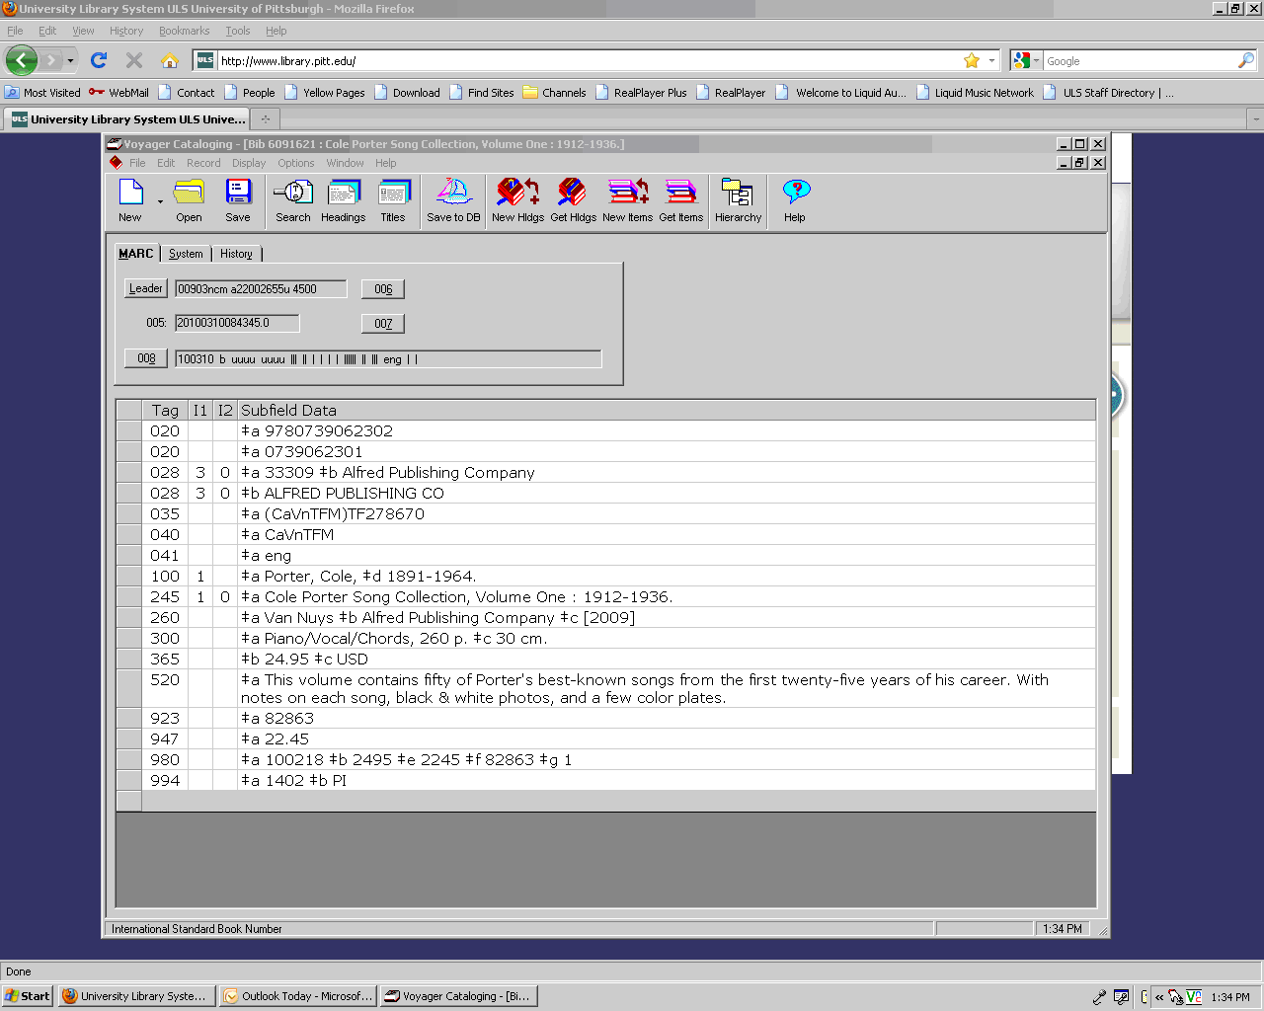
Example 1. Theodore Front MARC Record

There is however a difference in the quality and amount of information provided in the bibliographic records of these two vendors. Front provides basic information. Forms of names may or may not be under authority control; uniform titles, subject headings, and full extent of the publication are generally not included. These records take more time to update to full level than those offered by Harrassowitz (see EXAMPLE 2), which contain more bibliographic data, and in the proper MARC format, although also does not include subject analysis or uniform titles.

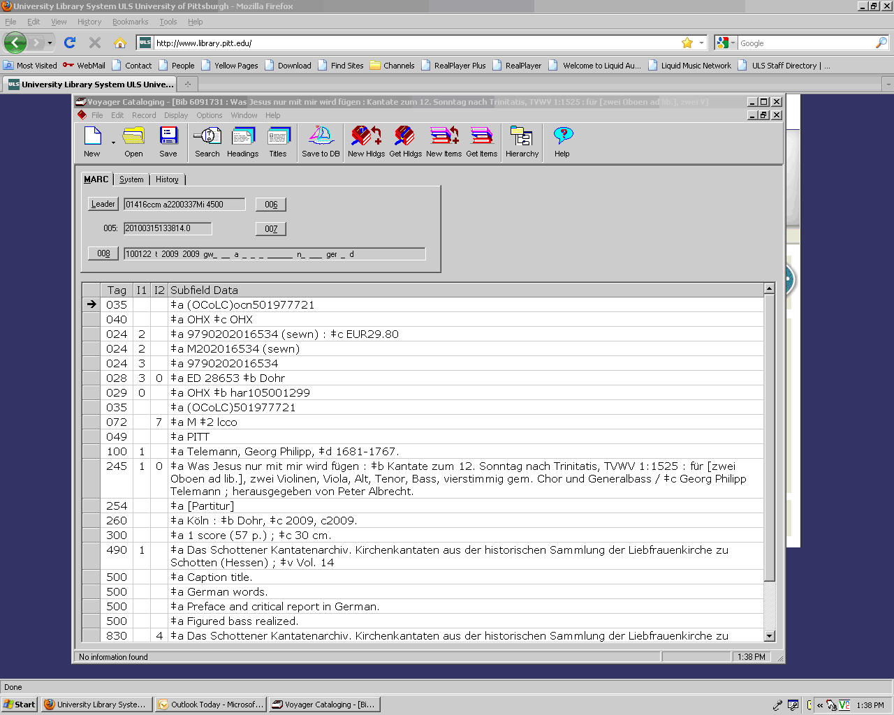
Example 2. Harrassowitz MARC Record

Money is also saved. Every approval plan comes with a discount, typically 10% off the retail price of the score. While this may not on the surface sound like much, it does add up quite quickly, helping to stretch your acquisition budget.
One of the fallacies of approval plans, however, is that you will no longer need to spend time selecting scores for your collection. Nothing could be farther from the truth. While the time one spends selecting scores may diminish, and no matter how finely tuned your profile is, additional selection will be necessary to continue adequate coverage or to continue to fill in gaps. Collection development is further complicated today by the unavailability of certain repertoire from any vendor. Several contemporary composers now sell their scores via their own Web sites, and in small print runs. Many institutions, Pitt is one of them, cannot purchase materials via Web sites without using an intermediary vendor who will charge an extra cost to acquire the material for you. However, despite such obstacles, we, as music librarians, continue to stock our shelves with currently published materials, and will continue to do so, not matter what library “visionaries” say about the book, or any printed material for that matter, being dead, and the future purely digital.

Conclusion
My remarks today are based on my experience with approval plans for music scores as implemented by the University Library System at Pitt. What we have put in place is working out quite well for our collection needs, and for the use of our teaching faculty and students. Were it that I had more funds to earmark for our approval plans, so that coverage would be extended, and the quality of service might be increased. One can always dream! If you are seriously contemplating the implementation of an approval plan for music scores, whether it be with Front, Harrassowitz, or J. W. Pepper, among others, and have any doubts of jumping on this particular bandwagon, let me conclude by paraphrasing Alexander Pope (1688–1744) as found in Part II of his Essay on Criticism, “Fools admire, but those of sense approve.”
Thank you.

