Supplementary material:
Figure S1: symmetry index (SI) of Strongylocentrotus purpuratus larvae in triplicate cultures exposed to control (pH 8.1, filled symbols) and elevated pCO₂ (pH 7.7, open symbols) conditions. SI was calculated as the ratio of right to left overall length. SI was not correlated to neither time post-fertilization (A) nor body length (B).
A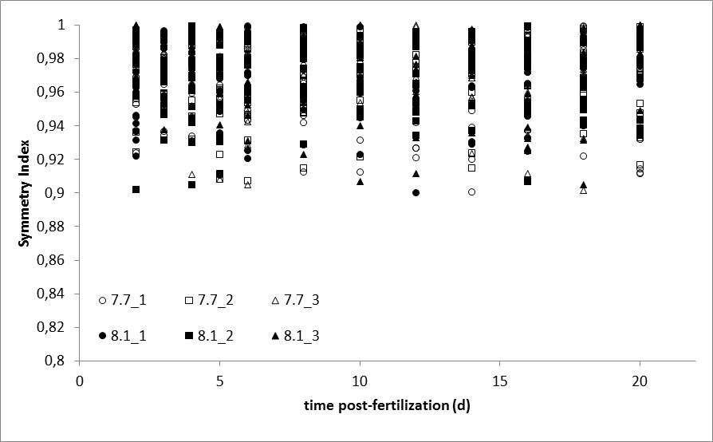
B