Human Suv3 protein reveals its unique features among SF2 helicases

Robert Jedrzejczak^{1,5}, Jiawei Wang^{2,6}, Miroslawa Dauter²,
Roman J. Szczesny^{3,4}, Piotr P. Stepien^{3,4}, Zbigniew Dauter¹

¹Synchrotron Radiation Research Section, MCL, National Cancer Institute, Argonne National Laboratory, Argonne, IL 60439, USA
²Basic Research Program, SAIC-Frederick, Inc., Argonne National Laboratory, Argonne, IL 60439, USA
³Department of Genetics and Biotechnology, Warsaw University, Pawinskiego 5A, 02-106 Warsaw, Poland
⁴Institute of Biochemistry and Biophysics, Polish Academy of Sciences, Pawinskiego 5A, 02-106 Warsaw, Poland
⁵Midwest Center for Structural Genomics, Biosciences Division, Argonne National Laboratory, Argonne, IL 60439, USA
⁶Center for Structural Biology, School of Life Sciences and School of Medicine, Tsinghua University, Beijing 100084, China

e-mail: dauter@anl.gov, stepien@ibb.waw.pl

Keywords: human helicase hSuv3, mitochondrial helicase, RNA processing

Synopsis: The crystal structures of the human mitochondrial helicase hSuv3 in complex with AMPPNP and with short strand of RNA are presented.

Abbreviations: PDB, Protein Data Bank; AMPPNP, adenosine 5′-(β,γ-imido)triphosphate

PDB codes: 3RC3: hSuv3:AMPPNP complex, 3RC8: hSuv3:RNA complex
Abstract
Suv3 is a helicase involved in efficient turnover and surveillance of RNA in eukaryotes. In vitro study shows that human Suv3 (hSuv3) in complex with human polynucleotide phosphorylase has RNA degradosome activity. The enzyme is mainly localized in mitochondria; but small fractions are found in cell nuclei. Here we present two X-ray crystallographic structures of human Suv3 in complex with AMPPNP, a non-hydrolysable analog of ATP, and with a short five-nucleotide strand of RNA, at a resolution of 2.08 and 2.9 Å, respectively. The structure of the enzyme is very similar in the two complexes and consists of four domains. Two RecA-like domains form a tandem typical for all helicases from the SF2 superfamily which, together with the C-terminal all-helix domain, makes a ring structure through which the nucleotide strand threads. The N-terminal, mostly helical, domain is positioned externally with respect to the core of the enzyme. Most of the typical helicase motifs are present in hSuv3, but the protein shows certain unique characteristics, suggesting that Suv3 enzymes may constitute a separate subfamily of helicases.

1. Introduction
The human nuclear SUV3 gene (SUPV3L1) encodes an NTP-dependent RNA/DNA helicase (Suv3p, hSuv3p), which is related to the DexH/D (Ski2p) superfamily. The gene has been conserved during evolution and is present in purple bacteria and in all eukaryotes (Dmochowska et al., 1999). In the yeast Saccharomyces cerevisiae the Suv3 protein is localized to mitochondria and forms a degradosome complex with the 3'-5' exoribonuclease Dss1 (Stepien et al., 1992; Dziembowski et al., 2003; Malecki et al., 2007). Both proteins are required for degradation and surveillance of mitochondrial RNAs.
In humans the hSuv3 (hSuv3p) protein is localized predominantly in the mitochondrial matrix (Minczuk et al., 2002) and is necessary for degradation of mature mtRNAs, processing intermediates transcribed from H- and L-strands, and aberrant RNA molecules (Szczesny et al., 2010). The molecular partner of hSuv3p in human mitochondria is likely polynucleotide phosphorylase (PNPase), as both proteins were found to interact in vitro (Wang et al., 2009) and copurify from human cells (Szczesny et al., 2010).
The human hSuv3 protein is not confined to mitochondria. It is localized in the cell nucleus, and was found to have several interacting partners: HBXIP (Minczuk et al., 2005), BLM helicase, and WRN helicase (Pereira et al., 2007). Perturbations in mammalian SUV3 gene expression were found to lead to apoptosis, elevated levels of sister chromatid exchange, impaired ATP production, finally resulting in cellular senescence and death (Szczesny et al., 2007; Pereira et al., 2007). Interestingly, conditional knockout of the mouse SUV3 gene results in premature aging phenotypes, including loss of fat and muscle, kyphosis, cachexia, and scaling of feet and tail (Paul et al., 2009).
In summary, the hSuv3 protein is one of the players in regulating mitochondrial RNA metabolism, chromatin maintenance, and cell death.
Despite an accumulation of substantial amounts of biological data, the structure of hSuv3 has not been described so far. Any bioinformatics approach to model its structure has been doomed to fail, since sequence similarity of hSuv3 to any known protein structure is below 25%. In order to facilitate further studies of this important enzyme, we have initiated its crystallographic studies. Here we present two structures of human Suv3; one in complex with non-hydrolysable analog of ATP; AMPPNP (resolution 2.08Å, Protein Data Bank [PDB] ID 3rc3); and a second one harboring a short piece of bound RNA oligonucleotide (PDB ID 3rc8, resolution 2.9 Å). A comparison of these structures with other helicases gives detailed information about the unique characteristics of this enzyme, its ATP-binding pocket, and the nucleotide binding site.

2. Materials and Methods
2.1 Cloning, Expression and purification of hSUV3
All of the preparation steps were performed similarly to the procedure described previously (Szczesny et al., 2007), with some modification for crystallization trials. The cDNA fragment coding 47–722 residues of hSuv3 was amplified according to the procedure described by Tropea et al. (2007). The amplicon was inserted to entry vector pDON, generating pDON-47-722-hSUV3, followed by recombination to pDEST-His-MBP, producing pMBP-47-722-hSUV3. BL21(DE3) CodonPlus-RIL cells (Stratagene) containing pMBP-47-722-hSUV3 were grown in M9 media in conditions suppressing production of methionine (Van Duyne et al., 1993). At OD600 about 1.0 the bacterial culture was cooled down to 18ºC. At this point IPTG and selenomethionine were added (0.4 ml of 1 M and 75 mg, respectively, to 1 L of culture). The culture was centrifuged after an additional 18 hours of shaking at 18ºC/180 rpm. The cell pellet from 1 L of bacterial culture was re-suspended in 35 mL of buffer A [50 mM Tris/HCl, pH 8.0, 50 mM K₂PO₄, 0.3 M KCl, 10% (v/v) glycerol, 25 mM imidazole and 5 mM 2-mercaptoethanol]. After the addition of benzamidine/HCl to a final concentration of 3 mM, the cells were stored in −80ºC. All further purification steps were performed at 4ºC. Frozen bacteria were thawed and lysed by sonication. The crude extract was centrifuged at 40,000 g for 40 min and the supernatant was applied on an 20 mL Ni-NTA (Ni²⁺-Nitrilotriacetic acid, Qiagen) column equilibrated with buffer A. The column was washed with 10 column volumes of buffer A adjusted to 2 M KCl, followed by 10 column volumes of buffer A. Bound proteins were eluted with buffer A supplemented with 200 mM imidazole. The eluate was adjusted to 1 mM dithiothreitol (DTT) and 1 mM EDTA. TEV (tobacco etch virus) protease (Tropea et al., 2007) was added to a ratio of 1:100 of TEV protease:total protein. After overnight digestion, the protein solution was precipitated with ammonium sulfate (0.39 g ml⁻¹) and centrifuged at 10,000 g for 20 min. The pellet was re-suspended in buffer A lacking imidazole, and applied onto a 25 mL Ni-NTA column. 47-722-hSuv3 was eluted with buffer A, followed by a second precipitation with ammonium sulfate (0.39 g ml⁻¹) and centrifuged. The pellet was re-suspended in 2 ml of buffer B (0.25 M NaCl, 20 mM Hepes pH7.5, 10% glycerol, 10 mM DTT, 0.02% NaN₃) and applied on a Superdex 200 size-exclusion chromatography column equilibrated with the same buffer. Fractions containing 47-722-hSuv3 were collected, concentrated to 10 mg/ml and set up for crystallization. The selenomethionine-enriched protein was used for setting the AMPPNP crystallization trials. Once the SeMet structure was solved, the native 47-722-hSuv3 was expressed in Luria Bertani broth, purified as described above and co-crystallized with E. coli crude RNA.

2.2 Crude RNA extract preparation
Overnight grown E .coli (DH5α strain) cells were treated according to Qiagen plasmid purification protocols, omitting RNase A in the P1 buffer. The cells were re-suspended in P1 buffer, lysed with P2 and the solution was neutralized with N3 buffer. After removal of precipitant, the supernatant was mixed with 95% ethanol at ratios 1:2.5. The resulting precipitant was spun down, washed with 70% ethanol, air-dried and re-suspended in buffer B.

2.3 Crystallization
Two crystallization trials were performed. Initially, 1 mM AMPPNP was added to the purified protein solution and hanging crystallization drops were set after mixing it at 1:1 ratio with the well solution containing 6% PEG3350, 0.1M sodium citrate pH 6.5 and 10% glycerol at 4°C. The crystals of hSuv3 grew after about one week.
In the second crystallization trial, the hSuv3 protein was mixed with crude RNA extract from E. coli. The protein and crude RNA were incubated at 4°C overnight, followed by the addition of RNaseA in a 1:100 ratio of RNaseA:hSuv3. The mixture was incubated for four hours at 4ºC with the purpose of “shaving off” any RNA fragments sticking out of the protein. Finally, the solution of hSuv3 was concentrated to 10 mg/ml of protein. Crystallization conditions were the same as for AMPPNP protein complex.

2.4 Structure solution and refinement
A crystal, approximately 0.12 × 0.15 × 0.3 mm, was dipped for about 5 s in the solution prepared from the well solution supplemented with 20% of glycerol and then transferred in a rayon loop to the stream of cold nitrogen gas at the goniostat of the SER-CAT beam line 22ID of the Advanced Photon Source, Argonne National Laboratory, equipped with a MAR300 CCD detector. One set of diffraction data was collected at the wavelength of 0.9754 Å, corresponding to the high-energy remote region near the X-ray absorption edge of selenium. The structure was solved using the program HKL-3000 (Minor et al., 2006). The initial SAD phases were introduced to the ARPwARP procedure (Perrakis et al., 1997), which built 584 residues (out of the expected 675). The hSuv3 model was finalized by refinement with REFMAC (Murshudov et al., 1997) interspersed with graphics sessions of COOT (Emsley & Cowtan, 2004). The final model with R factor of 15.96% and R_{free} of 20.32% contains 607 residues of the protein, one molecule of AMPPNP, and 513 water sites. The remaining expected parts of the protein chain are disordered and not identifiable in the electron density maps. The statistics of the diffraction data and model refinement are summarized in Table 1.
The crystal of the RNA complex of hSuv3 was treated according to the same cryo procedure, and diffraction data were also collected at the 22ID beam line of SERCAT, but using wavelength of 1.0 Å, since here the protein did not contain selenomethionine, but native methionine. The previously refined molecule of hSuv3 (stripped of solvent and ligand molecules) was positioned in the cell with MOLREP (Vagin & Teplyakov, 1997) and refined with REFMAC. The short fragment of RNA was identified in the electron density and included in refinement. It was decided that the resolution of 2.9 Å did not warrant inclusion of water solvent. The final R factor was 17.72% and R_{free} 23.78%. The remaining information about data and refinement of hSuv3RNA is included in Table 1.
Several other programs from the CCP4 (1994) suite were used for various purposes during structure refinement and comparison with other models of helicases. The illustrations were made with PyMol (DeLano, 2002) (Figs. 1, 2, 3, 6) and ChemDraw (CambridgeSoft) (Figs. 7, 8).

3. Results and Discussion
3.1. hSuv3 model
Both structures of hSuv3, the complex with AMPPNP and with RNA, crystallize in the same space group P3₂, but with cell parameters a and b different by about 5 Å. The structure of the protein is shown in Fig. 1 and is similar in both complexes. The aspects relevant to the interaction of hSuv3 with AMPPNP or RNA will therefore be discussed based on the corresponding structures containing either AMPPNP (PDB code 3RC3) or RNA (code 3RC8) and referred to by hSuv3AMPPNP or hSuv3RNA, respectively. The AMPPNP and RNA are presented in the corresponding electron density in Figs. 2 and 3, respectively.
The construct of hSuv3 used for crystallization contained residues 47–722 of the complete genome sequence, plus an additional Gly at the N-terminus. In both crystal structures the fragments of both termini (residues 46–57 and 690–722), as well as two other fragments of the chain (73–86 and 446–456), are disordered and not visible in the electron density map. These fragments are therefore absent in the atomic models of both structures..
The overall structure of hSuv3 can be divided into four domains, as shown in Figs. 1 and 4. Domains B, C and D form a ring structure with a tunnel in its center.The N-terminal domain A is loosely connected to the rest of the molecule.
The helical N-terminal domain A (residues 59–170) can be approximately described as a left-handed three-helix bundle ornamented with additional helices and loops, according to the DALI server (Holm & Rosenström, 2010). No significantly similar domains were identified in the PDB.
The fold of domains B (residues 187–348) and C (residues 349–500) is typical for the SF2 family of helicases represented by the DEAD box RecA helicase, with some variations. The B domain has eight β-strands, all parallel except the last Bβ2”, and four accompanying helices (two pairs on both sides of the β-sheet) with two additional short helices. The C domain has six parallel β-strands and four helices (three and one on two sides of the β-sheet). In comparison with the canonical RecA fold, domain B has three additional strands and two short helices, while domain C has one strand and one additional helix. Both of them lack one helix between the third and fourth strand. The domains form a compact dimer, typical for many helicases.
The C-terminal domain D (residues 501–689) consists of nine helices and only one β-sheet consisting of two short strands. The last three helices form a three-helix bundle and the previous three are also arranged analogously to a short three-helix bundle. The DALI server identifies some three-helix bundles with low structural similarity to this domain.
In a number of multi-domain helicases, the domains additional to the two “standard” α/β RecA domains constitute insertions between their strands (Caruthers & McKay, 2002). In hSuv3, the four domains are consecutive in the sequence, except for one of the helices (Dα0) linking domains A and B, which topologically belongs to the last domain D, as shown in Fig. 4.
The short strand of RNA, consisting of five nucleosides, identified in the hSuv3RNA complex, is located within the tunnel formed between domains B, C, and D. Its localization with respect to the helicase domains B and C is analogous to the place of the short nucleic acid strands in the other SF2 helicase:nucleic acid complexes (PDB codes: 3PEW, 3G0H, 2HYI, 2DB3, 3I62, 2JLV, 2NMV, 2XGJ, 3O8R).

3.2. Helicase motifs in hSuv3
Helicases from the SF1/SF2 superfamilies possess several conserved sequence motifs, first identified by Gorbalenya & Koonin (1993). Fig. 5 shows sequences of these motifs in hSuv3 compared to some other typical helicases, and Fig. 6 presents their localization in the structure of hSuv3. The highest sequence similarity of hSuv3 to any known structure from the PDB is 27% and, as shown in Fig. 5, similarity within the characteristic motifs does not seem to be higher than that.
According to the classification of Cordin et al. (2006), the motifs Q, I, Ia, Ib, II, and III reside in the first RecA domain B and motifs IV, V, and VI in the second RepA domain C. The motifs Q, I, and VI take part in binding ATP, the motifs II and III in the hydrolysis of ATP, and motifs Ia, Ib, IV, and V in binding of the nucleic acid (Caruthers & McKay, 2002). A more recent classification, taking into account several additional motifs, has been proposed by Jankowsky and his coworkers (Fairman-Williams et al., 2010; Jankowsky, 2011), but the sequence conservation of the new motifs is much lower and it is not possible to assign them unequivocally to hSuv3.
The characteristics of these motifs in hSuv3 in comparison with some other structures of helicases present in the PDB (Berman et al., 2000) and quoted by their PDB codes are discussed below.

3.3 Binding of AMPPNP - motifs Q, I, II, III and VI
Several residues around the ATP-binding pocket, mostly from motifs I, II, III, and VI, form hydrogen bonds with the ligand in the structure of the AMPPNPhSuv3 complex, as presented in Fig. 7. Inspection of the hSuv3 sequence and structure leads to the conclusion that hSuv3 does not have motif Q. Motif Q appears in helicases possessing the so called “cap” attached to the first RecA domain (Tanner et al., 2003), and contains residues engaged in binding ATP. If this motif exists, e.g., in 3G0H, 2HYI, and 2DB3 (Fig. 5), it contains the aromatic Tyr or Phe with their rings positioned parallel and interacting with the adenine aromatic ring system. The third residue after Tyr/Phe (of various types) provides its carbonyl O atom to form an H-bond with the adenine N6 atom. Most characteristically, the eighth residue after Tyr/Phe is Gln, forming two hydrogen bonds between its OE1 and NE2 atoms and the adenine N6 and N7 atoms, respectively.
The structure of hSuv3 does not have the insertion in the from of a “cap” characteristic to the above-mentioned helicases and it belongs to the group of helicases lacking the motif Q altogether. In all helicase structures that contain ATP (or its analog, e.g., AMPPNP) there is always at least one (sometimes two) aromatic residues involved in π-π interactions with the adenine ring. In hSuv3 this role is taken by Tyr215, located in the sequence at the end of motif I. On the other side of the adenine moiety resides Phe 474, located in sequence immediately after motif VI. The aromatic ring of Phe474 is not completely parallel to the adenine, so that the π-sandwich is not ideal. The N atoms of adenine form hydrogen bonds not with any protein atoms, but with solvent water molecules. Similarly to other helicases, if the adenine N atoms are not H-bonded to protein, they are surrounded by solvent. In some helicases the Tyr residue stacked with adenine is located at the end of the last β-strand of the first RecA domain. The location of ATP-stacking Tyr or Phe at the end of motif I, as in hSuv3, is not encountered in any other helicase containing adenosine present in PDB.
Motif I, also called Walker A motif, is present in all helicases and contains residues binding ATP. The sequence of this motif in hSuv3 is GPTNSGKTY. All of the last seven residues of this fragment in hSuv3 directly bind AMPPNP, either through the main chain hydrogen bonds (N atoms of Asn210, Ser211, and Gly212, with oxygen atoms of phosphates), side-chain hydrogen bonds (Thr 209, Thr214, and through a water molecule, Lys213) or by π-stacking with the adenine ring (Tyr215). The canonical fingerprint of SF2 helicases is GxGKS/T (Gorbalenya et al., 1989), but in contrast to the majority of other helicases, in hSuv3 the first Gly in this fragment is changed to Asn.
Both glycines in the classic motif I lie in the left-handed helical region of the Ramachandran plot in the majority of known structures of helicases. This is not unusual, since Gly residues have a similar propensity for the right- and left-handedness of their main chain (Nicholson et al., 1989). The non-Gly residues only rarely occur in this region of the plot, due to the steric hindrance between the side chains of consecutive L-amino acids. However, the ϕ,ψ-angles of Asn210 in hSuv3 locate this residue in the left-handed region of the Ramachandran plot, so that the conformation of the main chain backbone is the same in hSuv3 as in other helicases.
As pointed out above, the Tyr215 residue, forming the parallel π-stack with adenine, occurs in the hSuv3 sequence immediately after motif I. This is a unique characteristic of hSuv3, since in other helicases the aromatic residues stacking with adenine of ATP are located in different locations (motifs) in the protein sequence.
Motif VI is characterized by His or Gln at the beginning, two glycines at positions 4 and 7, and two arginines at positions 5 and 8; and most helicases conform to this consensus. In hSuv3 this motif has the sequence QIAGRAGRF.
The side chains of Gln466, Arg470, and Arg473 form hydrogen bonds with the phosphate oxygen atoms of AMPPNP. Immediately following the last Arg of this motif in hSuv3 is Phe474, located near the adenine ring of AMPPNP, on the side opposite Y215. This is similar to some other helicase structures, where the adenine is sandwiched between two aromatic residues (3PEW, 3G0H, 2HYI).

Motif II with its most general fingerprint, DExx, is present in all helicases. The most common amino acids in the fourth place of this motif are Asp or His, but in hSuv3 this place is occupied by Gln.
The proposed role of this motif is to indirectly (through water molecules) coordinate the Mg²⁺ ion of the MgATP complex by the carboxyl group of Asp and to assist as a catalytic base in the ATP hydrolysis through the carboxyl of Glu. In most of the available structures of helicases containing MgAMPPNP, both Asp and Glu are hydrogen-bonded to water molecules coordinated by the Mg²⁺ ion. In the hSuv3AMPPNP structure there is no metal ion, but both carboxyl oxygen atom atoms of Asp291 are connected to the terminal phosphate oxygen O2γ through two water molecules. The side chain of Glu292 is directed away and does not interact, even indirectly, with the AMPPNP. There is enough space available around this location to allow Glu292 to change its conformation (in concert with nearby Met429) and adopt a position analogous to that in the structures containing Mg.
Motif III is proposed to link the process of hydrolysis of ATP and unwinding of RNA. The characteristic for the SF2 helicases sequence of this motif consists of three residues, SAT. In hSuv3 the sequence at the location of the typical SAT triplet of residues is occupied by the GEP triplet. In this respect, hSuv3 is unique among SF2 helicases, and the details of coupling of the ATPase and RNA unwinding activities evidently differ from the majority of the SF2 superfamily members. Helicases from the SF1 superfamily usually have the GDx triplet in this place, confirming that the SAT fragment is not absolutely necessary for the helicase activity.

3.4 Binding of RNA - motifs Ia, Ib, IV, and V
The nucleic acid binding motifs are located on the opposite side of the double RecA dimer from the ATP-binding cleft, and contain residues binding a single strand of nucleic acid. Since the RNA fragment bound to hSuv3 originated from the natural source, its sequence can only be deduced from electron density. Among five interpretable locations of RNA bases in the map, the first and last two are best filled by cytosines and the middle one by guanine, as shown in Fig. 3, although their identities are not 100% certain. Residues of hSuv3 bound to nucleic acid in the RNA complex through hydrogen bonds are shown in Fig. 8. RNA interacts mostly through its phosphate and sugar moieties; the five bases are mutually stacked, but they form only two hydrogen bonds with the surrounding protein residues. Generally, the sequence conservation of these motifs is lower than in the ATP-binding motifs, but some characteristics are common for most of the SF2 superfamily members.
Among crystal structures of SF2 helicases in the PDB, some contain fragments of single-stranded nucleic acids, and they are included in Fig. 5. At least five nucleotides are modeled in these structures, even though additional nucleotides may be present but not visible in the electron density map. In the hSuv3RNA structure, five nucleotides (numbered 4 to 8) are identified and present in the refined model of 3RC8.
Motif Ia usually has the PxRxLA sequence, and in hSuv3 it is PLKLLA. In the complexes, typically the carbonyl oxygen of the first residue in this motif is hydrogen-bonded to the O2′ hydroxyl group of the ribose of the third nucleotide and the peptide N atom of the third residue is hydrogen-bonded to the phosphate oxygen of the next nucleotide. In hSuv3 the N atom of Lys234 is bonded to the Cyt8 phosphate oxygen, but Pro232 is not bound to RNA. In some complexes containing Arg in the third place, its guanidinium group makes an ion pair with the successive phosphate group of the nucleic acid, but in hSuv3RNA the NZ atom of Lys234 is coupled with the carboxyl OE1 of Glu257.
Motif Ib has variants of the sequence TPGRL, with the first Thr being most conserved. In hSuv3 this fragment is TVEMC and the OG1 atom of the threonine is hydrogen bonded to oxygen of the last phosphate in the five-nucleotide fragment of RNA, similarly to other helicase complexes. In some helicases the N atoms of the third and fourth residues of this motif hydrogen bond with the O2′ hydroxyl of the fourth residue and the phosphate oxygen of the fifth residue of RNA. There are no such interactions in hSuv3RNA.
Motif IV has the consensus sequence LIFxxTxR with the third Phe most conserved, while in hSuv3 this fragment has sequence CIVCFSKN. Typically, two residues from this fragment form hydrogen bonds with the nucleic acid. The carbonyl oxygen of the fifth residue bonds with the hydroxyl of the first nucleotide and the peptide N atom of the seventh residue bonds with the phosphate oxygen of the second nucleotide in the pentamer of RNA. The hSuv3RNA conforms to this scheme with its N atom of Phe373 and O atom of Lys375 engaged in hydrogen bonds with RNA. If, as in some helicases, the seventh residue in this motif is Arg, it may be engaged in an ion pair with the phosphate oxygen of the third RNA residue. In hSuv3RNA the side-chain NZ atom of Lys375 resides in the vicinity, but not close enough to interact effectively with the phosphate.
In motif V, with the typical sequence TDVxARGID, the first Thr and seventh Gly are most conserved. In hSuv3 the sequence of this motif is TDAIGMGLN. The OG1 atom of the threonine is always engaged in the hydrogen bond with phosphate of the third nucleotide of RNA. In hSuv3RNA the OD1 carboxyl side-chain atom of Asp425 (from the second place in this motif) is hydrogen-bonded with the O2′ hydroxyl of the second RNA nucleotide, but there is no such interaction in any other helicase complexes with RNA. In some helicases the last Asp of this motif extends towards the ATP and makes a hydrogen bond with the O3′ atom of its ribose, and in hSuv3 the OD1 atom of Asn432 is connected with the corresponding ribose hydroxyl through one water molecule. Characteristically, in all helicases the Gly residue has its backbone in the left-handed α-helical conformation.

6. Conclusions
The human mitochondrial helicase hSuv3 has many characteristics typical of helicases from the SF2 superfamily, but it also has a number of features that are unique. In keeping with other SF2 helicases, hSuv3 contains two RecA-like domains and several characteristic sequence/structure motifs, which are engaged in binding ATP or nucleic acids or in linking the ATPase and nucleic acid unwinding activities. SF2 helicases often possess additional domains, but the N- and C-terminal domains of hSuv3 do not show any significant similarity to such auxiliary domains of known helicase structures, except that they are almost exclusively α-helical. The C-terminal domain of hSuv3, together with the two helicase domains, forms a tunnel through which the unwound single strand of nucleic acid is threaded. The N-terminal domain of hSuv3 is located externally with respect to the enzyme core, and its functional role in hSuv3 is not clear.
The typical helicase motifs in hSuv3 also have some peculiarities, unique for this enzyme. hSuv3 does not have motif Q; rather, the tyrosine stacked with the adenine of ATP is located immediately after motif I. The first two residues of motif II in hSuv3 (DE) are absolutely conserved among SF1/SF2 helicases, but the last two (IQ) are rarely encountered at this position. The residues present in hSuv3 in the location of the motif III (GEP) are different than in the usual sequence (SAT) in SF2 helicases. Motif Ia, Ib, IV, V, and VI in hSuv3, although significantly different in their sequences from other SF2 helicases, contain certain important residues conserved among the whole family. Characteristically, all residues in motifs Q, I, V, and VI that have left-handed backbone conformation (not necessarily glycines) are highly conserved in all SF1/SF2 helicases.
The human Suv3 enzyme shares a low sequence similarity with other structurally characterized helicases, but its sequence is 75% similar to the yeast enzyme. This, together with the described unique structural features, suggests that Suv3 enzymes may constitute a separate subfamily of SF2 helicases.

Acknowledgments
This work was supported in part by the Polish National Centre for Research and Development (NR 3010154333) and the Intramural Research Program of the NIH, National Cancer Institute, Center for Cancer Research, and with Federal funds from the National Cancer Institute, National Institutes of Health (Contract No. HHSN261200800001). The content of this publication does not necessarily reflect the views or policies of the Department of Health and Human Services, nor does the mention of trade names, commercial products, or organizations imply endorsement by the U. S. Government. Use of the Advanced Photon Source was supported by the U.S. Department of Energy, Office of Science, Office of Basic Energy Sciences, under Contract No. W-31-109-Eng-38.

References

Andersen, C. B. F., Ballut, L., Johansen, J. S., Chamieh, H., Nielsen, K. H., Oliveira, C. L., Pedersen, J. S., Seraphin, B., Le Hir, H. & Andersen, G. R. (2006). Science 313, 1968–1972.
Appleby, T. C., Anderson, R., Fedorova, O., Pyle, A. M., Wang, R., Liu, X., Brendza, K. M. & Somoza, J. R. (2011). J. Mol. Biol. 405, 1139–1153.
Berman, H. M, Westbrook, J., Feng, Z., Gilliland, G., Bhat, T. N., Weissig, H., Shindyalov, I. & Bourne, P. E. (2000). Nucl. Acids Res. 28, 235–242.
Caruthers, J. M. & McKay, D. B. (2002). Curr. Opin. Struct. Biol. 12, 123–133.
Collaborative Computational Project, Number 4 (1994). Acta Cryst. D50, 760–763.
Collins, R., Karlberg, T., Lehtio, L., Schutz, P., van den Berg, S., Dahlgren, L. G., Hammarstrom, M., Weigelt, J. & Schuler, H. (2009). J. Biol. Chem. 284, 10296–10300.
Cordin, O., Banroques, J., Tanner, N. K. & Linder, P. (2006). Gene 367, 17–37.
DeLano, W. L. (2002). PyMOL. http://www.pymol.org.
Del Campo, M., Lambowitz, A. M. (2009). Mol. Cell 35, 598–609.
Dmochowska, A., Kalita, K., Krawczyk, M. Golik, P., Mroczek, K., Lazowska, J., Stepien, P. P. & Bartnik, E. (1999). Acta Biochim. Pol. 46, 155–162.
Dziembowski, A., Piwowarski, J., Hoser, R., Minczuk, M., Dmochowska, A., Siep, M., von der Spek, H., Grivell, L. & Stepien, P. (2003). J. Biol. Chem. 278, 1603–1611.
Emsley, P. & Cowtan, K. (2004). Acta Cryst. D60, 2126–2132.
Fairman-Williams, M. E., Guenther, U.-P. & Jankowsky, E. (2010). Curr. Opin. Struct. Biol. 20, 313–324.
Gorbalenya, A. E. & Koonin, E. V. (1993). Curr. Opin. Struct. Biol. 3, 419–429.
Gorbalenya, A. E., Koonin, E. V., Donchenko, A. P. & Blinov, V. M. (1989). Nucl. Acids Res. 17, 4713–4730.
Holm, L. & Rosenström, P. (2010). Nucl. Acids Res. 38, W545–549.
Jankowsky, E. (2011). Trends Biochem. Sci. 36, 19–29.
Li, W., Stevenson, C. E. M., Burton, N., Jakimowicz, P., Paget, M. S. B., Buttner, M. J., Lawson, D. M. & Kleanthous, C. (2002). J. Mol. Biol. 323, 225–236.
Luo, D. H., Xu, T., Watson, R. P., Becker, D. S., Sampath, A., Jahnke, W., Yeong, S. S., Wang, C. H., Lim, S. P., Strongin, A., Vasudevan, S. G. & Lescar, J. (2008) EMBO J. 27, 3209–3219.
Malecki, M., Jedrzejczak, R., Stepien, P. & Golik, P. (2007). J. Mol. Biol. 372, 23–36.
Minczuk, M., Dmochowska, A., Palczewska, M. & Stepien, P. (2002). Yeast 19, 1285–1293.
Minczuk, M., Mroczek, S., Pawlak, S. D. & Stepien, P. (2005). FEBS J. 272, 5008–5019.
Minor, W., Cymborowski, M., Otwinowski, Z. & Chruszcz, M. (2006). Acta Cryst. D62, 859–866.
Montpetit, B., Thomsen N. D., Helmke, K. J., Seeliger, M. A., Berger, J. M. & Weis, K. (2011). Nature 472, 238–242.
Murshudov, G. N., Vagin, A. A. & Dodson, E. J. (1997). Acta Cryst. D53, 240–255.
Nicholson, H., Söderlind, E., Tronrud, D. E. & Matthews, B. W. (1989). J. Mol. Biol. 210, 181-193.
Paul, E., Cronan, R., Weston, P. J., Boekelheide, K., Sedivy, J. M., Lee, S. Y., Wiest, D. L., Resnick, M. B. & Klysik J. E. (2009). Mamm. Genome 20, 92-108.
Pereira, M., Mason, P., Szczesny, R. J., Maddukuri, L., Dziwura S., Jedrzejczak, R., Paul, E., Wojcik, A., Dybczynska, L., Tudek, B., Bartnik, E., Klysik, J., Bohr, V. A. & Stepien, P. (2007). Mech. Ageing Dev. 128, 609–617.
Perrakis, A., Morris, R. & Lamzin, V. S. (1997). Nat. Struct. Biol. 6, 458–463.
Sengoku, T., Nureki, O., Nakamura, A., Kobayashi, S. & Yokoyama, S. (2006). Cell 125, 287–300.
Stepien, P. P., Margossian, S. P., Landsman, D. & Butow, R. A. (1992). Proc. Natl. Acad. Sci. USA 89, 6813–6817.
Szczesny, R. J., Borowski, L. S., Brzezniak, L. K., Dmochowska, A., Gewartowski, K., Bartnik, E. & Stepien, P. P. (2010). Nucleic Acids Res. 38, 279–298.
Tanner, N. K., Cordin, O., Banroques, J., Doere, M. & Linder, P. (2003). Mol. Cell 11, 127–138.
Tropea, J. E., Cherry, S., Nallamsetty, S., Bignon, C. & Waugh, D. S. (2007). Methods Mol. Biol. 363, 1–19.
Vagin, A. & Teplyakov, A. (1997). J.Appl. Cryst. 30, 1022-1025.
Van Duyne, G. D., Standaert, R. F., Karplus, P. A., Schreiber, S. L. & Clardy, J. (1993). Atomic structures of the human immunophilin FKBP-12 complexes with FK506 and rapamycin. J. Mol. Biol. 229, 105-124.
Wang, D. D., Shu, Z., Lieser, S. A., Chen, P. L. & Lee, W. H. (2009). J. Biol. Chem. 284, 20812–20821.
Waters, T. R., Eryilmaz, J., Geddes, S. & Barrett, T. E. (2006). FEBS Lett. 580, 6423–6427.
Weir, J. R., Bonneau, F., Hentschel, J. & Conti, E. (2010). Proc. Natl. Acad. Sci. USA 107, 12139–12144.

Table 1
Statistics of the diffraction data and structure refinement. Values corresponding to the highest resolution range are given in parentheses.

Data collection: hSUV hSUV_RNA
Beamline 22ID (SER-CAT) 22ID (SER-CAT)
Temperature (K) 100 100
Wavelength (Å) 0.9754 1.0000
Space group P3₂ P3₂
a,b (Å) 89.39 94.43
c (Å) 88.07 88.03
Resolution limit (Å) 40-2.08 (2.15-2.08) 30-2.9 (3.0-2.9)
Reflections measured 179,028 (13,871) 107,954 (11,070)
Reflections unique 47,146 (4,565) 19,390 (1,957)
Multiplicity 3.8 (3.2) 5.6 (5.5)
Completeness native (%) 99.6 (96.5) 100 (100)
Completeness anomalous (%) 98.6 (91.1) -
R_{merge} (%) 5.7 (32.6) 7.5 (40.7)
Average I/σ(I) 26.9 (3.4) 22.6 (4.5)
Wilson B factor (Å²) 33.9 75.2

Refinement:
Resolution (Å) 40-2.08 30-2.9
R-factor (%) 15.96 17.72
Working reflections 46,139 18,398
R_{free} (%) 20.32 23.78
Free reflections 965 991

Protein atoms 4,854 4,869
RNA atoms - 107
ATP/AMPPNP atoms 31 -
Ion sites (Na⁺, Cl⁻, azide) 5 -
Water sites 522 -
Rmsd bonds (Å) 0.026 0.016
Rmsd angles (º) 1.98 1.66

Ramachandran statistics:
Most favored 517 (95.7%) 475 (87.5%)
Allowed 22 (4.1%) 63 (11.6%)
Generously allowed 0 3 (0.6%)
Disallowed 1 (0.2%) 2 (0.4%)

PDB code 3RC3 3RC8
Figure legends
Fig. 1. The structure of hSuv3 with its four domains colored as follows: the N-terminal domain A is shown in yellow, the two RecA domains B and C are in blue and green respectively, and the C-terminal domain D in red. Both AMPPNP and RNA are positioned as in their individual complexes and shown in magenta.
Fig. 2. The molecule of AMPPNP in AMPPNPhSuv3 with the corresponding F_{obs} electron density map (at 1.5σ contour level) and its surrounding residues.
Fig. 3. The identified fragment of nucleic acid in the RNAhSuv3 structure in the F_{obs} electron density (at 1.4σ contour level). The surrounding protein is represented as a cartoon.
Fig. 4 Topology of hSuv3. The N-terminal domain A is in yellow, the RecA domains B and C are in blue and green, respectively, and the C-terminal domain D is in red. The secondary structure elements of domains B and C, not present in the canonical topology of RecA, are represented in pale colors.
Fig. 5. Structurally aligned sequences of typical helicase motifs in hSuv3 and selected helicases from the PDB containing both, ATP analogs and fragments of nucleic acids. Residues hydrogen-bonded to ATP are shown in red, those hydrogen-bonded to nucleic acid are shown in blue and those stacked with adenine are shown in green. Residues in left-handed a-helical conformation are underlined.
Fig. 6. Localization of typical helicase motifs in hSuv3. The ATP-binding motifs (I, II, VI) are presented in red, those binding RNA (Ia, Ib, IV, and V) are in blue and motif III, with its unique sequence of GEP, is in yellow. This figure visualizes both AMPPNP and RNA positioned as in their individual complexes. AMPPNP and RNA are shown in magenta.
Fig. 7. Schematic representation of the hydrogen bond interactions between AMPPNP and surrounding residues of hSuv3. The side chain of tyrosine 215 is involved in π-π interactions with the adenine ring of AMPPNP.
Fig. 8. The scheme of hydrogen bonds identified between the RNA oligonucleotide and hSuv3.
Fig. 1. The structure of hSuv3 with its four domains colored as follows: the N-terminal domain A is shown in yellow, the two RecA domains B and C are in blue and green, respectively, and the C-terminal domain D in red. Both AMPPNP and RNA are positioned as in their individual complexes and shown in magenta.
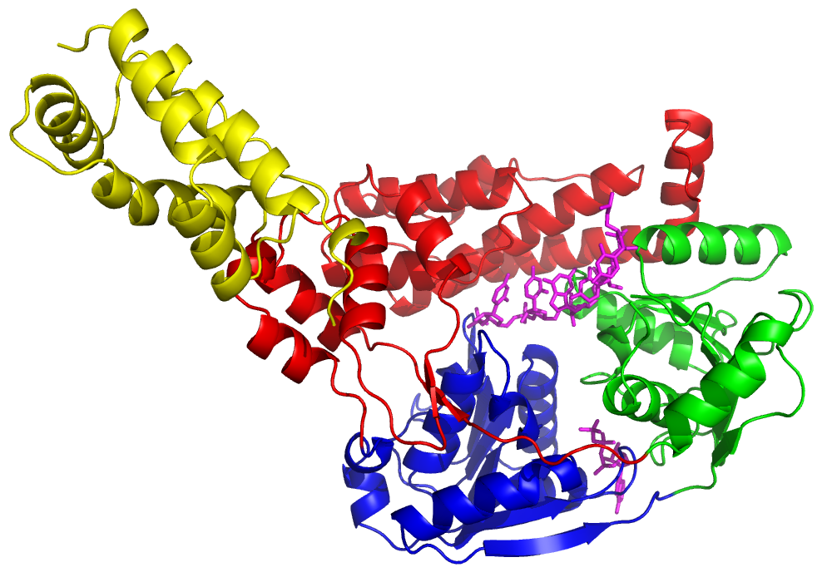

Fig. 2. The molecule of AMPPNP in AMPPNPhSuv3 with the corresponding F_{obs} electron density map (at 1.5σ contour level) and its surrounding residues.
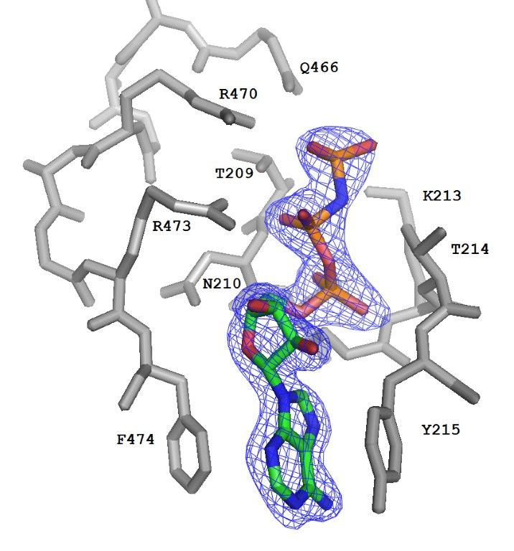

Fig. 3. The identified fragment of nucleic acid in the RNAhSuv3 structure in the F_{obs} electron density (at 1.4σ contour level). The surrounding protein is represented as a cartoon.
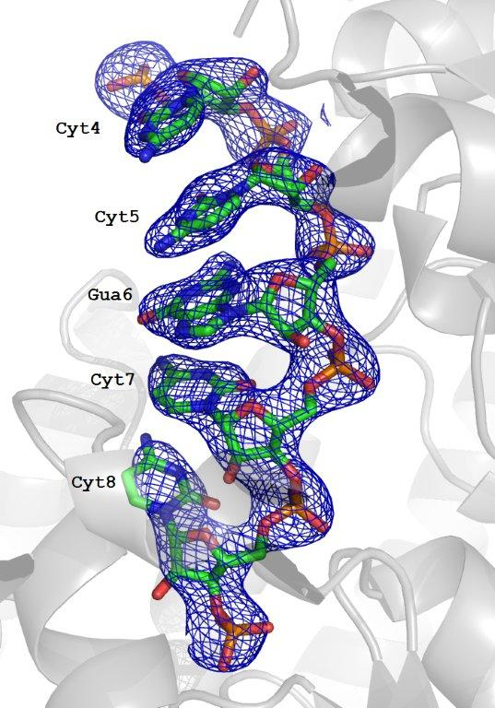

Fig. 4 Topology of hSuv3. The N-terminal domain A is in yellow, the RecA domains B and C are in blue and green respectively, and the C-terminal domain D is in red. The secondary structure elements of domains B and C not present in the canonical topology of RecA, are represented in pale colors.
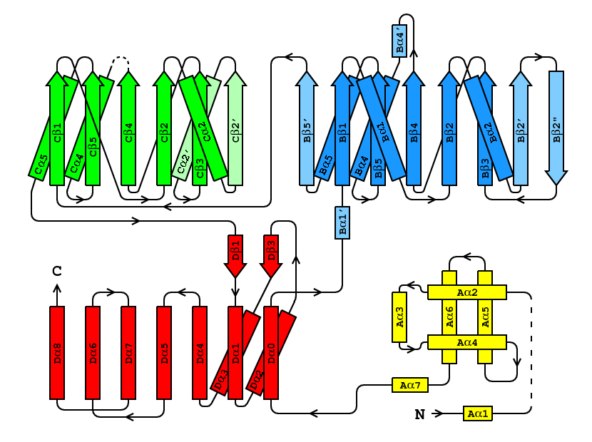

Fig. 5. Structurally aligned sequences of typical helicase motifs in hSuv3 and selected helicases from the PDB containing both, ATP analogs and fragments of nucleic acids. Residues hydrogen-bonded to ATP are shown in red, those hydrogen-bonded to nucleic acid are shown in blue and those stacked with adenine are shown in green. Residues in left-handed a-helical conformation are underlined.

Fig. 6. Localization of typical helicase motifs in hSuv3. The ATP-binding motifs (I, II, VI) are presented in red, those binding RNA (Ia, Ib, IV, and V) are in blue and motif III, with its unique sequence of GEP, is in yellow. This figure visualizes both AMPPNP and RNA positioned as in their individual complexes. AMPPNP and RNA are shown in magenta.
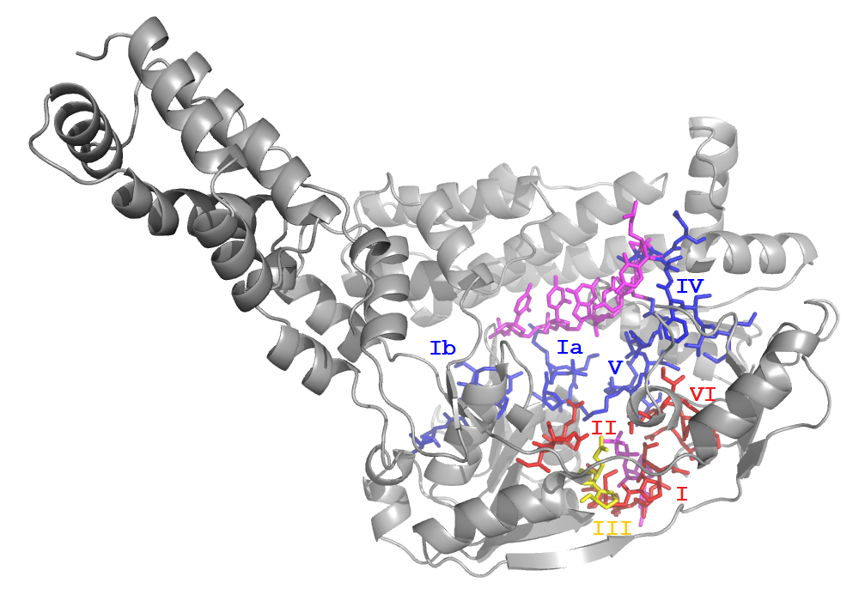

Fig. 7. Schematic representation of the hydrogen bond interactions between AMPPNP and surrounding residues of hSuv3. The side chain of tyrosine 215 is involved in π-π interactions with the adenine ring of AMPPNP.
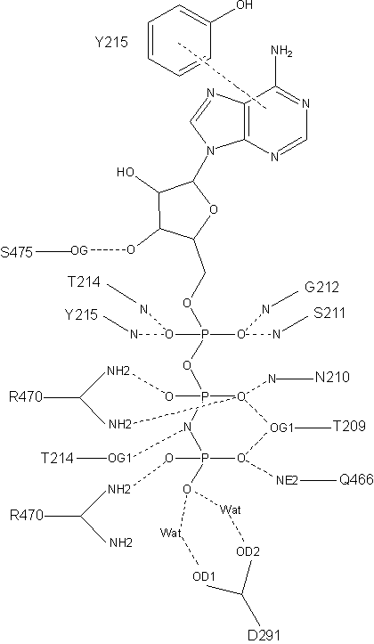

Fig. 8. The scheme of hydrogen bonds identified between the RNA oligonucleotide and hSuv3.
