Organic Rules Database: to support revision of the EU Regulation on organic agriculture

¹Jens G. Hansen, ¹Hugo F. Alrøe, and ²Otto Schmid

Abstract - Within the FP6 project, ORGANIC REVISION a public web-based database was implemented to support the revision of the EU Regulation on organic agriculture. The database describes differences between the major European organic production standards plus other relevant international organic standards (e.g. Codex Alimentarius and IFOAM Basic Standards) in relation to the EEC Reg. 2092/91 (“the EU Regulation”) and gives information on areas not yet covered by the EEC Reg. 2092/91. The database at: http://www.organicrules.org, is still under development.

Introduction
The purpose of the Organic Rules database is to:

- Create an overview of differences between the EU regulation as well as public and private international and national organic standards.
- Contribute to the development of the EU regulation.
- Form a basis for communication and discussion with stakeholders.

The communication and discussion with stakeholders concerns questions on the relationship between the EU regulation and organic values and principles as well as harmonisation, simplification and regionalisation in the EU Regulation.

Target audience
The potential users of the database may be:

- Administrators: for equivalence questions, to learn how issues are understood (interpretation) and implemented/enforced. Which problems arise? Which subject areas may benefit from increased harmonisation or regionalisation?
- Certifiers and inspection bodies/authorities: for equivalence questions; to find inspiration for the development of their own standards; to support traders in exporting or importing issues; to learn about the additional requirements of market relevant standards.
- Traders: for equivalence questions; to learn about the additional requirements of market relevant standards.
- Advisors, researchers, standards setting institutions: to have a common information source; to learn about how special areas are regulated in different standards and in different countries and regions; to learn what the reasons for the differences are and to get other basic information necessary for research or standards setting.
¹ Danish Research Centre for Organic Farming (DARCOF)
² Forschungsinstitut für Biologischen Landbau (FiBL)
Contact: otto.schmid@fibl.org

Methods
The database was developed based on experiences from the Organic Eprints database. Organic Rules is running on Linux and other open source software. It is based on GNU EPrints archive-creating software.
Different information including attached docu-ments (Eprints types) can be uploaded to the database (Figure 1):

- Complete regulations. A whole set of governmental regulations, private standards or implementation rules. Including a link to the most recently updated version.
- Differences between other regulations-/standards and EEC No 2092/91. A description of differences in standards, interpretation or implementation rules between other regulations-/standards and the EEC Regulation No 2092/91.
- Recommendations or comments. Re-commendation or comments for improvements of EEC No 2092/91.

Partners from the Organic Revision project upload the national and private complete standards as well as the descriptions and justifications of differences between these other standards and the EU regulation. FiBL is responsible for the quality and consistency of the information in the database.
Users of the database can find information via full text search and via several browse trees (Figure 2). The Organic Rules database will be demonstrated at the Joint Organic Congress.

Results
Currently, approximately 30 national and private standards, as well as 600 differences between these standards and the existing regulation are in the database. Via the development of the database, the following weaknesses in the structure of the existing EU regulation have been identified.
It is difficult to navigate in the EU Regulation, because information on one subject may be found in several articles and annexes. There are some inconsistencies regarding subject areas covered and not covered. The degree of details varies strongly. Therefore, the Organic Revision project proposed an improved and adapted structure, which has a more logical structure and a more clear differentiation between the different decision levels as well as the different subject areas. The new structure also allows the inclusion of new subject areas, which at present are not covered by the EU Regulation.

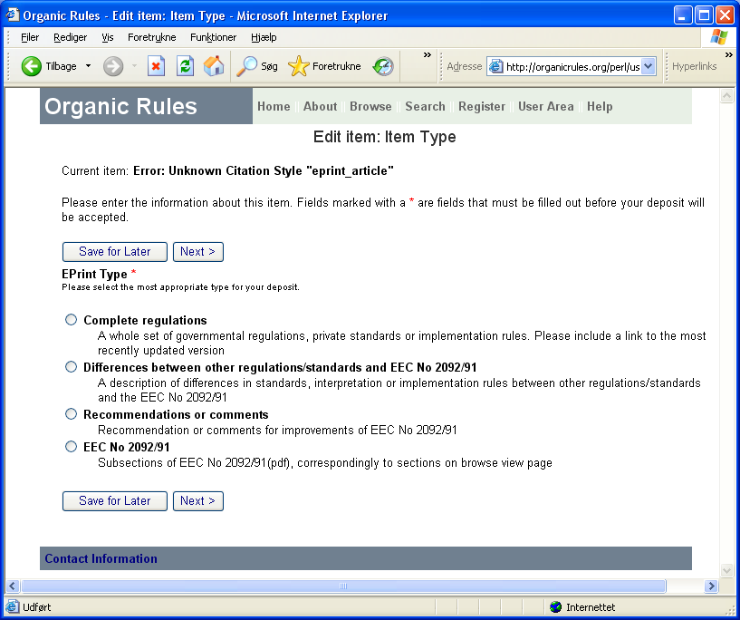
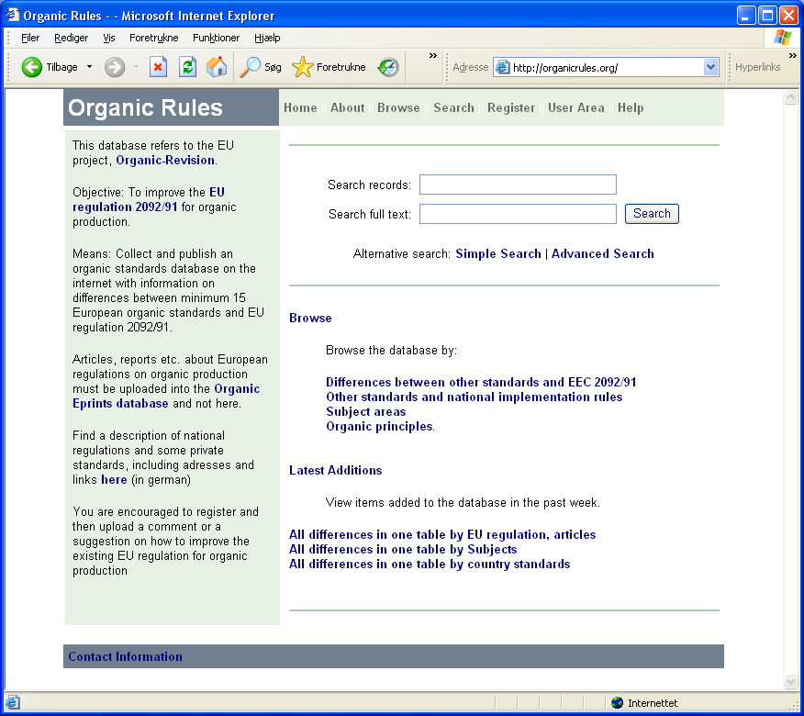
Database
GNU EPrints

Figure 1. Structure of the Organic Rules database and web system. The database holds national and private standards. Partners from the Organic Revision project upload national and private standards via web interfaces, as well as differences between other standards and the existing EU regulation on organic farming. All stakeholders are encourraged to upload comments and suggestions for improvement of the regulation, using the same system at: www.organicrules.org.

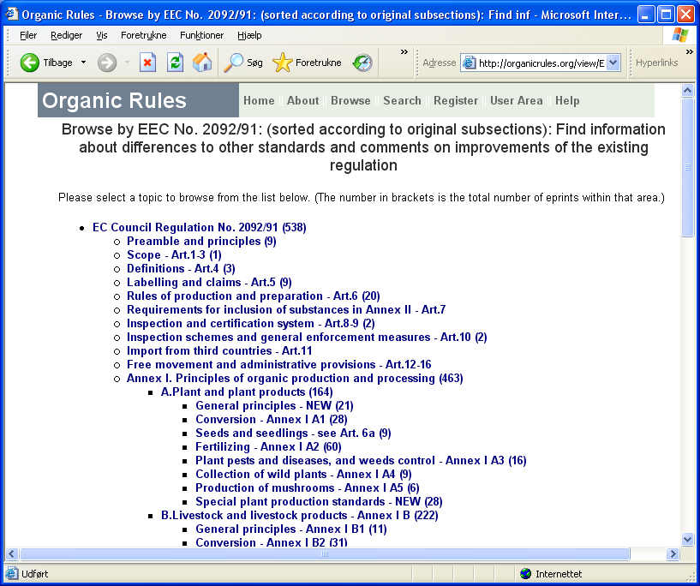
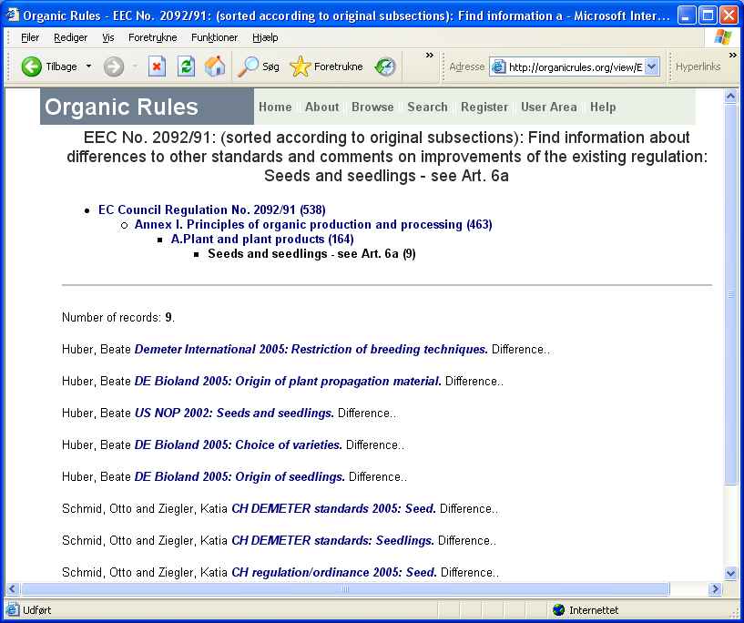
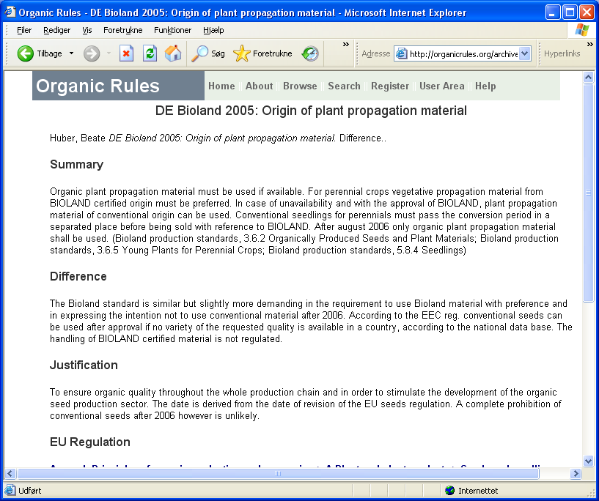
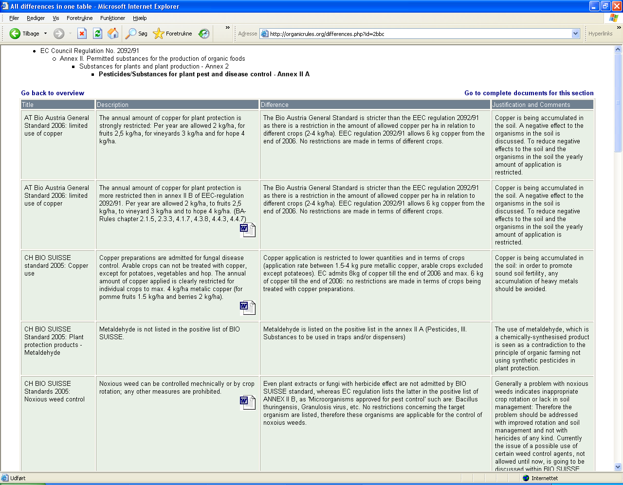

Figure 2. Example of database views of “Differences” between other standards and the EU regulation. Left: all differences related to a certain paragraph in one table including title, description of rule, description of the difference and justification of the difference. Right: via browse trees, the same differences can be found, including attached documents regarding the difference of concern.
Database
GNU EPrints

